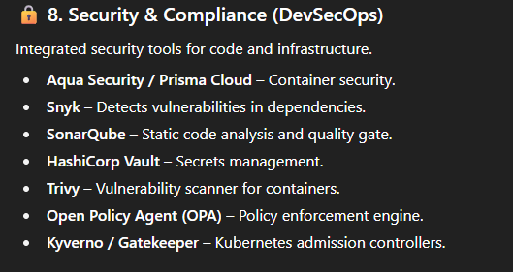
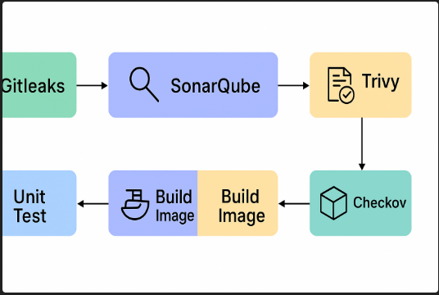
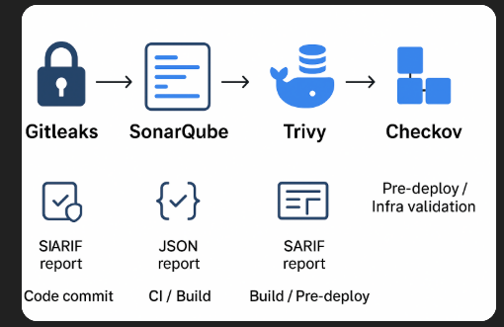

Gitleaks in our CI/CD pipeline

  - Why do we include Gitleaks in our CI/CD pipeline — what is it, how important is it, and what does it do?

  - Why do we include Gitleaks in our CI/CD pipeline — what is it, how important is it, and what does it do?

  - Why is scanning for secrets like API keys, passwords, or tokens necessary before deployment?

  - Why should this process be automated within the CI/CD pipeline instead of relying on manual review?

  - Why is it vital for protecting the company’s infrastructure and ensuring compliance?

  - Why does catching leaks early prevent costly security breaches and reputational damage?

  - Why must every commit be checked to maintain consistent security standards across all teams?
Important links https://github.com/gitleaks/gitleaks https://gitleaks.io/ https://medium.com/@BioCatchTechBlog/gitleaks-a-secret-scanner-for-git-repositories-3a33a6c77b0c https://www.geeksforgeeks.org/linux-unix/gitleaks/

1 & 2. Why do we include Gitleaks in our CI/CD pipeline — what is it, how important is it, and what does it do?
What is Gitleaks?
Gitleaks is an open-source tool designed to detect and prevent sensitive information (secrets) like API keys, passwords, or tokens from being committed to code repositories. It scans Git repositories and their commit history for patterns matching common secret formats.
What does it do?
Gitleaks identifies secrets in code, configuration files, or commit messages by using regular expressions and entropy-based detection. It flags or blocks commits containing sensitive data, ensuring they don’t reach production or public repositories.
How important is it?
It’s critical for security and compliance. Leaked secrets can lead to unauthorized access, data breaches, or financial loss. Integrating Gitleaks into the CI/CD pipeline ensures proactive detection, reducing the risk of exposing sensitive data. It’s especially vital for organizations handling regulated data (e.g., GDPR, HIPAA) to avoid penalties and maintain trust.

3. Why is scanning for secrets like API keys, passwords, or tokens necessary before deployment?
Scanning for secrets before deployment prevents sensitive data from being exposed in public or production environments. Secrets like API keys or passwords, if leaked, can allow attackers to access systems, steal data, or disrupt services. Pre-deployment scanning ensures these are caught early, reducing the attack surface and ensuring secure deployments.

4. Why should this process be automated within the CI/CD pipeline instead of relying on manual review?
Automation in the CI/CD pipeline ensures consistent, rapid, and thorough scanning of every commit, which manual reviews can’t match due to human error, oversight, or time constraints. It scales with development velocity, catches secrets in real-time, and enforces security policies without slowing down workflows. Manual reviews are prone to inconsistencies and delays, especially in large teams or frequent deployments.
5. Why is it vital for protecting the company’s infrastructure and ensuring compliance?
Gitleaks protects infrastructure by preventing unauthorized access through exposed secrets, which could compromise servers, databases, or cloud services. For compliance, it helps meet standards like GDPR, PCI-DSS, or SOC 2, which mandate safeguarding sensitive data. Non-compliance can result in fines, legal issues, or loss of customer trust. Automated scanning demonstrates due diligence and strengthens security posture.

6. Why does catching leaks early prevent costly security breaches and reputational damage?
Catching leaks early stops secrets from reaching public repositories or production, where they could be exploited. A single exposed API key can lead to breaches costing millions (e.g., data theft, ransomware). Early detection minimizes remediation costs, prevents downtime, and avoids reputational harm from public exposure or customer distrust, which can erode brand value.

7. Why must every commit be checked to maintain consistent security standards across all teams?
Checking every commit ensures no secrets slip through, regardless of team size, experience, or workload. Developers may inadvertently commit secrets, and inconsistent manual checks can create vulnerabilities. Uniform scanning enforces a baseline security standard, aligns with DevSecOps principles, and ensures all code adheres to the same rigorous security policies, reducing risks across the organization.
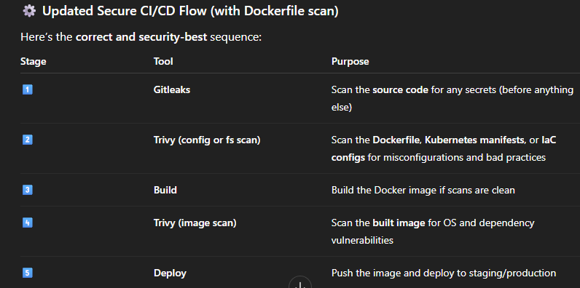

Gitleaks first
- Source code & Dockerfil.It prevents leaking secrets in code or Dockerfile.

- Example: an accidentally hardcoded AWS key.
.

1. What is Gitleaks?
Gitleaks is an open-source secrets detection tool used to find hardcoded secrets (like API keys, passwords, tokens, etc.) in:
- Git repositories (local or remote)
- Commits, branches, and tags
- Pull requests and CI/CD workflows
It helps prevent sensitive information from being committed to code repositories, thereby protecting your systems from security breaches.
Developed by: Zachary Rice (zricethezav)
Language: Go (Golang)
License: MIT

2. Why Use Gitleaks?
Secrets are one of the most common sources of data breaches. Developers may accidentally push:
- AWS Access Keys
- Database passwords
- GitHub tokens
- Slack or API credentials
- SSH private keys
Even if deleted later, Git history keeps them. Gitleaks scans all commit history and current working files to identify and alert you about potential leaks before attackers find them.

3. How Gitleaks Works

✅ Scanning Sources
Gitleaks can scan:
- A local Git repo (gitleaks detect --source .)
- A remote repo URL (gitleaks detect --source=https://github.com/...)
- Commits, branches, PRs, or specific paths

🔍 Detection Logic
It uses:
- Regex-based rules – predefined patterns to detect secrets (e.g., AWS key format).
- Entropy checks – identifies random-looking strings that might be secrets.
- Custom rules – you can define your own regex or keywords in a .gitleaks.toml config file.

🧾 Reporting
It outputs findings as:
- Console summary
- JSON report
- SARIF report (for GitHub Security tab)

4. Key Features
Feature | Description
🔒 Secret scanning | Detects credentials and tokens across Git history
⚡ Fast and lightweight | Written in Go, optimized for large repositories
⚙️ Custom rules | Define your own detection patterns in config file
🧾 Reports | Export JSON/SARIF for automation and auditing
🚫 Pre-commit hooks | Stop commits containing secrets before they’re pushed
🔁 CI/CD integration | Works with GitHub Actions, GitLab CI, Jenkins, etc.
🕵️ Git history scanning | Scans all branches, tags, and commit histories

🔸 Docker
docker run --rm -v $(pwd):/repo zricethezav/gitleaks:latest detect --source=/repo

🧰 6. Basic Commands
Command | Description
gitleaks detect --source . | Scan current repo
gitleaks detect --source=https://github.com/user/repo.git | Scan remote repo
gitleaks detect --config .gitleaks.toml | Use custom config
gitleaks protect --staged | Protect pre-commit (checks staged files)
gitleaks detect --report-format json --report-path report.json | Save results as JSON
gitleaks help | Show help menu
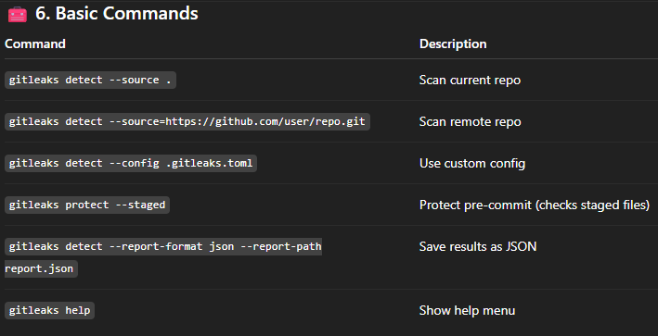

🧩 7. Example Workflow

1️⃣ Scan local repo:
gitleaks detect --source . --report-path report.json

2️⃣ Scan before commit (Pre-commit hook):
# .git/hooks/pre-commit
#!/bin/sh
gitleaks protect --staged --verbose
Make it executable:
chmod +x .git/hooks/pre-commit

3️⃣ GitHub Actions example (.github/workflows/gitleaks.yml)
name: Gitleaks Scan
on:
push:
pull_request:

jobs:
gitleaks:
runs-on: ubuntu-latest
steps:
- name: Checkout code
uses: actions/checkout@v4
with:
fetch-depth: 0

- name: Run Gitleaks
uses: gitleaks/gitleaks-action@v2
with:
args: detect --source . --no-git --report-format sarif --report-path gitleaks.sarif

⚖️ 8. Configuration File
A sample .gitleaks.toml config file:
title = "Custom Gitleaks Config"

[[rules]]
id = "aws-access-key"
description = "AWS Access Key"
regex = '''AKIA[0-9A-Z]{16}'''
entropy = 3.5
tags = ["key", "AWS"]

[[rules]]
id = "slack-webhook"
description = "Slack Webhook"
regex = '''https://hooks.slack.com/services/T[a-zA-Z0-9_]+/B[a-zA-Z0-9_]+/[a-zA-Z0-9_]+'''
tags = ["slack", "webhook"]
You can tweak regex, entropy, or exclusions as per your organization’s security policy.

🧠 9. Common Use Cases
- ✅ Pre-commit scans to prevent leaks before pushing code
- 🔍 Periodic scans of repos for compliance
- 🧾 Integration in CI/CD for automated checks
- 🧱 Security audits for existing repositories
- 🔄 Migration checks when moving repos between systems (e.g., GitHub → GitLab)

Gitleaks stands out for speed, simplicity, and on-prem usage (no external dependency).

🛡️ 11. Best Practices
- Run in CI/CD pipelines to stop leaks early
- Set up pre-commit hooks for local protection
- Customize rules to reduce false positives
- Regularly scan all branches & forks
- Rotate any leaked credentials immediately

⚙️ 5. Create a GitHub Action for Gitleaks
Create a file:
.github/workflows/gitleaks.yml
Paste this YAML configuration:
name: Gitleaks Secret Scan

on:
push:
pull_request:

jobs:
gitleaks-scan:
name: Run Gitleaks
runs-on: ubuntu-latest
steps:
- name: Checkout code
uses: actions/checkout@v4
with:
fetch-depth: 0 # Ensures full commit history for scanning

- name: Run Gitleaks
uses: gitleaks/gitleaks-action@v2
with:
args: detect --source . --report-format sarif --report-path gitleaks.sarif

- name: Upload SARIF report
uses: github/codeql-action/upload-sarif@v3
with:
sarif_file: gitleaks.sarif
✅ What this does:
- Runs automatically on push and pull requests
- Scans the entire repo for secrets
- Outputs a SARIF report visible under GitHub → Security → Code Scanning Alerts

🧠 8. CI/CD Integration Tips
- Add Gitleaks as an early stage in your CI pipeline (before build or deploy).
- Combine it with Trivy (for image scanning) to cover both code & container security.
- Run Gitleaks on all branches to ensure coverage.
- Rotate any credentials found and revoke compromised tokens immediately.

🧩 9. Run Gitleaks from VS Code Git Bash
Typical developer workflow:
# 1. Run scan manually
gitleaks detect --source .

# 2. Fix any issues
# Remove the secret, update env vars, or use Git filter-repo to purge from history

# 3. Commit safely
git add .
git commit -m "Safe changes"

- 🧩 Secrets (via Gitleaks)
- 🐳 Vulnerabilities in Docker images, dependencies, and config (via Trivy)
This creates a DevSecOps pipeline that secures your code before deployment.

⚙️ 1. Overview: Why Combine Gitleaks + Trivy
Tool | Purpose | Example Detection
Gitleaks | Scans for hardcoded secrets in your source code and commit history | API keys, passwords, tokens
Trivy | Scans container images, Dockerfiles, and dependencies for vulnerabilities | CVEs, misconfigurations, outdated packages
Together → full security coverage for code + containers.

🧾 4. What Each Section Does
Step | Purpose
checkout | Gets your repo code
gitleaks | Scans your repo for secrets
upload-sarif | Sends results to GitHub → Security → Code Scanning Alerts
trivy fs | Scans files, dependencies, and IaC config
trivy image | Scans Docker image for CVEs
severity | Limits alerts to HIGH and CRITICAL only

🧠 5. Local Testing from VS Code Git Bash

🧩 Run Gitleaks
gitleaks detect --source . --report-format json --report-path gitleaks-local.json

🐳 Run Trivy File System Scan
trivy fs . --severity HIGH,CRITICAL --format table

🧱 Run Trivy Image Scan
docker build -t myapp:latest .
trivy image myapp:latest --severity HIGH,CRITICAL --format table

🛡️ 9. Security Best Practices
- ✅ Run both Gitleaks + Trivy on every PR and push.
- 🔑 Rotate credentials immediately if Gitleaks finds any.
- 🧱 Use .gitleaks.toml to reduce false positives.
- 🚫 Never store .env files or secrets in Git history.
- 🧩 Use GitHub Secrets or AWS Secrets Manager instead.

- Docker Desktop that hooks Gitleaks automatically into Docker’s UI or dashboards, as far as the information shows.

🔐 Comparison: Gitleaks vs Trivy vs Checkov
🔸 Feature / Aspect | 🧩 Gitleaks | 🐳 Trivy | 🏗️ Checkov
Primary Function | Detects hardcoded secrets (API keys, tokens, passwords) in source code and git history | Scans for vulnerabilities in containers, OS packages, dependencies, and IaC | Detects misconfigurations in Infrastructure-as-Code (IaC) files like Terraform, Kubernetes, Dockerfile, CloudFormation
Focus Area | Source code secrets | Vulnerabilities and CVEs | Cloud/IaC security posture
Type of Security Scan | Secrets detection | Vulnerability scanning | Compliance & configuration scanning
Scans | Source code, Git commits, branches, tags | File system, Docker images, Kubernetes manifests, dependencies | IaC templates (Terraform, CloudFormation, K8s, Dockerfile, ARM, etc.)
Detects | Hardcoded secrets, credentials, tokens | Known CVEs, outdated dependencies, misconfigurations | Insecure IaC configurations, missing encryption, weak IAM policies
Scanning Method | Regex + entropy analysis | CVE database + policy checks | Static analysis using built-in security policies (CIS, NIST, etc.)
Languages / Formats Supported | Any codebase with text files | OS packages, app dependencies (Node, Python, Go, etc.), Docker images | Terraform, CloudFormation, Dockerfile, Kubernetes YAML, ARM, Serverless
Typical CI/CD Stage | 🧱 Early: Code commit / Pre-commit / Push | ⚙️ Build stage (after image creation) | 🏗️ Pre-deploy / Infrastructure validation
Example Use in Pipeline | Runs before or during commit to block secrets in source | Runs after Docker build to check image vulnerabilities | Runs after IaC code is committed to detect weak cloud configs
Output Formats | JSON, SARIF, CSV | JSON, SARIF, Table | JSON, JUnit, CLI table
Integrations | GitHub Actions, GitLab CI, Jenkins, pre-commit hooks | GitHub Actions, Docker, Jenkins, GitLab, AWS CodeBuild | GitHub Actions, Terraform Cloud, Jenkins, GitLab
Installation | Binary, Go, or Docker | Binary, Docker, or GitHub Action | Python (pip) or Docker
Speed | Fast (lightweight) | Moderate (depends on scan type) | Fast for IaC scanning
Reporting | GitHub Code Scanning (SARIF), CLI | GitHub Code Scanning, CLI, HTML | CLI, JSON, integrations with Prisma Cloud
Maintained by | Open source (Zachary Rice) | Aqua Security | Bridgecrew (by Palo Alto Networks)
License | MIT | Apache 2.0 | Apache 2.0
Best For | Developers to prevent secret leaks | DevOps teams to detect vulnerable images/packages | Cloud engineers validating IaC templates
Example Command | gitleaks detect --source . | trivy image myapp:latest | checkov -d .

🧭 Where Each Fits in the CI/CD Pipeline
CI/CD Phase | Tool | Purpose
1️⃣ Code Commit (Developer’s Stage) | 🧩 Gitleaks | Prevent pushing secrets into the repo (pre-commit or push)
2️⃣ Build Stage (CI) | 🐳 Trivy | Scan Docker images and dependencies for vulnerabilities
3️⃣ Infrastructure Validation (Pre-Deploy) | 🏗️ Checkov | Scan Terraform, Dockerfile, and K8s manifests for compliance and misconfigurations
4️⃣ Deployment Stage (CD) | (Trivy optional again) | Validate image still passes policy before deployment

💡 Why Include All Three in the Pipeline
Reason | Explanation
Full security coverage | Each tool covers a unique attack vector — secrets, vulnerabilities, and misconfigurations.
Shift-left security | Detects issues early (Gitleaks at commit, Trivy during build, Checkov before deploy).
Prevent data breaches | Gitleaks ensures no credentials leak; Trivy blocks vulnerable base images; Checkov ensures IaC is compliant.
Compliance enforcement | Checkov applies CIS, NIST, and custom policies to IaC templates.
Automated governance | Integrated in CI/CD → no manual reviews needed to catch common security gaps.
Faster incident response | Each stage gives fast, actionable feedback to developers or DevOps before production.

Stage | Tool / Action | Purpose
1. Pre-Commit / Code Commit | Gitleaks | Detect exposed secrets before pushing code
2. CI / Build Stage | Unit Tests | Verify code functionality and prevent broken builds
3. CI / Build Stage | SonarQube | Analyze code quality, coverage, and security issues
4. Build / Pre-Deploy | Trivy | Scan Docker images and dependencies for vulnerabilities
5. Pre-Deploy / Infra Validation | Checkov | Check Infrastructure-as-Code misconfigurations
6. Deploy / Monitor | Optional tools (e.g., Prometheus, Grafana) | Runtime monitoring & feedback

Tool | Purpose | Pipeline Stage | Why It Runs Here
Gitleaks | Detects hardcoded secrets (API keys, tokens, passwords) in your Git history or working directory. | Pre-commit / Pre-build (early in CI) | To stop secret exposure before any code or Docker image is built.
Unit Tests | Validates code logic and functionality. | After code checkout and setup | Ensures app logic works before analyzing or building.
SonarQube | Performs static code analysis for bugs, vulnerabilities, and code smells. | After unit tests | Helps maintain quality and security in source code.
Trivy (Config Scan) | Scans Dockerfiles, IaC (Terraform, K8s YAMLs) for misconfigurations. | Before building Docker image | Ensures configurations are safe before build.
Docker Build | Builds the image. | Build stage | Generates the artifact for deployment.
Trivy (Image Scan) | Scans built images for known vulnerabilities (CVEs). | After image build | Ensures no vulnerable base images or dependencies.
Checkov | Validates IaC security & compliance (Terraform, CloudFormation, K8s). | Before deployment | Prevents insecure infrastructure definitions.
Deploy | Deploys to test/prod environment. | Final stage | After all checks have passed.

🧩 Why include all three (Gitleaks, Trivy, Checkov)?
Each focuses on different layers of security:
- Gitleaks → code-level secret protection
- Trivy → build-level vulnerability and misconfiguration detection
- Checkov → infrastructure-level compliance and security checks
Together they form a complete DevSecOps defense — securing from source → build → infrastructure.
Would you like me to show this as a pipeline diagram with all these tools and their order visually labeled?
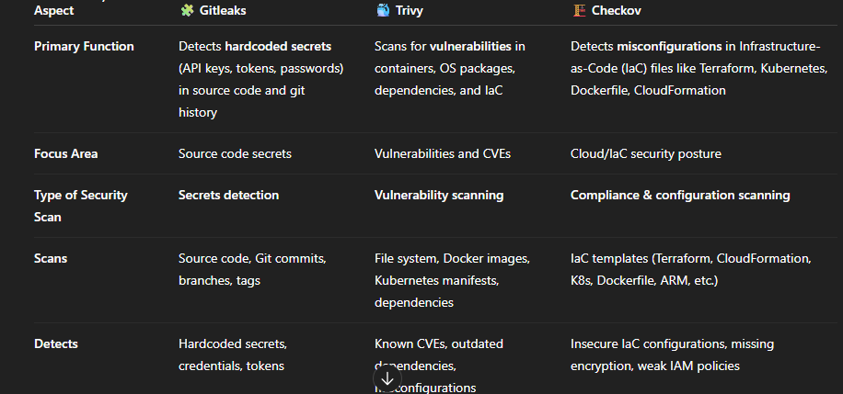

For installation on bash terminal: gitleaks version to verify
gitleaks detect --source ./Dockerfile.secret --no-git- so scan one specific docker file
to find exactly what git leak found.
