Model-View-Controller(MVC)

M(Model模型)列出程式的資料:

1. todoTemplate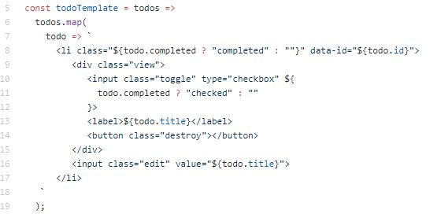
2. footerTemplate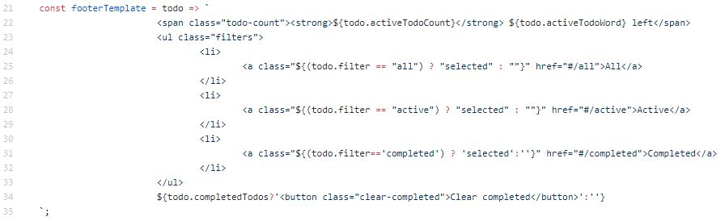
3. uuid (util.uuid)
4. pluralize (util.pluralize)
5. store (util.store)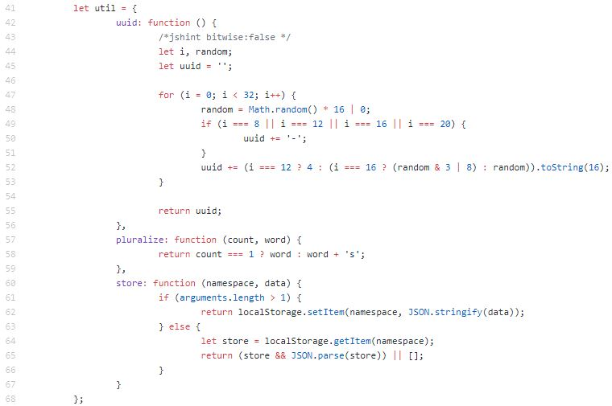
6. bindEvents (App.bindEvents)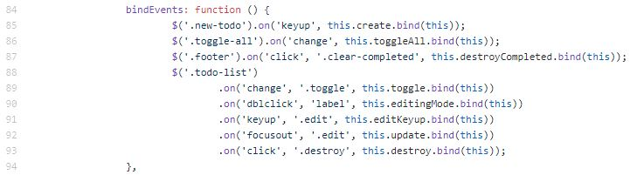
7. destroyCompleted (App.destroyCompleted)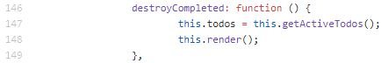

V(View視圖)列出程式的範本:

1. init (App.init)

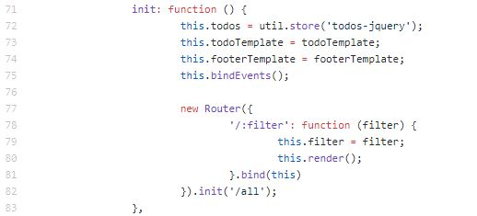

1. render (App.render)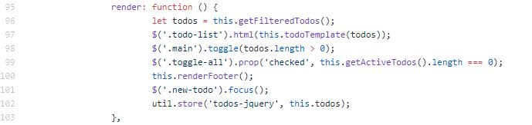
2. renderFooter (App.renderFooter)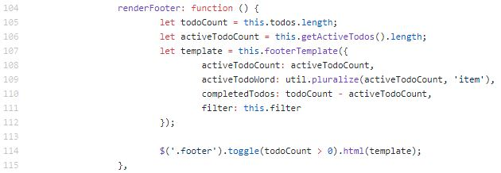

C(controller控制器)列出城市的methods:

1. toggleAll (App.toggleAll)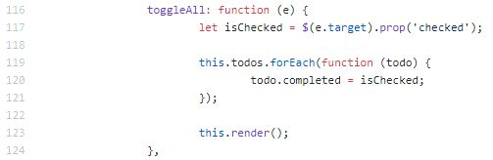
2. getActiveTodos (App.get)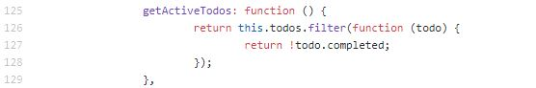
3. getCompletedTodos (App.getCompletedTodos)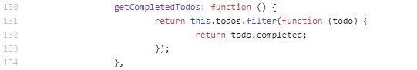
4. getFilteredTodos (App.getFilteredTodos)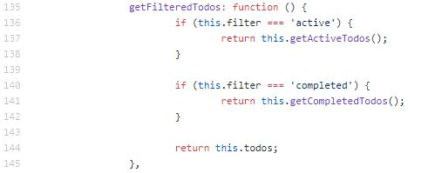
5. getIndexFromEl (App.getIndexFromEl)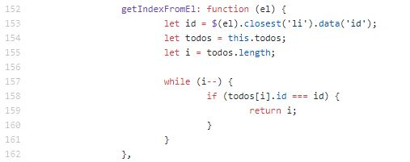
6. create (App.create)

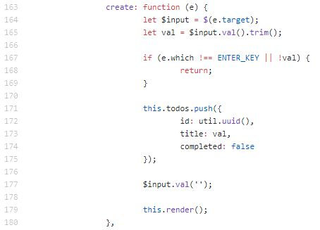

1. toggle (App.toggle)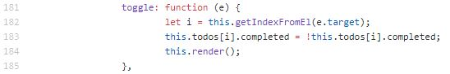
2. editingMode (App.editingMode)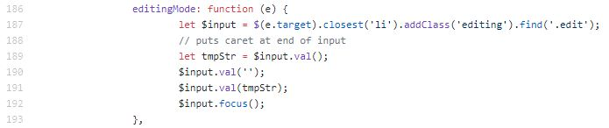
3. editKeyup (App.editKeyup)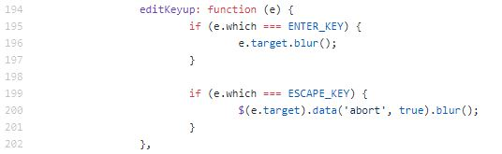
4. update (App.update)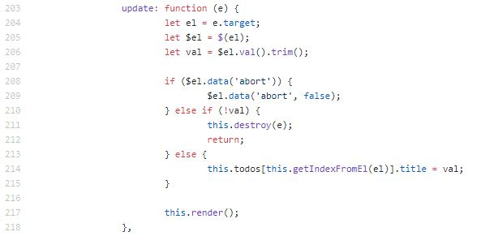
5. destroy (App.destroy)