BAZAR.COM
Lab 1 Report
Multi-tier Online Book Store

MICROSERVICES  Frontend + backend services | REST API  HTTP JSON endpoints | SQLITE  Persistent storage | DOCKER  Containerized deployment

Course | Distributed Operating Systems
Student Name | Ameer AboShams & Zeina Anabtawi
Student ID | 12217464 & 12217834
Instructor | Dr. Samer Arandi
Date | 24/5

01 | Project Overview  Purpose, scope, and Lab 1 requirements.

This report presents Lab 1 of the Bazar.com project. The system is a small online bookstore implemented using a multi-tier microservices design. The frontend receives client requests and forwards them to backend services. The catalog service manages book information, while the order service processes purchase operations and records orders.
Lab 1 Goal
The main goal is to build a lightweight distributed web application using REST APIs, persistent storage, and separate deployable services. The system should support search, info, and purchase operations and run the services as independent components.

FRONTEND  Client entry point  Receives search, info, and purchase requests. | CATALOG  Book data  Stores title, topic, quantity, and price. | ORDER  Purchases  Checks stock, decreases quantity, and saves orders.
REST  HTTP JSON  Services communicate using REST endpoints. | SQLITE  Persistence  Database stores books and order records. | DOCKER  Deployment  Three containers run the application services.
02 | System Architecture  Container layout and request flow.

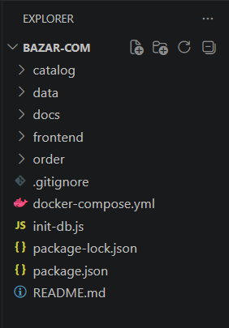

The system follows a two-tier web design.
The frontend is the single entry point for users.
The backend consists of two separate services: catalog and order.
The catalog service is responsible for read and update operations on book data.
The order service is responsible for purchase operations and
communicates with the catalog service to verify availability before buying.
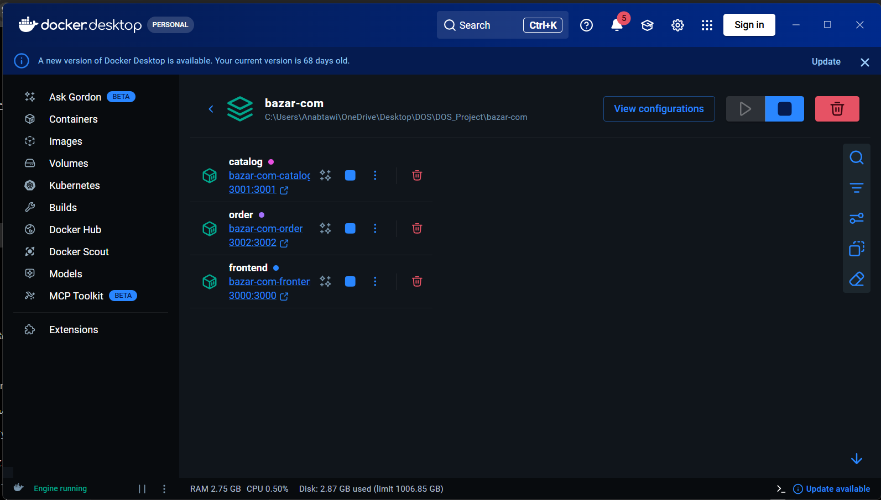
Figure 1. Docker Desktop or terminal output showing the three running containers.
Component | Container | Port | Responsibility
Frontend | bazar_frontend | 3000 | Client entry point; forwards search, info, and purchase requests.
Catalog | bazar_catalog | 3001 | Handles catalog queries and stock/price updates.
Order | bazar_order | 3002 | Processes purchases and saves order records.
Database | bazar.db | SQLite file | Stores books and orders persistently on disk.

Request flow
Search and info requests go from the client to the frontend and then to the catalog service. Purchase requests go from the client to the frontend, then to the order service. The order service queries the catalog, updates stock, and writes the order to the database.

03 | Docker Deployment  docker-compose.yml and service startup.

Each service has its own Dockerfile and runs as a separate container. Docker Compose starts the three containers together and maps each internal service port to the host machine.
docker-compose.yml excerpt - three microservices
services:
catalog:
build: ./catalog
container_name: bazar_catalog
ports:
- "3001:3001"
environment:
- DB_PATH=/app/data/bazar.db
volumes:
- ./data:/app/data
order:
build: ./order
container_name: bazar_order
ports:
- "3002:3002"
depends_on:
- catalog
environment:
- DB_PATH=/app/data/bazar.db
- CATALOG_URL=http://catalog:3001
volumes:
- ./data:/app/data
frontend:
build: ./frontend
container_name: bazar_frontend
ports:
- "3000:3000"
depends_on:
- catalog
- order
environment:
- CATALOG_URL=http://catalog:3001
- ORDER_URL=http://order:3002

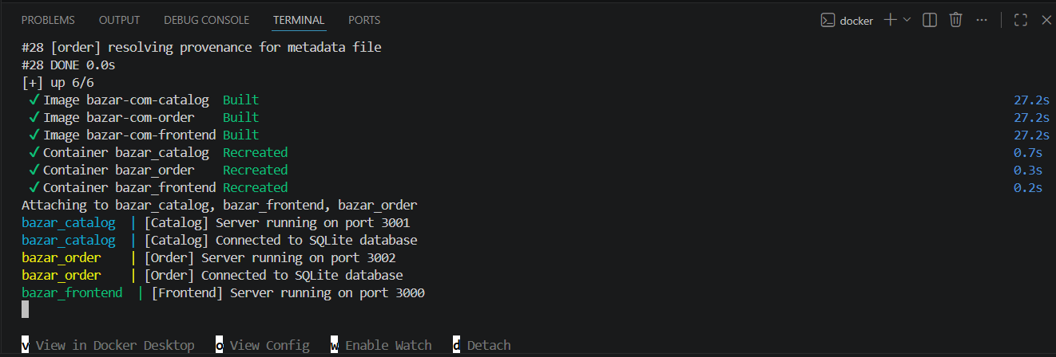
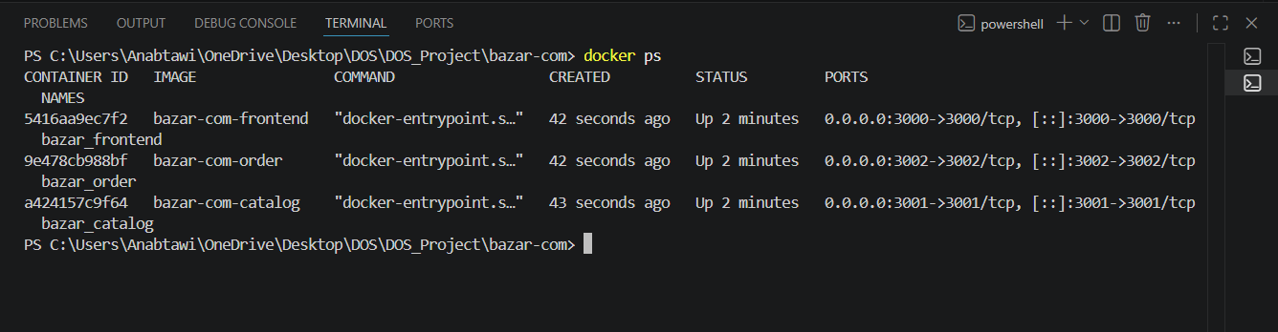
Figure 2. docker compose up --build output showing frontend, catalog, and order services running.

04 | Implementation Details  Major services and how each one works.

Feature | Implementation | How it is verified
Search by topic | Frontend forwards /search/:topic to catalog /query/topic/:topic. | Postman returns matching book IDs and titles.
Book details | Frontend forwards /info/:id to catalog /query/item/:id. | Response includes title, topic, quantity, and price.
Purchase | Frontend forwards /purchase/:id to order service. | Stock decreases and order is saved.
Persistence | SQLite database is mounted using Docker volume. | Database viewer shows books and orders tables.
Error handling | Services return 404/400/500 messages when needed. | Invalid item IDs return Item not found.

The implementation also stores the ordered quantity in the orders table. The default quantity is one copy, which matches the basic Lab 1 purchase behavior. This makes the order log more descriptive without changing the main requirement.

04 | Frontend Service  Client entry point and request forwarding.

The frontend service is the only service directly accessed by the client. It receives requests, performs basic routing, and forwards each request to the correct backend service. It does not directly update the database.
Endpoint | Method | Forwarded To | Purpose
/search/:topic | GET | Catalog /query/topic/:topic | Search books by topic.
/info/:id | GET | Catalog /query/item/:id | Return details for one book.
/purchase/:id | POST | Order /purchase/:id | Buy a book item.

frontend/server.js excerpt - search forwarding
const CATALOG_URL = process.env.CATALOG_URL || 'http://localhost:3001';
const ORDER_URL = process.env.ORDER_URL || 'http://localhost:3002';

app.get('/search/:topic', async (req, res) => {
const topic = req.params.topic;
const response = await axios.get(
`${CATALOG_URL}/query/topic/${encodeURIComponent(topic)}`
);
res.json({
message: 'Search completed successfully',
items: response.data.items
});
});

frontend/server.js excerpt - info and purchase forwarding
app.get('/info/:id', async (req, res) => {
const id = req.params.id;
const response = await axios.get(`${CATALOG_URL}/query/item/${id}`);
res.json({
message: 'Item details retrieved successfully',
item: response.data.item
});
});

app.post('/purchase/:id', async (req, res) => {
const id = req.params.id;
const response = await axios.post(`${ORDER_URL}/purchase/${id}`, req.body);
res.json(response.data);
});

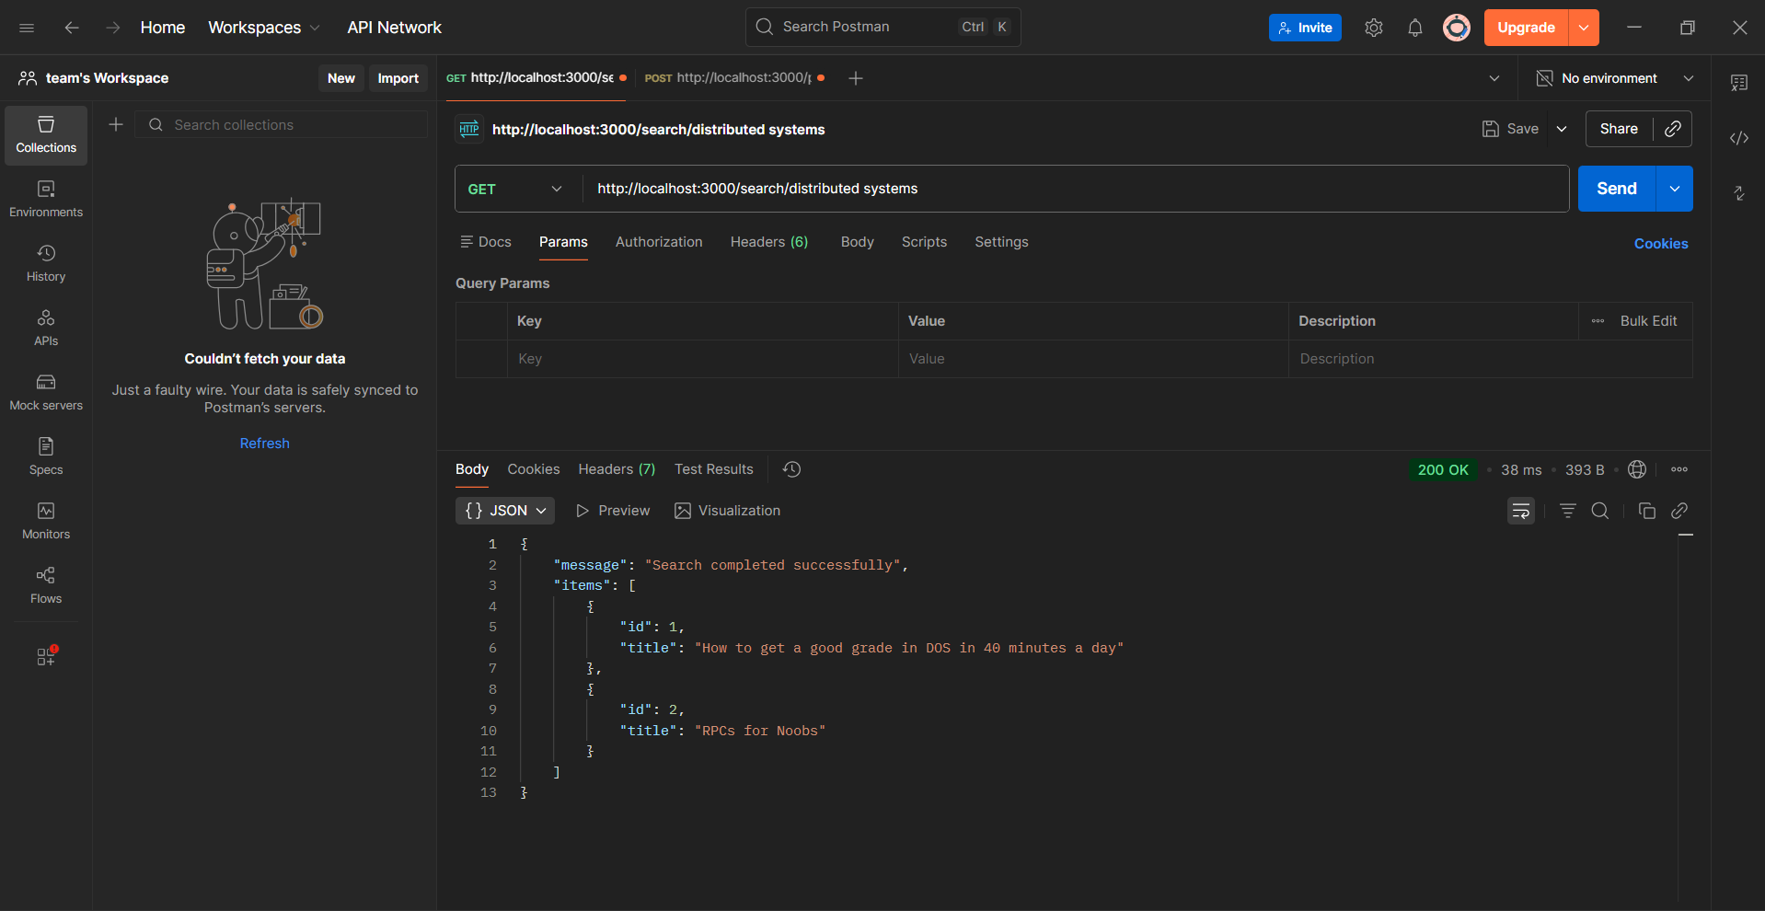
Figure 3. Frontend search request output from Postman.

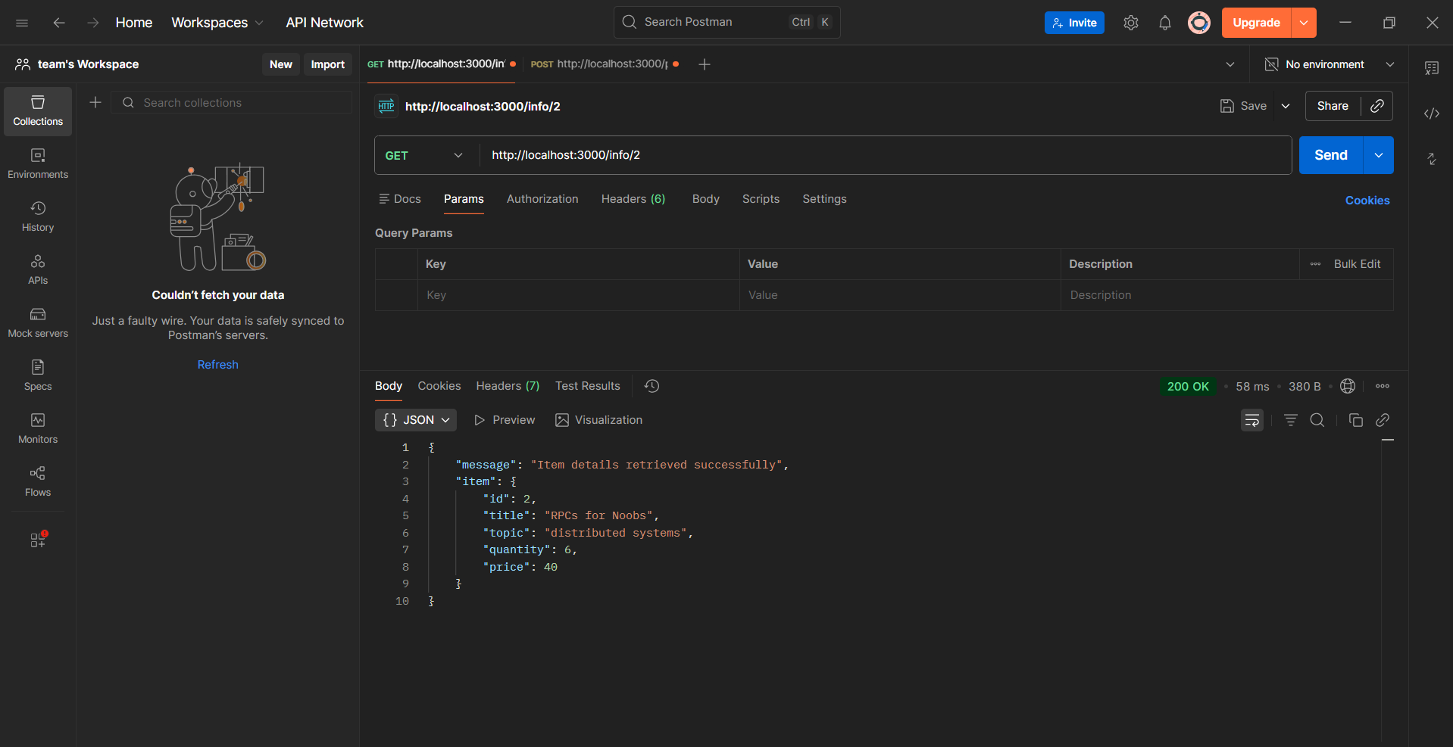
Figure 4. Frontend info request output from Postman.

frontend/server.js excerpt - frontend API routes
app.get('/search/:topic', async (req, res) => {
const topic = req.params.topic;
const response = await axios.get(`${CATALOG_URL}/query/topic/${encodeURIComponent(topic)}`);
res.json({ message: 'Search completed successfully', items: response.data.items });
});
app.get('/info/:id', async (req, res) => {
const id = req.params.id;
const response = await axios.get(`${CATALOG_URL}/query/item/${id}`);
res.json({ message: 'Item details retrieved successfully', item: response.data.item });
});
app.post('/purchase/:id', async (req, res) => {
const id = req.params.id;
const response = await axios.post(`${ORDER_URL}/purchase/${id}`, req.body);
res.json(response.data);
});

05 | Catalog Service  Query and update operations.

The catalog service maintains the book catalog. It supports query-by-topic, query-by-item, update stock, and update price operations. The frontend uses the query operations for search and info requests, while the order service uses query and stock update during purchases.
Endpoint | Method | Purpose
/query/topic/:topic | GET | Returns all books that belong to a topic.
/query/item/:id | GET | Returns full details for one book item.
/update/stock/:id | POST | Increases or decreases the stock quantity.
/update/price/:id | POST | Updates the price of a specific book.
catalog/server.js excerpt - query item
// Query books by topic
app.get('/query/topic/:topic', (req, res) => {
const topic = req.params.topic.toLowerCase();
db.all(
`SELECT id, title FROM books WHERE LOWER(topic) = ?`,
[topic],
(err, rows) => {
if (err) {
return res.status(500).json({
message: 'Failed to retrieve books by topic'
});
}
res.json({
message: 'Books retrieved successfully',
items: rows
});
}
);
});

// Query one item by id
app.get('/query/item/:id', (req, res) => {
const id = req.params.id;
db.get(
`SELECT id, title, topic, quantity, price FROM books WHERE id = ?`,
[id],
(err, row) => {
if (err) {
return res.status(500).json({
message: 'Failed to retrieve item details'
});
}
if (!row) {
return res.status(404).json({
message: 'Item not found'
});
}
res.json({
message: 'Item details retrieved successfully',
item: row
});
}
);
});

// Update stock quantity
app.post('/update/stock/:id', (req, res) => {
const id = req.params.id;
const change = Number(req.body?.change);
db.get(`SELECT * FROM books WHERE id = ?`, [id], (err, book) => {
if (!book) {
return res.status(404).json({
message: 'Item not found'
});
}
const newQuantity = book.quantity + change;
if (newQuantity < 0) {
return res.status(400).json({
message: 'Not enough stock available'
});
}
db.run(
`UPDATE books SET quantity = ? WHERE id = ?`,
[newQuantity, id],
() => {
res.json({
message: 'Stock updated successfully',
item: {
id: book.id,
title: book.title,
quantity: newQuantity
}
});
}
);
});
});

// Update book price
app.post('/update/price/:id', (req, res) => {
const id = req.params.id;
const price = Number(req.body?.price);
db.run(
`UPDATE books SET price = ? WHERE id = ?`,
[price, id],
function () {
if (this.changes === 0) {
return res.status(404).json({
message: 'Item not found'
});
}
res.json({
message: 'Price updated successfully',
item: {
id: Number(id),
price
}
});
}
);
});

06 | Order Service  Purchase operation and stock update.

The order service receives purchase requests. It first asks the catalog service for the requested item. If the item exists and enough stock is available, it calls the catalog stock update endpoint to decrease the quantity and then inserts a new record into the orders table.
Step | Action | Result
1 | Receive POST /purchase/:id | The item ID is extracted from the URL.
2 | Query catalog service | The order service checks item details and stock.
3 | Validate availability | If stock is zero or insufficient, the request fails.
4 | Update catalog stock | The quantity is decreased.
5 | Insert order record | The order is saved in SQLite.

order/server.js excerpt - purchase logic
app.post('/purchase/:id', async (req, res) => {
const id = req.params.id;
const quantity = Number(req.body?.quantity ?? 1);
const catalogResponse = await axios.get(`${CATALOG_URL}/query/item/${id}`);
const book = catalogResponse.data.item;
if (book.quantity < quantity) {
return res.status(400).json({ message: 'Not enough stock available' });
}
const updateResponse = await axios.post(`${CATALOG_URL}/update/stock/${id}`, {
change: -quantity
});
db.run(
`INSERT INTO orders (item_id, title, quantity, status, ordered_at)
VALUES (?, ?, ?, ?, ?)`,
[book.id, book.title, quantity, 'SUCCESS', new Date().toISOString()]
);
});

07 | Database Design  SQLite tables and initial data.

The database is stored in data/bazar.db. It contains two main tables: books and orders. The books table stores the catalog items, while the orders table stores successful purchase records.
Table | Columns | Purpose
books | id, title, topic, quantity, price | Stores catalog data and current stock levels.
orders | id, item_id, title, quantity, status, ordered_at | Stores purchase history.
ID | Title | Topic
1 | How to get a good grade in DOS in 40 minutes a day | distributed systems
2 | RPCs for Noobs | distributed systems
3 | Xen and the Art of Surviving Undergraduate School | undergraduate school
4 | Cooking for the Impatient Undergrad | undergraduate school

CREATE TABLE IF NOT EXISTS books (
id INTEGER PRIMARY KEY,
title TEXT NOT NULL,
topic TEXT NOT NULL,
quantity INTEGER NOT NULL,
price REAL NOT NULL
);

CREATE TABLE IF NOT EXISTS orders (
id INTEGER PRIMARY KEY AUTOINCREMENT,
item_id INTEGER NOT NULL,
title TEXT NOT NULL,
quantity INTEGER NOT NULL,
status TEXT NOT NULL,
ordered_at TEXT NOT NULL
);

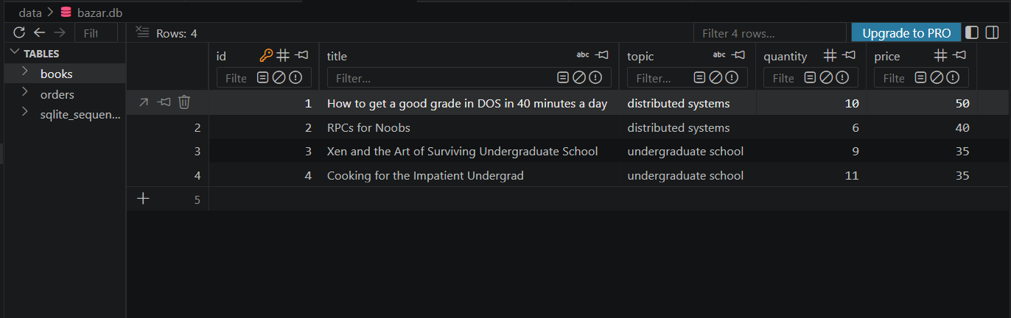
Figure 5. SQLite viewer showing the books table.

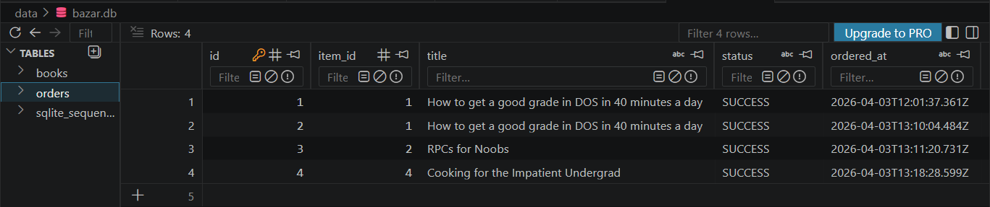
Figure 6. SQLite viewer showing the orders table after purchase.

08 | Testing Procedure and Output  Postman requests and expected results.

The following test cases verify the main functionality of the system. Each screenshot should show the request URL, HTTP method, status code, and returned JSON response.

Step | Request | Expected Result
1 | GET /search/distributed systems | Returns books 1 and 2.
2 | GET /search/undergraduate school | Returns books 3 and 4.
3 | GET /info/2 | Returns RPCs for Noobs with quantity and price.
4 | POST /purchase/2 | Returns purchase success and saves an order.
5 | GET /info/2 after purchase | Quantity decreases by one.
7 | POST /update/stock/2 | Stock quantity changes successfully.
8 | POST /update/price/2 | Price changes successfully.


Figure 7. GET /info/2 response before purchase.

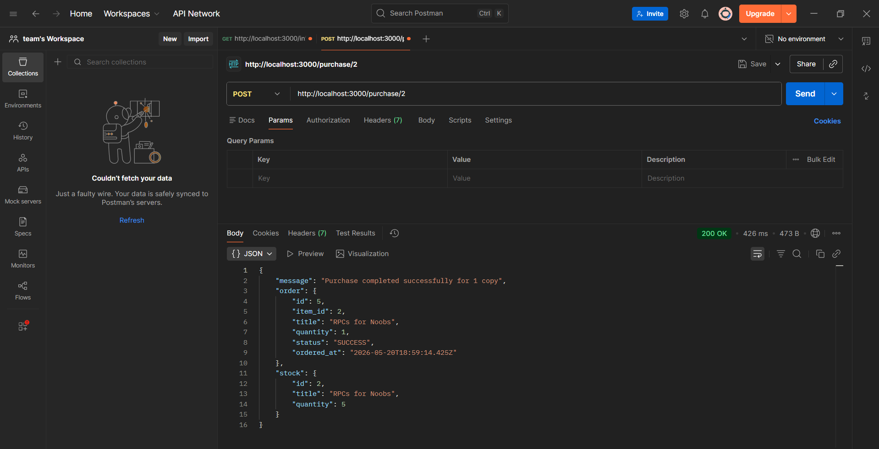
Figure 8. POST /purchase/2 response showing successful purchase.

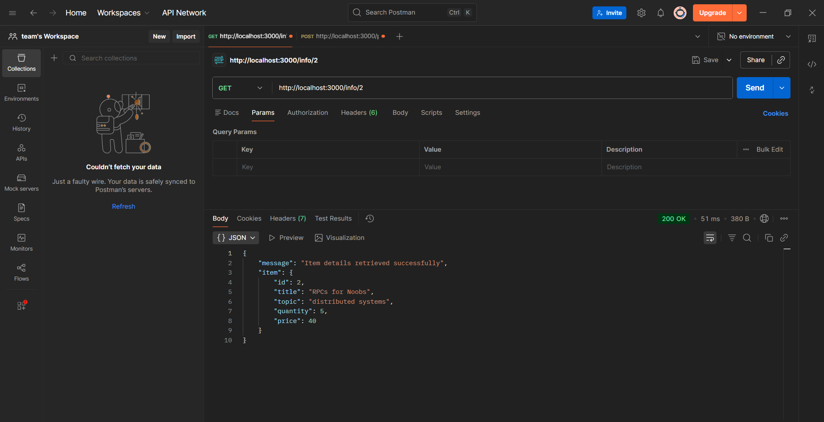
Figure 9. Item details after purchase showing updated stock.

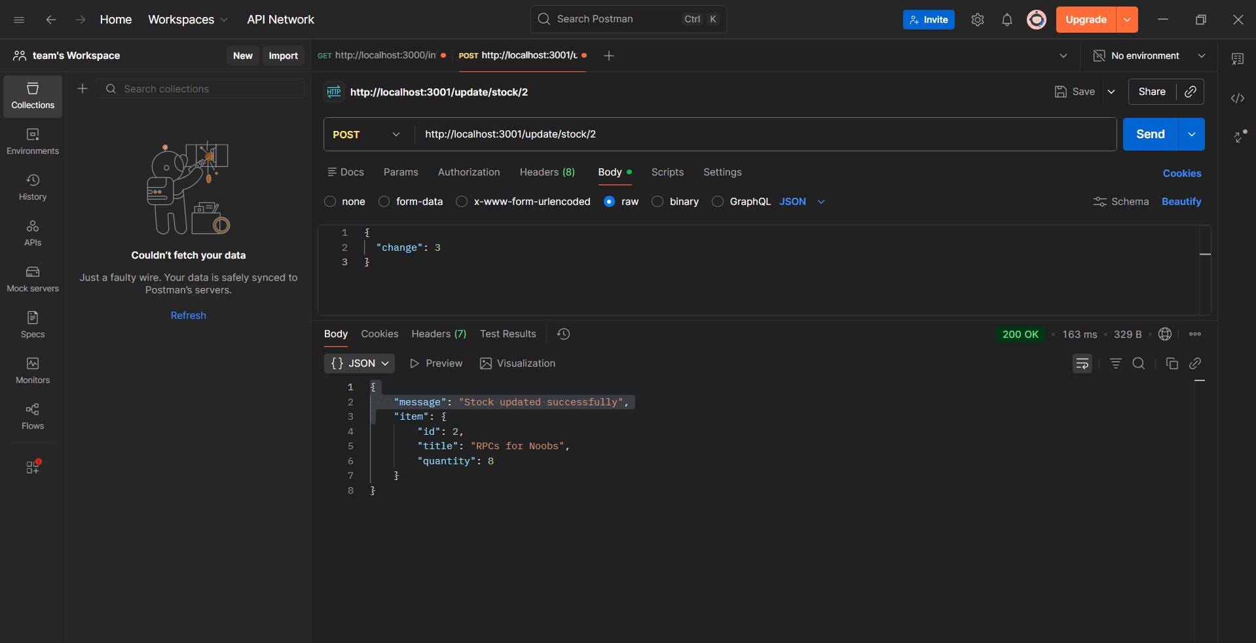
Figure 10. Catalog stock update output.

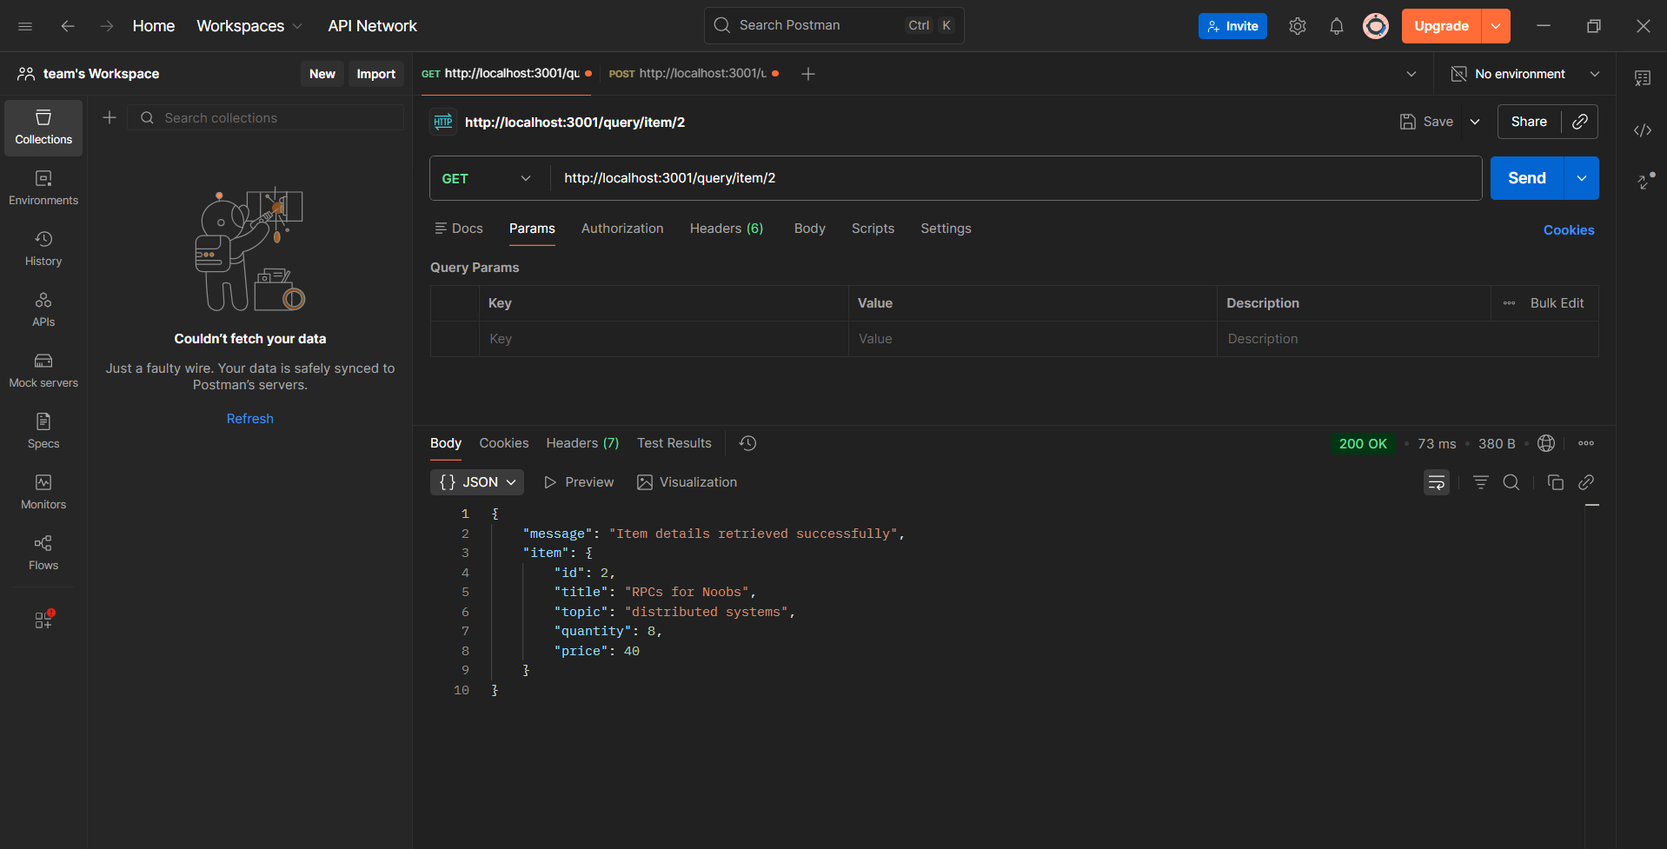
Figure 11. Item details after update showing updated stock.

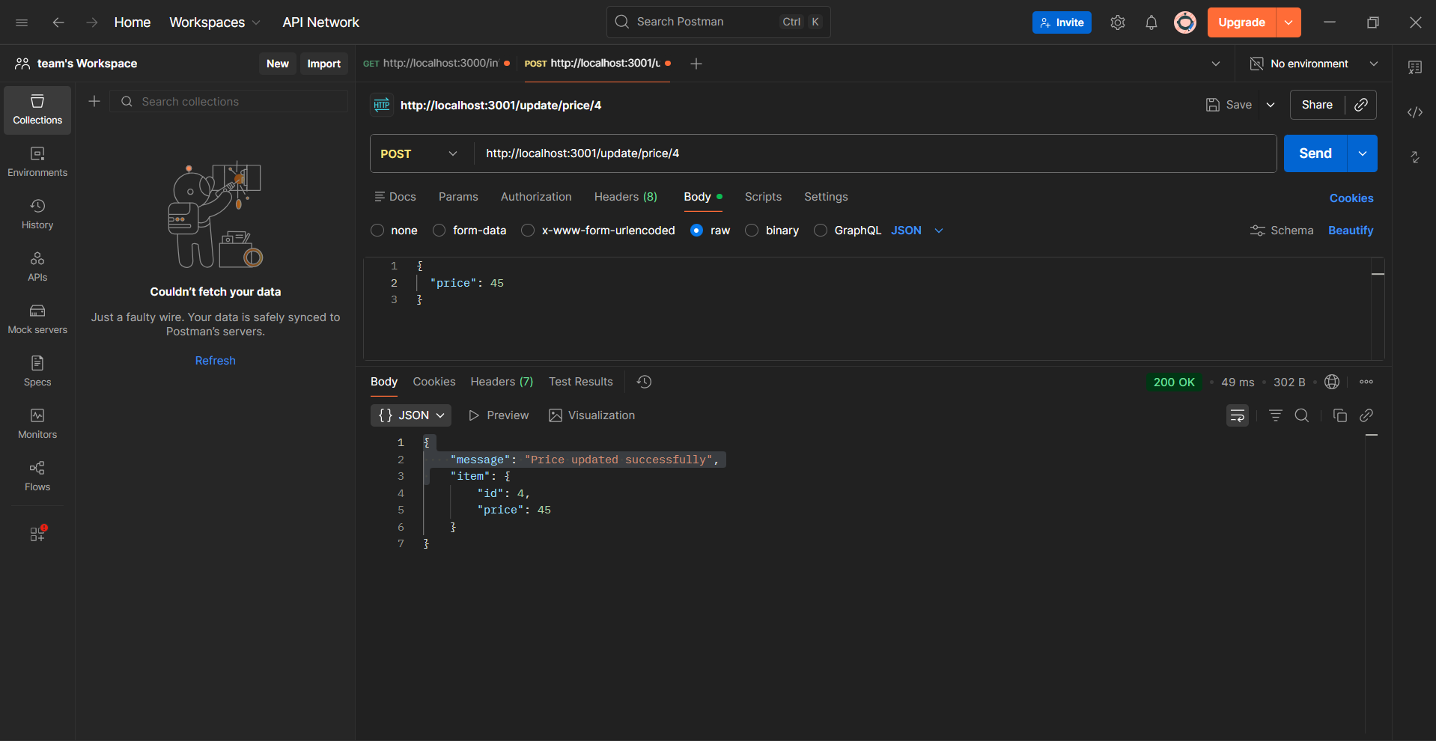
Figure 12. Catalog price update output.

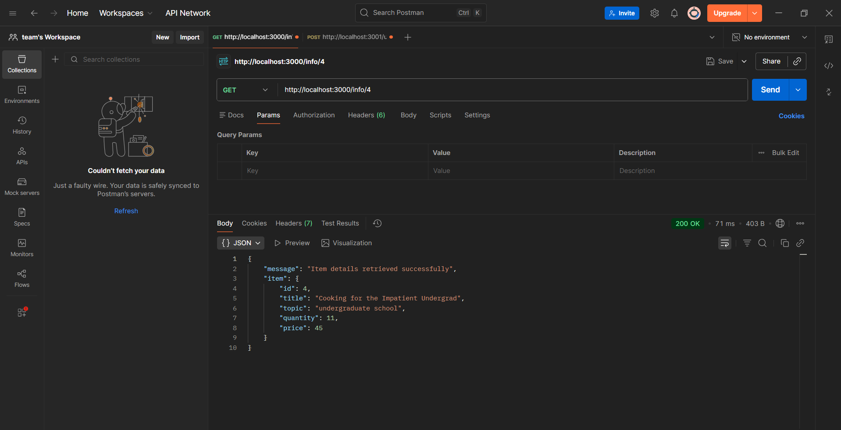
Figure 13. Item details after update showing updated price.

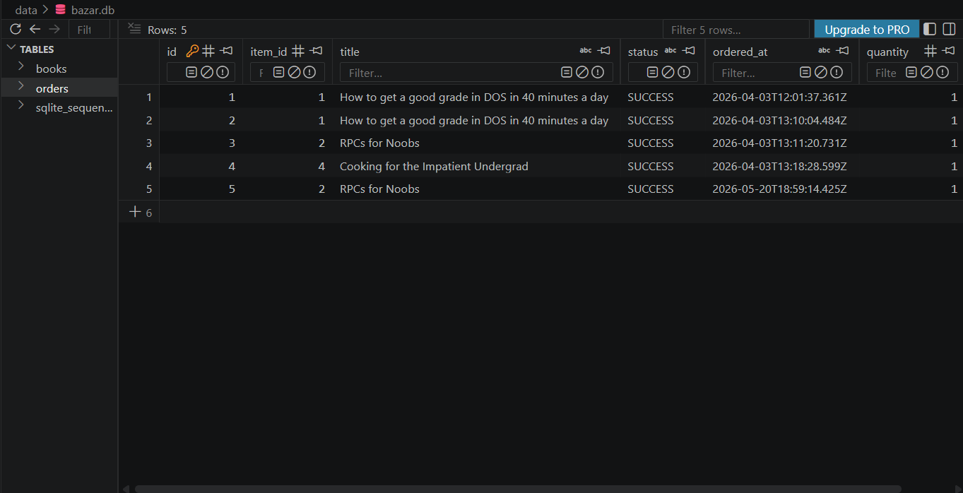
Figure 14. Orders table after all.
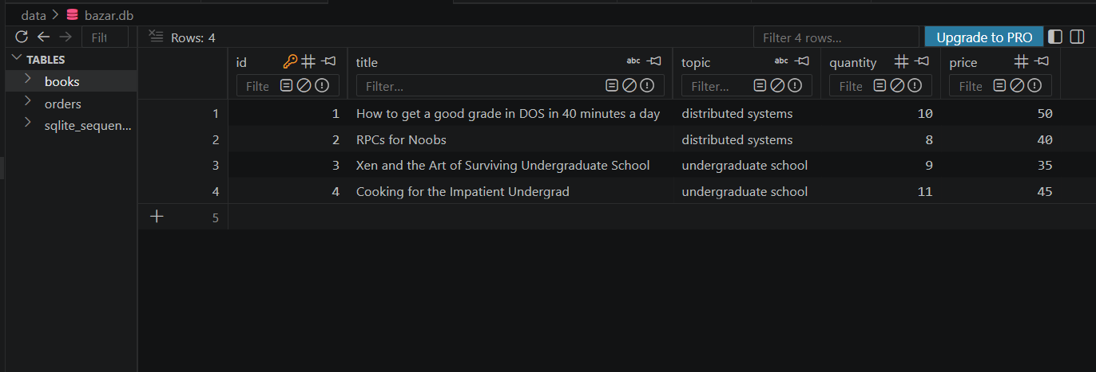
Figure 15. Books table after all.

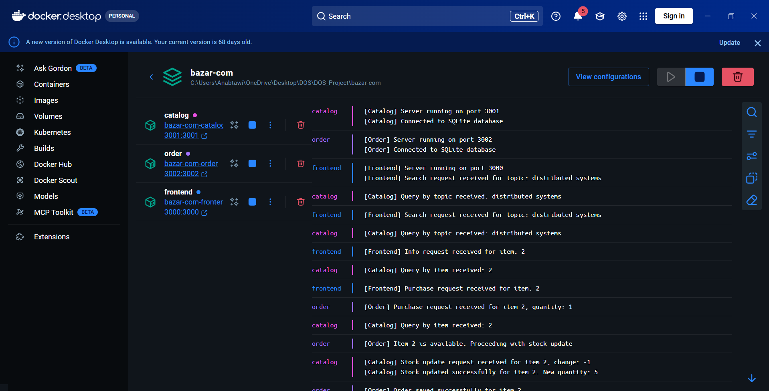
Figure 16. Docker logs.

09 | Error Handling  Invalid requests and failure cases.

The system handles invalid cases by returning clear JSON messages. This makes the services easier to test and prevents silent failures.
Case | Request | Expected Response
Invalid item info | GET /info/99 | 404 Item not found.
Invalid purchase | POST /purchase/99 | 404 Item not found.
Not enough stock | POST /purchase/:id when quantity is unavailable | 400 Not enough stock available.
Invalid stock update | POST /update/stock/:id with invalid change | 400 Invalid stock change value.
Invalid price update | POST /update/price/:id with negative price | 400 Invalid price value.

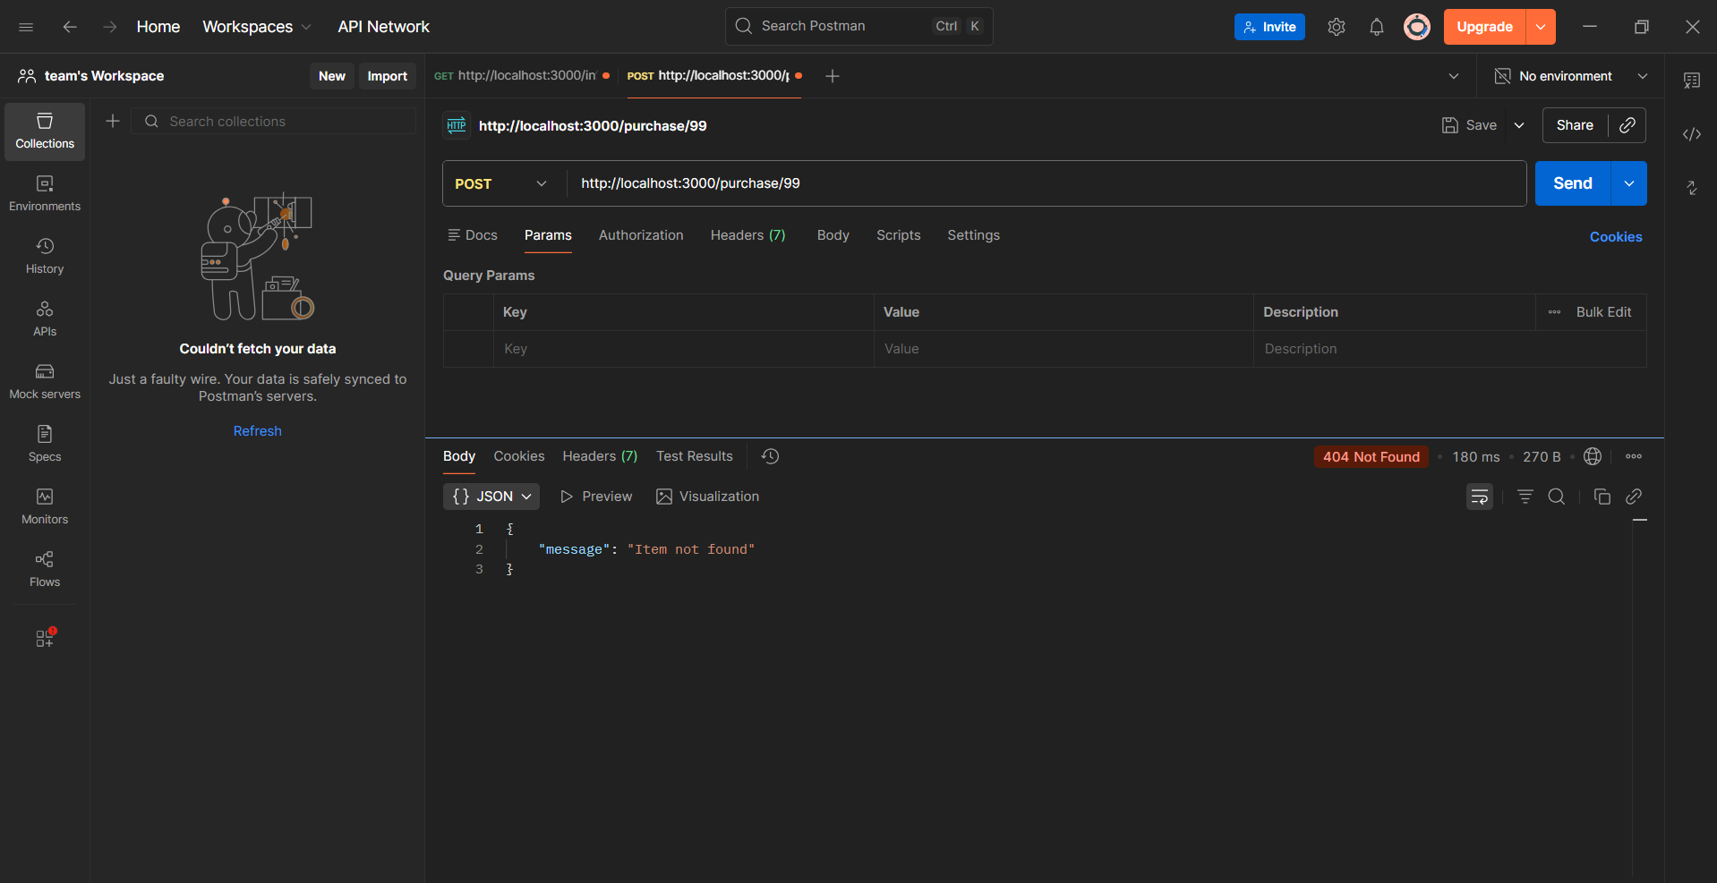
Figure 17. Invalid purchase request showing Item not found.

10 | How to Run the Project  Commands used to build, run, and test the application.

The project can be run using Docker Compose. The database file should exist in the data directory, or it can be initialized using init-db.js before starting the containers.
Run commands
# Install dependencies locally if needed
npm install
# Initialize the SQLite database
node init-db.js
# Build and start all services
docker compose up --build
# Stop all services
docker compose down

Useful test URLs
GET http://localhost:3000/search/distributed systems
GET http://localhost:3000/search/undergraduate school
GET http://localhost:3000/info/2
POST http://localhost:3000/purchase/2
GET http://localhost:3001/query/item/2
POST http://localhost:3001/update/stock/2
POST http://localhost:3001/update/price/2

12 | Design Tradeoffs and Improvements  Implementation decisions and possible extensions.

Design choice
The system uses SQLite instead of a heavyweight database. This keeps the project simple, portable, and suitable for a lab-scale microservices experiment.

- The frontend is simple and does not include a graphical interface because the project accepts browser/Postman or command-line clients.
- The services communicate using REST calls, which makes each service independently testable.
- SQLite is shared through a Docker volume so data persists after containers are restarted.
- A future version can add authentication, better input validation, a web user interface, and more detailed logging.
- Another future improvement is to add caching and replicas, which is implemented later in Lab 2.

13 | Conclusion  Summary of Lab 1 results.

Lab 1 successfully implements Bazar.com as a multi-tier microservices application. The frontend, catalog, and order services run separately and communicate using HTTP REST APIs. The catalog service stores and updates book information, while the order service verifies stock, decreases quantity, and records successful purchases. SQLite provides persistent storage, and Docker Compose makes the system easy to build and run.
Final result
The implementation satisfies the core Lab 1 requirements: search, info, purchase, persistent storage, REST communication, and containerized deployment.

