BAZAR.COM
Lab 2 Report

REPLICATION  Catalog + Order replicas | CACHING  Frontend in-memory cache | CONSISTENCY  Invalidation on writes

Course | Distributed Operating Systems
Student Name | Ameer AboShams & Zeina Anabtawi
Student ID | 12217464 & 12217834
Instructor | Dr. Samer Arandi
Date | 24/5

01 | Project Overview  Purpose, scope, and what changed from Lab 1.

This report presents the second part of the Bazar.com project. The system from Lab 1 was extended to support replication, load balancing, frontend caching, cache invalidation, and performance evaluation. The goal is to improve request latency while preserving consistent results after purchase and catalog update operations.
Lab 2 Goal
The main goal is to re-architect the original multi-tier online bookstore so it can handle higher workload using replication and caching while maintaining cache consistency.

CATALOG  New Catalog Items  Three new books were added to the catalog, increasing the database from four items to seven items. | REPLICATION  Replicated Services  Two catalog replicas and two order replicas are deployed as separate containers.
CACHE  Frontend Cache  The frontend stores recently accessed book details in an in-memory cache. | CONSISTENCY  Consistency Mechanism  The cache is invalidated whenever a write operation changes stock or price data.
BALANCING  Load balancing  Round-robin selection inside frontend/server.js | ERFORMANCE  Performance evaluation  Postman response times with/without cache

02 | System Architecture  Container layout and request flow.

The system keeps the frontend as the single entry point for all client requests. The frontend performs round-robin load balancing across replicated catalog and order services. The cache is integrated into the frontend process, which avoids an additional network hop for cached read requests.

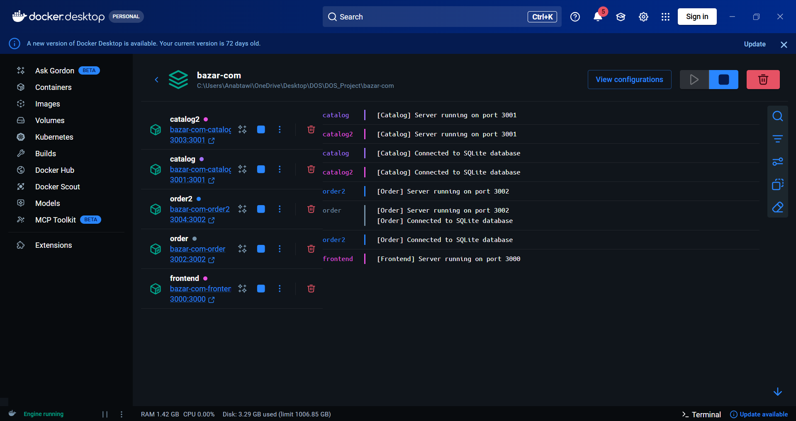

Component | Container | Port | Responsibility
Frontend | bazar_frontend | 3000 | Client entry point, load balancing, caching, invalidation endpoint
Catalog Replica 1 | bazar_catalog | 3001 | Query items and update stock/price
Catalog Replica 2 | bazar_catalog2 | 3003 -> 3001 | Second catalog replica for load balancing
Order Replica 1 | bazar_order | 3002 | Processes purchase requests
Order Replica 2 | bazar_order2 | 3004 -> 3002 | Second order replica for load balancing
Database | bazar.db | SQLite file | Persistent storage for books and orders

Design simplification
In this implementation, the catalog and order replicas share the same SQLite database volume. This keeps data consistent and avoids divergence between replicas. A future version can use separate databases with an internal replication protocol.

docker-compose.yml excerpt - replicas and environment variables
services:
catalog:
build: ./catalog
container_name: bazar_catalog
ports:
- "3001:3001"
environment:
- DB_PATH=/app/data/bazar.db
- FRONTEND_URL=http://frontend:3000
volumes:
- ./data:/app/data
catalog2:
build: ./catalog
container_name: bazar_catalog2
ports:
- "3003:3001"
environment:
- DB_PATH=/app/data/bazar.db
- FRONTEND_URL=http://frontend:3000
volumes:
- ./data:/app/data
order:
build: ./order
container_name: bazar_order
ports:
- "3002:3002"
environment:
- DB_PATH=/app/data/bazar.db
- CATALOG_URL=http://catalog:3001
- FRONTEND_URL=http://frontend:3000
order2:
build: ./order
container_name: bazar_order2
ports:
- "3004:3002"
environment:
- DB_PATH=/app/data/bazar.db
- CATALOG_URL=http://catalog2:3001
- FRONTEND_URL=http://frontend:3000

03 | Implementation Details  Major changes added in Lab 2.

Feature | Implementation | How it is verified
Replication | docker-compose defines catalog2 and order2 in addition to the original catalog and order services. | Docker Desktop / docker compose logs show five containers running.
Load Balancing | The frontend uses round-robin indexes to alternate catalog and order requests between replicas. | Responses contain servedBy: catalog or servedBy: catalog2.
Caching | The frontend stores /info/:id results inside an in-memory Map. | First request is MISS; second request is HIT.
Invalidation | Order and catalog services call frontend /invalidate/:id before write operations. | Cache is cleared after purchase, stock update, or price update.
Persistence | SQLite stores books and order records on disk. | Database viewer shows books and orders tables.

04 | Load Balancing

Round-robin behavior
The frontend stores a list of catalog replicas and order replicas. For each new request, it picks the next replica in the list. This distributes requests between the two replicas in a simple and predictable way.

frontend/server.js excerpt - replica lists and round-robin functions
const CATALOG_REPLICAS = [
process.env.CATALOG_URL || 'http://localhost:3001',
process.env.CATALOG_URL_2 || 'http://localhost:3003'
];
const ORDER_REPLICAS = [
process.env.ORDER_URL || 'http://localhost:3002',
process.env.ORDER_URL_2 || 'http://localhost:3004'
];
let catalogIndex = 0;
let orderIndex = 0;
function getNextCatalogReplica() {
const replica = CATALOG_REPLICAS[catalogIndex];
catalogIndex = (catalogIndex + 1) % CATALOG_REPLICAS.length;
console.log(`[Frontend] Forwarding catalog request to: ${replica}`);
return replica;
}
function getNextOrderReplica() {
const replica = ORDER_REPLICAS[orderIndex];
orderIndex = (orderIndex + 1) % ORDER_REPLICAS.length;
console.log(`[Frontend] Forwarding order request to: ${replica}`);
return replica;
}

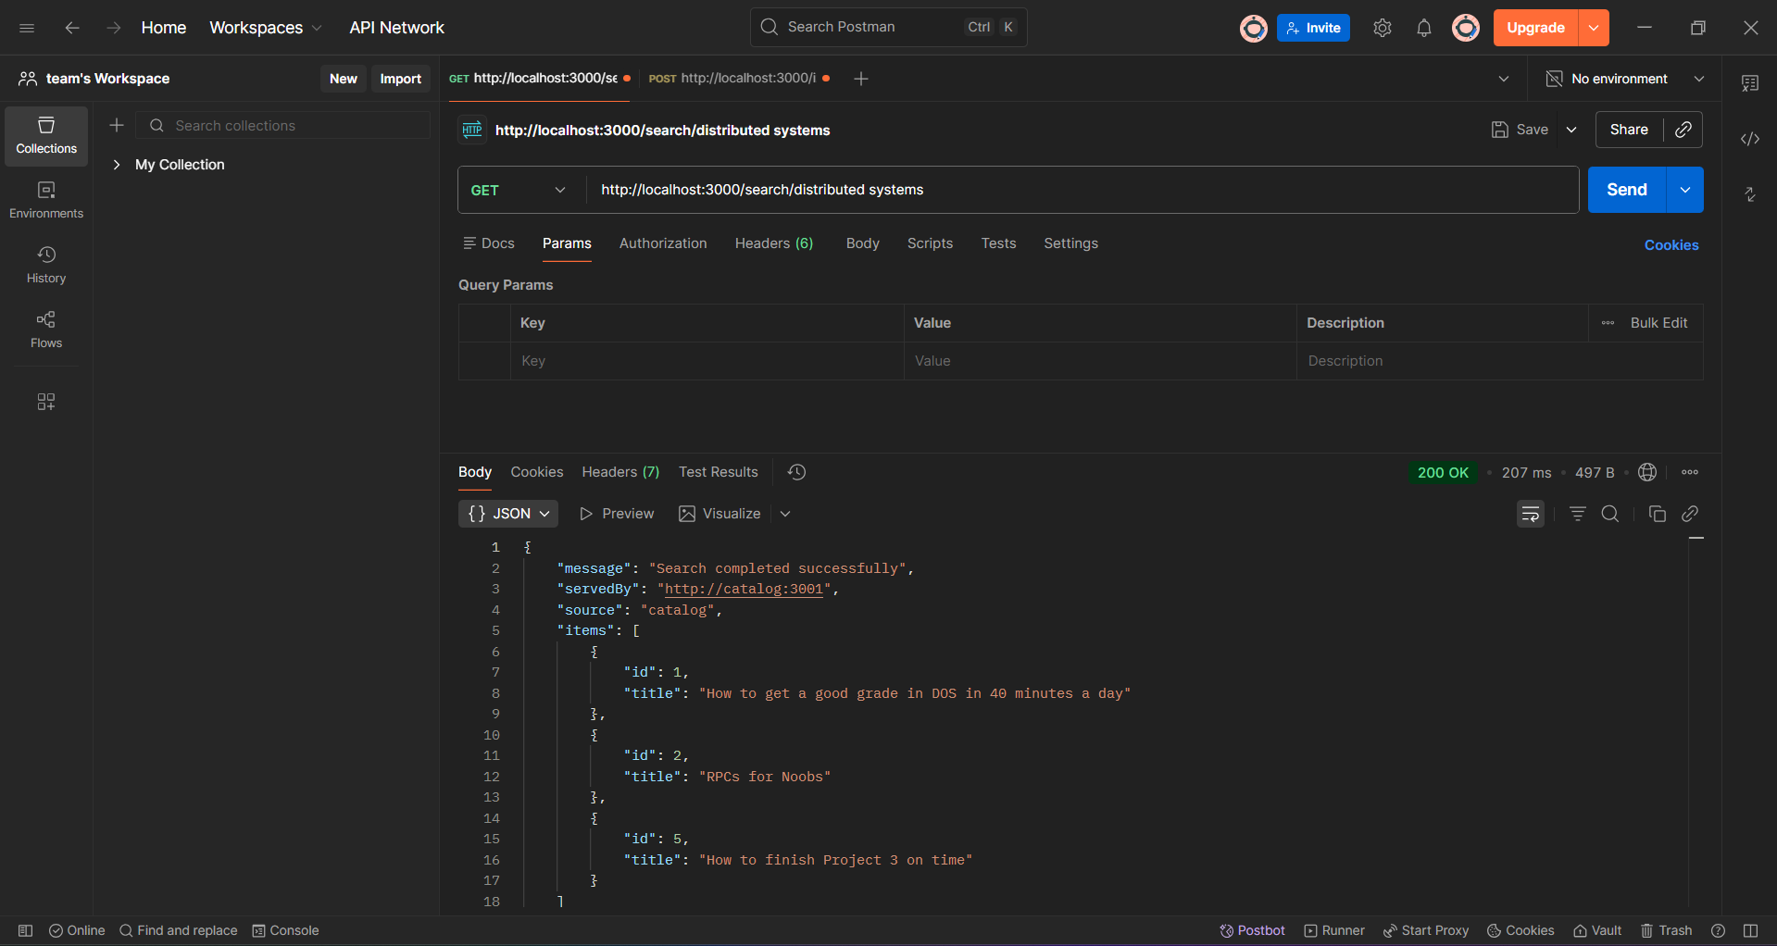
Figure 4. Load balancing output: request served by catalog replica 1.

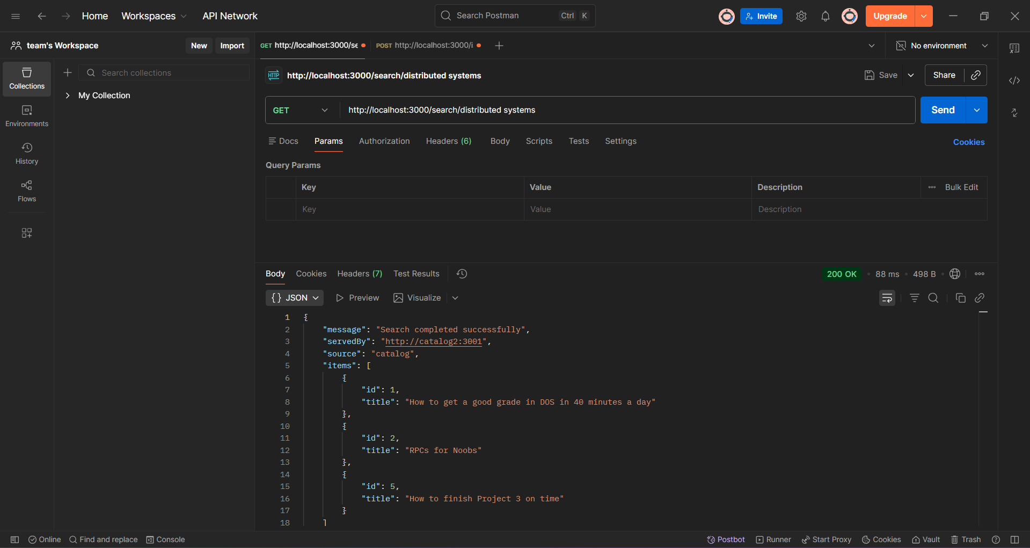

Figure 5. Load balancing output: request served by catalog replica 2.

05 | Frontend Cache

Caching idea
The cache is implemented as an in-memory Map inside the frontend service. It stores results of /info/:id requests. If the requested item is already stored, the frontend returns it directly from memory. Otherwise, it forwards the request to a catalog replica and stores the result.

frontend/server.js excerpt - cache map and cache endpoint
const itemCache = new Map();
app.get('/cache', (req, res) => {
const cacheContent = Object.fromEntries(itemCache);
res.json({
message: 'Current frontend cache content',
cacheSize: itemCache.size,
cache: cacheContent
});
});

frontend/server.js excerpt - cache HIT and MISS logic
app.get('/info/:id', async (req, res) => {
const id = req.params.id;
if (itemCache.has(id)) {
console.log(`[Frontend] CACHE HIT for item: ${id}`);
return res.json({
message: 'Item details retrieved successfully from cache',
source: 'cache',
cacheStatus: 'HIT',
item: itemCache.get(id)
});
}
console.log(`[Frontend] CACHE MISS for item: ${id}`);
const catalogUrl = getNextCatalogReplica();
const response = await axios.get(`${catalogUrl}/query/item/${id}`);
const item = response.data.item;
itemCache.set(id, item);
res.json({
message: 'Item details retrieved successfully from catalog',
servedBy: catalogUrl,
source: 'catalog',
cacheStatus: 'MISS',
item
});
});

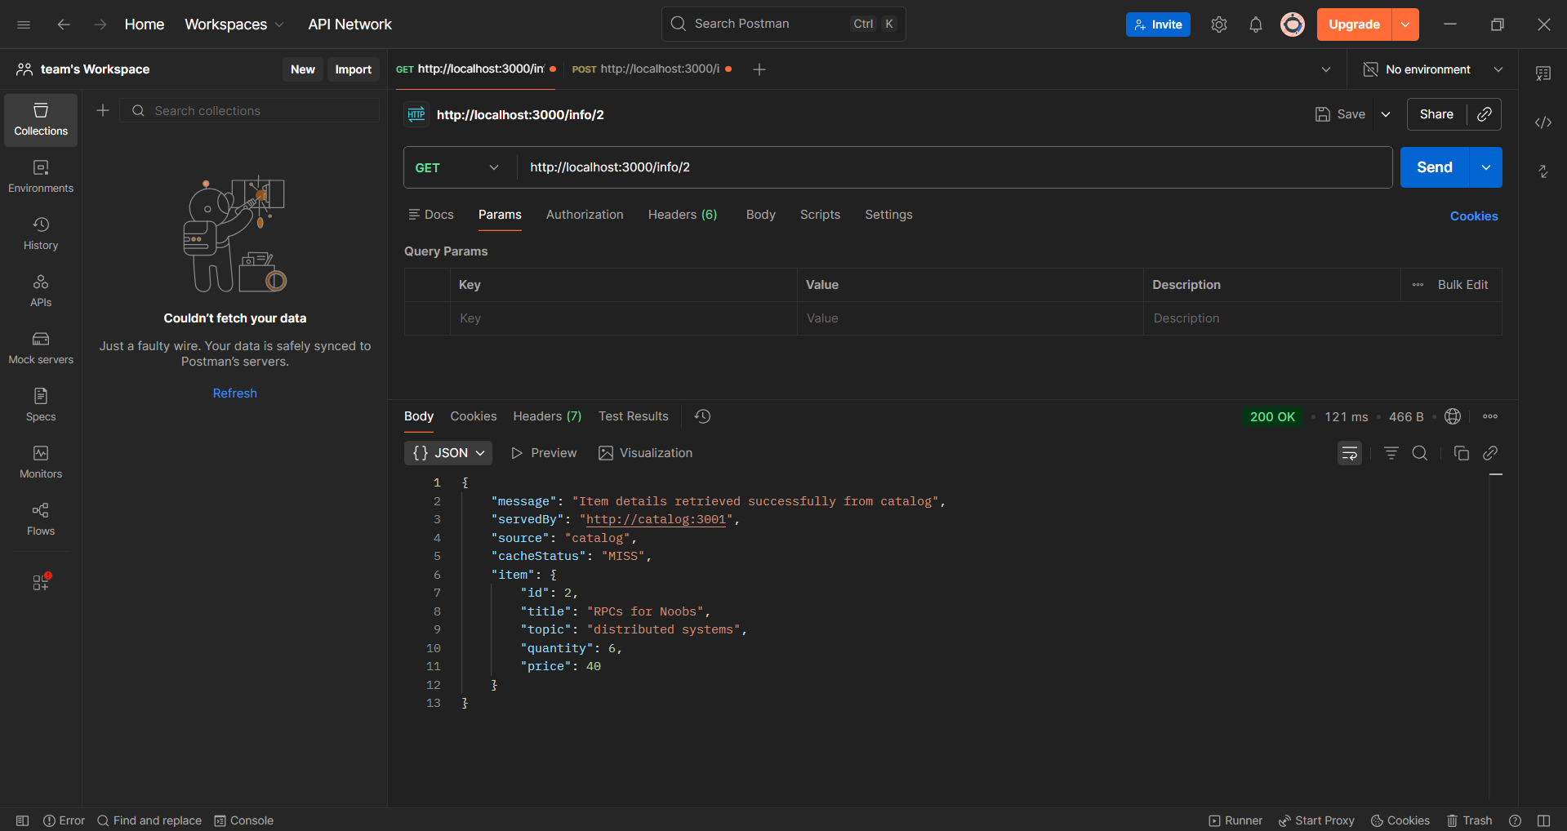

Figure 6. First GET /info/2 request showing CACHE MISS.

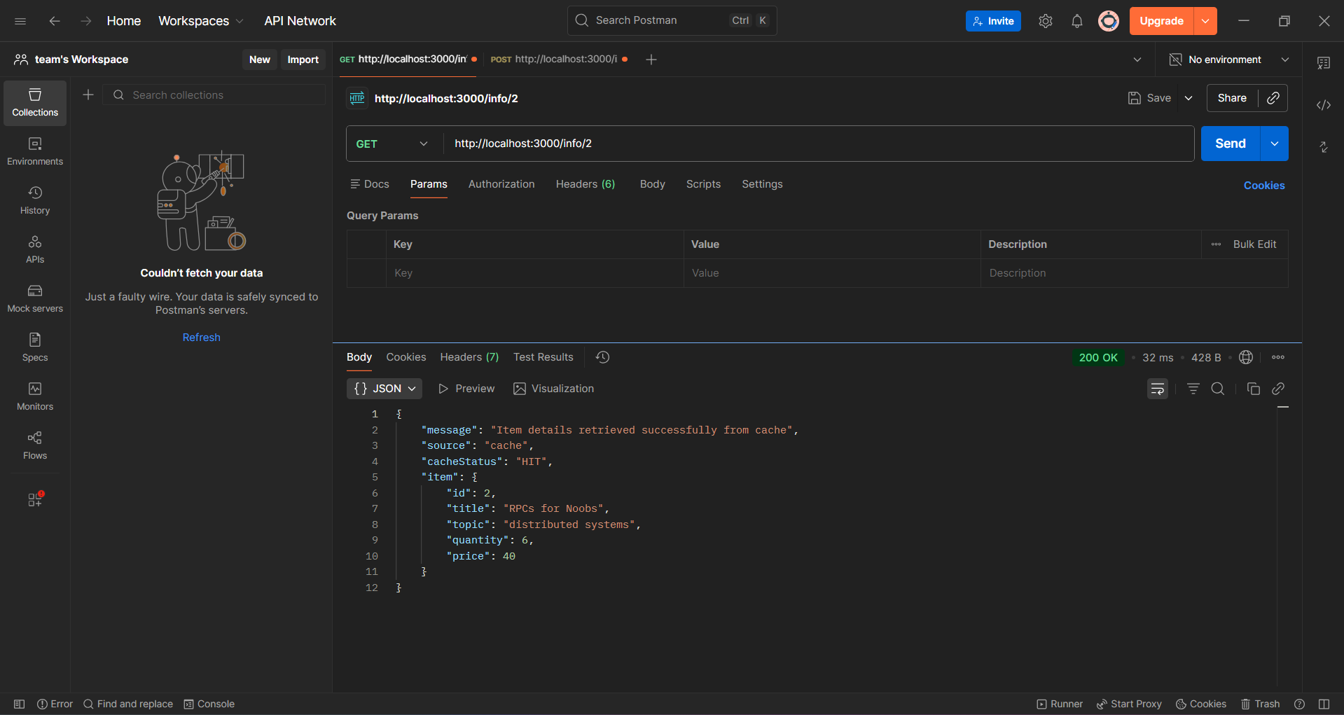
Figure 7. Second GET /info/2 request showing CACHE HIT.
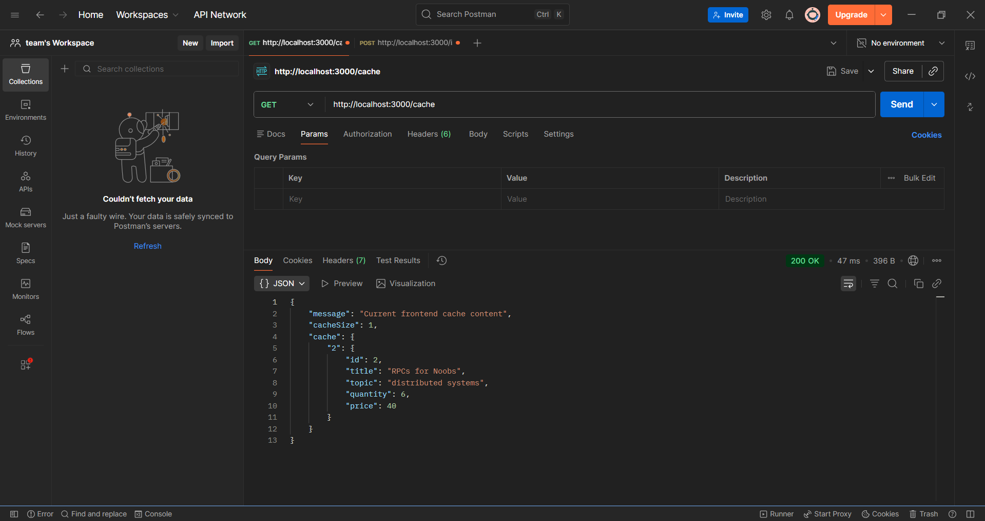
Figure 8. GET /cache showing item 2 stored in the frontend cache.

06 | Cache Invalidation and Consistency

Why invalidation is needed
Read results can become stale after a purchase, stock update, or price update. To keep the cache consistent, the backend sends an invalidate request to the frontend before writing to the database. The frontend then removes the cached item.

frontend/server.js excerpt - invalidate one item
app.post('/invalidate/:id', (req, res) => {
const id = req.params.id;
if (itemCache.has(id)) {
itemCache.delete(id);
console.log(`[Frontend] Cache invalidated for item: ${id}`);
return res.json({
message: `Cache invalidated for item ${id}`,
itemId: id
});
}
res.json({
message: `No cache entry found for item ${id}`,
itemId: id
});
});

order/server.js excerpt - invalidate cache before purchase write
const FRONTEND_URL = process.env.FRONTEND_URL || 'http://frontend:3000';
async function invalidateFrontendCache(itemId) {
try {
await axios.post(`${FRONTEND_URL}/invalidate/${itemId}`);
console.log(`[Order] Cache invalidation request sent for item ${itemId}`);
} catch (error) {
console.warn(`[Order] Cache invalidation failed for item ${itemId}: ${error.message}`);
}
}
// inside purchase endpoint, before stock update:
await invalidateFrontendCache(id);
const updateResponse = await axios.post(`${CATALOG_URL}/update/stock/${id}`, {
change: -quantity
});

catalog/server.js excerpt - invalidate cache before catalog update
const FRONTEND_URL = process.env.FRONTEND_URL || 'http://frontend:3000';
async function invalidateFrontendCache(itemId) {
try {
await axios.post(`${FRONTEND_URL}/invalidate/${itemId}`);
console.log(`[Catalog] Cache invalidation request sent for item ${itemId}`);
} catch (error) {
console.warn(`[Catalog] Cache invalidation failed for item ${itemId}: ${error.message}`);
}
}
// before UPDATE books SET quantity = ? WHERE id = ?
await invalidateFrontendCache(id);

07 | Cache Invalidation and Consistency

Testing flow
The following screenshots should be added after running each request in Postman. Each screenshot should clearly show the URL, method, status code, and important fields such as servedBy, cacheStatus, cacheInvalidated, or cacheSize.

Step | Request | Expected Result
1 | GET /info/2 | First request returns cacheStatus = MISS
2 | GET /info/2 again | Second request returns cacheStatus = HIT
3 | GET /cache | Item 2 appears in frontend cache
4 | POST /purchase/2 | cacheInvalidated = true and stock decreases
5 | GET /cache | Item 2 removed from cache
6 | GET /info/2 | cacheStatus = MISS and fresh data is returned
7 | POST /update/stock/2 | cacheInvalidated = true after catalog update

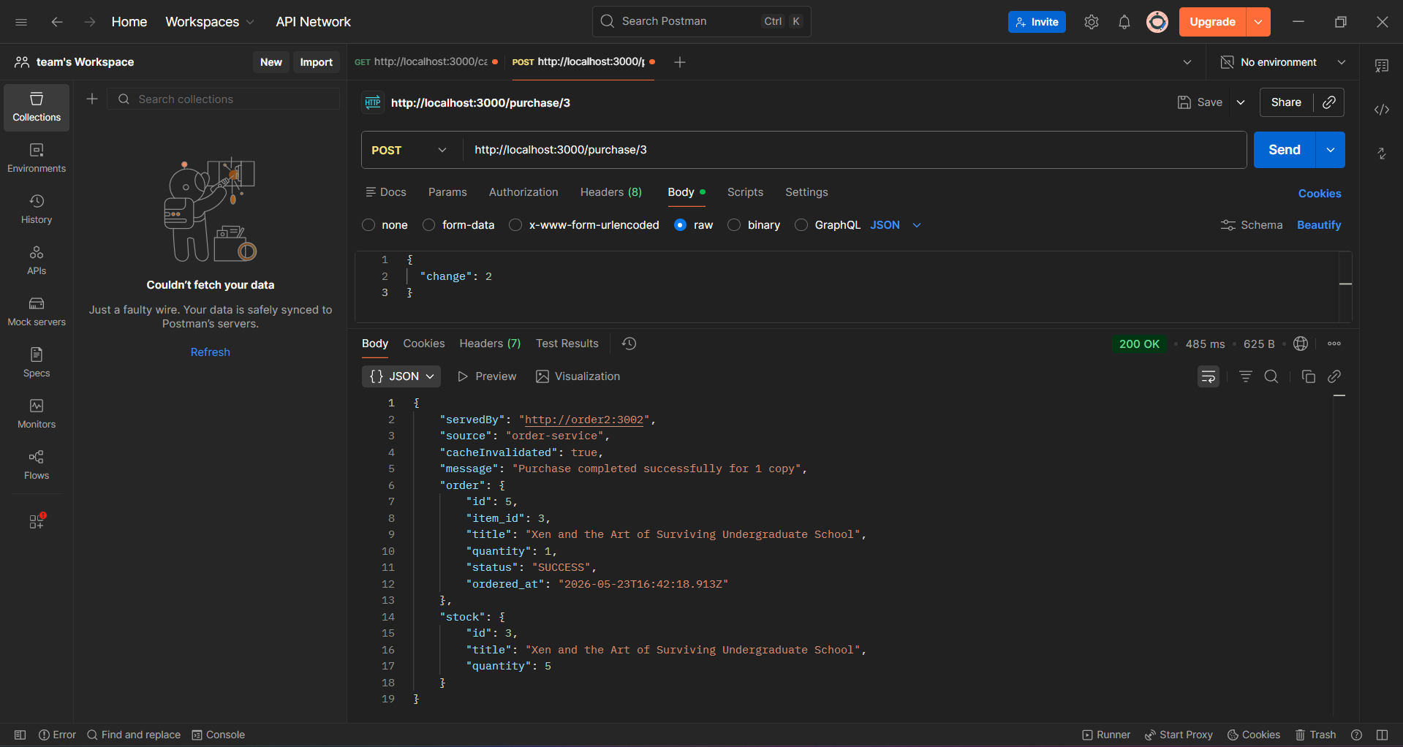
Figure 9. Purchase request showing cacheInvalidated = true.
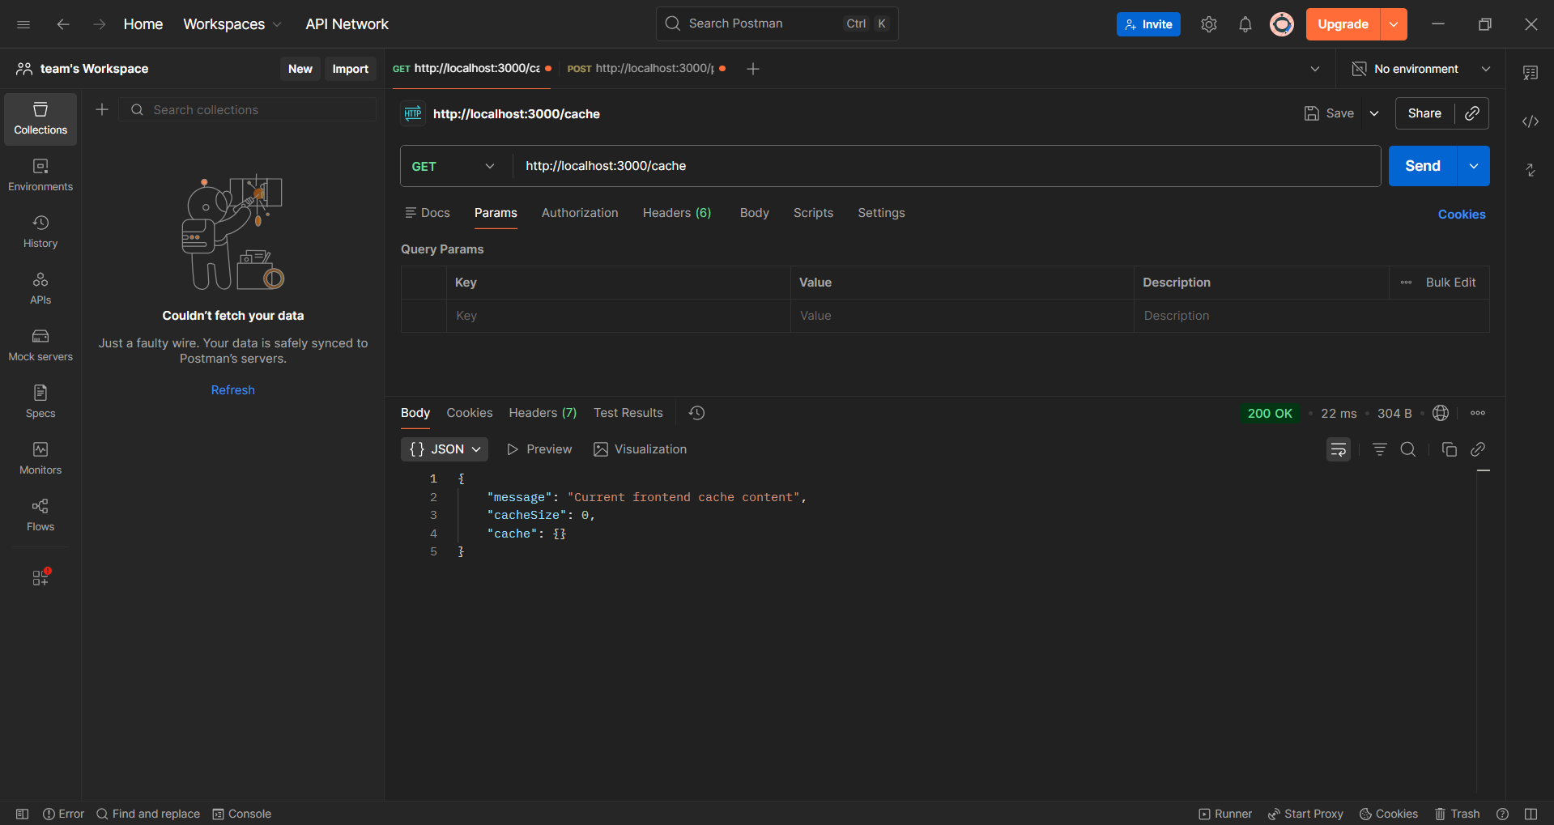
Figure 10. Cache after purchase showing the item removed.

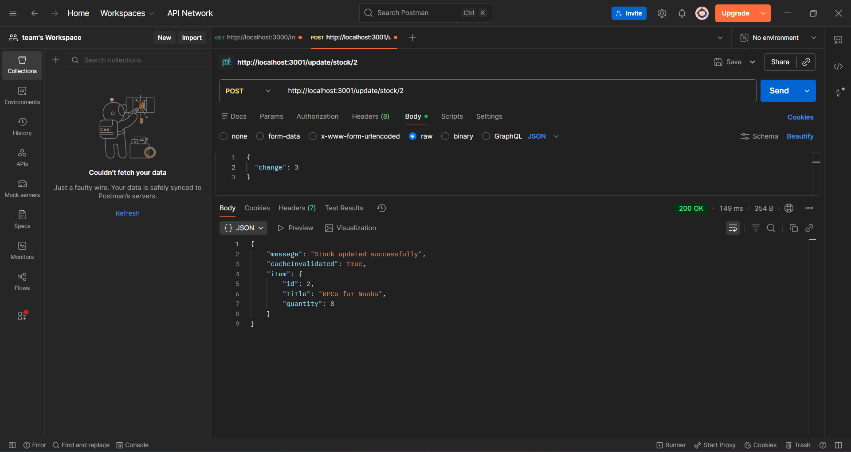
Figure 11. Catalog stock update showing cacheInvalidated = true.

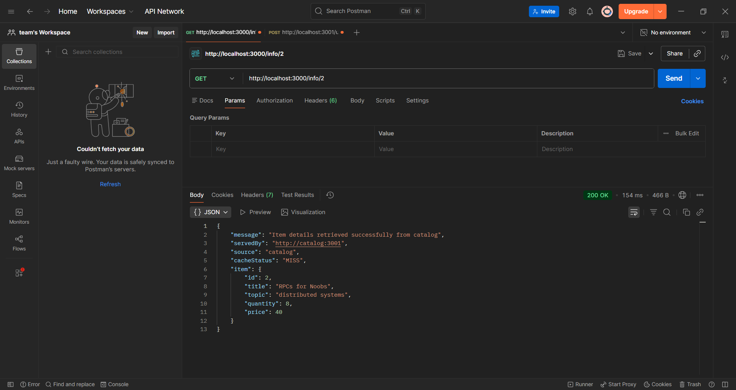
Figure 12. Request after invalidation showing CACHE MISS and fresh data.
08 | Performance Evaluation  Response-time measurements and analysis.

The following table should be filled with measured response times from Postman. Each request can be executed three times and averaged. The expected result is that cache HIT requests should be faster than cache MISS requests because they are served locally by the frontend without contacting the catalog replicas.
Test Case | Run 1 | Run 2 | Run 3 | Average | Notes
GET /info/2 - Cache MISS | 49ms | 17ms | 12ms | 26ms | Catalog request
GET /info/2 - Cache HIT | 12ms | 8ms | 10ms | 10ms | Served from cache
POST /purchase/2 | 212ms | 167 ms | 75ms | 151ms | Write request
GET /info/2 after purchase invalidation | 30ms | 17ms | 16ms | 21ms | MISS after invalidation
POST /update/stock/2 | 33ms | 39 ms | 33ms | 35ms | Catalog write
GET /info/2 after catalog update | 17ms | 19ms | 15ms | 17ms | Fresh data

09 | Conclusion

The second part of Bazar.com successfully extends the Lab 1 system with replication, load balancing, caching, and consistency handling. The frontend now balances read and purchase requests across replicas and stores recently accessed item details in memory. Cache invalidation is triggered before write operations, which prevents stale item data after purchases and catalog updates. Performance measurements can be used to show that cached reads reduce response time compared with cache misses.

