

Sultan Qaboos University
COMP3700
Introduction to Web Computing
Course Project - Part I: Project Proposal

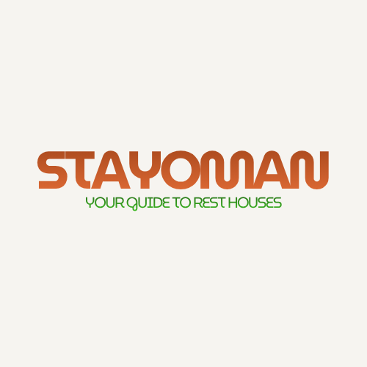
StayOman

• Team Members:
- Alzahra Issa Almufargi
-Seham Hamed AlMahrouqi

Contents

Cover page………………………………………………………………………………………………………1
Contents…………………………………………………………….……………………………………………2
Project overview and objectives…………………………………………………………….……….3
Website Content and Page Descriptions……………………………………….………………..4
CSS description…………………………………….………………………………….…………………….6
Hyper Links………………………………………….………………………………….…………………….7
Members contributions…………………………………………………………………………………8

Project overview and objectives

Overview:
StayOman is a web-based platform designed to help users easily find and book rest houses across different governorates of Oman. The website provides detailed information about each rest house, including location, price, facilities, and photos, allowing users to make informed decisions before booking.

The main goal of StayOman is to simplify the search process for people looking for suitable rest houses for vacations, gatherings, or weekend getaways. The platform also offers an opportunity for rest house owners to promote their properties and reach a wider audience.

By combining user-friendly design, accurate data, and an organized structure, StayOman aims to become the leading local directory for rest houses in Oman — supporting domestic tourism and connecting customers directly with owners in a convenient and professional way.

Website Content and Page Descriptions
Page name | Content discerption | picture
Home(index) | Displays featured rest houses, popular destinations, and current offers. | 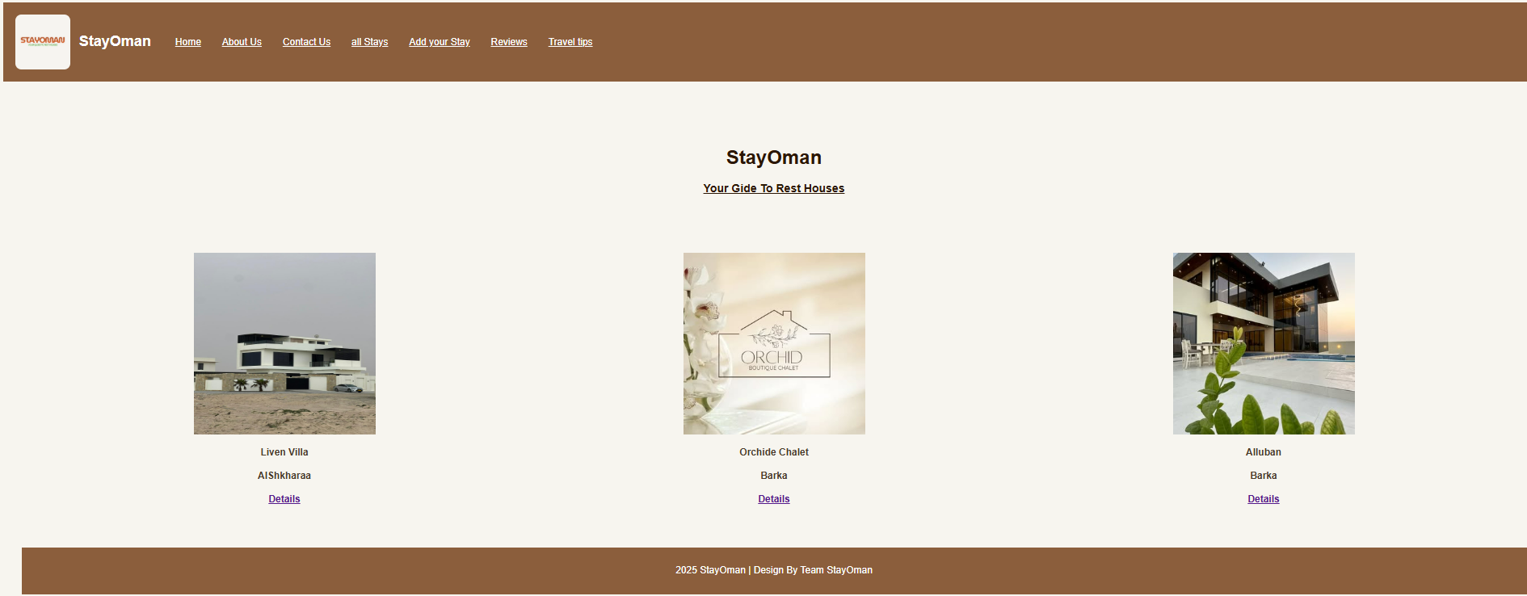
About us | Provides background information about the StayOman project, its mission, and the development team. | 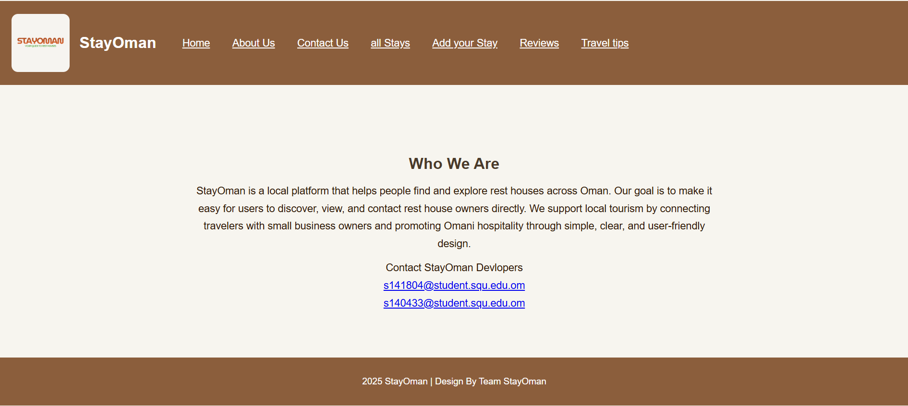
Contact us | Contains a contact form, email. | 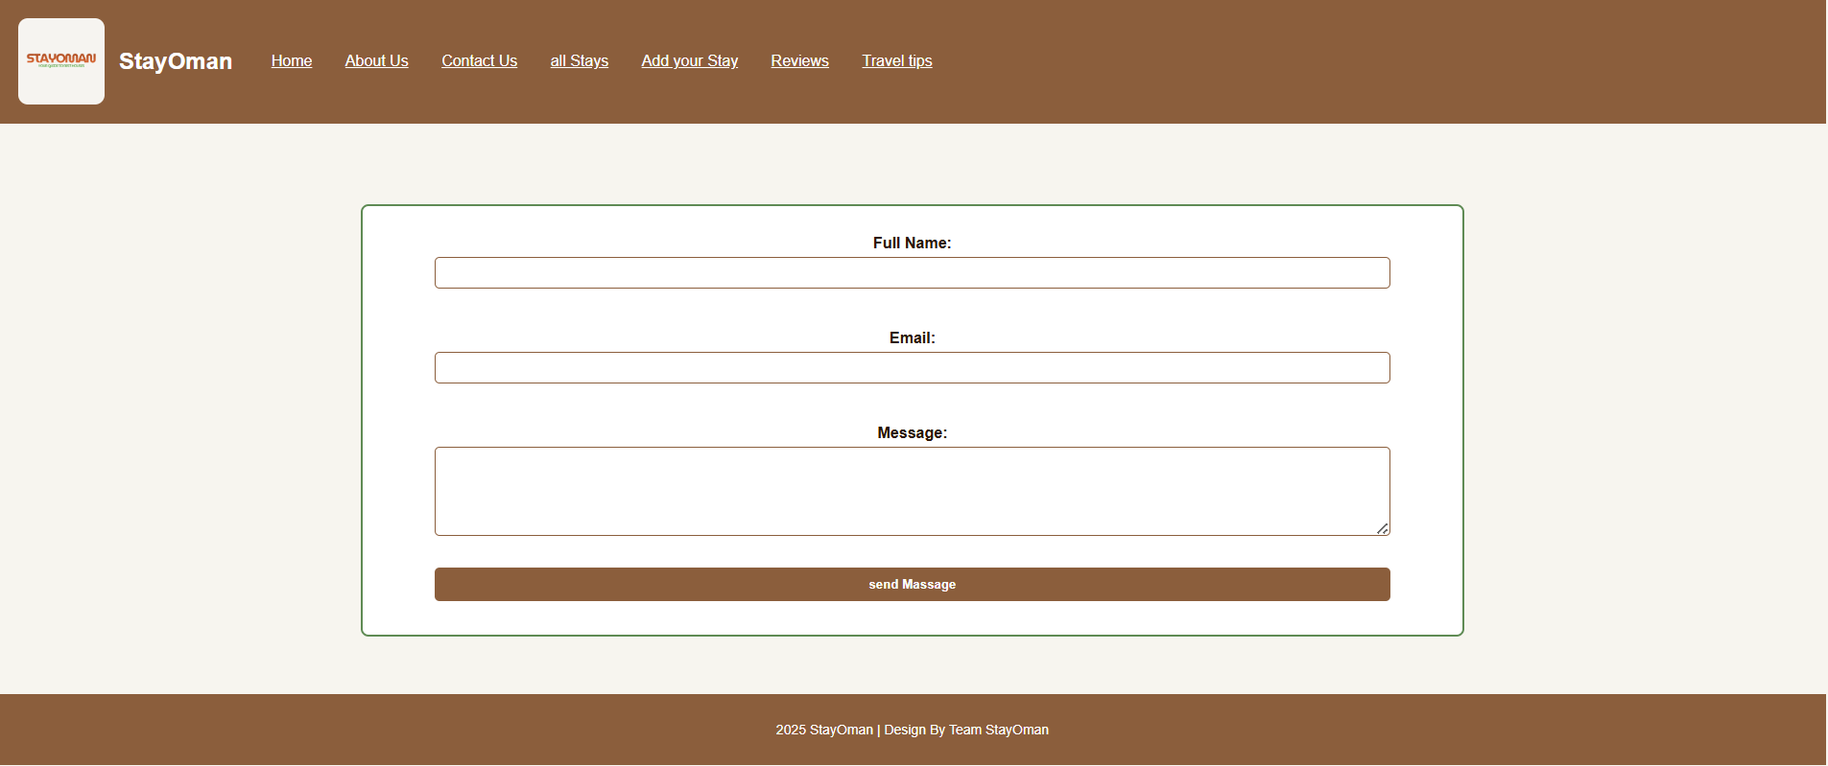
All Stays | Lists all rest houses | 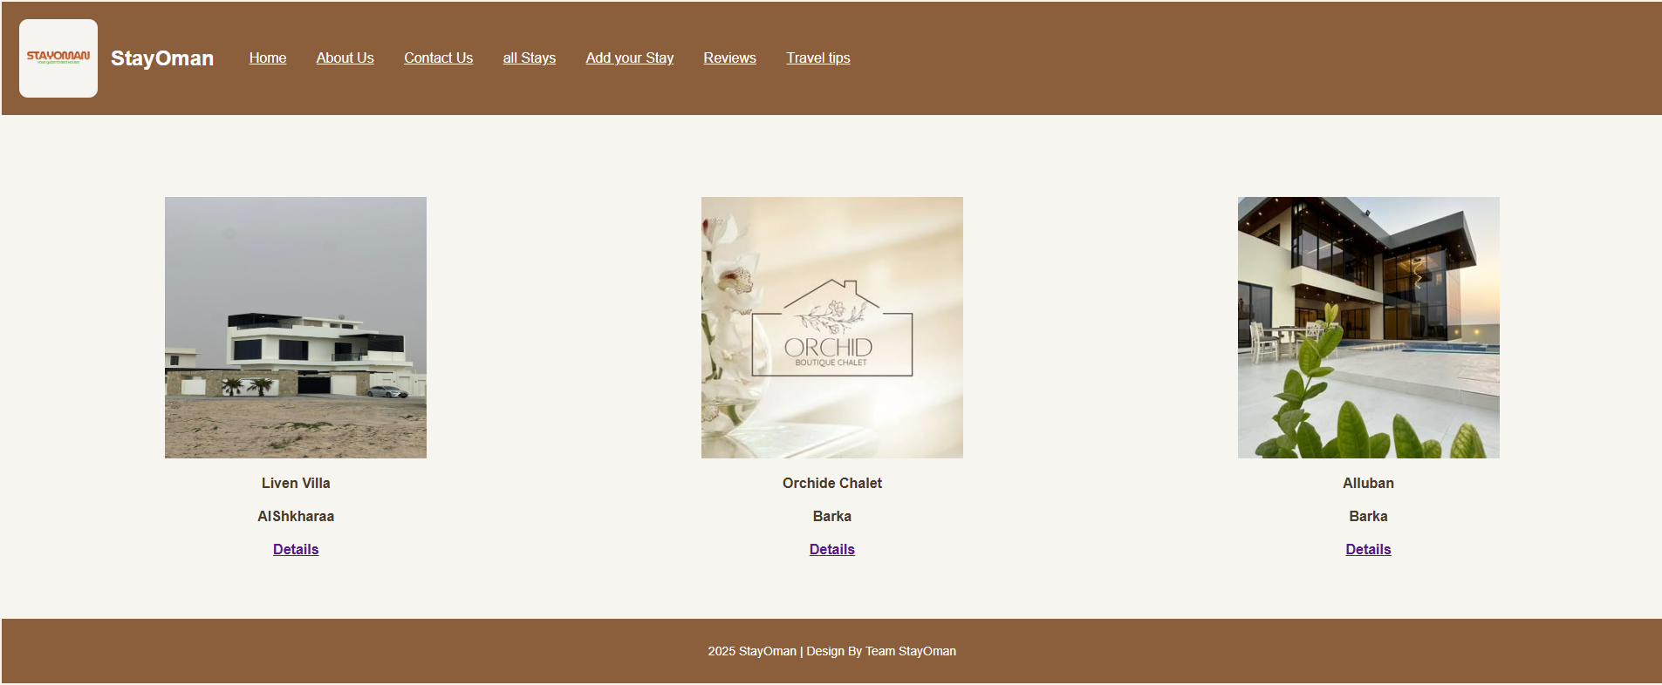
Details page | Shows full details of a selected rest house — photos, description, price, facilities, location, and owner contact info. | 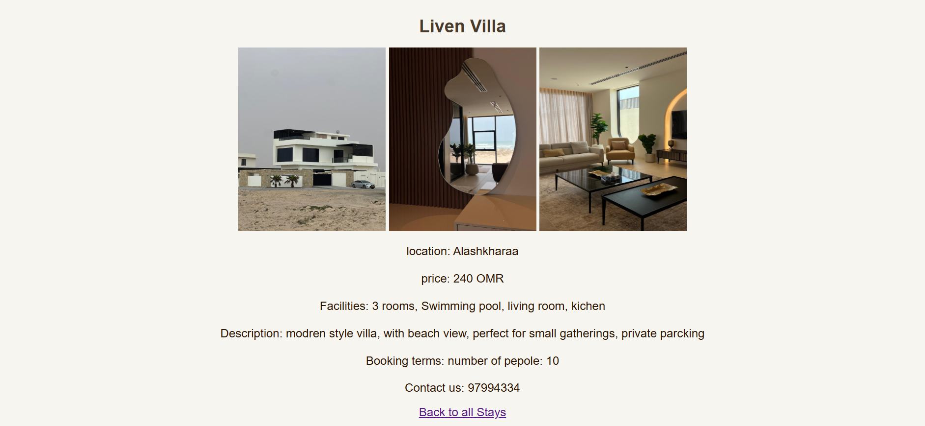
Add Your Stay | A form for rest house owners to add new listings, including photos and descriptions. | 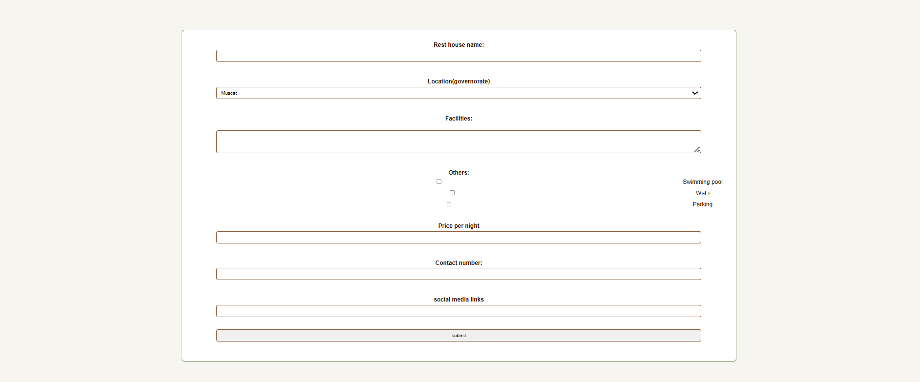
Reviews | Displays user reviews and ratings for different rest houses. Users can submit their feedback here. | 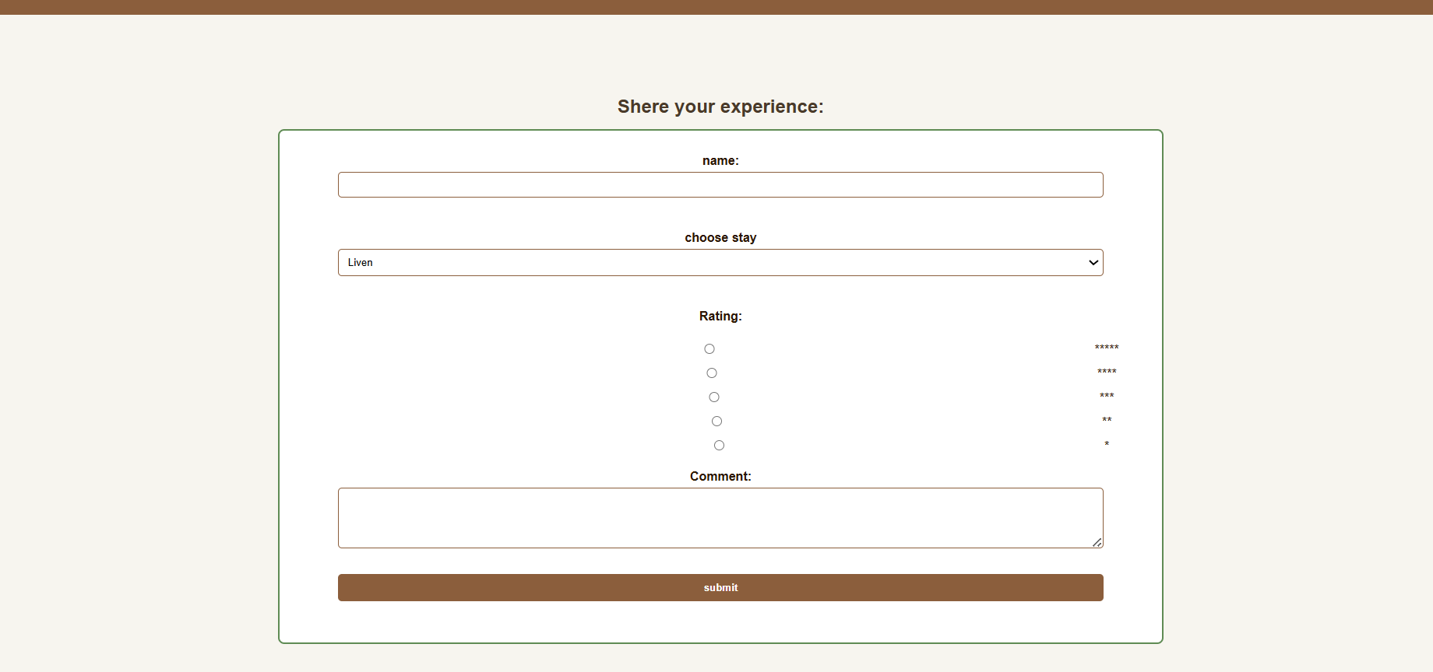
Blog / Travel Tips | tourism in Oman, travel advice, local attractions, and seasonal recommendations. | 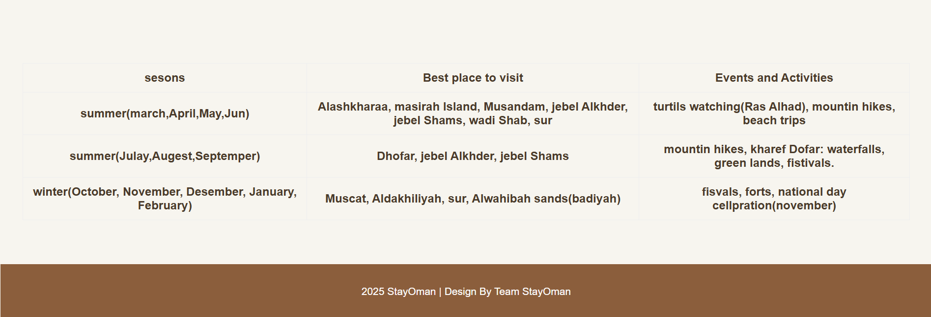

CSS description
Css type | section | Categories | page
External (simple) | Body, header, footer, nav, section | Background color  Font type  Font color | All pages
External (simple) | input, select, text area | Background color  Font type  Font color  Text align  Margins  borders | Add stay, review  Contact us
External (simple) | Table , th | Border  width  background-color | Home  All stays  Blog
External (simple) | form | Border  width  background-color  margin | Review, add stay  Contact us
External (universal) | All | Font family | All pages
External (class) | Div. logo-container | Display  Align item  Justify content  gap | All pages
External (generic) | .logo | Width  Height  border | all
External (Id) | #sub | Border  background-color  padding  font weight | Review, add stay  (submit button)
External (contextual) | Nav a  Section h2  Section p | Color  Margin  Font size | All
External (pseudo) | a: hover | Color  border | All
internal | label | display  margin  font-weight | Review, add stay  Contact us
In line | table | border | blog

Hyper links

- Hosted website:
https://s141804-ui.github.io/stayOman/
- GitHup Repository:
https://github.com/s141804-ui/stayOman

Members Contributions

As we are only 2 members in the project we always work together at same device and at the same time.
Member 1 | Content of:  Home page  Review  About us  All stays
Member 2 | Content of:  Contact us  Add stay  Blog  details
Group work(together) | Styling (CSS)  Upload the files from the working device with same account

