Download Apache ANT zip file from below link

**https://ant.apache.org/bindownload.cgi**

Go to download folder & unzip ANT folder

Copy ANT folder to Jar files Folder location

Go to ANT folder & copy path

Now Open System Property from control panel

Select Advanced System Settings => Environmental Variables =>

1st Box Select New => Name Box Type: ANT_HOME & Variable Value Box paste ANT Folder location click OK.

2nd Box Select Path => Click on Edit => New window pops-up => Select New => Past %ANT_HOME%\bin => click ok ok ok !!!

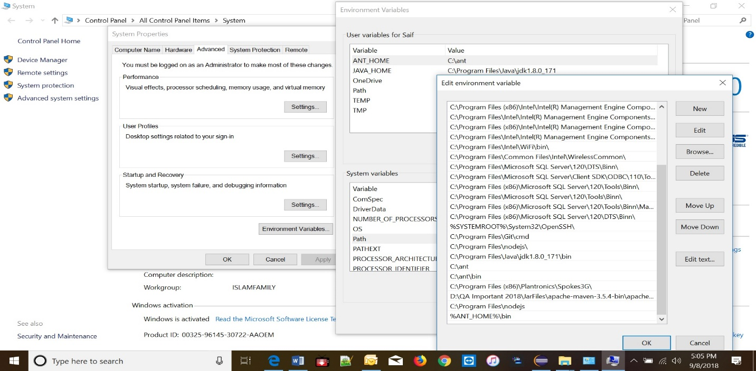

Now go to command prompt

Type: ant (hit enter)

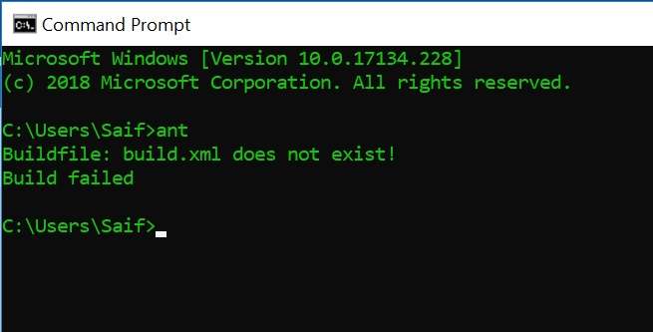

Now type: ant -version (hit enter)

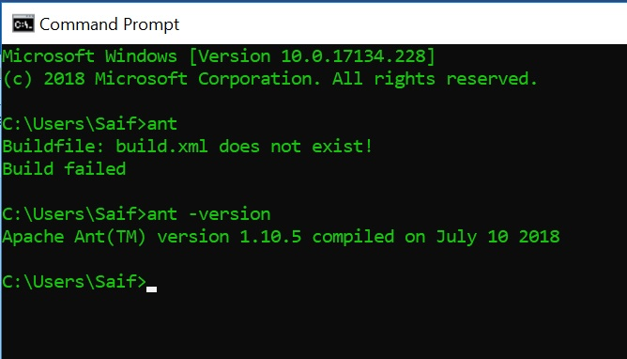

ANT installed successfully.

Create Project => package => class file

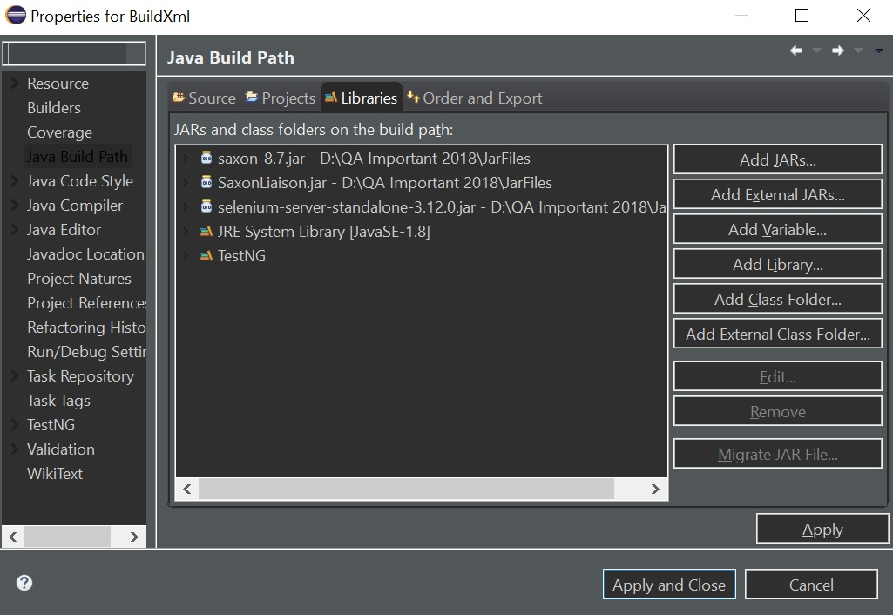

Right click on Project => Build Path => Configure Build Path // New window pops-up

Click on Add External Jars (Navigate to jar files folder to add above jars)

Add **testNG** jar also

Write some test case.

Right click on Project => TestNG => Convert to TestNG (New window open) Select Finish

(It will create **testing.xml** file under Project folder.)

Create a new folder by name **“xslt”** under Project => package =>src (D:\eclipse-workspace\BuildXml\src\xslt)

Copy **“testng-results.xsl”** under the **“xslt”** folder

Copy build.xml under Project Directory (D:\eclipse-workspace\BuildXml\build.xml)

**Open build.xml & edit below mentioned lines**

Line 5: **<project** **name=***"BuildXml"* **default=***"usage"* **basedir=***"."***>**

=>>**Name: Your Project Name**

Line 11: **<property** **name=***"ws.jars"* **value=***"D:\QA Important 2018\JarFiles"***/>**

==> **value: Your Jar files directory path**

Line 77: **<testng** **classpath=***"${test.classpath}:${test.dest}"* **suitename=***"Suite"***>**

==> **suitename: Your testing.xml file suite name**

Go to command prompt again

Navigate to your project folder

Type: **ant clean**

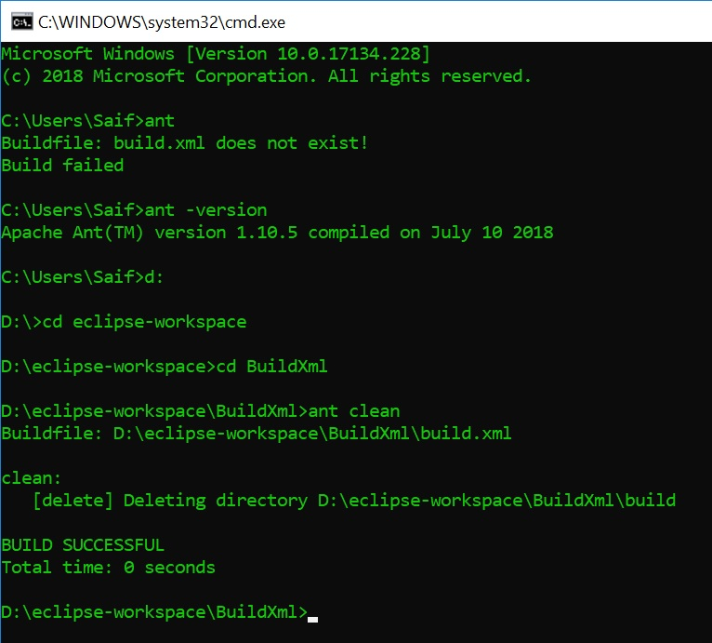

Now Type: ant compile

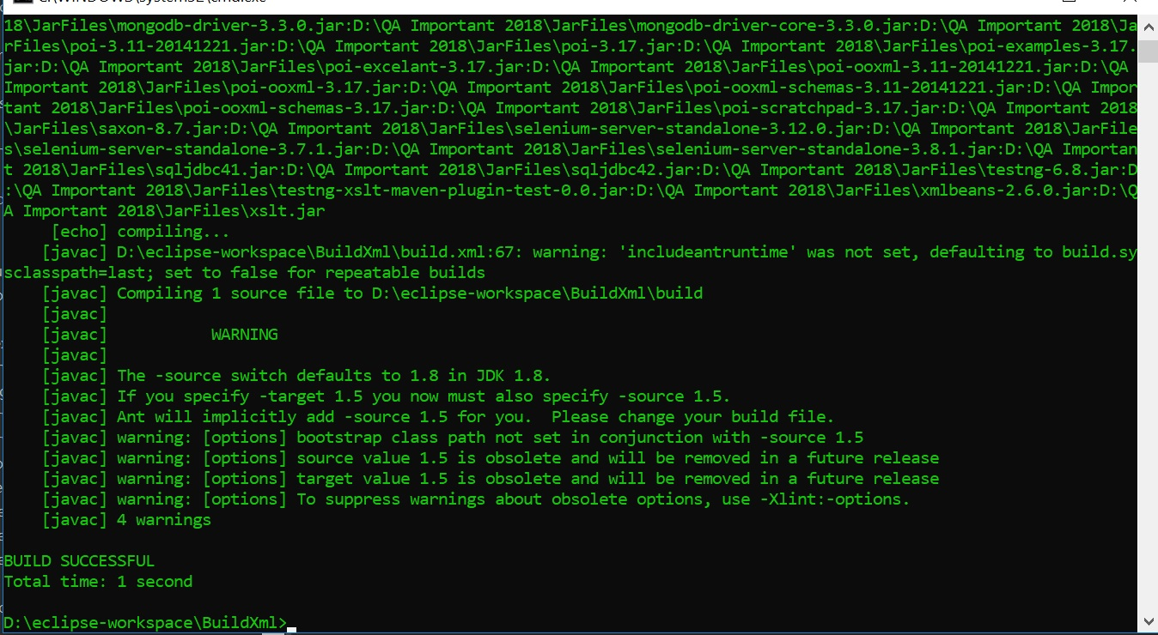

Now type: ant run

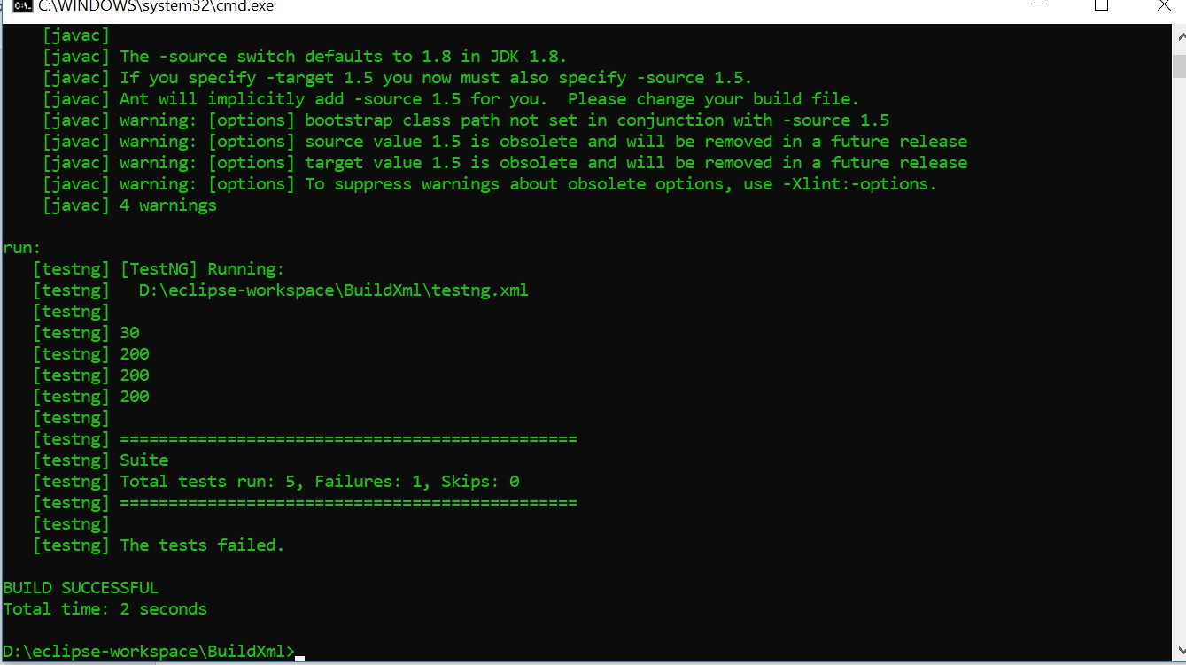

Finally Type: ant makexsltreports

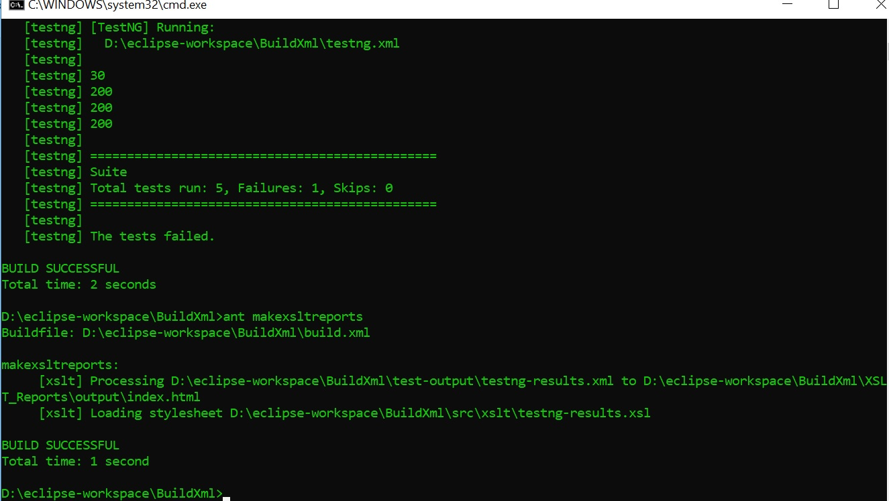

Now right click on your Project Select Refresh

Under your project you’ll see XSLT_Report => output => index.html generated

Copy the index.html file location and open with any browser.

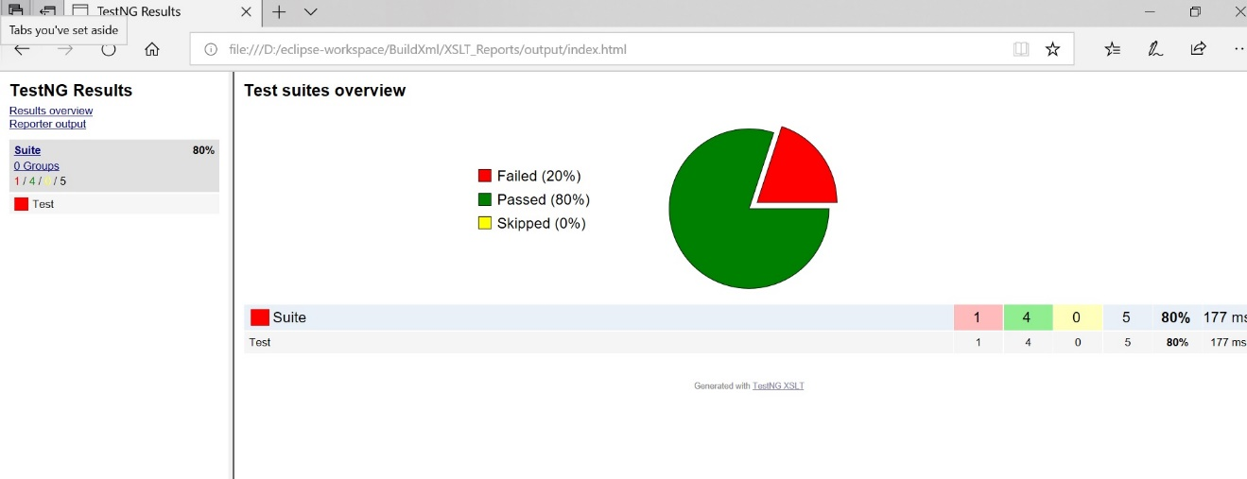

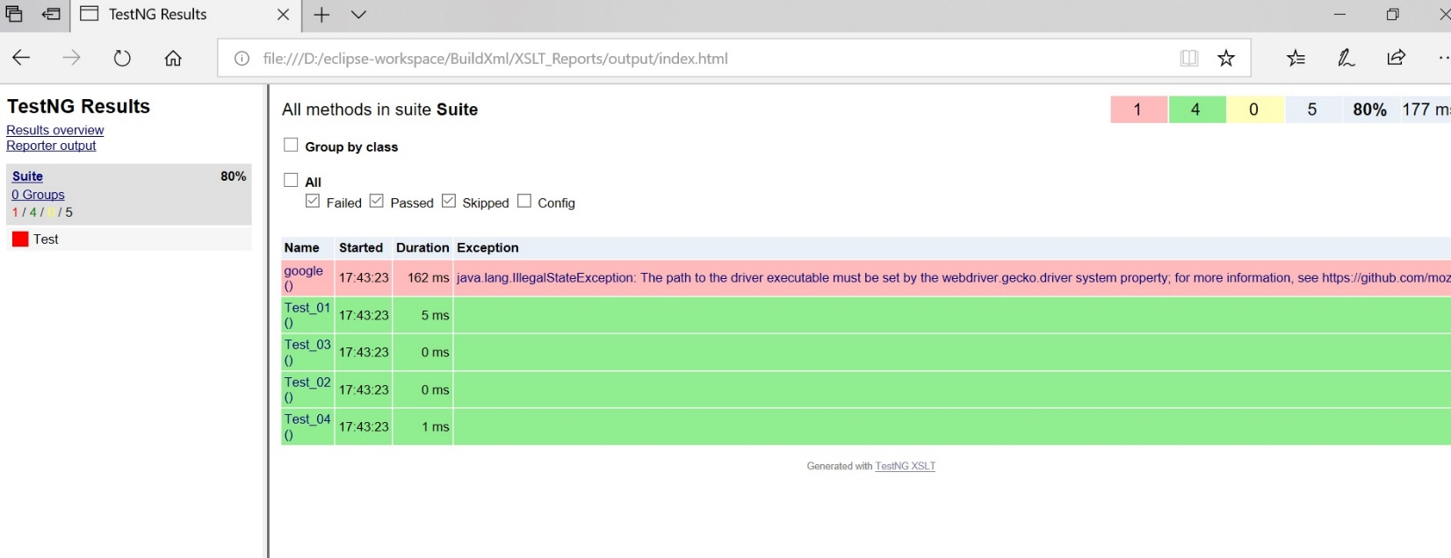

Now

Under your Project directory create a bat file

Open the file and type: ant clean compile run makexsltreports

Save the File & Exit

DONE!!!!!!!!!!!!!!!!!!!!!!!!!!!!!!