Sample: No Data Loaded

Optical Model
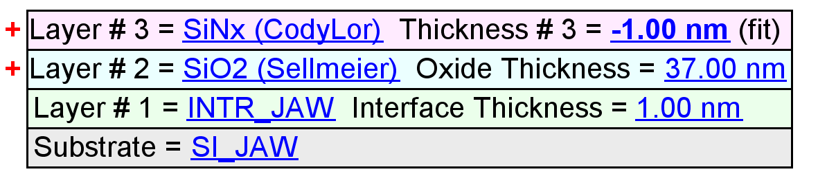
Fit Results
Parameter | Average | Min. | Max. | Std. Dev. | % Range
MSE | 2.001 | 1.101 | 4.520 | 1.044 | 170.926
Thickness # 3 (nm) | 13.42 | -1.00 | 26.44 | 10.22 | 204.5507
Amp. | 1.6008 | 1.2718 | 1.7065 | 0.1681 | 27.1562
Center Wvl. (µm) | 0.0220 | 0.0000 | 0.1025 | 0.0437 | 465.7186
IR Pole Amp. | -0.0465 | -0.0962 | 0.0007 | 0.0357 | -208.3974
Einf | 0.3402 | 0.0082 | 0.4463 | 0.1691 | 128.8015
Angle Offset | -0.0524 | -0.2625 | 0.3454 | 0.2235 | -1159.8977
Total Thickness (nm) | 51.42 | 37.00 | 64.44 | 10.22 | 53.3759
n of SiO2 (Sellmeier) @ 632.8 nm | 1.3974 | 1.1469 | 1.4803 | 0.1263 | 23.8599

Model Parameters vs. Position
