Sample: No Data Loaded

Optical Model
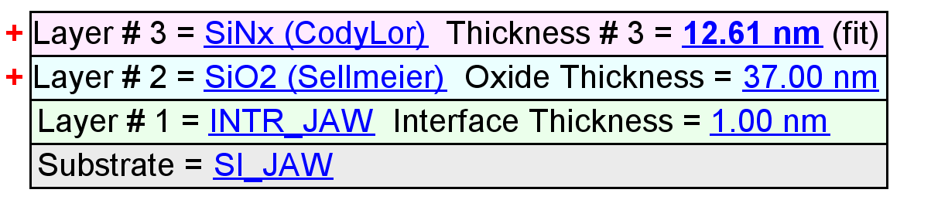
Fit Results
Parameter | Average | Min. | Max. | Std. Dev. | % Range
MSE | 2.180 | 1.219 | 4.965 | 1.161 | 171.791
Thickness # 3 (nm) | 25.81 | 12.61 | 36.71 | 8.86 | 93.3865
Amp. | 2.0536 | 1.7782 | 2.1927 | 0.1162 | 20.1867
Center Wvl. (µm) | 0.0270 | 0.0000 | 0.1211 | 0.0447 | 449.2915
IR Pole Amp. | 0.0340 | -0.0687 | 0.2012 | 0.0991 | 793.0958
Einf | 0.1130 | 0.0421 | 0.4397 | 0.1237 | 351.9001
Angle Offset | 0.0091 | -0.1837 | 0.1877 | 0.1637 | 4097.7573
Total Thickness (nm) | 63.81 | 50.61 | 74.71 | 8.86 | 37.7708
n of SiO2 (Sellmeier) @ 632.8 nm | 1.4717 | 1.4462 | 1.4885 | 0.0130 | 2.8715

Model Parameters vs. Position
