Sample: No Data Loaded

Optical Model
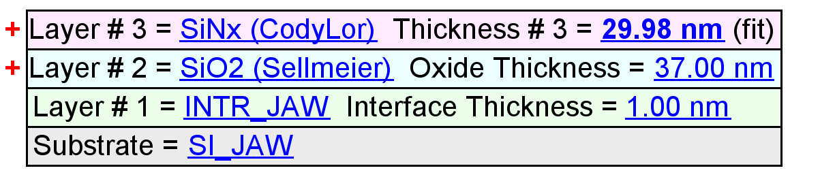
Fit Results
Parameter | Average | Min. | Max. | Std. Dev. | % Range
MSE | 2.380 | 1.426 | 2.992 | 0.546 | 65.822
Thickness # 3 (nm) | 32.36 | 29.98 | 34.51 | 1.84 | 13.9895
Amp. | 1.9549 | 1.3715 | 2.2116 | 0.3722 | 42.9746
Center Wvl. (µm) | 0.0723 | 0.0000 | 0.1337 | 0.0514 | 184.8633
IR Pole Amp. | 0.0564 | 0.0085 | 0.1142 | 0.0309 | 187.3522
Einf | 0.2326 | 0.0001 | 0.7837 | 0.3445 | 336.8340
Angle Offset | 0.0847 | -0.0581 | 0.3380 | 0.1483 | 467.4149
Total Thickness (nm) | 70.36 | 67.98 | 72.51 | 1.84 | 6.4342
n of SiO2 (Sellmeier) @ 632.8 nm | 1.4829 | 1.4654 | 1.4929 | 0.0091 | 1.8575

Model Parameters vs. Position
