Sample: No Data Loaded

Optical Model
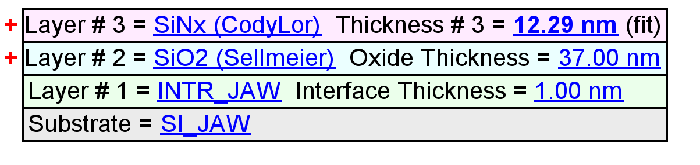
Fit Results
Parameter | Average | Min. | Max. | Std. Dev. | % Range
MSE | 1.597 | 1.100 | 2.296 | 0.445 | 74.872
Thickness # 3 (nm) | 10.35 | 5.37 | 12.93 | 2.55 | 73.0752
Amp. | 2.0174 | 1.9956 | 2.0346 | 0.0158 | 1.9337
Center Wvl. (µm) | 0.0000 | 0.0000 | 0.0000 | 0.0000 | 68.6341
IR Pole Amp. | -0.0489 | -0.0826 | -0.0155 | 0.0247 | -137.0831
Einf | 0.0201 | 0.0004 | 0.0395 | 0.0157 | 193.7133
Angle Offset | -0.1925 | -0.2547 | -0.1388 | 0.0352 | -60.1637
Total Thickness (nm) | 48.35 | 43.37 | 50.93 | 2.55 | 15.6375
n of SiO2 (Sellmeier) @ 632.8 nm | 1.4342 | 1.4172 | 1.4505 | 0.0137 | 2.3158

Model Parameters vs. Position
