Sample: No Data Loaded

Optical Model
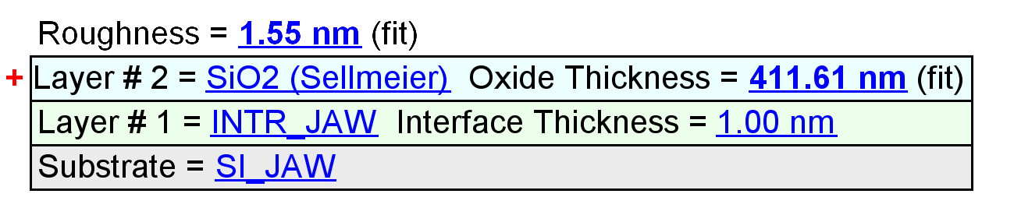
Fit Results
Parameter | Average | Min. | Max. | Std. Dev. | % Range
MSE | 4.349 | 3.461 | 6.325 | 1.231 | 65.870
Roughness (nm) | 1.89 | 1.42 | 2.17 | 0.27 | 39.6395
Oxide Thickness (nm) | 422.08 | 408.42 | 428.94 | 8.59 | 4.8634
Amp. | 1.6706 | 1.2003 | 2.1347 | 0.4476 | 55.9292
Center Wvl. (µm) | 0.0791 | 0.0691 | 0.0897 | 0.0095 | 26.0318
IR Pole Amp. | 0.0091 | 0.0052 | 0.0109 | 0.0018 | 63.0509
Einf | 0.4640 | 0.0000 | 0.9371 | 0.4493 | 201.9823
Angle Offset | -0.0255 | -0.0505 | -0.0127 | 0.0128 | -148.6662
n of SiO2 (Sellmeier) @ 405.0 nm | 1.4820 | 1.4787 | 1.4827 | 0.0012 | 0.2677

Model Parameters vs. Position
