Sample: No Data Loaded

Optical Model
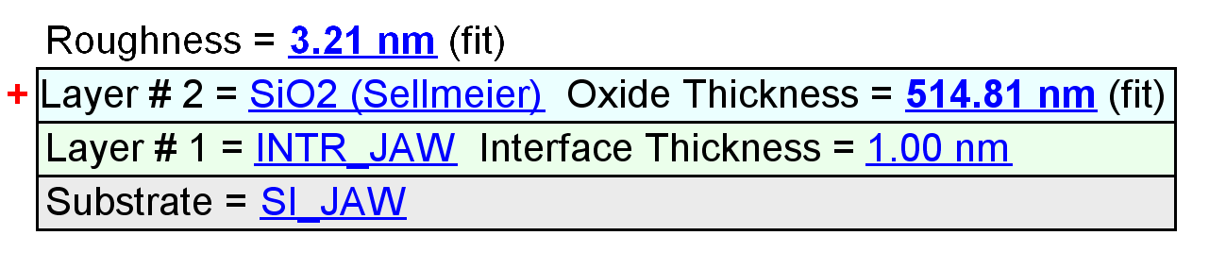
Fit Results
Parameter | Average | Min. | Max. | Std. Dev. | % Range
MSE | 5.491 | 3.937 | 12.139 | 2.537 | 149.380
Roughness (nm) | 2.36 | 1.82 | 3.82 | 0.64 | 84.9566
Oxide Thickness (nm) | 528.22 | 504.00 | 536.71 | 11.04 | 6.1924
Amp. | 1.7767 | 1.7733 | 1.7873 | 0.0047 | 0.7890
Center Wvl. (µm) | 0.0753 | 0.0748 | 0.0765 | 0.0004 | 2.3090
IR Pole Amp. | 0.0106 | 0.0079 | 0.0115 | 0.0011 | 34.6289
Einf | 0.3606 | 0.3446 | 0.3643 | 0.0065 | 5.4533
Angle Offset | -0.0223 | -0.1267 | 0.0047 | 0.0411 | -589.3945
n of SiO2 (Sellmeier) @ 405.0 nm | 1.4829 | 1.4812 | 1.4835 | 0.0008 | 0.1573

Model Parameters vs. Position
