Sample: 2025-10-02-14-16_LOCOS_post-litho_resist_strip

Fit Results  MSE = 4.609  Thickness # 2 = 81.14 ± 0.012 nm  Amp. = 417.640 ± 2.8013E-05  Brod. = 9.891 ± 9999.0000  Eo = 6.994 ± 1.0064E-07  Eg = 4.647 ± 0.006533  Einf = 0.00 ± 0.0106  n of Si3N4 (TaucLorentz) @ 632.8 nm = 2.00132 | Optical Model  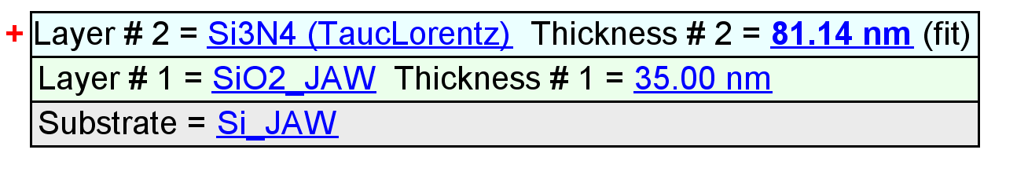

Optical Constants

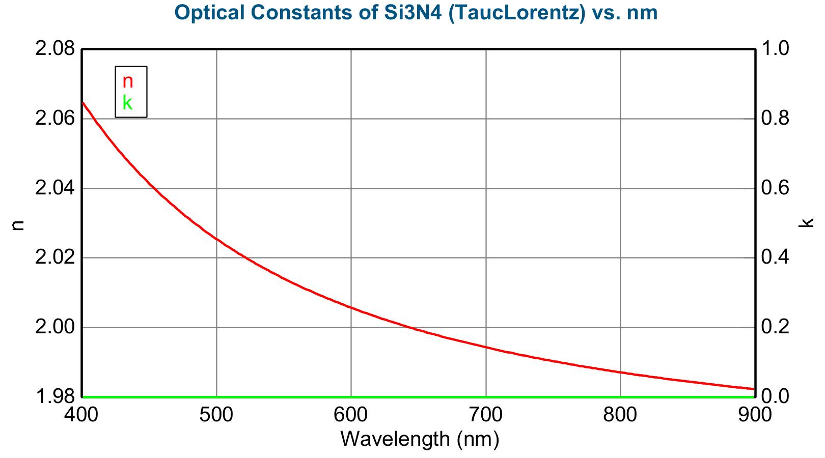

Experimental and Model Generated Data Fits

