Sample: 2025-10-21-14-29_LOCOS_nitride_icp_etch

Optical Model
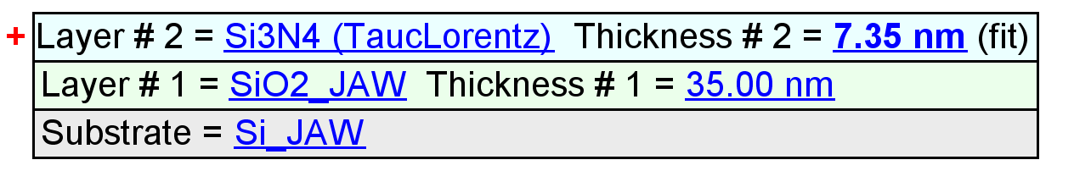
Fit Results
Parameter | Average | Min. | Max. | Std. Dev. | % Range
MSE | 9.823 | 8.963 | 10.371 | 0.706 | 14.333
Thickness # 2 (nm) | 7.46 | 5.54 | 8.43 | 1.15 | 38.6845
Amp. | 122.7672 | 103.1450 | 145.6346 | 19.1136 | 34.6099
Brod. | 0.0141 | 0.0000 | 0.0706 | 0.0316 | 500.0000
Eo | 7.3875 | 7.1907 | 7.5781 | 0.1785 | 5.2441
Eg | 5.8480 | 5.7317 | 5.9587 | 0.0982 | 3.8805
Einf | 2.7139 | 2.6214 | 2.7937 | 0.0649 | 6.3511
n of Si3N4 (TaucLorentz) @ 632.8 nm | 1.8682 | 1.8102 | 1.8914 | 0.0331 | 4.3451

Model Parameters vs. Position
