Sample: 2025-12-08-15-15-LPCVD_oxide_process

Optical Model
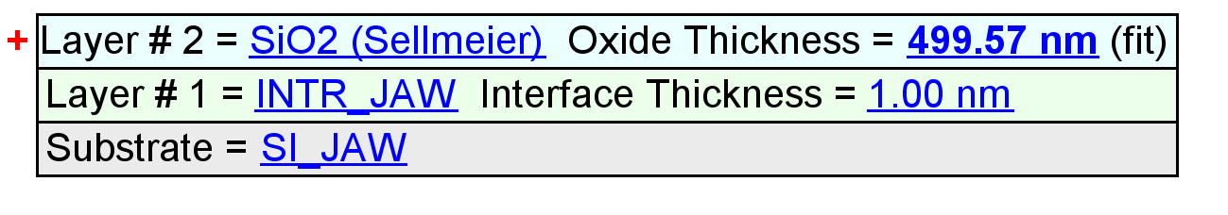
Fit Results
Parameter | Average | Min. | Max. | Std. Dev. | % Range
MSE | 8.935 | 8.614 | 9.316 | 0.275 | 7.857
Oxide Thickness (nm) | 498.71 | 484.07 | 514.39 | 10.82 | 6.0799
Amp. | 0.8894 | 0.8457 | 0.9155 | 0.0303 | 7.8379
Center Wvl. (µm) | 0.1010 | 0.0998 | 0.1030 | 0.0013 | 3.0916
IR Pole Amp. | 0.0114 | 0.0103 | 0.0129 | 0.0009 | 22.3005
Einf | 1.2297 | 1.2029 | 1.2752 | 0.0310 | 5.8768
Angle Offset | -0.1211 | -0.1379 | -0.0973 | 0.0153 | -33.4683
Total Thickness (nm) | 499.71 | 485.07 | 515.39 | 10.82 | 6.0677
n of SiO2 (Sellmeier) @ 632.8 nm | 1.4621 | 1.4618 | 1.4625 | 0.0003 | 0.0476

Model Parameters vs. Position
