Sample: 2025-08-28-15-06-LOCOS_E1_oxide_wafer1

Optical Model
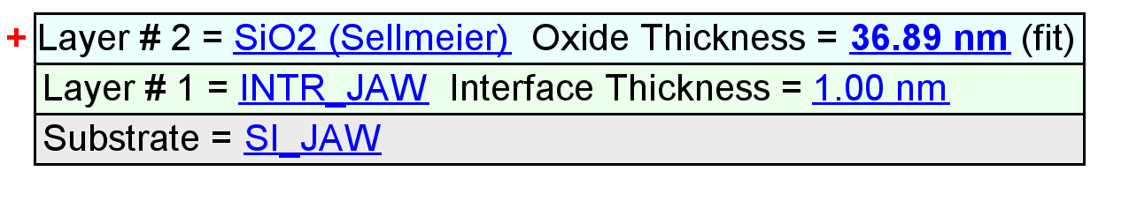
Fit Results
Parameter | Average | Min. | Max. | Std. Dev. | % Range
MSE | 1.200 | 0.942 | 1.794 | 0.283 | 70.990
Oxide Thickness (nm) | 37.15 | 36.89 | 37.63 | 0.25 | 1.9889
Amp. | 1.9155 | 1.1610 | 2.0984 | 0.3480 | 48.9405
Center Wvl. (µm) | 0.0717 | 0.0667 | 0.0901 | 0.0071 | 32.5634
IR Pole Amp. | 0.0237 | 0.0161 | 0.0277 | 0.0033 | 48.6274
Einf | 0.1758 | 0.0000 | 0.9253 | 0.3549 | 526.4345
Angle Offset | 0.1111 | -0.0271 | 0.1623 | 0.0577 | 170.4356
Total Thickness (nm) | 38.15 | 37.89 | 38.63 | 0.25 | 1.9368
n of SiO2 (Sellmeier) @ 632.8 nm | 1.4512 | 1.4474 | 1.4637 | 0.0051 | 1.1242

Model Parameters vs. Position
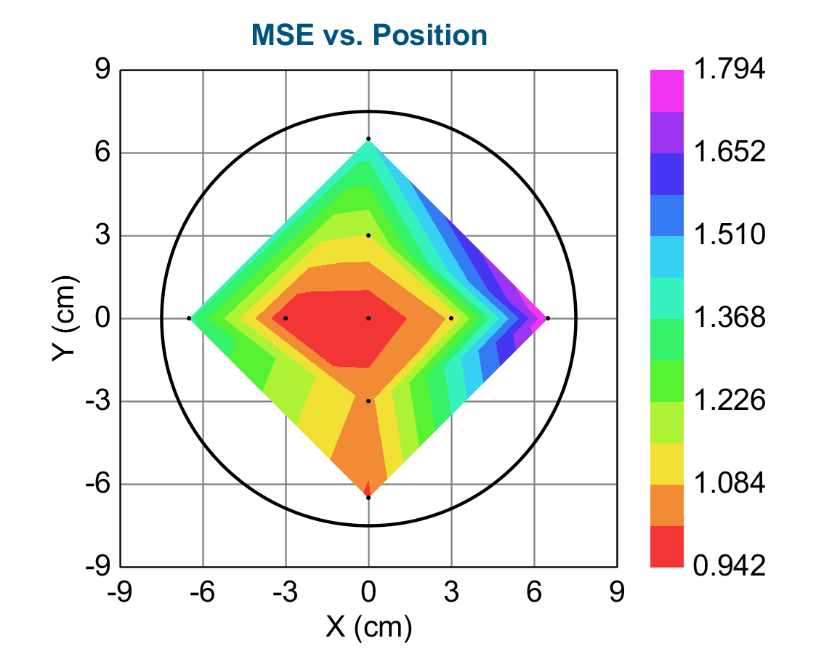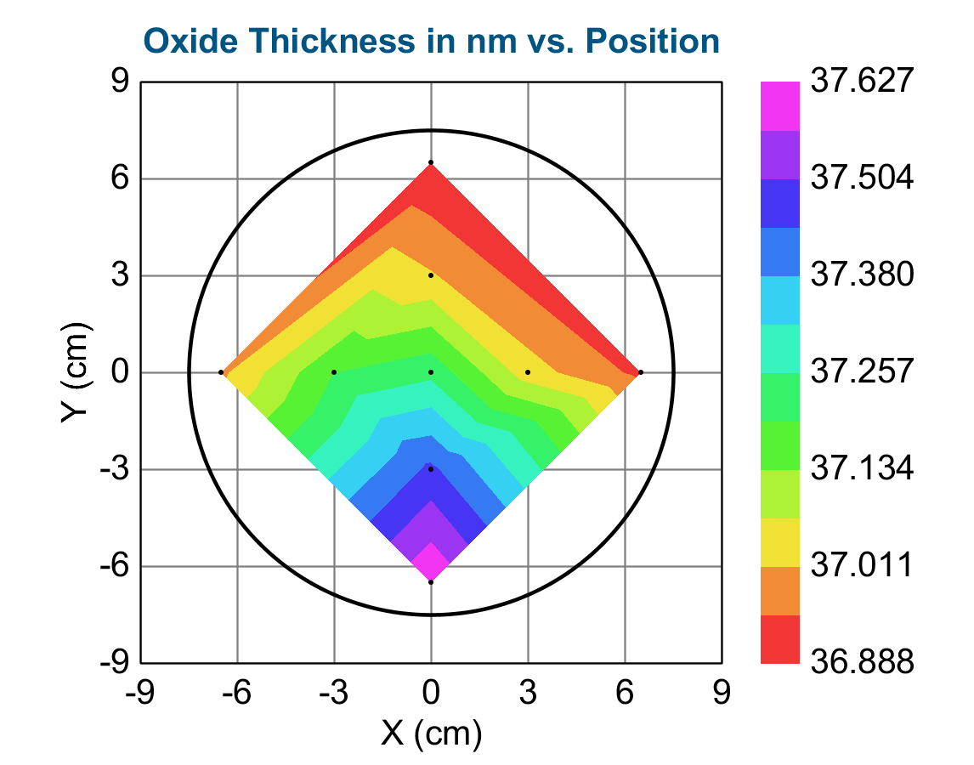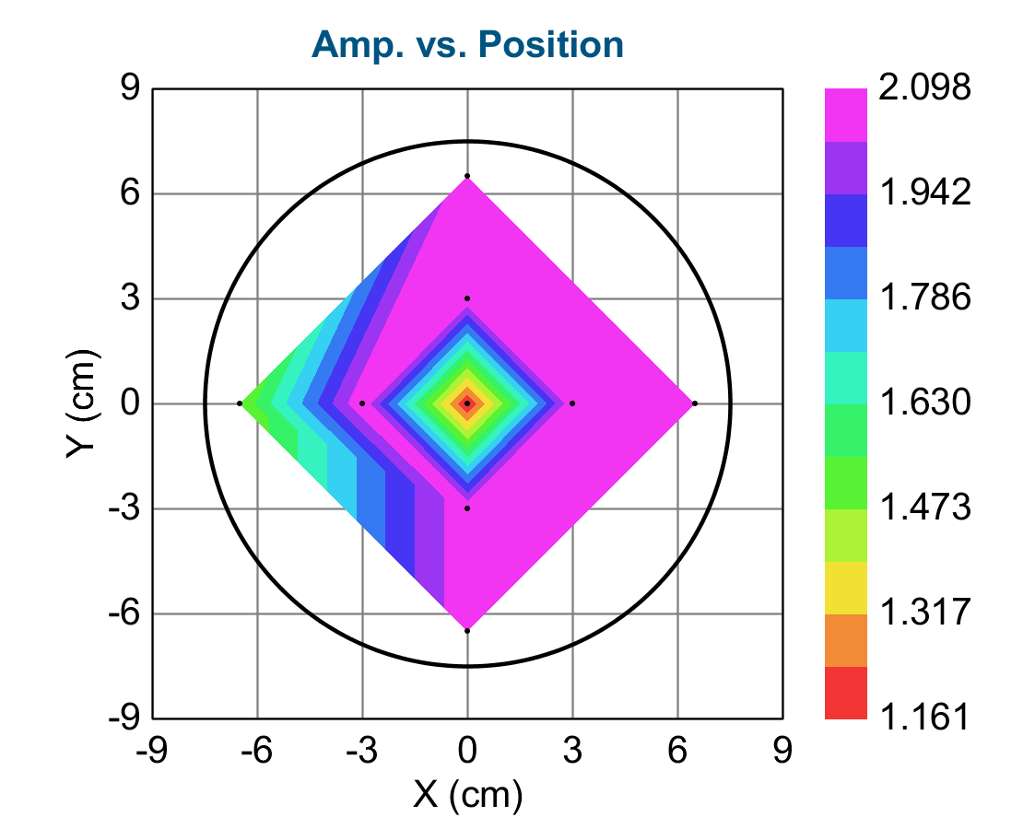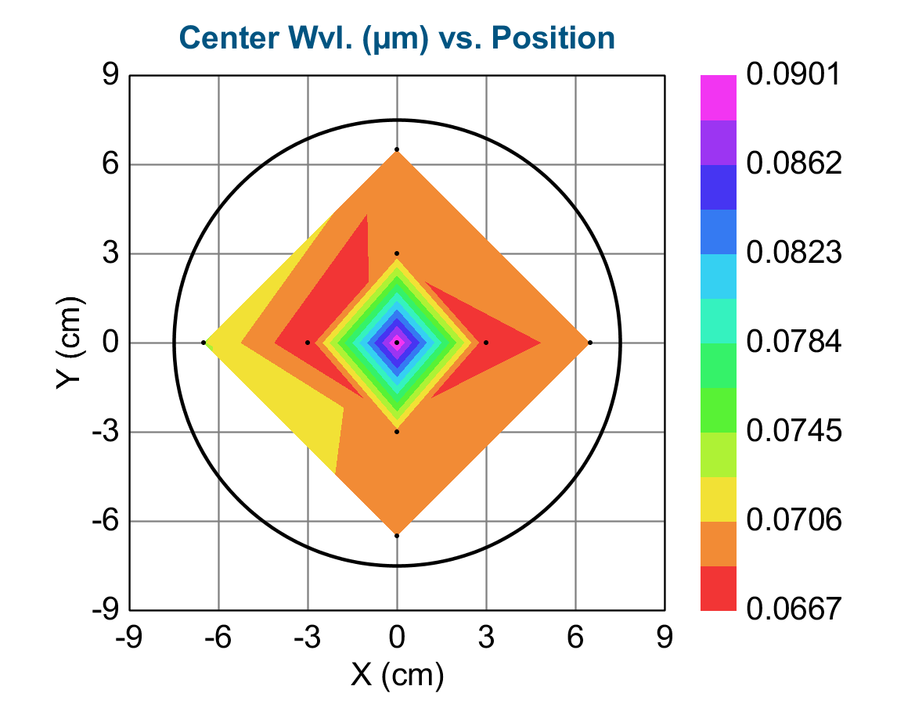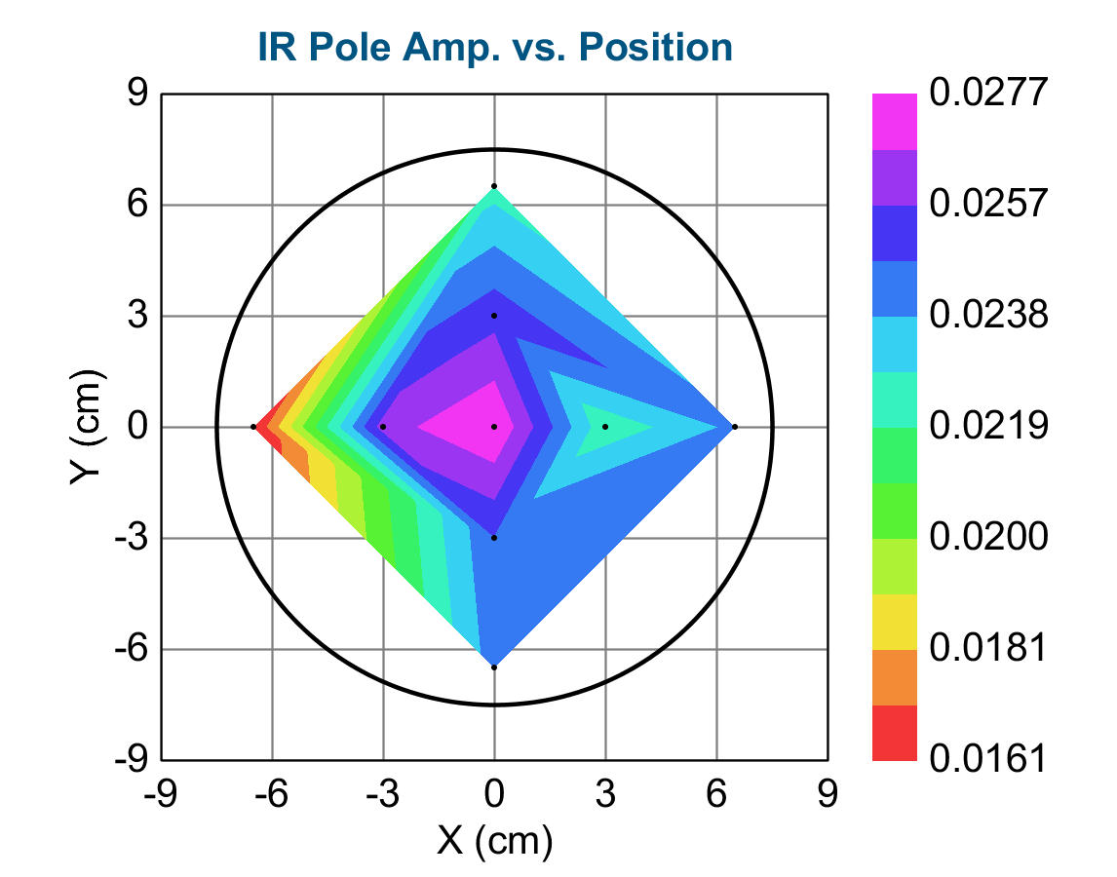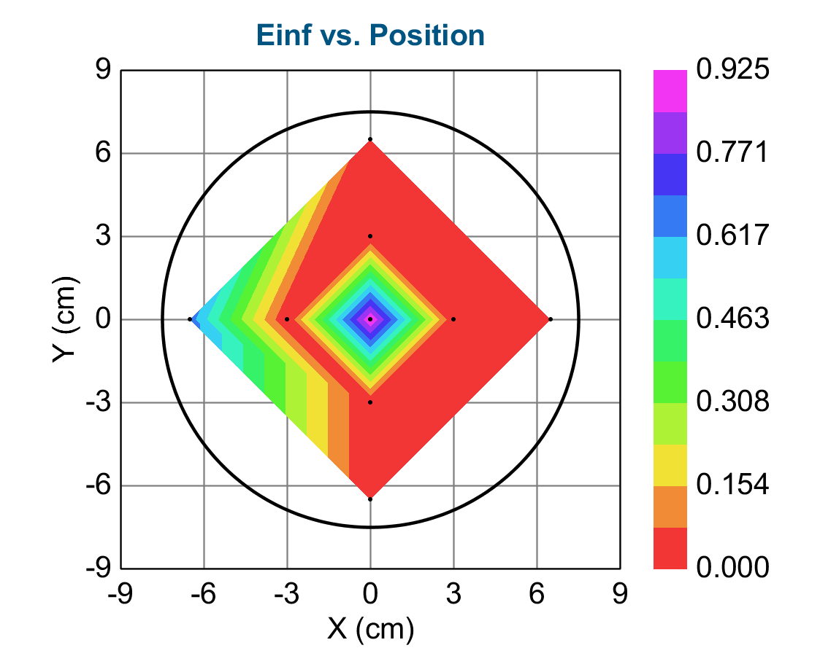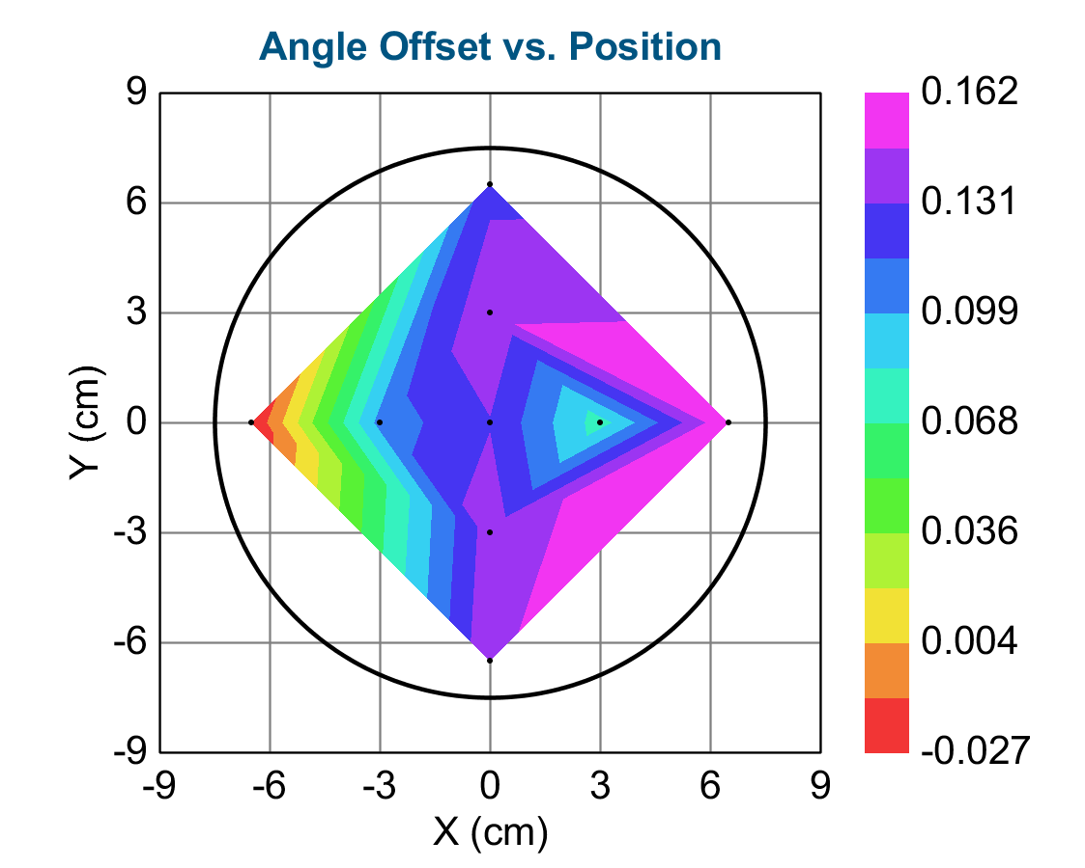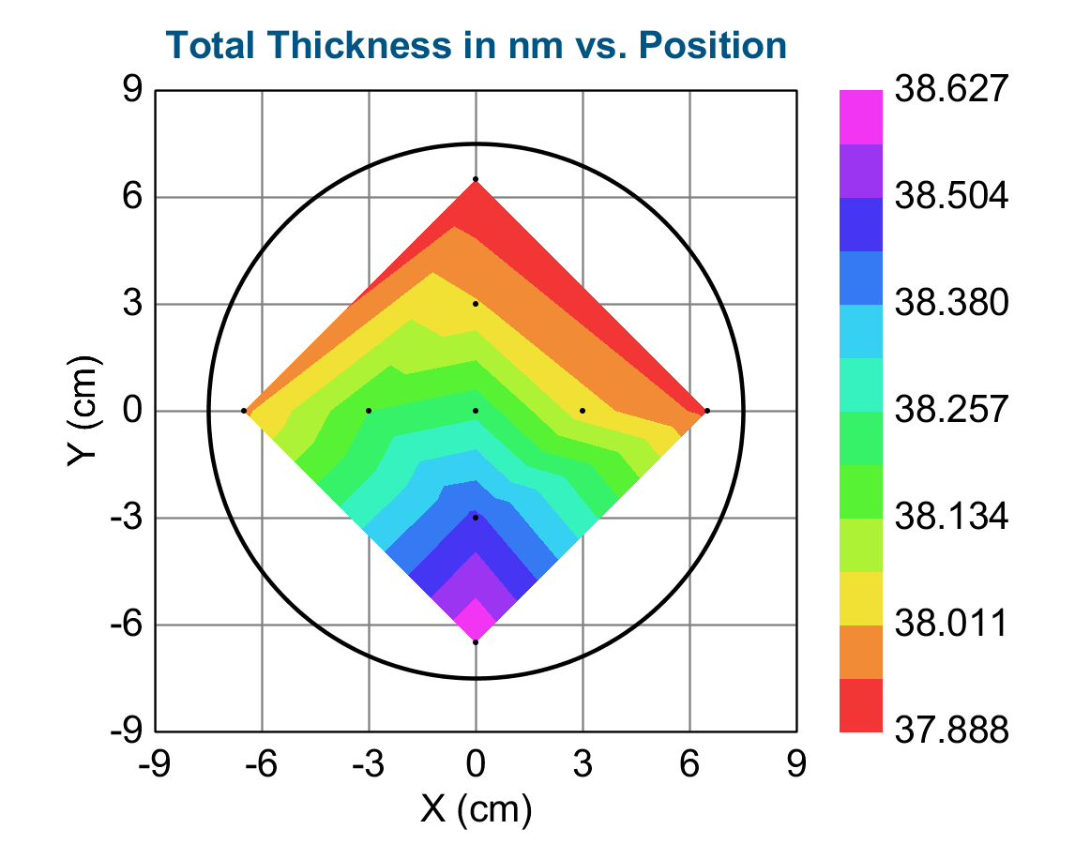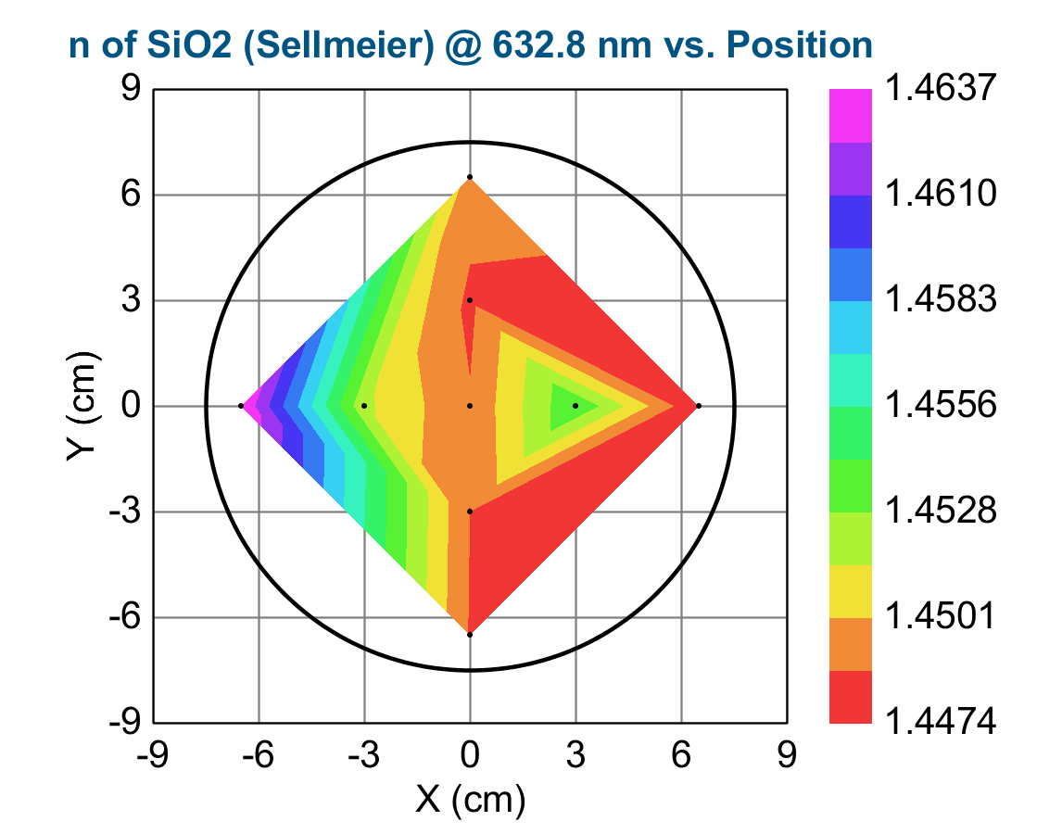
Oxide Thickness in nm vs. Position
X (cm) Y (cm) Z
0.000000 0.000000 37.239990
3.000000 0.000000 37.038521
-0.000000 -3.000000 37.457802
-3.000000 0.000000 37.195042
0.000000 3.000000 37.017235
6.500000 0.000000 36.932625
-0.000000 -6.500000 37.626766
-6.500000 0.000000 36.996891
0.000000 6.500000 36.887791
X (cm) Y (cm) MSE Oxide Thickness (nm) Amp. Center Wvl. (µm) IR Pole Amp. Einf Angle Offset Total Thickness (nm) n of SiO2 (Sellmeier) @ 632.8 nm Oxide Thickness (nm) Error Amp. Error Center Wvl. (µm) Error IR Pole Amp. Error Einf Error Angle Offset Error Total Thickness (nm) Error n of SiO2 (Sellmeier) @ 632.8 nm Error
0.00000 0.00000 0.942 37.24 1.161 0.09009 0.02766 0.925 0.130 38.24 1.44887 0.016 0.7219 0.024889 0.002975 0.7246 0.002548 0.016 0.00000
3.00000 0.00000 1.094 37.04 2.098 0.06674 0.02216 0.00129 0.0757 38.04 1.45411 0.019 2.9777 0.044411 0.003646 2.9810 0.003008 0.019 0.00000
-0.00000 -3.00000 1.060 37.46 2.083 0.06984 0.02473 0.00 0.140 38.46 1.44875 0.018 2.3087 0.036079 0.003379 2.3117 0.002863 0.018 0.00000
-3.00000 0.00000 0.947 37.20 2.095 0.06677 0.02630 0.00 0.105 38.20 1.45179 0.016 2.4862 0.037162 0.003076 2.4890 0.002583 0.016 0.00000
0.00000 3.00000 1.150 37.02 2.083 0.06956 0.02541 0.00 0.145 38.02 1.44848 0.020 2.5484 0.039698 0.003691 2.5517 0.003099 0.020 0.00000
6.50000 0.00000 1.794 36.93 2.079 0.07044 0.02409 0.00 0.162 37.93 1.44741 0.031 3.7586 0.059302 0.005737 3.7636 0.004812 0.031 0.00000
-0.00000 -6.50000 1.002 37.63 2.083 0.06965 0.02429 3.3465E-08 0.144 38.63 1.44862 0.017 2.1779 0.033963 0.003163 2.1807 0.002708 0.017 0.00000
-6.50000 0.00000 1.381 37.00 1.474 0.07271 0.01614 0.655 -0.0271 38.00 1.46372 0.024 2.6969 0.061592 0.004723 2.7012 0.003946 0.024 0.00000
0.00000 6.50000 1.430 36.89 2.084 0.06963 0.02247 4.0012E-08 0.125 37.89 1.44947 0.025 3.1769 0.049490 0.004633 3.1810 0.003866 0.025 0.00000

