Sample: 2025-08-28-15-06-LOCOS_E1_oxide_wafer25

Optical Model
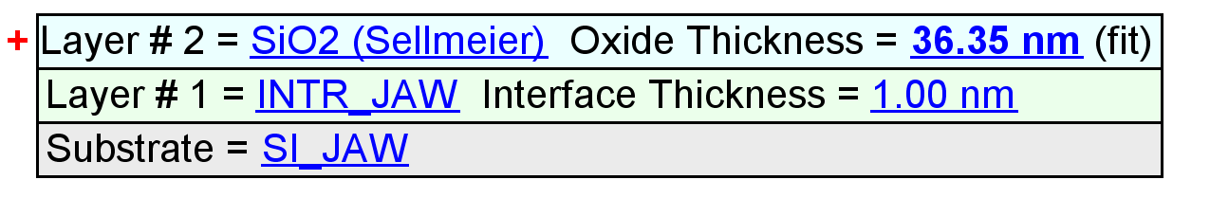
Fit Results
Parameter | Average | Min. | Max. | Std. Dev. | % Range
MSE | 1.209 | 0.951 | 1.529 | 0.195 | 47.854
Oxide Thickness (nm) | 36.42 | 36.12 | 36.69 | 0.18 | 1.5844
Amp. | 1.9588 | 1.4068 | 2.1113 | 0.2668 | 35.9663
Center Wvl. (µm) | 0.0702 | 0.0641 | 0.0788 | 0.0043 | 20.9238
IR Pole Amp. | 0.0240 | 0.0165 | 0.0277 | 0.0034 | 46.6223
Einf | 0.1363 | 0.0000 | 0.7250 | 0.2762 | 531.7513
Angle Offset | 0.1039 | -0.0314 | 0.1618 | 0.0644 | 186.0168
Total Thickness (nm) | 37.42 | 37.12 | 37.69 | 0.18 | 1.5420
n of SiO2 (Sellmeier) @ 632.8 nm | 1.4525 | 1.4474 | 1.4644 | 0.0057 | 1.1716

Model Parameters vs. Position
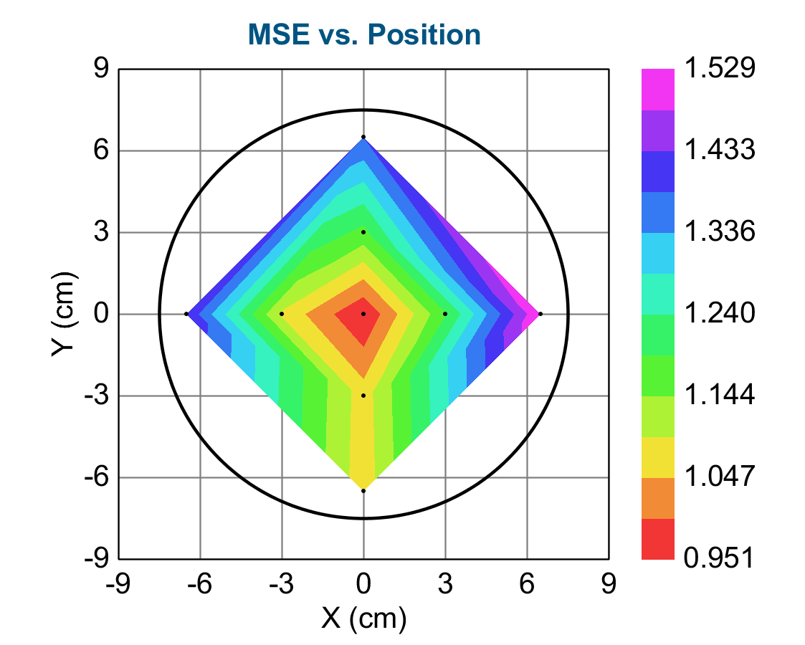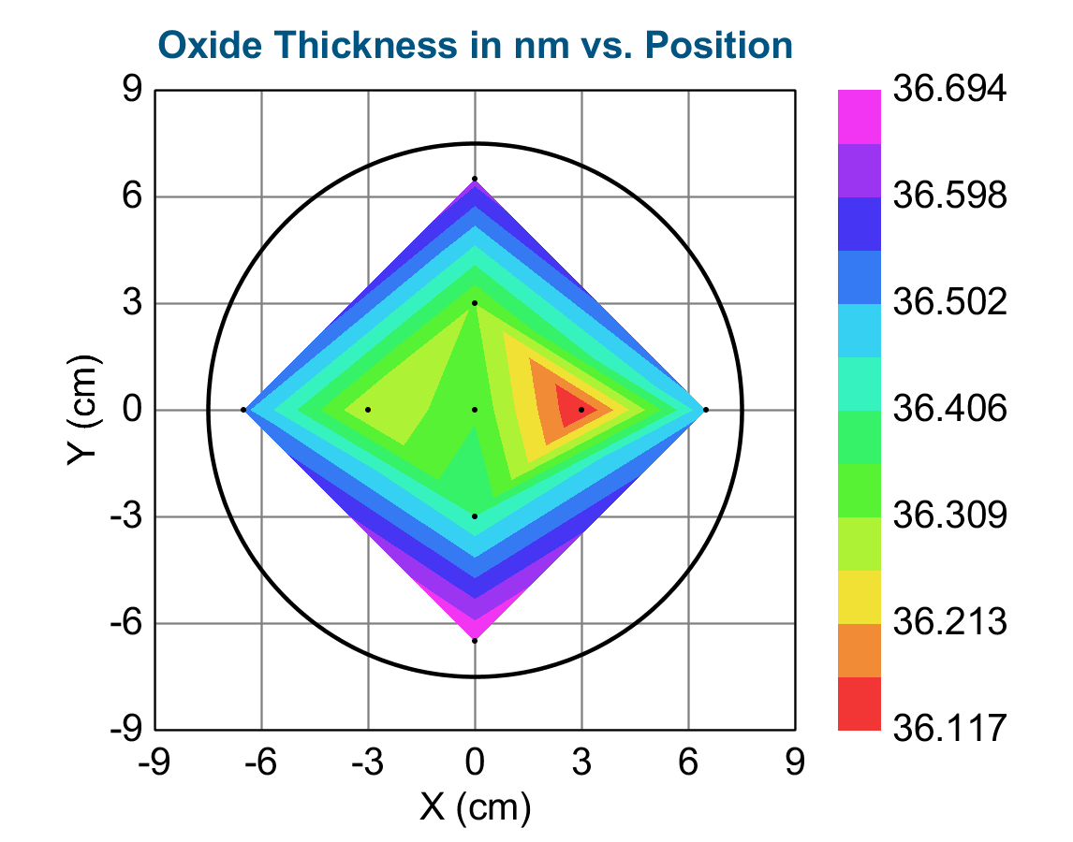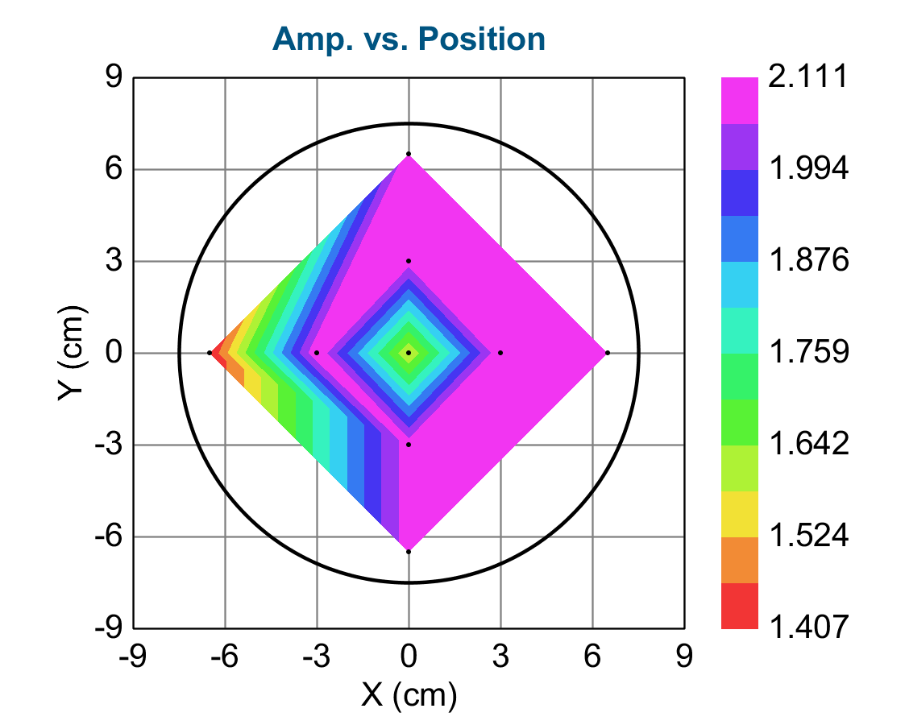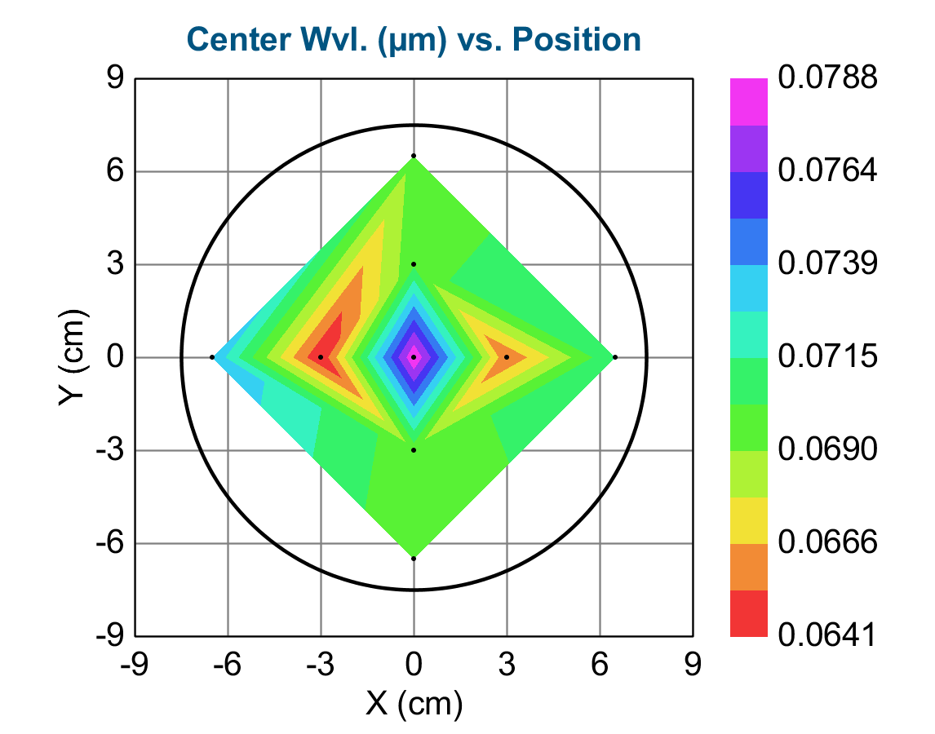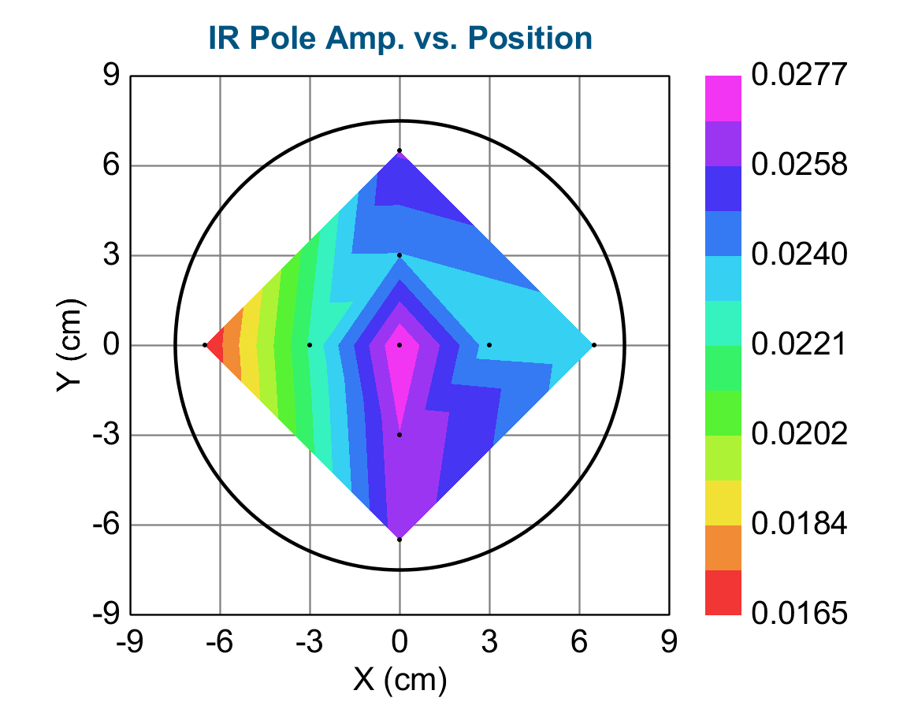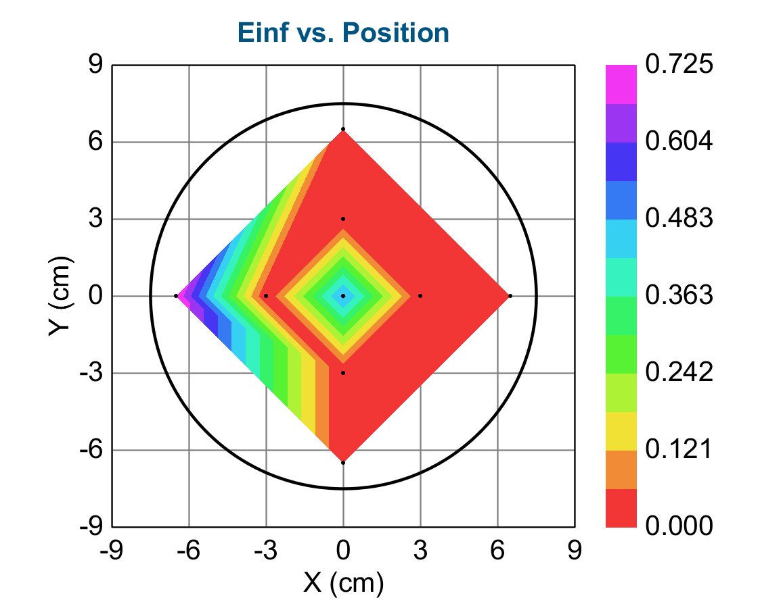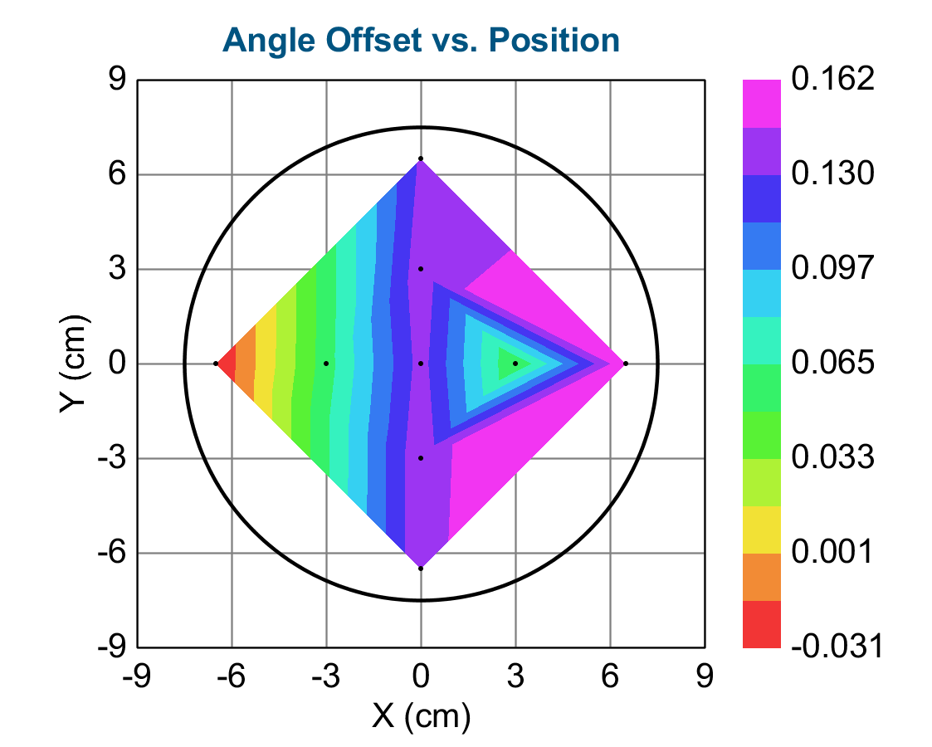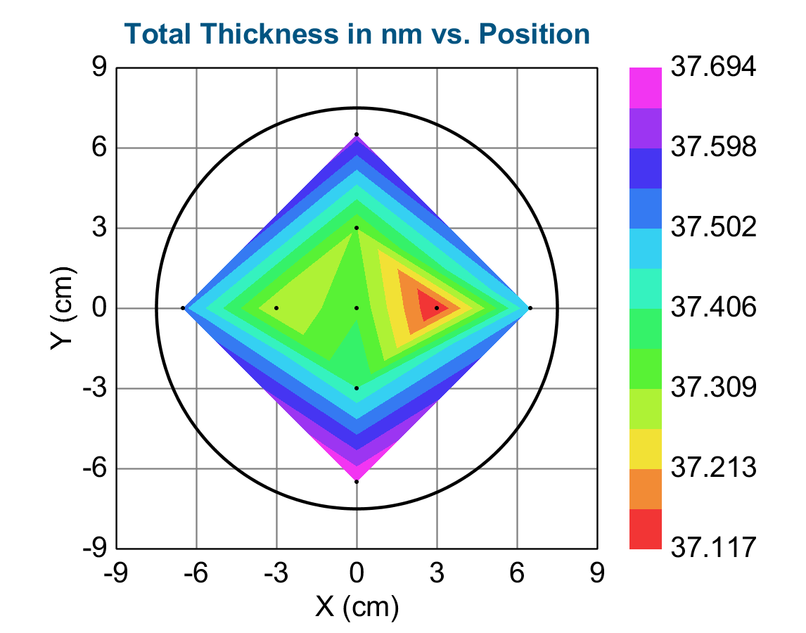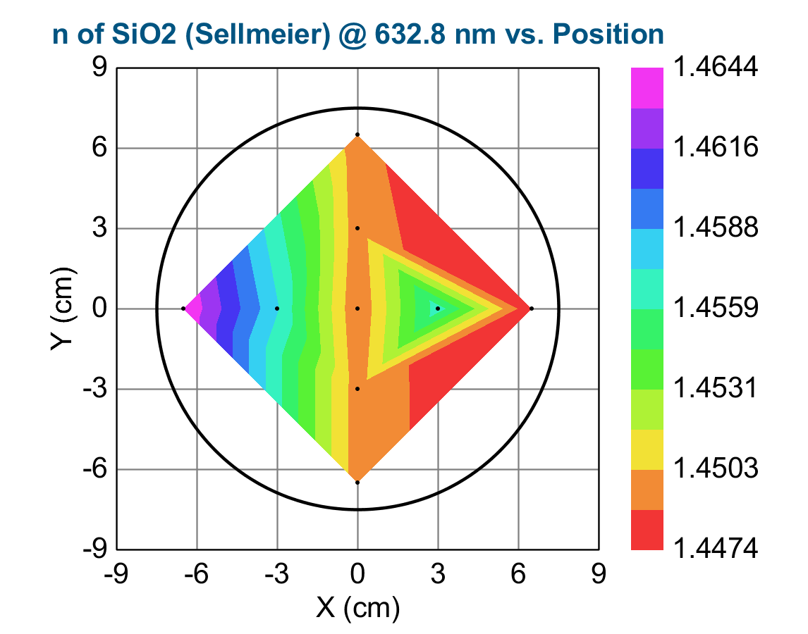
X (cm) Y (cm) MSE Oxide Thickness (nm) Amp. Center Wvl. (µm) IR Pole Amp. Einf Angle Offset Total Thickness (nm) n of SiO2 (Sellmeier) @ 632.8 nm Oxide Thickness (nm) Error Amp. Error Center Wvl. (µm) Error IR Pole Amp. Error Einf Error Angle Offset Error Total Thickness (nm) Error n of SiO2 (Sellmeier) @ 632.8 nm Error
0.00000 0.00000 0.951 36.35 1.583 0.07881 0.02768 0.502 0.137 37.35 1.44889 0.017 1.3036 0.029655 0.003118 1.3064 0.002557 0.017 0.00000
3.00000 0.00000 1.186 36.12 2.109 0.06544 0.02348 2.4376E-07 0.0492 37.12 1.45669 0.021 3.4678 0.050588 0.004015 3.4713 0.003270 0.021 0.00000
-0.00000 -3.00000 1.071 36.41 2.086 0.06947 0.02672 0.00 0.143 37.41 1.44944 0.019 2.4365 0.037852 0.003513 2.4397 0.002881 0.019 0.00000
-3.00000 0.00000 1.086 36.26 2.111 0.06412 0.02220 1.0085E-07 0.0579 37.26 1.45749 0.019 3.4075 0.048777 0.003624 3.4106 0.003008 0.019 0.00000
0.00000 3.00000 1.176 36.31 2.084 0.06998 0.02390 0.00 0.141 37.31 1.44935 0.021 2.6106 0.040840 0.003884 2.6140 0.003165 0.021 0.00000
6.50000 0.00000 1.529 36.49 2.077 0.07150 0.02320 0.00 0.162 37.49 1.44743 0.027 3.0696 0.049079 0.004959 3.0740 0.004091 0.027 0.00000
-0.00000 -6.50000 1.065 36.69 2.086 0.06910 0.02642 1.8012E-07 0.143 37.69 1.44945 0.019 2.4556 0.037968 0.003474 2.4586 0.002872 0.019 0.00000
-6.50000 0.00000 1.427 36.52 1.407 0.07382 0.01649 0.725 -0.0314 37.52 1.46444 0.025 2.6516 0.064266 0.004950 2.6561 0.004076 0.025 0.00000
0.00000 6.50000 1.386 36.62 2.085 0.06947 0.02595 3.7185E-06 0.133 37.62 1.44911 0.025 3.1671 0.049230 0.004536 3.1712 0.003733 0.025 0.00000

