Sample: 2025-08-28-15-32-LOCOS_E3_nitride_wafer14

Optical Model
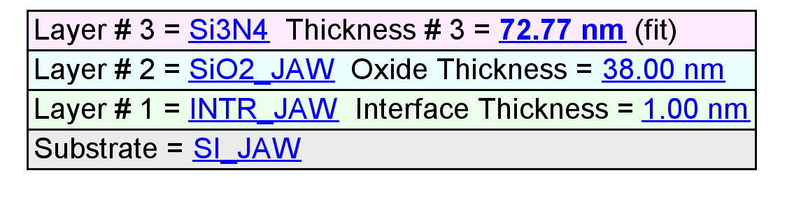
Fit Results
Parameter | Average | Min. | Max. | Std. Dev. | % Range
MSE | 13.663 | 13.021 | 14.487 | 0.364 | 10.727
Thickness # 3 (nm) | 72.52 | 71.45 | 73.66 | 0.69 | 3.0491
Angle Offset | -0.0168 | -0.0782 | 0.0105 | 0.0300 | -528.5991
Total Thickness (nm) | 111.52 | 110.45 | 112.66 | 0.69 | 1.9827
n of SiO2_JAW @ 632.8 nm | 1.4623 | 1.4623 | 1.4623 | 0.0000 | 0.0000

Model Parameters vs. Position
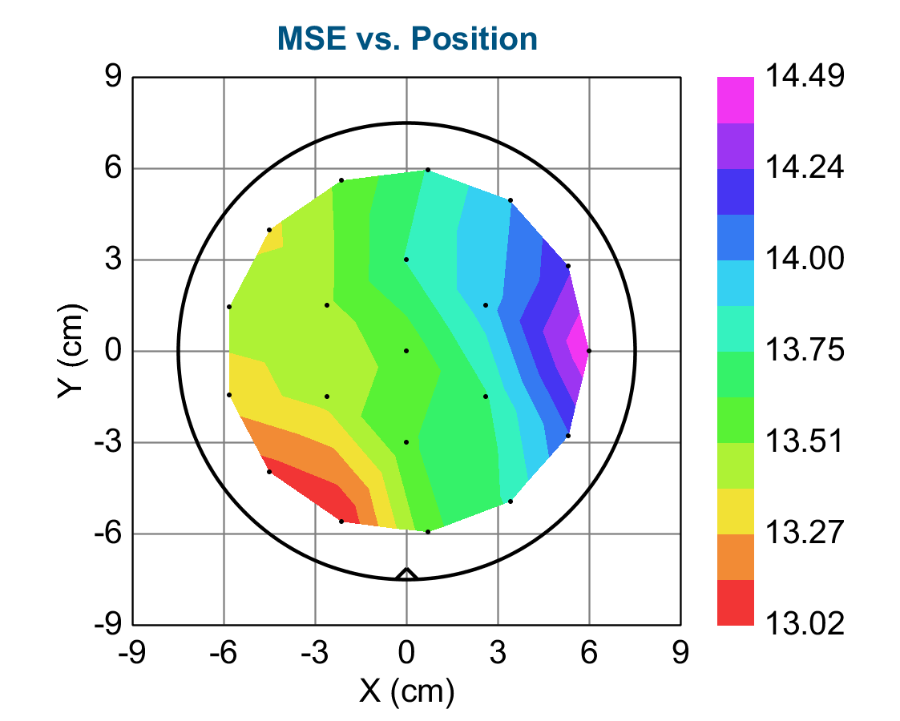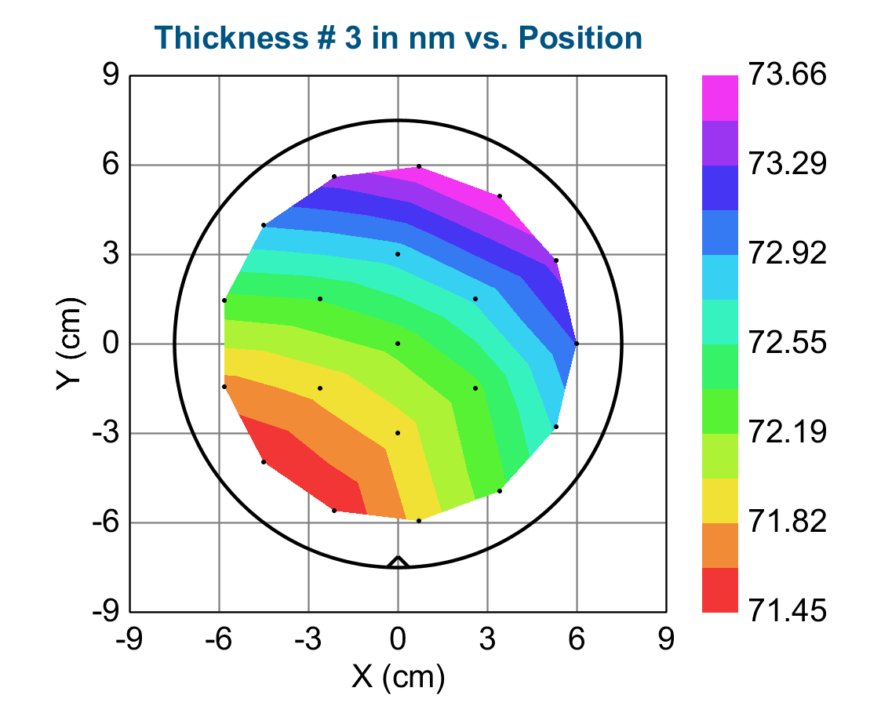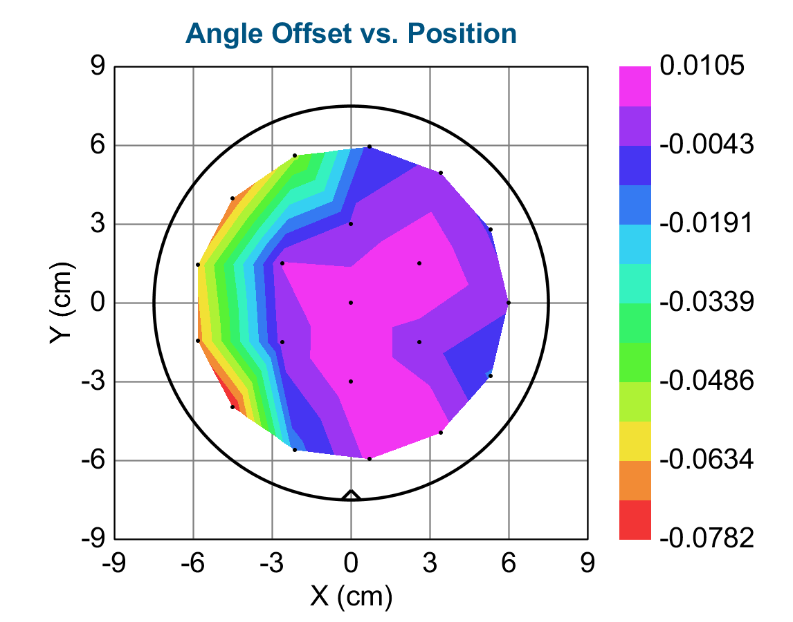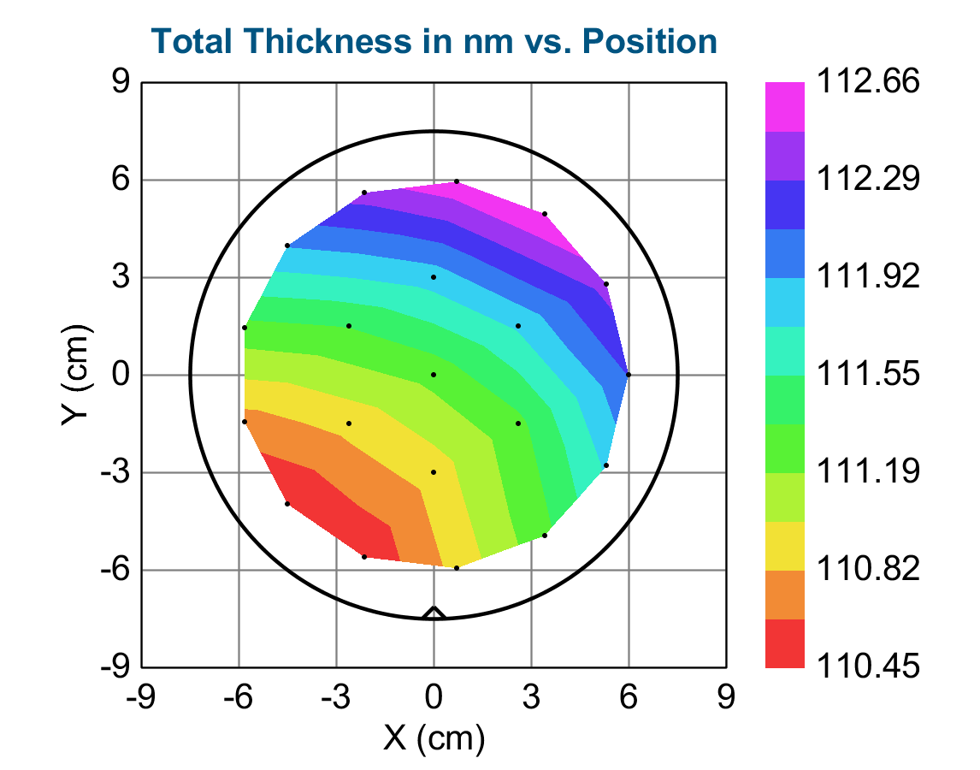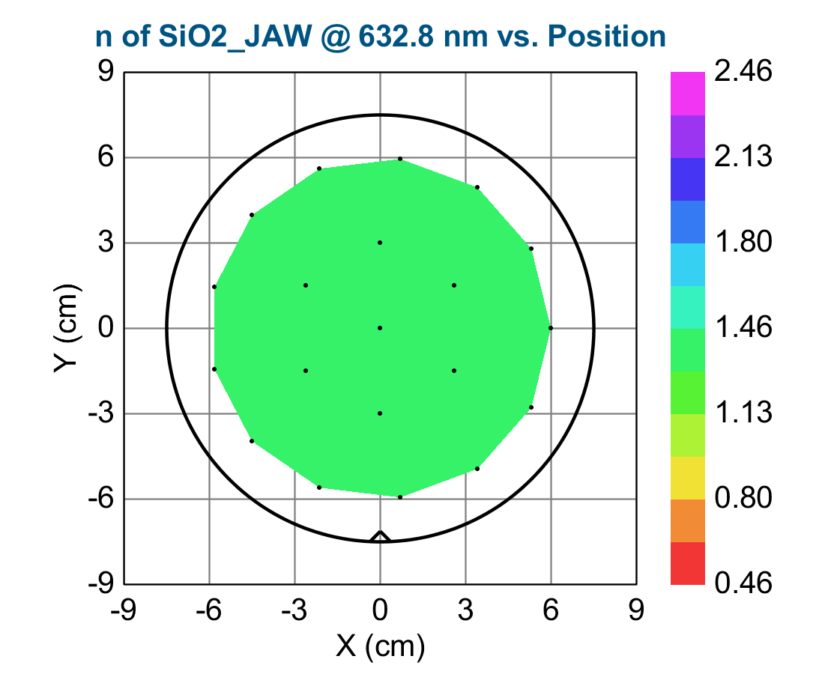
X (cm) Y (cm) MSE Thickness # 3 (nm) Angle Offset Total Thickness (nm) n of SiO2_JAW @ 632.8 nm Thickness # 3 (nm) Error Angle Offset Error Total Thickness (nm) Error n of SiO2_JAW @ 632.8 nm Error
0.00000 0.00000 13.551 72.25 0.00804 111.25 1.46233 0.022 0.0252 0.022 0.00000
2.59808 -1.50000 13.739 72.32 -9.9793E-05 111.32 1.46233 0.023 0.0256 0.023 0.00000
-0.00000 -3.00000 13.613 71.90 0.00814 110.90 1.46233 0.022 0.0253 0.022 0.00000
-2.59808 -1.50000 13.436 71.88 -0.00032006 110.88 1.46233 0.022 0.0249 0.022 0.00000
-2.59808 1.50000 13.488 72.38 0.00333 111.38 1.46233 0.022 0.0251 0.022 0.00000
0.00000 3.00000 13.763 72.83 -0.00284 111.83 1.46233 0.023 0.0257 0.023 0.00000
2.59808 1.50000 13.940 72.77 0.0105 111.77 1.46233 0.023 0.0260 0.023 0.00000
6.00000 0.00000 14.487 73.12 -0.00289 112.12 1.46233 0.024 0.0271 0.024 0.00000
5.31274 2.78834 14.219 73.37 -0.00514 112.37 1.46233 0.024 0.0266 0.024 0.00000
3.40839 4.93790 13.994 73.66 -0.00246 112.66 1.46233 0.024 0.0263 0.024 0.00000
0.72322 5.95625 13.763 73.62 -0.00826 112.62 1.46233 0.023 0.0258 0.023 0.00000
-2.12763 5.61010 13.534 73.38 -0.0512 112.38 1.46233 0.023 0.0254 0.023 0.00000
-4.49106 3.97874 13.359 72.94 -0.0704 111.94 1.46233 0.022 0.0250 0.022 0.00000
-5.82565 1.43589 13.450 72.31 -0.0610 111.31 1.46233 0.022 0.0250 0.022 0.00000
-5.82565 -1.43589 13.330 71.74 -0.0672 110.74 1.46233 0.022 0.0247 0.022 0.00000
-4.49106 -3.97874 13.092 71.45 -0.0782 110.45 1.46233 0.021 0.0242 0.021 0.00000
-2.12763 -5.61010 13.021 71.48 -0.0147 110.48 1.46233 0.021 0.0241 0.021 0.00000
0.72322 -5.95625 13.599 71.88 0.00505 110.88 1.46233 0.022 0.0252 0.022 0.00000
3.40839 -4.93790 13.769 72.31 0.00653 111.31 1.46233 0.023 0.0256 0.023 0.00000
5.31274 -2.78834 14.110 72.77 -0.0127 111.77 1.46233 0.023 0.0263 0.023 0.00000

