Sample: 2025-09-22-15-43-MOSCAP-testwafer-center-13

Fit Results  MSE = 2.126  Roughness = -2.00 ± 0.100 nm  Oxide Thickness = 37.95 ± 0.018 nm  Amp. = 0.474 ± 0.0381  Center Wvl. (µm) = 0.11977 ± 0.002909  IR Pole Amp. = 0.01168 ± 0.001476  Einf = 1.681 ± 0.0407  Angle Offset = 0.00725 ± 0.003993  n of SiO2 (Sellmeier) @ 1550.0 nm = 1.45953 | Optical Model  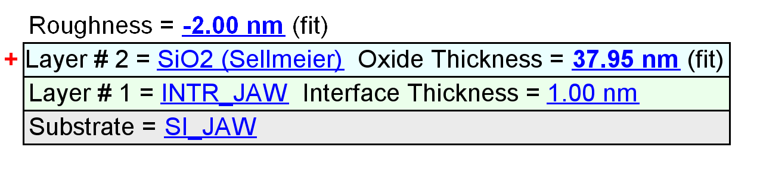

Optical Constants

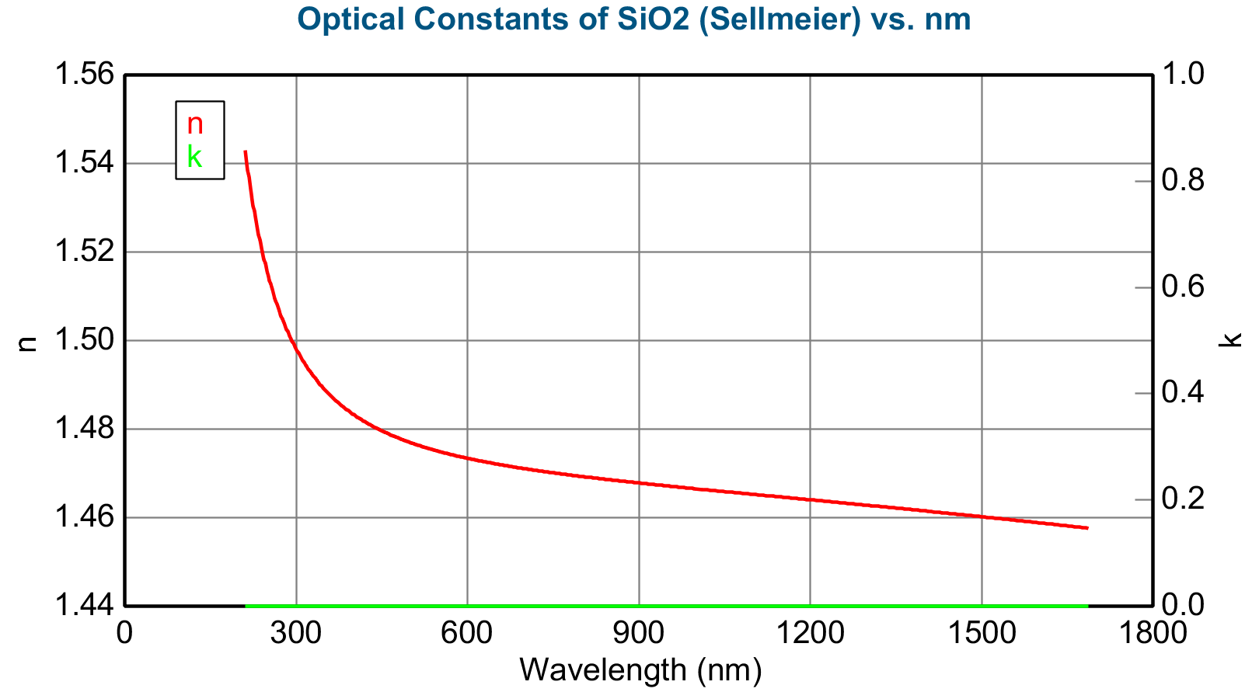

Experimental and Model Generated Data Fits

