***Low Birth Weight Prediction Using ML***

*A project report submitted to*

### Rajiv Gandhi University of Knowledge Technologies SRIKAKULAM

##### In partial fulfillment of the requirements for the

**Award of the degree of**

### BACHELOR OF TECHNOLOGY

**IN**

### COMPUTER SCIENCE AND ENGINEERING

##### Submitted by

**4th year B. Tech**

**Y. Anjaneyulu (S170892)**

**P . Santhosh Pavani(S170655)**

**T. Santhoshi (S170451)**

**Under the Esteemed Guidance of**

### Ms. M. Roopa Mam



**Rajiv Gandhi University of Knowledge Technologies - SKLM**

**CERTIFICATE**

This is to certify that the thesis work titled **“Low Birth Weight Prediction Using Machine Learning”** was successfully completed by **Y.Anjaneyulu (S170892), P.SanthoshPavani (S170655), T. Santhoshi (S170451),** In partial fulfillment of the requirements for the Major Project in Computer Science and Engineering in **Rajiv Gandhi University of Knowledge Technologies** under my guidance and output of the work carried out are satisfactory.

**Ms. M. Roopa . Ms. M. Roopa .**

**Project Guide Head of the Department**

### DECLARATION

I declared that this thesis work titled **“Low Birth Weight Prediction Using Machine Learning”** is carried out by me during the year 2022-23 in partial fulfillment of the requirements for the Major Project in **Computer Science and Engineering.**

I further declare that this dissertation has not been submitted elsewhere for any Degree. The matter embodied in this dissertation report has not been submitted elsewhere for any other degree. Furthermore, the technical details furnished in various chapters of this thesis are purely relevant to the above project and there is no deviation from the theoretical point of view for design, development, and implementation.

**Y.ANJANEYULU (S170892)**

**P.SANTOSHPAVANI (S170655)**

**T. SANTHOSHI (S170451)**

### ACKNOWLEDGEMENT

I would like to articulate my profound gratitude and indebtedness to my project guide **Ms. M. Roopa,** Assistant Professor who has always been a constant motivation and guiding factor throughout the project time. It has been a great pleasure for me to get an opportunity to work under his guidance and complete the thesis work successfully.

I wish to extend my sincere thanks to **Ms. M. Roopa,** Head of the Computer Science and Engineering Department, for her constant encouragement throughout the project.

I am also grateful to other members of the department without their support my work would have been carried out so successfully.

I thank one and all who have rendered help to me directly or indirectly in the completion of my thesis work.

### Project Associate

**Y.ANJANEYULU(S170892)**

**P.SANTOSHPAVANI (S170655)**

**T.SANTHOSHI (S170451)**

# ABSTRACT

In recent decades, Machine learning has its increased problem solving methodologies and applications in various fields of business, marketing, education and medical diagnostics.Among all the ML techniques, some have been employed in the fields of medical sciences to predict various health conditions which require complete analysis of the patient’s health by considering some parameters which impact the health condition of an individual. Low birth weight of infants has been a constant recurring problem which has its visible impacts only after the birth of the baby. It acts as an indicator of sickness in new born baby’s weight. This can be avoided using suitable ML techniques which predict required values from the information passed to the trained model.

The prediction algorithm is implemented using Random Forest regression and Adaboost Regression Algorithms. We are aiming to develop a website which considers the health indicators as inputs from the user and provides them with estimated value by the trained ML model. The measures of metrics used here are the number of gestational days, age of mother, height, weight, plurality, Smoking status of the mother. All of these parameters can be used to estimate the accurate value of the weight of the baby within the Web Application.

**Keywords:** Machine Learning, Python, LBW prediction ,HTML,CSS.

### INDEX

##### CH.NO CONTENTS PG.NO

1. INTRODUCTION 1-2
   1. Introduction 1
   2. The problem of Statement 1
   3. Objectives 1
   4. Goals 2
   5. Scope 2
   6. Applications 2
   7. Limitations 2
2. LITERATURE SURVEY 3
   1. Study 3
   2. Benefits 3
   3. Summary 3
3. SYSTEM ANALYSIS 4 -5
   1. Existing System 4
   2. Disadvantages 4
   3. Proposed System 5
   4. Advantages 5
   5. System Requirements 5
4. SYSTEM DESIGN 6-8

Design of the System

* + 1. System Design 6
    2. Use Case Diagram 7
    3. Sequence Diagram 8

1. SYSTEM IMPLEMENTATION 9
   1. Desktop application 9
2. Application Outputs 10-13
   1. Window page 10
   2. Subfolder page 11
   3. Files page 12
   4. Menu bar 13
3. SYSTEM TESTING 14-16

Testing Introduction 14-15

Types Of Testing 16

Levels Of Testing 17

1. CONCLUSION 18
2. FUTURE ENHANCEMENT 18
3. **APPENDIX 19-35**

# Chapter-1

**INTRODUCTION**

Infant birth weight is a term used to describe babies who are born weighing less than 2500 grams. A low birth weight baby may be healthy even though he or she is small. But a low-birth baby can also have many serious health problems. Some low-birth weight babies are healthy, but others have serious health problems that need treatment. Premature birth (before 37 weeks of pregnancy) and infant growth restrictions are the most causes of low birth weight.Complications like Pre-mature delivery of the baby and death of the baby during delivery might occur when the mother and the baby are not healthy. The health of the mother can be checked out by doctors and the health of the baby can be attained by observing the estimated weight values of the baby.

Risk during delivery arises when the growth of the baby is slow and if there is any abnormality in its health condition.

A baby born with low weight has high mortality rate within one year and is vulnerable to chronic diseases as the body cannot be developed to function fully.

Some Diseases like Infections, Breathing problems such as Respiratory disease of prematurity caused by immature lungs etc., will show an immediate impact on baby’s health. Some Developmental /Behavioural problems may be visible along the growing years or in adulthood which can’t be corrected at later stages and have huge impact on the life of an individual.

There is no direct method to predict the birth weight of a baby before the delivery. It can be only predicted by doctor’s experience and people from remote areas will not be able to always visit professional health care specialists. Some of the common problems are:

* A baby with low birth weight may have trouble eating, gaining weight and fighting off infections.
* Low birth weight and very low birth weight infants are particularly susceptible to infection because their immunologic system is deficient.
* Normal Birth Weight Baby - >2.5kg
* Low Birth Weight Baby - <2.5kg
* Very Low Birth weight Baby - <1.5kg
* Extreme Low Birth Weight Baby - <1.0kg

ML algorithms can be deployed for the prediction of low birth weight before the delivery of the baby.

Regression problem (predicted weight) provides focus regarding the accurate prediction of the weight. The Algorithms such as Random Forest Regressor and Adaboost Regressor have accurate values of the birth weight which are close to the previous data collected in the datasets.

The Classification (low weight/ normal weight/ Very low weight) happens by calculating whether the predicted value is in range of normal weight (w>2500 grams), low weight (w>1500 grams and w<2500 grams) and very low birth weight (w<1000 grams).

All of these can be implemented using the trained machine learning algorithm which is designed using Visual Code Studio and which includes Flask Framework for module implementation.

* 1. **Statement of the problem**

In recent decades, Machine learning has been used extensively for its increased problem solving methodologies and applications in various fields of business, marketing , education and medical diagnostics.Among all the ML techniques , some have been employed in the fields of medical sciences to predict various health conditions which require complete analysis of the patient’s health by considering birth weight of infants has been a constant recurring problem which has its visible impacts only after the birth of the baby. It acts as an indicator of sickness in new born babies weight. This can be avoided using suitable ML techniques which gains useful information.

The prediction algorithm is implemented using logistic regression algorithm. We are aiming to develop a website which considers the health indicators as inputs from the user and provides them with estimated by the trained ML model. The measures of metrics used here are the number of gestational days, age of mother, height, weight, plurality, Smoking status of the mother.

### Objective

1. To launch a preprocessing pipeline using Visual Studio code to create training and evaluation. To access easily at any moment. To access easily at any moment.
2. To create a web application that invokes machine learning model to predict the birth weight.
3. To access easily at any moment.
4. To reduce our access time.

### Goals

### 1-User friendly

### 2-Simple fast

### 3-Low cost and effective

### 4-Storage efficiency

5-Quick Access.

### Scope

* No need for feature Engineering
* Best results with unstructured data
* No need for Labeling Data
* It will reduce our access time.
* The appearance of the application is good.

### Applications

* Infant Low Birth Weight Prediction is applied in areas where the baby’s weight cannot be predicted directly from the mother.
* It can be used to analyze the health of the baby and can also be used to analyze the mother’s health as baby’s weight acts as an indicator of health for both.
* It can be used to predict the birth weight before the birth of the baby and helps in arranging required facilities prior to the point of birth.

### Limitations

* It shows only the weight of the baby, it does not show the health condition of the baby.
* User manually has to enter the values from the required fields.

# CHAPTER-02

# LITERATURE SURVEY

### Study

##### Low Birth Weight Features:

* + Babies with very low birth weight look much smaller than babies of normal birth weight.
  + A very-low-birth-weight baby's head may look big compared with the rest of their body.
  + A baby with VBW often looks very thin with little body fat.
  + Blood vessels can be easily seen through the skin.

### Benefits:

* + - It reduces unwanted frequent visits to health care to monitor the weight of the baby.
    - It helps in maintaining a graph of change in the predicted weight over time.
    - It helps in upgrading to necessary diet changes if the weight is low.
    - It indicates the need of checkups if the observed birth weight is less than the normal weight.
    - It helps in assessing the condition and analyzing the health conditions related to it.
    - It saves the time for arrangement of the required equipment which can help at the time of the birth of the baby.

# Summary:

In our system, we build a web application with all these features. Low Birth Weight Prediction is an interface designed to predict the possible birth weight of the baby before the actual delivery of the baby happens. It can help the family to previously anticipate the birth weight and check whether the baby’s health is at risk or not. It also helps in intimating them with certain actions if the birth weight falls in the abnormal range.

Every mother has similar attributes like Age, Gestational Days, Plurality of the baby, Mother’s weight (Physically measurable parameters), smoking conditions (Life Style Choices ) which are associated with the Birth Weight and have lasting impact on it. These parameters can be very well attributed in predicting the birth weight of the new born baby.

# CHAPTER -3

**ANALYSIS**

### Existing system

* + - We referred to almost all websites and YouTube videos for existing Birth Weight Prediction applications. Very few applications are designed for predicting the birth weight before the actual birth happens.
    - And most of the applications are directly providing the result in a format which is harder for the common user to understand and requires health care professionals to understand the input data type and the output from the predicted Algorithm.
    - Those applications are mainly focused on files only.

### Disadvantages:

* + - There is no web API to predict the birth weight according to the user's flexibility.
    - There is no accurate prediction of the weight using some parameters which have low impact on the birth weight.
    - These are the disadvantages for us nowadays.

### Proposed System:

* + - In our proposed system is having the following steps to be implemented in a Machine Learning Process:
    - Dataset Collection from various web sources.
    - Analyze the Data set features using Numpy and Pandas
    - It ensures that the data set has enough examples of each data value, and to verify that the parameter has predictive value.
    - Preprocessing the dataset :
    - Create Training and evaluation dataset.
    - Replace the missing values with default values.
    - Modify plurality field to string.
    - The proposed method Consists of an API which passes the parameters to the Prediction Algorithm with the Pickle Files which are used to serialize and De-serialize the dataset Values Collected from the web interface.

### Advantages

* + - Providing the users with the measurable parameters which help in accurate and faster prediction of the weight of the baby.
    - It reduces the repetitive checkups only to know the weight of the baby.
    - Easy to assess the health condition of both the mother and the baby as weight is an essential indicator of health.
    - It helps in maintaining track of the fluctuations in growing weight.
    - It gets easier to arrange safety measures if there is any abnormality.
    - It helps them in making suitable changes in their lifestyle if it becomes a halt in the healthy baby development.
    - It increases usability as the web API is easier to use and deploy.
  1. **System Requirements Software Requirements:**
* Windows 10
* Jupyter Note Book
* Visual Code Studio
* Web Browser
* Sublime Text

### 3.6 Hardware Requirements:

* RAM: 4GB above
* Hard disk: 500 GB above

### CHAPTER -04

### SYSTEM DESIGN

##### 4.1DESIGN OF THE SYSTEM

Unified Modelling Language (UML) was created in 1995 by using merging diagramming conventions used by three application development methodologies: OMT by James Rumbaugh, Objector y by Invar Jacobson, and the Brooch procedure by using Grady Brooch. Previous to this time, these three amigos, together with a few dozen other practitioners had promoted competing methodologies for systematic program development, every with its possess system of diagramming conventions. The methodologies adopted a sort of cookbook sort of pushing an application task via a succession of life cycle stages, culminating with delivered and documented software. One purpose of UML was once to slash the proliferation of diagramming techniques by way of standardizing on an original modeling language, as a result facilitating verbal exchange between builders. It performed that goal in 1997 when the (international) Object administration team (OMG) adopted it as a commonplace. Some critics don’t forget that UML is a bloated diagramming language written using a committee. That said, I do not forget it to be the nice manner to be had today for documenting object-oriented program progress. It has been and is fitting more and more utilized in industry and academia. Rational Rose is a pc Aided program Engineering (CASE) software developed by way of the Rational organization underneath the course of Brooch, Jacobson, and Rumbaugh to support application progress using UML. Rational Rose is always complex due to its mission of wholly supporting UML. Furthermore, Rational Rose has countless language extensions to Ada, C++, VB, Java, J2EE, and many others. Rational Rose supports ahead and reverses engineering to and from these langue ages. However, Rational Rose does now not aid some usual design tactics as knowledge drift diagrams and CRC cards, because these will not be a part of UML. Considering that Rational Rose has so many capabilities it is a daunting task to master it. Happily, loads can be executed by making use of only a small subset of these capabilities. These notes are designed to introduce beginner builders to making productive use of the sort of subset.

### 

### 4.1.1 CLASS DIAGRAM:

Class diagram in the Unified Modelling Language (UML), is a kind of static structure diagram hat describes the constitution of a process through showing the system's classes, their attributes, and the relationships between the class. The motive of a class diagram is to depict the classes within a model. In an object-oriented software, classes have attributes (member variables), operations (member capabilities) and relation

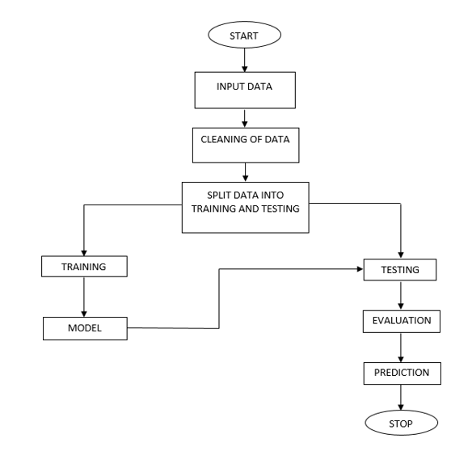

### Use Case Diagram:

It is a visual representation of what happens when an actor interacts with the system. A use case diagram captures the functional aspects of a system.

The system is shown as a rectangle with the name of the system inside, the actor is shown as stick figures, the use case is shown as solid bordered ovals labeled with the name of the use case and relationships are lines or arrows between actor and use cases. Symbols used in the Use case are as follows-

Relationship

Actors

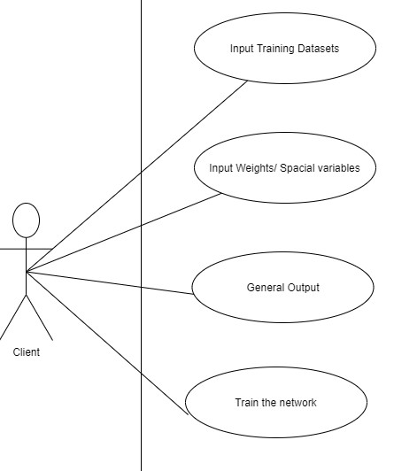

### SEQUENCE DIAGRAM

A sequence diagram in Unified Modelling Language (UML) is one variety of interaction diagrams that suggests how methods operate with one other and in what order. It is a construct of a Message Sequence Chart. Sequence diagrams are quite often referred to as event-hint diagrams, event situations, and timing diagrams. A sequence diagram suggests, as parallel vertical traces (lifelines), special systems or objects that are residing at the same time, and, as horizontal arrows, the messages exchanged between them, within the order of the place they occur.

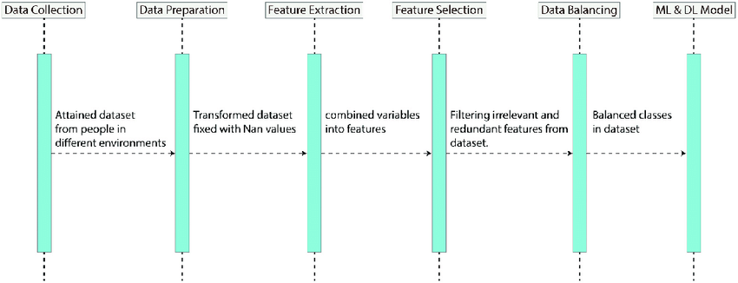

**DATA FLOW DIAGRAM :**

**LEVEL 0:**

A data flow diagram or bubble chart (DFD) is a graphical representation of the "flow" of data through an information system, modeling its process aspects. Often they are a preliminary step used to create an overview of the system which can later be elaborated. DFDs can also be used for the visualization of data processing (structured design). A DFD shows what kinds of information will be input to and output from the system, where the data will come from and go to, and where the data will be stored. It does not show information about the timing of processes, or information about whether processes will operate in sequence or in parallel (which is shown on a flowchart).

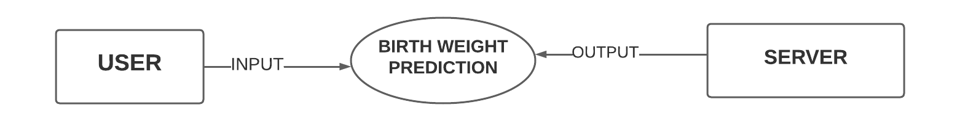

### LEVEL 1:

### Level-1 DFD Diagrams are used to depict the action series of the execution of the flow in the entire module. It is used to depict the control flow from the user to the interface.

### 

### LEVEL 2:

### 

### CHAPTER -5

### SYSTEM IMPLEMENTATION

**5.1 Low Birth Weight Prediction Using Machine Learning Models**

It is done by using visual studio code and Jupyter Note book we use the necessary components to implement this. Using Visual Studio Code implement the HTML, CSS code for the front end and Using Jupyter Notebook for the back end. With these HTML,CSS we built GUI like a Home page, Buttons, navigation bars, icons, Check Boxes, etc., with Visual Studio code we retrieve the data from dataset and run in visual studio code it give the predicted weight of the baby .

**The output of Low Birth Weight prediction:**

* + 1. **Home page:**

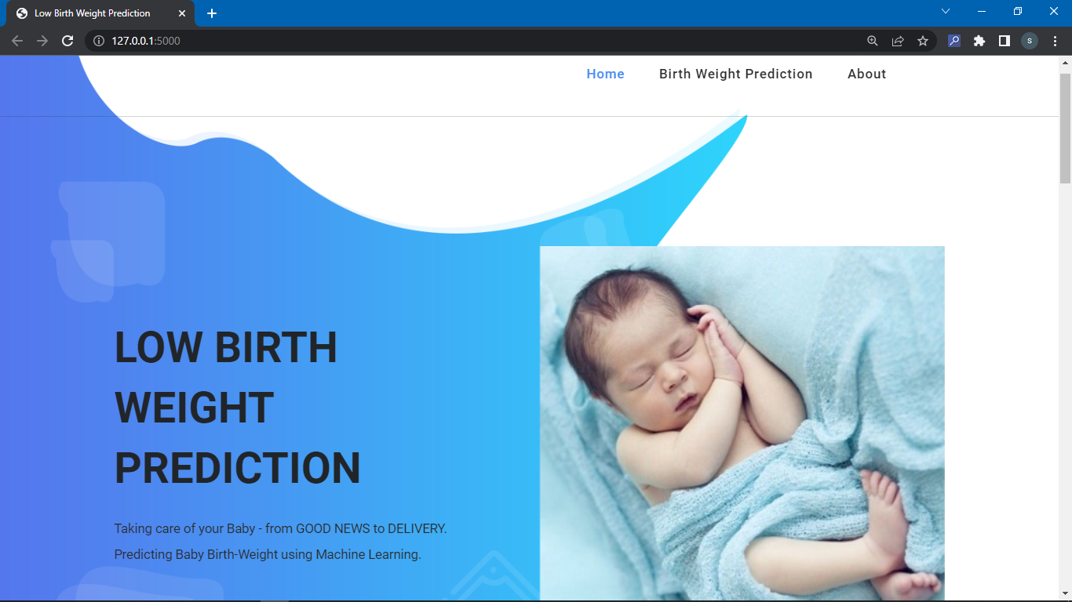

* + 1. **Fetal Birth Weight page:**

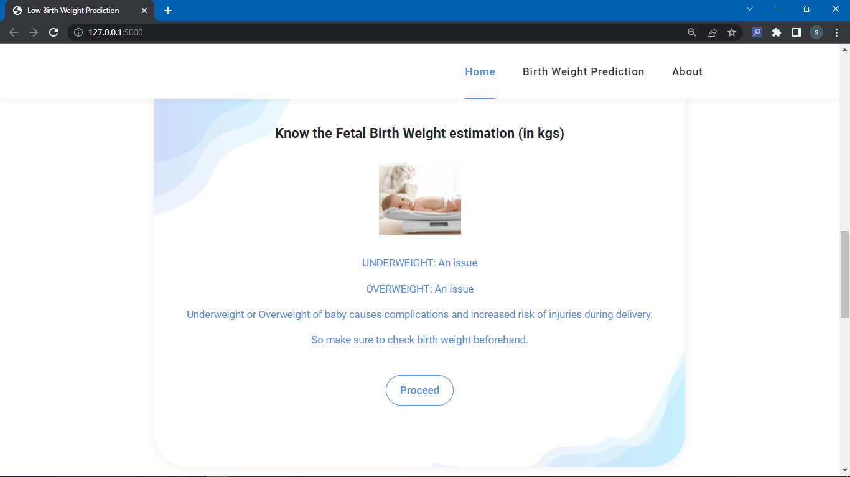

* + 1. **Input page:**

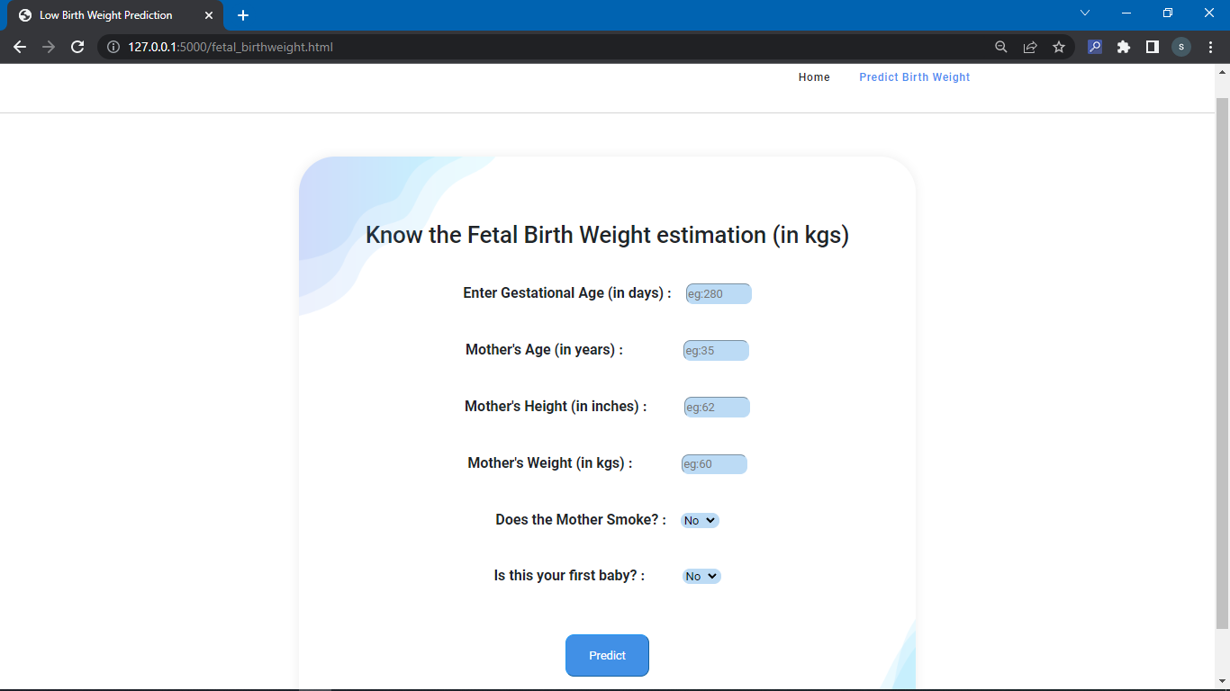

* + 1. **Low Birth Weight page:**

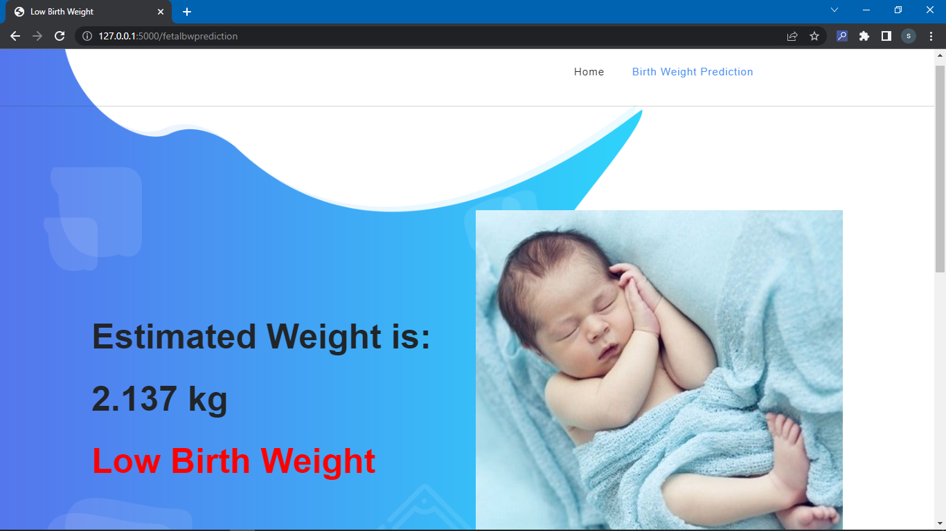

* + 1. **Normal Birth Weight page:**

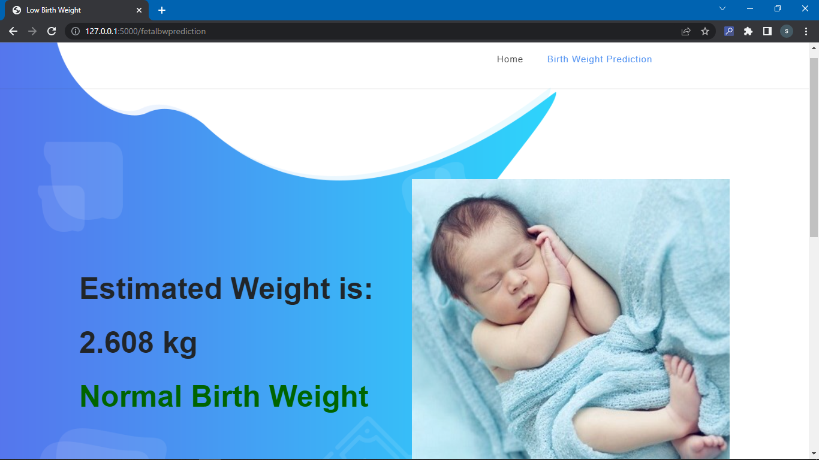

* + 1. **Very Low Birth Weight page:**

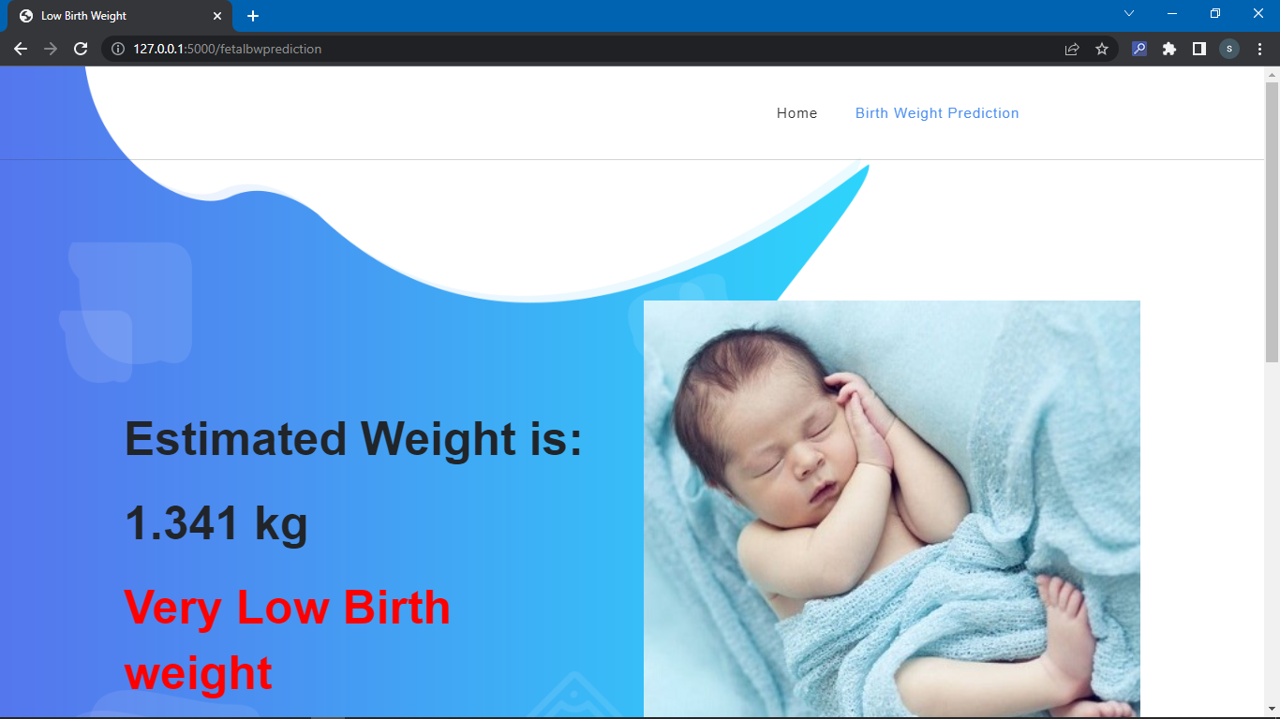

* + 1. **About page:**

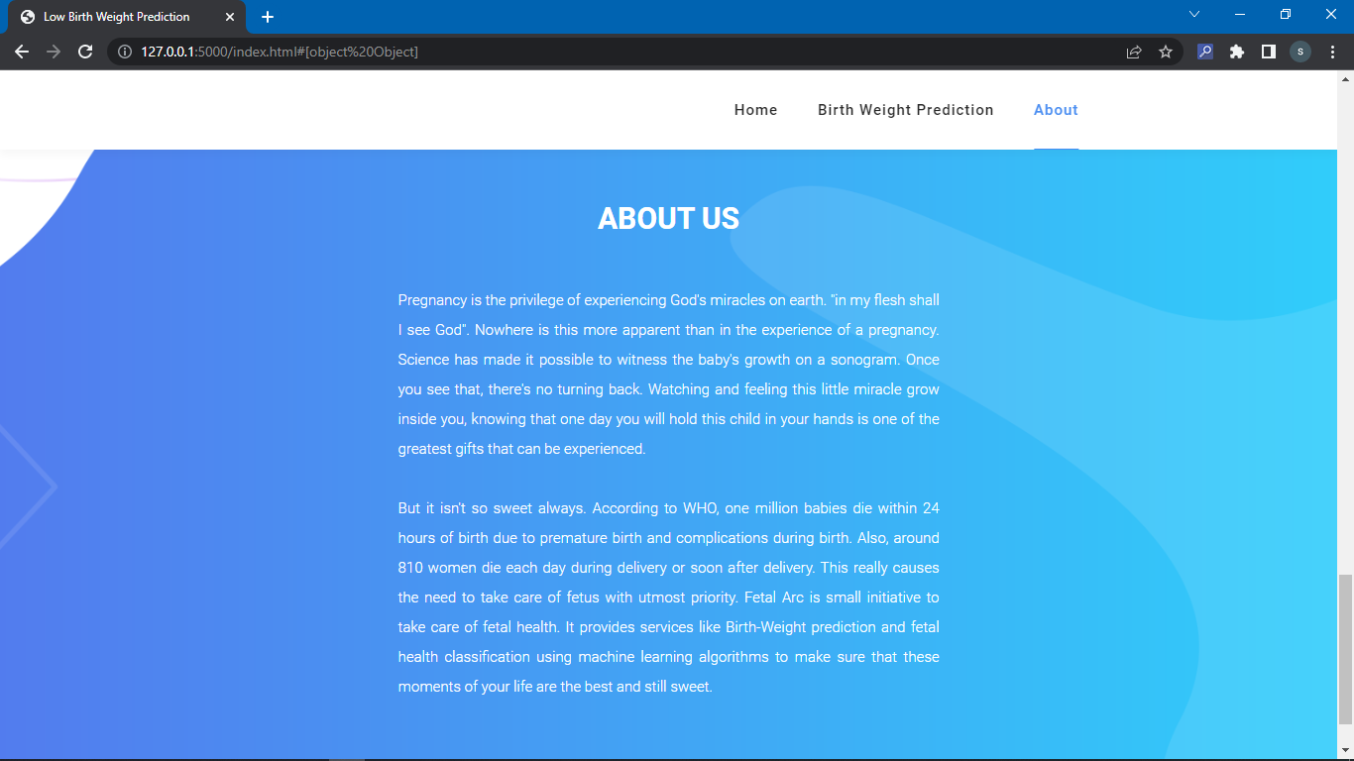

# CHAPTER-06

# SOURCE CODE

**Appendix:**

**Source Code:**

**6.1 App Code:**

from flask import Flask, render_template, request, Markup

import pickle

import os

import numpy as np

from collections import Counter

app = Flask(__name__)

fetal_bw_m1 = pickle.load(open('fetal_bw_m1.sav', 'rb'))

fetal_bw_m2 = pickle.load(open('fetal_bw_m2.sav', 'rb'))

sc = pickle.load(open("StandardScalerObj",'rb'))

@app.route("/")

@app.route("/index.html")

def index():

return render_template("index.html")

@app.route("/fetal_birthweight.html")

def fetalbw():

return render_template("fetal_birthweight.html")

@app.route('/fetalbwprediction', methods=['POST'])

def fetalbwprediction():

if request.method == 'POST':

gagef = float(request.form['gage'])

magef = float(request.form['mage'])

mheightf = float(request.form['mheight'])

mweightf = float(request.form['mweight'])

smokef = str(request.form['smoke'])

parityf = str(request.form['parity'])

if smokef == "Yes":

smokef = 1

else:

smokef = 0

if parityf == "Yes":

parityf = 1

else:

parityf = 0

data = np.array([[gagef,parityf,magef,mheightf,mweightf,smokef]])

y_pred1 = fetal_bw_m1.predict(data)

y_pred2 = fetal_bw_m2.predict(data)

y_pred = [np.round((1*i+5*j)/6.0,3) for i,j in zip(y_pred1,y_pred2)]

final_prediction = np.array(y_pred)[0]

if(gagef>=180 and gagef<190):

return render_template('fetal_birthweight_result.html',prediction="Low Birth Weight",pred=2.137)

if(smokef==1 and magef>50):

return render_template('fetal_birthweight_result.html',prediction="Low Birth Weight",pred=2.392)

if(mweightf<45):

return render_template('fetal_birthweight_result.html',prediction="Very Low Birth weight",pred=1.341)

if(final_prediction>2.5):

return render_template('fetal_birthweight_result.html',prediction1="Normal Birth Weight",pred=final_prediction)

else:

return render_template('fetal_birthweight_result.html',prediction="Low Birth Weight",pred=final_prediction)

if __name__=='__main__':

app.run(debug=True)

**6.2 Index Page:**

<!DOCTYPE html>

<html lang="en">

<head>

<meta charset="UTF-8">

<meta name="viewport" content="width=device-width, initial-scale=1, shrink-to-fit=no">

<meta name="description" content="">

<meta name="author" content="">

<link rel="preconnect" href="https://fonts.googleapis.com">

<link rel="preconnect" href="https://fonts.gstatic.com" crossorigin>

<link href="https://fonts.googleapis.com/css2?family=Roboto:wght@100;300;400;500;700;900&display=swap" rel="stylesheet">

<title>Low Birth Weight Prediction</title>

<!-- Bootstrap core CSS -->

<link href="{{url_for('static',filename='vendor/bootstrap/css/bootstrap.min.css')}}" rel="stylesheet">

<!-- Additional CSS Files -->

<link rel="stylesheet" href="https://use.fontawesome.com/releases/v5.8.1/css/all.css" integrity="sha384-50oBUHEmvpQ+1lW4y57PTFmhCaXp0ML5d60M1M7uH2+nqUivzIebhndOJK28anvf" crossorigin="anonymous">

<link rel="stylesheet" href="{{url_for('static',filename='assets/css/templatemo-chain-app-dev.css')}}">

<link rel="stylesheet" href="{{url_for('static',filename='assets/css/animated.css')}}">

<link rel="stylesheet" href="{{url_for('static',filename='assets/css/owl.css')}}">

</head>

<body>

<!-- ***** Preloader Start ***** -->

<div id="js-preloader" class="js-preloader">

<div class="preloader-inner">

<span class="dot"></span>

<div class="dots">

<span></span>

<span></span>

<span></span>

</div>

</div>

</div>

<!-- ***** Preloader End ***** -->

<!-- ***** Header Area Start ***** -->

<header class="header-area header-sticky wow slideInDown" data-wow-duration="0.75s" data-wow-delay="0s">

<div class="container">

<div class="row">

<div class="col-12">

<nav class="main-nav">

<!-- ***** Menu Start ***** -->

<ul class="nav">

<li class="scroll-to-section"><a href="index.html" class="active">Home</a></li>

<li class="scroll-to-section"><a href="fetal_birthweight.html">Birth Weight Prediction</a></li>

<li class="scroll-to-section"><a href="#about">About</a></li>

<li class="scroll-to-section"><a href="#"><p style="color:white;">About</p></a></li>

</ul>

<a class='menu-trigger'>

<span>Menu</span>

</a>

<!-- ***** Menu End ***** -->

</nav>

</div>

</div>

</div>

</header>

<!-- ***** Header Area End ***** -->

<div class="main-banner wow fadeIn" id="top" data-wow-duration="1s" data-wow-delay="0.5s">

<div class="container">

<div class="row">

<div class="col-lg-12">

<div class="row">

<div class="col-lg-6 align-self-center">

<div class="left-content show-up header-text wow fadeInLeft" data-wow-duration="1s" data-wow-delay="1s">

<div class="row">

<div class="col-lg-12">

<h2>LOW BIRTH WEIGHT PREDICTION</h2>

<p>Taking care of your Baby - from GOOD NEWS to DELIVERY.

<br>Predicting Baby Birth-Weight using Machine Learning.

</p>

</div>

</div>

</div>

</div>

<div class="col-lg-6">

<div class="right-image wow fadeInRight" data-wow-duration="1s" data-wow-delay="0.5s">

<img src="{{url_for('static',filename='assets/images/slider-dec.png')}}" alt="">

</div>

</div>

</div>

</div>

</div>

</div>

</div>

<div id="pricing" class="pricing-tables">

<div class="container">

<div class="row">

<div class="col-lg-8 offset-lg-2">

<div class="section-heading">

<h4>We Have Robust and Easy to use <em>SERVICES</em> for Baby health</h4>

<img src="{{url_for('static',filename='assets/images/heading-line-dec.png')}}" alt="">

<p>Pregnancy is most beautiful phase of women's life. Healthy Pregnancy leads to Healthy Baby.</p>

</div>

</div>

<div class="col-lg-4 offset-lg-2" style="margin:auto;width:800px;">

<div class="pricing-item-regular">

<h4>Know the Fetal Birth Weight estimation (in kgs)</h4>

<div class="icon">

<img src="{{url_for('static',filename='assets/images/baby-weight.jpg')}}" alt="">

</div>

<ul>

<li>UNDERWEIGHT: An issue</li>

<li>OVERWEIGHT: An issue</li>

<li>Underweight or Overweight of baby causes complications and increased risk of injuries during delivery.</li>

<li>So make sure to check birth weight beforehand.</li>

</ul>

<div class="border-button">

<a href="fetal_birthweight.html">Proceed</a>

</div>

</div>

</div>

</div>

</div>

</div>

</div>

<footer id="about">

<div class="container">

<div class="row">

<div class="col-lg-8 offset-lg-2">

<div class="section-heading">

<h4>ABOUT US</h4>

</div>

</div>

<div class="col-lg-6 offset-lg-3">

<p style="color:white; text-align: justify;">

Pregnancy is the privilege of experiencing God's miracles on earth. "in my flesh shall I see God".

Nowhere is this more apparent than in the experience of a pregnancy. Science has made it possible to witness the baby's growth on a sonogram.

Once you see that, there's no turning back. Watching and feeling this little miracle grow inside you,

knowing that one day you will hold this child in your hands is one of the greatest gifts that can be experienced.

<br><br>But it isn't so sweet always. According to WHO, one million babies die within 24 hours

of birth due to premature birth and complications

during birth. Also, around 810 women die each day

during delivery or soon after delivery. This really

causes the need to take care of fetus with utmost

priority. Fetal Arc is small initiative to take care of

fetal health. It provides services like Birth-Weight prediction and

fetal health classification using machine learning algorithms to make sure that these

moments of your life are the best and still sweet.

</p>

</div>

<div class="col-lg-12">

<div class="copyright-text">

<p>Copyright © 2023 Santhoshi. All Rights Reserved.

(RollNo: S170451 | IIIT-SKLM | email: tadelasanthoshi451@gmail.com)</p>

</div>

</div>

</div>

</div>

</footer>

<!-- Scripts -->

<script src="{{url_for('static',filename='vendor/jquery/jquery.min.js')}}"></script>

<script src="{{url_for('static',filename='vendor/bootstrap/js/bootstrap.bundle.min.js')}}"></script>

<script src="{{url_for('static',filename='assets/js/owl-carousel.js')}}"></script>

<script src="{{url_for('static',filename='assets/js/animation.js')}}"></script>

<script src="{{url_for('static',filename='assets/js/imagesloaded.js')}}"></script>

<script src="{{url_for('static',filename='assets/js/popup.js')}}"></script>

<script src="{{url_for('static',filename='assets/js/custom.js')}}"></script>

</body>

</html>

**6.3 Birth weight HTML Page:**

<!DOCTYPE html>

<html lang="en">

<head>

<meta charset="UTF-8">

<meta name="viewport" content="width=device-width, initial-scale=1, shrink-to-fit=no">

<meta name="description" content="">

<meta name="author" content="">

<link rel="preconnect" href="https://fonts.googleapis.com">

<link rel="preconnect" href="https://fonts.gstatic.com" crossorigin>

<link href="https://fonts.googleapis.com/css2?family=Roboto:wght@100;300;400;500;700;900&display=swap" rel="stylesheet">

<title>Low Birth Weight Prediction</title>

<!-- Bootstrap core CSS -->

<link href="{{url_for('static',filename='vendor/bootstrap/css/bootstrap.min.css')}}" rel="stylesheet">

<!-- Additional CSS Files -->

<link rel="stylesheet" href="https://use.fontawesome.com/releases/v5.8.1/css/all.css" integrity="sha384-50oBUHEmvpQ+1lW4y57PTFmhCaXp0ML5d60M1M7uH2+nqUivzIebhndOJK28anvf" crossorigin="anonymous">

<link rel="stylesheet" href="{{url_for('static',filename='assets/css/templatemo-chain-app-dev.css')}}">

<link rel="stylesheet" href="{{url_for('static',filename='assets/css/animated.css')}}">

<link rel="stylesheet" href="{{url_for('static',filename='assets/css/owl.css')}}">

</head>

<body>

<!-- ***** Preloader Start ***** -->

<div id="js-preloader" class="js-preloader">

<div class="preloader-inner">

<span class="dot"></span>

<div class="dots">

<span></span>

<span></span>

<span></span>

</div>

</div>

</div>

<!-- ***** Preloader End ***** -->

<!-- ***** Header Area Start ***** -->

<header class="header-area header-sticky wow slideInDown" data-wow-duration="0.75s" data-wow-delay="0s">

<div class="container">

<div class="row">

<div class="col-12">

<nav class="main-nav">

<!-- ***** Menu Start ***** -->

<ul class="nav">

<li class="scroll-to-section"><a href="index.html">Home</a></li>

<li class="scroll-to-section"><a href="fetal_birthweight.html" class="active">Predict Birth Weight</a></li>

<!--<li class="scroll-to-section"><a href="fetalhc_opt.html">Fetal Health</a></li>-->

<li class="scroll-to-section"><a href="#"><p style="color:white;">About</p></a></li>

</ul>

<a class='menu-trigger'>

<span>Menu</span>

</a>

<!-- ***** Menu End ***** -->

</nav>

</div>

</div>

</div>

</header>

<!-- ***** Header Area End ***** -->

<div id="pricing" class="pricing-tables">

<div class="container">

<div class="row">

<div class="col-lg-8 offset-lg-2">

<div class="pricing-item-regular">

<h2>Know the Fetal Birth Weight estimation (in kgs)</h2><br><br>

<form method="POST" action="{{url_for('fetalbwprediction')}}">

<label for="gage"><h4>Enter Gestational Age (in days) :</h4></label>&emsp;

<input type="number" id="gage" name="gage"

placeholder="eg:280"

min="180"

max="335"

step=".01"

required

style="background-color: #bcdbf5;border-radius: 10px;border-color: #bcdbf5;"><br><br>

<label for="mage"><h4>Mother's Age (in years) :</h4></label>&emsp;&emsp;&emsp;&emsp;&emsp;

<input type="number" id="mage" name="mage"

placeholder="eg:35"

min="0.1"

max="150"

step=".01"

required

style="background-color: #bcdbf5;border-radius: 10px;border-color: #bcdbf5;"><br><br>

<label for="mheight"><h4> Mother's Height (in inches) :</h4></label>&emsp;&emsp;&emsp;

<input type="number" id="mheight" name="mheight"

placeholder="eg:62"

min="6"

max="108"

step=".01"

required

style="background-color: #bcdbf5;border-radius: 10px;border-color: #bcdbf5;"><br><br>

<label for="mweight"><h4> Mother's Weight (in kgs) :</h4></label>&emsp;&emsp;&emsp;&emsp;

<input type="number" id="mweight" name="mweight"

placeholder="eg:60"

min="30"

max="300"

step=".01"

required

style="background-color: #bcdbf5;border-radius: 10px;border-color: #bcdbf5;"><br><br>

<label for="smoke"><h4 >Does the Mother Smoke? :</h4></label>&emsp;

<select

name="smoke"

id="smoke"

required

style="background-color: #bcdbf5;border-radius: 10px;border-color: #bcdbf5;">

<option selected>No</option>

<option>Yes</option>

</select><br><br>

<label for="parity"><h4>Is this your first baby? :</h4></label>&emsp;&emsp;&emsp;

<select

name="parity"

id="parity"

required

style="background-color: #bcdbf5;border-radius: 10px;border-color: #bcdbf5;">

<option selected>No</option>

<option>Yes</option>

</select>

<div class="border-button">

<button type="submit" style="border-radius: 12px;padding: 16px 32px;

color: white;border-color: #2196F3;background-color: rgb(65, 144, 230);font-family: 'Roboto';">Predict</button>

</div>

</form>

</div>

</div>

</div>

</div>

</div>

<!-- <footer id="about">

<div class="container">

<div class="row">

<div class="col-lg-12">

<div class="copyright-text">

<p>Copyright © 2023 Santhoshi. All Rights Reserved.

(RollNo: S170451 | <IIIT-SKLM> | email: tadelasanthoshi451@gmail.com)</p>

</div>

</div>

</div>

</div>

</footer>-->

<!-- Scripts -->

<script src="{{url_for('static',filename='vendor/jquery/jquery.min.js')}}"></script>

<script src="{{url_for('static',filename='vendor/bootstrap/js/bootstrap.bundle.min.js')}}"></script>

<script src="{{url_for('static',filename='assets/js/owl-carousel.js')}}"></script>

<script src="{{url_for('static',filename='assets/js/animation.js')}}"></script>

<script src="{{url_for('static',filename='assets/js/imagesloaded.js')}}"></script>

<script src="{{url_for('static',filename='assets/js/popup.js')}}"></script>

<script src="{{url_for('static',filename='assets/js/custom.js')}}"></script>

</body>

</html>

**6.4 Birth Weight Result Weight HTML Page:**

<!DOCTYPE html>

<html lang="en">

<head>

<meta charset="UTF-8">

<meta name="viewport" content="width=device-width, initial-scale=1, shrink-to-fit=no">

<meta name="description" content="">

<meta name="author" content="">

<link rel="preconnect" href="https://fonts.googleapis.com">

<link rel="preconnect" href="https://fonts.gstatic.com" crossorigin>

<link href="https://fonts.googleapis.com/css2?family=Roboto:wght@100;300;400;500;700;900&display=swap" rel="stylesheet">

<title>Low Birth Weight</title>

<!-- Bootstrap core CSS -->

<link href="{{url_for('static',filename='vendor/bootstrap/css/bootstrap.min.css')}}" rel="stylesheet">

<!-- Additional CSS Files -->

<link rel="stylesheet" href="https://use.fontawesome.com/releases/v5.8.1/css/all.css" integrity="sha384-50oBUHEmvpQ+1lW4y57PTFmhCaXp0ML5d60M1M7uH2+nqUivzIebhndOJK28anvf" crossorigin="anonymous">

<link rel="stylesheet" href="{{url_for('static',filename='assets/css/templatemo-chain-app-dev.css')}}">

<link rel="stylesheet" href="{{url_for('static',filename='assets/css/animated.css')}}">

<link rel="stylesheet" href="{{url_for('static',filename='assets/css/owl.css')}}">

</head>

<body>

<!-- ***** Preloader Start ***** -->

<div id="js-preloader" class="js-preloader">

<div class="preloader-inner">

<span class="dot"></span>

<div class="dots">

<span></span>

<span></span>

<span></span>

</div>

</div>

</div>

<!-- ***** Preloader End ***** -->

<!-- ***** Header Area Start ***** -->

<header class="header-area header-sticky wow slideInDown" data-wow-duration="0.75s" data-wow-delay="0s">

<div class="container">

<div class="row">

<div class="col-12">

<nav class="main-nav">

<!-- ***** Menu Start ***** -->

<ul class="nav">

<li class="scroll-to-section"><a href="index.html">Home</a></li>

<li class="scroll-to-section"><a href="fetal_birthweight.html" class="active">Birth Weight Prediction</a></li>

<li class="scroll-to-section"><a href="#"><p style="color:white;">About</p></a></li>

</ul>

<a class='menu-trigger'>

<span>Menu</span>

</a>

<!-- ***** Menu End ***** -->

</nav>

</div>

</div>

</div>

</header>

<!-- ***** Header Area End ***** -->

<div class="main-banner wow fadeIn" id="top" data-wow-duration="1s" data-wow-delay="0.5s">

<div class="container">

<div class="row">

<div class="col-lg-12">

<div class="row">

<div class="col-lg-6 align-self-center">

<div class="left-content show-up header-text wow fadeInLeft" data-wow-duration="1s" data-wow-delay="1s">

<div class="row">

<div class="col-lg-12">

<h2>Estimated Weight is:</h2>

<h2>{{pred}} kg

</h2>

<h2 style="color:darkgreen;">

{{prediction1}}

</h2>

<h2 style="color:red;">{{prediction}}</h2>

</div>

</div>

</div>

</div>

<div class="col-lg-6">

<div class="right-image wow fadeInRight" data-wow-duration="1s" data-wow-delay="0.5s">

<img src="{{url_for('static',filename='assets/images/slider-dec.png')}}" alt="">

</div>

</div>

</div>

</div>

</div>

</div>

</div>

<footer id="about">

<div class="container">

<div class="row">

<div class="col-lg-12">

<div class="copyright-text">

<p>Copyright © 2023 Santhoshi. All Rights Reserved.

(RollNo: S170451 | </IIIT-SKLM> | email: tadelasanthoshi451@gmail.com)</p>

</div>

</div>

</div>

</div>

</footer>

<!-- Scripts -->

<script src="{{url_for('static',filename='vendor/jquery/jquery.min.js')}}"></script>

<script src="{{url_for('static',filename='vendor/bootstrap/js/bootstrap.bundle.min.js')}}"></script>

<script src="{{url_for('static',filename='assets/js/owl-carousel.js')}}"></script>

<script src="{{url_for('static',filename='assets/js/animation.js')}}"></script>

<script src="{{url_for('static',filename='assets/js/imagesloaded.js')}}"></script>

<script src="{{url_for('static',filename='assets/js/popup.js')}}"></script>

<script src="{{url_for('static',filename='assets/js/custom.js')}}"></script>

</body>

</html>

### CHAPTER 7

### SYSTEM TESTING

##### INTRODUCTION

The cause of testing is to detect mistakes. Attempting out is the technique of looking to realize each viable fault or weakness in a piece of product. It presents a method to determine the performance of add-ons, sub-assemblies, assemblies, and/or a completed product. It is the method of ex exciting program with the intent of constructing certain that the application procedure meets its necessities and client expectations and does no longer fail in an unacceptable process. There are rather plenty of forms of the scan. Each experiment sort addresses a special trying- out requirement.

**TYPES OF TESTS:**

## Unit testing:

Unit checking out involves the design of scan circumstances that validate that the Internal application's good judgment is functioning safely and that program

input produce legitimate outputs. All decision branches and interior code float must be validated. It's the checking out of character application items of the application. It is achieved after the completion of a person unit earlier than integration. It is a structural checking out, that relies on competencies of its construction and is invasive. Unit exams participate in common exams at the component level and scan a distinct business approach, utility, and/or process configuration. Unit assessments are certain that every specified course of an industry method performs appropriately to the documented requisites and involves clearly outlined inputs and anticipated results.

Integration testing:

Integration Testing is designed to scan built-in program accessories to determine within the occasion that they run as one software. Trying out is occasion driven and is more concerned with the fundamental final result of screens or fields. Integration assessments reveal that even though the accessories had been for my part pleasure, as proven through effectively unit checking out, the combo of accessories is correct and regular. Integration checking out is chiefly aimed at exposing the issues that come up from the performance of different components.

#### Functional testing:

Functional Testing checks provide systematic demonstrations that capabilities established are to be had as particular using the business and technical specifications, method documentation, and consumer manuals. Functional testing is working on the below-mentioned data:

Legitimate input: identified lessons of honest input ought to be accredited. Invalid enter: recognized lessons of unacceptable effort must be rejected.

Capabilities: recognized features ought to be exercised.

Output: recognized courses of software outputs have got to be exercised. Systems/Procedures: performance of the system here was invoked

Individuals and teamwork of useful checks are fascinated by specifications, key capabilities, or special scan instances. Moreover, a systematic insurance plan concerning established business method flows; data fields, predefined processes, and successive strategies have to be regarded for trying out. Before useful trying out is whole, extra checks are recognized and the strong price of present checks be strong minded.

System testing:

Scheme difficult to ensure so as the whole included agenda process meets principles. It examines a pattern to make the sure identified and predictable outcome. An illustration of procedure testing is the configuration-oriented approach integration scan. System testing is based on approach descriptions and flows, emphasizing pre-driven system links and integration aspects.

#### White Box Testing:

This testing is a trying out wherein the application tester has competencies of the interior workings, constitution, and software language, or at least its cause.

It's the rationale. It's used to test areas that can't be reached from a black box stage.

#### Black Box Testing:

This is testing the software with no advantage of the inside workings,the establishment, or words of the unit life form veteran. Black field checks, as most other sortsof

### LEVELS OF TESTING

#### Unit testing strategy

Unit checking out is most commonly performed as a part of a mixed code and unit experiment part of the software lifecycle, though it is not exceptional for coding and unit checking out to be performed as two targeted phases.

Test strategy and approach:

Field testing out can be carried out manually and sensible assessments shall be written in element.

Test objectives

Each field must work correctly.

Each page must be activated through the specified link.

Features to be tested Verify that the entries are of the correct format No duplicate

entries should be allowed

#### Integration testing strategy

Software integration testing is the incremental integration checking out of two otherwise further included software gears on top of a solo stage to fabricate failure induced with the aid of interface defects. The project of the mixing scan is to check that component or program applications,

Example:

Components in a program approach or œ one step up œ software purposes at the company degree œ interact without error.

Test Results:

All of the scan circumstances recounted above passed efficiently. No defects were encountered.

#### Acceptance Testing

User Acceptance testing trying out is a crucial section of any mission and requires enormous participation by the tip user. It additionally ensures that the procedure meets the functional specifications.

Test Results:

The entire test cases recounted above passed effectually. No defects Encountered

# Conclusion

The project entitled to ***Infant Birth Weight Prognosis*** was completed successfully. The system has been developed with much care and free of errors and at the same time it is efficient and less time consuming. The purpose of this project was to develop a web Application which provides users a better interface to predict the birth of the infant with correct parameters.

This project helped us in gaining valuable information and practicalknowledge on several topics like designing web pages using HTML and CSS, design of the ***Predictive Models*** using ***Machine Learning Algorithms***. The entire system is secured. Also the project helped us in understanding about the development phases of a project and software development life cycle.

# Future Enhancement

The Future Enhancements that we like to provide an accurate working model which contains several other parameters like father’s physical parameters like height, age, weight, diet, chronic health issues and habitual malpractices, hereditary diseases etc. efficiently using other Classification Techniques using Machine Learning and Artificial Intelligence.

In the future, we can add more AI/ML algorithms to this web application to further predict the weight of the baby with more number of parameters which can help improve the accuracy in the weight of the baby. It can help in further understanding the causes of the low birth in the infants and can help parents in correcting their lifestyle for a healthy future of the baby and their family.

# REFERENCES

# <https://www.nature.com/articles/s41598-022-14393-6>

# <https://www.ncbi.nlm.nih.gov/pmc/articles/PMC9859143/>

# World health organization reports

# Reduction of low birth weight: A South Asia priority— <https://docplayer.net/20755175-Reduction-of-low-birth-weight-a-south-asia-priority.html>

# Li, J. et al. Comparison of different machine learning approaches to predict small for gestational age infants---IEEE Trans. Big Data.6, 334–346. <https://doi.org/10.1109/TBDATA.2016.2620981>

# Donders A. R. T., van der Heijden G. J. M. G., Stijnen, T. & Moons, K. G. M. Review: A gentle introduction to imputation of missing values. J. Clin. Epidemiol. 59, 1087–1091 (2006)

# Akhtar, F. et al. Effective large for gestational age prediction using machine learning techniques with monitoring biochemical indicators.