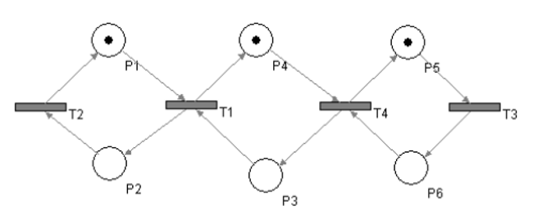

**Save – true**

**Live – true**

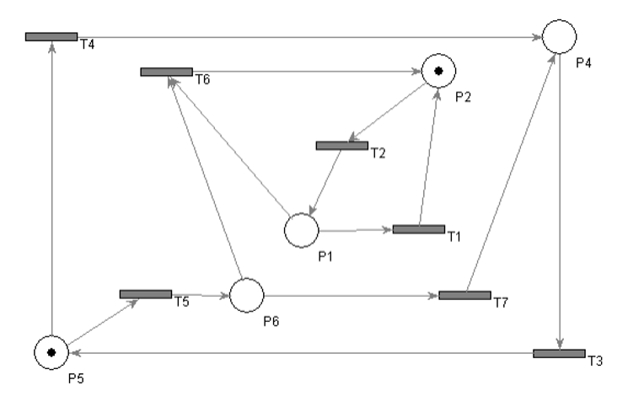

**Save – true**

**Live – true**

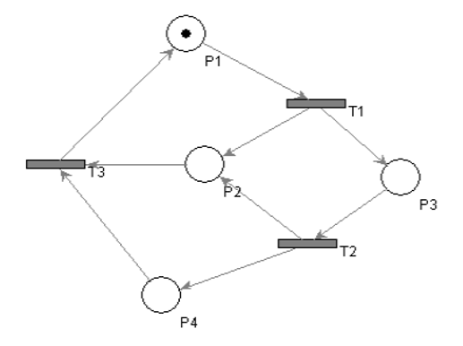

**Save – false**

**Live – true**

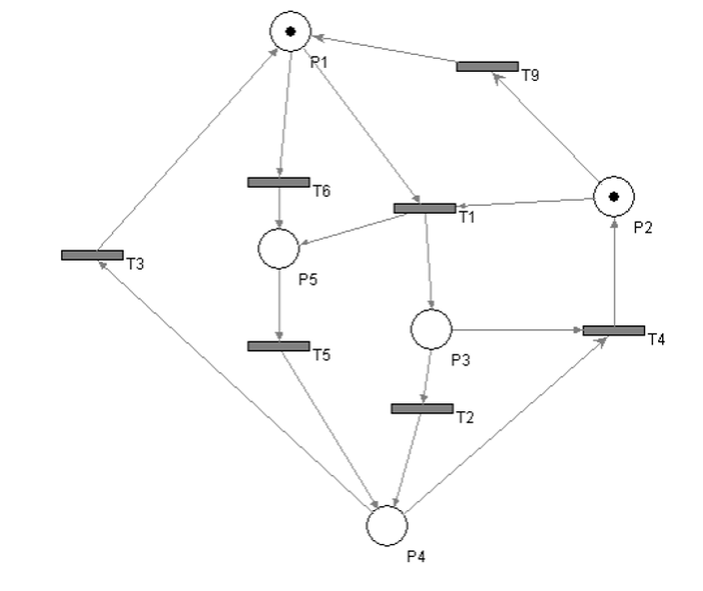

**Save – true**

**Live – false**