Machine Vision – is scientific discipline with focus on finding information from images or creating a model

Augmented reality – interactive system, working with environment to create model from image, than possibly add something and then create computer graphic out of augmented model

Binary image – image that consist of pixels that can have one of 2 values. Usually black and white.

Erosion – make object in the image smaller by rejecting border pixels. Erodes away boundaries.

Dilation – make object in the image bigger.

Opening – erosion then dilation. Useful in removing noice (Removes objects with comparably small size to structuring elements).

Closing – dilation then erosion. It’s useful in closing small holes inside the foreground objects, or small points in the object.

# Image Processing/Filtering

In Linear filters,

(Wrong) new value of pixel could be calculated based on some morphological transformation

(Correct) new value of pixel could be calculated(locally) based on neighborhood

1) Machine vision is

(Correct) Scientific discipline with focus on finding information from images or creating a model

2)In linear filters

(Correct) Neighboring pixels are used to determine a value of a new pixel

3)In order to Linear Filter, not change energy (sum of the pixels) of Image

(Correct)Sum of weights should be 1

4)For blurring an image a filter could be used:

(Correct)Gaussian, Averaging, Median, Laplasian (?), Bilateral, Box filter

5)Morphological operations. (What shape should a Structular element have):

(Correct) It can have any shape

-What image could be used in Morphological operations

(Correct) Binary image

NOTE: in case of Morphological operation called ‘Dylation’, if any point agrees with our pattern, we add that pixel

NOTE: Result of ‘Erosion’ is that original image is much thinner since we reject border pixels

NOTE: reverse operation to ‘erosion’ is ‘dilation’ where we extend original shape so its wider

6)What is ‘Opening’ in erosion:

(correct) it removes comparably small objects to structuring elements

NOTE: Opening is used to remove noise from image,

NOTE: Opening is combination of 1st Erosion 2nd Dilation

7) ‘Closing’ operation:

(correct) Used for closing small holes holes inside the foreground objects, or small points in the objects

NOTE: in task with moving ball, noise was removed with ‘opening’ and shadow was removed with ‘closing’

8) Edges:

(Correct)Are always perpendicular to Lines

9) Norm of Edge:

(-?)określa kierunek maksymalnej zmiany intensywności pikseli

(-?)określa kierunek krawędzi

(?)określa pozycję obrazu, w której znajduje się krawędzi

10) Points on the edges could be detected by:

(?)wykrywajac lokalne minima drugiej pochodnej

(?)wykrywając przejście przez zero drugiej pochodnej

(?) z zastosowaniem operacji morfologicznych

11(Potential question) How we calculate edges?  
 (correct) using first and second order derivative.

NOTE: First order derivative gives thick edges

NOTE: Second order derivative gives double edges.

NOTE: Second order derivative enhance fine detail much better

12(Potential question) What Canny filter uses?

(correct) Double thresholding (pixel belongs to edge or not)

NOTE: Important features can be extracted from edges like: corners, lines, curves

NOTE: those are usred for: segmentation and recognition

Goals of edge detector:

-(orientation)Direction of the edge

-strength of edge(intensity of change)

NOTE: Laplacian operator (used for edge detection using second derivative)

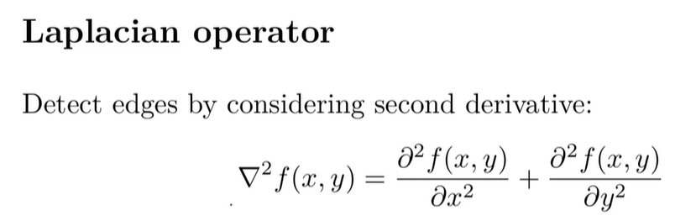

Laplacian operator is very sensitive to noise, that’s why blurring has to be used as a first step.

NOTE: derivatives are in general sensitive to noise therefore we need to smooth it first

Laplacian of Gaussian (LoG) is basically first using blurring and then taking Laplacian.

NOTE: Smooting:

-isused to remove noises

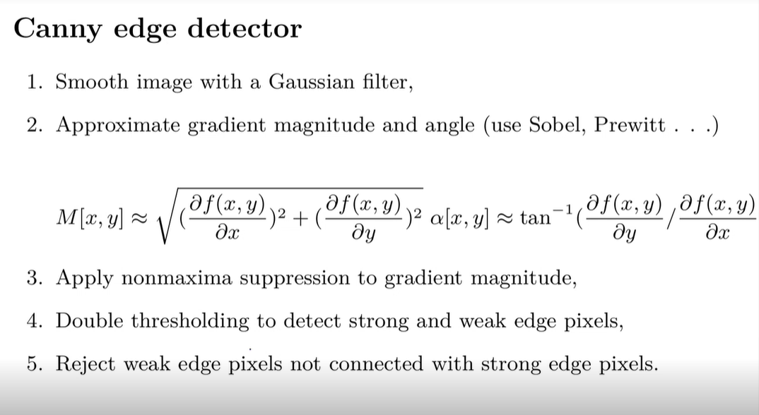

NOTE: Canny edge detector uses ‘nonmaxima’ suppression and double thresholding

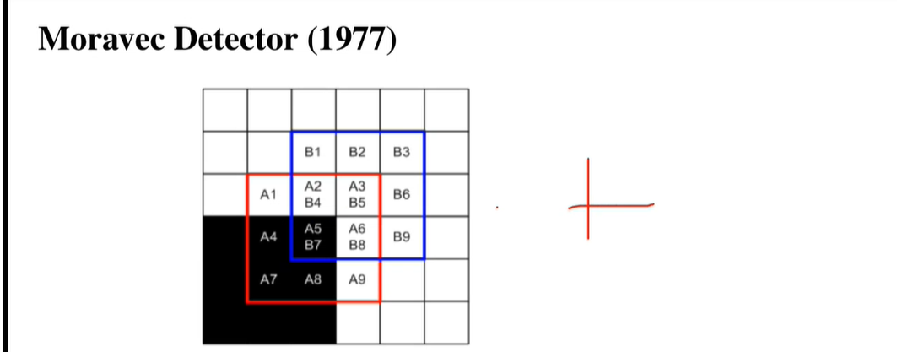

Moravec edge detector works in a way that that it moves window in 8 directions and check for changes.

Moravec detector is very sensitive to rotation.

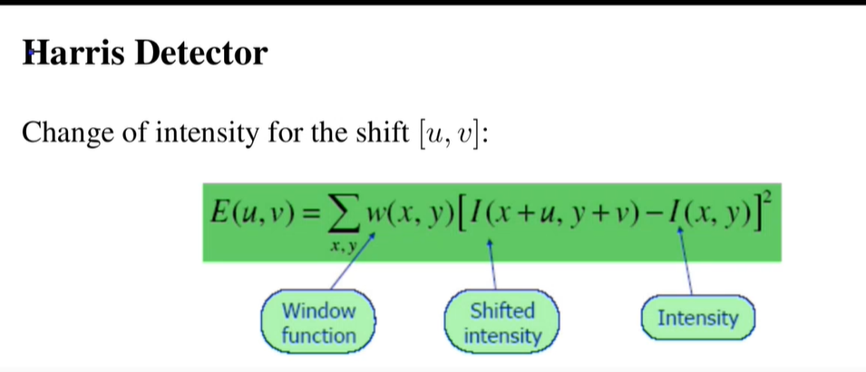

Uses eigen values.

Invariant for image rotation (not-sensetive)

Not invariant for scaling (sensitive)

SIFT algorithm uses pyramid of scales

SIFT uses DoG (differential of Gaussian)

MAX-Poling layer and flatten – no parameters to train.

**Just additional notes**

1. 1st derivative makes wide edges

2nd derivative makes thin edges and sometimes double lines (double pixels ?)

Zero crossing – something between maximum and minimum in second derivative (after Laplacian)

Edge – maximum of first derivative

1. In edge detection we use Gaussian filter for blurring (calculates average of neighborhood)
2. Laplacian operator is second derivative (kinda).
3. Canny filter uses double thresholding. We have 2 thresholds (max and min) and between we can estimate some neighborhood
4. Hough transform converts geometrical features to parametrical space.
5. Moravec algorithm for corner detection uses idea of moving window. 45 degrees. 8 directions. Very sensitive to rotation.
6. Harris algorithm is for corner detection too. It uses eigen values. Not sensitive for rotation, but sensitive for scaling
7. SIFT algorithm uses differential of Gaussian (DoG)
8. Something about Wave transform – Fourier Transform – from some domain to frequency domain.
9. Optical flow – 2 methods (local and global). It calculates change of intensity of image. It may be caused by movement, illumination etc.