Project2: Survival data

Table of Contents

# Data

## Load

act_data <- read.delim("../Data/actg320.txt", header = T, sep = "\t")  
log_data <- read.delim("../Data/Logistic.txt", header = T, sep = "\t") %>%   
 bind_rows(data.frame(AZT = "Total", AIDS_yes = sum(.$AIDS_yes), n= sum(.$n)))

## Summaries

### Logistic data

summary(log_data)

## AZT AIDS_yes n   
## Length:3 Min. :25.0 Min. :168.0   
## Class :character 1st Qu.:34.5 1st Qu.:169.0   
## Mode :character Median :44.0 Median :170.0   
## Mean :46.0 Mean :225.3   
## 3rd Qu.:56.5 3rd Qu.:254.0   
## Max. :69.0 Max. :338.0

### ACT data

summary(act_data)

## id time event tx   
## Min. : 1.0 Min. : 1.0 Min. :0.00000 Min. :0.0000   
## 1st Qu.: 290.5 1st Qu.:174.0 1st Qu.:0.00000 1st Qu.:0.0000   
## Median : 579.0 Median :257.0 Median :0.00000 Median :0.0000   
## Mean : 579.1 Mean :230.2 Mean :0.08341 Mean :0.4987   
## 3rd Qu.: 868.5 3rd Qu.:300.0 3rd Qu.:0.00000 3rd Qu.:1.0000   
## Max. :1156.0 Max. :364.0 Max. :1.00000 Max. :1.0000   
## sex raceth karnof cd4   
## Min. :1.000 Min. :1.000 Min. : 70.0 Min. : 0.00   
## 1st Qu.:1.000 1st Qu.:1.000 1st Qu.: 90.0 1st Qu.: 23.00   
## Median :1.000 Median :1.000 Median : 90.0 Median : 74.50   
## Mean :1.174 Mean :1.712 Mean : 91.3 Mean : 86.46   
## 3rd Qu.:1.000 3rd Qu.:2.000 3rd Qu.:100.0 3rd Qu.:136.50   
## Max. :2.000 Max. :5.000 Max. :100.0 Max. :392.00   
## age   
## Min. :15.00   
## 1st Qu.:33.00   
## Median :38.00   
## Mean :38.65   
## 3rd Qu.:44.00   
## Max. :73.00

## Plot

#pairplot_act <- ggpairs(act_data)  
#ggsave("Plots/pairplot_act.png", pairplot_act)

# Analysis of binomial data

## Binomial fit - all

We summarise the data into one group - total number of AIDS cases and total number of patients. Afterwards we fit the binomial distribution to the full (total) dataset. The binomial distribution has the density:

$$p_{θ}(k)=\left(\begin{matrix}n \\ k\end{matrix}\right)θ^{k}(1−θ)^{n−k}$$

With $n$ being the total number of patients and $k$ the total number of patients with aids. Hence we get the likelihood:

$$L(θ)=\left(\begin{matrix}n \\ k\end{matrix}\right)θ^{k}(1−θ)^{n−k}$$

MLE for $θ$ is estimated numerically, buut: $MLE=\frac{k}{n}$ Confidence intervals are estimated using the likelihood interval method

$$CI:\left[θ,\frac{L(θ)}{L(\hat{θ})}>c\right]$$

with $c = exp(- _{1,(1-)}^2) $ - with $χ_{1}^{2}$ being $χ^{2}$ distribution with 1 degree of freedom.

data <- as.numeric(log_data[3,2:3])  
binomial <- function(data, theta){  
 k <- data[1]  
 n <- data[2]  
 choose(n,k) * theta^k *(1-theta)^(n-k)  
}  
  
theta <- seq(0,1,0.001)  
MLE <- data[1]/data[2]  
c <- exp(-1/2*qchisq(1-0.05,1))  
  
plot(theta, binomial(data, theta)/max(binomial(data, theta)), "l")  
abline(c,0)

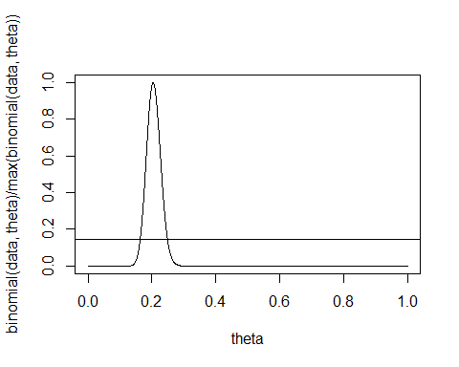

a <- theta[binomial(data,theta)/max(binomial(data,theta)) > c]  
CI <- c(min(a), max(a))  
cat("Maximum Likelihood estimate: ", MLE, "\n")

## Maximum Likelihood estimate: 0.204142

cat("Likelihood Confidence intervals: ", CI)

## Likelihood Confidence intervals: 0.164 0.249

## Binomial fit seperately

Data is divided into 2 groups: a control group (without AZT) and a test group (with AZT). A binomial distribution is fitted to each - as in previous question.

AZT_yes <- as.numeric(log_data[1,2:3])  
AZT_no <- as.numeric(log_data[2,2:3])  
  
theta <- seq(0,1,0.00001)  
par(mfrow=c(1,2))  
alpha <- 0.05  
c <- exp(-1/2*qchisq(1-alpha,1))  
plot(theta, binomial(AZT_yes, theta)/max(binomial(AZT_yes, theta)), "l")  
abline(c, 0)  
plot(theta, binomial(AZT_no, theta)/max(binomial(AZT_no, theta)), "l")  
abline(c, 0)

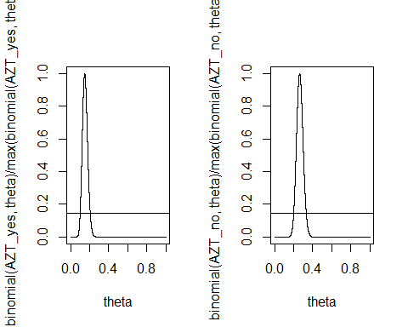

MLE_yes <- optimize(binomial, c(0,1), data = AZT_yes, maximum = TRUE)$maximum  
MLE_no <- optimize(binomial, c(0,1), data = AZT_no, maximum = TRUE)$maximum  
  
a_yes <- theta[binomial(AZT_yes,theta)/max(binomial(AZT_yes,theta)) > c]  
CI_yes <- c(min(a_yes), max(a_yes))  
  
a_no <- theta[binomial(AZT_no,theta)/max(binomial(AZT_no,theta)) > c]  
CI_no <- c(min(a_no), max(a_no))  
  
CI_yes

## [1] 0.09927 0.20540

CI_no

## [1] 0.19936 0.33166

We notice a slight overlap in the 95 % confidence intervals, indicating no difference (on a 5 & significance level) in the succes probabilities (‘succes’ = you have AIDS).

## Estimate the parameters in the model (logistic model) with parameters $β_{0}$ and $β_{1}$

With a logistic model we get the succes probability for the control group $p_{0}$ and for the test group $p_{1}$:

$$p_{0}=\frac{e^{β_{0}}}{1+e^{β_{0}}}, p_{1}=\frac{e^{β_{0}+β_{1}}}{1+e^{β_{0}+β_{1}}}$$

The parameter $b_{1}$ is the parameter describing the difference in succes probabilities ie. if $β_{1}=0$ no difference. We can write the likelihood function for the logsitic distribution:

$$L(β_{0},β_{1})=Π_{i}p_{i}^{y_{i}}(1−p_{i})^{1−y_{i}}$$

with $y_{i}$ denoting succes in category i. $i=0$ control group, $i=1$ test group. The log likelihood for this is



logL_partial <- function(b0, b1, data, AZT = TRUE){  
 y = if (AZT) {data[1,2]} else {data[2,2]} %>% as.numeric()  
 n = if (AZT) {data[1,3]} else {data[2,3]} %>% as.numeric()  
 false = n-y  
   
 y*((b0 + b1 * AZT) * 1 - log(1+exp(b0+b1*AZT))) + false*((b0 + b1 * AZT) * 0 - log(1+exp(b0+b1*AZT)))  
}  
  
logL <- function(theta, data){  
 - (logL_partial(theta[1], theta[2],data, F) + logL_partial(theta[1],theta[2],data, T))  
}  
  
  
opt <- nlminb(c(0, 0), logL, lower = c(-Inf,-Inf), data = log_data)  
  
p0 <- exp(opt$par[1])/(1+exp(opt$par[1]))  
p1 <- exp(opt$par[1] + opt$par[2])/(1+exp(opt$par[1] + opt$par[2]))  
  
  
  
  
  
logL_b1 <- function(theta, b1, data){  
 -(logL_partial(theta[1], b1,data, F) + logL_partial(theta[1],b1,data, T))  
}  
  
profile_b1 <- function(b1, data){  
 opt <- nlminb(c(0), logL_b1, lower = c(-Inf), data = log_data, b1 = b1)  
 # optimize(logL)  
 b0 <- opt$par  
 -logL_b1(c(b0),b1,data)  
}  
  
  
b1 <- seq(-5,5,0.01)  
alpha <- 0.05  
c <- exp(-1/2*qchisq(1-alpha,1))  
p = c()  
for (i in 1:length(b1)){  
 p[i] = exp(profile_b1(b1[i], log_data))  
}  
  
MLE_b1 <- optimize(profile_b1, c(-5,5), data = log_data, maximum = T)$maximum  
  
plot(b1, p/max(p), 'l')  
abline(c, 0)  
abline(v = MLE_b1)

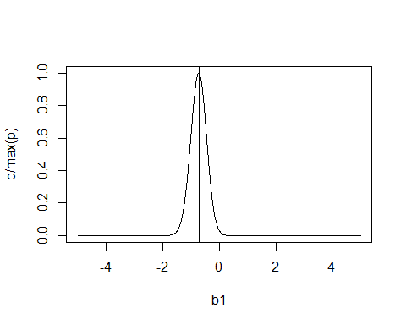

a_b1 <- b1[p/max(p) > c]  
CI_b1 <- c(min(a_b1), max(a_b1))  
  
  
cat("The maximum likelihood estimates of p0 and p1 are: p0 = ", p0, " p1 = ", p1, "\n")

## The maximum likelihood estimates of p0 and p1 are: p0 = 0.2619048 p1 = 0.1470588

cat("The maximum profile likelihood estimate of b1 is: ", MLE_b1, "\n")

## The maximum profile likelihood estimate of b1 is: -0.7217656

cat("With confidence intervals: ", CI_b1, "\n")

## With confidence intervals: -1.27 -0.19

The 95% confidence interval does not include 0. The difference is significant.

# Survival stuff

A little bit of summary statistics …. Proportion of death/AIDS in each group…

act_data <- act_data %>%   
 select(time, event, tx)

## Exponential distribution

data <- act_data$time  
likelihood_gamma <- function(theta, data){  
 -sum(dgamma(data, shape = theta[1], rate = theta[2], log = T))  
}  
likelihood_pois <- function(theta, data)  
 -sum(dpois(data, lambda = theta[1], log = T))  
dpois

## function (x, lambda, log = FALSE)   
## .Call(C_dpois, x, lambda, log)  
## <bytecode: 0x000000001cc056a8>  
## <environment: namespace:stats>

opt <- nlminb(c(5,5), likelihood_gamma, lower = c(0,0), data = data)  
  
x <- seq(1,400, 1)  
plot(x,dgamma(x, opt$par[1], opt$par[2]), 'l')  
par(new = T)  
hist(data)

