|  |  |
| --- | --- |
|  | Marketing Proposal |
|  |  |
| 4/12/2017 | Group 2 |
| Alexa  Corey  Justin  Sarah  Sidhant | 1. Abstract 2. Introduction 3. Background 4. Data 5. Analysis 6. Conclusion |

Ferrari’s Pizzeria

Group 2

# Abstract

The research provided below reflects the current market conditions and potential market conditions for Ferrari’s Pizzeria in the Plano/Dallas area. The purpose of this document is to address the potential customers for the pizzeria and how to market to them. Ferrari’s Pizzeria is a family owned New York Style pizzeria located in Plano, Texas. The main points we addressed in our research was “How far are people willing to travel for pizza” and “How many people have heard of Ferrari’s Pizzeria.” After review of the surveys collected we have concluded that Ferrari’s Pizzeria would best be marketed through social media, local sports teams, schools, and businesses.

# Introduction

## Ferrari’s Pizzeria

Ferrari’s Pizzeria is a family owned and operated restaurant established in 2008. The owners are Vinny Ferrari Jr. and Vinny Ferrari Sr., a father and son duo looking to open the most authentic New York Style Pizzeria in the Plano area. The first Ferrari’s location ever opened was back in August of 2008 in Plano, Texas off of Preston Road and Tennyson Parkway. The duo soon opened a second location in October of 2013 located in Plano off Coit Road and Legacy Drive. Vinny Jr. learned the pizza business from friends back in Yonkers, New York where he studied the pizza-making artistry. Vinny’s favorite mentors were the Dibitettos family, who owned a pizzeria and deli in New York City. That pizzeria and deli inspired much of the atmosphere of the elegant Ferrari’s Pizzeria today. The raving atmosphere of the restaurants displays a family oriented vibe with an Italian flair. Every family member of the Ferrari’s family works in the restaurant adding to the authentic pizzeria atmosphere. Aside from New York-Style pizza, Ferrari’s also offers genuine Italian cuisine and a delivery service to local sites.

# Background

## Product:

Ferrari’s Pizzeria is a family owned and operated restaurant in Plano. While the restaurant features New York style pizza, they offer a variety of other well-known Italian dishes, such as calzones, strombolis and pastas. In addition to dining in, Ferrari’s Pizzeria allows customers to order their food online with the option to either pick it up, or have it delivered.

## Price:

The food at Ferrari’s Pizzeria is modestly priced. Yelp’s price rating system, which rates prices using a dollar sign rating system ($ = under $10, $$ = $11-$30, $$$ = $31-$60, $$$$ = above $61), rates the food prices at Ferrari’s pizzeria at one dollar sign out of four.  By offering their food at such affordable prices, Ferrari’s pizzeria is a very attractive option for any customers looking for a casual dining experience.

## Place:

Ferrari’s Pizzeria is in a shopping center in West Plano, at the Northeast corner of the intersection of Coit road and Legacy drive. This location is near a large residential area of Plano consisting of a large Caucasian and Asian population. There are also Elementary and Middle schools, along with a community center nearby which provide more opportunities for business.

## Promotion:

Currently Ferrari’s Pizzeria does not designate many resources to promotion and marketing, relying mostly on word of mouth and neighborhood patronage.  They have a small social media presence on Facebook, but there are opportunities to grow with other social media platforms such as Twitter and Instagram.

## Market Description

Local competitors of Ferrari’s Pizzeria include Angelo and Vito’s Italian Food, Taverna Rossa, Campisi’s Pizza, Brooklyn Old Neighborhood Style Pizzeria, and Palio’s Pizza. The following is a comparison of prices and overall customer satisfaction according to Yelp’s ratings:

* Angelo and Vito’s Italian: similar prices (Under $10) but a lower customer satisfaction rating with 3.5 stars
* Taverna Rossa: slightly more expensive ($11-$30) and a lower customer satisfaction rating with 4.0 stars
* Campisi’s Pizza: slightly more expensive ($11-$30) and a lower customer satisfaction rating with 3.0 stars
* Brooklyn Old Neighborhood Style Pizzeria: slightly more expensive ($11-$30) and a lower customer satisfaction rating with 4.0 stars
* Palio’s Pizza: slightly more expensive ($11-$30) and a lower customer satisfaction rating with 3.7 stars

Ferrari’s Pizzeria currently has the highest customer satisfaction rating at 4.5 stars, while also having a price rating (Under $10) which was equal or better than each local competitor that was listed.

As mentioned in the background, there is a neighborhood in close proximity of the restaurant. The population of this neighborhood is 2,121 people, which consists of the following:

* 45.3% Caucasian
* 41% Asian
* 6.4% African American
* 2.6% Hispanic
* 2.5% American Indian
* 2.2% Multi-race

Family households make up most this area; 553 of the 628 (88.1%). This is a relatively high income area with the median income being $151,500.

## Customer description

The customer base for Ferrari’s Pizzeria is extremely broad because pizza is highly customizable, comes in many varieties, and can feed large groups of people.  This makes pizza convenient for families feeding large households, hosting a gathering as well as businesses and schools looking to cater functions. People of all ages, regardless of race and gender, will likely have some style of pizza that they enjoy.

# Purpose

## Questions Explored

Ferrari’s, like most small businesses, has a small marketing budget that is often on the chopping block when times get tough.  The question trying to be answered is how to maximize the businesses marketing dollars through targeted marketing strategies.  The survey questions were developed with the goal to identify our key demographic and discern their tastes as well as priorities when looking to dine out on pizza.   According to the data, 76% of those surveyed were willing to travel no more than 10 miles for a quality slice of pie.  The most common age ranges were 18-24 and 25-34-year-old people with 25% of the entire sample making $24,999 or less per year, yet taste and quality were the leading considerations. This begs two questions:

1. How does Ferrari’s market a tasty high quality product at reasonable price?
2. How does Ferrari’s convert their local customer base into loyal clientele?

## Goals

After spending time evaluating some of the challenges that Ferrari’s Pizzeria is faced with as a small business, it is apparent that a clear marketing strategy can reap rewards. Our goal as a team was to focus on relatively small-scale marketing approach. This will be achieved by utilizing social media, location within the local community, and product placement. By taking this approach we feel that Ferrari’s can expand its customer base and raise awareness within the community. Projections based on taking these small steps can increase sales by 5-10% for Ferrari’s. This is a relatively low customer acquisition cost.

# Data

## Survey Data

Ferrari’s Pizzeria is a small mom and pop shop known for their New York style pizza which is loved by many in the surrounding neighborhoods. To further brand Ferrari’s restaurant and spread the word to potential customers we needed to understand where they live, what they are looking for in a pizza and how far they are willing to venture for a slice of pizza pie. We conducted a simple seven question survey through Survey Monkey to study these topics, find our target demographic and gain insight into our target clientele. We emailed the survey link to students at UTD and handed out paper surveys to teachers, students and staff at Plano Senior High School to collect local data. Our survey gathered information about age, race and income to help us understand the type of individuals looking for a place to grab a bite to eat with friends or to enjoy a cocktail with coworkers after a long week. In addition, our survey collected information regarding our competitors and what our new guests look for when seeking a new restaurant. Over 100 survey responses were collected giving us a sample of information to serve as springboard for a marketing plan.

## Survey Results

|  |  |  |
| --- | --- | --- |
| **Question/Description** | **Percentage** | **Quantity (Total = 116)** |
| **What is your age bracket?** |  |  |
| 18 to 24 | 47% | 54 |
| 25 to 34 | 26% | 30 |
| 35 to 44 | 9% | 10 |
| 45 to 54 | 11% | 13 |
| 55 to 64 | 5% | 6 |
| 65 to 74 | 3% | 3 |
| 75 or older | 0% | 0 |
| **Which race/ethnicity best describes you?** |  |  |
| American Indian or Alaskan Native | 0% | 0 |
| Asian/ Pacific Islander | 21% | 24 |
| Black or African American | 9% | 10 |
| Hispanic | 14% | 16 |
| White/ Caucasian | 48% | 56 |
| Multiple ethnicity/ other | 9% | 10 |
| **What is your approximate average household income?** |  |  |
| 0 - 24,999 | 25% | 29 |
| 25k - 49,999 | 14% | 16 |
| 50k - 74,999 | 12% | 14 |
| 75K - 99,999 | 9% | 10 |
| 100K - 124,999 | 18% | 21 |
| 125k - 149,999 | 6% | 7 |
| 150k - 174,999 | 7% | 8 |
| 175k -199,999 | 1% | 1 |
| 200k+ | 9% | 10 |
| **How far are you willing to travel when looking to eat?** |  |  |
| 0 - 5 miles | 26% | 30 |
| 6 - 10 miles | 50% | 58 |
| 11 - 20 miles | 15% | 17 |
| 21+ miles | 9% | 10 |
| Deliver only/no distance | 1% | 1 |
| **When searching for a place to eat pizza, what are your major concerns?** |  |  |
| Price | 60% | 70 |
| Taste | 94% | 109 |
| Location | 46% | 53 |
| Quality | 80% | 93 |
| Reviews/Word of Mouth | 36% | 42 |
| Customer Service | 33% | 38 |
| Other | 4% | 5 |
| **Please select which restaurants you have visited before.** |  |  |
| Campisi's | 48% | 56 |
| Picasso's Ristorante | 29% | 34 |
| Ferrari's Pizzeria | 15% | 17 |
| Palio's Pizza Café | 47% | 54 |
| Carmine's Pizzeria | 9% | 11 |
| Tony's Pizza and Pasta | 16% | 19 |
| Angelo & Vito's Pizzeria | 20% | 23 |
| Cici's Pizza | 79% | 92 |
| Alfredo's Pizzeria | 15% | 17 |
| Jet's Pizza | 27% | 31 |

## City Data

In addition to our in-house survey, we researched publicly available data for the local area of Ferrari’s Pizzeria. This was mostly used to determine how representative our sample for the survey was in terms of demographics. The URL where we acquired this from is: <http://www.city-data.com/city/Plano-Texas.html>

## Data Variables

Once all survey responses were collected to our zip code question an excel sheet was generated which we used to calculate the parts of Dallas/Plano market where most people were located. This sheet allowed us to create a map of the zip codes collected (See Figure A). This information provides us with a good understanding for different marketing tactics we can use to spread the word about Ferrari’s.

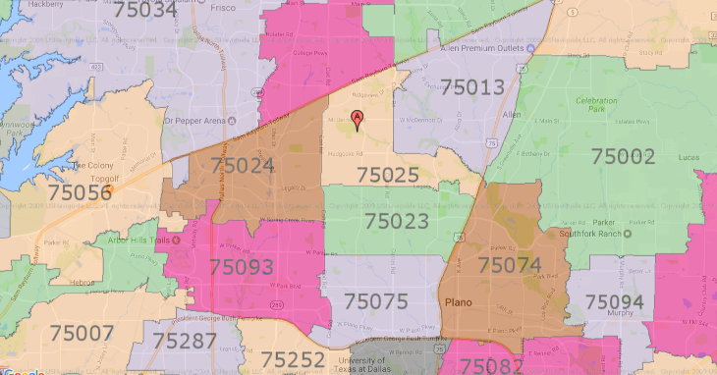

Figure A

One of the most important variables in our survey is the data collected showing the range people will travel for food (see Figure B). The data showed 51% of people would only travel 6-10 miles to eat while only 15% would travel 11-20 miles. This information provided us with a target market of a ten-mile radius from the restaurant.

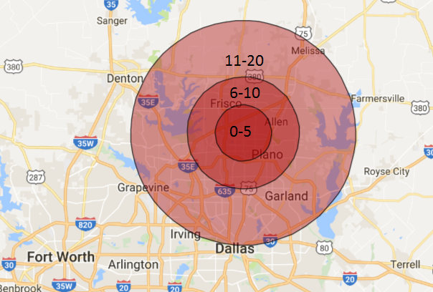

Figure B

# Analysis

## Relevance

The first step in analyzing data was to determine the usefulness and biases of our sample. The respondents to our survey were mostly individuals which we already knew or had some form of contact with, and the demographic breakdown is therefore more representative of the people we know rather than the pizzeria’s current customer base. However irrelevant that seems, this data would be still useful for expansion and catering to different customer groups further away than the neighborhood surrounding the restaurant.

One of the most important statistics regarding expansion of customer base is how far customers were willing to travel for food. What we’ve found is that among those surveyed, 50% were willing to travel up to 10 miles for food. Only about 25% were willing to travel more than 10 miles with 15% of those being up to a maximum of 20 miles. Clearly the area of focus should be a ten-mile radius around the restaurant. Our survey data shows that our respondents were largely (70%+) from within a 10-mile radius of the restaurant which makes our data extremely relevant to the Pizzeria.

## Visualization

To better understand the data, we needed to visualize it into graphs and charts. For analyzing demographic information such as age and race we used pie charts to visualize our largest demographic segments and where we should focus our attention (Figure 1&2). When it came to the household income data, there were too many segments to be visualized effectively on a pie chart so we used a bar graph for comparing the sizes of the segments (Figure 3). Similarly, for the rest of the data sets, we found that bar graphs presented our data in the easiest to understand format (Figures 4-6).

Zip codes were an important part of the survey as they allowed us to see where the respondents were from, and if their answers were relevant to us. Using a heat map, we could visualize this extremely effectively and being able to see the borders of the zip codes was useful in inferring and visualizing distance. As is shown, there were a few zip codes that had a disproportionately large response rate and these were the zip codes that were most important to see distance from, and data of. In addition, the radius map is useful if one wants to take a quick glance to see how far they are from the restaurant, and what set they belong to (Refer to Appendix).

## Graphs & Charts

Figure 2

Figure 3

Figure 4

Figure 5

Figure 6

Figure 7

Figure 8

## 

## Interpretation

What we see in this data is an important part of understanding and analyzing it. The basic facts are that most of our respondents skew young (18-24) which is good because consumers of pizza also skew young. Racially our survey is diverse, and generally representative of North Dallas. Household income varies, and skews lower, which is to be expected considering the age of most respondents.

In terms of distance customers were willing to travel, we found that among those surveyed, 50% were willing to travel up to 10 miles for food and less than 10% were willing to travel more than 20. This seems to conclude that our focus should be on the 0-10-mile range with a bit of wiggle room. Any focus on more 20 miles is an inefficient use of resources. In addition, our survey data shows that our respondents were largely (70%+) from within a 10-mile radius of the restaurant which makes our data extremely relevant to the Pizzeria.

When it came to priorities of customers, the 1st and 2nd most important things in a pizza was its taste and its quality of ingredients. 3rd was price. This shows that our respondents were willing to pay a higher price if it meant they were getting a better pizza; they weren’t just hunting for the lowest price. The balance between price & quality is very important, and it is also important to find a niche in that zone with your competitors. Ferrari’s Pizzeria may already have that figured but further research in a similar vein may be used in influencing future pricing decisions.

The final question was an analysis of the competition. Ferrari’s wasn’t as popular as some of the other restaurants, most notably the pizza chain CiCi’s pizza, however, it was reasonably competitive with restaurants of the same size. Since not all respondents were from the local area, chains would naturally do better than individual restaurants, but we plan to propel Ferrari’s to the top of the independent restaurants.

# Conclusion

## Limitations

The major limitations of this marketing study are the sample size of the survey as well as sample of participants who filled out the surveys.  Most of the survey participants were neither current customers of the pizzeria nor were they residents of the neighborhoods surrounding the restaurants.  National statistics from “Consumption of Pizza-What we eat in America, NHANES 2007-2010” also tell us that the largest demographic for pizza consumptions is males ages 6-19 and they were not a part of the sample collected; all participants surveyed were 18 or older.

## Conclusion

Cost versus reward with all businesses is the bottom line when looking to spend marketing dollars.  However, with the limited budget and manpower of a small business this becomes a time, material and manpower cost versus reward consideration.  Spending old fashioned marketing dollars on fliers, coupons and newspaper ads are relics of the past that will not serve Ferrari’s interests.   For Ferrari’s to maximize their marketing time, energy and money they are going to have to think outside the box.  Through social media marketing, school and local business partnerships, as well as sponsoring local sport teams, Ferrari’s can establish themselves as the neighborhood go to for a great slice.   With competition in the area on the rise in the mom and pop shop space as well as the “big box” pizza chains, Ferrari’s will need to establish a loyal neighborhood foothold to survive and grow.

# Appendix

Survey:

<https://www.surveymonkey.com/results/SM-NTMBHRLB/>

City Data Link:

<http://www.city-data.com/city/Plano-Texas.html>

Consumption of Pizza Stats: <https://www.ars.usda.gov/ARSUserFiles/80400530/pdf/DBrief/11_consumption_of_pizza_0710.pdf>

Zip Code Map Distance From Pizzeria Map



Competitor’s Location & Percentage of Respondents who Visited

