# Test 1

In this task you have to design a web API application that will support the database presented in the diagram. We create a website which is related to dividing work between team members of an IT project.

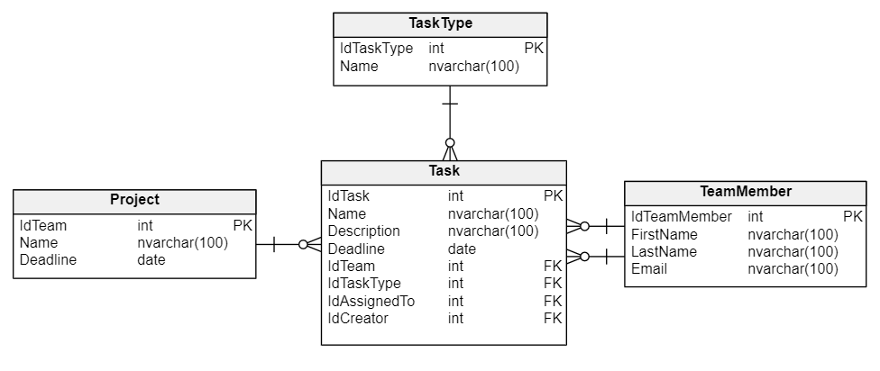

1. Design an endpoint that will allow you to return data about the team member and his tasks. Endpoint should take as a parameter an id of the team member. Endpoint should return all the information about the team member, the list of tasks assigned to him and the list of tasks created by this team member. Tasks in lists should be sorted in descending order by deadlines. The following information about the task should be returned: name of the task, description, deadline, name of the project this task is a part of and the task type. Remember to return the appropriate error codes.
2. GET /api/tasks/1 HTTP/1.1
3. Host: localhost:5000
4. Design an endpoint that allows you to delete the data about a given project. In case if project has some tasks, then we also want to delete the data about those tasks. Don’t forget that endpoint should use the transaction to maintain database consistency. Remember to return correct error codes with error message.
5. DELETE /api/tasks/10 HTTP/1.1
6. Host: localhost:3000
7. Remember about:
   1. Properly name the controller and variables
   2. Remember to maintain proper code structure.
   3. Remember to inject dependencies.
   4. Remember to handle errors.
   5. Place the code in the new repository. Remember about the .gitignore file and push changes to the server.