To change an Illustrator file to an EX2 Presentation:

1. In Illustrator
   1. Make sure each step belongs to its own layer. If you want a blank step (no images), be sure to include a blank layer.
   2. Rename all layers according to their corresponding step, in the format: “step#” all lowercase, no spaces. (i.e., “step1,” “step2,” etc)
   3. Convert all text to outlines (or run the risk that it will not display properly in some or all browsers)

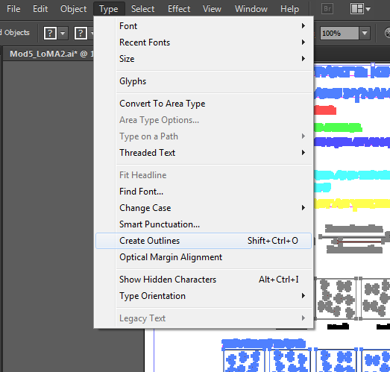

* 1. Save the file as an SVG

1. In a Text Editor
   1. Put the SVG code generated by Illustrator in the template where indicated. Do not include the SVG tags, just the <g> tags containing the steps.

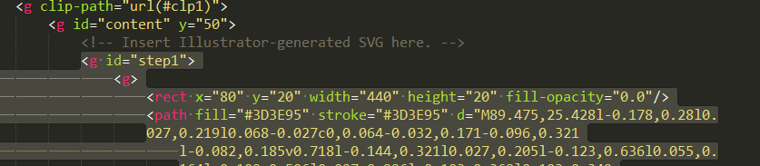

* 1. Adjust the STEPS variable with the number of steps in the SVG.
  2. Add the text to the text variable.
  3. Add the paths to the audio in the audioFiles variable. Note that for each step you should have 3 audio files – an mp3, ogg, and wav. These should all have the same name and be in the same location, just have different file extensions.
  4. If you desire, you can add rectangles around the steps with a fill-opacity value of “0.0” This makes it much easier to click steps in review mode.
  5. To add interactive questions:
     1. Add a <g> (with appropriate step id) OUTSIDE of the main content <g> where the rest of the steps are located.
     2. An example is located in the template; you can copy this and only change the path to the HTML
     3. Any question type can go within the HTML.
     4. Note that these questions will not work in Internet Explorer (at least up to IE10), and do not scroll with the rest of the EX2, but rather hover above the presentation and disappear when answered.

