
Module code and name: | Operating Systems
Assessment: | CW 1 (Refer/Defer)
Student ID: | 00022128
Submission deadline: | 6/5/2026 11:59:59 PM
Wordcount | 4987
Results date and type of feedback
Result (Pass or Fail)
Feedback

Table of Contents
Right-click here and choose 'Update Field' to generate the contents.

Part A: Theoretical Analysis

1. Case Study: Class A Education / NETS Homework Platform
Class A Education is a small private tutoring provider that operates the NETS Homework Platform, an internal web application used daily by tutors and students. Tutors publish course materials and assignments, while students log in to download materials and upload completed homework. The whole service runs on a single Linux server administered by a small technical team of one or two part-time system administrators.
The platform has clear operational requirements. It must serve a web front-end reliably to dozens of concurrent users during peak study hours, and store structured records — student accounts, assignments, submission metadata and grades — safely and consistently. Because the team is small, the server must be largely self-managing: health monitoring, disk-space checking, log rotation and backups need to be automated rather than performed by hand. Downtime or data loss directly affects students’ ability to submit work on time, so reliability and data integrity are the primary concerns, followed by the security of the personal data the platform holds.
The system therefore combines multiple software components: a web server to deliver the front-end and proxy application traffic, and a relational database to persist platform data. Containerisation packages part of the stack in an isolated, reproducible way. Automated monitoring and alerting give the small team early warning of resource problems, and scheduled log management keeps the single disk from filling up — a realistic scenario that benefits strongly from operating-system-level automation.

2. System Software Selection and Justification
Two software packages were selected: Nginx (web server / reverse proxy) and PostgreSQL (relational database).
Nginx is well matched to the NETS Homework Platform because its event-driven, asynchronous architecture serves many simultaneous connections from a small number of worker processes using very little memory, rather than creating a new process or thread for every client. During peak study hours dozens of tutors and students load materials and upload homework at the same time, yet the server has only two virtual CPUs and roughly 3.3 GB of RAM, so a web server that stays responsive under concurrency without exhausting resources is exactly what the scenario needs. Nginx also serves the platform's static course materials efficiently and acts as a reverse proxy in front of the application, giving Class A a single, well-documented entry point that a one- or two-person team can configure and troubleshoot quickly.
PostgreSQL suits the platform because the data it stores - student accounts, assignments, submission metadata and grades - must be accurate, consistent and never silently lost. As a mature, ACID-compliant relational database it ensures that each submission or grade change is committed atomically and survives a crash, while keys and constraints enforce data integrity at the database level instead of relying on application code. Its MVCC concurrency model lets many students read materials and submit work at once without blocking one another, which matters most during deadline rushes. Together the two packages give a clean separation between the web tier (Nginx) and the data tier (PostgreSQL), each chosen for the property the case study prioritises: responsiveness for the front-end and integrity for the stored records.

3. Operating System Selection: Ubuntu 26.04 LTS
Selected distribution: Ubuntu Server 26.04 LTS.
Ubuntu Server 26.04 LTS is a strong fit for Class A because the priorities of the scenario - reliability, low maintenance and the security of student data - line up directly with what a Long Term Support release offers. An LTS version receives around five years of standard security and maintenance updates (extendable through ESM), so the platform can run for years without a risky full reinstall; for a team of only one or two part-time administrators that stability is worth more than chasing the newest features. Security is built in rather than bolted on: AppArmor mandatory access control confines services such as Nginx, security updates are published promptly, and unattended-upgrades can apply critical patches automatically - valuable when nobody watches the server full time but it still holds personal data.
The distribution also keeps day-to-day administration simple. APT and Ubuntu's very large package ecosystem mean Nginx, PostgreSQL and Docker all install and update with single, well-documented commands, which keeps the automation scripts short and reproducible. A modern Linux kernel uses the modest 2 vCPU / 3.3 GB virtual machine efficiently, so resources go to the application rather than the operating system. Finally, the combination of a huge community knowledge base and commercial backing from Canonical means that when the small team meets a problem, an answer or a supported upgrade path is almost always available - reducing the operational risk of running a single production server.

4. Critical Discussion of Operating System Components
The reliability and security of the NETS Homework Platform ultimately depend on four operating-system subsystems working well together on a deliberately constrained single server. This section discusses how the Linux kernel manages processes, memory, storage and users, and relates each subsystem to the decisions taken in the Class A deployment.

Process and Thread Management
On the two-vCPU server the kernel must share processor time between Nginx workers, several PostgreSQL backend processes and the periodic cron jobs that run monitoring, disk alerts and log rotation. It does this with the Completely Fair Scheduler (CFS), which tracks the virtual runtime each runnable task has accumulated and always dispatches the task that has received the least, so that no single service can starve the others of CPU (Linux kernel documentation, "CFS Scheduler"). A process is an independent program with its own protected address space, whereas threads share one address space and are cheaper to switch between; PostgreSQL uses a process-per-connection model for strong isolation, while Nginx keeps a small, fixed pool of worker processes. Each time the kernel moves a CPU from one task to another it performs a context switch - saving and restoring registers and memory mappings - which is necessary but not free, so reducing unnecessary switches matters on a busy server. This is precisely why Nginx's event-driven model scales: instead of dedicating a thread to every connection (which would multiply context switches and memory use under load), a single worker uses non-blocking I/O and an event loop to multiplex thousands of connections, staying efficient during the peak-hour concurrency the case study describes (Nginx documentation; Tanenbaum and Bos, Modern Operating Systems).

Memory Management
Linux gives every process its own virtual address space, mapped to physical RAM by the memory-management unit. This virtual-memory abstraction isolates processes from each other, so a fault in one PostgreSQL backend or in the web server cannot corrupt another process's memory - an important protection on a host that runs several services side by side. When demand for memory exceeds the roughly 3.3 GB of RAM, the kernel pages less-used data out to swap on disk; this prevents immediate failure but is far slower than RAM, so heavy swapping (thrashing) appears as exactly the latency the monitoring script is designed to detect. The kernel also uses otherwise-free RAM as a page (buffer) cache, keeping recently read files and database pages in memory, which is why repeated reads of course materials and hot database pages stay fast without extra hardware. The main danger on a memory-limited host is exhaustion: if both RAM and swap fill, the kernel's Out-Of-Memory killer terminates a process to recover, and if the victim is PostgreSQL or Nginx the platform goes down. This is why the case study emphasises automated memory monitoring - early warning lets the small team add swap, tune PostgreSQL's memory settings or enlarge the VM before an OOM event causes data-affecting downtime (Linux kernel documentation; Silberschatz, Galvin and Gagne, Operating System Concepts).

File Systems and Storage
The root filesystem is ext4, a mature journaling filesystem chosen for reliability on the single 15 GB disk. ext4 records each file as an inode that stores its metadata - owner, group, permission bits and pointers to the data blocks - and these inodes are what make the project's permission model enforceable: the /var/classa tree relies on ownership (platform_admin:classa_staff) and mode bits to decide who may read, write or execute each path. The shared uploads directory uses the sticky bit (mode 1770) so that, although the whole staff group can create files in it, only the owner of a file (or root) may delete it, letting students share one drop-box without removing each other's submissions. Storage on a single disk is finite, so log rotation matters: the log-management script rotates the active log to a timestamped copy, truncates the original in place to preserve its inode, compresses old logs with gzip and finally moves and purges the archives, which stops the application logs from silently filling the disk and crashing services. ext4's journaling underpins this reliability - metadata changes are first recorded in a journal, so if the VM loses power mid-write the filesystem can replay or roll back the journal and recover to a consistent state rather than corrupting student data (ext4 documentation, kernel.org; Linux man pages chmod(1) and inode(7)).

User Management and Security
Linux is a multi-user system, and the project uses that to enforce least privilege and a separation of duties. Each role account (platform_admin, content_editor and support_user) is a real user with an entry in /etc/passwd, while the hashed passwords live in the root-readable /etc/shadow, keeping credentials away from ordinary users. The accounts are joined to a shared classa_staff group so files can be shared by role rather than by individual, and only platform_admin is granted sudo, concentrating administrative power in one auditable account instead of giving it to everyone. Default permissions are tightened with umask 0277, which masks all group and other access and removes write for the owner, so every new file is created as mode 0400 - readable only by its owner. Combined with the directory modes on /var/classa (for example 700 for the admin-only config that holds secrets and 750 for group-readable logs and data), this enforces the confidentiality the scenario demands: student personal data and platform secrets are not accessible to other users by default, and write access is granted deliberately rather than by accident. This layered use of users, groups, sudo and permission bits is a practical application of the principle of least privilege, limiting the damage that a mistake or a compromised account could cause on a server that holds personal data (Ubuntu Server documentation; Linux man pages umask(1), useradd(8) and sudo(8)).

Part B: Practical Implementation
All evidence below was captured live from the VirtualBox VM (host osCW, Ubuntu 26.04 LTS, aarch64). Each terminal figure shows the command issued and its real output.

1. Operating System Configuration
Ubuntu Server 26.04 LTS was installed in Oracle VirtualBox. The VM has 2 CPU cores and ~3.3 GB RAM on a single 15 GB virtual disk partitioned into an EFI system partition (/boot/efi) and an ext4 root (/). A primary administrative user (os_cw) was created with sudo rights, and networking allows the VM to be reached on the LAN so the web app is accessible from other devices.
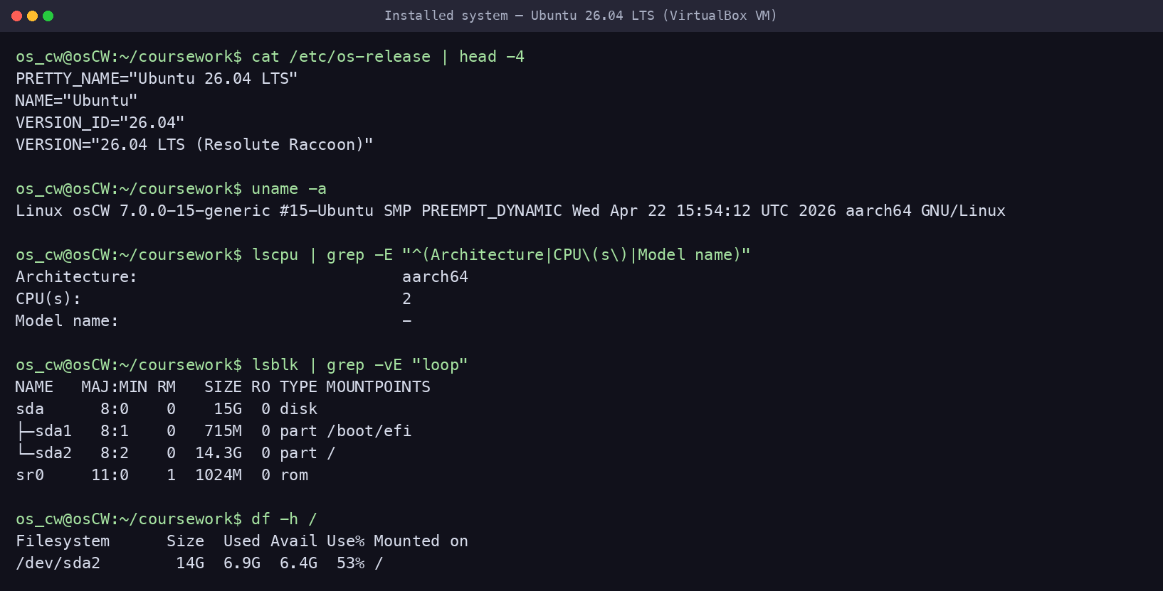
Figure — Installed OS, kernel, CPU, disk layout and usage

2. Software Installation and Deployment
install_classa_services.sh installs and enables the two Part A packages (Nginx + PostgreSQL) plus helper tools (curl, bc, gzip).
#!/bin/bash
#
# install_classa_services.sh — install the two core packages for Class A Education:
# Nginx (web server / reverse proxy) and PostgreSQL (relational database).
# Also installs the helper tools the other scripts rely on (curl, bc, gzip).
#
set -euo pipefail
export DEBIAN_FRONTEND=noninteractive

echo "Updating package lists..."
sudo apt update

echo "Installing Nginx, PostgreSQL and helper tools..."
sudo apt install -y nginx postgresql postgresql-contrib curl bc gzip

echo "Enabling and starting services..."
sudo systemctl enable --now nginx
sudo systemctl enable --now postgresql

echo "--------------------------------"
sudo systemctl is-active --quiet nginx && echo "Nginx status: Active" || echo "Nginx status: FAILED"
sudo systemctl is-active --quiet postgresql && echo "PostgreSQL status: Active" || echo "PostgreSQL status: FAILED"
echo "--------------------------------"
nginx -v
psql --version

echo "Class A Education services installation completed."
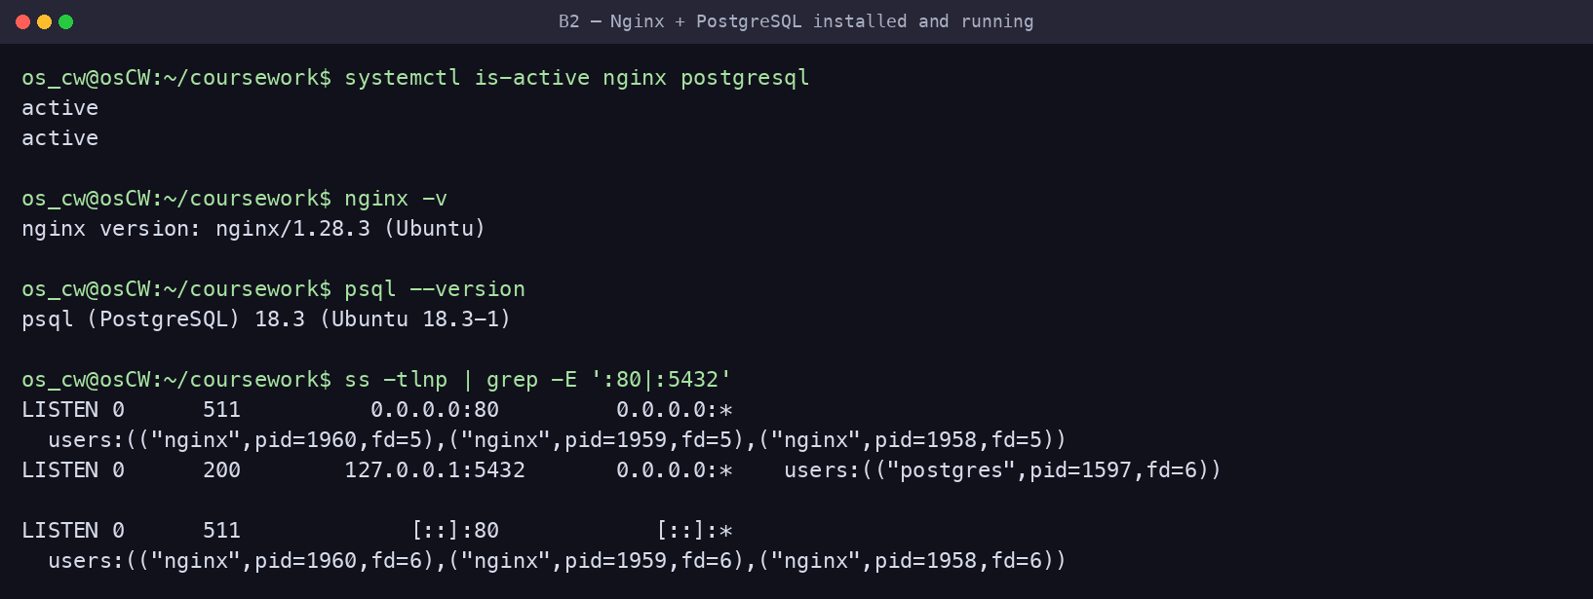
Figure — Both services active, versions, and listening sockets (:80, :5432)

3. User and Group Management
manage_users.sh creates the classa_staff group and three role accounts (platform_admin, content_editor, support_user), each with bash and a home directory; grants sudo to platform_admin; writes a read-only readme.txt; and appends three aliases plus umask 0277 to each .bashrc. The edit is marker-guarded so re-runs never duplicate it; --reset recreates the users cleanly.
#!/bin/bash
#
# manage_users.sh — Class A Education users & group management
# - Creates the classa_staff group and 3 role accounts (bash shell + home dir)
# - Grants sudo to the platform administrator
# - Drops a read-only readme.txt into each home
# - Adds 3 aliases + a restrictive umask (0277) to each .bashrc (idempotent)
#
# Safe to re-run. Use `--reset` to delete and recreate the users from scratch.
#
set -euo pipefail

GROUP_NAME="classa_staff"
USERS=("platform_admin" "content_editor" "support_user")
SUDO_USER_NAME="platform_admin"
MARKER="# >>> Class A Education config >>>"

# ----------------------------------------------------------------- --reset ---
if [[ "${1:-}" == "--reset" ]]; then
for u in "${USERS[@]}"; do
if id "$u" >/dev/null 2>&1; then
echo "Removing existing user $u ..."
sudo pkill -u "$u" 2>/dev/null || true
sudo userdel -r "$u" 2>/dev/null || true
fi
done
fi

echo "Creating group: $GROUP_NAME"
sudo groupadd -f "$GROUP_NAME"

for user in "${USERS[@]}"; do
if id "$user" >/dev/null 2>&1; then
echo "User $user already exists — ensuring configuration."
else
echo "Creating user: $user"
sudo useradd -m -s /bin/bash "$user"
fi

echo " adding $user to $GROUP_NAME"
sudo usermod -aG "$GROUP_NAME" "$user"

# Custom file in the home directory, owner read-only.
echo "Welcome to the Class A Education server. Your files are private and read-only by default." \
| sudo tee "/home/$user/readme.txt" >/dev/null
sudo chown "$user:$user" "/home/$user/readme.txt"
sudo chmod 400 "/home/$user/readme.txt"

# Aliases + umask — appended only once thanks to the marker (no duplicates on re-run).
if ! sudo grep -qF "$MARKER" "/home/$user/.bashrc" 2>/dev/null; then
sudo tee -a "/home/$user/.bashrc" >/dev/null <<EOF

$MARKER
alias ll='ls -la'
alias logs='cd /var/classa/app/logs'
alias app='cd /var/classa/app'
# New files default to owner read-only (0400); nothing for group/others.
umask 0277
# <<< Class A Education config <<<
EOF
sudo chown "$user:$user" "/home/$user/.bashrc"
echo " configured aliases + umask for $user"
else
echo " $user already configured (skipping .bashrc append)"
fi

# Keep each home private.
sudo chmod 750 "/home/$user"
done

echo "Granting sudo permissions to $SUDO_USER_NAME ..."
sudo usermod -aG sudo "$SUDO_USER_NAME"

echo "User and group setup completed successfully."
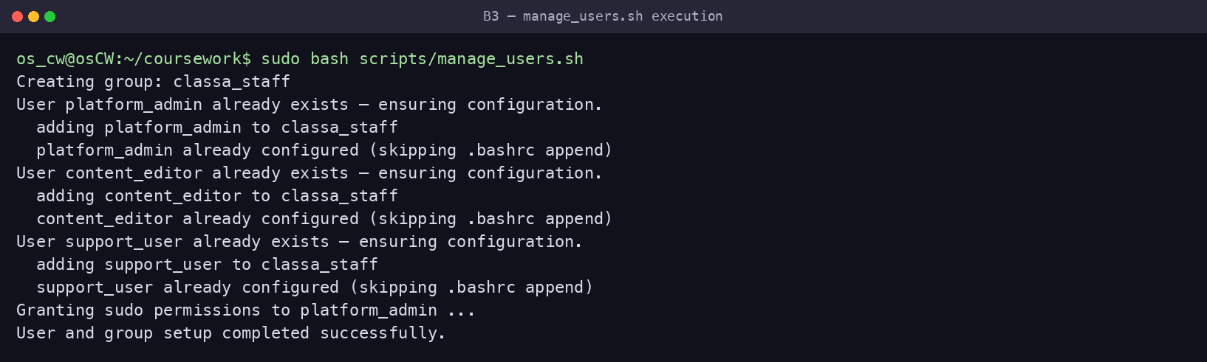
Figure — manage_users.sh executed (idempotent)

3.1 User and Group Check
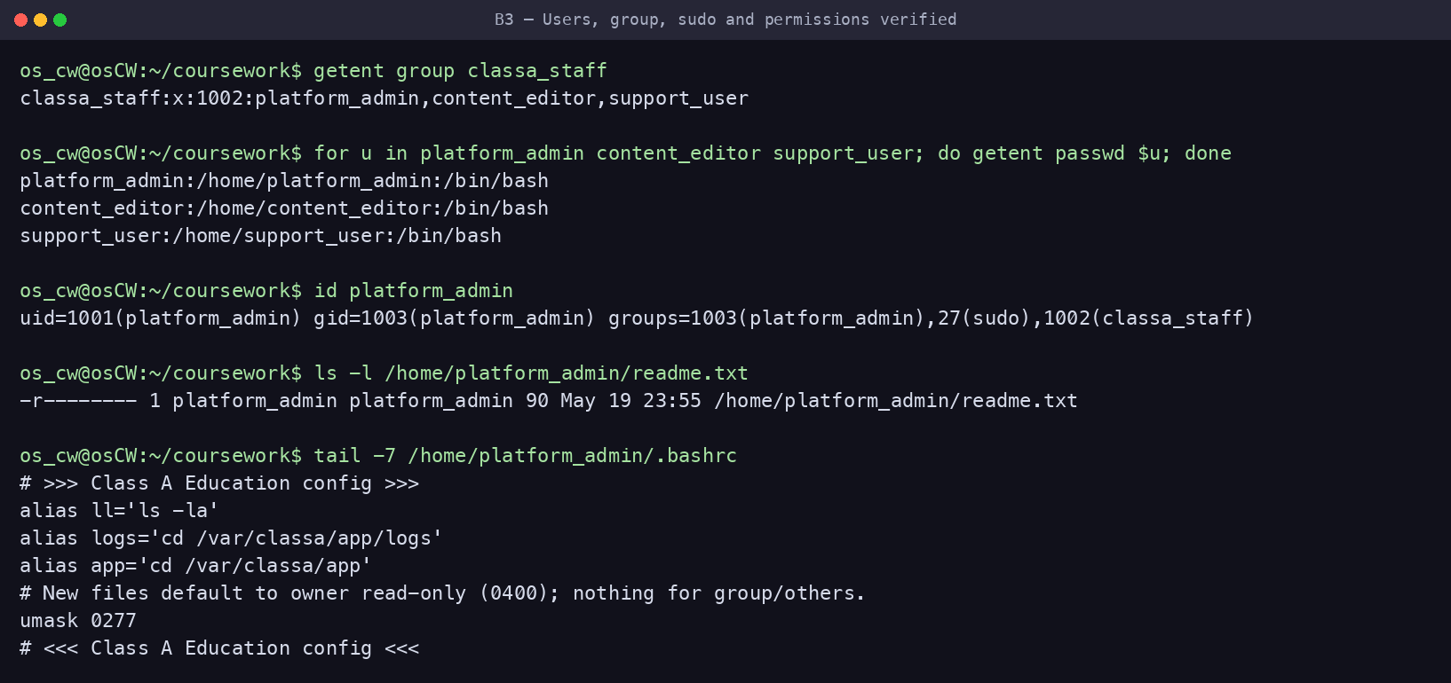
Figure — Group membership, shells, sudo, readme (0400) and .bashrc aliases

3.2 Aliases, Files and Security Policy (umask 0277)
Each .bashrc defines three aliases (ll, logs, app) and sets umask 0277 so new files default to owner-read-only (0400) with no access for group or others — visible in the figure above.

4. File system structure and permissions
setup_structure.sh builds the /var/classa tree: course_materials (shared, world-readable files 644), uploads_exchange (group drop-box with the sticky bit, 1770), and an app/ subtree (config/logs/data/backups) demonstrating a range of permissions; it also creates two symbolic links.
#!/bin/bash
#
# setup_structure.sh — Class A Education filesystem layout & permissions
# /var/classa/course_materials -> shared, readable by others (read-only)
# /var/classa/uploads_exchange -> group drop-box with sticky bit (no deleting others' files)
# /var/classa/app/{config,logs,data,backups} -> app tree demonstrating a range of permissions
# + 2 symbolic links in support_user's home
#
# Safe to re-run (idempotent).
#
set -euo pipefail

BASE="/var/classa"
GROUP_NAME="classa_staff"
OWNER="platform_admin"

# Make the script self-sufficient.
getent group "$GROUP_NAME" >/dev/null || sudo groupadd "$GROUP_NAME"

echo "Creating Class A directory structure..."
sudo mkdir -p "$BASE/course_materials" \
"$BASE/uploads_exchange" \
"$BASE/app/config" \
"$BASE/app/logs" \
"$BASE/app/data" \
"$BASE/app/backups"

echo "Creating sample files..."
echo "Class A public course material: Lesson 1" | sudo tee "$BASE/course_materials/lesson1.txt" >/dev/null
echo "Platform rules and student guide" | sudo tee "$BASE/course_materials/rules.txt" >/dev/null
echo "Database connection settings placeholder" | sudo tee "$BASE/app/config/settings.conf" >/dev/null
echo "Class A application log started" | sudo tee "$BASE/app/logs/server.log" >/dev/null
echo "Sample homework session data" | sudo tee "$BASE/app/data/homework_session.txt" >/dev/null

echo "Setting ownership..."
sudo chown -R "$OWNER:$GROUP_NAME" "$BASE"

echo "Setting permissions..."
# Shared course materials: world-readable, read-only for others.
sudo chmod 755 "$BASE/course_materials"
sudo chmod 644 "$BASE/course_materials/"*

# Upload exchange: group members create files; sticky bit stops them deleting each other's.
sudo chmod 1770 "$BASE/uploads_exchange"
sudo chown "$OWNER:$GROUP_NAME" "$BASE/uploads_exchange"

# Application tree (4 subdirectories demonstrating a range of permission models).
sudo chmod 700 "$BASE/app/config"; sudo chmod 600 "$BASE/app/config/settings.conf"
sudo chmod 750 "$BASE/app/logs"; sudo chmod 640 "$BASE/app/logs/server.log"
sudo chmod 750 "$BASE/app/data"; sudo chmod 640 "$BASE/app/data/homework_session.txt"
sudo chmod 700 "$BASE/app/backups"

echo "Creating symbolic links..."
if id support_user >/dev/null 2>&1; then
sudo ln -sfn "$BASE/course_materials" /home/support_user/classa_materials
sudo ln -sfn "$BASE/uploads_exchange" /home/support_user/classa_uploads
# NB: do NOT `chown -h` these links. On this system chown -h on a
# symlink-to-directory dereferences and rewrites the TARGET's ownership
# (reverting /var/classa/uploads_exchange to support_user). Symlink
# ownership is cosmetic on Linux — the target's permissions govern access —
# so leaving the links root-owned is correct and safe.
else
echo " (support_user not found — run manage_users.sh first to create the symlinks)"
fi

echo "Class A file structure is ready."
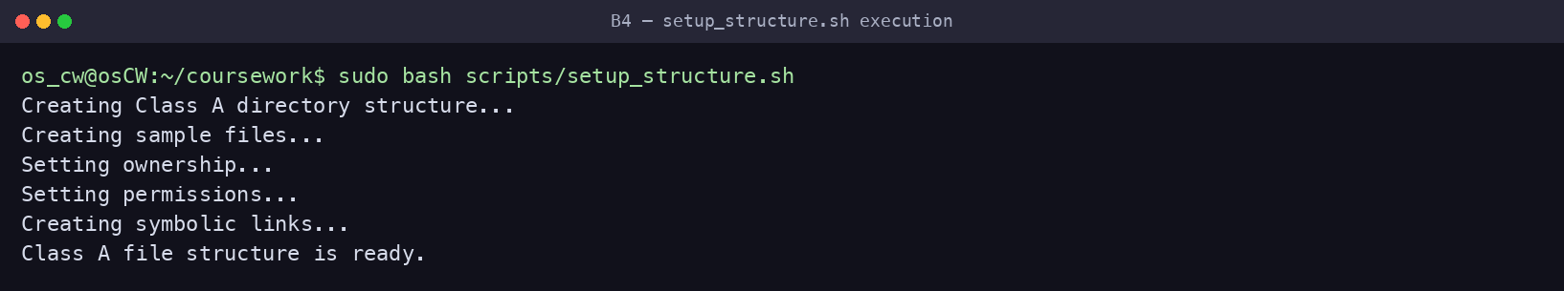
Figure — setup_structure.sh executed
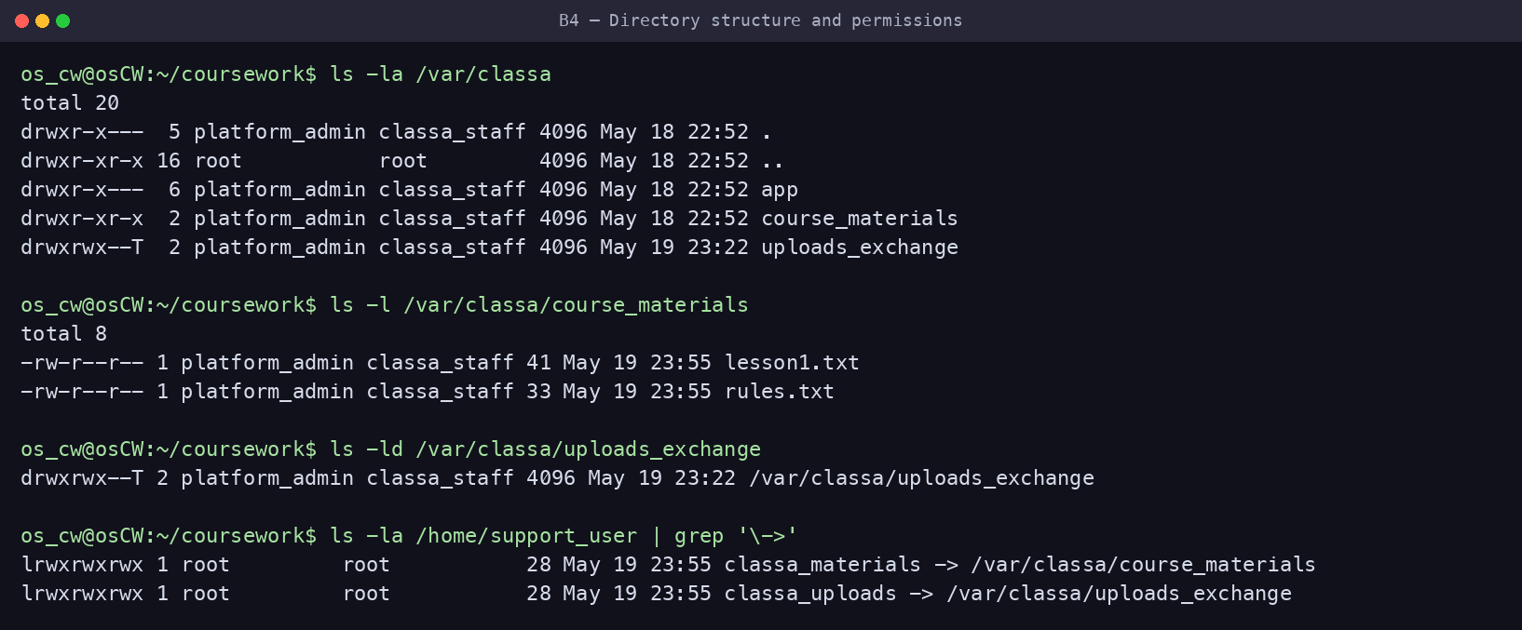
Figure — Directory tree, permission bits, sticky bit and symlinks
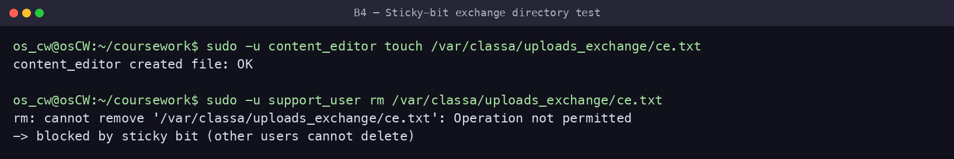
Figure — Functional proof: a group member can create but cannot delete another's file

5. System Monitoring Script
monitor.sh records CPU, memory and disk usage with a timestamp to system_monitor.log (CPU via awk, no bc dependency). setup_cron.sh schedules it automatically every 5 minutes.
#!/bin/bash
#
# monitor.sh — Class A Education system monitor
# Collects CPU, memory and disk usage and appends a timestamped line to the log.
# Designed to run unattended from cron (see setup_cron.sh).
#
set -uo pipefail
export LC_ALL=C # force '.' as decimal separator so parsing is locale-independent

# Re-run as root if needed (so we can always write under /var/classa). When cron
# runs this as root the check is skipped; a manual run will prompt once for sudo.
if [[ $EUID -ne 0 ]]; then exec sudo "$0" "$@"; fi

LOG_DIR="/var/classa/app/logs"
LOGFILE="$LOG_DIR/system_monitor.log"
mkdir -p "$LOG_DIR"

TIMESTAMP=$(date "+%Y-%m-%d %H:%M:%S")

# CPU usage = 100 - idle%. Pull the idle ("id") field out of `top` without needing
# the external `bc` tool — awk does the arithmetic.
CPU_IDLE=$(top -bn1 | awk -F',' '/[Cc]pu\(s\)/{
for (i = 1; i <= NF; i++)
if ($i ~ /id/) { gsub(/[^0-9.]/, "", $i); print $i; exit }
}')
CPU_USAGE=$(awk -v idle="${CPU_IDLE:-0}" 'BEGIN { printf "%.1f", 100 - idle }')

# Memory: used/total in MB plus percentage.
MEM_USAGE=$(free -m | awk 'NR==2{printf "Memory: %s/%sMB (%.2f%%)", $3, $2, ($2>0 ? $3*100/$2 : 0)}')

# Disk: usage percentage of the root filesystem.
DISK_USAGE=$(df -h / | awk 'NR==2{print $5}')

echo "[$TIMESTAMP] CPU: ${CPU_USAGE}% | $MEM_USAGE | Disk: $DISK_USAGE" >> "$LOGFILE"
Automatic scheduling (setup_cron.sh):
#!/bin/bash
#
# setup_cron.sh — install the Class A Education scheduled jobs automatically.
#
# Schedules (installed into ROOT's crontab so the jobs run with the privileges
# they need — no interactive sudo inside cron):
# monitor.sh every 5 minutes (system monitoring at regular intervals)
# disk_alert.sh every 15 minutes (homework uploads can fill disk quickly)
# log_management.sh daily at 00:00 (rotate/compress/back up logs)
#
# Paths are derived from THIS script's own location, so the jobs always point at
# the real scripts (no hard-coded /home/<user>/... that breaks if the repo moves).
#
set -euo pipefail

# Re-run as root so we edit root's crontab.
if [[ $EUID -ne 0 ]]; then exec sudo "$0" "$@"; fi

SCRIPT_DIR="$(cd "$(dirname "${BASH_SOURCE[0]}")" && pwd)"
MON="$SCRIPT_DIR/monitor.sh"
DISK="$SCRIPT_DIR/disk_alert.sh"
LOGR="$SCRIPT_DIR/log_management.sh"
TAG="# CLASS_A_CRON"

chmod +x "$MON" "$DISK" "$LOGR"

# --- Install/refresh entries in root's crontab (idempotent) ---
tmp=$(mktemp)
crontab -l 2>/dev/null | grep -v "$TAG" > "$tmp" || true
cat >> "$tmp" <<EOF
*/5 * * * * $MON $TAG
*/15 * * * * $DISK $TAG
0 0 * * * $LOGR $TAG
EOF
crontab "$tmp"
rm -f "$tmp"

# --- Remove any stale Class A entries the user may have added manually elsewhere ---
INVOKER="${SUDO_USER:-}"
if [[ -n "$INVOKER" ]] && crontab -u "$INVOKER" -l >/dev/null 2>&1; then
crontab -u "$INVOKER" -l 2>/dev/null \
| grep -vE "($TAG|coursework/scripts/(monitor|disk_alert|log_management)\.sh)" \
| crontab -u "$INVOKER" - || true
echo "Cleaned any stale Class A entries from ${INVOKER}'s crontab."
fi

echo "Installed Class A cron jobs (root):"
crontab -l | grep "$TAG"
echo "Cron setup completed."
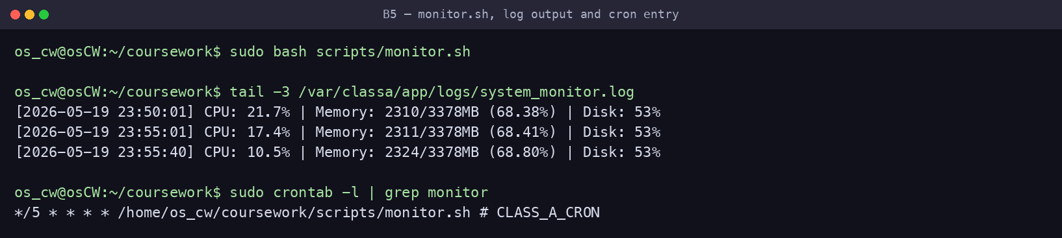
Figure — monitor.sh output, the timestamped log, and the installed cron entry
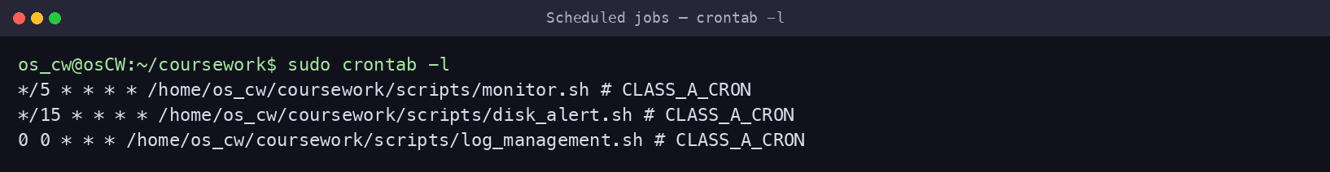
Figure — All scheduled Class A jobs (monitor / disk_alert / log rotation)

6. Disk Space Monitoring and Alerts
disk_alert.sh checks the root filesystem against an 80% threshold and notifies through three channels — terminal + OS broadcast (wall/notify-send), a file log, and Telegram. It is non-interactive so it runs from cron (config via --setup in /etc/classa/alert.conf) and is scheduled every 15 minutes, appropriate because homework uploads can fill the single disk quickly.
#!/bin/bash
#
# disk_alert.sh — Class A Education low-disk-space monitor
# Sends alerts through THREE channels when the root filesystem crosses the
# threshold: (1) terminal + OS broadcast, (2) file log, (3) Telegram.
#
# Runs unattended from cron (config comes from /etc/classa/alert.conf).
# Interactive first-time setup: sudo ./disk_alert.sh --setup
#
set -uo pipefail
export LC_ALL=C

# Re-run as root if needed (write logs, broadcast with `wall`).
if [[ $EUID -ne 0 ]]; then exec sudo "$0" "$@"; fi

# ---------------------------------------------------------------- defaults ---
THRESHOLD=80
LOG_DIR="/var/classa/app/logs"
LOGFILE="$LOG_DIR/disk_alerts.log"
CONFIG_FILE="/etc/classa/alert.conf"
HOST=$(hostname)

# Shared coursework Telegram bot — students who have not configured their own bot
# still receive alerts. Override BOT_TOKEN/CHAT_ID/THRESHOLD in $CONFIG_FILE.
BOT_TOKEN="8755151887:AAFen7m89xP6CYhS0934G7VHXFQGUw7Z4bg"
CHAT_ID=""

# Load saved overrides if present.
# shellcheck source=/dev/null
[[ -f "$CONFIG_FILE" ]] && source "$CONFIG_FILE"

mkdir -p "$LOG_DIR"

# ----------------------------------------------------- interactive --setup ---
if [[ "${1:-}" == "--setup" ]]; then
mkdir -p "$(dirname "$CONFIG_FILE")"
read -rp "Use your OWN Telegram bot token? (y/N): " own
if [[ "$own" =~ ^[Yy]$ ]]; then
read -rp "Enter your bot token: " BOT_TOKEN
else
echo "Using the shared coursework bot — open Telegram and press START on @Viper_worker_bot"
fi
read -rp "Enter your Telegram chat/user ID: " CHAT_ID
umask 077
cat > "$CONFIG_FILE" <<EOF
# Class A Education disk-alert configuration
THRESHOLD=$THRESHOLD
BOT_TOKEN="$BOT_TOKEN"
CHAT_ID="$CHAT_ID"
EOF
chmod 600 "$CONFIG_FILE"
echo "Saved configuration to $CONFIG_FILE"
exit 0
fi

# ----------------------------------------------------------------- measure ---
USAGE=$(df / | awk 'NR==2 {gsub(/%/, "", $5); print $5}')
USAGE=${USAGE:-0}
TS=$(date '+%Y-%m-%d %H:%M:%S')

send_telegram() {
local msg="$1"
if [[ -z "$BOT_TOKEN" || -z "$CHAT_ID" ]]; then
echo "Telegram skipped (no CHAT_ID — run: sudo $0 --setup)"
return
fi
if curl -fsS -m 10 -X POST "https://api.telegram.org/bot$BOT_TOKEN/sendMessage" \
--data-urlencode "chat_id=$CHAT_ID" \
--data-urlencode "text=$msg" >/dev/null; then
echo "Telegram notification sent."
else
echo "Telegram notification failed."
fi
}

# ------------------------------------------------------------ alert / status -
if (( USAGE > THRESHOLD )); then
MSG="ALERT [$HOST]: disk usage ${USAGE}% exceeds ${THRESHOLD}% threshold ($TS)"

echo "----------------------------------------------------"
echo "$MSG" # 1a. terminal
echo "----------------------------------------------------"
command -v wall >/dev/null 2>&1 && echo "$MSG" | wall 2>/dev/null # 1b. OS broadcast
command -v notify-send >/dev/null 2>&1 && notify-send -u critical "Class A Disk Alert" "$MSG" 2>/dev/null

echo "$TS $MSG" >> "$LOGFILE" # 2. file log
send_telegram "$MSG" # 3. Telegram
else
MSG="STATUS [$HOST]: disk usage OK at ${USAGE}% (threshold ${THRESHOLD}%) ($TS)"
echo "$MSG" # terminal
echo "$TS $MSG" >> "$LOGFILE" # file log (no Telegram spam when healthy)
fi
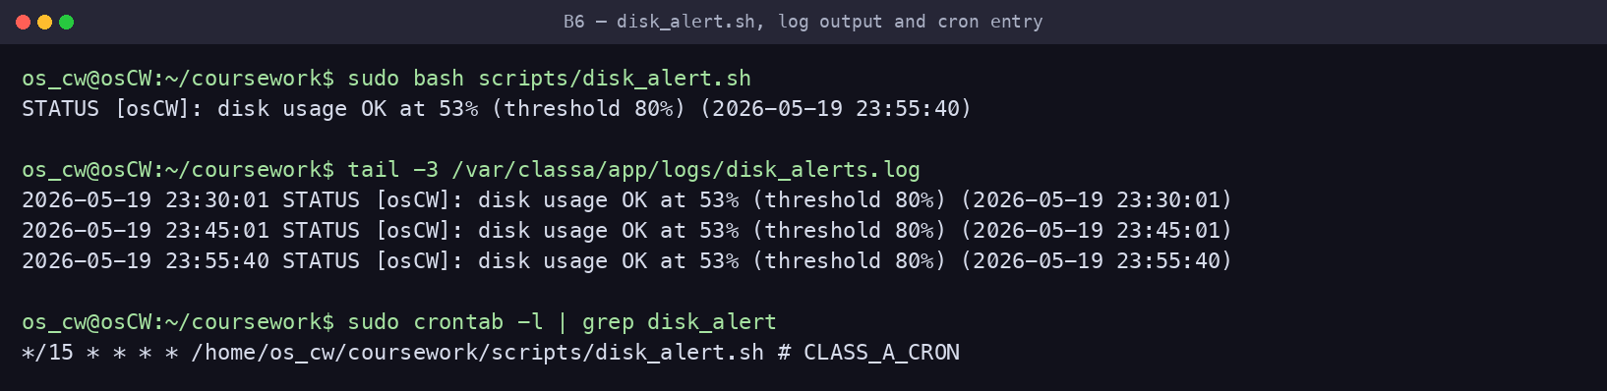
Figure — disk_alert.sh output, the alert log, and the installed cron entry

7. Log Rotation and Backup
log_management.sh rotates the active logs into timestamped copies, compresses them, moves compressed logs older than the retention period to backup storage, and purges archives older than 30 days. Intervals suit the case study: daily rotation, 7-day retention, 30-day archive. --force performs all stages immediately for demonstration.
#!/bin/bash
#
# log_management.sh — Class A Education log rotation & backup
# 1. Rotate active logs into timestamped copies (runs daily via cron).
# 2. Compress rotated logs older than COMPRESS_AFTER_DAYS.
# 3. Move compressed (.gz) logs older than RETENTION_DAYS to backup storage.
# 4. Purge backups older than ARCHIVE_DAYS.
#
# Use `--force` to compress + archive everything immediately (handy for the demo).
#
set -uo pipefail
export LC_ALL=C

# Re-run as root if needed (logs live under root-owned /var/classa).
if [[ $EUID -ne 0 ]]; then exec sudo "$0" "$@"; fi

LOG_DIR="/var/classa/app/logs"
BACKUP_DIR="/var/classa/app/backups"
COMPRESS_AFTER_DAYS=1 # education platform: keep yesterday's logs handy, then compress
RETENTION_DAYS=7 # keep a week of compressed logs in the live log dir
ARCHIVE_DAYS=30 # keep a month of archives in backup, then purge
TS=$(date +%Y%m%d_%H%M%S)
LOGS=("system_monitor.log" "disk_alerts.log" "server.log")

FORCE=0
[[ "${1:-}" == "--force" ]] && FORCE=1

mkdir -p "$LOG_DIR" "$BACKUP_DIR"

echo "[log_management] Rotating active logs..."
for name in "${LOGS[@]}"; do
f="$LOG_DIR/$name"
if [[ -s "$f" ]]; then # only rotate non-empty logs
cp -p "$f" "$f.$TS" # rotate: timestamped copy
: > "$f" # truncate in place (keeps inode/permissions)
echo " rotated: $name -> $name.$TS"
fi
done

echo "[log_management] Compressing rotated logs..."
if (( FORCE )); then
find "$LOG_DIR" -maxdepth 1 -type f -name "*.[0-9]*" ! -name "*.gz" -exec gzip -f {} \; -print
else
find "$LOG_DIR" -maxdepth 1 -type f -name "*.[0-9]*" ! -name "*.gz" \
-mtime +"$COMPRESS_AFTER_DAYS" -exec gzip -f {} \; -print
fi

echo "[log_management] Moving old compressed logs to backup storage..."
if (( FORCE )); then
find "$LOG_DIR" -maxdepth 1 -type f -name "*.gz" -exec mv -f {} "$BACKUP_DIR/" \; -print
else
find "$LOG_DIR" -maxdepth 1 -type f -name "*.gz" \
-mtime +"$RETENTION_DAYS" -exec mv -f {} "$BACKUP_DIR/" \; -print
fi

echo "[log_management] Purging backups older than ${ARCHIVE_DAYS} days..."
find "$BACKUP_DIR" -type f -name "*.gz" -mtime +"$ARCHIVE_DAYS" -delete

echo "$(date '+%Y-%m-%d %H:%M:%S') Log rotation completed (rotate/compress/backup/purge)." >> "$LOG_DIR/rotation.log"
echo "[log_management] Done."
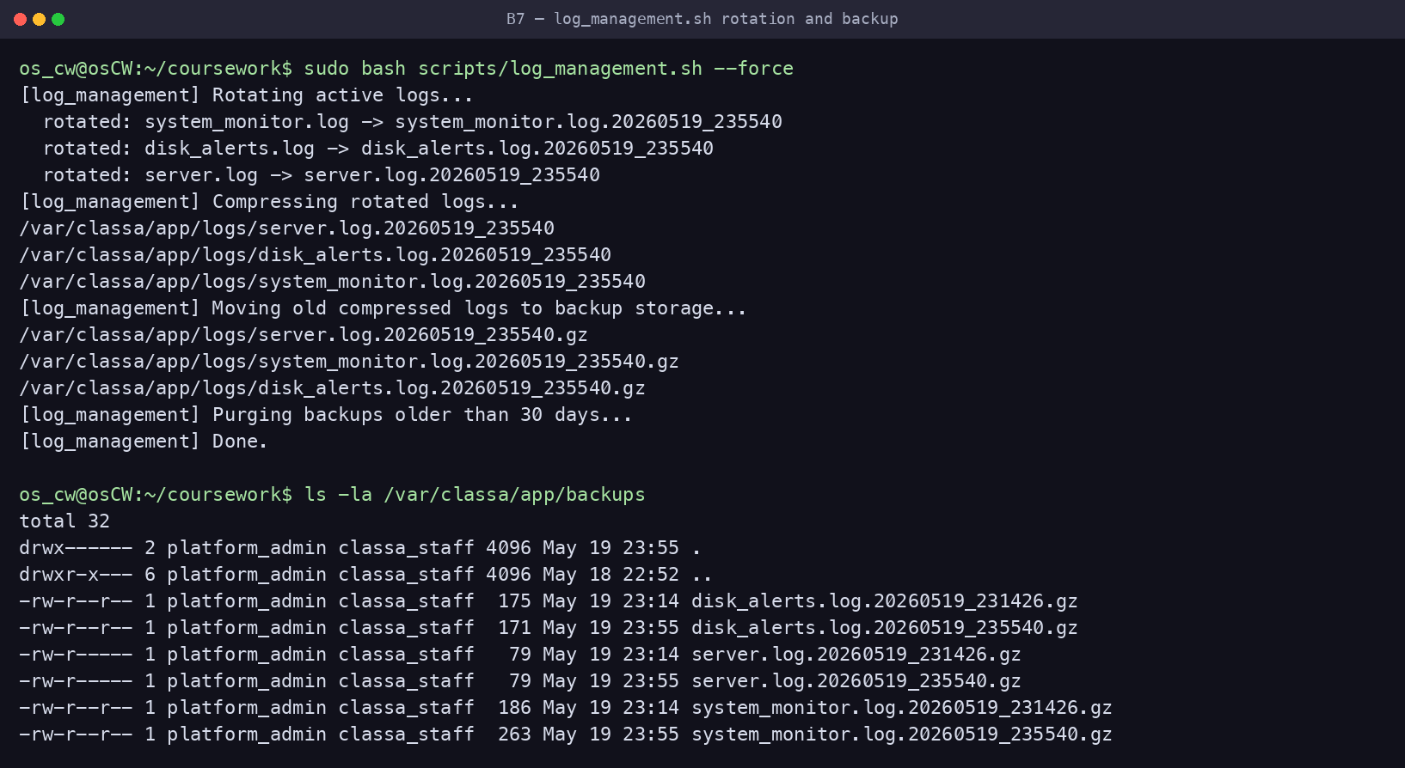
Figure — Rotation/compression run and the resulting .gz archives in backups/

8. Docker Installation and Configuration
install_docker.sh installs Docker Engine via Docker’s official script, enables the service, and adds the administrative user to the docker group. Installation is verified with the version command and the hello-world container.
#!/bin/bash
#
# install_docker.sh — install Docker Engine on Ubuntu and verify it.
# Uses Docker's official install script (detects distro/arch automatically),
# enables the service, and lets the current user run docker without sudo.
#
set -euo pipefail

echo "Installing prerequisites..."
sudo apt update
sudo apt install -y curl ca-certificates

echo "Installing Docker Engine (official get.docker.com script)..."
curl -fsSL https://get.docker.com -o /tmp/get-docker.sh
sudo sh /tmp/get-docker.sh
rm -f /tmp/get-docker.sh

echo "Enabling and starting Docker..."
sudo systemctl enable --now docker

# Allow the invoking user to use docker without sudo (takes effect after re-login).
TARGET_USER="${SUDO_USER:-$USER}"
sudo usermod -aG docker "$TARGET_USER"
echo "Added '$TARGET_USER' to the 'docker' group — log out/in (or run: newgrp docker) to apply."

echo "--------------------------------"
echo "Docker version:"
sudo docker --version
echo "Verifying installation with hello-world:"
sudo docker run --rm hello-world

echo "Docker installation and verification completed."
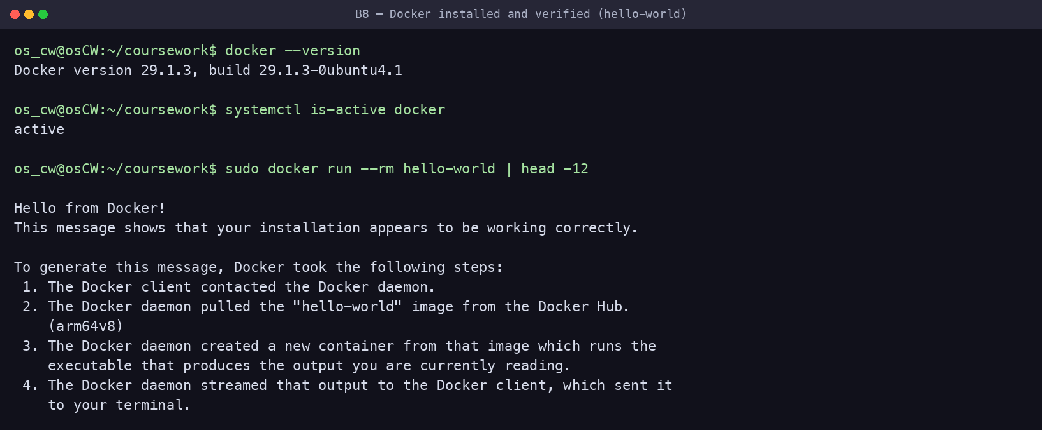
Figure — Docker version, service active, and hello-world verification

9. Creating and Running a Docker Image
The second Part A package (Nginx) is containerised to serve the Class A status web page.
FROM nginx:alpine
COPY index.html /usr/share/nginx/html/index.html
EXPOSE 80
Build & run commands:
docker build -t classa-web-app docker-web/
docker run -d -p 8080:80 --name classa-web-container \
-v classa_data:/usr/share/nginx/html classa-web-app
curl -I http://localhost:8080
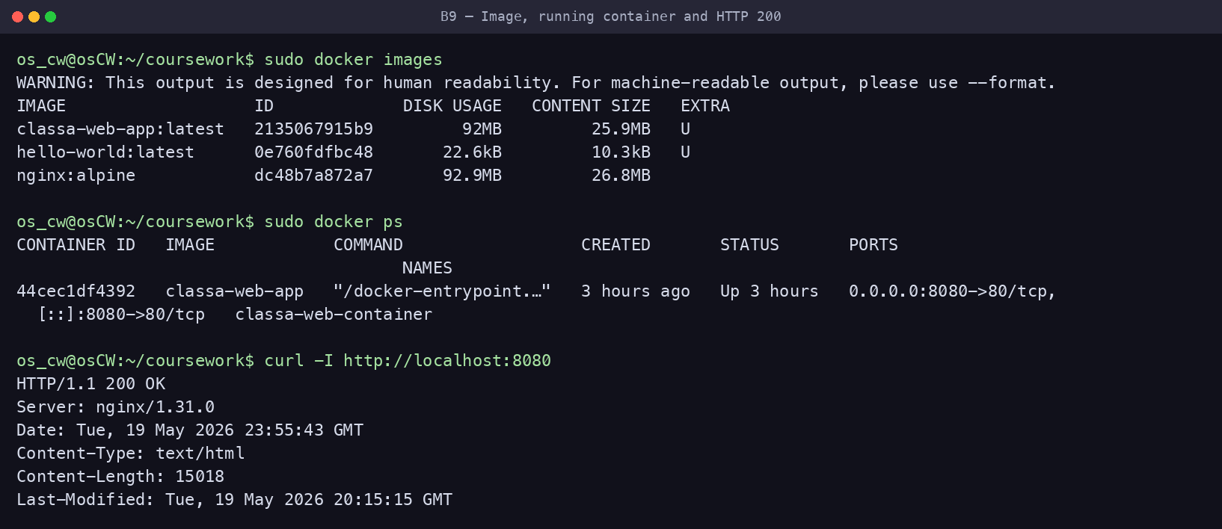
Figure — Built image, running container, and HTTP/1.1 200 OK from the app
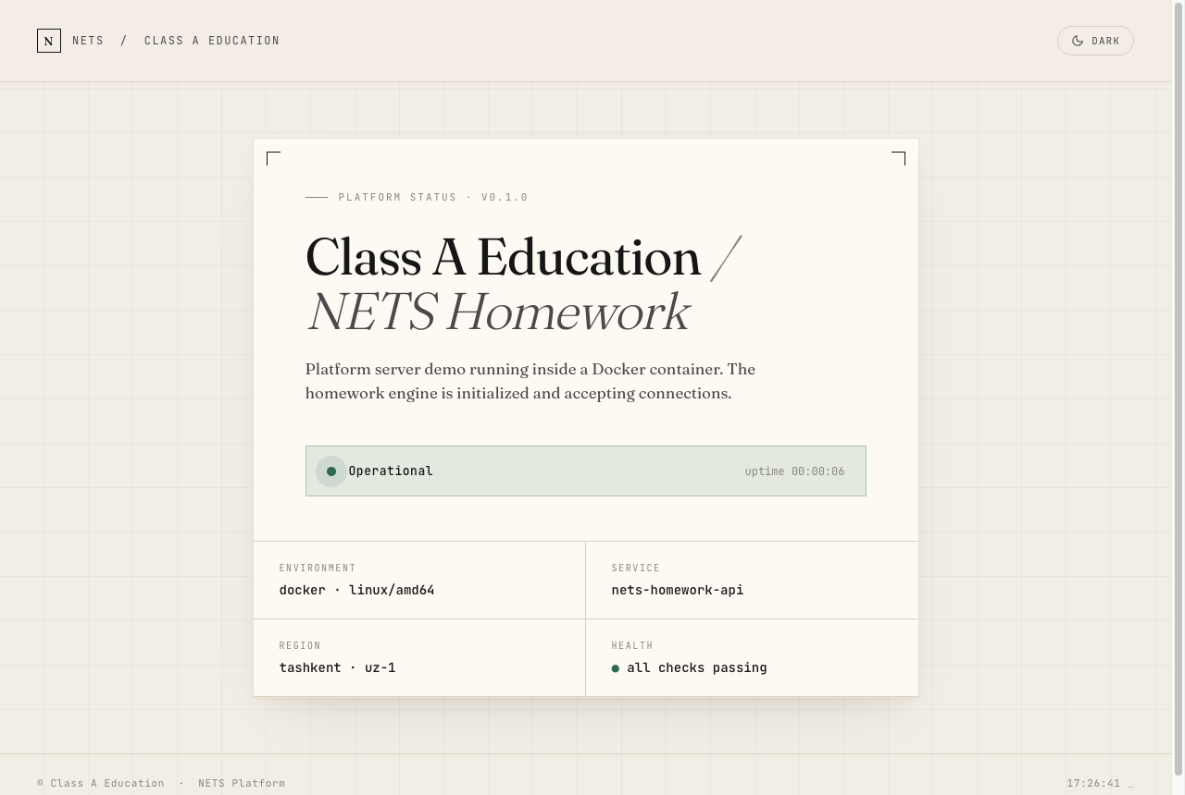
Figure — The running application rendered in a browser at http://192.168.1.56:8080

10. Docker Configuration and Management
docker_manage.sh demonstrates the full container lifecycle: listing running and stopped containers, viewing logs, mapping ports (8081→80), using a named volume for persistent data, and stopping then removing the container.
#!/bin/bash
#
# docker_manage.sh — demonstrates the full Docker container lifecycle:
# list, logs, port mapping, volumes, stop and remove.
# Builds the classa-web-app image first if it is not present.
#
set -uo pipefail

# Use docker without sudo when possible, otherwise fall back to sudo.
DOCKER="docker"
if ! docker info >/dev/null 2>&1; then DOCKER="sudo docker"; fi

IMAGE="classa-web-app"
CONTAINER="classa-managed-container"
PORT=8081
SCRIPT_DIR="$(cd "$(dirname "${BASH_SOURCE[0]}")" && pwd)"
WEB_DIR="$(cd "$SCRIPT_DIR/../docker-web" && pwd)"

# Build the image if it does not exist yet (B.9 build step).
if ! $DOCKER image inspect "$IMAGE" >/dev/null 2>&1; then
echo "Image '$IMAGE' not found — building from $WEB_DIR ..."
$DOCKER build -t "$IMAGE" "$WEB_DIR"
fi

echo "Removing old managed container if it exists..."
$DOCKER rm -f "$CONTAINER" 2>/dev/null || true

echo "Creating Docker volume (persistent data)..."
$DOCKER volume create classa_data >/dev/null

echo "Running container with port mapping and volume..."
$DOCKER run -d \
-p ${PORT}:80 \
--name "$CONTAINER" \
-v classa_data:/usr/share/nginx/html \
"$IMAGE"

echo "== Running containers =="
$DOCKER ps
echo "== Container logs =="
$DOCKER logs "$CONTAINER"
echo "== All containers (including stopped) =="
$DOCKER ps -a
echo "== Docker volumes =="
$DOCKER volume ls
echo "== Port mapping =="
$DOCKER port "$CONTAINER"

echo "Stopping container..."
$DOCKER stop "$CONTAINER"
echo "Removing container..."
$DOCKER rm "$CONTAINER"

echo "Docker management operations completed."
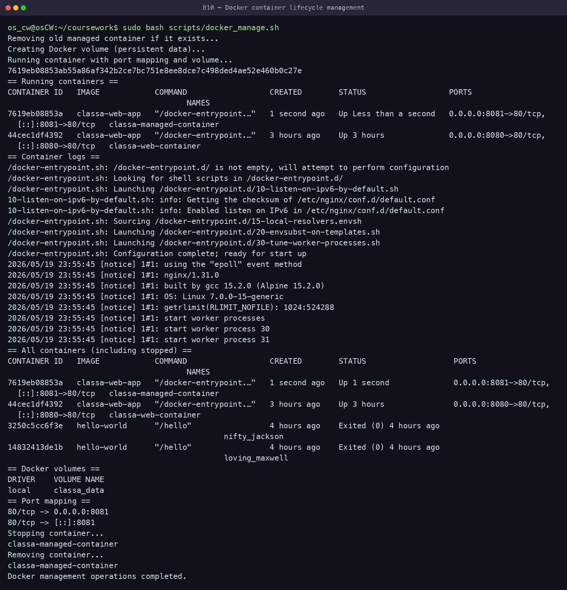
Figure — Container lifecycle: run, list, logs, ports, volumes, stop, remove

References
Nginx (2024) nginx documentation. Available at: https://nginx.org/en/docs/ (Accessed: 5 June 2026).
Silberschatz, A., Galvin, P.B. and Gagne, G. (2018) Operating System Concepts. 10th edn. Hoboken, NJ: Wiley.
Tanenbaum, A.S. and Bos, H. (2015) Modern Operating Systems. 4th edn. Boston, MA: Pearson.
The Linux Kernel (2024) CFS Scheduler. Available at: https://www.kernel.org/doc/html/latest/scheduler/sched-design-CFS.html (Accessed: 5 June 2026).
The Linux Kernel (2024) ext4 Data Structures and Algorithms. Available at: https://www.kernel.org/doc/html/latest/filesystems/ext4/ (Accessed: 5 June 2026).
The Linux man-pages project (2024) Linux manual pages: chmod(1), inode(7), umask(1), useradd(8), sudo(8). Available at: https://man7.org/linux/man-pages/ (Accessed: 5 June 2026).
Ubuntu (2024) Ubuntu Server documentation. Available at: https://ubuntu.com/server/docs (Accessed: 5 June 2026).

