Operating Systems
Coursework (Refer / Defer) — Report & Practical Implementation
Case study: Class A Education / NETS Homework Platform Server
Student name: ______________________________
Student ID: ______________________________
Module: Operating Systems Weighting: 40%
Lecturer: Pochitaev Dmitriy
Submission date: ______________________________

HOW TO USE THIS DOCUMENT — Part B (scripts + screenshots) is complete with live evidence captured from the VM. In Part A, the case-study description is drafted, but the software/distribution justifications and the OS-components critical discussion are left as guided placeholders: per the coursework AI rule, all critical discussion, analysis and evaluation must be written in YOUR OWN WORDS. Replace every [WRITE THIS YOURSELF] block.

Part A — Report

1. Case study description
Class A Education is a small private tutoring provider that operates the NETS Homework Platform, an internal web application used daily by tutors and students. Tutors publish course materials and assignments, while students log in to download materials and upload completed homework. The whole service runs on a single Linux server that is administered by a small technical team (one or two part-time system administrators).
The platform has clear operational requirements. It must serve a web front-end reliably to dozens of concurrent users during peak study hours, and it must store structured records — student accounts, assignments, submission metadata and grades — safely and consistently. Because the team is small, the server must be largely self-managing: routine tasks such as health monitoring, disk-space checking, log rotation and backups need to be automated rather than performed by hand. Downtime or data loss directly affects students’ ability to submit work on time, so reliability and data integrity are the primary concerns, followed by security of the personal data the platform holds.
The system therefore combines multiple software components: a web server to deliver the front-end and proxy application traffic, and a relational database to persist platform data. Containerisation is used to package and run part of the stack in an isolated, reproducible way. Automated monitoring and alerting give the small team early warning of resource problems, and scheduled log management keeps the single disk from filling up — making this a realistic scenario that benefits strongly from operating-system-level automation.
(~260 words — adjust to fit the 200–300 word limit.)

2. System requirements and software selection
Two software packages were selected: Nginx (web server / reverse proxy) and PostgreSQL (relational database).
Reference facts you can build your justification on:
• Nginx — event-driven web server with very low memory use and high concurrency; serves static content and reverse-proxies the application; widely deployed and well documented.
• PostgreSQL — mature, ACID-compliant relational database with strong data integrity, MVCC concurrency, and robust constraint/transaction support suitable for submission/grade records.
[WRITE THIS YOURSELF] Briefly justify (in your own words) why EACH package fits the Class A case study — e.g. why Nginx suits many concurrent student connections, and why PostgreSQL’s integrity guarantees matter for homework/grade data. (4 marks)

3. Operating system distribution selection
Selected distribution: Ubuntu Server 26.04 LTS.
Reference facts you can build your justification on:
• Stability & support — LTS releases receive ~5 years of standard security/maintenance updates (extendable via ESM), giving a predictable, stable base.
• Security — AppArmor mandatory access control, regular security updates, optional unattended-upgrades for automatic patching.
• Package management — APT with a very large package ecosystem; Nginx, PostgreSQL and Docker are all easily installed and updated.
• Performance — modern kernel with good hardware support and efficient resource use on a modest single-server deployment.
• Community / enterprise support — huge community knowledge base plus commercial backing from Canonical.
[WRITE THIS YOURSELF] Turn the bullets above into a justification IN YOUR OWN WORDS, linking each factor to the Class A scenario (small team, single server, reliability/security needs). (5 marks)

4. Operating system components — critical discussion
[WRITE THIS YOURSELF — 16 marks, ~1000 words, your own words only.] Critically explain each component below and link it to the Class A case study (performance, reliability, security). The prompts are only a checklist of what to cover — do not submit them as-is.
4.1 Process and thread management
Prompts: how the scheduler shares the 2 vCPUs between Nginx worker processes, PostgreSQL backends and your cron jobs; processes vs threads; context switching; why Nginx’s event model scales; impact on responsiveness during peak student load.
4.2 Memory management, including paging and virtual memory
Prompts: virtual address spaces and isolation; paging/swapping and what happens when RAM is exhausted; page cache speeding up repeated reads of course materials; the risk of OOM with limited RAM and how it affects reliability.
4.3 File systems and storage management
Prompts: the ext4 root filesystem; inodes, permissions and ownership; how your /var/classa layout, the sticky-bit exchange directory and log rotation relate to storage management; journaling and reliability.
4.4 User management, authentication, and access control
Prompts: Linux users/groups, /etc/passwd & /etc/shadow, sudo and least privilege; how your classa_staff group, the umask 0277 default and the directory permissions enforce confidentiality of student data and separation of duties.

Part B — Practical Implementation
All evidence below was captured live from the VirtualBox VM (host osCW, Ubuntu 26.04 LTS, aarch64). Each terminal figure shows the command issued and its real output.

1. Operating system installation (8)
Ubuntu Server 26.04 LTS was installed in an Oracle VirtualBox VM. Key configuration choices: a single 15 GB virtual disk partitioned into an EFI system partition (/boot/efi) and an ext4 root (/); a primary administrative user (os_cw) with sudo rights; and bridged/NAT networking so the VM is reachable on the LAN. The figure confirms the installed distribution, kernel, CPU, disk layout and free space.
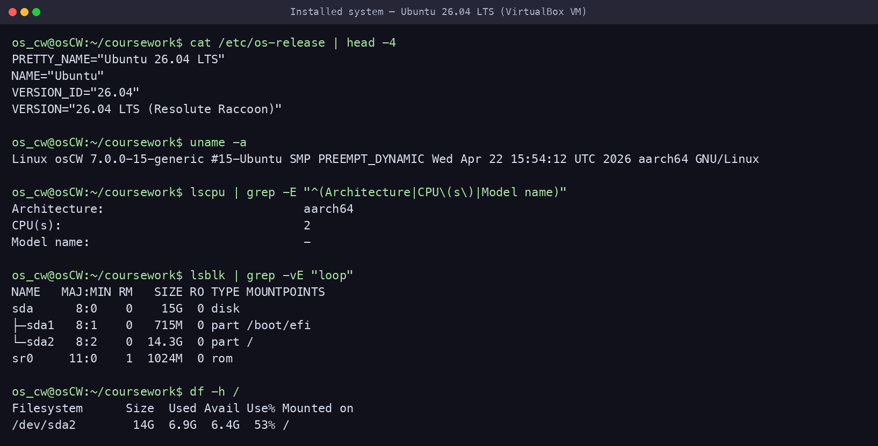
Figure — Installed OS, kernel, CPU, disk layout and usage
Add your own VirtualBox installation screenshots here (installer steps, disk partitioning, user creation, network settings) to fully evidence the install process.

2. Software installation and configuration (4)
install_classa_services.sh installs and enables the two Part A packages (Nginx + PostgreSQL) plus helper tools (curl, bc, gzip). Script:
#!/bin/bash
#
# install_classa_services.sh — install the two core packages for Class A Education:
# Nginx (web server / reverse proxy) and PostgreSQL (relational database).
# Also installs the helper tools the other scripts rely on (curl, bc, gzip).
#
set -euo pipefail
export DEBIAN_FRONTEND=noninteractive

echo "Updating package lists..."
sudo apt update

echo "Installing Nginx, PostgreSQL and helper tools..."
sudo apt install -y nginx postgresql postgresql-contrib curl bc gzip

echo "Enabling and starting services..."
sudo systemctl enable --now nginx
sudo systemctl enable --now postgresql

echo "--------------------------------"
sudo systemctl is-active --quiet nginx && echo "Nginx status: Active" || echo "Nginx status: FAILED"
sudo systemctl is-active --quiet postgresql && echo "PostgreSQL status: Active" || echo "PostgreSQL status: FAILED"
echo "--------------------------------"
nginx -v
psql --version

echo "Class A Education services installation completed."
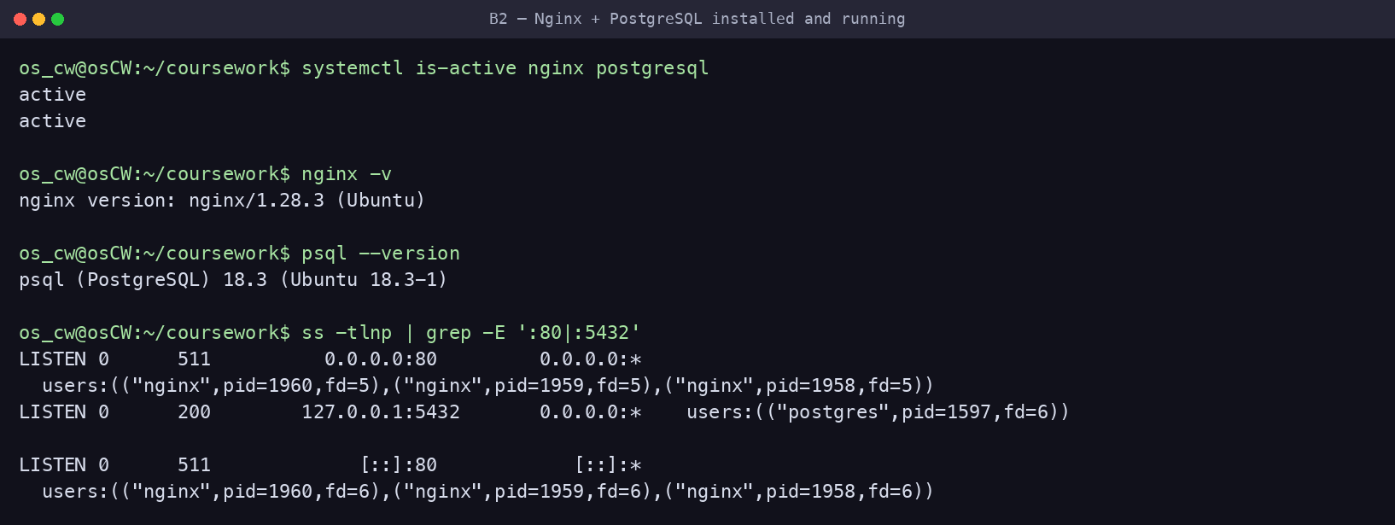
Figure — Both services active, versions, and listening sockets (:80, :5432)

3. User and group management (8)
manage_users.sh creates the classa_staff group and three role accounts (platform_admin, content_editor, support_user), each with a bash shell and home directory; grants sudo to platform_admin; writes a read-only readme.txt; and appends three aliases plus a restrictive umask 0277 to each .bashrc (so new files default to owner-read-only, 0400). The .bashrc edit is guarded by a marker so re-runs never duplicate it; --reset recreates the users cleanly.
#!/bin/bash
#
# manage_users.sh — Class A Education users & group management
# - Creates the classa_staff group and 3 role accounts (bash shell + home dir)
# - Grants sudo to the platform administrator
# - Drops a read-only readme.txt into each home
# - Adds 3 aliases + a restrictive umask (0277) to each .bashrc (idempotent)
#
# Safe to re-run. Use `--reset` to delete and recreate the users from scratch.
#
set -euo pipefail

GROUP_NAME="classa_staff"
USERS=("platform_admin" "content_editor" "support_user")
SUDO_USER_NAME="platform_admin"
MARKER="# >>> Class A Education config >>>"

# ----------------------------------------------------------------- --reset ---
if [[ "${1:-}" == "--reset" ]]; then
for u in "${USERS[@]}"; do
if id "$u" >/dev/null 2>&1; then
echo "Removing existing user $u ..."
sudo pkill -u "$u" 2>/dev/null || true
sudo userdel -r "$u" 2>/dev/null || true
fi
done
fi

echo "Creating group: $GROUP_NAME"
sudo groupadd -f "$GROUP_NAME"

for user in "${USERS[@]}"; do
if id "$user" >/dev/null 2>&1; then
echo "User $user already exists — ensuring configuration."
else
echo "Creating user: $user"
sudo useradd -m -s /bin/bash "$user"
fi

echo " adding $user to $GROUP_NAME"
sudo usermod -aG "$GROUP_NAME" "$user"

# Custom file in the home directory, owner read-only.
echo "Welcome to the Class A Education server. Your files are private and read-only by default." \
| sudo tee "/home/$user/readme.txt" >/dev/null
sudo chown "$user:$user" "/home/$user/readme.txt"
sudo chmod 400 "/home/$user/readme.txt"

# Aliases + umask — appended only once thanks to the marker (no duplicates on re-run).
if ! sudo grep -qF "$MARKER" "/home/$user/.bashrc" 2>/dev/null; then
sudo tee -a "/home/$user/.bashrc" >/dev/null <<EOF

$MARKER
alias ll='ls -la'
alias logs='cd /var/classa/app/logs'
alias app='cd /var/classa/app'
# New files default to owner read-only (0400); nothing for group/others.
umask 0277
# <<< Class A Education config <<<
EOF
sudo chown "$user:$user" "/home/$user/.bashrc"
echo " configured aliases + umask for $user"
else
echo " $user already configured (skipping .bashrc append)"
fi

# Keep each home private.
sudo chmod 750 "/home/$user"
done

echo "Granting sudo permissions to $SUDO_USER_NAME ..."
sudo usermod -aG sudo "$SUDO_USER_NAME"

echo "User and group setup completed successfully."
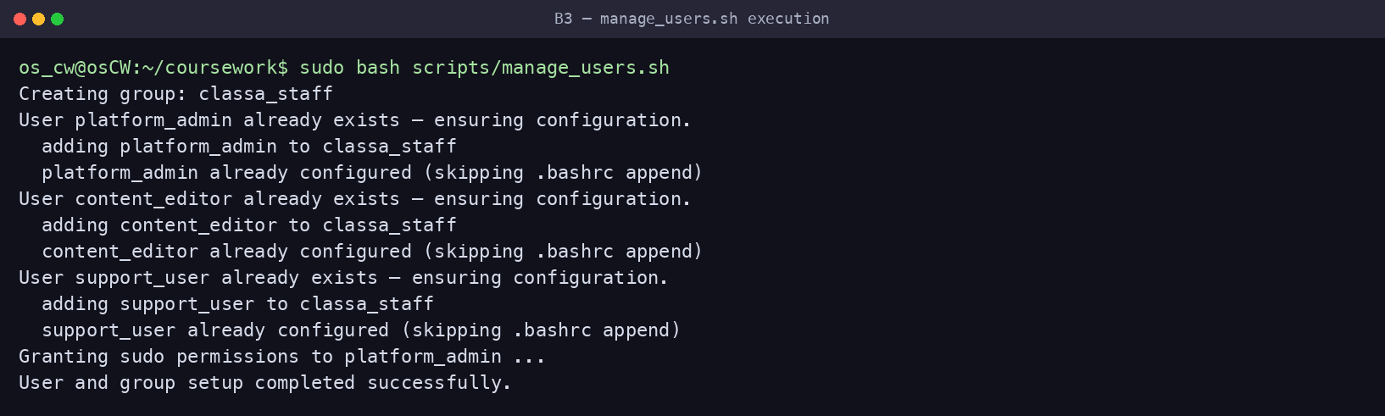
Figure — manage_users.sh run (idempotent)
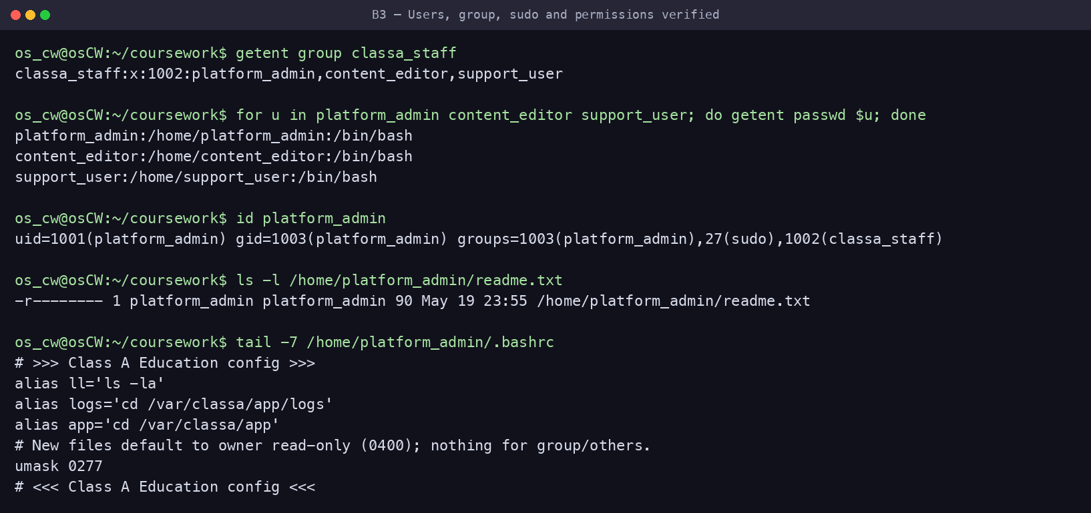
Figure — Group, shells, sudo, readme (0400) and .bashrc aliases + umask

4. File system structure and permissions (8)
setup_structure.sh builds the /var/classa tree: course_materials (shared, world-readable files 644), uploads_exchange (group drop-box with the sticky bit, 1770, so users can create but not delete each other’s files), and an app/ subtree (config/logs/data/backups) demonstrating a range of permissions; it also creates two symbolic links.
#!/bin/bash
#
# setup_structure.sh — Class A Education filesystem layout & permissions
# /var/classa/course_materials -> shared, readable by others (read-only)
# /var/classa/uploads_exchange -> group drop-box with sticky bit (no deleting others' files)
# /var/classa/app/{config,logs,data,backups} -> app tree demonstrating a range of permissions
# + 2 symbolic links in support_user's home
#
# Safe to re-run (idempotent).
#
set -euo pipefail

BASE="/var/classa"
GROUP_NAME="classa_staff"
OWNER="platform_admin"

# Make the script self-sufficient.
getent group "$GROUP_NAME" >/dev/null || sudo groupadd "$GROUP_NAME"

echo "Creating Class A directory structure..."
sudo mkdir -p "$BASE/course_materials" \
"$BASE/uploads_exchange" \
"$BASE/app/config" \
"$BASE/app/logs" \
"$BASE/app/data" \
"$BASE/app/backups"

echo "Creating sample files..."
echo "Class A public course material: Lesson 1" | sudo tee "$BASE/course_materials/lesson1.txt" >/dev/null
echo "Platform rules and student guide" | sudo tee "$BASE/course_materials/rules.txt" >/dev/null
echo "Database connection settings placeholder" | sudo tee "$BASE/app/config/settings.conf" >/dev/null
echo "Class A application log started" | sudo tee "$BASE/app/logs/server.log" >/dev/null
echo "Sample homework session data" | sudo tee "$BASE/app/data/homework_session.txt" >/dev/null

echo "Setting ownership..."
sudo chown -R "$OWNER:$GROUP_NAME" "$BASE"

echo "Setting permissions..."
# Shared course materials: world-readable, read-only for others.
sudo chmod 755 "$BASE/course_materials"
sudo chmod 644 "$BASE/course_materials/"*

# Upload exchange: group members create files; sticky bit stops them deleting each other's.
sudo chmod 1770 "$BASE/uploads_exchange"
sudo chown "$OWNER:$GROUP_NAME" "$BASE/uploads_exchange"

# Application tree (4 subdirectories demonstrating a range of permission models).
sudo chmod 700 "$BASE/app/config"; sudo chmod 600 "$BASE/app/config/settings.conf"
sudo chmod 750 "$BASE/app/logs"; sudo chmod 640 "$BASE/app/logs/server.log"
sudo chmod 750 "$BASE/app/data"; sudo chmod 640 "$BASE/app/data/homework_session.txt"
sudo chmod 700 "$BASE/app/backups"

echo "Creating symbolic links..."
if id support_user >/dev/null 2>&1; then
sudo ln -sfn "$BASE/course_materials" /home/support_user/classa_materials
sudo ln -sfn "$BASE/uploads_exchange" /home/support_user/classa_uploads
# NB: do NOT `chown -h` these links. On this system chown -h on a
# symlink-to-directory dereferences and rewrites the TARGET's ownership
# (reverting /var/classa/uploads_exchange to support_user). Symlink
# ownership is cosmetic on Linux — the target's permissions govern access —
# so leaving the links root-owned is correct and safe.
else
echo " (support_user not found — run manage_users.sh first to create the symlinks)"
fi

echo "Class A file structure is ready."
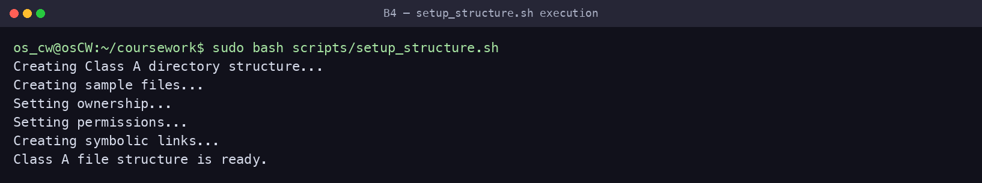
Figure — setup_structure.sh run
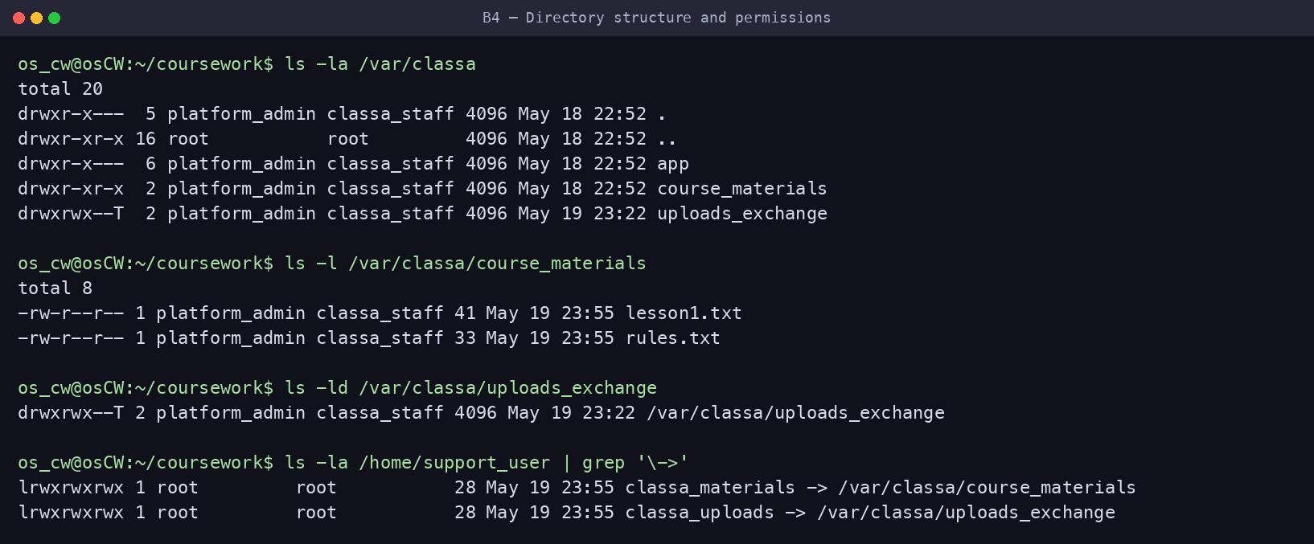
Figure — Directory tree, permission bits, sticky bit and symlinks
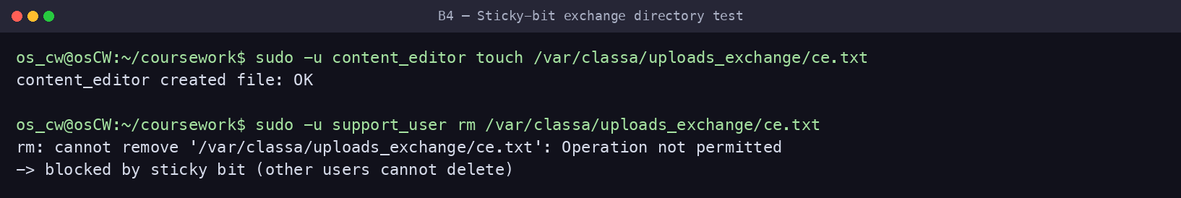
Figure — Functional proof: a group member can create but cannot delete another's file

5. System monitoring script (8)
monitor.sh records CPU, memory and disk usage with a timestamp to /var/classa/app/logs/system_monitor.log (CPU is computed with awk, so no bc dependency). setup_cron.sh schedules it automatically every 5 minutes.
#!/bin/bash
#
# monitor.sh — Class A Education system monitor
# Collects CPU, memory and disk usage and appends a timestamped line to the log.
# Designed to run unattended from cron (see setup_cron.sh).
#
set -uo pipefail
export LC_ALL=C # force '.' as decimal separator so parsing is locale-independent

# Re-run as root if needed (so we can always write under /var/classa). When cron
# runs this as root the check is skipped; a manual run will prompt once for sudo.
if [[ $EUID -ne 0 ]]; then exec sudo "$0" "$@"; fi

LOG_DIR="/var/classa/app/logs"
LOGFILE="$LOG_DIR/system_monitor.log"
mkdir -p "$LOG_DIR"

TIMESTAMP=$(date "+%Y-%m-%d %H:%M:%S")

# CPU usage = 100 - idle%. Pull the idle ("id") field out of `top` without needing
# the external `bc` tool — awk does the arithmetic.
CPU_IDLE=$(top -bn1 | awk -F',' '/[Cc]pu\(s\)/{
for (i = 1; i <= NF; i++)
if ($i ~ /id/) { gsub(/[^0-9.]/, "", $i); print $i; exit }
}')
CPU_USAGE=$(awk -v idle="${CPU_IDLE:-0}" 'BEGIN { printf "%.1f", 100 - idle }')

# Memory: used/total in MB plus percentage.
MEM_USAGE=$(free -m | awk 'NR==2{printf "Memory: %s/%sMB (%.2f%%)", $3, $2, ($2>0 ? $3*100/$2 : 0)}')

# Disk: usage percentage of the root filesystem.
DISK_USAGE=$(df -h / | awk 'NR==2{print $5}')

echo "[$TIMESTAMP] CPU: ${CPU_USAGE}% | $MEM_USAGE | Disk: $DISK_USAGE" >> "$LOGFILE"
Automatic scheduling (setup_cron.sh):
#!/bin/bash
#
# setup_cron.sh — install the Class A Education scheduled jobs automatically.
#
# Schedules (installed into ROOT's crontab so the jobs run with the privileges
# they need — no interactive sudo inside cron):
# monitor.sh every 5 minutes (system monitoring at regular intervals)
# disk_alert.sh every 15 minutes (homework uploads can fill disk quickly)
# log_management.sh daily at 00:00 (rotate/compress/back up logs)
#
# Paths are derived from THIS script's own location, so the jobs always point at
# the real scripts (no hard-coded /home/<user>/... that breaks if the repo moves).
#
set -euo pipefail

# Re-run as root so we edit root's crontab.
if [[ $EUID -ne 0 ]]; then exec sudo "$0" "$@"; fi

SCRIPT_DIR="$(cd "$(dirname "${BASH_SOURCE[0]}")" && pwd)"
MON="$SCRIPT_DIR/monitor.sh"
DISK="$SCRIPT_DIR/disk_alert.sh"
LOGR="$SCRIPT_DIR/log_management.sh"
TAG="# CLASS_A_CRON"

chmod +x "$MON" "$DISK" "$LOGR"

# --- Install/refresh entries in root's crontab (idempotent) ---
tmp=$(mktemp)
crontab -l 2>/dev/null | grep -v "$TAG" > "$tmp" || true
cat >> "$tmp" <<EOF
*/5 * * * * $MON $TAG
*/15 * * * * $DISK $TAG
0 0 * * * $LOGR $TAG
EOF
crontab "$tmp"
rm -f "$tmp"

# --- Remove any stale Class A entries the user may have added manually elsewhere ---
INVOKER="${SUDO_USER:-}"
if [[ -n "$INVOKER" ]] && crontab -u "$INVOKER" -l >/dev/null 2>&1; then
crontab -u "$INVOKER" -l 2>/dev/null \
| grep -vE "($TAG|coursework/scripts/(monitor|disk_alert|log_management)\.sh)" \
| crontab -u "$INVOKER" - || true
echo "Cleaned any stale Class A entries from ${INVOKER}'s crontab."
fi

echo "Installed Class A cron jobs (root):"
crontab -l | grep "$TAG"
echo "Cron setup completed."
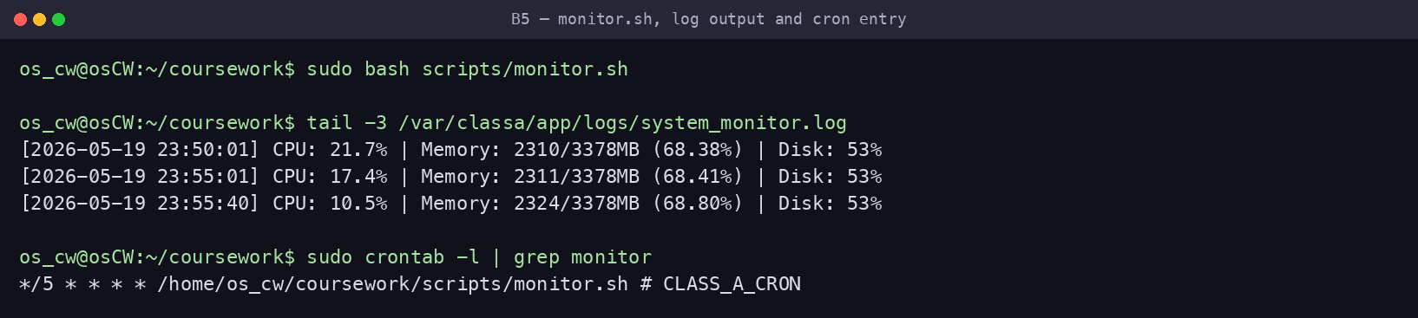
Figure — monitor.sh output, the timestamped log, and the installed cron entry

6. Disk space monitoring and alerts (7)
disk_alert.sh checks the root filesystem against an 80% threshold and notifies through three channels — terminal + OS broadcast (wall/notify-send), a file log, and Telegram. It is non-interactive so it can run from cron (configuration is stored once via --setup in /etc/classa/alert.conf). It is scheduled every 15 minutes — appropriate because homework uploads can fill the single disk relatively quickly during peak periods.
#!/bin/bash
#
# disk_alert.sh — Class A Education low-disk-space monitor
# Sends alerts through THREE channels when the root filesystem crosses the
# threshold: (1) terminal + OS broadcast, (2) file log, (3) Telegram.
#
# Runs unattended from cron (config comes from /etc/classa/alert.conf).
# Interactive first-time setup: sudo ./disk_alert.sh --setup
#
set -uo pipefail
export LC_ALL=C

# Re-run as root if needed (write logs, broadcast with `wall`).
if [[ $EUID -ne 0 ]]; then exec sudo "$0" "$@"; fi

# ---------------------------------------------------------------- defaults ---
THRESHOLD=80
LOG_DIR="/var/classa/app/logs"
LOGFILE="$LOG_DIR/disk_alerts.log"
CONFIG_FILE="/etc/classa/alert.conf"
HOST=$(hostname)

# Shared coursework Telegram bot — students who have not configured their own bot
# still receive alerts. Override BOT_TOKEN/CHAT_ID/THRESHOLD in $CONFIG_FILE.
BOT_TOKEN="8755151887:AAFen7m89xP6CYhS0934G7VHXFQGUw7Z4bg"
CHAT_ID=""

# Load saved overrides if present.
# shellcheck source=/dev/null
[[ -f "$CONFIG_FILE" ]] && source "$CONFIG_FILE"

mkdir -p "$LOG_DIR"

# ----------------------------------------------------- interactive --setup ---
if [[ "${1:-}" == "--setup" ]]; then
mkdir -p "$(dirname "$CONFIG_FILE")"
read -rp "Use your OWN Telegram bot token? (y/N): " own
if [[ "$own" =~ ^[Yy]$ ]]; then
read -rp "Enter your bot token: " BOT_TOKEN
else
echo "Using the shared coursework bot — open Telegram and press START on @Viper_worker_bot"
fi
read -rp "Enter your Telegram chat/user ID: " CHAT_ID
umask 077
cat > "$CONFIG_FILE" <<EOF
# Class A Education disk-alert configuration
THRESHOLD=$THRESHOLD
BOT_TOKEN="$BOT_TOKEN"
CHAT_ID="$CHAT_ID"
EOF
chmod 600 "$CONFIG_FILE"
echo "Saved configuration to $CONFIG_FILE"
exit 0
fi

# ----------------------------------------------------------------- measure ---
USAGE=$(df / | awk 'NR==2 {gsub(/%/, "", $5); print $5}')
USAGE=${USAGE:-0}
TS=$(date '+%Y-%m-%d %H:%M:%S')

send_telegram() {
local msg="$1"
if [[ -z "$BOT_TOKEN" || -z "$CHAT_ID" ]]; then
echo "Telegram skipped (no CHAT_ID — run: sudo $0 --setup)"
return
fi
if curl -fsS -m 10 -X POST "https://api.telegram.org/bot$BOT_TOKEN/sendMessage" \
--data-urlencode "chat_id=$CHAT_ID" \
--data-urlencode "text=$msg" >/dev/null; then
echo "Telegram notification sent."
else
echo "Telegram notification failed."
fi
}

# ------------------------------------------------------------ alert / status -
if (( USAGE > THRESHOLD )); then
MSG="ALERT [$HOST]: disk usage ${USAGE}% exceeds ${THRESHOLD}% threshold ($TS)"

echo "----------------------------------------------------"
echo "$MSG" # 1a. terminal
echo "----------------------------------------------------"
command -v wall >/dev/null 2>&1 && echo "$MSG" | wall 2>/dev/null # 1b. OS broadcast
command -v notify-send >/dev/null 2>&1 && notify-send -u critical "Class A Disk Alert" "$MSG" 2>/dev/null

echo "$TS $MSG" >> "$LOGFILE" # 2. file log
send_telegram "$MSG" # 3. Telegram
else
MSG="STATUS [$HOST]: disk usage OK at ${USAGE}% (threshold ${THRESHOLD}%) ($TS)"
echo "$MSG" # terminal
echo "$TS $MSG" >> "$LOGFILE" # file log (no Telegram spam when healthy)
fi
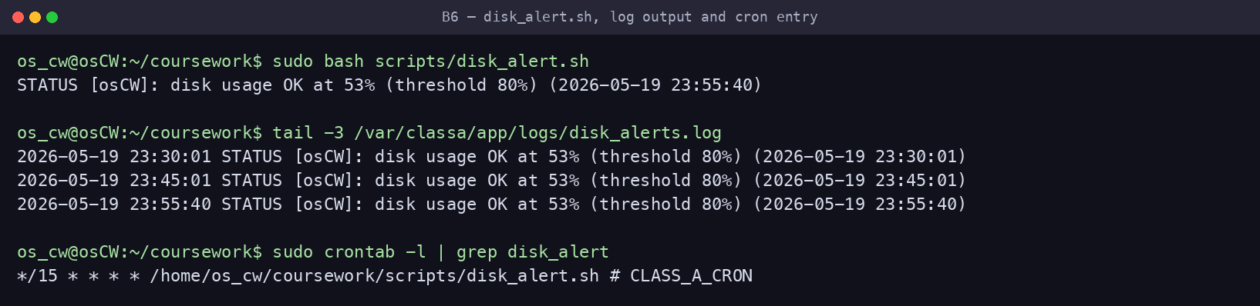
Figure — disk_alert.sh output, the alert log, and the installed cron entry
At demo time run 'sudo ./disk_alert.sh --setup' to enter your own Telegram chat ID; to show an actual ALERT (disk is only 53%), temporarily lower THRESHOLD in /etc/classa/alert.conf.

7. Log rotation and backup (9)
log_management.sh rotates the active logs into timestamped copies, compresses them, moves compressed logs older than the retention period to backup storage, and purges archives older than 30 days. Intervals suit the case study: daily rotation (via cron at 00:00), 7-day retention, 30-day archive. --force performs all stages immediately for demonstration.
#!/bin/bash
#
# log_management.sh — Class A Education log rotation & backup
# 1. Rotate active logs into timestamped copies (runs daily via cron).
# 2. Compress rotated logs older than COMPRESS_AFTER_DAYS.
# 3. Move compressed (.gz) logs older than RETENTION_DAYS to backup storage.
# 4. Purge backups older than ARCHIVE_DAYS.
#
# Use `--force` to compress + archive everything immediately (handy for the demo).
#
set -uo pipefail
export LC_ALL=C

# Re-run as root if needed (logs live under root-owned /var/classa).
if [[ $EUID -ne 0 ]]; then exec sudo "$0" "$@"; fi

LOG_DIR="/var/classa/app/logs"
BACKUP_DIR="/var/classa/app/backups"
COMPRESS_AFTER_DAYS=1 # education platform: keep yesterday's logs handy, then compress
RETENTION_DAYS=7 # keep a week of compressed logs in the live log dir
ARCHIVE_DAYS=30 # keep a month of archives in backup, then purge
TS=$(date +%Y%m%d_%H%M%S)
LOGS=("system_monitor.log" "disk_alerts.log" "server.log")

FORCE=0
[[ "${1:-}" == "--force" ]] && FORCE=1

mkdir -p "$LOG_DIR" "$BACKUP_DIR"

echo "[log_management] Rotating active logs..."
for name in "${LOGS[@]}"; do
f="$LOG_DIR/$name"
if [[ -s "$f" ]]; then # only rotate non-empty logs
cp -p "$f" "$f.$TS" # rotate: timestamped copy
: > "$f" # truncate in place (keeps inode/permissions)
echo " rotated: $name -> $name.$TS"
fi
done

echo "[log_management] Compressing rotated logs..."
if (( FORCE )); then
find "$LOG_DIR" -maxdepth 1 -type f -name "*.[0-9]*" ! -name "*.gz" -exec gzip -f {} \; -print
else
find "$LOG_DIR" -maxdepth 1 -type f -name "*.[0-9]*" ! -name "*.gz" \
-mtime +"$COMPRESS_AFTER_DAYS" -exec gzip -f {} \; -print
fi

echo "[log_management] Moving old compressed logs to backup storage..."
if (( FORCE )); then
find "$LOG_DIR" -maxdepth 1 -type f -name "*.gz" -exec mv -f {} "$BACKUP_DIR/" \; -print
else
find "$LOG_DIR" -maxdepth 1 -type f -name "*.gz" \
-mtime +"$RETENTION_DAYS" -exec mv -f {} "$BACKUP_DIR/" \; -print
fi

echo "[log_management] Purging backups older than ${ARCHIVE_DAYS} days..."
find "$BACKUP_DIR" -type f -name "*.gz" -mtime +"$ARCHIVE_DAYS" -delete

echo "$(date '+%Y-%m-%d %H:%M:%S') Log rotation completed (rotate/compress/backup/purge)." >> "$LOG_DIR/rotation.log"
echo "[log_management] Done."
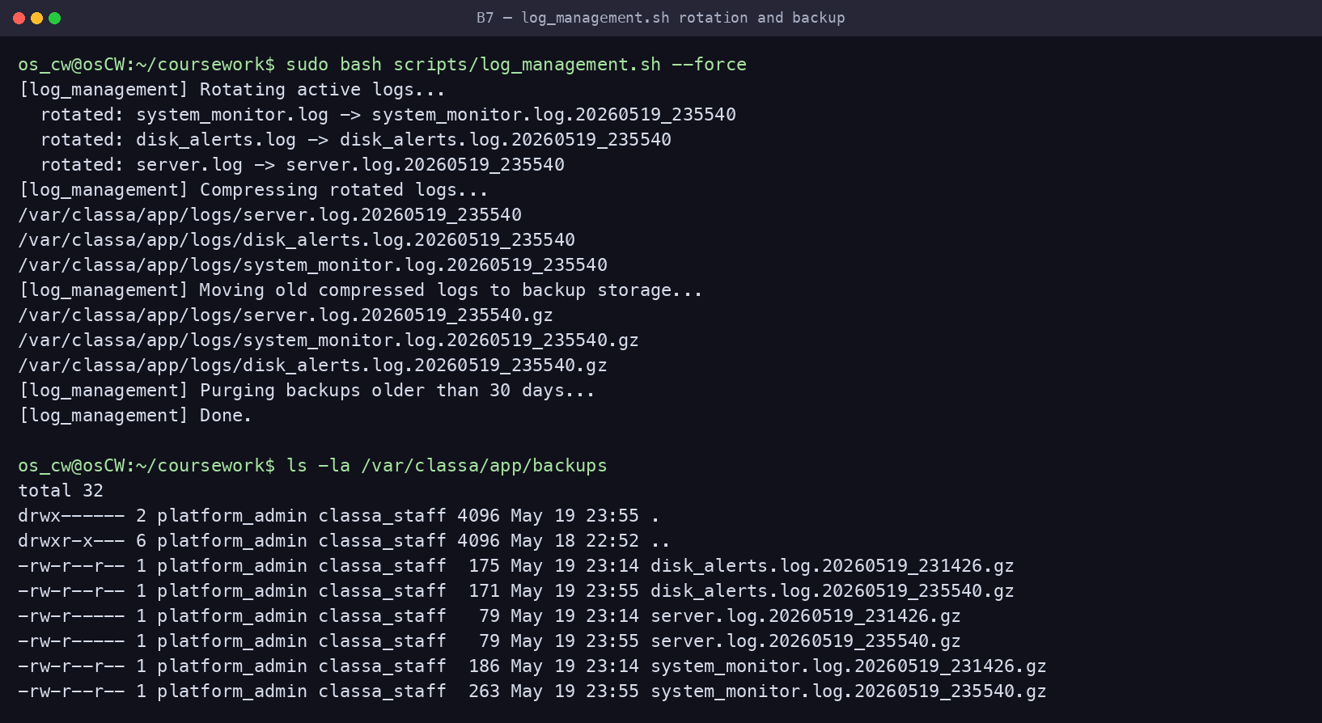
Figure — Rotation/compression run and the resulting .gz archives in backups/

8. Docker installation and configuration (6)
install_docker.sh installs Docker Engine via Docker’s official script, enables the service, and adds the administrative user to the docker group. Installation is verified with the version command and the hello-world container.
#!/bin/bash
#
# install_docker.sh — install Docker Engine on Ubuntu and verify it.
# Uses Docker's official install script (detects distro/arch automatically),
# enables the service, and lets the current user run docker without sudo.
#
set -euo pipefail

echo "Installing prerequisites..."
sudo apt update
sudo apt install -y curl ca-certificates

echo "Installing Docker Engine (official get.docker.com script)..."
curl -fsSL https://get.docker.com -o /tmp/get-docker.sh
sudo sh /tmp/get-docker.sh
rm -f /tmp/get-docker.sh

echo "Enabling and starting Docker..."
sudo systemctl enable --now docker

# Allow the invoking user to use docker without sudo (takes effect after re-login).
TARGET_USER="${SUDO_USER:-$USER}"
sudo usermod -aG docker "$TARGET_USER"
echo "Added '$TARGET_USER' to the 'docker' group — log out/in (or run: newgrp docker) to apply."

echo "--------------------------------"
echo "Docker version:"
sudo docker --version
echo "Verifying installation with hello-world:"
sudo docker run --rm hello-world

echo "Docker installation and verification completed."
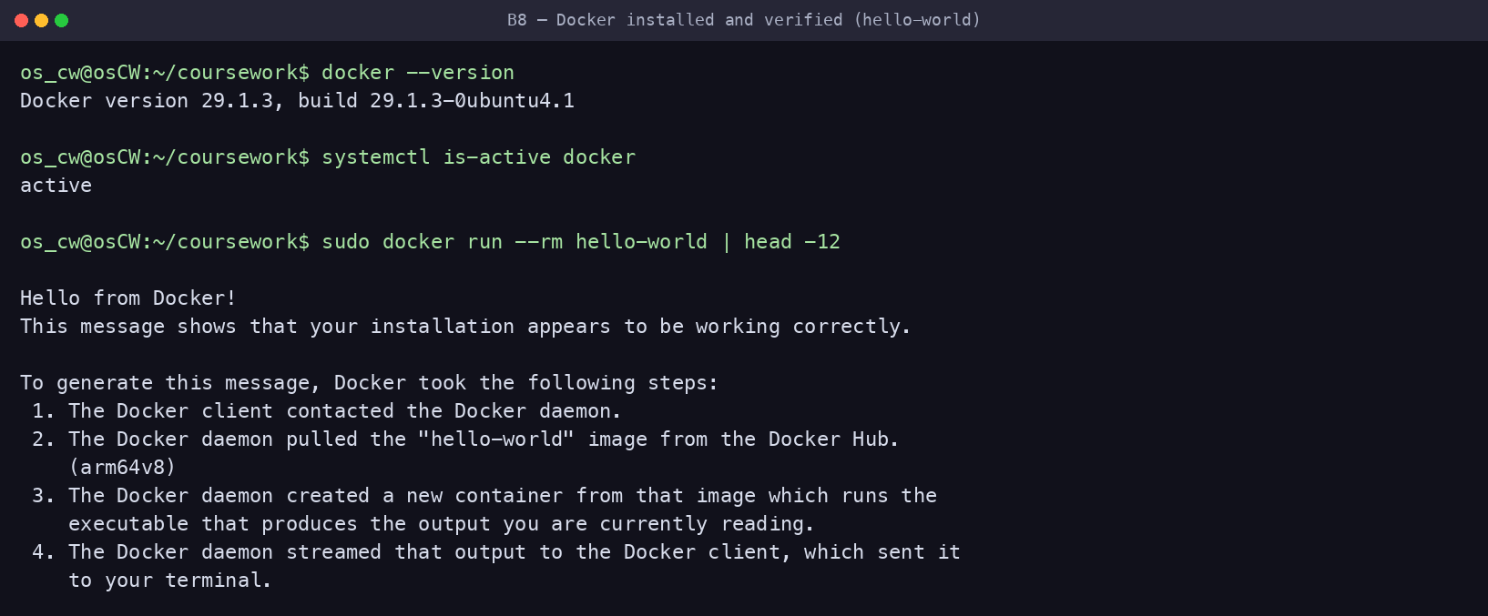
Figure — Docker version, service active, and hello-world verification

9. Creating and running a Docker image (7)
The second Part A package (Nginx) is containerised to serve the Class A status web page. Dockerfile:
FROM nginx:alpine
COPY index.html /usr/share/nginx/html/index.html
EXPOSE 80
Build & run commands:
docker build -t classa-web-app docker-web/
docker run -d -p 8080:80 --name classa-web-container \
-v classa_data:/usr/share/nginx/html classa-web-app
curl -I http://localhost:8080
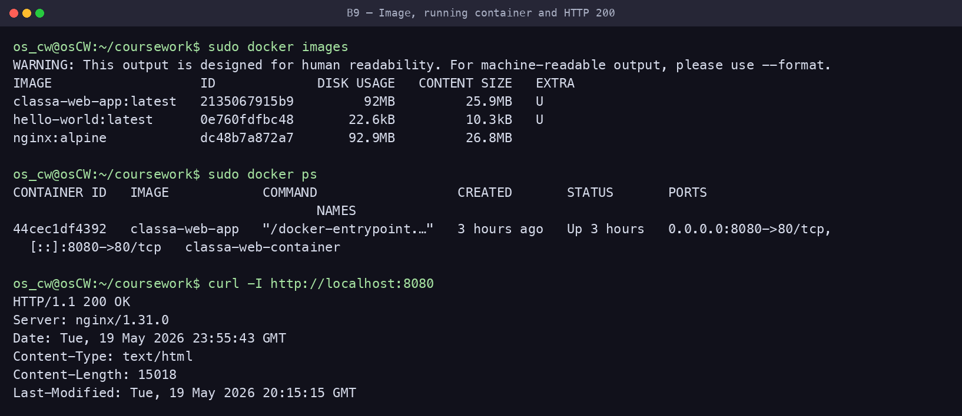
Figure — Built image, running container, and HTTP/1.1 200 OK from the app
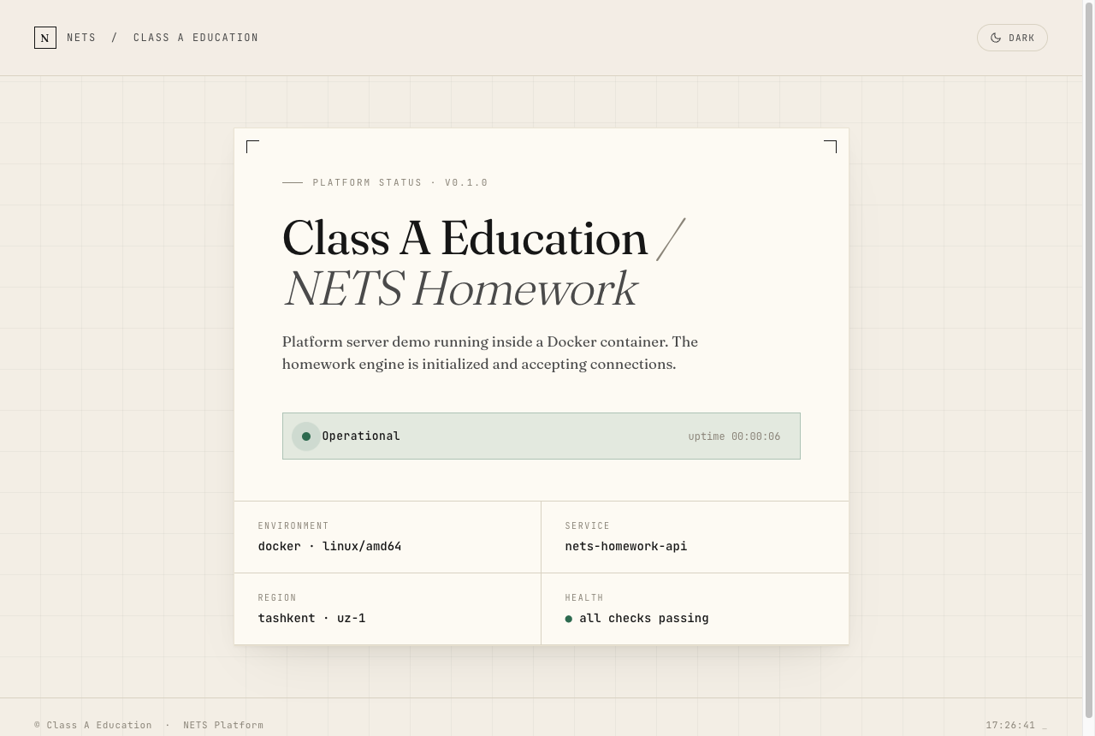
Figure — The running application rendered in a browser at http://192.168.1.56:8080

10. Docker configuration and management (5)
docker_manage.sh demonstrates the full container lifecycle: listing running and stopped containers, viewing logs, mapping ports (8081→80), using a named volume for persistent data, and stopping then removing the container.
#!/bin/bash
#
# docker_manage.sh — demonstrates the full Docker container lifecycle:
# list, logs, port mapping, volumes, stop and remove.
# Builds the classa-web-app image first if it is not present.
#
set -uo pipefail

# Use docker without sudo when possible, otherwise fall back to sudo.
DOCKER="docker"
if ! docker info >/dev/null 2>&1; then DOCKER="sudo docker"; fi

IMAGE="classa-web-app"
CONTAINER="classa-managed-container"
PORT=8081
SCRIPT_DIR="$(cd "$(dirname "${BASH_SOURCE[0]}")" && pwd)"
WEB_DIR="$(cd "$SCRIPT_DIR/../docker-web" && pwd)"

# Build the image if it does not exist yet (B.9 build step).
if ! $DOCKER image inspect "$IMAGE" >/dev/null 2>&1; then
echo "Image '$IMAGE' not found — building from $WEB_DIR ..."
$DOCKER build -t "$IMAGE" "$WEB_DIR"
fi

echo "Removing old managed container if it exists..."
$DOCKER rm -f "$CONTAINER" 2>/dev/null || true

echo "Creating Docker volume (persistent data)..."
$DOCKER volume create classa_data >/dev/null

echo "Running container with port mapping and volume..."
$DOCKER run -d \
-p ${PORT}:80 \
--name "$CONTAINER" \
-v classa_data:/usr/share/nginx/html \
"$IMAGE"

echo "== Running containers =="
$DOCKER ps
echo "== Container logs =="
$DOCKER logs "$CONTAINER"
echo "== All containers (including stopped) =="
$DOCKER ps -a
echo "== Docker volumes =="
$DOCKER volume ls
echo "== Port mapping =="
$DOCKER port "$CONTAINER"

echo "Stopping container..."
$DOCKER stop "$CONTAINER"
echo "Removing container..."
$DOCKER rm "$CONTAINER"

echo "Docker management operations completed."
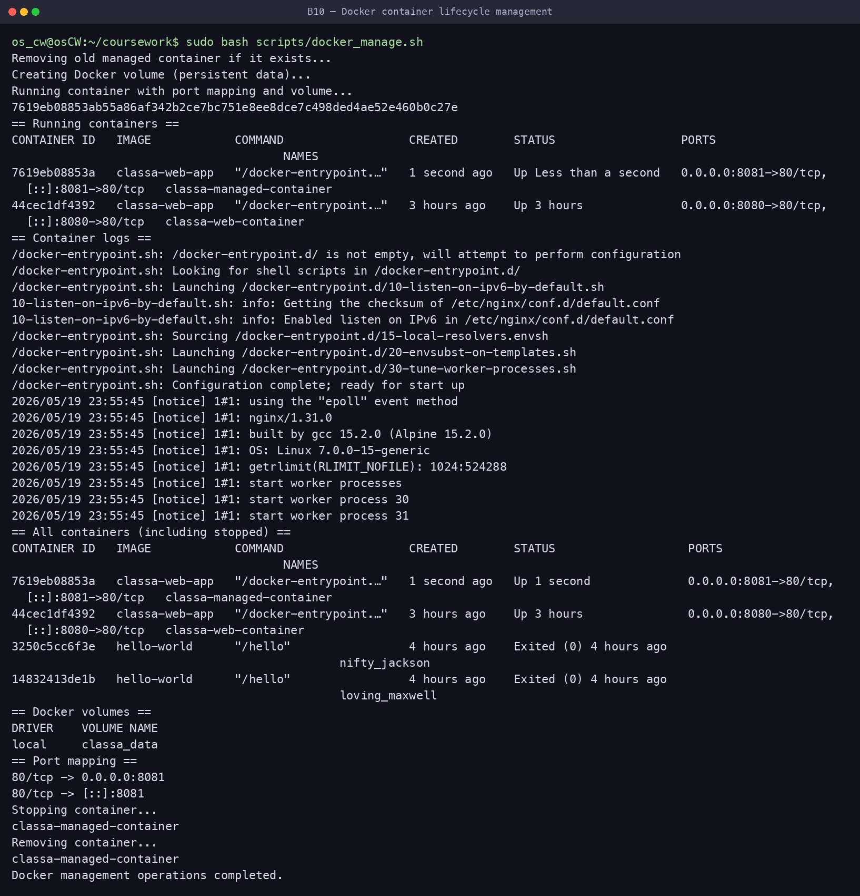
Figure — Container lifecycle: run, list, logs, ports, volumes, stop, remove

Appendix — Scheduled automation (crontab)
setup_cron.sh installs all three scheduled jobs into root’s crontab with absolute paths derived from the script location:
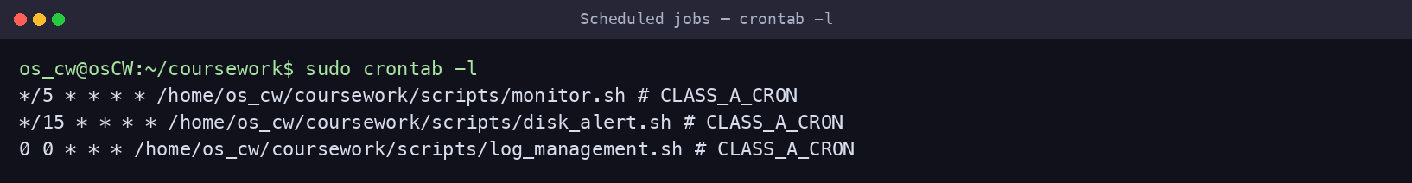
Figure — All scheduled Class A jobs (monitor / disk_alert / log rotation)
Source repository: https://github.com/s1gmamale1/Class-A-Education-Server-OS

