Revised Computational Response to Reviewer Questions
Draft for the authors. This document updates the previous response with second- and third-wave VASP/DeepMD/DPMD calculations addressing high-temperature coverage, exact experimental dilution, nanosecond sampling, 13.6 at.% solubility-composition dispersion statistics, and direct R2-3 Pt-Pt/Ga-Pt bonding tests by cluster formation energies and constrained insertion/migration barriers.

Executive Conclusion
The v3 calculations address the reviewers' computational scope by adding 2000/3000 K coverage, exact and large-cell 0.2 at.% Pt models, 1 ns DPMD trajectories, per-Pt 13.6 at.% dispersion statistics, and direct DeepMD cluster-formation/insertion-barrier tests for R2-3. The calculations remain designed structural and MLP energetic tests, not a complete catalytic mechanism or rigorous thermodynamic solubility boundary.
The concentration issue is now handled explicitly: Ga998Pt2 is the minimal exact 0.2 at.% pair model, and Ga21342Pt43 is the large 0.201 at.% statistical model. For Ga998Pt2 close at 923 K, the DPMD median minimum Pt-Pt distance is 15.2 A with loose-contact fraction 0. For Ga21342Pt43 at 923 K, the median minimum Pt-Pt distance is 4.78 A with loose-contact fraction 0.0787.
The 13.6 at.% fixed-composition stress test is reported as such: dispersed Ga864Pt136 has loose-contact fraction 1, while clustered Ga864Pt136 has 1. These trajectories test the force-field behavior near the experimental solubility composition but are not promoted to a rigorous solubility boundary.
The saturated 13.6 at.% whole-cell loose-contact metric is now replaced by per-Pt statistics. The dispersed 13.6 at.% trajectory has isolated-Pt fractions of 0.966 +/- 0.001 at 2.79 A and 0.671 +/- 0.002 at 3.35 A; the initially clustered 13.6 at.% trajectory gives 0.967 +/- 0.001 and 0.682 +/- 0.002, respectively. Both have positive Warren-Cowley alpha values near 0.656-0.666, while random same-geometry Pt assignments are near zero, supporting Pt-Pt avoidance rather than persistent aggregation within the accepted DeepMD model.
For R2-3, the response no longer relies only on contact probabilities. The dilute-host same-geometry cluster-formation series is sign-mixed (n=2: 2.235 +/- 1.274 eV, n=4: -1.399 +/- 1.575 eV, n=8: -0.610 +/- 0.871 eV, n=16: 4.091 +/- 2.681 eV), so it is not a converged monotonic concentration trend and should not be used alone to claim that clustering is always disfavored. The separate 13.6 at.% fixed-composition stress test remains strongly positive, E(clustered)-E(dispersed) = 96.028 +/- 8.164 eV. The constrained pair-formation drag path has a forward barrier of 6.656 eV and final-minus-initial energy of 0.816 eV, but this is not a full NEB activation barrier.

Direct Responses to the Five Computational Issues
Issue | Classification | Answer
The dataset covers too narrow a temperature range. | addresses | The revised dataset includes new VASP AIMD labels and DPMD trajectories at 2000 K and 3000 K for the Ga98Pt2 close-pair model. The DPMD high-temperature cases each contain 1001 dumped frames for a nominal 1 ns trajectory; the 2000 K loose Pt-Pt contact fraction is 0.0262, and the 3000 K loose-contact fraction is 0.0387.
The DP-MD model is too small and should match the experimental 0.2 at.% Pt concentration. | addresses | The revised workflow distinguishes concentration from computational cell size. Ga998Pt2 is the minimal exact 0.2 at.% pair model, and Ga21342Pt43 is a large statistical model at 0.201 at.% Pt. By contrast, Ga2063Pt432 would be 17.31 at.% Pt, not 0.2 at.%, and would be a high-Pt stress test rather than the experimental catalyst concentration.
The DP-MD simulation time is too short. | addresses | All nine revision DPMD cases were extended to 1,000,000 steps with a 1 fs timestep, corresponding to a nominal 1 ns trajectory per case. The first 20% of dumped frames is excluded from reported structural statistics.
Use the experimental 13.6% solubility to test force-field accuracy. | addresses_as_force_field_stress_test | The 13.6 at.% case is no longer evaluated only by the saturated whole-cell loose-contact fraction. Per-Pt statistics show isolated-Pt fractions of 0.966 +/- 0.001 at 2.79 A and 0.671 +/- 0.002 at 3.35 A for the dispersed trajectory; the initially clustered trajectory gives 0.967 +/- 0.001 and 0.682 +/- 0.002. The largest loose Pt cluster fraction is only 0.031 +/- 0.000 to 0.031 +/- 0.000, and Warren-Cowley alpha is 0.656-0.666 versus near-zero random same-geometry baselines. Thus the accepted DeepMD model supports Pt-Pt avoidance/single-atom-like dispersion at fixed 13.6 at.% composition.
Reviewer R2-3 requests a quantitative explanation of the Pt-Pt/Ga-Pt bond-energy ordering. | addresses_with_limitations | R2-3 is now answered with direct MLP energetic tests rather than only contact probabilities or free-energy proxies. The dilute-host same-geometry cluster-formation series is sign-mixed: n=2: 2.235 +/- 1.274 eV, n=4: -1.399 +/- 1.575 eV, n=8: -0.610 +/- 0.871 eV, n=16: 4.091 +/- 2.681 eV. Therefore it should not be presented as a monotonic concentration-dependent proof that clustering is always disfavored; the n=4 and n=8 means slightly favor the constructed clustered motif within the present three-frame sample. The separate 13.6 at.% fixed-composition stress test gives a large positive contrast, E(clustered)-E(dispersed) = 96.028 +/- 8.164 eV, consistent with the DPMD dispersion statistics at that composition. The constrained Pt-Pt pair-formation path has a forward barrier of 6.656 eV and final-minus-initial energy of 0.816 eV; isolated Pt-Ga exchange has a barrier of 1.531 eV. The barrier profile is a constrained-relaxed arc-exchange drag test, so it is best interpreted as showing that this forced pair-formation path is energetically costly, not as a quantitative NEB activation barrier.

Second-Wave Calculation Inventory
Artifact | Status / key number
VASP revision labels | complete across 4 cases
DeepMD v2 dataset | ready; 20000 DFT frames
DeepMD v2 QA | pass; energy RMSE 0.00752 eV/atom; force RMSE 0.142 eV/A
Descriptor PCA | ready_for_review
DPMD revision trajectories | complete; 9 one-nanosecond cases
R2-3 energy ordering | complete; 9 cases
13.6 at.% dispersion statistics | complete; 2 cases with random-site baselines
Direct DeepMD cluster/barrier tests | complete; 30 minimized structures and 42 barrier images
Model schematics | complete; DPMD and direct-bonding model panels

Model Schematics
The schematics below show the actual LAMMPS/POSCAR coordinates used in the revision calculations. Red points are all Pt atoms; gray points are a deterministic Ga subsample for visual context; red lines mark Pt-Pt minimum-image contacts below 3.35 A. The Ga subsampling affects only the drawing, not any calculation.
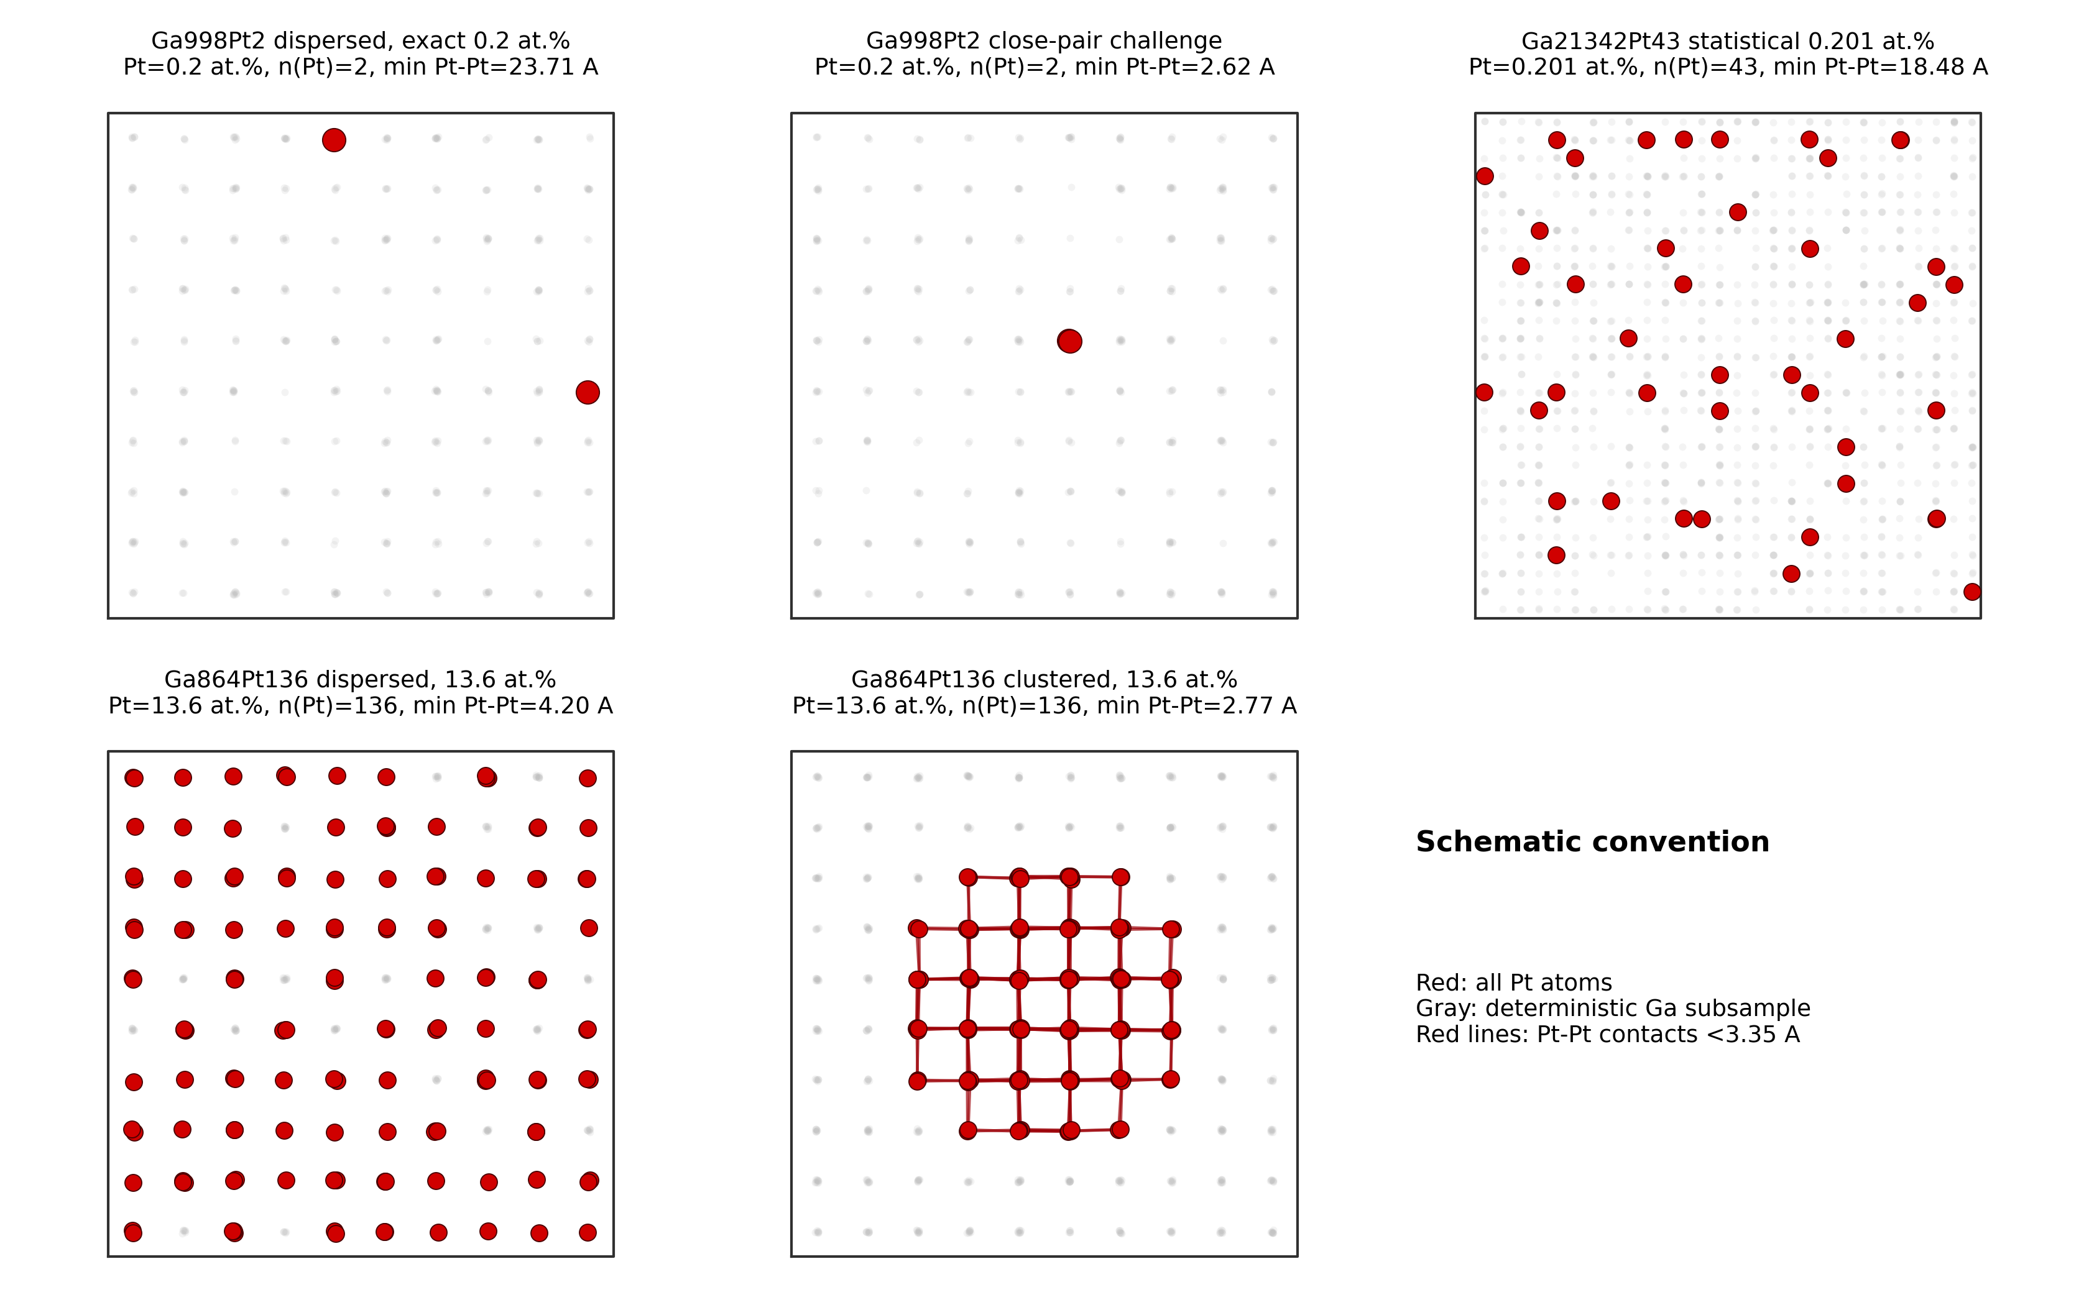
Figure S1. DPMD model schematics for the exact 0.2 at.% two-Pt cells, the large 0.201 at.% Ga21342Pt43 statistical model, and the 13.6 at.% Ga864Pt136 dispersed/clustered stress-test cells. The panels document that Ga998Pt2 is the exact experimental-dilution pair model, whereas Ga21342Pt43 supplies the large-cell statistical dilution model.
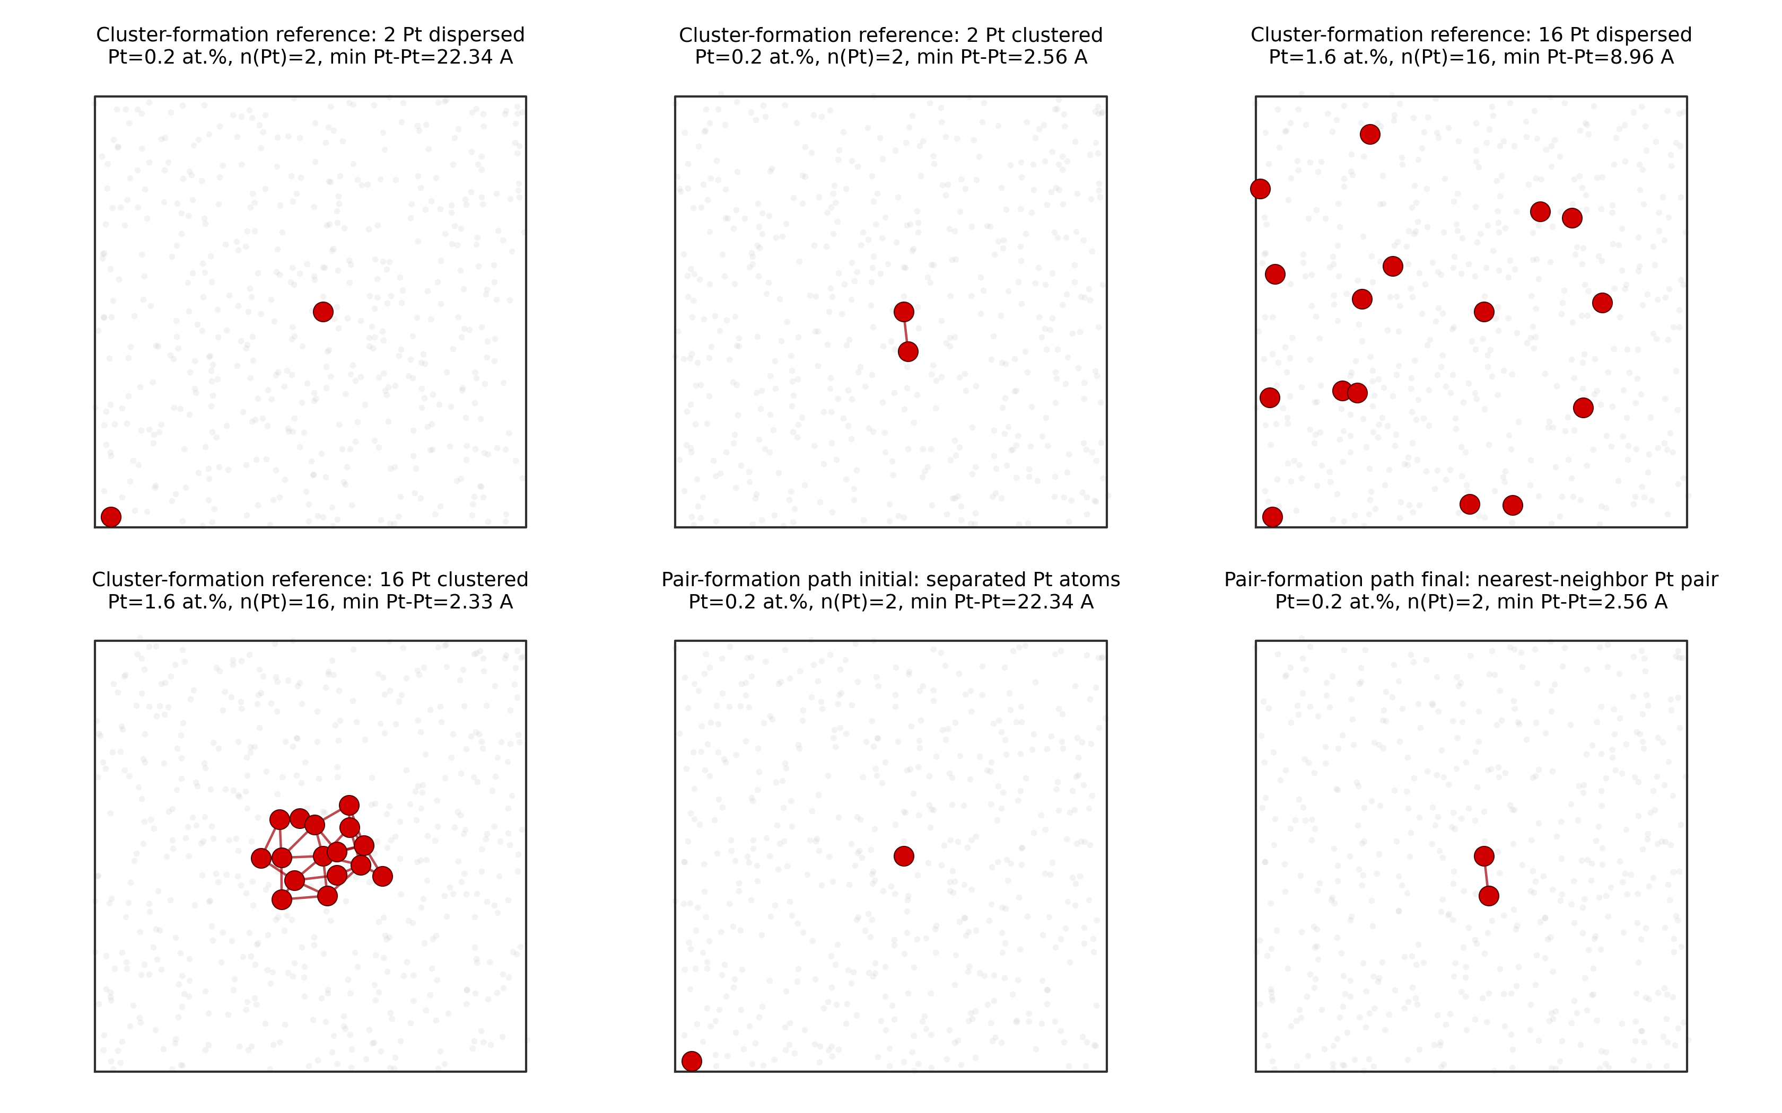
Figure S2. Direct-bonding model schematics used for R2-3. Cluster formation energies compare clustered and dispersed Pt assignments in the same Ga998Pt2 liquid host frame; the pair-formation path moves a second Pt from a separated site to a nearest-neighbor site next to another Pt. These panels define the geometrical meaning of the cluster-energy and constrained-barrier calculations.

VASP AIMD Revision Labels
Case | T mean (K) | Pt-Pt p50 (A) | Bond-contact fraction | Loose-contact fraction
ga86pt14_cluster_923K | 922 | 2.66 | 0.972 | 1
ga86pt14_dispersed_923K | 923 | 3.21 | 0.028 | 0.619
ga98pt2_close_2000K | 2e+03 | 3.55 | 0.014 | 0.467
ga98pt2_close_3000K | 3e+03 | 3.48 | 0.0607 | 0.392
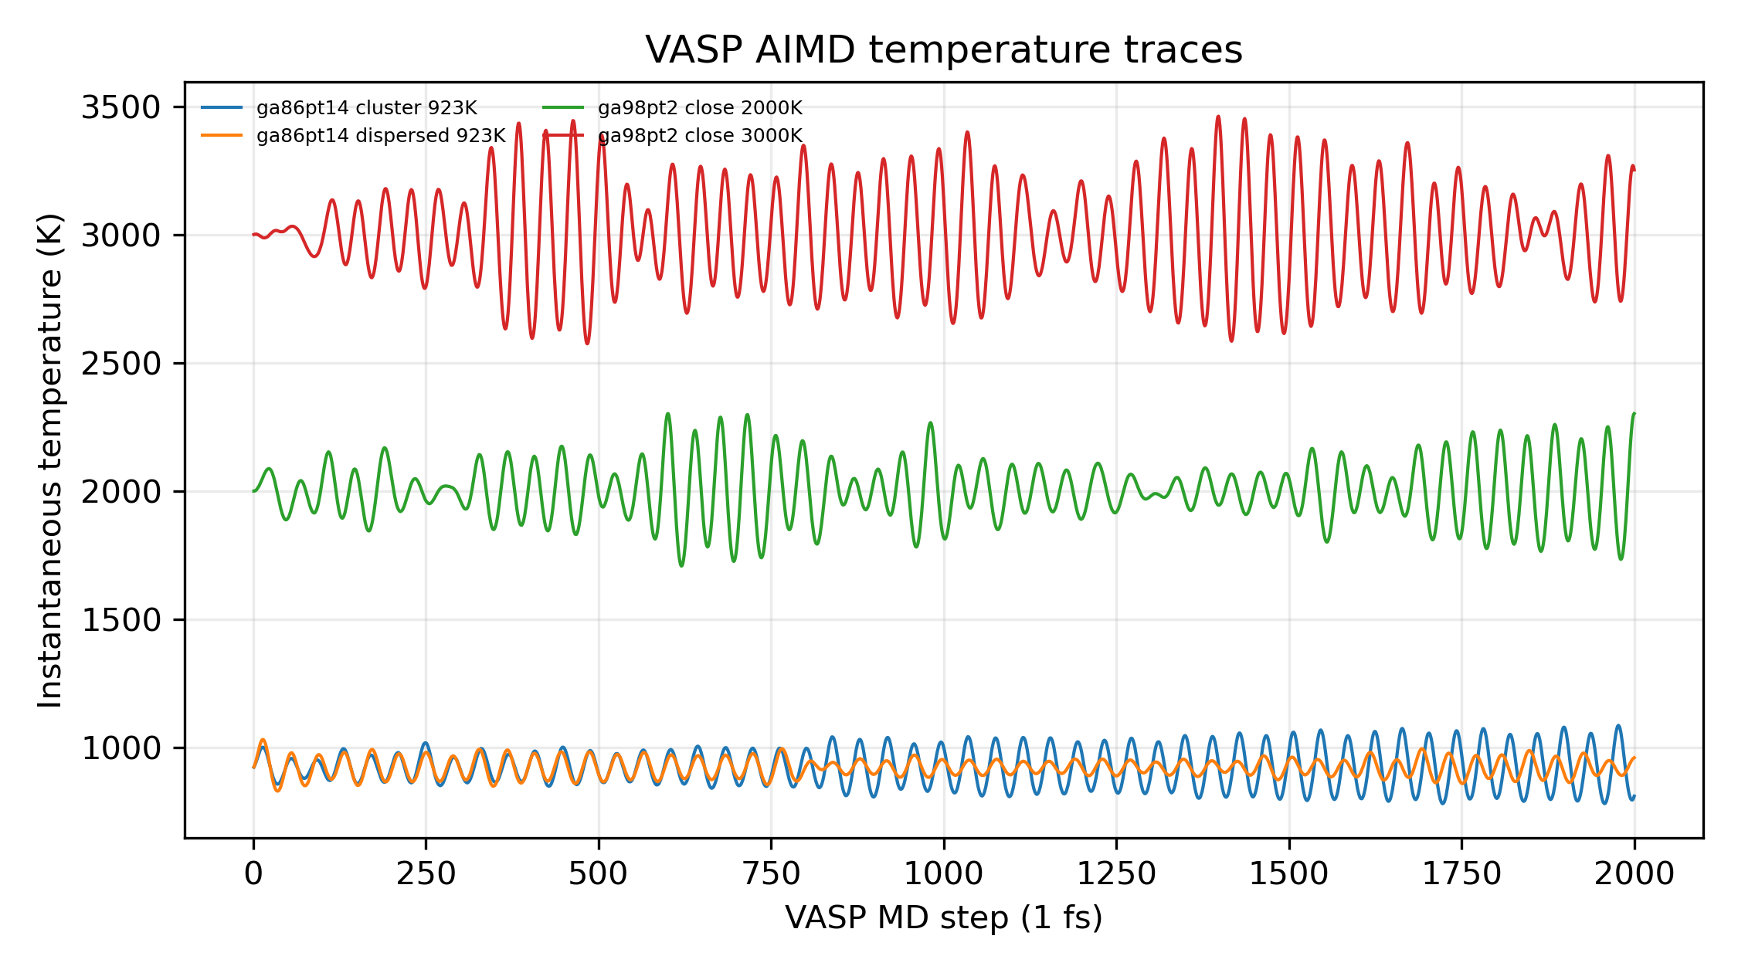
Figure 1. Revision VASP AIMD temperature traces for high-temperature and 13.6/14 at.% training labels.
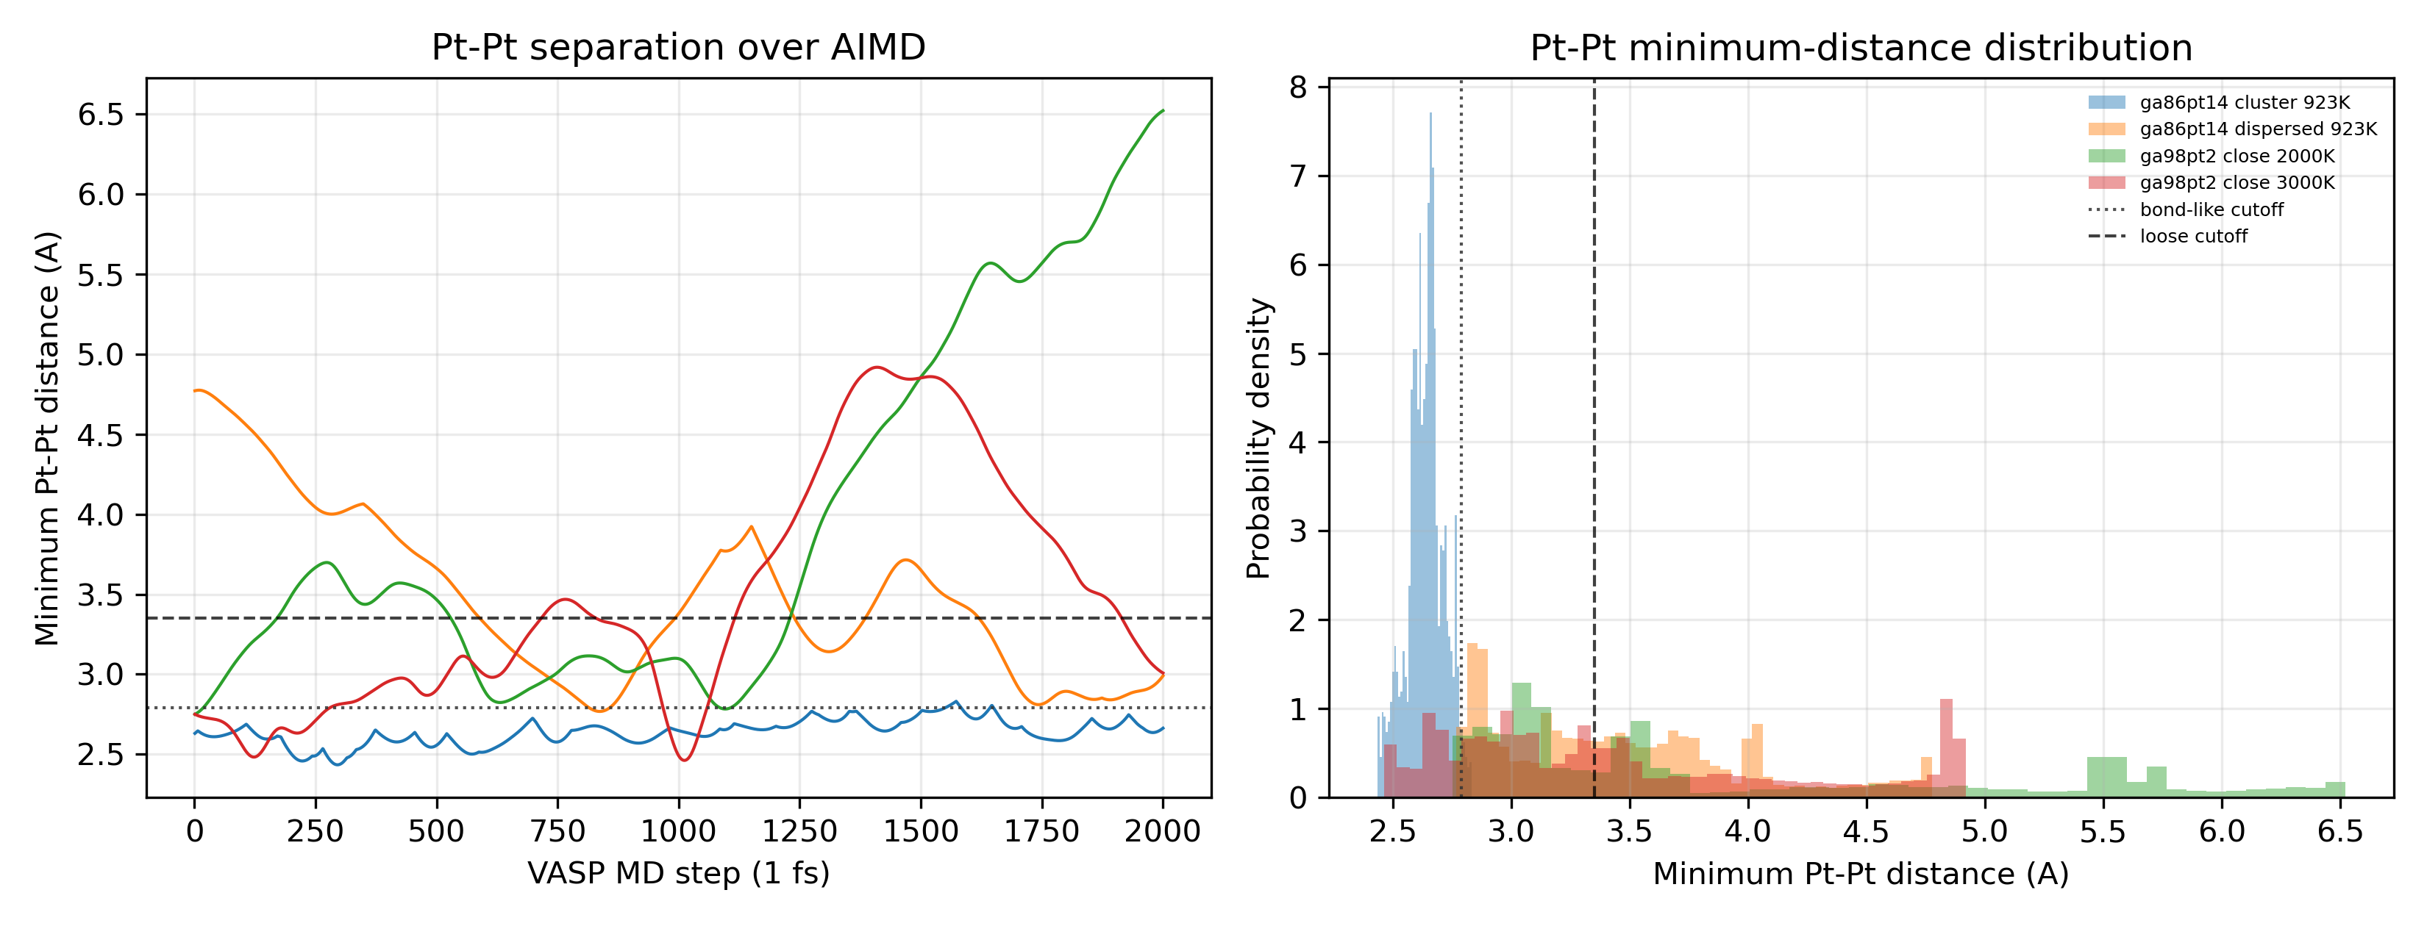
Figure 2. Revision VASP AIMD minimum Pt-Pt distances.
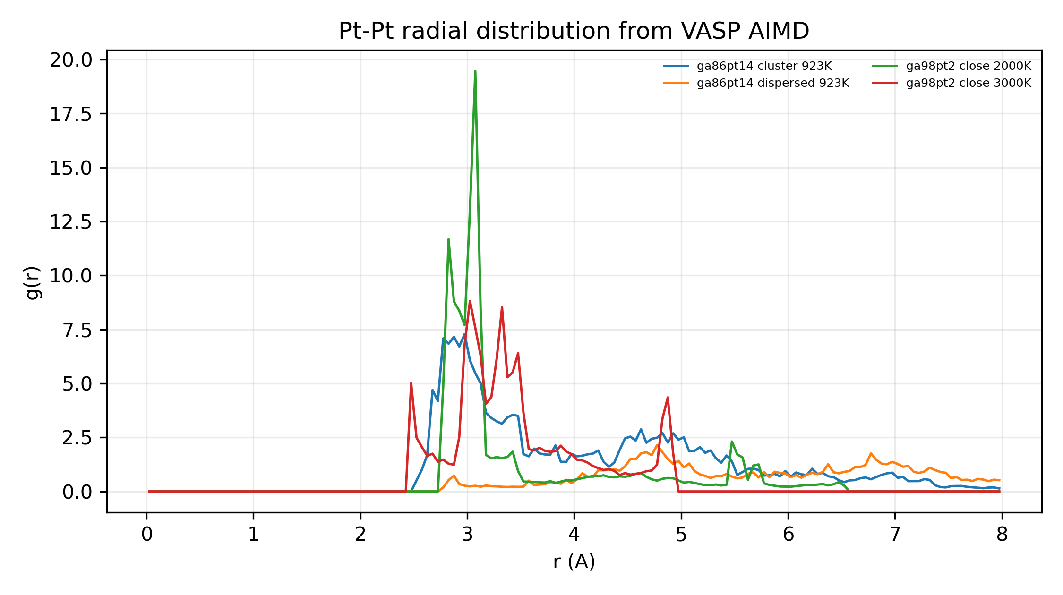
Figure 3. Revision VASP AIMD Pt-Pt RDFs.
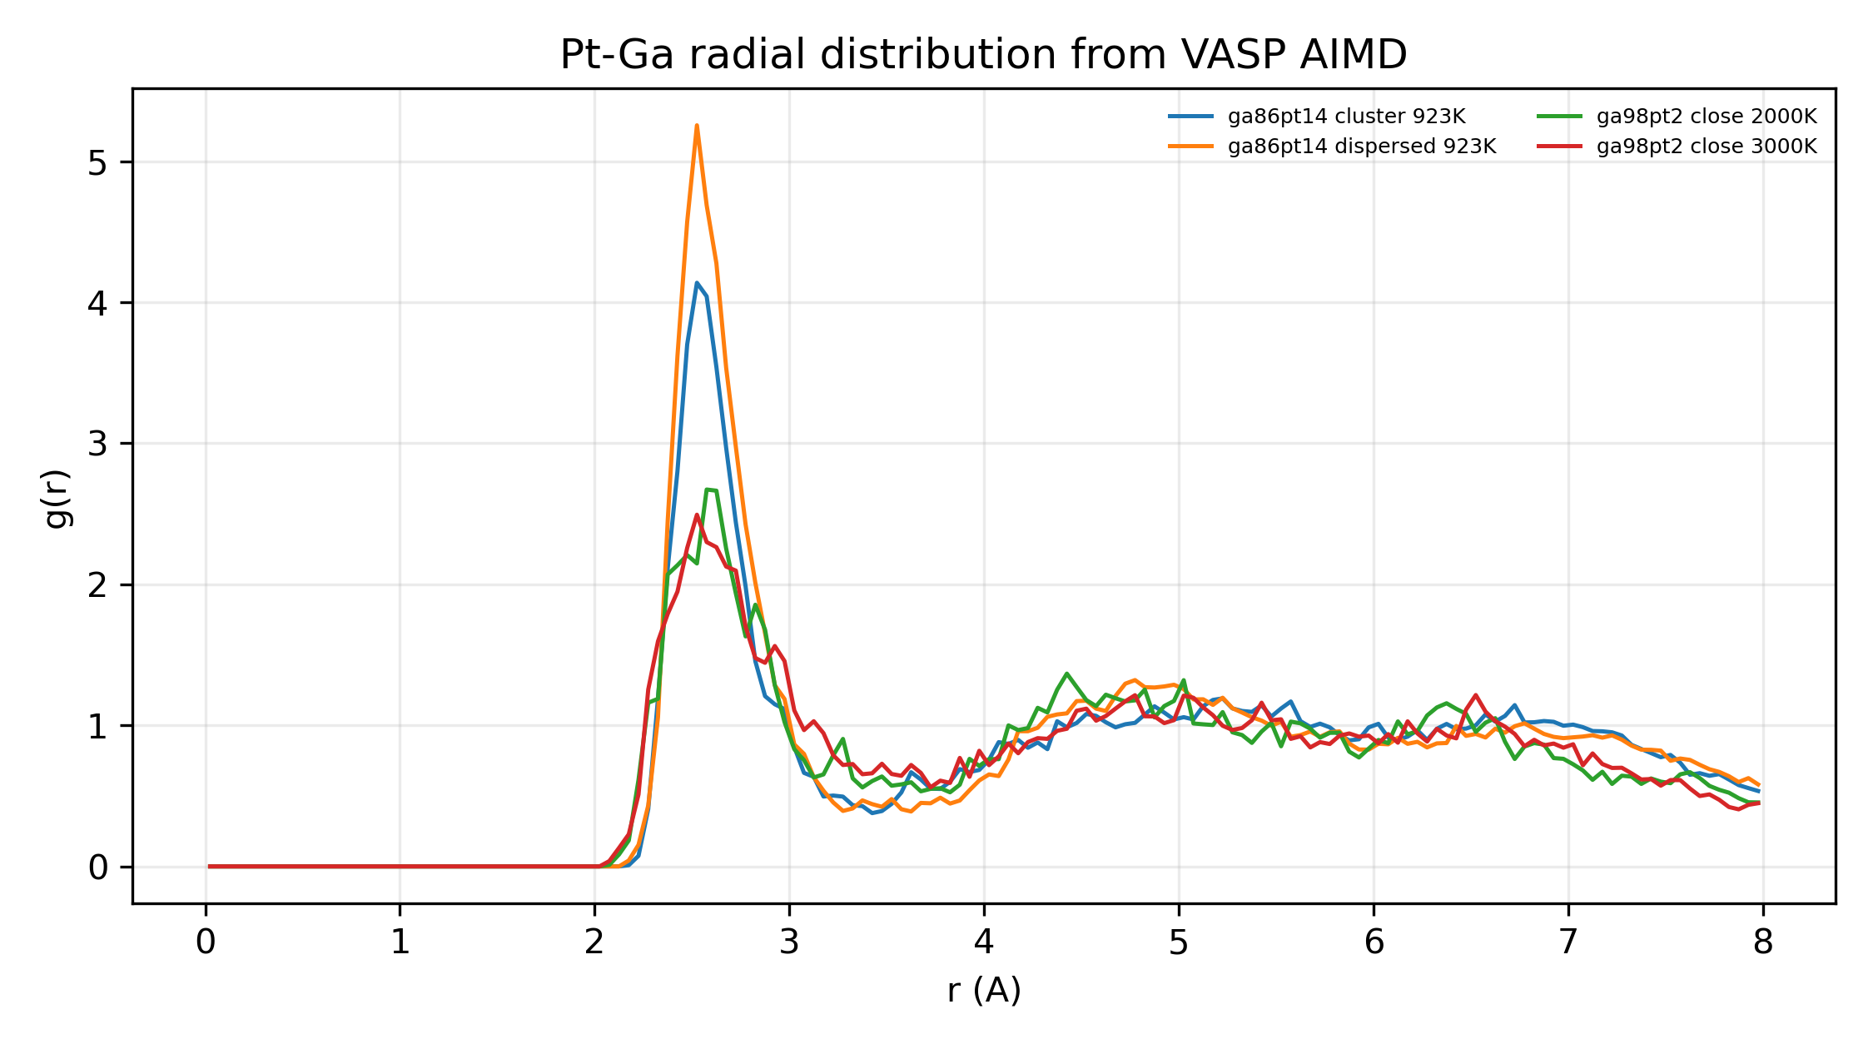
Figure 4. Revision VASP AIMD Pt-Ga RDFs.

DeepMD v2 Validation
DeepMD v2 was trained on the six first-wave VASP labels plus four revision labels. It is accepted for structural stress tests with the finite force-error limitation stated below, not for high-precision thermochemistry.
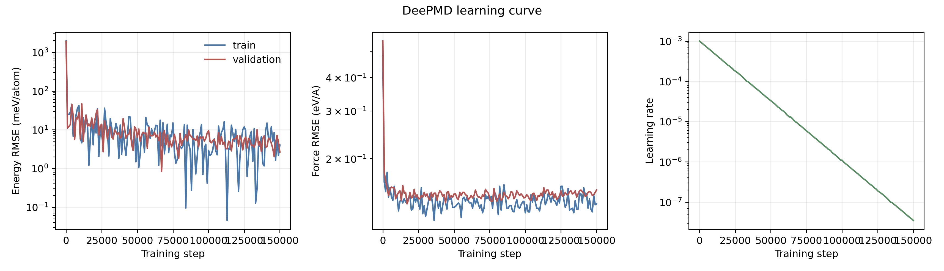
DeepMD v2 QA figure: deepmd_lcurve_energy_force_lr.png.
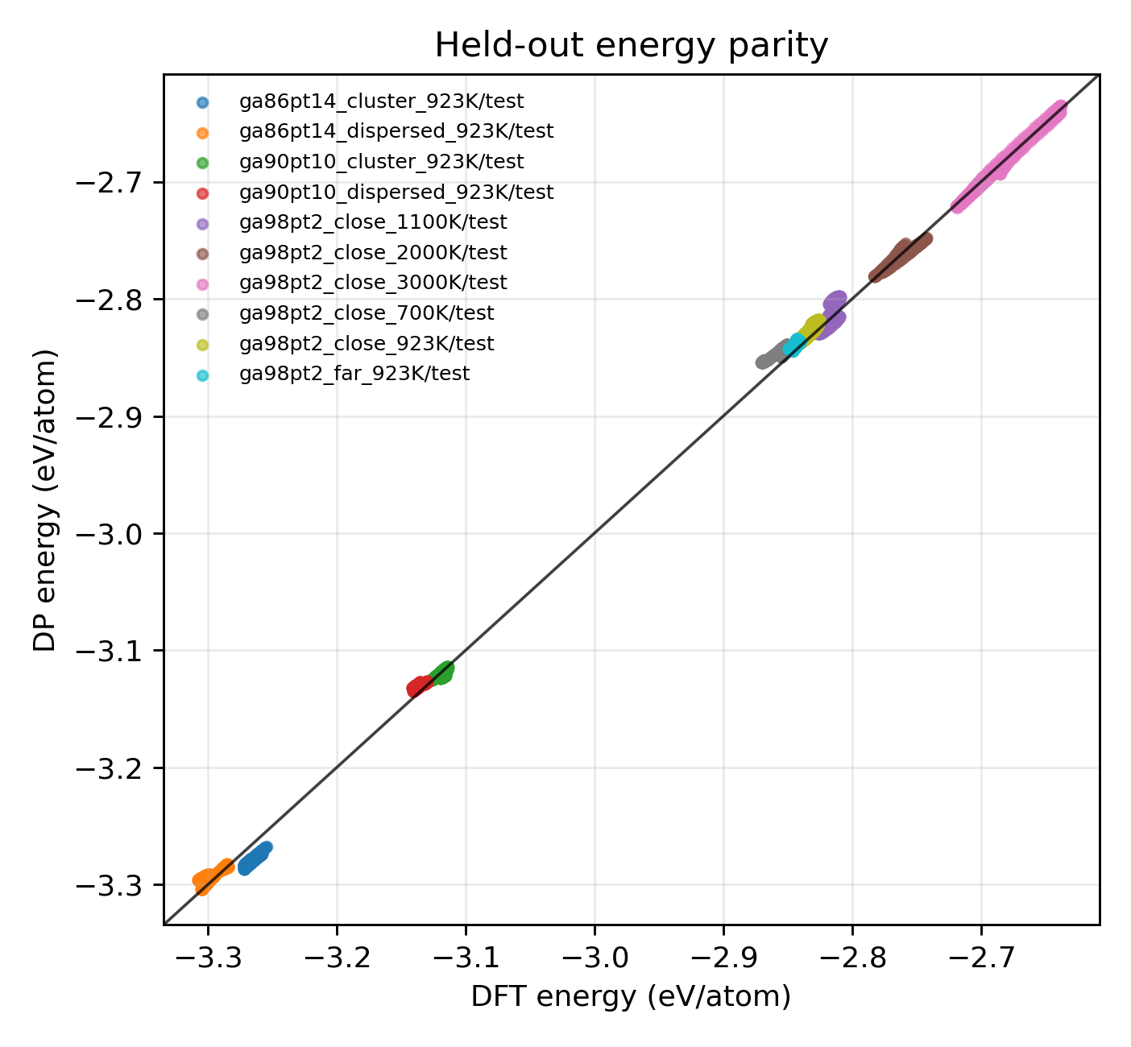
DeepMD v2 QA figure: deepmd_dp_test_energy_parity.png.
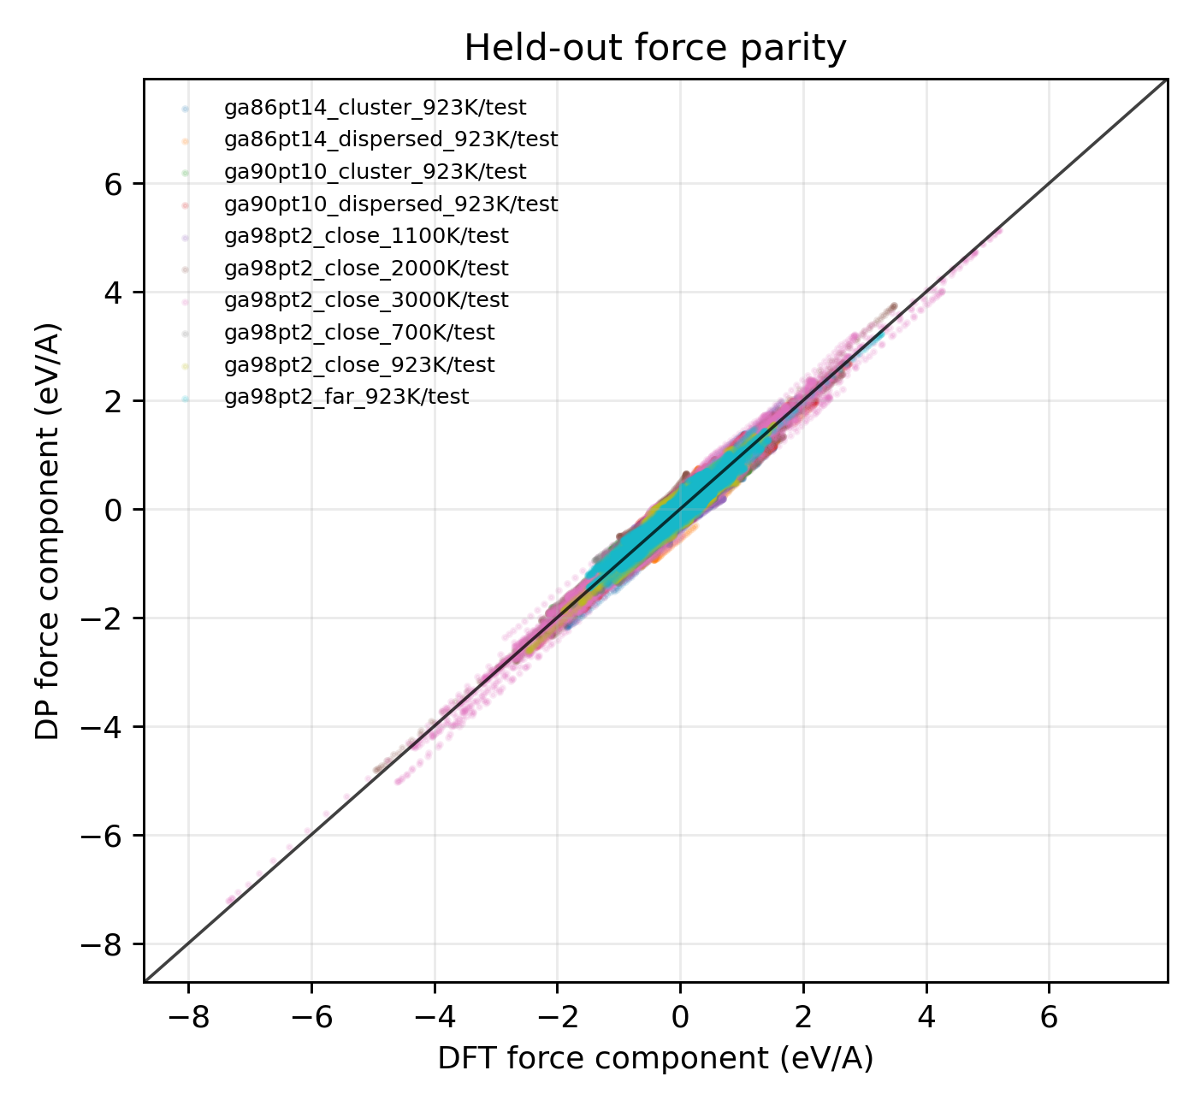
DeepMD v2 QA figure: deepmd_dp_test_force_parity.png.
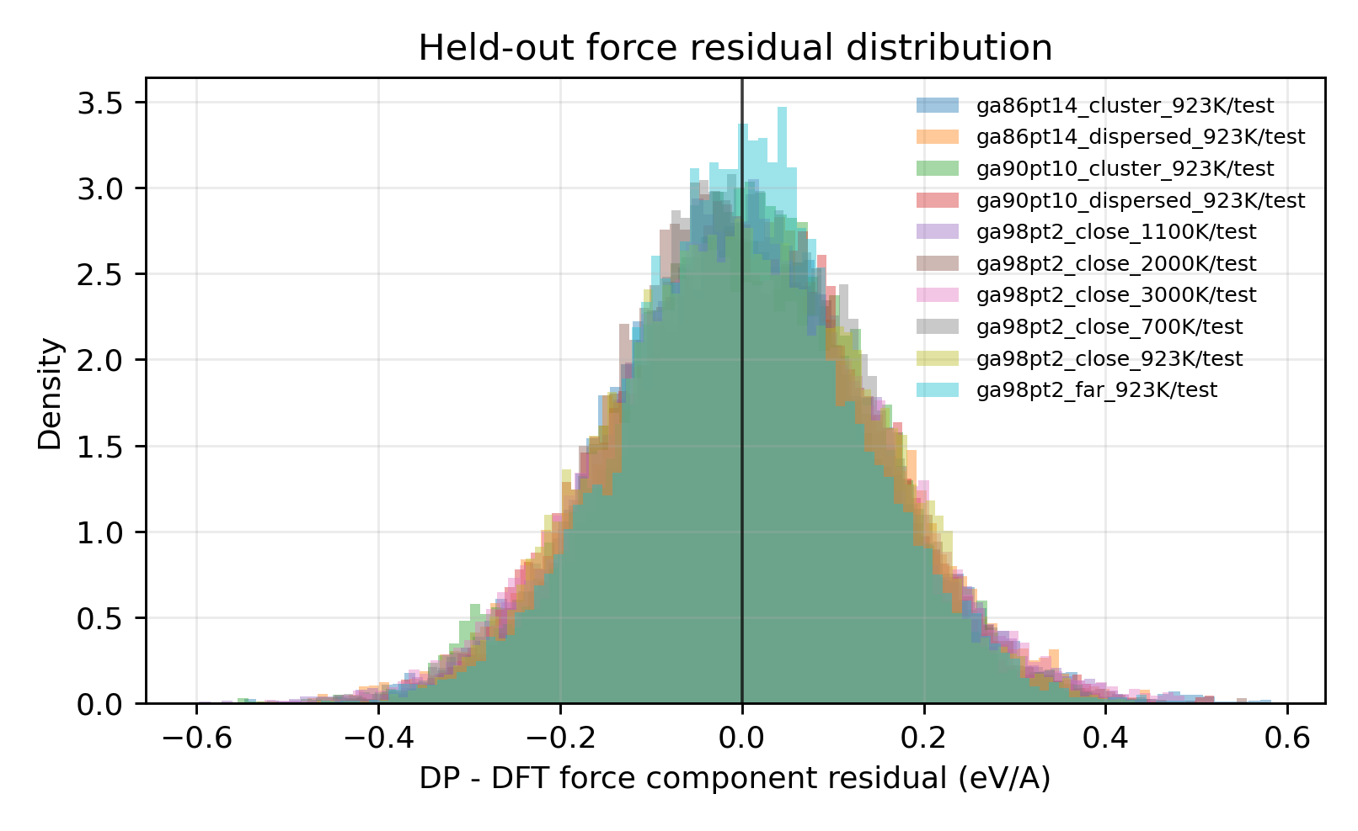
DeepMD v2 QA figure: deepmd_dp_test_force_residual_hist.png.
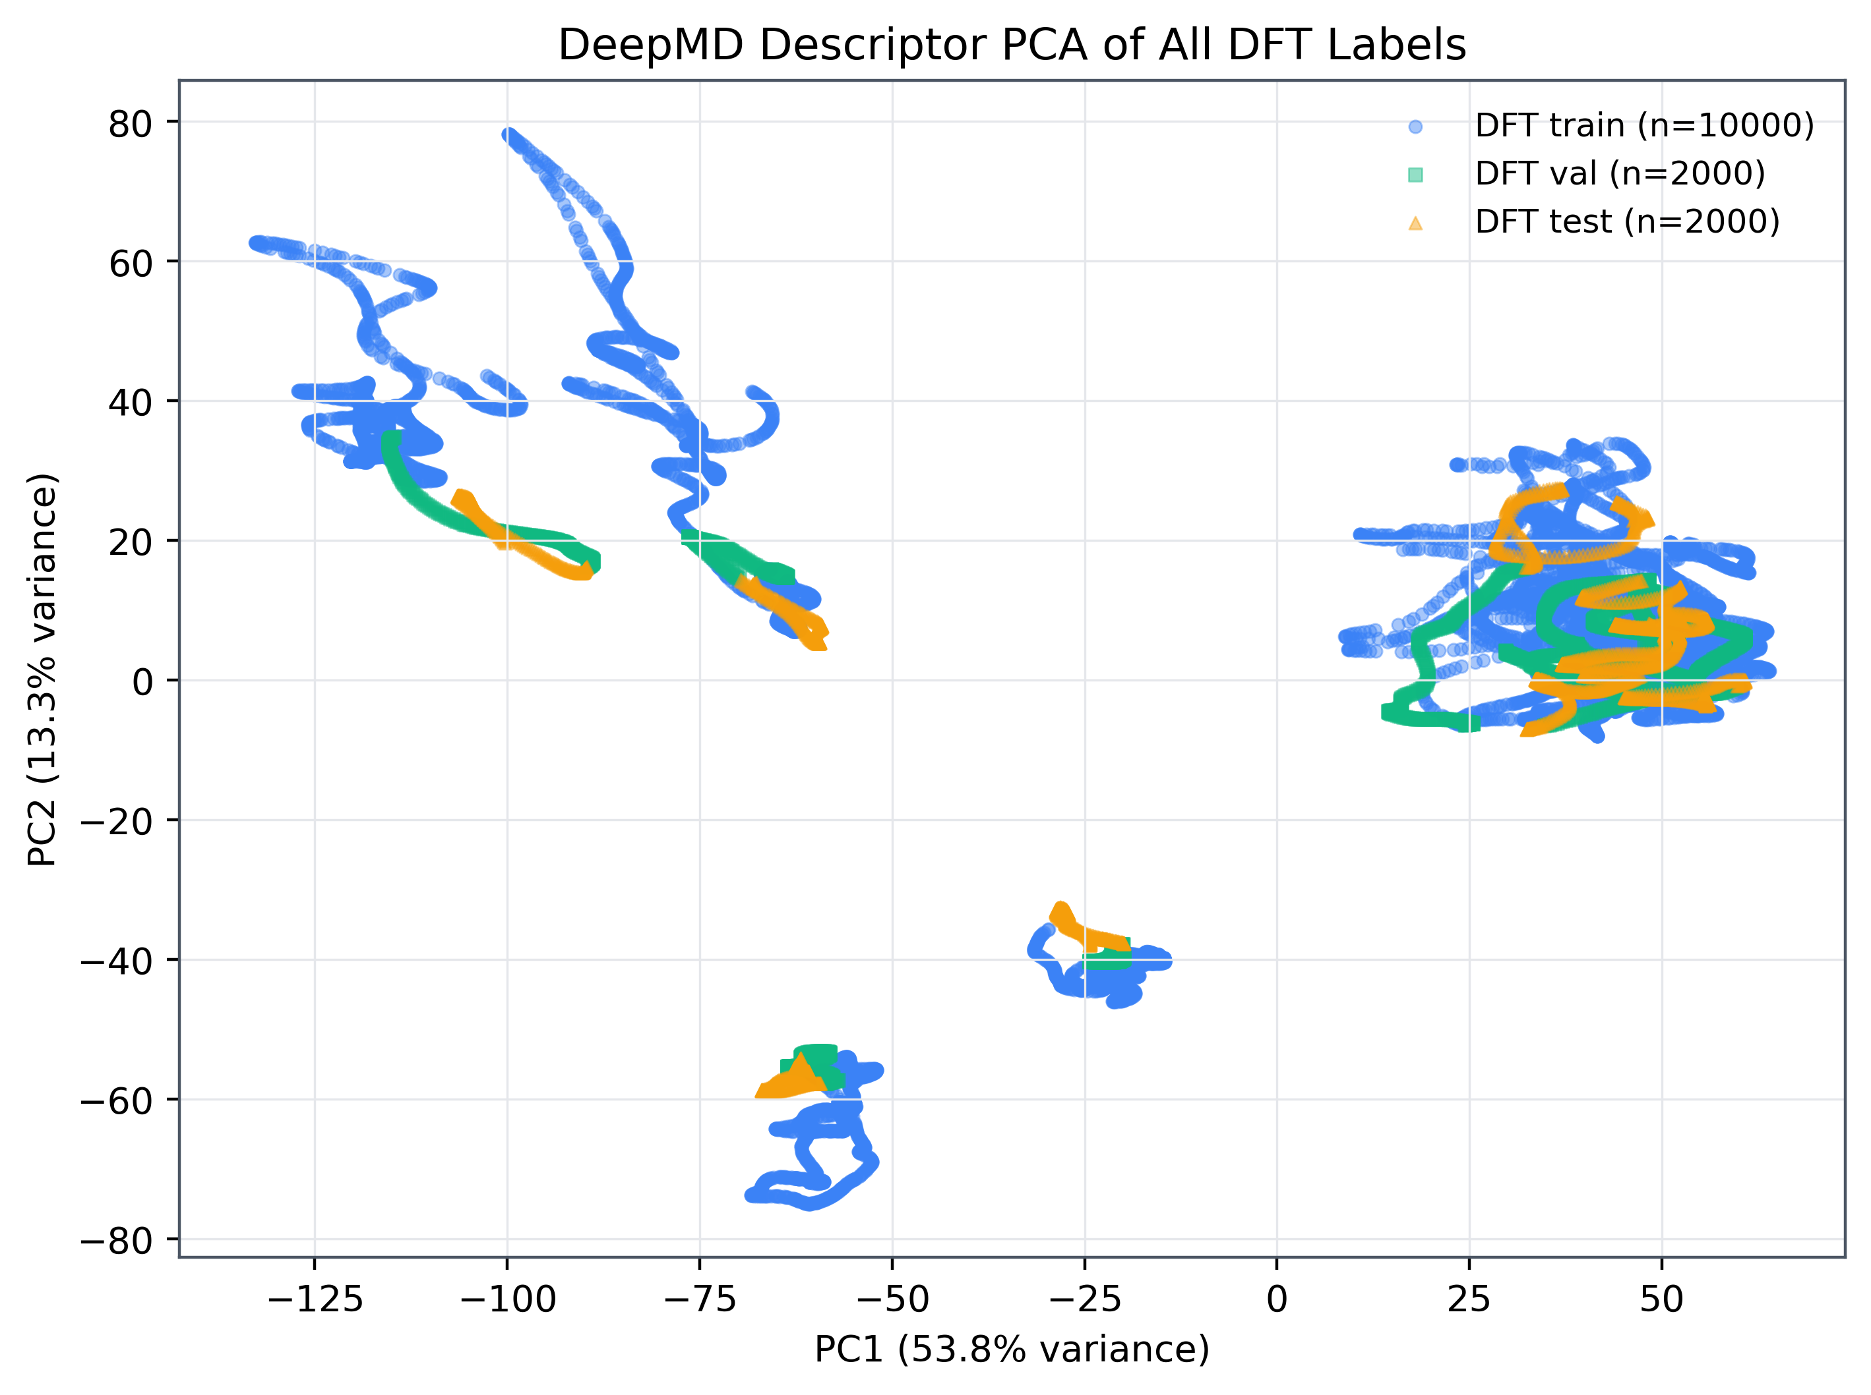
DeepMD v2 descriptor PCA of DFT labels.

Nanosecond DPMD Results
LAMMPS DPMD used metal units, pair_style deepmd, 1 fs timestep, and 1,000,000 production steps per revision case. The first 20% of dumped frames was excluded from reported structural statistics.
Case | Pt at.% | Frames | Pt-Pt p50 (A) | Bond contact | Loose contact | Largest loose cluster
ga21342pt43_dispersed_923K | 0.201 | 1001 | 4.78 | 0.00624 | 0.0787 | 3
ga864pt136_cluster_923K | 13.6 | 1001 | 2.7 | 0.893 | 1 | 8
ga864pt136_dispersed_923K | 13.6 | 1001 | 2.69 | 0.901 | 1 | 9
ga86pt14_cluster_923K | 14 | 1001 | 2.93 | 0.195 | 0.924 | 8
ga86pt14_dispersed_923K | 14 | 1001 | 2.91 | 0.228 | 0.943 | 8
ga98pt2_close_2000K | 2 | 1001 | 6.69 | 0.00624 | 0.0262 | 2
ga98pt2_close_3000K | 2 | 1001 | 6.64 | 0.0137 | 0.0387 | 2
ga998pt2_close_923K | 0.2 | 1001 | 15.2 | 0 | 0 | 1
ga998pt2_far_923K | 0.2 | 1001 | 9.73 | 0 | 0.00375 | 2
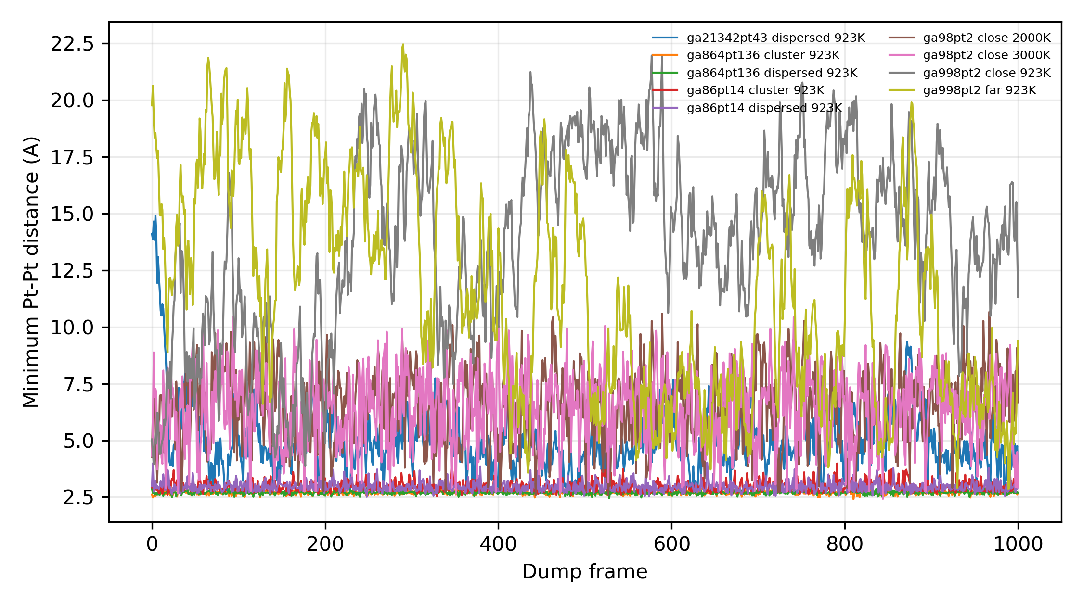
Figure 5. Revision DPMD minimum Pt-Pt distance over nanosecond trajectories.
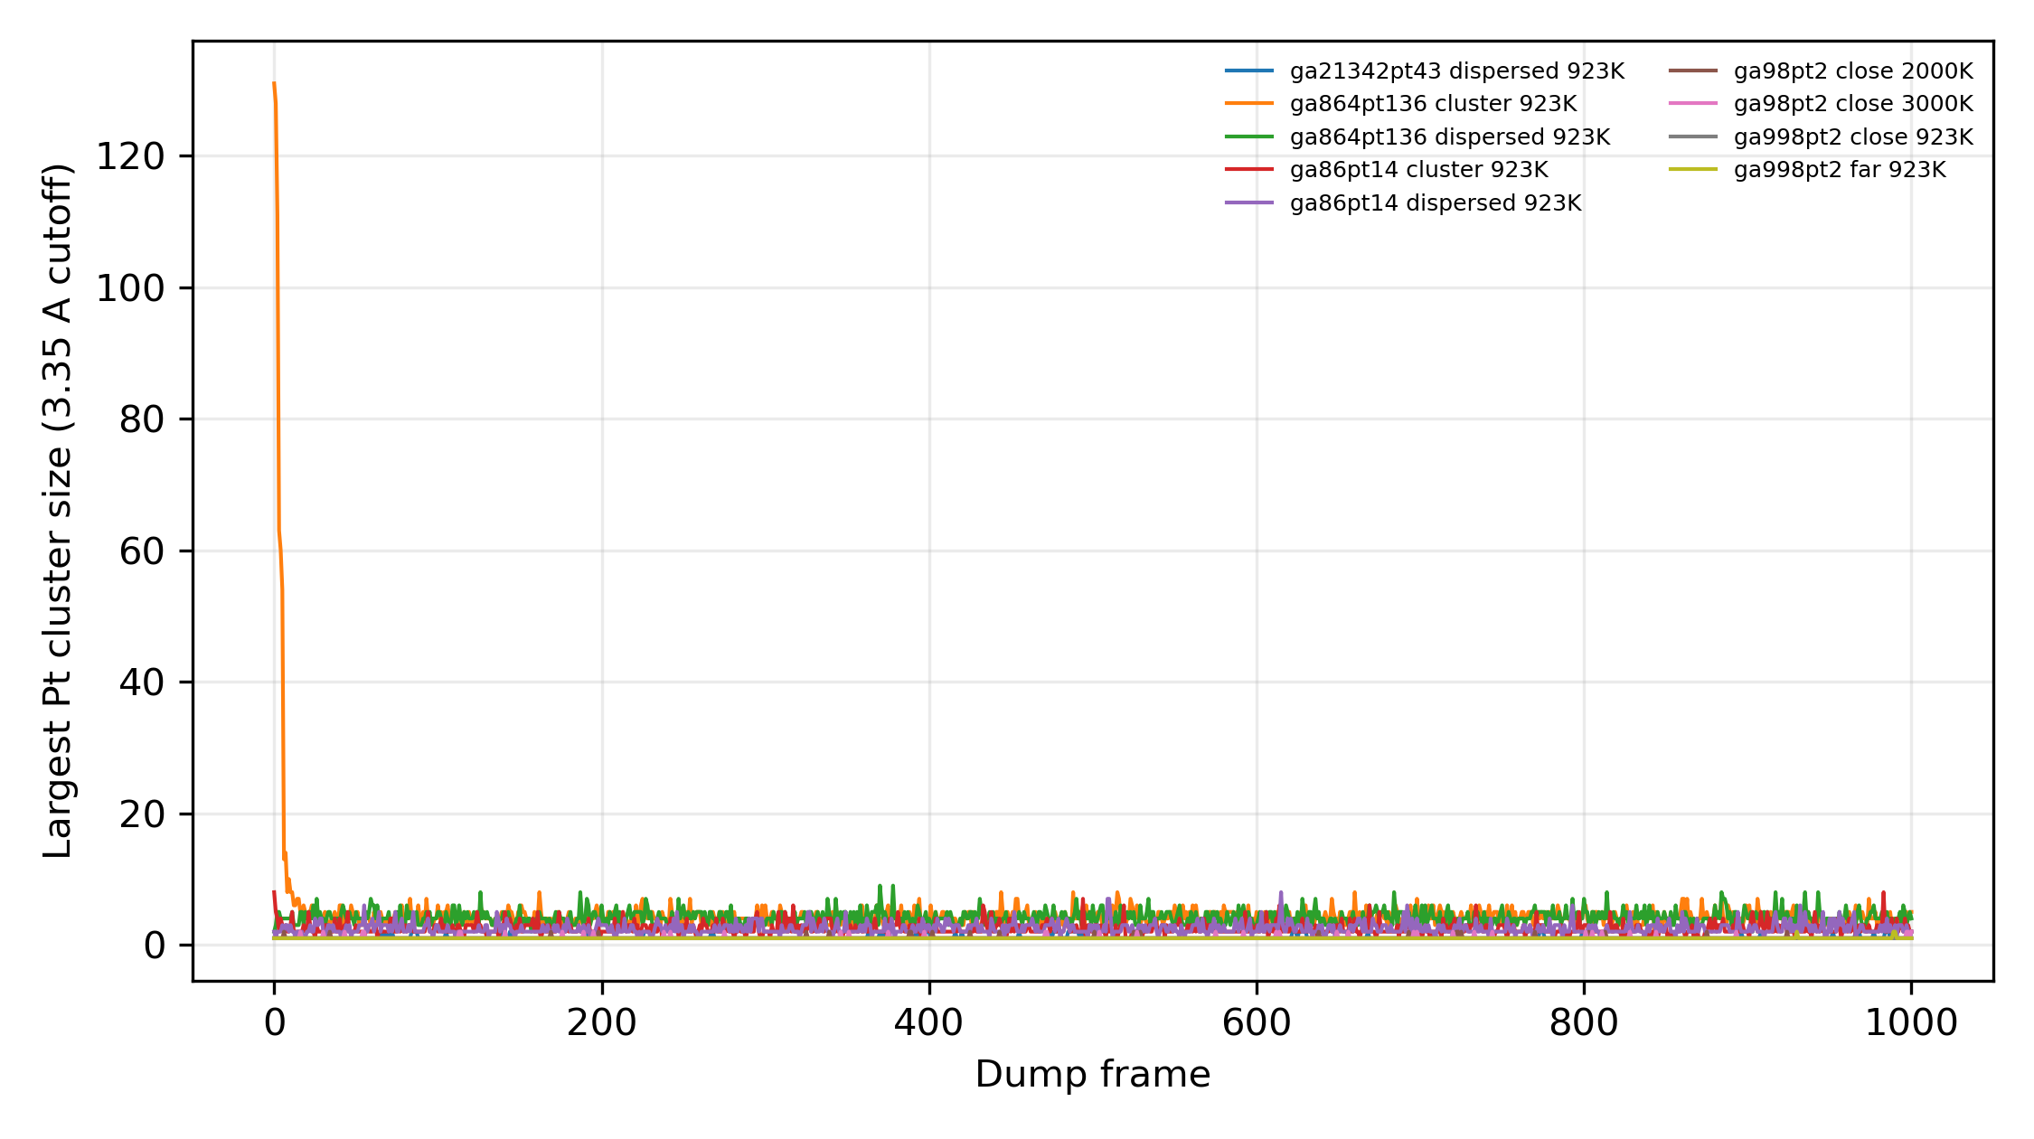
Figure 6. Revision DPMD largest Pt cluster size under the 3.35 A loose-contact cutoff.

13.6 at.% Solubility-Composition Dispersion Statistics
The original whole-cell loose-contact fraction is not diagnostic at 13.6 at.% Pt because a 1000-atom cell with 136 Pt atoms almost inevitably contains at least one Pt-Pt distance below 3.35 A. The revised analysis therefore reports per-Pt isolation fractions, cluster-size fractions, Warren-Cowley short-range order, contact persistence, and random-site baselines on the same instantaneous liquid geometries.
Case | Pt isolated <2.79 A | Pt isolated <3.35 A | Largest loose cluster fraction | Pt-Pt loose CN | Pt-Ga loose CN | Warren-Cowley alpha | Random alpha | Loose survival 50 ps
ga864pt136_dispersed_923K | 0.966 +/- 0.001 | 0.671 +/- 0.002 | 0.031 +/- 0.000 | 0.382 | 7.79 | 0.656 | 0.00354 | 0.0071
ga864pt136_cluster_923K | 0.967 +/- 0.001 | 0.682 +/- 0.002 | 0.031 +/- 0.000 | 0.369 | 7.74 | 0.666 | 0.00709 | 0.00786
Interpretation: high isolated-Pt fractions, small largest-cluster fractions, rapidly decaying Pt-Pt contact persistence, and positive Warren-Cowley alpha values relative to random same-geometry baselines support Pt-Pt avoidance/single-atom-like dispersion at fixed 13.6 at.% composition. These data strengthen the force-field stress test but still do not constitute a rigorous thermodynamic solubility calculation.
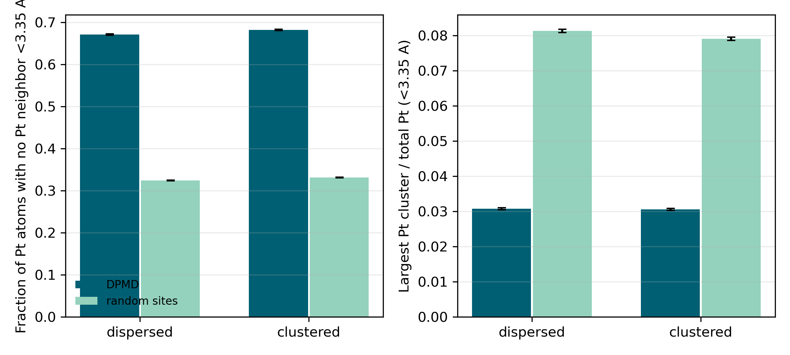
Figure S3. Per-Pt isolation and largest-cluster fractions for the 13.6 at.% DPMD trajectories. The random same-geometry baseline demonstrates that the observed Pt distribution is more isolated and less clustered than random Pt placement at the same composition.
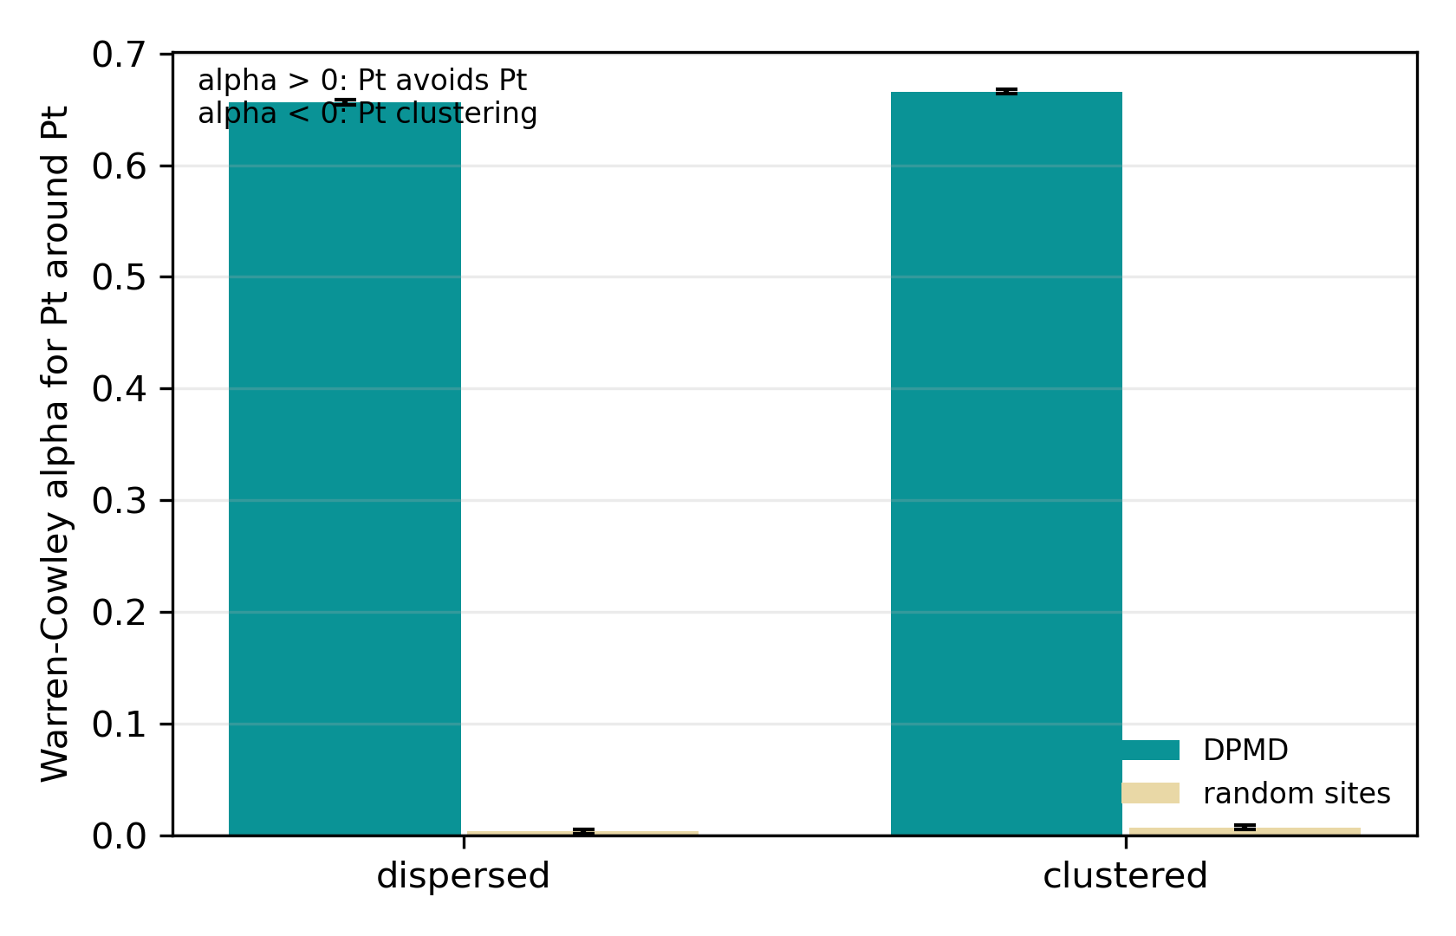
Figure S4. Warren-Cowley short-range order at 13.6 at.% Pt. Positive alpha indicates Pt-Pt avoidance relative to random mixing, providing a quantitative test of single-atom-like dispersion when the whole-cell loose-contact fraction is saturated.
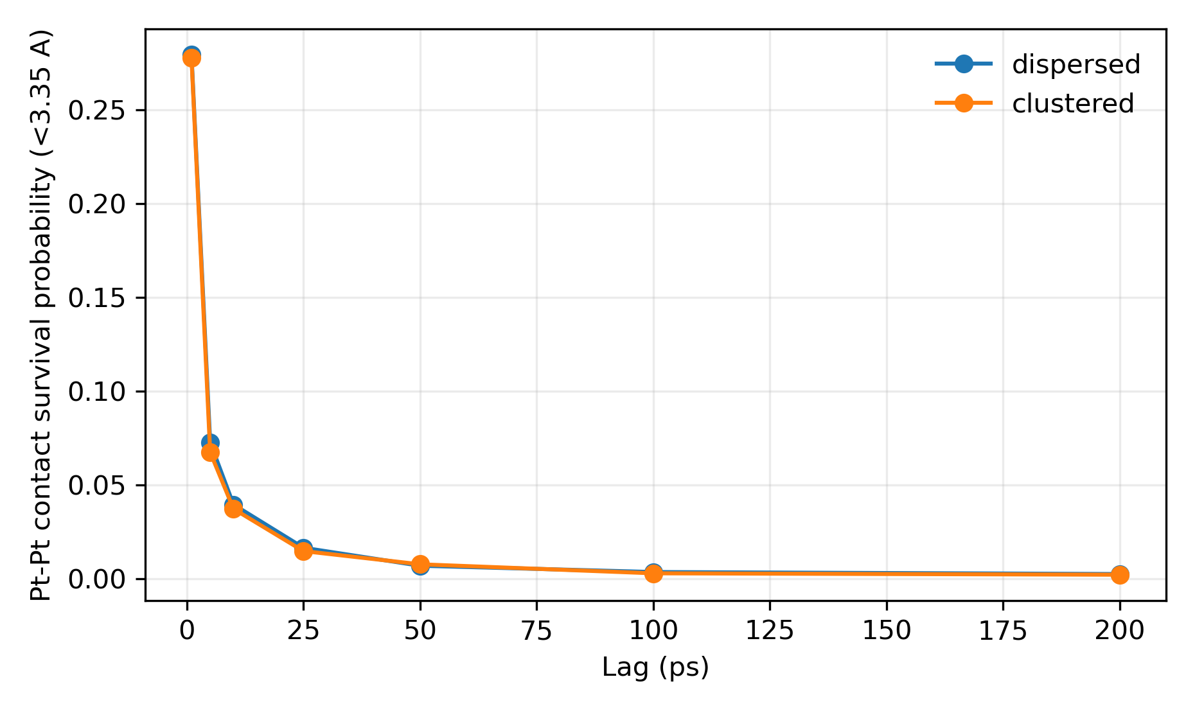
Figure S5. Pt-Pt contact survival probability at 13.6 at.% Pt. The rapid decay of both bond-cutoff and loose-cutoff contacts shows that Pt-Pt contacts are transient liquid encounters rather than persistent aggregates.

R2-3: Pt-Pt/Ga-Pt Energy Ordering
A transferable isolated pairwise Pt-Pt versus Ga-Pt bond-energy decomposition is not well-defined for a many-body DeepMD liquid. To answer R2-3 more directly, the revised workflow now computes same-host cluster formation energies and constrained-relaxed Pt insertion/migration barriers with the accepted DeepMD v2 model. Positive E(clustered)-E(dispersed) means Pt aggregation is energetically disfavored relative to separated Pt atoms in the same liquid Ga host geometry; negative values mean the constructed clustered motif is lower in the specific same-host minimization. The dilute-host n=2/4/8/16 sequence is therefore interpreted by its full sign pattern, not by selected positive entries.
Source host | n(Pt) | Mean E(clustered)-E(dispersed) (eV) | SEM (eV) | Delta Pt-Pt contacts <3.35 A | Delta Pt-Ga contacts <3.35 A
ga864pt136_dispersed_923K | 136 | 96.028 | 8.164 | 246.3 | -401.3
ga998pt2_far_923K | 2 | 2.235 | 1.274 | 0.3 | -0.7
ga998pt2_far_923K | 4 | -1.399 | 1.575 | 1.3 | -2.0
ga998pt2_far_923K | 8 | -0.610 | 0.871 | 3.3 | -7.0
ga998pt2_far_923K | 16 | 4.091 | 2.681 | 13.7 | -23.0
Constrained path | Forward barrier (eV) | Final-initial energy (eV) | Images
pt_pair_formation | 6.656 | 0.816 | 21
single_pt_migration | 1.531 | -0.090 | 21
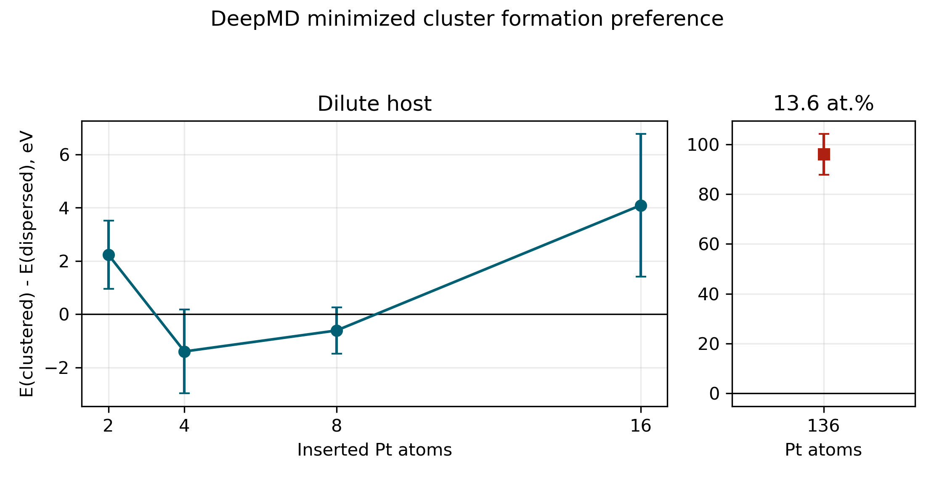
Figure S6. Direct DeepMD cluster-formation energy contrasts. Each point compares clustered and dispersed Pt assignments at identical composition and initial Ga-host geometry before minimization; positive values indicate that Pt clustering is less stable than separated Pt in that constructed liquid host, whereas negative values indicate that the clustered motif is lower. The dilute-host n=2/4/8/16 values are sign-mixed and should be treated as inconclusive rather than as a monotonic concentration trend.
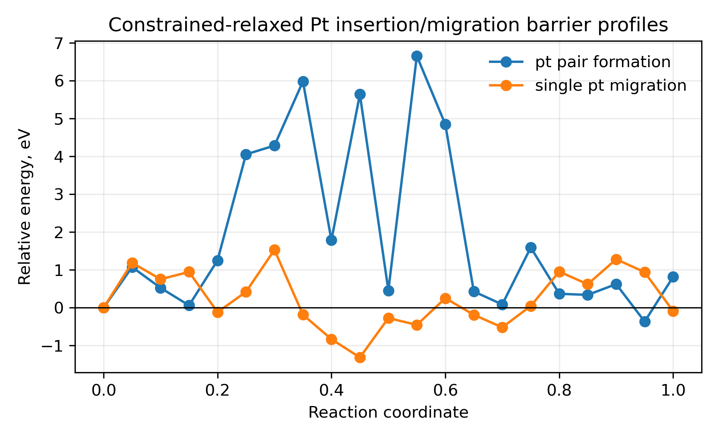
Figure S7. Constrained-relaxed DeepMD barrier profiles for isolated Pt-Ga exchange migration and Pt-Pt pair formation. These are arc-exchange MLP drag barriers with the moving Pt/Ga atoms fixed at curved exchange coordinates while the rest of the liquid host relaxes; they are not full DFT NEB barriers.
The cluster-formation calculations are direct energetic tests of whether the MLP favors Pt-Pt aggregation or Pt separation in liquid Ga, but the dilute-host series is not converged enough to define a composition window: n=4 and n=8 are slightly negative, n=2 and n=16 are positive, and the uncertainties are large. The robust use of the table is therefore to show mixed/inconclusive dilute-host energetics plus a separate strong 13.6 at.% anti-clustering stress-test result. The constrained-barrier profiles test the energetic cost of one constructed insertion path; the high pair-formation barrier should be treated as an MLP drag-path penalty, not as a quantitative kinetic barrier.

Supporting Liquid-Contact Proxies
The following DPMD contact statistics are retained as supporting liquid-ensemble observables, not as the primary R2-3 evidence.
Case | Pt at.% | T (K) | Pt-Ga CN | P(Pt-Pt <2.79 A) | Delta G contact (eV) | P(Pt-Pt <3.35 A)
ga21342pt43_dispersed_923K | 0.201 | 9e+02 | 8.28 | 0.00624 | 0.403 | 0.0787
ga864pt136_cluster_923K | 13.6 | 9e+02 | 7.74 | 0.893 | -0.168 | 1
ga864pt136_dispersed_923K | 13.6 | 9e+02 | 7.79 | 0.901 | -0.176 | 1
ga86pt14_cluster_923K | 14 | 9e+02 | 7.42 | 0.195 | 0.113 | 0.924
ga86pt14_dispersed_923K | 14 | 9e+02 | 7.39 | 0.228 | 0.0968 | 0.943
ga98pt2_close_2000K | 2 | 2e+03 | 7.67 | 0.00624 | 0.874 | 0.0262
ga98pt2_close_3000K | 2 | 3e+03 | 7.52 | 0.0137 | 1.1 | 0.0387
ga998pt2_close_923K | 0.2 | 9e+02 | 7.98 | 0 | 0.587 | 0
ga998pt2_far_923K | 0.2 | 9e+02 | 8.02 | 0 | 0.587 | 0.00375
Contrast | Delta E (eV/cell) | Block SEM (eV) | Meaning
ga998pt2_close_923K - ga998pt2_far_923K | -0.126 | 0.0655 | positive means lhs is higher in potential energy than rhs over the analyzed NVT window
ga864pt136_cluster_923K - ga864pt136_dispersed_923K | 4.83 | 0.163 | positive means lhs is higher in potential energy than rhs over the analyzed NVT window
ga86pt14_cluster_923K - ga86pt14_dispersed_923K | -0.144 | 0.0858 | positive means lhs is higher in potential energy than rhs over the analyzed NVT window
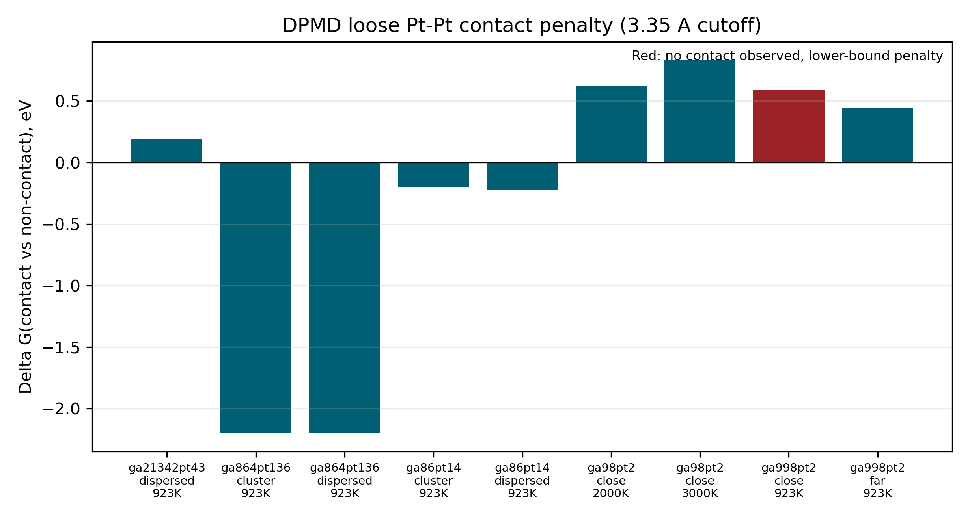
Figure 7. R2-3 Pt-Pt contact free-energy proxy from DPMD occupancy.

Recommended Response-Letter Text

Response 1: addresses
The revised dataset includes new VASP AIMD labels and DPMD trajectories at 2000 K and 3000 K for the Ga98Pt2 close-pair model. The DPMD high-temperature cases each contain 1001 dumped frames for a nominal 1 ns trajectory; the 2000 K loose Pt-Pt contact fraction is 0.0262, and the 3000 K loose-contact fraction is 0.0387.
- VASP revision labels: ga98pt2_close_2000K and ga98pt2_close_3000K completed 2000 AIMD steps each.
- DPMD ga98pt2_close_2000K: Pt-Pt p50 6.69 A, bond-contact fraction 0.00624.
- DPMD ga98pt2_close_3000K: Pt-Pt p50 6.64 A, bond-contact fraction 0.0137.
- Limitation: The 2000 K and 3000 K cases test force-field coverage and thermal robustness; they are not asserted to be the experimental reaction temperature or phase condition.

Response 2: addresses
The revised workflow distinguishes concentration from computational cell size. Ga998Pt2 is the minimal exact 0.2 at.% pair model, and Ga21342Pt43 is a large statistical model at 0.201 at.% Pt. By contrast, Ga2063Pt432 would be 17.31 at.% Pt, not 0.2 at.%, and would be a high-Pt stress test rather than the experimental catalyst concentration.
- DPMD ga998pt2_close_923K: Pt at.% 0.2, Pt-Pt p50 15.2 A, loose-contact fraction 0.
- DPMD ga998pt2_far_923K: Pt at.% 0.2, Pt-Pt p50 9.73 A, loose-contact fraction 0.00375.
- DPMD ga21342pt43_dispersed_923K: Pt at.% 0.201, Pt-Pt p50 4.78 A, loose-contact fraction 0.0787.
- Limitation: The Ga21342Pt43 trajectory is still a designed fixed-composition model with an assumed density and finite trajectory length.

Response 3: addresses
All nine revision DPMD cases were extended to 1,000,000 steps with a 1 fs timestep, corresponding to a nominal 1 ns trajectory per case. The first 20% of dumped frames is excluded from reported structural statistics.
- work/calculations/dpmd_revision/manifest.json records production_steps = 1000000 and production_time_ns = 1.0 for each revision case.
- Revision DPMD analysis status: complete; analyzed cases: 9.
- Limitation: Nanosecond DPMD improves sampling of structural contacts but does not make a rigorous phase-equilibrium or chemical-potential calculation.

Response 4: addresses_as_force_field_stress_test
The 13.6 at.% case is no longer evaluated only by the saturated whole-cell loose-contact fraction. Per-Pt statistics show isolated-Pt fractions of 0.966 +/- 0.001 at 2.79 A and 0.671 +/- 0.002 at 3.35 A for the dispersed trajectory; the initially clustered trajectory gives 0.967 +/- 0.001 and 0.682 +/- 0.002. The largest loose Pt cluster fraction is only 0.031 +/- 0.000 to 0.031 +/- 0.000, and Warren-Cowley alpha is 0.656-0.666 versus near-zero random same-geometry baselines. Thus the accepted DeepMD model supports Pt-Pt avoidance/single-atom-like dispersion at fixed 13.6 at.% composition.
- 13.6 at.% dispersed: Pt isolated <2.79 A = 0.966 +/- 0.001; Pt isolated <3.35 A = 0.671 +/- 0.002.
- 13.6 at.% initially clustered: Pt isolated <2.79 A = 0.967 +/- 0.001; Pt isolated <3.35 A = 0.682 +/- 0.002.
- Random same-geometry Warren-Cowley alpha is 0.00354-0.00709, much smaller than the DPMD alpha values.
- Direct 13.6 at.% DeepMD formation contrast: E(clustered)-E(dispersed) = 96.028 +/- 8.164 eV.
- Limitation: A fixed-composition NVT clustered/dispersed comparison is a force-field stress test at the experimental solubility composition, not a rigorous solubility calculation.
- Limitation: A true solubility calculation would require chemical-potential/free-energy sampling across compositions.

Response 5: addresses_with_limitations
R2-3 is now answered with direct MLP energetic tests rather than only contact probabilities or free-energy proxies. The dilute-host same-geometry cluster-formation series is sign-mixed: n=2: 2.235 +/- 1.274 eV, n=4: -1.399 +/- 1.575 eV, n=8: -0.610 +/- 0.871 eV, n=16: 4.091 +/- 2.681 eV. Therefore it should not be presented as a monotonic concentration-dependent proof that clustering is always disfavored; the n=4 and n=8 means slightly favor the constructed clustered motif within the present three-frame sample. The separate 13.6 at.% fixed-composition stress test gives a large positive contrast, E(clustered)-E(dispersed) = 96.028 +/- 8.164 eV, consistent with the DPMD dispersion statistics at that composition. The constrained Pt-Pt pair-formation path has a forward barrier of 6.656 eV and final-minus-initial energy of 0.816 eV; isolated Pt-Ga exchange has a barrier of 1.531 eV. The barrier profile is a constrained-relaxed arc-exchange drag test, so it is best interpreted as showing that this forced pair-formation path is energetically costly, not as a quantitative NEB activation barrier.
- Two-Pt same-host cluster formation: 2.235 +/- 1.274 eV.
- Four-Pt same-host cluster formation: -1.399 +/- 1.575 eV.
- Eight-Pt same-host cluster formation: -0.610 +/- 0.871 eV.
- Sixteen-Pt same-host cluster formation: 4.091 +/- 2.681 eV.
- 13.6 at.% same-host cluster formation: 96.028 +/- 8.164 eV.
- Pt-Pt pair-formation constrained path: barrier 6.656 eV, final-initial 0.816 eV.
- Limitation: The cluster formation energies are DeepMD same-host minimized energy contrasts, not isolated Pt-Pt or Ga-Pt pair bond energies.
- Limitation: The dilute-host n=2/4/8/16 series is non-monotonic and under-sampled; it should be reported as mixed/inconclusive rather than as a concentration-window conclusion.
- Limitation: The insertion/migration barriers are constrained-relaxed DeepMD arc-exchange drag barriers, not full DFT NEB barriers or Gibbs activation free energies.

Manuscript/SI-Ready Scientific Description

Suggested SI Methods Text
For the 13.6 at.% Pt fixed-composition trajectories, the whole-cell probability of at least one Pt-Pt contact is not a discriminating dispersion metric because the cell contains 136 Pt atoms. We therefore analyzed per-Pt isolation fractions at 2.79 and 3.35 A, the largest Pt cluster fraction, Pt-Pt and Pt-Ga coordination numbers, Warren-Cowley short-range order parameters, contact survival probabilities, and random-site baselines generated on the same instantaneous liquid geometries. Reported uncertainties are standard errors over the post-equilibration DPMD frames.
For the direct R2-3 energetic test, clustered and dispersed Pt assignments were generated in identical liquid Ga host frames and minimized with LAMMPS pair_style deepmd using the accepted DeepMD v2 graph. The cluster formation energy is defined as E(clustered)-E(dispersed) at fixed composition and cell. Constrained migration/insertion profiles were obtained by moving the exchanging Pt/Ga atoms along curved arc-exchange coordinates and minimizing all non-constrained atoms at each image; the resulting barriers are DeepMD constrained-relaxed arc-exchange drag barriers.

Suggested Results Text
At 13.6 at.% Pt, both the initially dispersed and initially clustered Ga864Pt136 DPMD trajectories evolve to highly dispersed Pt distributions. The dispersed trajectory gives 0.966 +/- 0.001 isolated Pt atoms at the 2.79 A bond cutoff and 0.671 +/- 0.002 at the 3.35 A loose cutoff; the initially clustered trajectory gives 0.967 +/- 0.001 and 0.682 +/- 0.002, respectively. The largest loose Pt cluster contains only 0.031 +/- 0.000 to 0.031 +/- 0.000 of the Pt atoms, and the Warren-Cowley alpha values are strongly positive relative to random same-geometry Pt assignments. Thus, within the validated DeepMD model, the 13.6 at.% fixed-composition stress test supports Pt-Pt avoidance/single-atom-like dispersion rather than persistent Pt aggregation.
Direct DeepMD energetic tests give a more nuanced R2-3 picture. Same-host minimizations for the dilute Ga998Pt2-derived host are sign-mixed (n=2: 2.235 +/- 1.274 eV, n=4: -1.399 +/- 1.575 eV, n=8: -0.610 +/- 0.871 eV, n=16: 4.091 +/- 2.681 eV); these values do not establish that 0.4-0.8 at.% Pt intrinsically favors clustering, because they come from only three liquid frames, carry sizable SEMs, and compare constructed motifs after local minimization rather than equilibrated composition-dependent free energies. The separate 13.6 at.% model gives E(clustered)-E(dispersed) = 96.028 +/- 8.164 eV, consistent with the DPMD structural evidence for Pt-Pt avoidance at that fixed composition. The constrained Pt-Pt pair-formation path has a forward drag-path barrier of 6.656 eV and a final-minus-initial energy of 0.816 eV, whereas isolated Pt-Ga exchange has a barrier of 1.531 eV. These direct tests should be reported as limited energetic probes rather than as a complete Pt-Pt/Ga-Pt bond-energy ordering.

Methods and Limitations
VASP labels used the locally documented PBE PAW AIMD setup, Gamma sampling, 400 eV cutoff, metallic smearing, non-spin-polarized electronic structure, and 1 fs steps. DeepMD datasets used element order Ga Pt and only validated completed VASP frames. DPMD used LAMMPS with the accepted DeepMD v2 graph.
- All structures are designed/reconstructed liquid models, not original experimental coordinates.
- The 5.6 g/cm3 density is a documented modeling assumption.
- The 3.35 A cutoff is a conservative loose-contact threshold, not a Pt-Pt bond definition.
- The 13.6 at.% tests are fixed-composition structural/energetic stress tests, not rigorous solubility calculations.
- The R2-3 cluster formation energies are DeepMD same-host minimized energy contrasts, not isolated pairwise bond decompositions.
- The dilute-host R2-3 cluster-formation series is sign-mixed and under-sampled; it should not be selectively quoted or promoted into a monotonic concentration-dependent clustering conclusion.
- The R2-3 insertion/migration barriers are constrained-relaxed DeepMD arc-exchange drag paths, not full DFT NEB barriers or Gibbs activation free energies.
- The R2-3 contact penalties are retained only as supporting occupancy/free-energy proxies, not Gibbs free energies.
- Catalytic performance claims remain grounded in the experimental conversion, selectivity, TOF, activation-energy, XAFS/PDF/XRD, and stability evidence.

Calculation Directory Index
Report item | Source path
vasp_first | work/analysis/vasp_aimd/vasp_aimd_summary.json
vasp_revision | work/analysis/vasp_aimd_revision/vasp_aimd_summary.json
deepmd_conversion | work/calculations/deepmd/ga_pt_liquid_v2/conversion_summary.json
deepmd_chain | work/calculations/deepmd/ga_pt_liquid_v2/analysis/deepmd_chain/deepmd_chain_summary.json
deepmd_post | work/calculations/deepmd/ga_pt_liquid_v2/analysis/deepmd_postprocess/postprocess_summary.json
deepmd_pca | work/calculations/deepmd/ga_pt_liquid_v2/analysis/deepmd_descriptor_pca_dft_all/summary.json
dpmd_revision | work/analysis/dpmd_revision/dpmd_summary.json
r2_revision | work/analysis/r2_3_energy_ordering_revision/r2_3_energy_ordering.json
dispersion_13p6 | work/analysis/dispersion_13p6/dispersion_13p6_summary.json
mlp_bonding | work/analysis/mlp_bonding_revision/mlp_bonding_revision.json
model_schematics | work/analysis/model_schematics/model_schematics_summary.json
reviewer_claims | work/analysis/reviewer_claims_v3.json
consistency_checks | work/analysis/scientific_consistency_checks_v2.md
DPMD raw trajectories | work/calculations/dpmd_revision/
13.6 at.% dispersion frame data | work/analysis/dispersion_13p6/
Direct MLP bonding calculations | work/calculations/mlp_bonding_revision/
Direct MLP bonding analysis | work/analysis/mlp_bonding_revision/
Model schematic figures | work/analysis/model_schematics/
DPMD production jobs | work/calculations/dpmd_revision/submitted_production_jobs.tsv
Workflow state | work/.research/

