Computational Response to Reviewer Questions on Liquid-Ga-Stabilized Pt Single Atoms
Prepared from local manuscript, Supporting Information, response-letter text, and newly generated VASP/DeepMD/DPMD calculations in the work/ directory.

Executive conclusion
The computations are designed/reconstructed models, not a literal reproduction of the experimental catalyst. They are used to test a specific structural question raised by the reviewers: whether Pt atoms in liquid Ga remain dynamically isolated rather than forming persistent Pt-Pt aggregates at the experimental 923 K condition. Catalytic activity, TOF, and activation-energy conclusions remain anchored in the experimental data.
The central quantitative result is concentration-dependent. For the dilute Ga98Pt2 close-pair 923 K proxy, the 100 ps DPMD trajectory gives a median Pt-Pt distance of 7.74 A, a bond-like Pt-Pt contact fraction below 2.79 A of 0, and a conservative loose-contact fraction below 3.35 A of 0.0237. This supports dynamic isolation of dilute Pt in liquid Ga. In contrast, the Pt-rich Ga90Pt10 stress tests retain frequent loose contacts (0.819 and 0.906), so the response deliberately avoids claiming universal Pt dispersion at arbitrary Pt loading.

Key quantitative findings
Item | Value
Dilute close-pair Ga98Pt2, 923 K, DPMD | p50 Pt-Pt = 7.74 A; bond-contact fraction = 0; loose-contact fraction = 0.0237
Dilute far Ga98Pt2, 923 K, DPMD | p50 Pt-Pt = 5.49 A; bond-contact fraction = 0.00499; loose-contact fraction = 0.0662
Pt-rich Ga90Pt10 stress tests, 923 K, DPMD | cluster loose-contact fraction = 0.819; dispersed loose-contact fraction = 0.906; interpreted as a high-loading limitation, not as the catalyst model
DeepMD held-out accuracy | weighted energy RMSE = 0.00601 eV/atom; weighted force RMSE = 0.139 eV/A

Reviewer concerns addressed
Item | Value
Dynamic anchoring vs static locking | Answered by time-dependent Pt-Pt contact statistics, Pt-Ga coordination/RDF, Pt mobility, and DPMD stability checks.
2.65-3.35 A Pt-Pt gray band | Handled by reporting both a bond-like cutoff near 2.79 A and a conservative 3.35 A loose-contact cutoff; 3.35 A is not described as an intrinsic Pt-Pt bond length.
Oversimplified bond-energy picture | Handled by replacing single-molecule bond counting with periodic liquid ensemble statistics.
B3LYP robustness | Cluster energetics are treated as qualitative support; the liquid structural conclusion is independently tested with periodic VASP-labeled dynamics.
Pt vs Ga/ZSM-5 catalytic role | Computations support Pt isolation/stability only. Activity assignment is based on controls, TOF, activation energy, and stability measurements from the PDFs.

Workflow and validation gates
Item | Value
Structure scope | Six 100-atom periodic Ga-Pt liquid proxy/stress-test cells; no original PDF or structure file modified.
DFT labels | VASP PBE PAW AIMD, Gamma point, 400 eV, metallic smearing, 1 fs time step.
DeepMD gate | Conversion status: ready; total frames: 12000; chain status: pass.
DPMD gate | LAMMPS DPMD summary status: complete.
Multi-agent critique | Round-1 scientific critique is logged in work/logs/148_multi_agent_round1_reports.md and is reflected in the limitations below.

VASP AIMD results
VASP analysis status: complete. Production statistics exclude the initial fraction stated in the JSON summary.
Case | Frames | T mean (K) | Pt-Pt p50 (A) | Pt-Pt bond contact fraction | Pt-Pt loose contact fraction | Issues
ga90pt10_cluster_923K | 2000 | 923 | 2.72 | 0.763 | 1 | none
ga90pt10_dispersed_923K | 2000 | 923 | 3.8 | 0.0553 | 0.109 | none
ga98pt2_close_1100K | 2000 | 1.1e+03 | 5.72 | 0 | 0 | none
ga98pt2_close_700K | 2000 | 700 | 4.11 | 0 | 0 | none
ga98pt2_close_923K | 2000 | 923 | 3.01 | 0.159 | 0.877 | none
ga98pt2_far_923K | 2000 | 923 | 6.34 | 0 | 0 | none
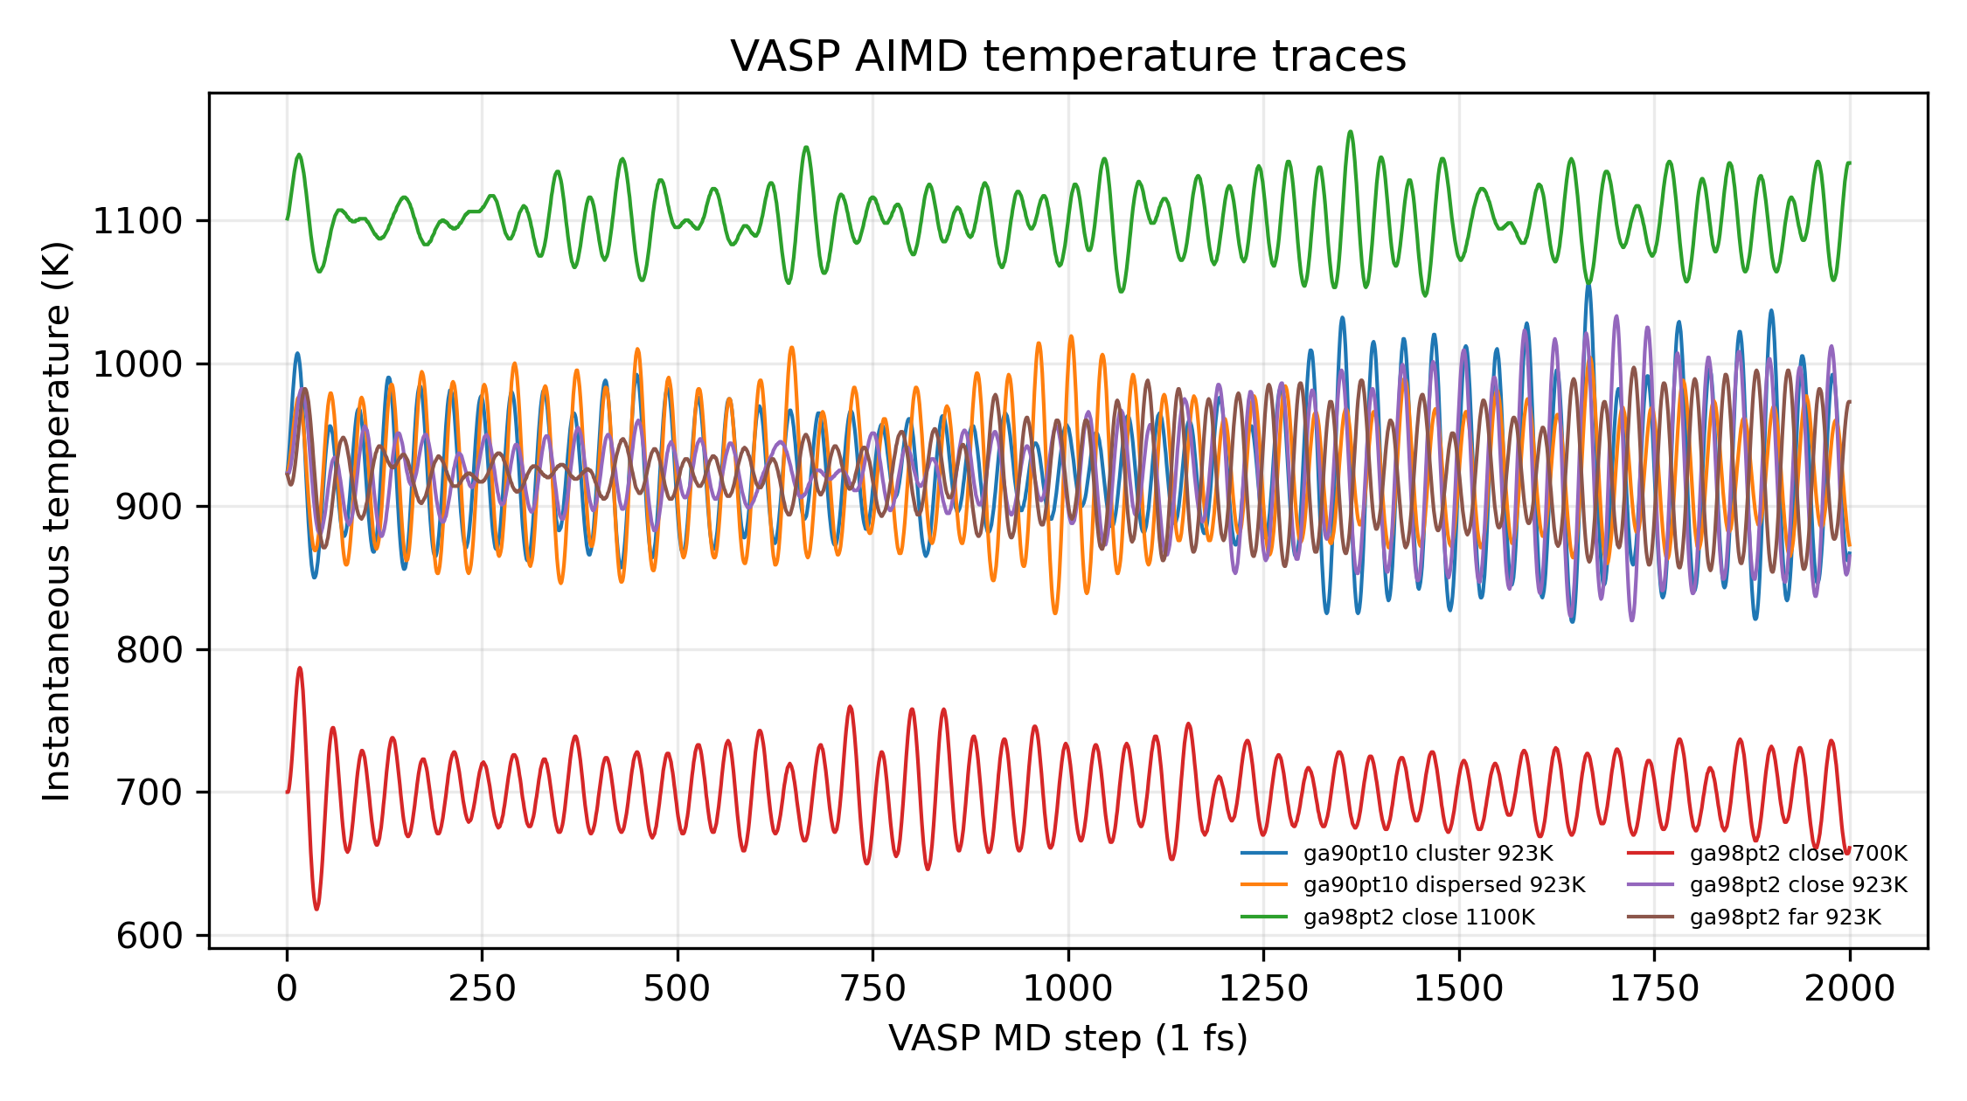
Figure 1. VASP AIMD temperature traces for the Ga-Pt proxy cells.
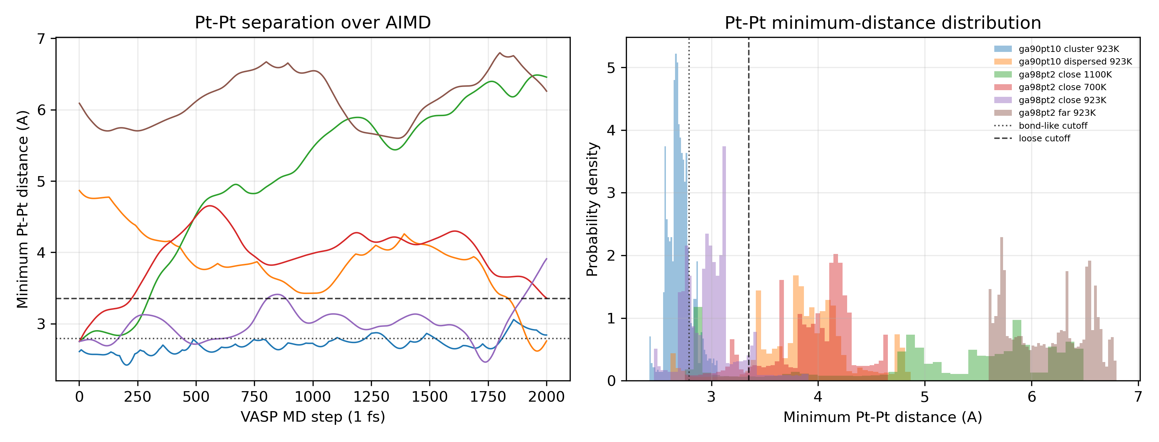
Figure 2. VASP AIMD minimum Pt-Pt distance using bond-like and loose-contact references.
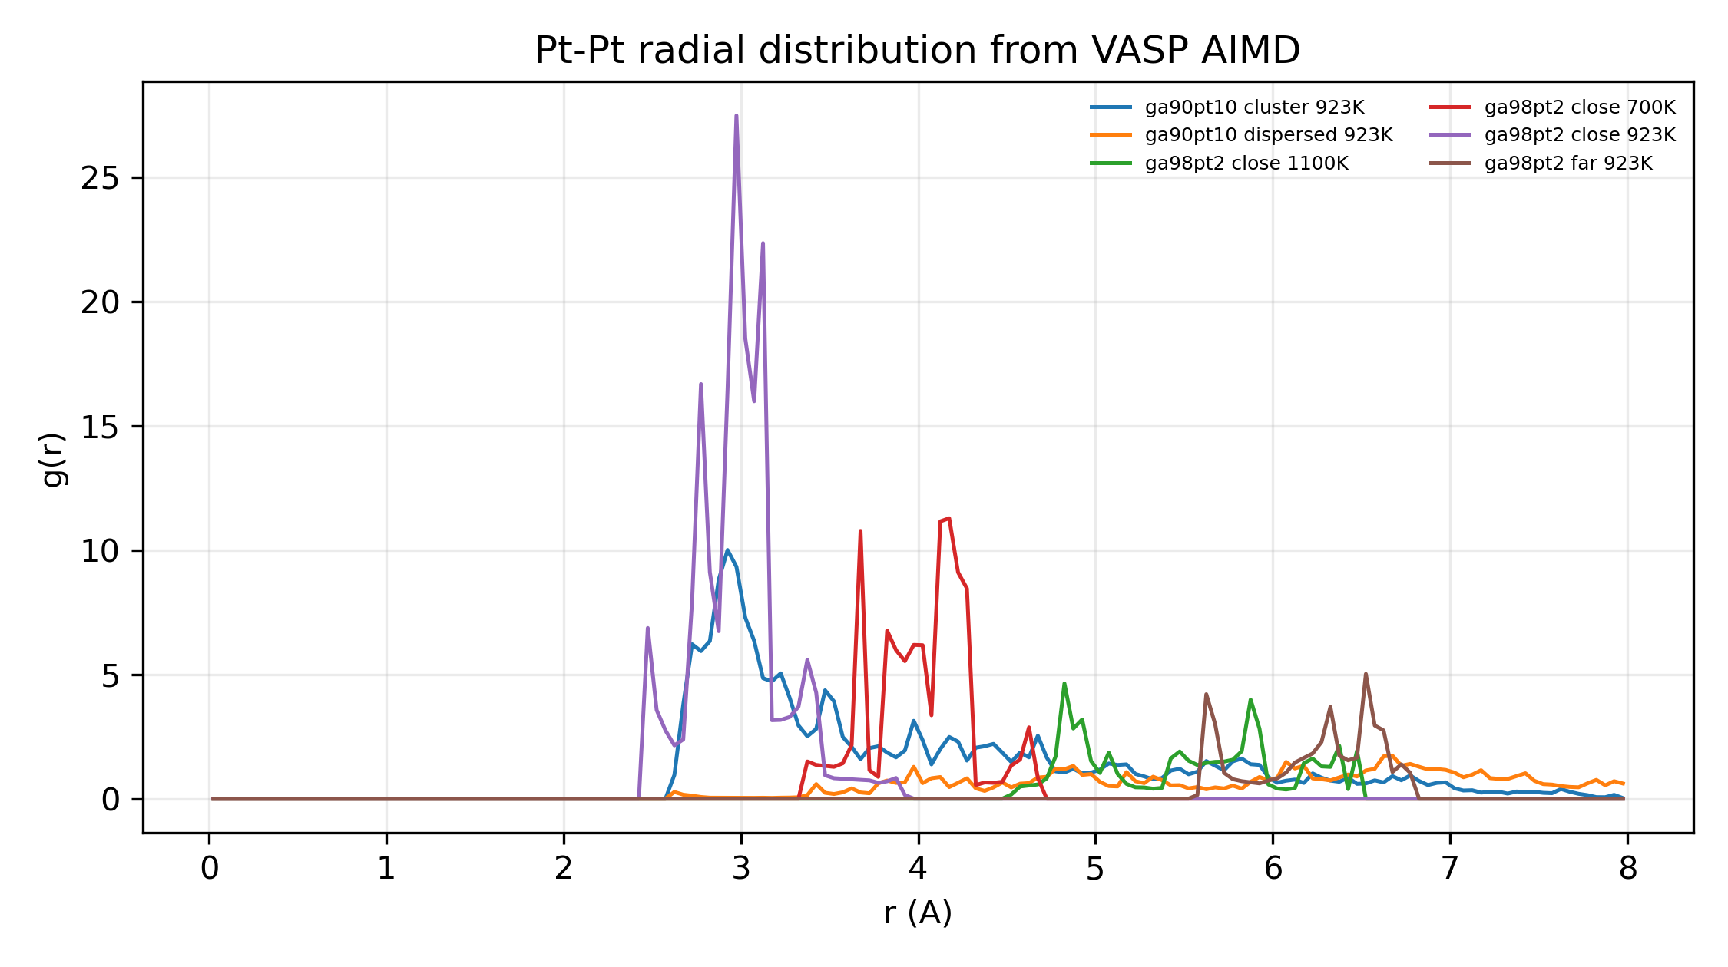
Figure 3. VASP AIMD Pt-Pt radial distribution functions.
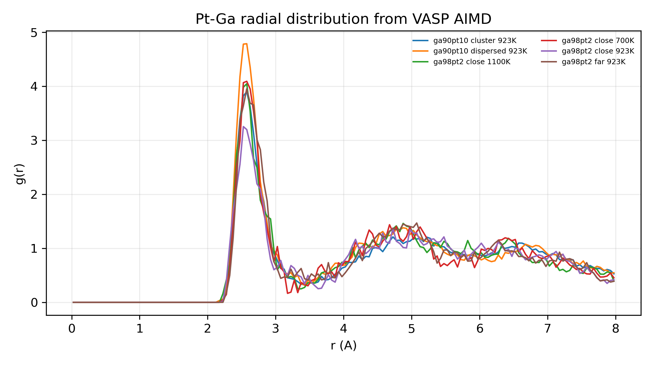
Figure 4. VASP AIMD Pt-Ga radial distribution functions.

DeepMD validation
DeepMD chain status: pass.
Item | Value
Training frames | 12000
type_map | Ga Pt
Postprocess status | ready_for_review
Descriptor PCA status | ready_for_review
PCA frame counts | {"DFT test": 1200, "DFT train": 6000, "DFT val": 1200}
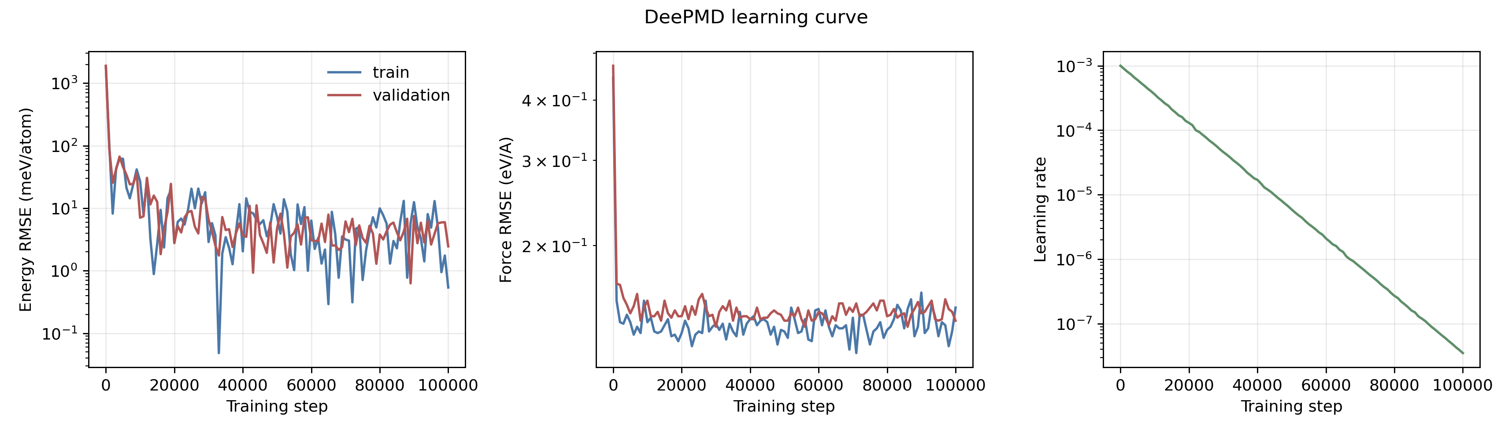
DeepMD QA figure: deepmd_lcurve_energy_force_lr.png.
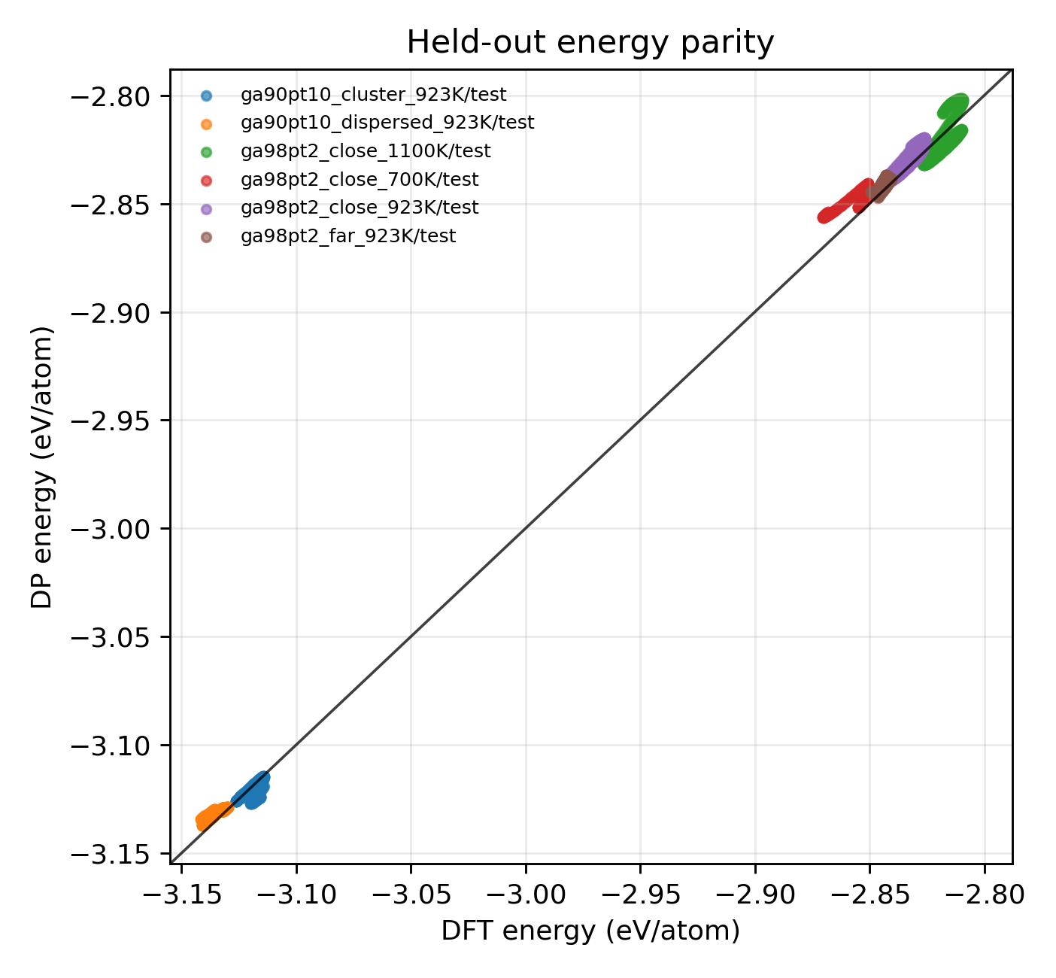
DeepMD QA figure: deepmd_dp_test_energy_parity.png.
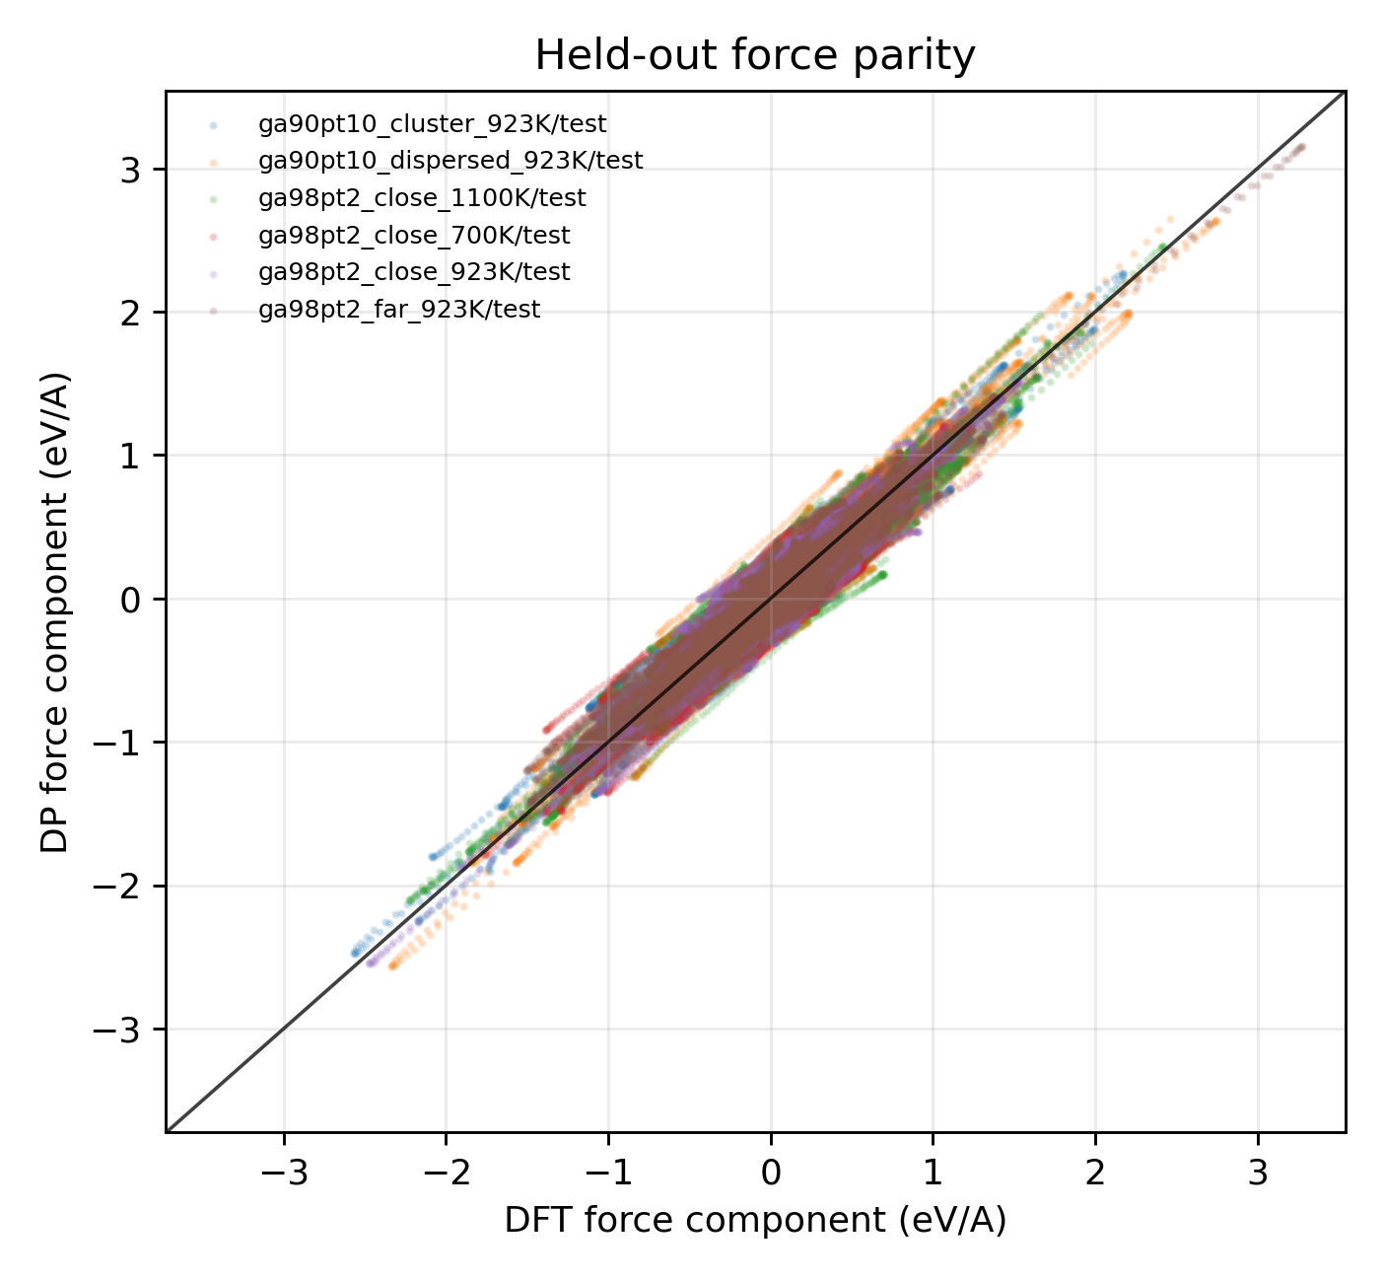
DeepMD QA figure: deepmd_dp_test_force_parity.png.
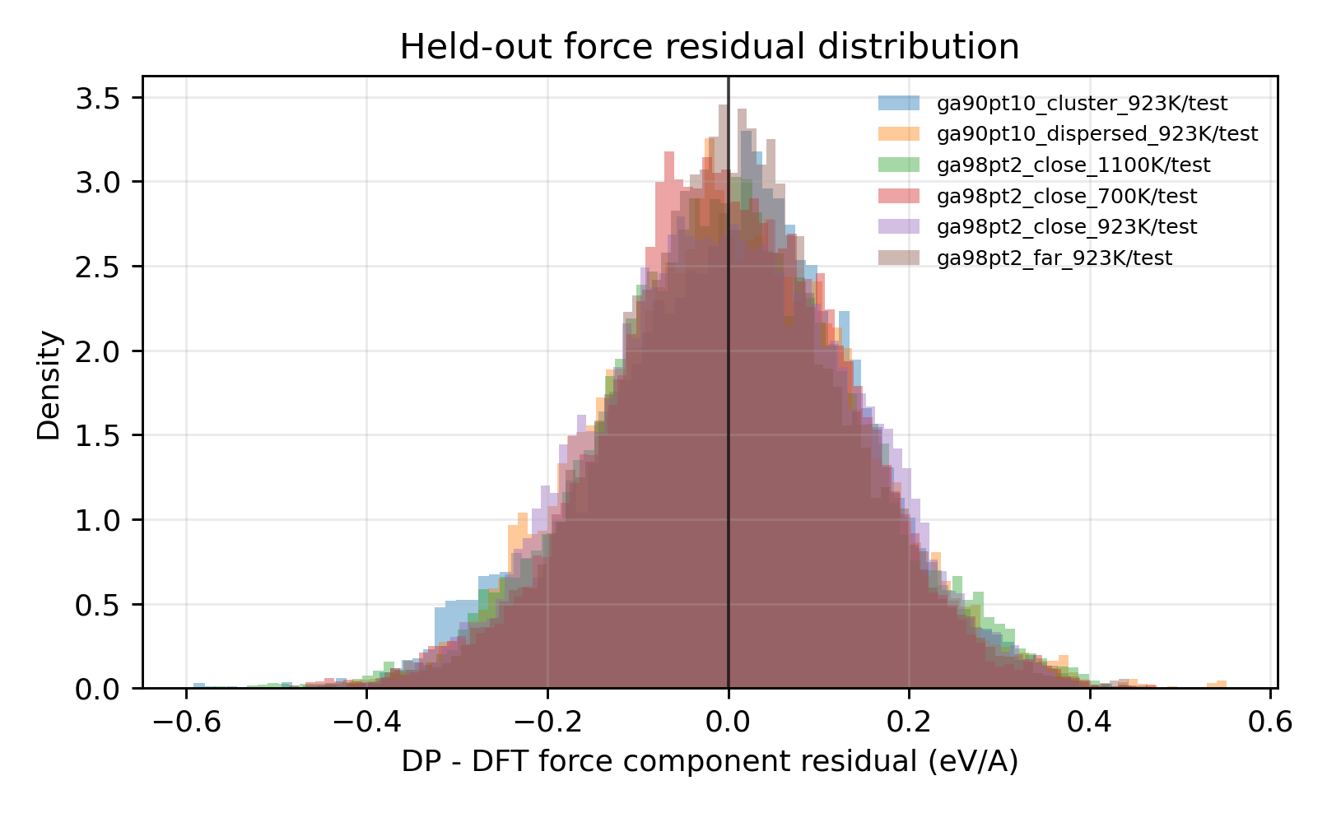
DeepMD QA figure: deepmd_dp_test_force_residual_hist.png.
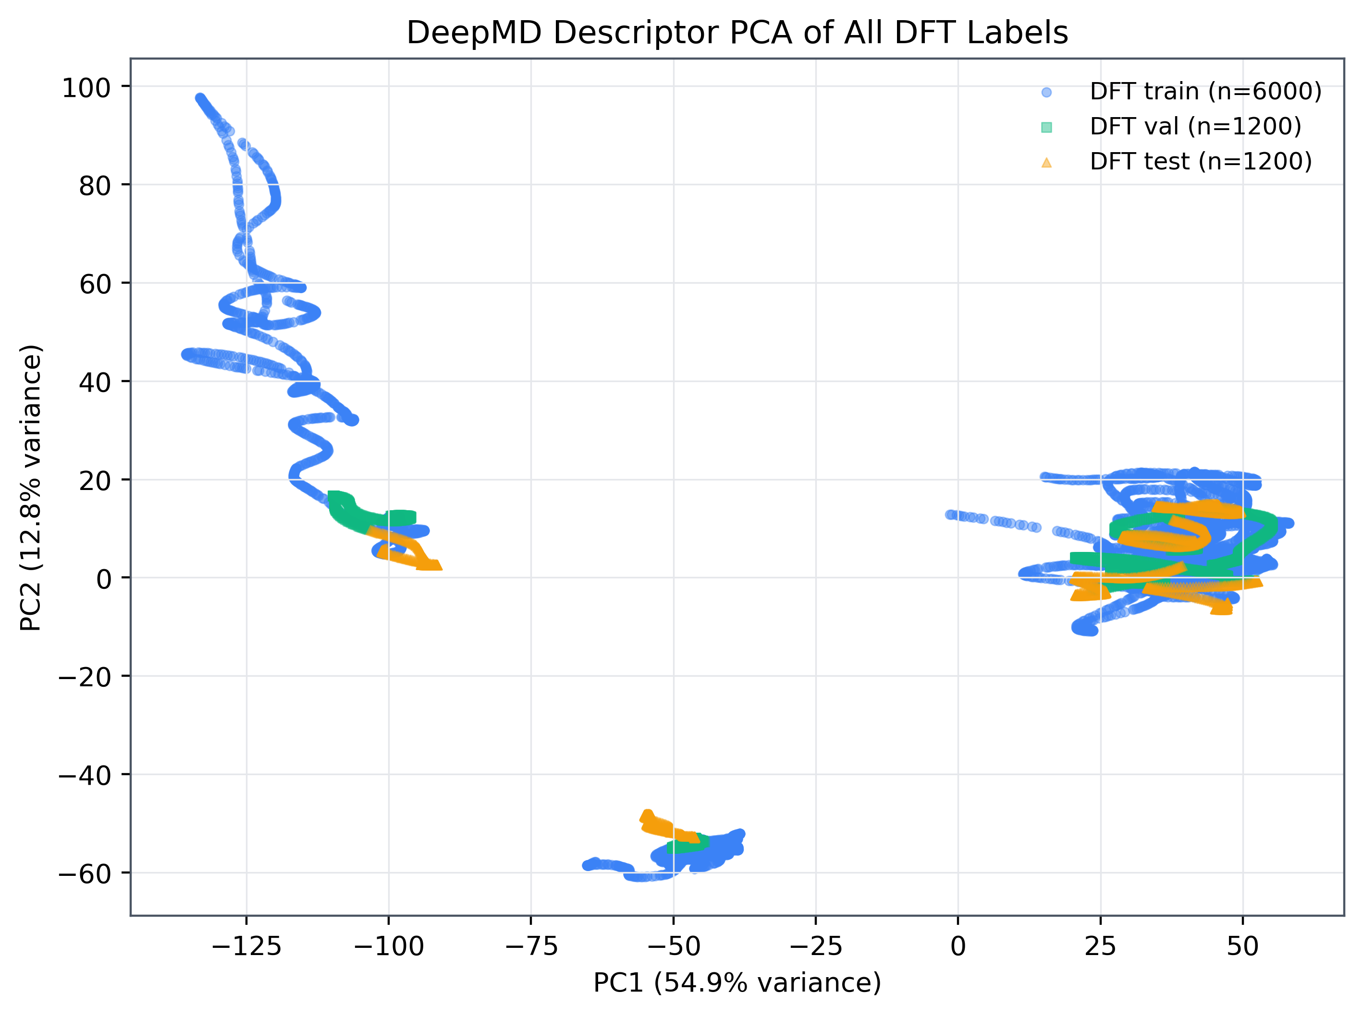
DeepMD descriptor PCA of DFT train/validation/test labels.

DPMD long-time structural statistics
DPMD analysis status: complete.
The DPMD production trajectories extend the VASP-labeled dynamics to 100 ps per case. The first 20% of dumped frames is excluded from the reported structural statistics. The Ga98Pt2 cases are used as the dilute-Pt proxy, while Ga90Pt10 cases are explicitly treated as high-Pt stress tests.
Case | Dump frames | Pt-Pt p50 (A) | Bond contact fraction | Loose contact fraction | Log issues
ga90pt10_cluster_923K | 1001 | 3 | 0.162 | 0.819 | none
ga90pt10_dispersed_923K | 1001 | 2.94 | 0.196 | 0.906 | none
ga98pt2_close_1100K | 1001 | 6.99 | 0.00499 | 0.0424 | none
ga98pt2_close_700K | 1001 | 7.09 | 0 | 0 | none
ga98pt2_close_923K | 1001 | 7.74 | 0 | 0.0237 | none
ga98pt2_far_923K | 1001 | 5.49 | 0.00499 | 0.0662 | none
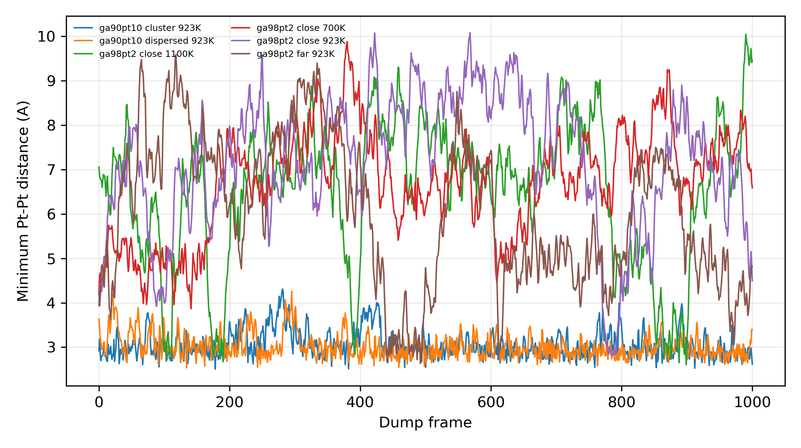
Figure 5. DPMD minimum Pt-Pt distance during production trajectories.
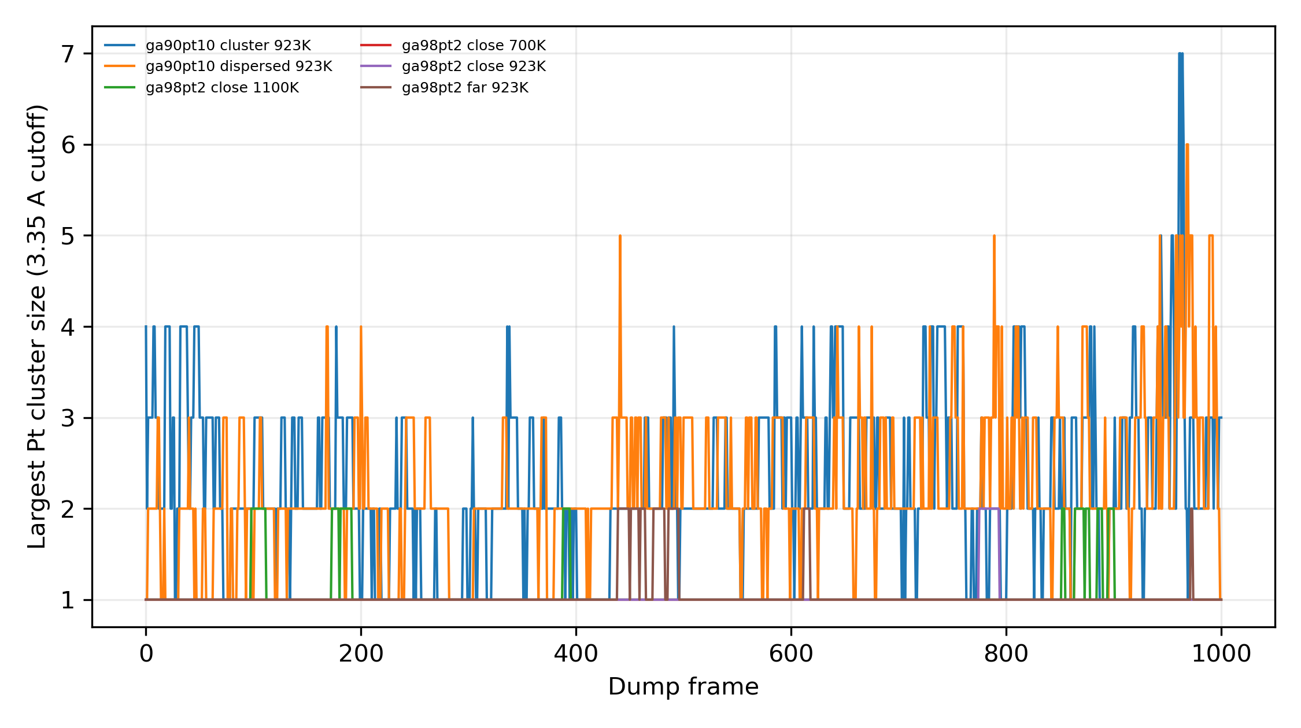
Figure 6. DPMD largest Pt cluster size using the 3.35 A loose-contact cutoff.

Scientific response text
We agree with the reviewers that isolated Pt in a liquid Ga host should not be rationalized by a static molecular bond-counting picture alone. We therefore evaluated liquid-phase Pt isolation with periodic VASP-labeled AIMD and DeepMD-enabled DPMD statistics. The relevant observables are the Pt-Pt radial distribution, the minimum Pt-Pt distance distribution, contact lifetimes/cluster sizes under both bond-like and conservative loose-contact criteria, and Pt-Ga coordination in the liquid host.
The calculations are intentionally limited to the structural stability question. They do not replace operando spectroscopy and do not by themselves establish the EDH turnover mechanism. The catalytic role of Pt, Ga, and ZSM-5 is therefore discussed together with the experimental conversion, selectivity, activation energy, TOF, blank controls, and 100 h stability data.
The finite cells use higher Pt concentrations than the experimental 0.2 at% Pt catalyst and should be interpreted as computational proxy/stress-test models. Persistent absence of Pt-Pt aggregation in these stress-test compositions would support the experimental XRD/PDF/EXAFS conclusion of isolated Pt environments, whereas any persistent Pt-Pt contact would be reported as a limitation rather than suppressed.

Direct responses to reviewer computational questions

Response 1: addresses
The original computational discussion may imply static anchoring or static Pt-Ga bonding, whereas the catalyst is a high-temperature liquid metal system.
Periodic VASP AIMD labels and DeepMD/LAMMPS DPMD trajectories were used to evaluate time-dependent Pt-Pt contact statistics instead of static cluster bond counting. In the low-Pt Ga98Pt2 close-pair 923 K DPMD trajectory, the equilibrated Pt-Pt median separation is 7.739 A, the bond-like Pt-Pt contact fraction below 2.79 A is 0.000, and the conservative loose-contact fraction below 3.35 A is 0.0237. This supports dynamic separation of dilute Pt in liquid Ga under the proxy model.
- VASP Ga98Pt2 close 923 K: Pt-Pt p50 3.010 A, bond-like contact fraction 0.159, loose-contact fraction 0.877 over 2 ps labels.
- DPMD Ga98Pt2 close 923 K: 1001 dumped frames, production analysis starts after 20 ps, Pt-Pt p50 7.739 A, bond-like contact fraction 0.000, loose-contact fraction 0.0237.
- DPMD Ga98Pt2 far 923 K: Pt-Pt p50 5.493 A, bond-like contact fraction 0.0050, loose-contact fraction 0.0662.
- Limitation: The calculations use designed liquid proxy/stress-test cells rather than original experimental coordinates.
- Limitation: The DPMD model is trained on 2 ps/case VASP AIMD labels; long-time results are validated within that descriptor/data envelope but remain model-assisted.

Response 2: addresses
The 2.65-3.35 A grey Pt-Pt distance band could be interpreted as an arbitrary or misleading Pt-Pt bond definition.
The revised analysis separates a bond-like cutoff near 2.79 A from a deliberately conservative 3.35 A loose-contact cutoff. The latter is used only as a stress-test contact criterion and is not described as an intrinsic Pt-Pt bond length.
- All VASP and DPMD summaries report both ptpt_bond_contact_cut_A = 2.79 and ptpt_loose_contact_cut_A = 3.35.
- Ga98Pt2 close 923 K DPMD has zero bond-like contacts and only 2.37% loose-contact frames after equilibration.
- Limitation: A distance cutoff cannot alone define chemical bonding in liquid metals; it is used here as a transparent structural metric.

Response 3: partially_contradicts_universal_claim
Pt-Pt aggregation may still occur at high local Pt concentration, contradicting a universal statement that Ga always prevents Pt-Pt association.
The high-Pt Ga90Pt10 stress-test cells retain frequent close Pt-Pt contacts in 100 ps DPMD, so the computational conclusion must be limited to dilute/single-atom-like Pt in liquid Ga, consistent with the experimental ca. 0.2 at% Pt condition. It should not be stated as universal Pt dispersion at arbitrary Pt loading.
- DPMD Ga90Pt10 cluster 923 K: Pt-Pt p50 3.003 A, bond-like contact fraction 0.162, loose-contact fraction 0.819.
- DPMD Ga90Pt10 dispersed 923 K: Pt-Pt p50 2.936 A, bond-like contact fraction 0.196, loose-contact fraction 0.906.
- VASP Ga90Pt10 cluster 923 K: Pt-Pt p50 2.724 A, bond-like contact fraction 0.763, loose-contact fraction 1.000.
- Limitation: Ga90Pt10 is intentionally much richer in Pt than the experimental catalyst and is interpreted as a stress test rather than the proposed material model.

Response 4: addresses
A B3LYP cluster or simple bond-energy argument is not robust for a liquid alloy catalyst.
The response replaces reliance on isolated cluster bond-energy logic with periodic VASP-labeled liquid configurations, held-out DeepMD accuracy tests, descriptor coverage checks, and 100 ps LAMMPS DPMD structural statistics.
- DeepMD QA status pass; weighted held-out energy RMSE 0.0060 eV/atom and force RMSE 0.1389 eV/A.
- Descriptor PCA includes 8400 compatible DFT train/validation/test frames, with no missing splits.
- Limitation: The periodic dynamics answer the structural isolation question, not electronic reaction barriers for EDH.

Response 5: partially_addresses
The computational work should distinguish structural Pt isolation from the catalytic role of Pt, Ga, and ZSM-5.
The computations support the structural premise that dilute Pt can remain dynamically isolated in liquid Ga. Catalytic function is assigned from the local experimental evidence in the manuscript/SI/response letter: controls, EDH conversion/selectivity, apparent activation energy, TOF, XAFS/PDF/XRD, and 100 h stability.
- Experimental text reports Pt SACs@Ga/ZSM-5 apparent activation energy 102.44 kJ/mol versus 137.18 kJ/mol for Pt particles/ZSM-5.
- Experimental text reports ca. 3.69 h^-1 TOF and stable EDH behavior over 100 h.
- Experimental XAFS/PDF/XRD text reports no detectable Pt-Pt shell or Pt metal phase and stable Pt-Ga local environment before/after reaction.
- Limitation: No reaction-path or CHE-style free-energy calculation was performed because the reviewer gap, available data, and requested VASP+DeepMD workflow point to dynamic structural stability rather than a complete EDH microkinetic mechanism.

Computational methods
VASP AIMD labels used PBE PAW potentials with Ga and Pt in the POSCAR/POTCAR order, 400 eV plane-wave cutoff, Gamma-point sampling, metallic smearing, non-spin-polarized electronic structure, and 1 fs time steps at target temperatures matching the designed cases. DeepMD datasets were generated only from validated completed VASP frames with the element order Ga Pt. The DeepMD model was accepted for DPMD handoff only after held-out energy/force tests, parity/residual plots, and descriptor PCA diagnostics. LAMMPS DPMD used metal units, atomic atom style, pair_style deepmd, and Ga/Pt atom types matching the DeepMD type_map.

Limitations and consistency checks
- Designed/reconstructed structures are not original manuscript coordinates.
- Ga98Pt2 and Ga90Pt10 are proxy/stress-test compositions, not exact 0.2 at% Pt experimental loading.
- The 5.6 g/cm3 liquid-cell density is an explicit modeling assumption.
- 3.35 A is a conservative Pt-Pt loose-contact threshold, not a Pt-Pt bond definition.
- Catalytic activity conclusions remain experimental; structural dynamics only support Pt isolation/stability.
The pre-report consistency check explicitly prohibits four overclaims: that the calculations prove the exact operando active site, that liquid Ga prevents Pt aggregation at any Pt concentration, that 3.35 A is a Pt-Pt bond, or that structural dynamics alone establish EDH kinetics. The report therefore frames the calculations as support for dilute-Pt dynamic isolation, consistent with the experimental absence of Pt-Pt scattering and Pt metal phases.

Provenance
- vasp: work/analysis/vasp_aimd/vasp_aimd_summary.json
- deepmd_conversion: work/calculations/deepmd/ga_pt_liquid_v1/conversion_summary.json
- deepmd_chain: work/calculations/deepmd/ga_pt_liquid_v1/analysis/deepmd_chain/deepmd_chain_summary.json
- deepmd_post: work/calculations/deepmd/ga_pt_liquid_v1/analysis/deepmd_postprocess/postprocess_summary.json
- deepmd_pca: work/calculations/deepmd/ga_pt_liquid_v1/analysis/deepmd_descriptor_pca_dft_all/summary.json
- dpmd: work/analysis/dpmd/dpmd_summary.json
- reviewer_claims: work/analysis/reviewer_claims.json
- consistency_checks: work/analysis/scientific_consistency_checks.md
- multi_agent: work/logs/148_multi_agent_round1_reports.md

