Computational response to reviewer questions on IDMP anchoring
VASP calculations based only on supplied PDFs 01-03 and project-local structures; draft for author response

Executive Summary
Reviewer #1 questioned whether IDMP can bind through both phosphonic-acid termini without steric hindrance. Reviewer #3 requested that the computational charge-density figures include coordinate axes and element-color identification. I addressed both points with a clean-room VASP workflow using only the supplied manuscript, Supporting Information, response letter, and project-local structures.
The central result is that the relaxed IDMP double-ended model forms two Pb-O contacts to two different surface Pb sites and two different phosphonate P centers, with Pb-O distances of 2.557 and 2.558 A. Its adsorption energy is -2.577 eV relative to the clean slab plus gas-phase IDMP, which is -1.069 eV more exothermic than the IDMP single-start control and -1.108 eV more exothermic than the AMP half-ligand control.
The computations therefore support the authors' mechanistic statement that double-ended IDMP anchoring is sterically feasible on adjacent exposed Pb sites. The result should be presented together with the experimental evidence already present in the supplied files: the IDMP P=O FTIR shift with PbBr2, Pb/Br XPS shifts after IDMP treatment, stronger 207Pb NMR affinity for IDMP than AMP, and unchanged PL/UV-vis peak positions as IDMP loading changes.
For Reviewer #3, the report includes revised Bader-charge, total charge-density, and frozen-fragment charge-density-difference visualizations with coordinate axes, atom labels, element-color legends, and colorbars. The CDD branch initially failed on GPU memory limits, but the fragment statics were completed on CPU nodes with the same 280 x 280 x 448 CHGCAR grid as the combined statics.

Reviewer 1 Comment 2
Reviewer comment: "The authors claimed that IDMP could anchor with the perovskite through double-ends, but I am worried about the steric hindrance. Please provide both experimental and theoretical evidence."
Computational strategy: I built an exposed-Pb local window from the supplied CsPbBr3 slab by neutral adjacent CsBr removal and compared IDMP double-ended anchoring, an IDMP single-start control, and AMP as the half-IDMP control. This is a local mechanistic model, not a reproduction of the full quasi-2D film morphology. It directly tests the steric feasibility of placing the two phosphonate termini onto nearby Pb sites.
The accepted IDMP double-ended structure remains intact after relaxation. The two shortest coordinating contacts are Pb33-O111 = 2.557 A and Pb35-O112 = 2.558 A. Contact-topology assignment shows that these two O atoms belong to two different phosphonate P centers, P105 and P106, so this is a genuine two-ended binding motif rather than two O atoms from one phosphonate group.
Energetically, the double-ended IDMP model is substantially favored. Using static VASP E0 values, E_ads(IDMP double-ended) = -2.577 eV, E_ads(IDMP single-start control) = -1.508 eV, and E_ads(AMP single-ended) = -1.469 eV. More negative values indicate stronger binding relative to the clean slab and gas-phase ligand reference states.
Table 1. Relative adsorption energies from final static E0 values. Reference states are the relaxed clean slab window plus the corresponding gas-phase ligand(s). More negative E_ads means stronger binding. Total VASP energies are not reported.
Model | Formula | E_ads (eV) | E_ads per ligand (eV) | Status
IDMP double-ended | E(ads_idmp_double_x)-E(slab_window)-E(gas_idmp) | -2.577 | -2.577 | computed
IDMP single-start control | E(ads_idmp_single)-E(slab_window)-E(gas_idmp) | -1.508 | -1.508 | computed
AMP single-ended | E(ads_amp_single)-E(slab_window)-E(gas_amp) | -1.469 | -1.469 | computed
Table 2. Relaxed Pb-O contact topology. P-center assignment is based on nearest ligand P-O connectivity in the relaxed CONTCAR.
Model | Pb-O contacts | Unique Pb sites | Unique phosphonate P centers | Contact distances
ads_idmp_double_x | 2 | 2 | 2 | Pb33-O111 2.557 A; Pb35-O112 2.558 A
ads_idmp_single | 2 | 2 | 2 | Pb33-O111 2.471 A; Pb35-O110 2.882 A
ads_amp_single | 1 | 1 | 1 | Pb33-O108 2.573 A
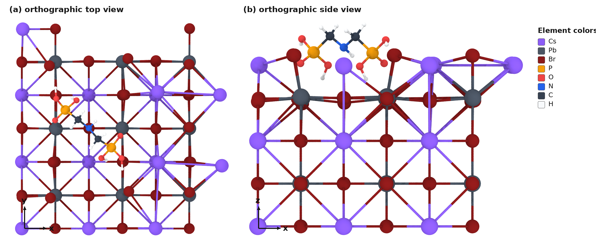
Figure 1. Relaxed IDMP double-ended adsorption model. (a) Orthographic top view; (b) orthographic side view. Element colors are listed in the panel. Source: work/calculations/relax_accepted/ads_idmp_double_x/CONTCAR.
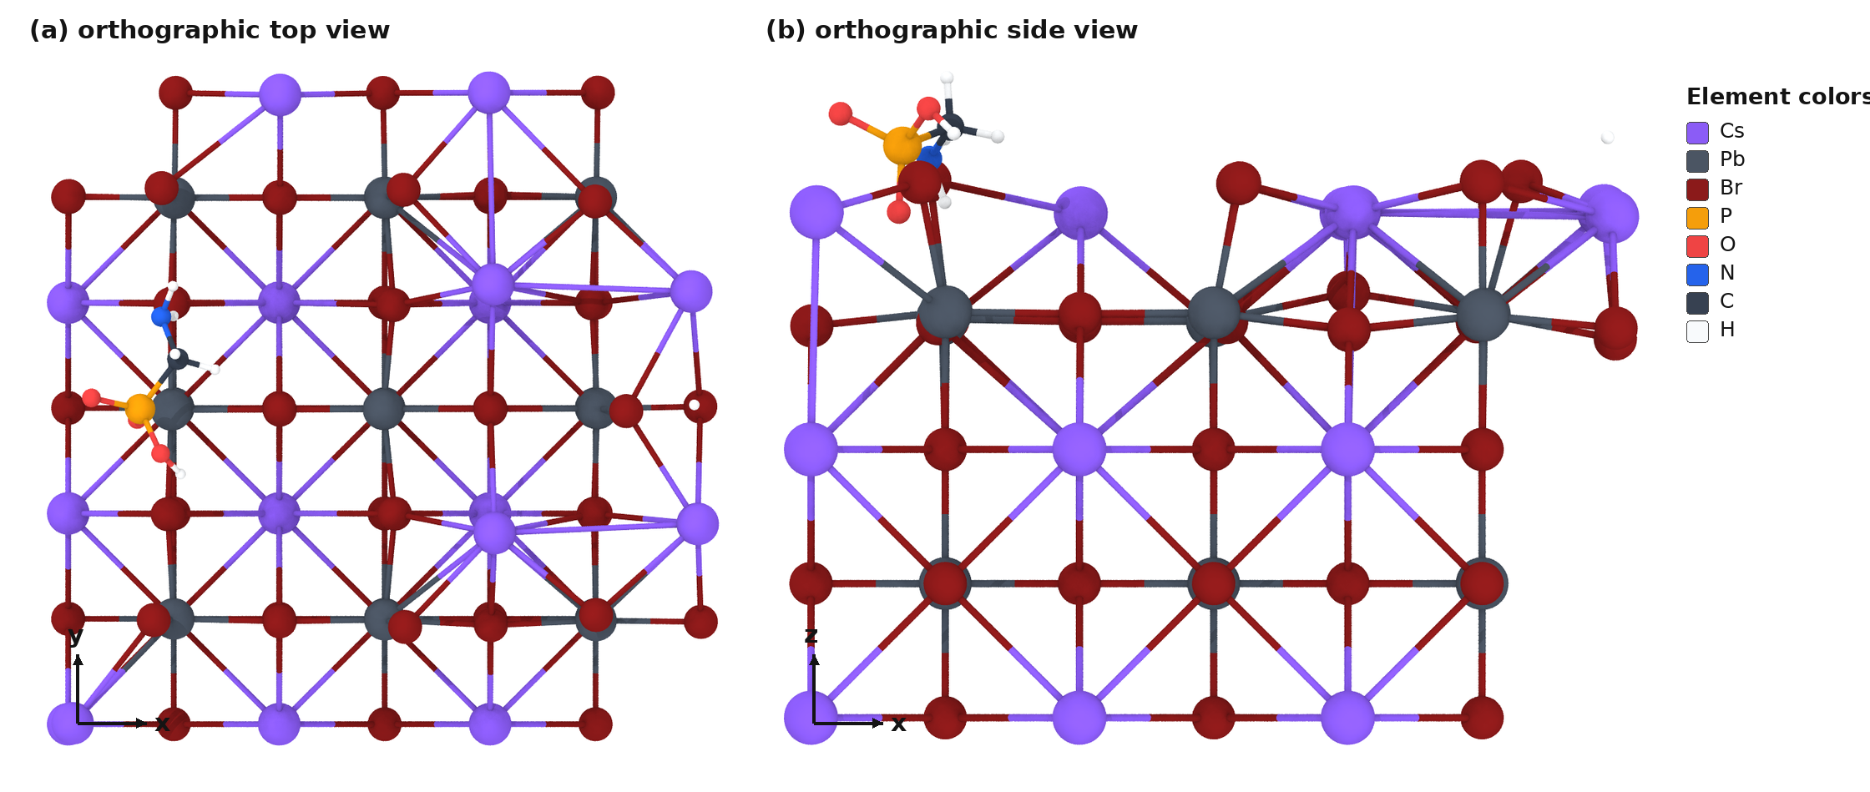
Figure 2. Relaxed AMP single-ended control. (a) Orthographic top view; (b) orthographic side view. Source: work/calculations/relax_accepted/ads_amp_single/CONTCAR.
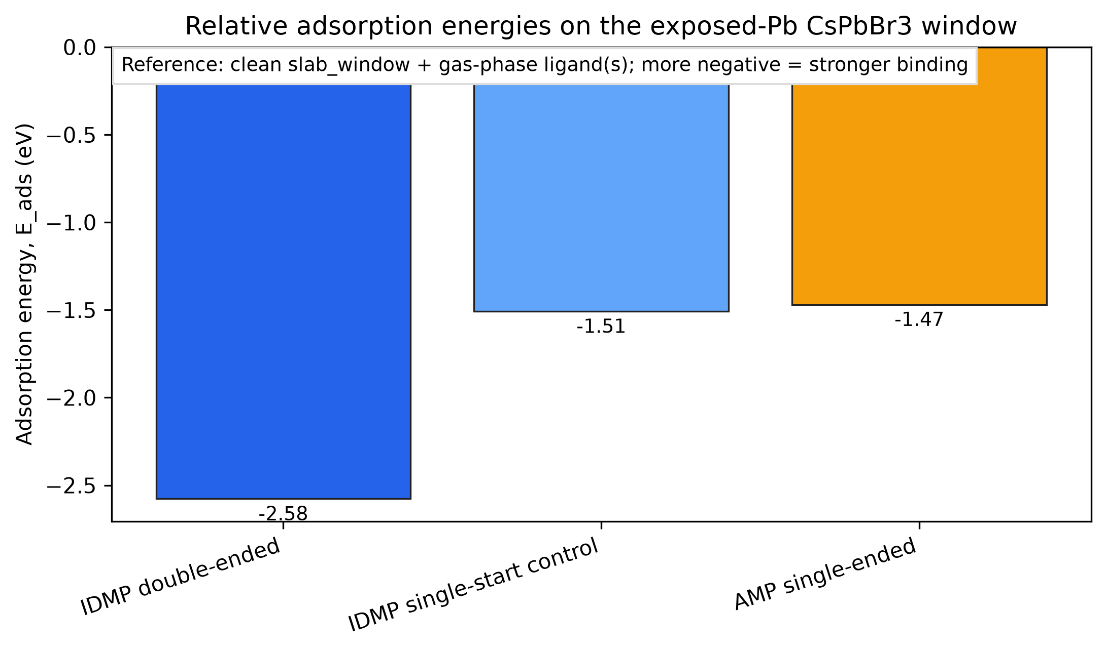
Figure 3. Adsorption-energy comparison on the same exposed-Pb CsPbBr3 window. IDMP double-ended anchoring is the most exothermic tested motif.
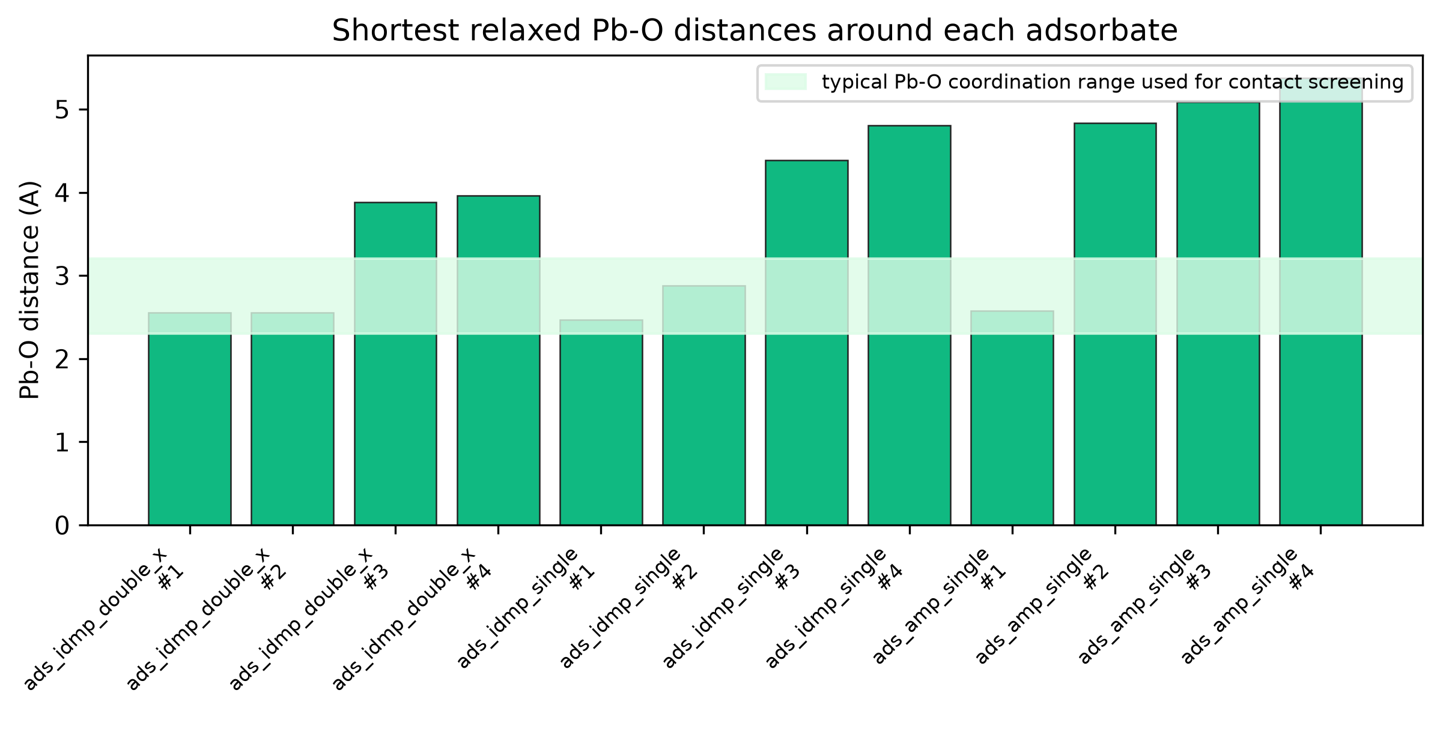
Figure 4. Shortest relaxed Pb-O distances around IDMP and AMP adsorbates. The IDMP double-ended model shows two near-identical Pb-O contacts assigned to two phosphonate termini.

Reviewer 3 Comment 6
Reviewer comment: "There are some format issues need to be addressed. For instance, the calculation of charge density, the author should provide the coordinate axes and mark the elements represented by each color."
The revised computational figures should include axes and element/color definitions directly on the figure. I generated three forms of charge evidence from validated static calculations: Bader charge-colored side views, static valence charge-density slices through the Pb-O-P coordination plane, and frozen-fragment charge-density-difference slices/planar averages. All figure types include coordinate axes and atom/element labels.
Bader analysis used AECCAR0 + AECCAR2 as the reference density, not the valence CHGCAR alone. The IDMP double-ended contact atoms have polar Pb-O charge character: Pb33 +1.125 e / O111 -1.372 e and Pb35 +0.937 e / O112 -1.169 e. These values support local Pb-O coordination but are not promoted to formal oxidation states.
Charge-density difference was evaluated as Delta rho = rho(combined adsorbate/slab) - rho(frozen slab fragment) - rho(frozen ligand fragment). The CPU CDD results show a larger robust charge-redistribution magnitude for double-ended IDMP than for AMP: the absolute 99th percentile is 50.25 versus 26.62 grid units, and the absolute 99.5th percentile is 89.72 versus 48.30 grid units.
Table 3. Bader net charges for Pb-O contact atoms. q = ZVAL - N_Bader; positive values indicate electron depletion relative to the PAW valence count. These are local charge descriptors, not formal oxidation states.
Model | Contact | Distance (A) | q(Pb) (e) | q(O) (e) | P center | q(P) (e)
ads_idmp_double_x | Pb33-O111 | 2.557 | +1.125 | -1.372 | P105 | +3.214
ads_idmp_double_x | Pb35-O112 | 2.558 | +0.937 | -1.169 | P106 | +2.593
ads_idmp_single | Pb33-O111 | 2.471 | +1.152 | -1.335 | P105 | +2.606
ads_idmp_single | Pb35-O110 | 2.882 | +0.645 | -1.236 | P106 | +2.946
ads_amp_single | Pb33-O108 | 2.573 | +1.044 | -1.203 | P105 | +2.401
Table 4. CPU frozen-fragment charge-density-difference summary. Delta rho is reported in CHGCAR grid units; positive values indicate accumulation in the combined interface relative to the frozen fragments.
Model | Grid | Min | Max | |Delta rho| p99 | |Delta rho| p99.5 | Slice atoms | Slice vmax
ads_idmp_double_x | 280x280x448 | -1145.4 | 2224.3 | 50.25 | 89.72 | 33-111-105 | 319.6
ads_amp_single | 280x280x448 | -943.4 | 2135.2 | 26.62 | 48.30 | 33-108-105 | 263.6
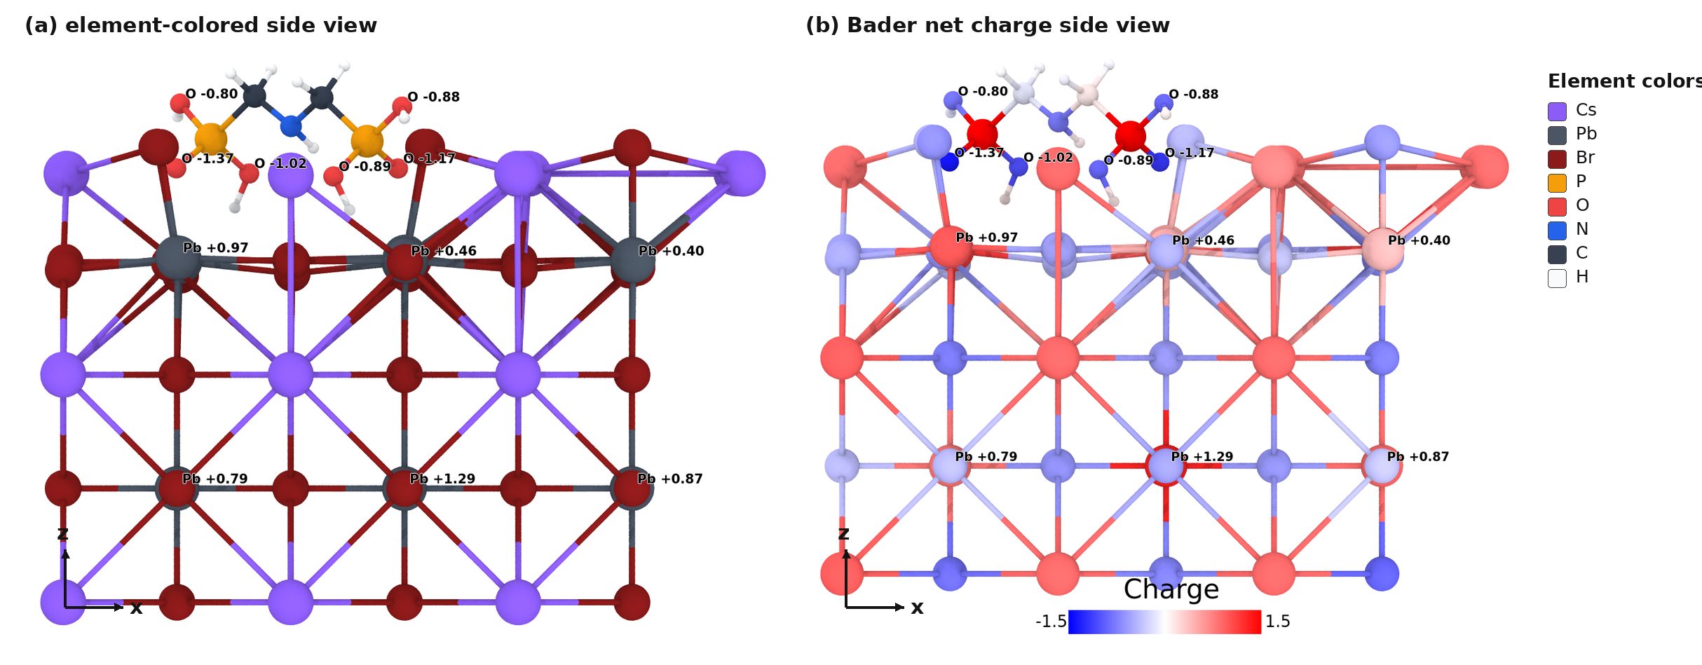
Figure 5. IDMP double-ended Bader charge visualization. (a) Element-colored side view; (b) same side view colored by Bader net charge, with colorbar and labeled Pb/O atoms. Source: work/calculations/static/ads_idmp_double_x.
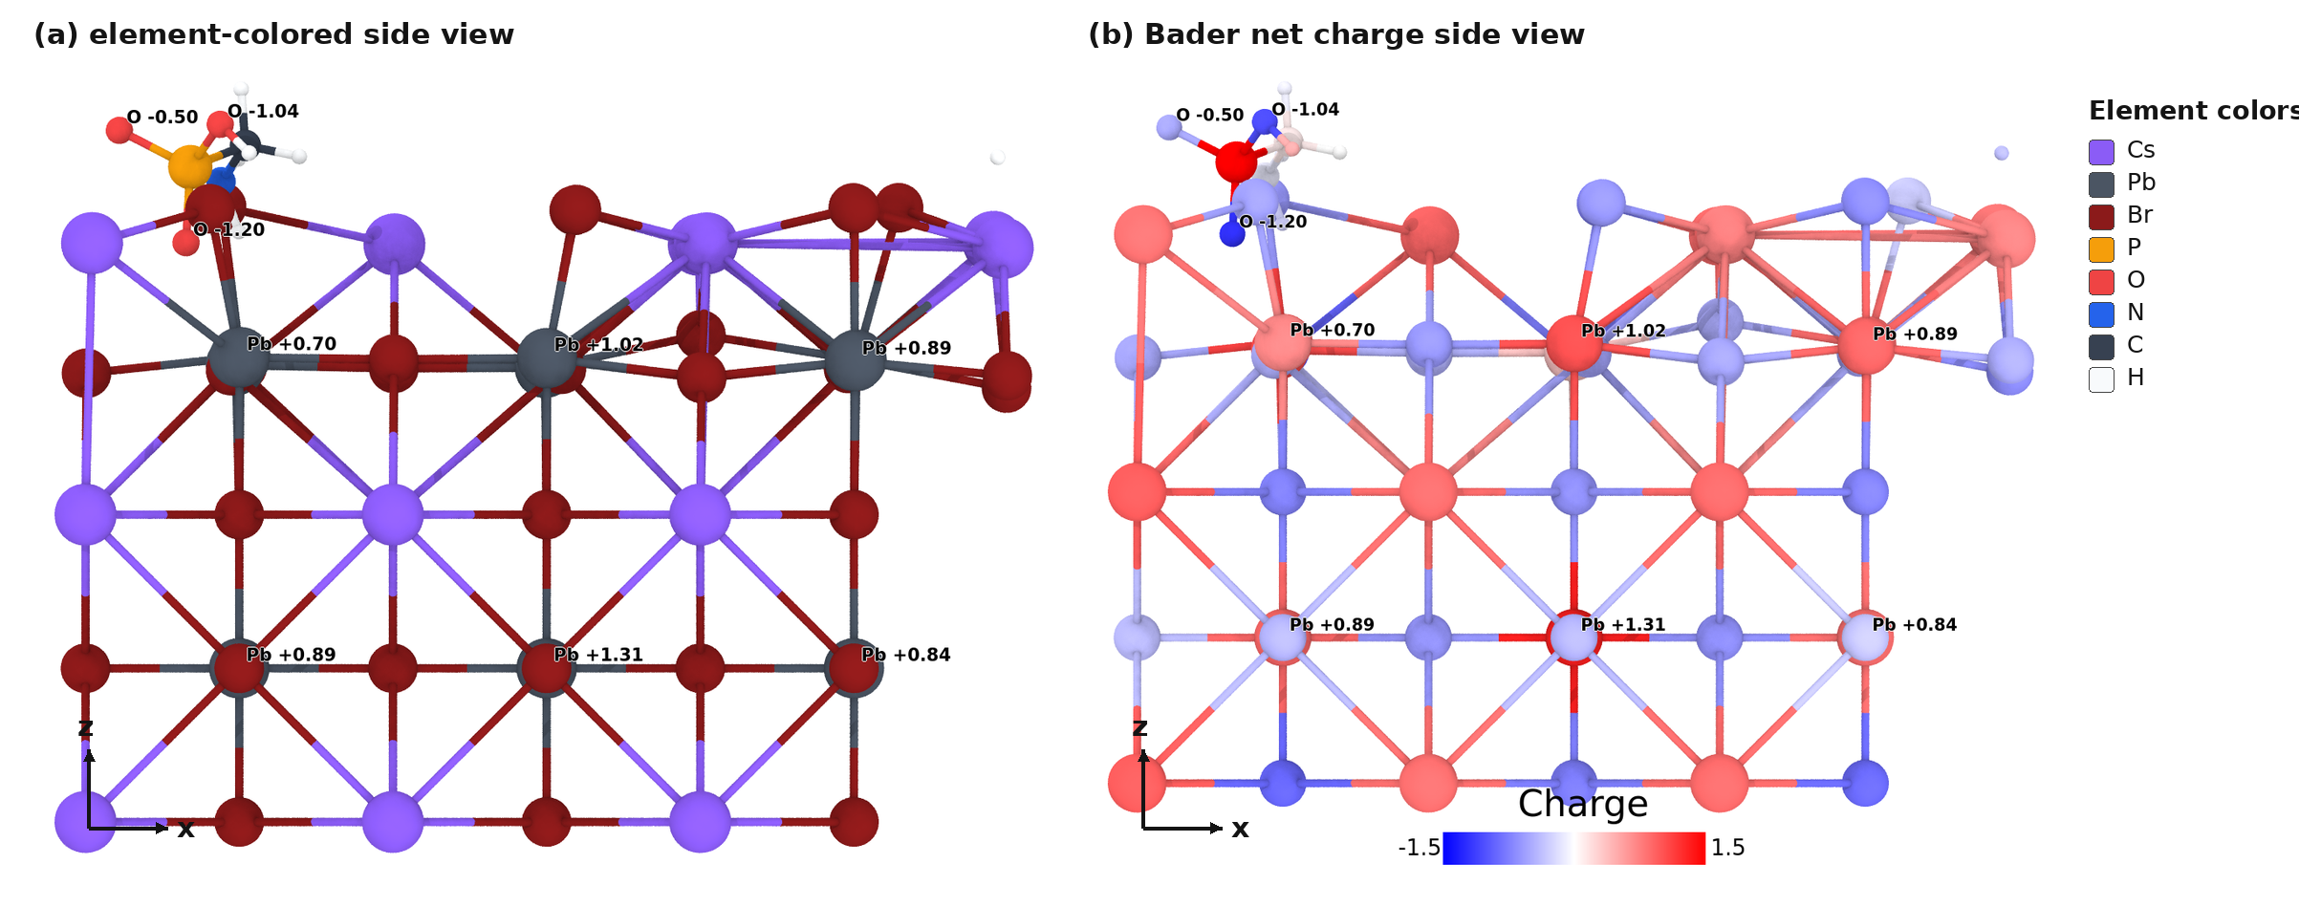
Figure 6. AMP control Bader charge visualization. (a) Element-colored side view; (b) same side view colored by Bader net charge. Source: work/calculations/static/ads_amp_single.
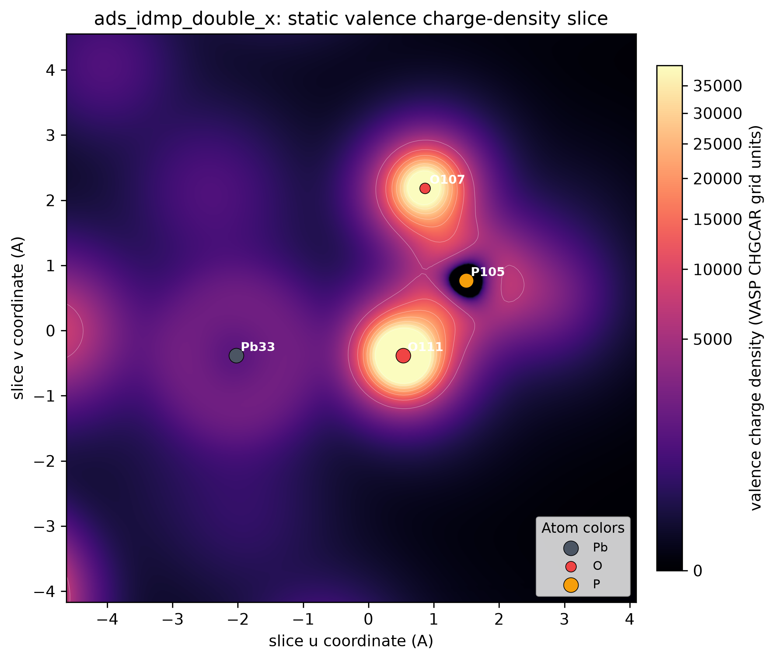
Figure 7. Static valence charge-density slice for IDMP through atoms Pb33, O111, and P105. Slice-coordinate axes, atom labels, element-color markers, and CHGCAR grid-units colorbar are shown. Source: work/calculations/static/ads_idmp_double_x/CHGCAR.
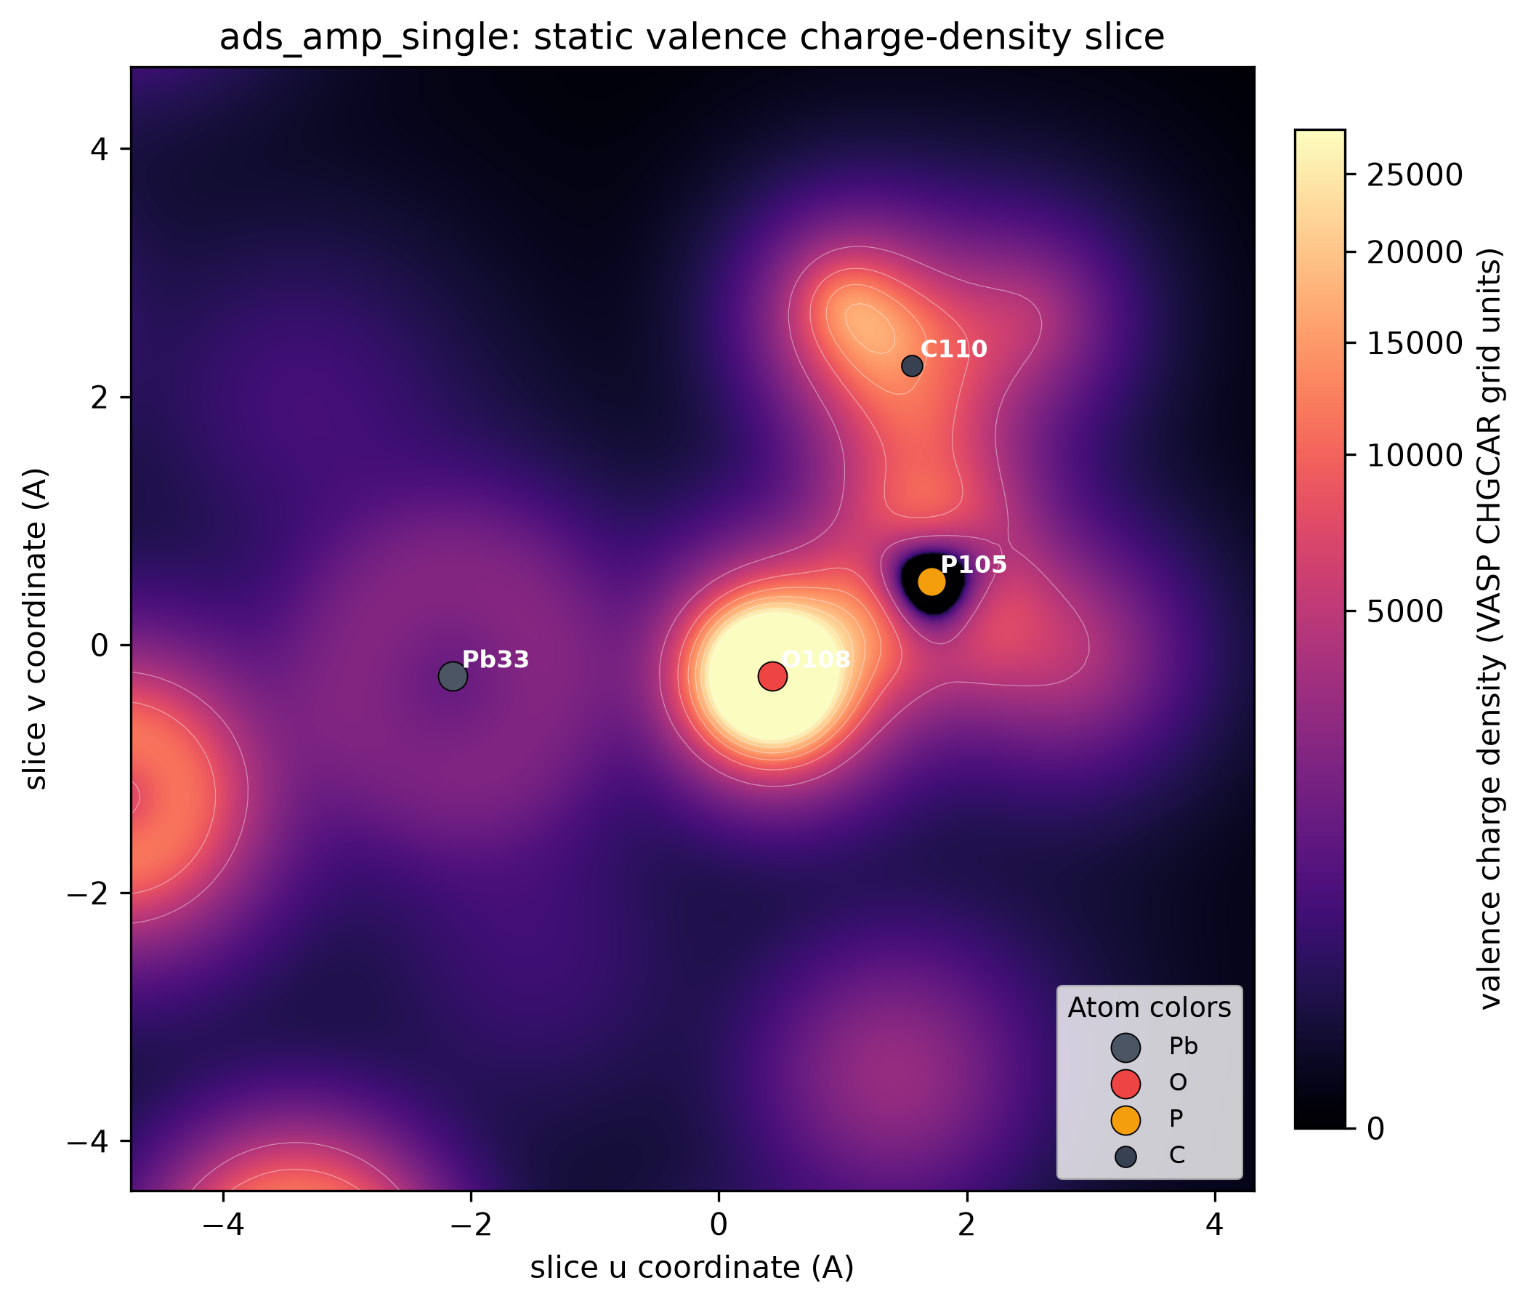
Figure 8. Static valence charge-density slice for AMP through atoms Pb33, O108, and P105. The panel includes coordinate axes and atom-color legend as requested by the reviewer. Source: work/calculations/static/ads_amp_single/CHGCAR.
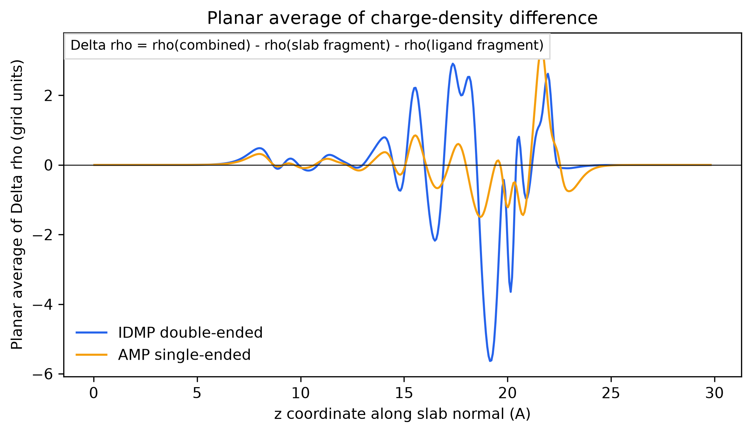
Figure 9. Planar average of frozen-fragment charge-density difference along the slab-normal direction. Delta rho = rho(combined) - rho(frozen slab fragment) - rho(frozen ligand fragment). Source: work/calculations/charge_density_difference_cpu/*/planar_average_z.csv.
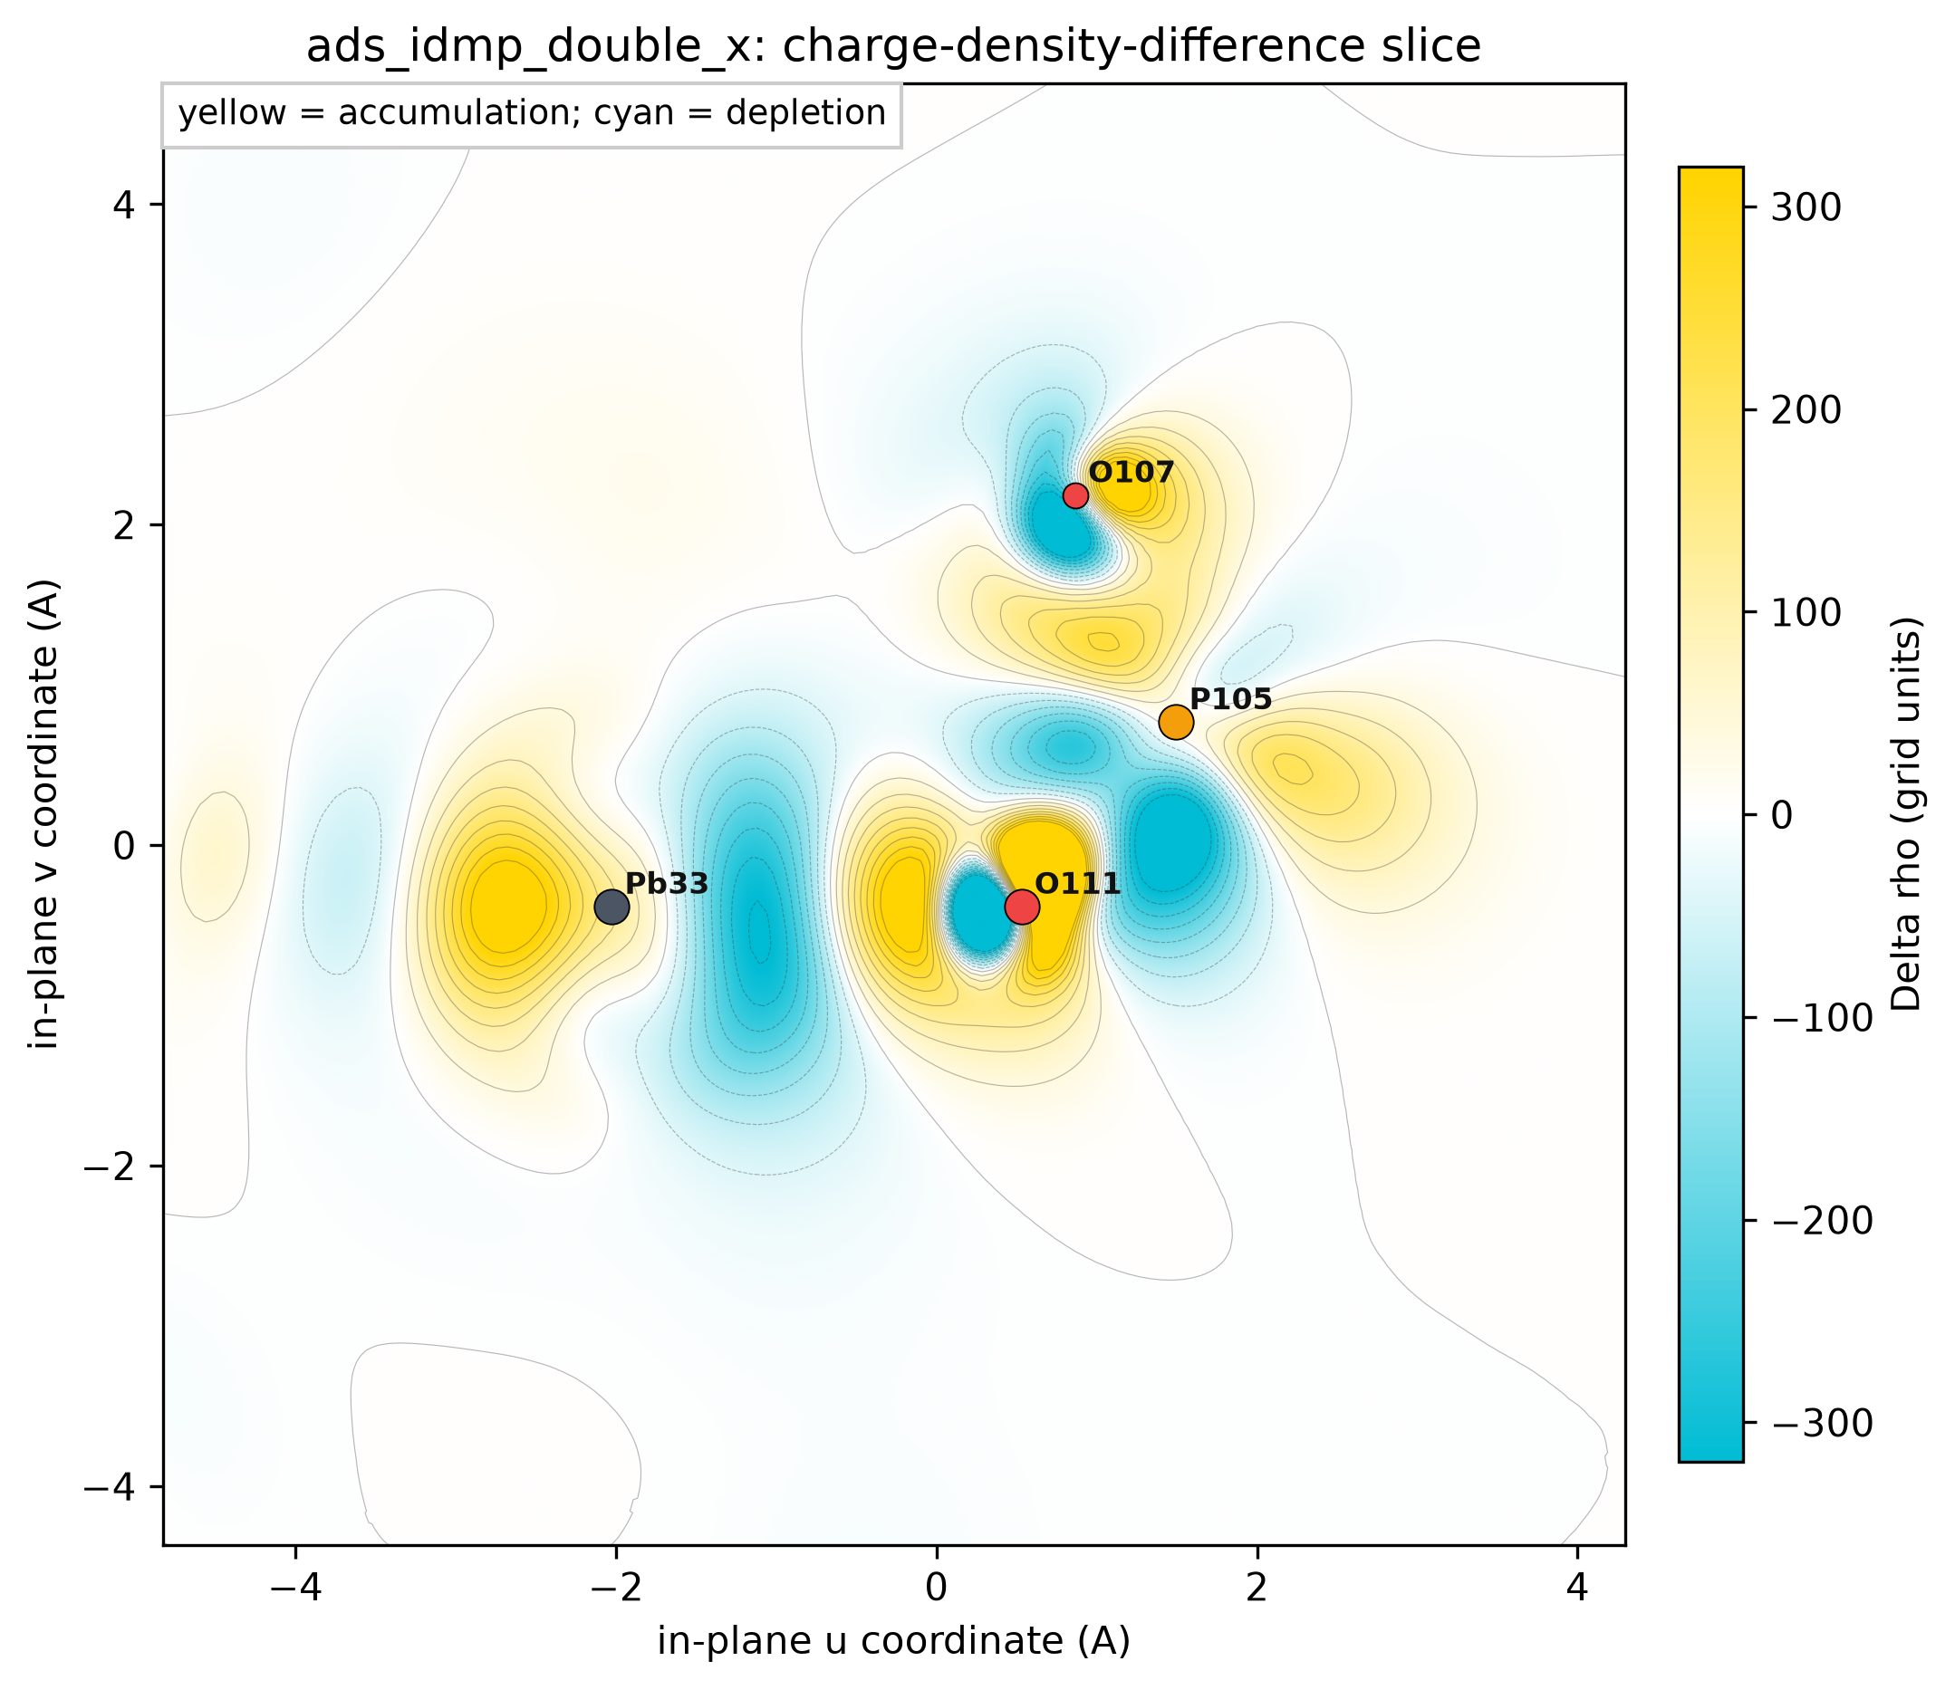
Figure 10. IDMP frozen-fragment charge-density-difference slice through Pb33, O111, and P105. Yellow indicates charge accumulation and cyan indicates depletion in the combined interface relative to frozen fragments. Source: work/calculations/charge_density_difference_cpu/ads_idmp_double_x/CHGDIFF.vasp.
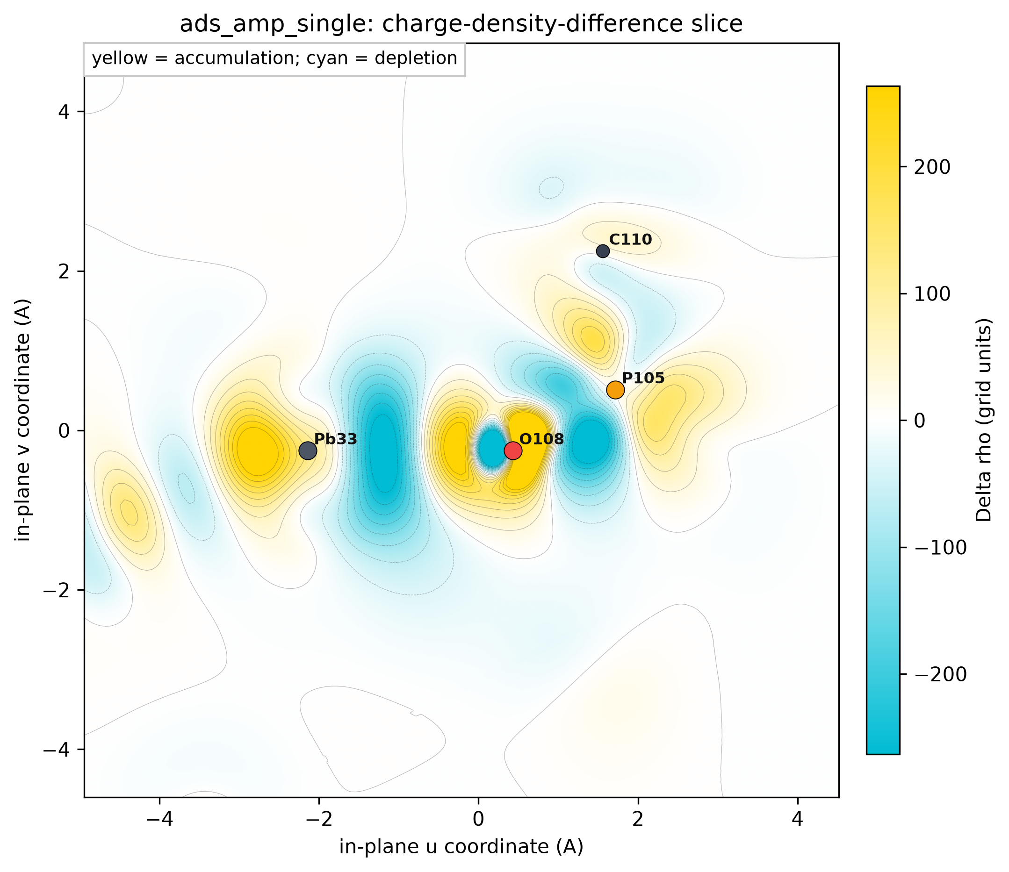
Figure 11. AMP frozen-fragment charge-density-difference slice through Pb33, O108, and P105 with the same sign convention and labeled element colors. Source: work/calculations/charge_density_difference_cpu/ads_amp_single/CHGDIFF.vasp.

Computational Methods
All calculations were performed with VASP in a new work/ directory. Original PDFs and original structure files in the project root were not modified. No online search was used.
The supplied CsPbBr3 slab was used as the parent structure. A local exposed-Pb window was constructed by removing adjacent neutral CsBr units from the top surface. Supplied IDMP and AMP molecular coordinates were used to build candidate adsorbate geometries. The accepted models were selected after structure review for chemically sensible contacts and absence of severe short contacts.
VASP settings: PBE with D3(BJ) dispersion correction (IVDW=12), ENCUT = 520 eV, Gamma-only KPOINTS, non-spin-polarized calculations, ISMEAR = 0, SIGMA = 0.05 eV, LASPH = .TRUE., LREAL = .FALSE., and ISYM = 0. Geometry relaxations used ISIF = 2 and EDIFFG = -0.03 eV/A. Static charge calculations used NSW = 0 and LCHARG/LAECHG where needed for Bader post-processing.
Frozen-fragment CDD calculations used the same relaxed combined cell and atom positions, with either the slab or ligand atoms removed while preserving the original lattice. The final CPU fragment statics used VASP/6.4.1-gzbuild-intel_8300, vasp_gam, NSW = 0, LCHARG = .TRUE., ADDGRID = .TRUE., and explicit NGXF/NGYF/NGZF = 280/280/448 so that all combined and fragment CHGCAR files shared the same grid. Delta rho was then generated as rho(combined) - rho(frozen slab fragment) - rho(frozen ligand fragment).
POTCAR selections were Cs_sv, Pb, Br, P, O, N, C, and H from the local PBE POTCAR installation. POTCAR file contents were not printed or copied into this report.
The reported adsorption energies are electronic energies, not Gibbs free energies. This is appropriate for the reviewer question because the target claim is local steric feasibility and relative binding strength of closely related motifs, not a finite-temperature phase boundary or adsorption isotherm. Entropic and solvent effects are therefore listed as limitations, not hidden corrections.
Table 5. Relaxation validation. Max force is the free-atom force from selective-dynamics parsing; constrained atoms are excluded from the relaxation gate.
Case | Accepted run directory | VASP footer | Ionic convergence | Max free force (eV/A)
slab_window | calculations/relax_accepted/slab_window | yes | yes | 0.0219
ads_idmp_double_x | calculations/relax_accepted/ads_idmp_double_x | yes | yes | 0.0260
ads_idmp_single | calculations/relax_accepted/ads_idmp_single | yes | yes | 0.0209
ads_amp_single | calculations/relax_accepted/ads_amp_single | yes | yes | 0.0278
gas_idmp | calculations/relax_accepted/gas_idmp | yes | yes | 0.0243
gas_amp | calculations/relax_accepted/gas_amp | yes | yes | 0.0250

Validation And Limitations
Multiple validation rounds were recorded in work/reviews/scientific_validation_rounds.md and work/.research/events.jsonl. The central relaxations all passed the parser gate, and static calculations for the clean slab, IDMP double-ended model, IDMP single-start control, AMP control, gas IDMP, and gas AMP completed with VASP timing footers.
The optional two-AMP control was not used because repeated continuations did not pass the force gate; the final continuation ended with max free-atom force 0.0987 eV/A. It is therefore correctly treated as inconclusive rather than reported as a result.
Frozen-fragment charge-density-difference calculations initially failed on GPU nodes because the fragment statics exceeded the site memory limit. A first CPU submission with VASP/6.6.0 failed before VASP startup due to a missing compute-node shared library, and a subsequent oversized-grid CPU branch was cancelled after the gate check detected a grid mismatch. The final grid-matched CPU branch completed and is used here; failed and cancelled branches are preserved only as provenance.
The slab-window model is exploratory and local. It should be described as theoretical support for local IDMP double-ended Pb-O anchoring, not as a full reproduction of quasi-2D film growth, ligand coverage, solvent chemistry, or device-scale morphology.

Paste-Ready Reviewer Responses
Response to Reviewer #1 comment 2: We thank the reviewer for raising the important concern about whether the short-chain IDMP ligand can anchor the perovskite through both phosphonic-acid termini without steric hindrance. Experimentally, the manuscript and Supporting Information show that IDMP interacts with Pb-containing octahedra: the P=O vibration shifts from 1264 to 1260 cm-1 after mixing with PbBr2, Pb 4f and Br 3d XPS peaks shift by about 0.2 eV after IDMP treatment, and 207Pb NMR indicates stronger affinity for IDMP than AMP. In addition, increasing IDMP concentration changes PL intensity but does not shift the PL peak position, and the UV-vis absorption edge remains unchanged, indicating that IDMP does not distort the phase composition or quantum-confinement structure.
To provide theoretical evidence, we performed VASP calculations on an exposed-Pb CsPbBr3 local surface model using the supplied slab and ligand structures. The relaxed IDMP double-ended model forms two Pb-O coordination contacts to two adjacent Pb sites. The two contacts are Pb33-O111 = 2.557 A and Pb35-O112 = 2.558 A; the coordinating O atoms are assigned to two different phosphonate P centers, confirming double-ended rather than single-end binding. The adsorption energy of this model is -2.577 eV relative to the clean slab and gas-phase IDMP, which is 1.069 eV more stable than the IDMP single-start control and 1.108 eV more stable than the AMP control under the same computational settings. These results indicate that double-ended IDMP anchoring is geometrically feasible and energetically favorable, so steric hindrance does not prevent the proposed synergistic Pb-O-P anchoring motif.
Response to Reviewer #3 comment 6: We have revised the computational charge-density figures to include coordinate axes and element-color information. The updated figures show the x/y or x/z axes for structure panels, slice-coordinate axes for total charge-density and charge-density-difference slices, atom labels for the key Pb/O/P atoms, colorbars for total charge density, Delta rho, and Bader net charge, and explicit element-color legends for Cs, Pb, Br, P, O, N, C, and H. The charge-density-difference panels use frozen-fragment VASP calculations on CPU nodes with matched 280 x 280 x 448 CHGCAR grids; yellow indicates accumulation and cyan indicates depletion relative to the frozen fragments. These additions make the charge-density calculation and the chemical identities in the models unambiguous.

Calculation Directory Index
The table below maps every report figure or table to the local directory or analysis file from which it was generated. All intermediate commands and validation outcomes are logged under work/logs/ and work/.research/.
Table 6. Provenance index for report assets.
Asset | Content | Primary provenance
Fig. 1 | IDMP relaxed top/side geometry | work/calculations/relax_accepted/ads_idmp_double_x
Fig. 2 | AMP relaxed top/side geometry | work/calculations/relax_accepted/ads_amp_single
Fig. 3 | Adsorption energy comparison | work/analysis/vasp_results_summary.json; work/calculations/static/*
Fig. 4 | Pb-O distance summary | work/analysis/contact_topology.json
Fig. 5 | IDMP Bader charge panel | work/calculations/static/ads_idmp_double_x
Fig. 6 | AMP Bader charge panel | work/calculations/static/ads_amp_single
Fig. 7 | IDMP static charge-density slice | work/calculations/static/ads_idmp_double_x/CHGCAR
Fig. 8 | AMP static charge-density slice | work/calculations/static/ads_amp_single/CHGCAR
Fig. 9 | CDD planar average | work/calculations/charge_density_difference_cpu/*/planar_average_z.csv
Fig. 10 | IDMP CDD slice | work/calculations/charge_density_difference_cpu/ads_idmp_double_x/CHGDIFF.vasp
Fig. 11 | AMP CDD slice | work/calculations/charge_density_difference_cpu/ads_amp_single/CHGDIFF.vasp
Table 1 | Adsorption energies | work/analysis/vasp_results_summary.json
Table 2 | Contact topology | work/analysis/contact_topology.json
Table 3 | Interface Bader contacts | work/analysis/interface_bader_contacts.json
Table 4 | CPU CDD summary | work/analysis/cdd_cpu_summary.json

