Updated Computational Response Report
Pt1Ni reviewer-response revision - draft for author review, 2026-07-04

Current Status And Scope
This updated report replaces the first-wave descriptor-only report. It consumes the accepted T005 endpoint/vacancy descriptors, accepted T007 C_alpha-OH COHP analysis, and accepted T008 413 K neutral-liquid-water VASPsol++ correction package.
The report is a draft for author review. Transition-state, NEB, barrier, H-transfer kinetic, and Eyring-rate calculations were removed from scope by user instruction and are not reported as computed. The skipped nial2o4_100_vac_multisite_2 and sg_on_ni100_o7_ni COHP calculations are treated as explicit waivers, not as negative evidence.
All energy values reported below are relative descriptors in eV. Raw VASP total energies are kept in the calculation directories and are not used as report claims.
Table 1. Accepted evidence and explicit limitations consumed by this report.
Issue | Report status | Primary evidence | Required wording
Three reaction pathways | Accepted as endpoint/intermediate profiles | Pathway DeltaE table and 413 K VASPsol++ DeltaG table | Thermodynamic descriptors only; no barrier or rate claim.
C_alpha-OH weakening | Accepted COHP descriptor | C6-O7 -ICOHP decreases from 9.0225 eV in gas SG to about 3.91 eV on Pt1Ni | Pair-bond weakening evidence; pure Ni(100) COHP waived.
413 K liquid-water correction | Accepted endpoint correction layer | 14 validated VASPsol++ rows, seven pathway terms, four H-affinity rows | Surface/adsorbate vibrational terms omitted explicitly.
Correct gamma-Al2O3 vacancy comparison | Accepted electronic multi-site descriptor | gamma-Al2O3 sites 4.460-6.009 eV; NiAl2O4 accepted sites 3.035-4.622 eV | Exploratory gamma-Al2O3 model; site 2 of NiAl2O4 waived.
Hydrogen affinity | Accepted DeltaG_H* descriptor | Pt1Ni-Ni adjacent DeltaG_H* = +0.023 eV at 413 K in water | Use quantitative H* free energy, not SG molecular adsorption.

Pathway Endpoint And Intermediate Profiles
The three revised pathways use the accepted Pt1Ni/Ni(100) SG* initial state as the common zero. H-rich states are stoichiometrically aligned with the H2 reservoir.
The 413 K liquid-water values are VASPsol++ fixed-electron single-point correction-layer descriptors at SOLTEMP = 413 K and C_MOLAR = 0.0. They include the validated gas-phase H2 reference G(H2, 413 K, 1 atm) = -6.97976030 eV. Surface and adsorbate vibrational terms were not computed.
Table 2. Endpoint/intermediate pathway descriptors relative to IS_sg_star. DeltaE is the 0 K electronic descriptor; DeltaG is the 413 K neutral-liquid-water VASPsol++ correction-layer descriptor. Units: eV.
Pathway | State | Case | DeltaE (eV) | DeltaG_413K_water (eV) | Scope note
shared | IS | IS_sg_star | +0.000 | +0.000 | 413 K VASPsol++ single-point solvent/electronic correction; adsorbate/surface vibrational free energy omitted.
deH | O-H cleaved alkoxide/H* | deH_IM1_alkoxide_Hstar | +0.218 | +0.247 | 413 K VASPsol++ single-point solvent/electronic correction; adsorbate/surface vibrational free energy omitted.
deH | C_alpha=O/H* | deH_IM2_carbonyl_Hstar | -0.396 | -0.394 | 413 K VASPsol++ single-point solvent/electronic correction; adsorbate/surface vibrational free energy omitted.
deOH shared | C_alpha-OH cleaved/OH* | deOH_IM1_C_OH_cleaved_OHstar | +0.248 | +0.135 | 413 K VASPsol++ single-point solvent/electronic correction; adsorbate/surface vibrational free energy omitted.
deOH-I | C-cleaved/OH*/H* | deOH_I_IS2_Ccleaved_OHstar_Hstar | -0.288 | -0.360 | 413 K VASPsol++ single-point solvent/electronic correction; adsorbate/surface vibrational free energy omitted.
deOH-I | H-added C_alpha | deOH_I_IM2_H_added_Calpha | -1.262 | -1.196 | 413 K VASPsol++ single-point solvent/electronic correction; adsorbate/surface vibrational free energy omitted.
deOH-II | Alkene/H* | deOH_II_IM2_alkene_Hstar | -0.645 | -0.731 | 413 K VASPsol++ single-point solvent/electronic correction; adsorbate/surface vibrational free energy omitted.
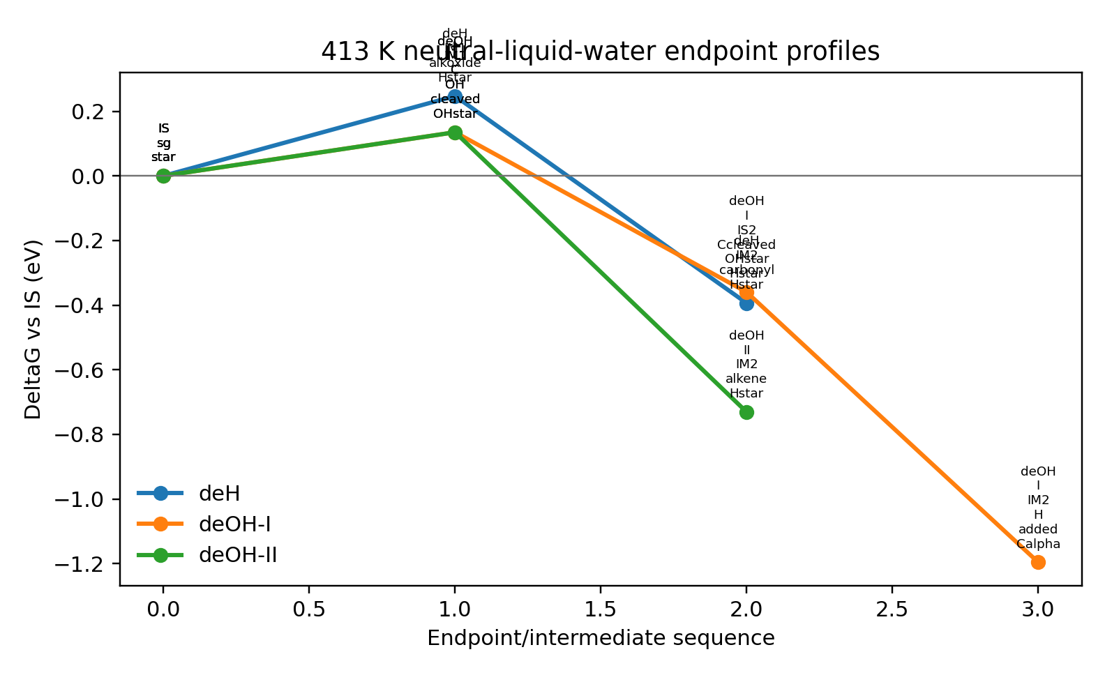
Figure 1. Endpoint/intermediate DeltaG profiles at 413 K in neutral liquid water. These are thermodynamic descriptors, not transition-state barriers.

C_alpha-OH COHP Evidence
LOBSTER COHP was used to quantify the C6-O7 pair bond directly. The raw ICOHP sign is retained in the table; larger -ICOHP values indicate stronger pair bonding when projection quality and basis are comparable.
The accepted Pt1Ni initial state and Pt1Ni/Ni-adjacent adsorption rows show much smaller -ICOHP values than gas SG and Pt(100), supporting C_alpha-OH bond weakening in the Pt1Ni/Ni environment.
Table 3. C6-O7 COHP descriptors and projection quality. Distance in Angstrom; ICOHP and -ICOHP in eV.
Description | Case | C6-O7 distance | ICOHP | -ICOHP | Charge spilling (%) | Projection status
gas-phase SG C_alpha-OH bond | sg_gas | 1.4278 | -9.0225 | 9.0225 | 1.39 | strong
SG on Pt(100), O7 initially anchored to Pt | sg_on_pt100_o7_pt | 1.4206 | -8.4306 | 8.4306 | 2.07 | acceptable
SG on Pt1Ni/Ni(100), O7 initially anchored to Ni adjacent to Pt | sg_on_pt1ni_o7_ni_adjacent | 1.4340 | -3.9148 | 3.9148 | 3.23 | acceptable
SG on Pt1Ni/Ni(100), O7 initially anchored to isolated Pt | sg_on_pt1ni_o7_pt | 1.4254 | -4.0514 | 4.0514 | 3.19 | acceptable
accepted second-wave Pt1Ni pathway initial state | IS_sg_star | 1.4351 | -3.9074 | 3.9074 | 3.23 | acceptable
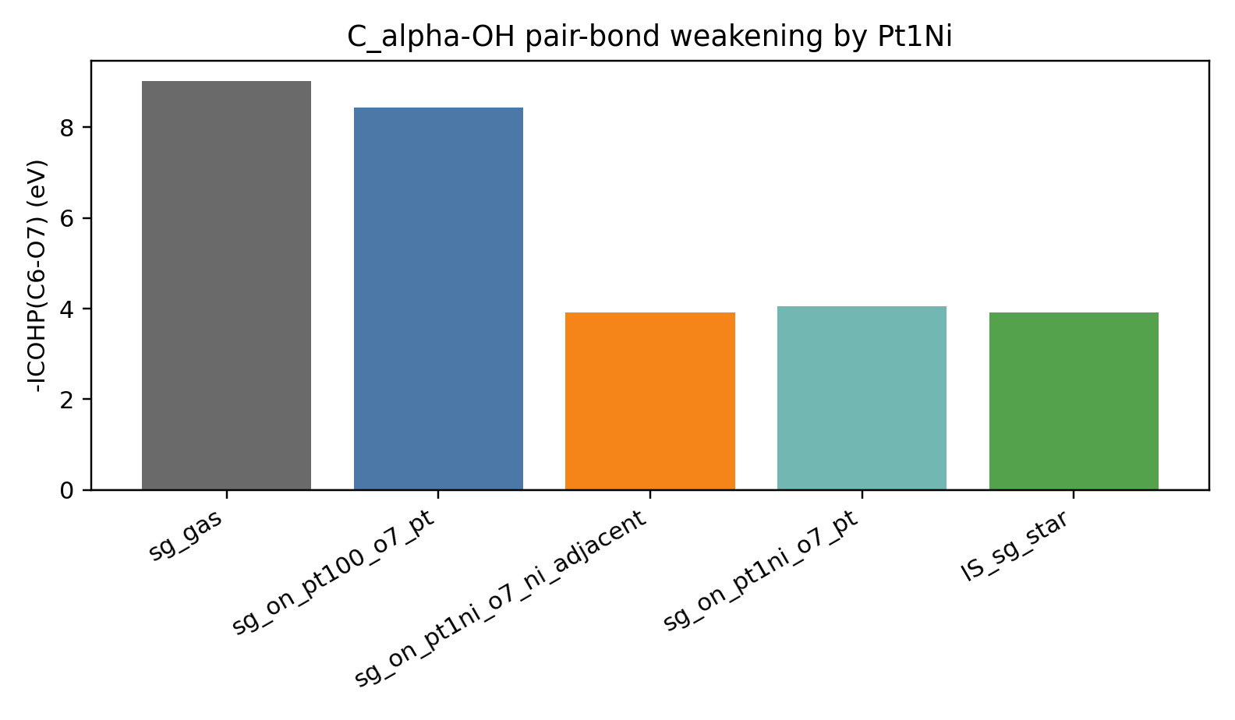
Figure 2. C6-O7 -ICOHP comparison. Pt1Ni rows show substantially weaker pair bonding than gas SG or SG/Pt(100).

Corrected Vacancy Comparison
The earlier alumina comparison is replaced with an exploratory defective-spinel gamma-Al2O3(110) multi-site model. Site identity is reported because vacancy energies vary strongly with local oxygen coordination.
The lowest accepted NiAl2O4 vacancy descriptor is 3.035 eV, lower than the lowest gamma-Al2O3 value of 4.460 eV by about 1.43 eV. This explains the discrepancy with the earlier single-site alumina descriptor as a phase/model and site-selection effect.
Table 4. Site-resolved oxygen-vacancy descriptors. E_vac(O) = E(slab-O) + 0.5E(O2) - E(perfect slab). H@V_O descriptor is E(H@V_O) - E(V_O) - 0.5E(H2). Units: eV.
Case | Removed O index | E_vac(O) | H@V_O descriptor | Reference
gamma_al2o3_110_vac1 | 91 | 4.460 | -0.995 | E_vac(O) = E(slab-O) + 0.5E(O2) - E(perfect slab); electronic only
gamma_al2o3_110_vac2 | 59 | 6.009 | -3.007 | E_vac(O) = E(slab-O) + 0.5E(O2) - E(perfect slab); electronic only
gamma_al2o3_110_vac3 | 49 | 5.964 | -1.369 | E_vac(O) = E(slab-O) + 0.5E(O2) - E(perfect slab); electronic only
gamma_al2o3_110_vac4 | 55 | 5.153 | -1.818 | E_vac(O) = E(slab-O) + 0.5E(O2) - E(perfect slab); electronic only
gamma_al2o3_110_vac5 | 99 | 5.153 | -1.819 | E_vac(O) = E(slab-O) + 0.5E(O2) - E(perfect slab); electronic only
nial2o4_100_vac_multisite_1 | 82 | 4.622 | not calculated | E_vac(O) = E(slab-O) + 0.5E(O2) - E(perfect slab); electronic only
nial2o4_100_vac_multisite_3 | 85 | 3.307 | not calculated | E_vac(O) = E(slab-O) + 0.5E(O2) - E(perfect slab); electronic only
nial2o4_100_vac_multisite_4 | 94 | 3.249 | not calculated | E_vac(O) = E(slab-O) + 0.5E(O2) - E(perfect slab); electronic only
nial2o4_100_vac_multisite_5 | 109 | 3.035 | not calculated | E_vac(O) = E(slab-O) + 0.5E(O2) - E(perfect slab); electronic only
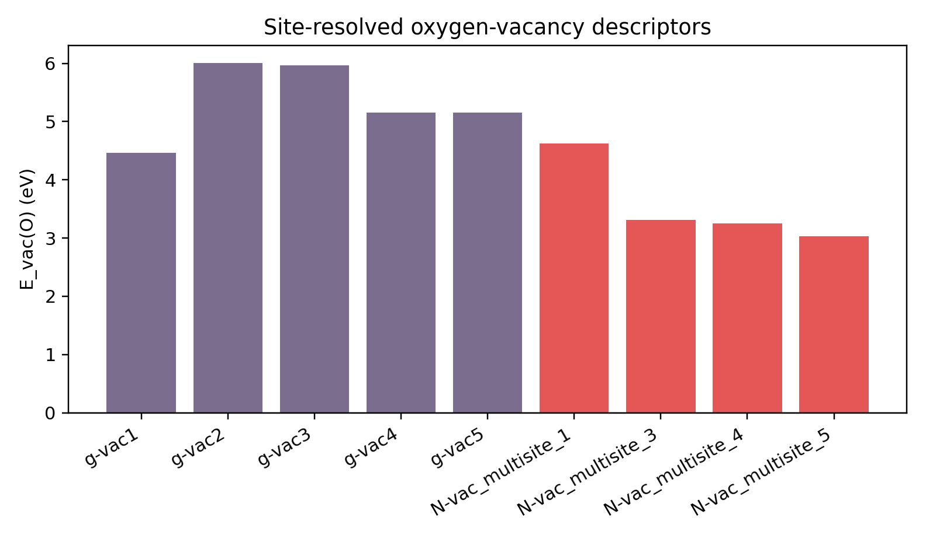
Figure 3. Multi-site oxygen-vacancy descriptors for exploratory gamma-Al2O3(110) and accepted NiAl2O4(100) sites. nial2o4_100_vac_multisite_2 was waived.

Quantitative Hydrogen Affinity
Molecular SG adsorption is no longer used as direct proof of hydrogen affinity. The report uses DeltaG_H* at 413 K in neutral liquid water as the quantitative descriptor.
The Pt1Ni/Ni-adjacent site is near thermoneutral, DeltaG_H* = +0.023 eV, comparable to Ni(100) at +0.011 eV. Pt-top and Pt(100) bind H more exergonically. These are thermodynamic H* descriptors, not H-transfer barriers.
Table 5. H-affinity descriptors at 413 K in neutral liquid water. DeltaG_H* = G(slab+H*) - G(clean slab) - 0.5G(H2,413 K,1 atm). Units: eV.
Model | H case | Clean slab case | DeltaG_H* | Reference
Pt1Ni/Ni(100), H on Pt | pt1ni_H_on_Pt | pt1ni_ni100_clean | -0.362 | DeltaG_H* = G(slab+H*) - G(clean slab) - 0.5G(H2,413K,1atm); VASPsol++ endpoint correction only, no adsorbate vibrational term.
Pt1Ni/Ni(100), H on Ni adjacent to Pt | pt1ni_H_on_Ni_adjacent_Pt | pt1ni_ni100_clean | +0.023 | DeltaG_H* = G(slab+H*) - G(clean slab) - 0.5G(H2,413K,1atm); VASPsol++ endpoint correction only, no adsorbate vibrational term.
Ni(100), H on Ni | ni100_H_on_Ni | ni100_clean | +0.011 | DeltaG_H* = G(slab+H*) - G(clean slab) - 0.5G(H2,413K,1atm); VASPsol++ endpoint correction only, no adsorbate vibrational term.
Pt(100), H on Pt | pt100_H_on_Pt | pt100_clean | -0.495 | DeltaG_H* = G(slab+H*) - G(clean slab) - 0.5G(H2,413K,1atm); VASPsol++ endpoint correction only, no adsorbate vibrational term.
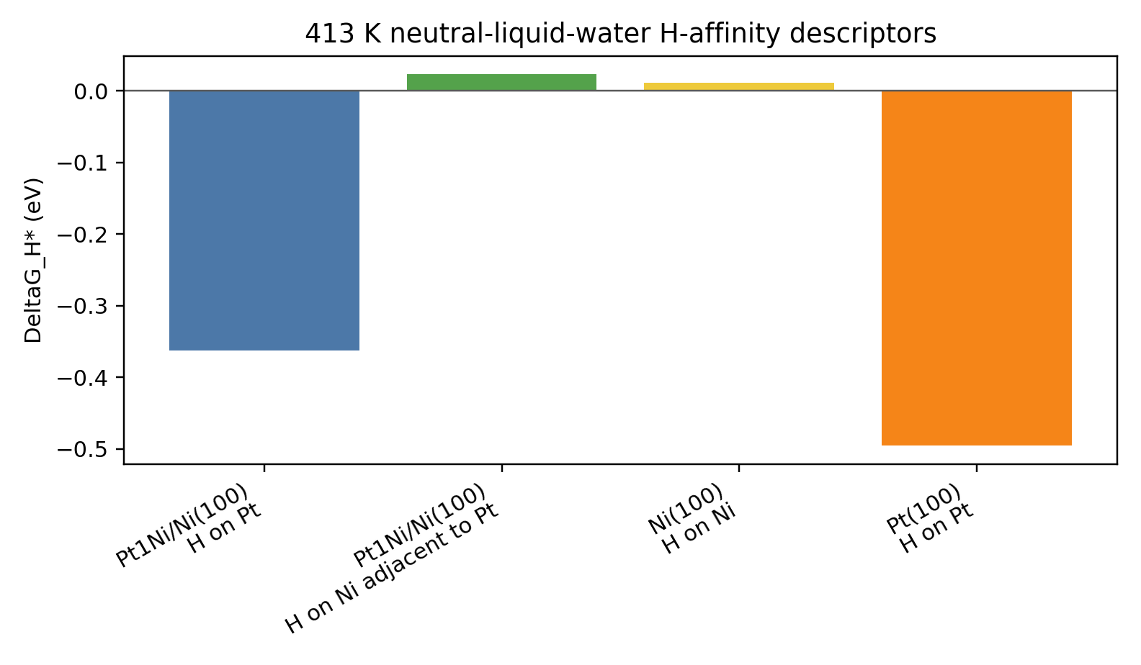
Figure 4. 413 K neutral-liquid-water DeltaG_H* descriptors. Near-zero values indicate near-thermoneutral H binding.

Response-Letter Text To Use
We have revised the calculations to replace adsorption-only language with endpoint/intermediate pathway descriptors, direct C_alpha-OH COHP evidence, 413 K liquid-water correction-layer descriptors, corrected gamma-Al2O3/NiAl2O4 multi-site vacancy descriptors, and quantitative DeltaG_H* H-affinity descriptors.
The calculations support substantial C_alpha-OH weakening on Pt1Ni from COHP and show favorable endpoint/intermediate thermodynamic descriptors for deOH/deH routes under the stated correction layer. They do not provide transition-state barriers or H-transfer kinetics, because TS/NEB calculations were removed from scope.
The corrected vacancy comparison shows that the accepted NiAl2O4 sites have a lower minimum oxygen-vacancy formation energy than the exploratory gamma-Al2O3 model, consistent with the experimental EPR, H-spillover, and TPR discussion while retaining the model limitations.

Calculation Directory Index
The table below maps each report item to its primary source data and validation provenance. Raw total energies remain in the calculation directories; the report tables use only relative descriptors.
Table 6. Traceability index for the updated report.
Report item | Primary data path | Validation/provenance
Pathway DeltaE table | work/revisions/results/pathway_electronic_profile.tsv | Accepted artifact revision-vasp-endpoint-results, decision D015
Pathway 413 K DeltaG table | work/revisions/free_energy/results/state_free_energy_profile_413K.tsv | Accepted artifact revision-free-energy-tables, decision D020
COHP table | work/revisions/cohp/cohp_calpha_oh_summary.tsv | Accepted artifact revision-cohp-results-accepted, decision D019
Vacancy table | work/revisions/results/vacancy_electronic_multisite.tsv | Accepted artifact revision-vasp-endpoint-results, decision D015; site 2 waiver D014
H-affinity table | work/revisions/free_energy/results/h_affinity_free_energy_413K.tsv | Accepted artifact revision-free-energy-tables, decision D020
Scope waivers | work/revisions/results/t006_ts_neb_scope_waiver.md; work/revisions/cohp/t007_sg_on_ni100_o7_ni_waiver.md | Decisions D017 and D018
Updated response draft | work/revisions/reviewer_response_update_draft_20260704.md | Draft artifact revision-reviewer-response-draft-20260704

