Computational Response To Reviewer Questions
VASP descriptor calculations for Pt1Ni/NiAl2O4 lignin model chemistry

Executive Summary
This report is a computational response package prepared from the edited manuscript, Supporting Information, response letter, supplied SG structure, and new VASP calculations generated under work/. The original PDFs and source structure files were not modified.
The strongest computational result concerns the support: in the prototype models, NiAl2O4 forms a surface O vacancy much more readily than Al2O3 and also accommodates H at the vacancy more favorably. This directly supports the experimental discussion of oxygen vacancies, H spillover, and metal-support interaction on NiAl2O4.
The SG adsorption calculations do not support the simple statement that Ni binds the C_alpha-OH O atom more strongly than Pt. Instead, they support a narrower adsorption-tuning statement: pure Pt(100) overbinds SG in this descriptor, Ni-like sites bind more moderately, and the Pt site in Pt1Ni/Ni(100) gives intermediate adsorption. Therefore the response should describe Pt1Ni as balancing adsorption and H activation rather than as a DFT-proven C_alpha-OH cleavage site.
No Mo/W/Nb oxide structures were computed. The Mo/W reviewer question should be answered by distinguishing broader oxophilic oxide/promoter chemistry from the specific Pt1Ni alloy ensemble, using the manuscript's experimental screening as the evidence.
Table 1. Claim status from the validated VASP descriptor calculations.
Reviewer issue | Computational status | Key evidence | Required wording discipline
NiAl2O4 support effect | Supported by descriptor thermodynamics | NiAl2O4 E_vac(O) is lower than Al2O3 by 2.95 eV and E_H@VO is more favorable by 1.11 eV. | Consistent with the experimental EPR/H-spillover/TPR evidence, but not a direct operando spillover barrier.
Ni oxophilicity / C_alpha-OH activation | Limited; adsorption-tuning evidence only | Ni-like sites give moderate O7-oriented SG adsorption (-1.522 and -1.515 eV), while Pt1Ni/Pt is intermediate (-1.778 eV) between Ni-like sites and pure Pt(100) (-2.623 eV). | Do not claim Ni binds O7 more strongly than Pt, and do not claim C_alpha-OH cleavage is proven without barriers.
Mo/W activity without Pt alloying | Not computed; answer from experiment plus mechanism distinction | No MoOx/WOx/NbOx structures were part of the validated VASP wave. | Mo/W should be described as a separate oxophilic/promoter route, not the same Pt1Ni alloy mechanism.

Direct Response: Support Role
Reviewer concern addressed: why NiAl2O4 is not merely an inert support and why it differs from Al2O3 with respect to oxygen vacancies, H spillover, and metal-support interaction.
Computational response: We compared ideal prototype NiAl2O4(100) and Al2O3(0001) slabs using the same VASP PBE-D3 final-static settings. One surface oxygen was removed to evaluate E_vac(O) = E(surface with one O vacancy) + 0.5 E(O2) - E(perfect surface). H accommodation was evaluated as E_H@VO = E(H at vacancy) - E(vacancy slab) - 0.5 E(H2). Negative or lower values indicate a more favorable descriptor under the same reference convention.
Result: E_vac(O) is 2.663 eV on NiAl2O4 and 5.611 eV on Al2O3; thus NiAl2O4 is lower by 2.948 eV. E_H@VO is -0.173 eV on NiAl2O4 and 0.933 eV on Al2O3; thus the H-at-vacancy descriptor is more favorable on NiAl2O4 by 1.105 eV.
Response text to reviewers: These comparative VASP descriptors support the experimental assignment that NiAl2O4 is a more reducible and H-accommodating support than Al2O3. They are consistent with the stronger EPR vacancy signal, H-spillover evidence, and TPR/MSI discussion in the manuscript. We will state this as descriptor support for the proposed support role, not as a direct simulation of the full hydrothermal spillover pathway.
Table 2. Support oxygen-vacancy and H-accommodation descriptors. Energies are electronic relative energies in eV; removed O sites are taken from the structure-builder metadata.
Support | Removed O site | E_vac(O) (eV) | E_H@VO (eV) | Vacancy case | H case | Validation note
NiAl2O4(100) | O85 at [4.9427, 0.9177, 22.8980] A | 2.663 | -0.173 | nial2o4_100_surf_vo | nial2o4_100_surf_vo_h | Vacancy-H relaxation accepted with selective-dynamics/free-force caveat; final static parser-accepted.
Al2O3(0001) | O28 at [0.9234, 1.3741, 24.8975] A | 5.611 | 0.933 | al2o3_0001_surf_vo | al2o3_0001_surf_vo_h | Parser-accepted relaxation/static descriptor.
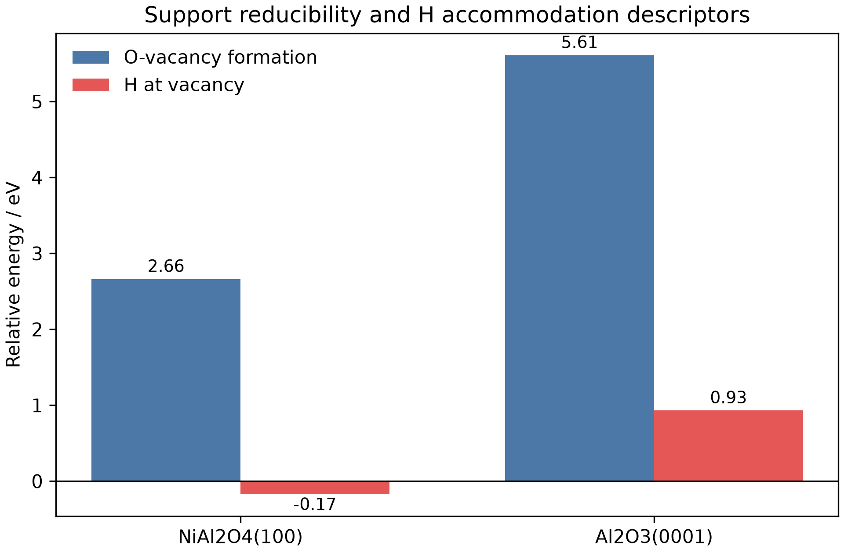
Figure 1. Support electronic-energy descriptors. E_vac(O) is referenced to 0.5 O2; E_H@VO is referenced to 0.5 H2. These are descriptors, not finite-temperature Gibbs free energies.
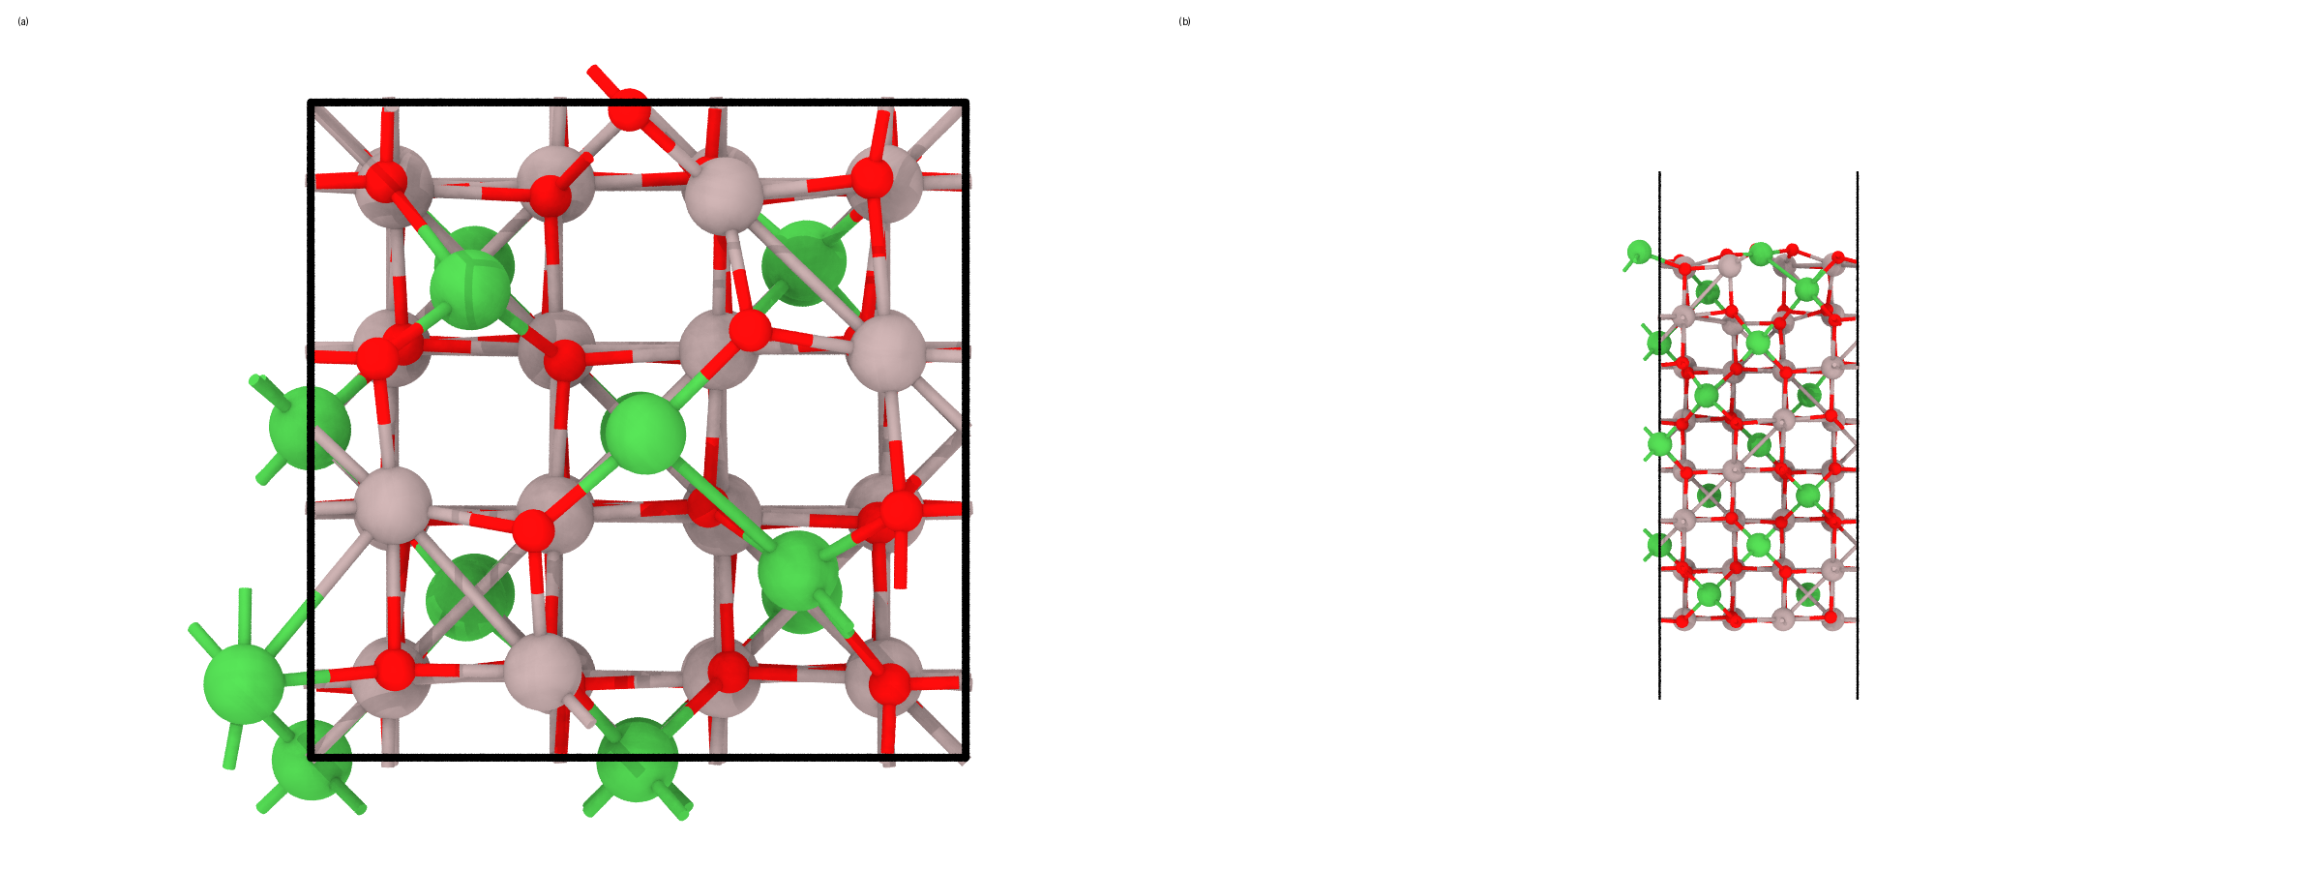
Figure 2. Relaxed NiAl2O4(100) surface-O-vacancy descriptor after removing O85: (a) top view; (b) side view.
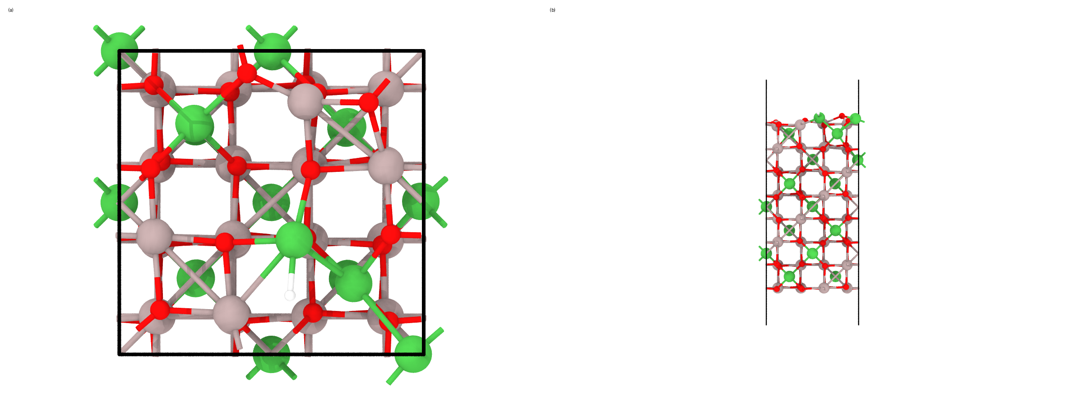
Figure 3. Relaxed H-at-vacancy NiAl2O4 descriptor: (a) top view; (b) side view.
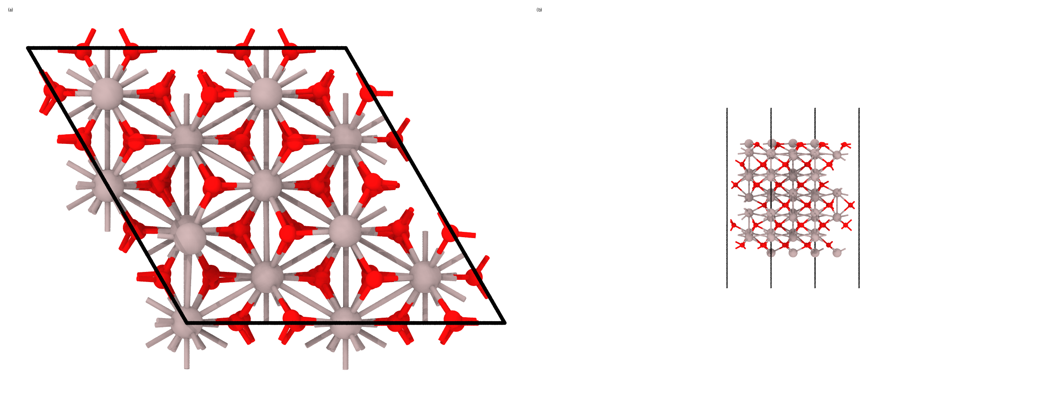
Figure 4. Relaxed Al2O3(0001) surface-O-vacancy descriptor after removing O28: (a) top view; (b) side view.
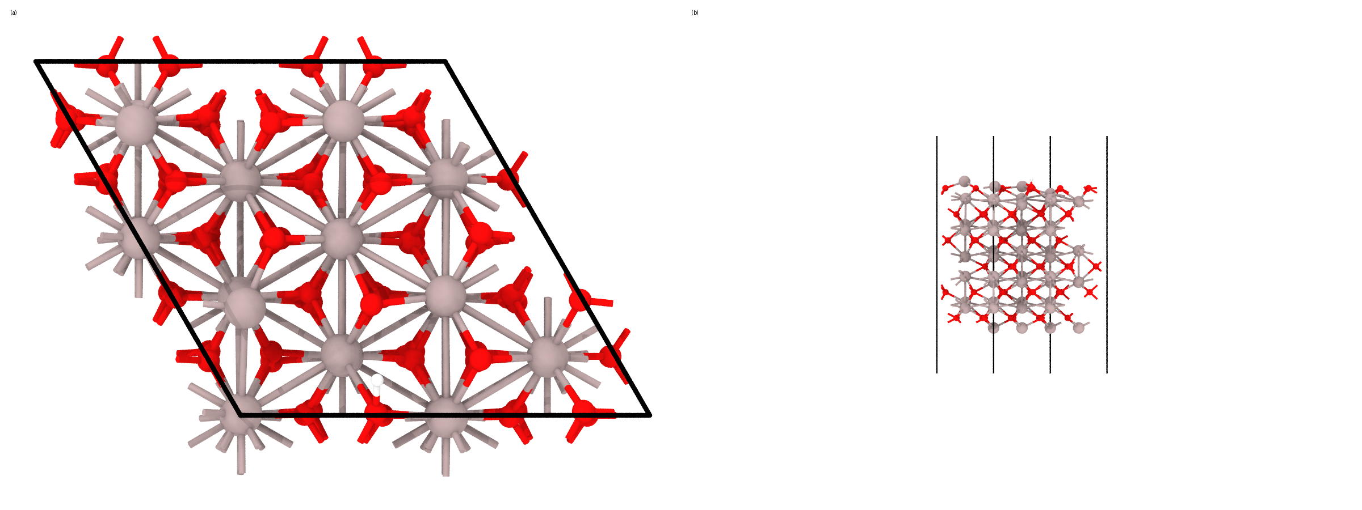
Figure 5. Relaxed H-at-vacancy Al2O3 descriptor: (a) top view; (b) side view.

Direct Response: Ni Oxophilicity
Reviewer concern addressed: how Ni promotes C_alpha-OH activation and propenyl-side-chain formation, and whether oxophilicity alone explains the selectivity.
Computational response: SG was adsorbed through the assigned O7 C_alpha-OH oxygen on Ni(100), Pt(100), and two Pt1Ni/Ni(100) sites. The descriptor is E_ads = E(slab+SG) - E(clean slab) - E(SG_gas). More negative values indicate stronger electronic adsorption under this model and method.
Result: E_ads is -1.522 eV on Ni(100), -2.623 eV on Pt(100), -1.515 eV on the Pt1Ni/Ni-site model, and -1.778 eV on the Pt1Ni/Pt-site model. The Pt1Ni/Ni-site value differs from Ni(100) by only 0.007 eV, which should be treated as indistinguishable at this descriptor level. The Pt1Ni/Pt-site value is 0.845 eV weaker than pure Pt(100), but 0.256 eV stronger than Ni(100).
Interpretation: The adsorption data do not prove that Ni is the strongest O7-binding site; in fact, pure Pt(100) is the strongest adsorption case, though it carries a soft-mode caveat. The defensible DFT statement is that Pt1Ni tunes SG adsorption away from pure-Pt overbinding while retaining moderate-to-favorable O7-oriented adsorption. This supports the experimental concept of a balanced Pt-Ni ensemble, but it does not by itself compute C_alpha-OH bond cleavage, hydrogen transfer, or product selectivity.
Response text to reviewers: The new VASP calculations have been added as comparative descriptors. They show that the Pt site in the Pt1Ni/Ni environment provides intermediate SG adsorption, weaker than pure Pt and stronger than Ni-like sites, while adjacent Ni-like sites provide moderate O7-oriented adsorption. Together with the experimental evidence for isolated Pt sites and Ni-containing catalysts, this supports a balanced adsorption/H-activation role for Pt1Ni. We will avoid claiming that the DFT calculations prove direct C_alpha-OH cleavage; a transition-state study would be required for that stronger statement.
Table 3. SG adsorption descriptors from parser-accepted final static VASP calculations. Energies are E_ads in eV relative to the corresponding clean slab and gas-phase SG; distances are from the relaxed CONTCAR geometry.
Model | E_ads (eV) | Initial site | O7-site distance (A) | Nearest surface atom | O7-nearest distance (A) | Case | Validation/interpretation note
Ni(100), O7-on-Ni | -1.522 | Ni | 3.022 | Ni 94 | 3.022 | sg_on_ni100_o7_ni | Moderate O7-oriented adsorption on Ni(100).
Pt(100), O7-on-Pt | -2.623 | Pt | 3.061 | Pt 94 | 3.061 | sg_on_pt100_o7_pt | Final static accepted; upstream geometry has adsorbate soft-mode caveat.
Pt1Ni/Ni(100), O7-on-Ni next to Pt | -1.515 | Ni | 2.966 | Ni 94 | 2.966 | sg_on_pt1ni_o7_ni_adjacent | Ni-like adsorption; indistinguishable from Ni(100) within descriptor precision.
Pt1Ni/Ni(100), O7-on-Pt | -1.778 | Pt | 3.526 | Pt 108 | 3.526 | sg_on_pt1ni_o7_pt | Intermediate adsorption; O7-Pt distance is long, so avoid strong-bond language.
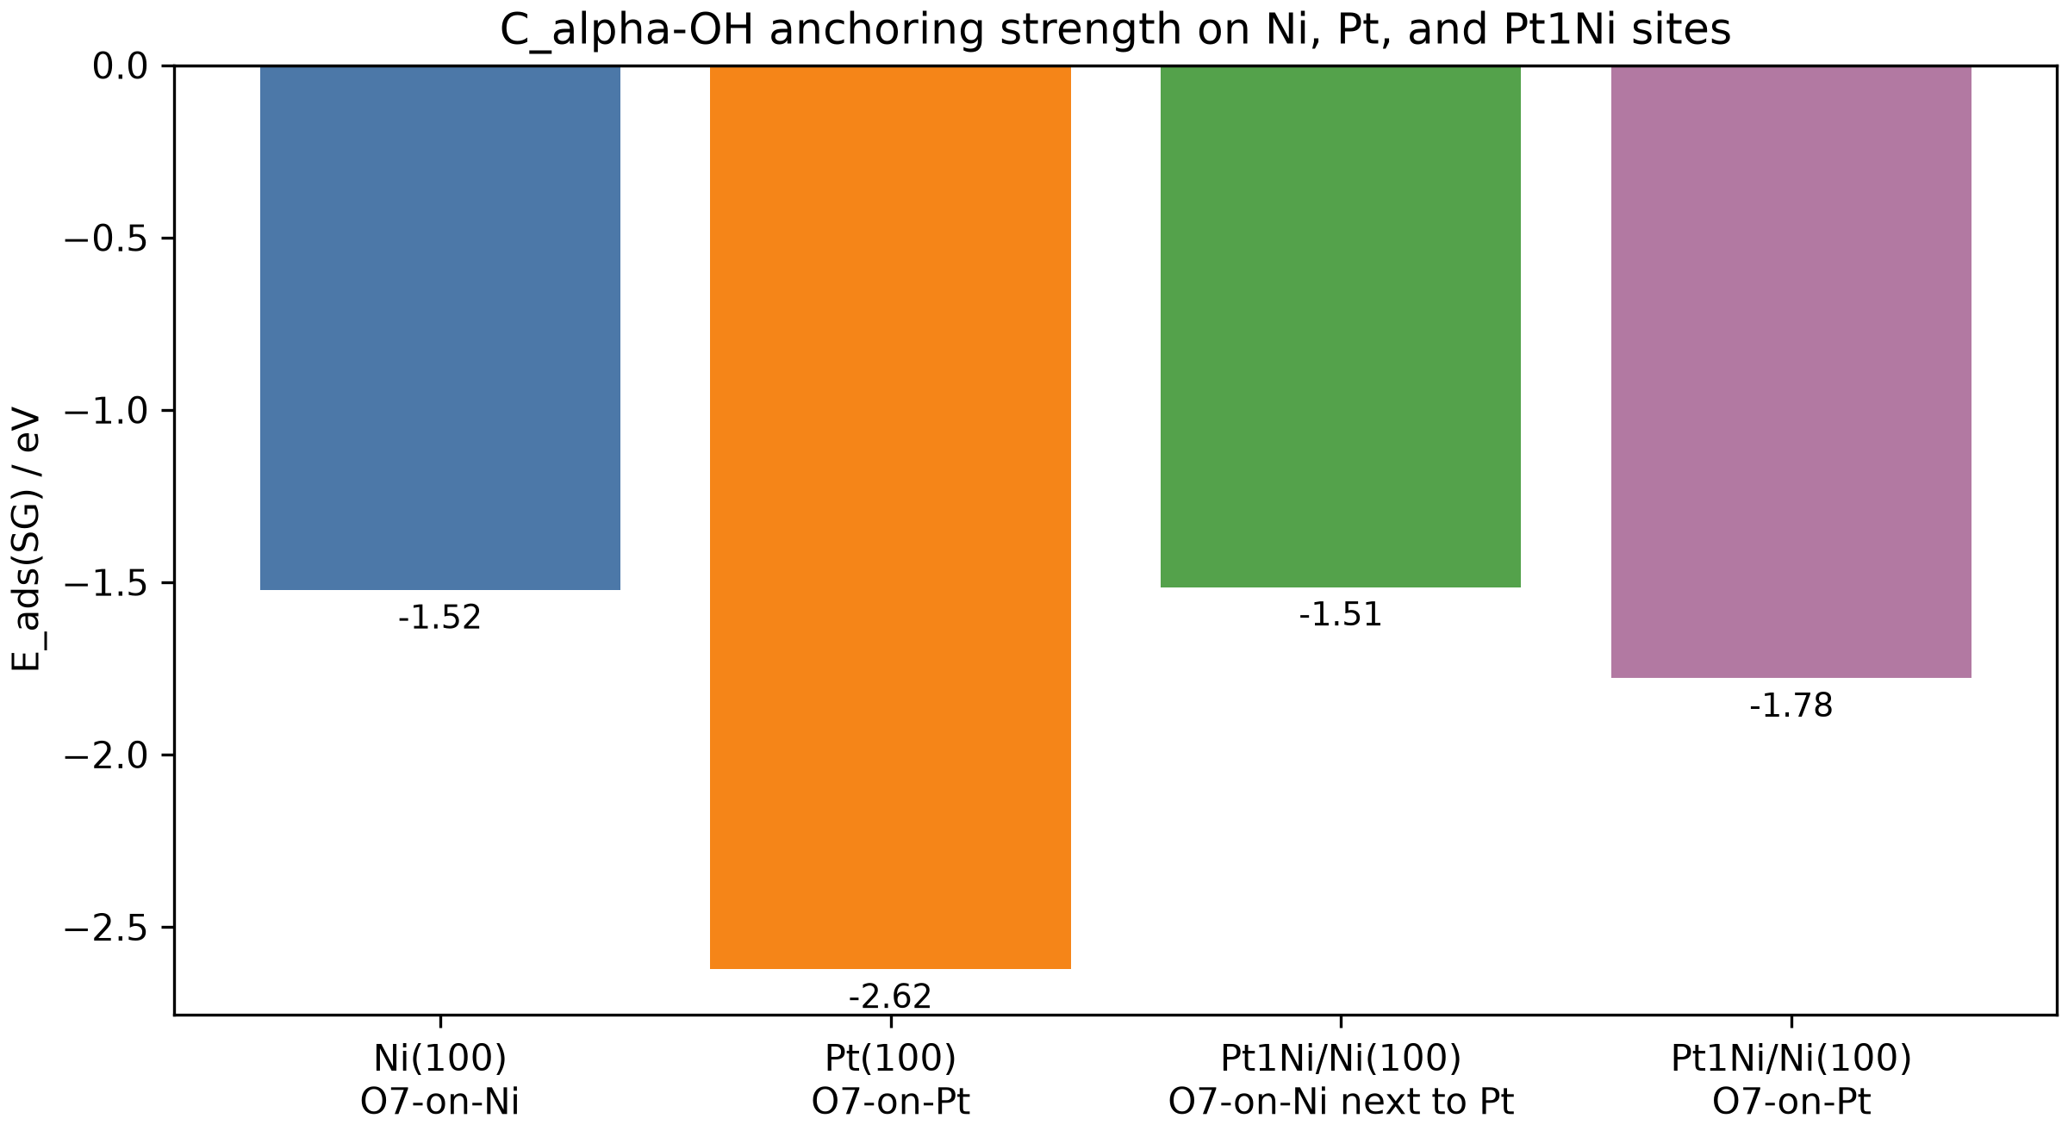
Figure 6. SG adsorption energies from final static VASP calculations. Negative values indicate exothermic adsorption relative to the corresponding clean slab plus gas-phase SG; all values are electronic energies at 0 K.
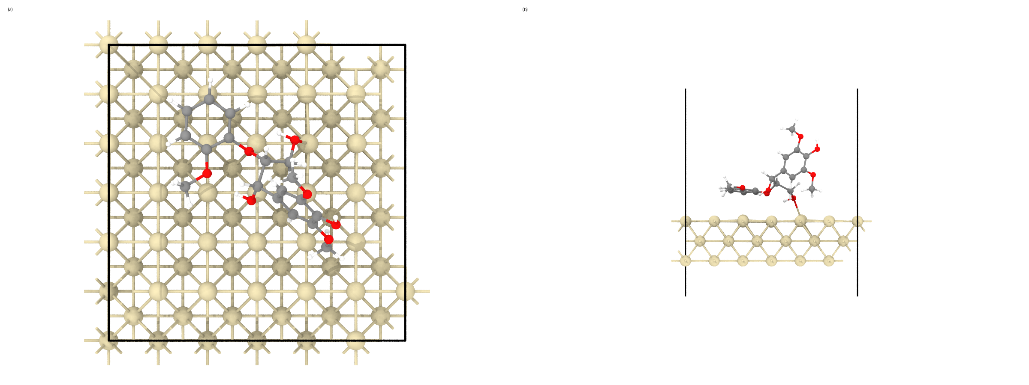
Figure 7. Relaxed SG on Pt(100): (a) orthographic top view; (b) zoomed side view. The initial O7/C_alpha-OH anchor was directed to a Pt surface atom.
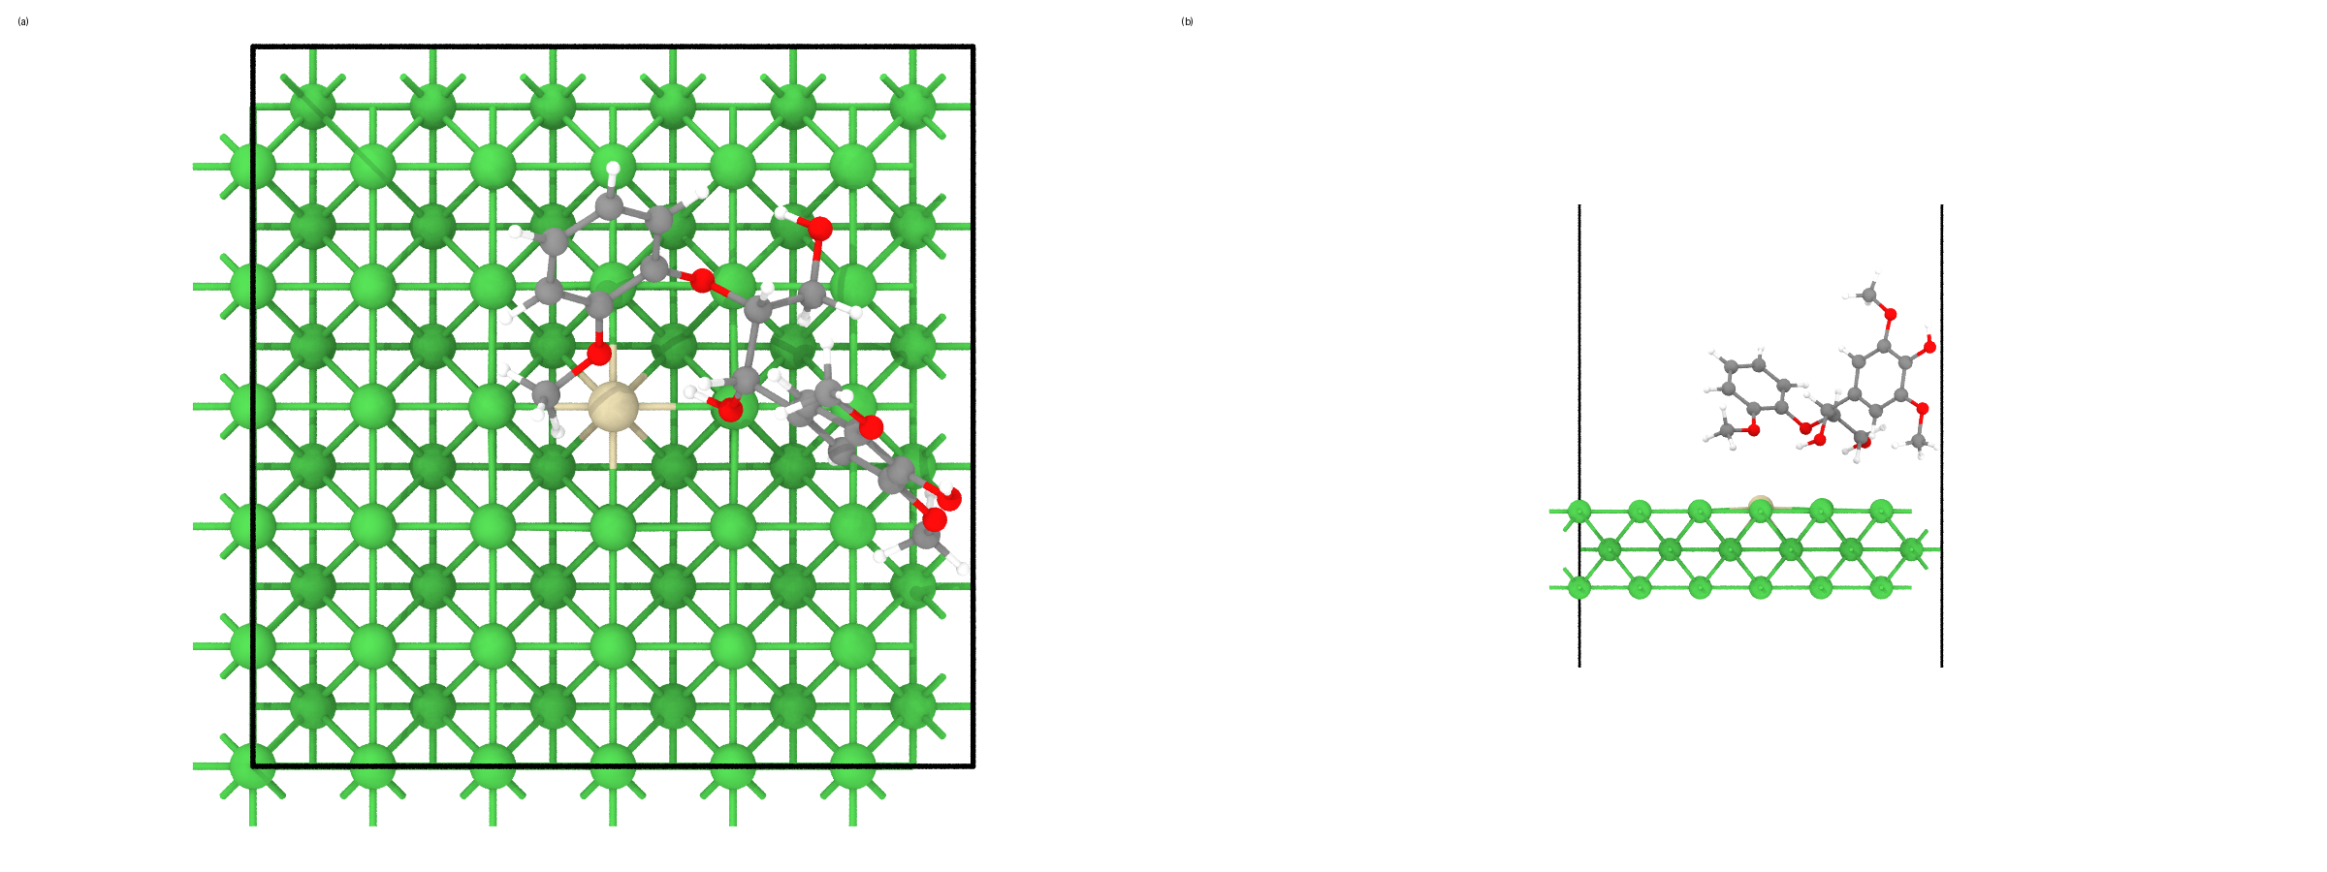
Figure 8. Relaxed SG on Pt1Ni/Ni(100) with O7 initially directed to a Ni atom adjacent to isolated Pt: (a) top view; (b) side view.
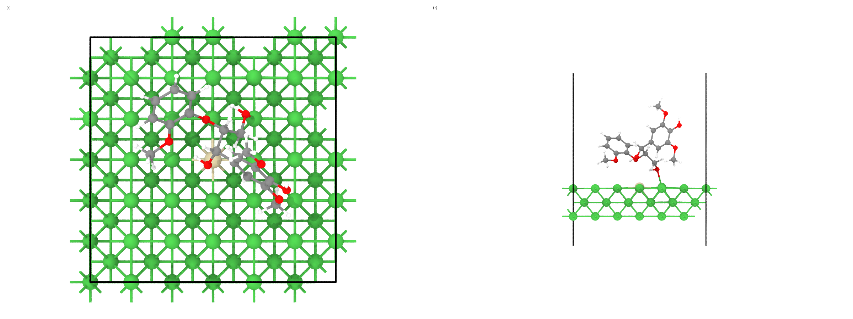
Figure 9. Relaxed SG on Pt1Ni/Ni(100) with O7 initially directed to isolated Pt: (a) top view; (b) side view.
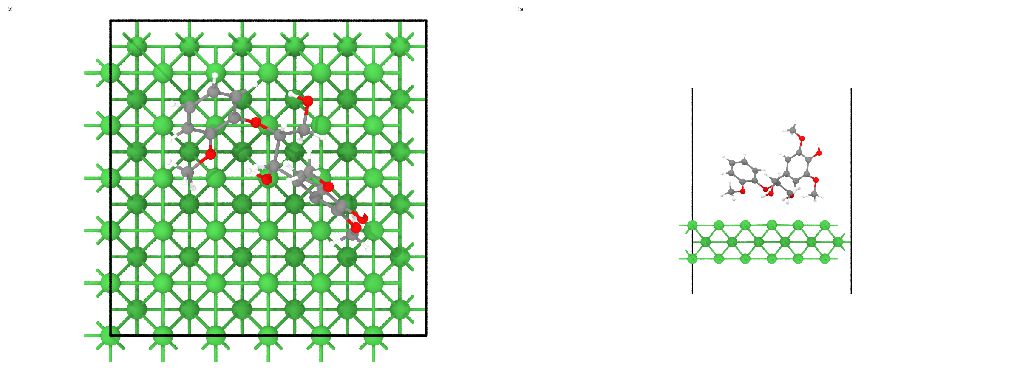
Figure 10. Relaxed SG on Ni(100) with O7 initially directed to Ni: (a) top view; (b) side view.

Direct Response: Mo And W
Reviewer concern addressed: why Mo and W show activity even though they do not form Pt alloy structures in the manuscript evidence.
Computational response: No validated MoOx, WOx, or NbOx models were included in the present VASP wave, so the Mo/W point should not be presented as a computed trend. The correct response is mechanistic separation: Pt1Ni is an alloyed metallic ensemble, whereas Mo/W likely introduce oxophilic oxide or interfacial promoter functions that can assist oxygenated-fragment activation but do not reproduce the same isolated Pt1Ni alloy site.
Response text to reviewers: The Mo/W screen indicates that Pt alloying is not the only possible promotional route for propenyl-product formation. However, their lower activity relative to Pt1Ni/NiAl2O4 and their lack of Pt-alloy evidence imply a distinct oxophilic promoter/support pathway rather than the same Pt1Ni single-atom-alloy mechanism. We will revise the wording to make this distinction explicit.

Validation And Caveats
Every numerical descriptor in this report comes from a final static VASP calculation with a parser-accepted OUTCAR and a timing footer. Failed, incomplete, or electronically unconverged attempts were retained in work/ but were not used in the descriptor tables.
Two upstream geometry caveats are carried into the interpretation. First, the Pt(100) SG geometry retained a small residual adsorbate soft-mode force, so the Pt(100) adsorption energy is best used as a qualitative pure-Pt overbinding reference. Second, the NiAl2O4 vacancy-H relaxation was accepted by the selective-dynamics/free-force criterion; its final static energy is parser-accepted, but the relaxation caveat is disclosed.
The calculations are 0 K electronic descriptors on designed prototype slabs. No DFT+U was used, and the calculations do not include vibrational free energies, entropy, solvent, hydrothermal pressure, reaction barriers, explicit spillover pathways, charge-density-difference analysis, COHP, or a complete Pt1Ni/NiAl2O4 interface.
Table 4. Validation and scope caveats that must accompany the reviewer response.
Item | Status | Required disclosure
Pt(100) SG geometry | Accepted with caveat | The final Pt(100) static is parser-accepted, but its upstream relaxation retained a small residual force on adsorbate soft modes. The Pt(100) value is used as a qualitative pure-Pt overbinding reference and is not the sole basis of any conclusion.
NiAl2O4 vacancy-H geometry | Accepted with caveat | The recovered relaxation stopped at NSW=60, but the free-atom force was 0.0279 eV/A below the 0.03 eV/A gate; the large all-atom force came from frozen layers. The final static energy is parser-accepted.
NiAl2O4 electronic structure | Qualitative defect/reducibility descriptor | No DFT+U was used because the edited files did not retain a U value and online recovery was prohibited; vacancy and H-defect trends should be treated as comparative descriptors, not exact oxidation-state energetics.
Thermodynamics and kinetics | Not computed | All reported values are 0 K electronic energies. No vibrational, entropy, solvent, pressure, transition-state, spillover-barrier, or hydrothermal free-energy corrections were computed.
Model scope | Designed prototypes | The metal slabs and oxide slabs are designed descriptor models built from local evidence; they are not reproductions of original hidden coordinates and do not represent every possible termination or interface.

Computational Methods
All calculations were performed with VASP in the work/ directory. The workflow used PBE PAW potentials, DFT-D3 dispersion with IVDW = 11, ENCUT = 520 eV, and fixed-cell slab relaxations. Slab and adsorbate calculations used ISYM = 0. Geometry relaxations used ISIF = 2 and EDIFFG = -0.03 eV/A, with documented SCF or optimizer recoveries where needed.
Final static calculations used EDIFF = 1E-6, LREAL = .FALSE., LASPH = .TRUE., and the same PAW/ENCUT/dispersion settings as the relaxations. Oxide support descriptors used 2 x 2 x 1 Gamma-centered k meshes; the large metal/adsorbate cells used Gamma-only calculations. Ni-containing metal and NiAl2O4 models were spin-polarized with Ni initial moments. CPU VASP jobs used NPAR = 4; GPU OpenACC Gamma-only recoveries omitted CPU parallelization tags.
SCF recovery for difficult NiAl2O4 defect statics used ALGO = Normal, NELM = 500, NELMDL = 0, clean charge initialization, and conservative AMIX/BMIX and AMIX_MAG/BMIX_MAG values. These settings are numerical stabilization choices; the physical model, PAWs, ENCUT, k mesh, spin treatment, and functional were unchanged.
Table 5. Parser-accepted final static energy provenance. The table lists the source OUTCAR for each relative-energy expression; raw total energies are intentionally not reported.
Case | Energy source | OUTCAR
al2o3_0001_surf | E0(sigma->0) | work/calculations/static_final/al2o3_0001_surf/OUTCAR
al2o3_0001_surf_vo | E0(sigma->0) | work/calculations/static_final/al2o3_0001_surf_vo/OUTCAR
al2o3_0001_surf_vo_h | E0(sigma->0) | work/calculations/static_final/al2o3_0001_surf_vo_h/OUTCAR
h2_gas | E0(sigma->0) | work/calculations/static_final/h2_gas/OUTCAR
ni100_clean | E0(sigma->0) | work/calculations/static_final_gpu/ni100_clean/OUTCAR
nial2o4_100_surf | E0(sigma->0) | work/calculations/static_final/nial2o4_100_surf/OUTCAR
nial2o4_100_surf_vo | E0(sigma->0) | work/calculations/static_final/nial2o4_100_surf_vo/OUTCAR
nial2o4_100_surf_vo_h | E0(sigma->0) | work/calculations/static_final/nial2o4_100_surf_vo_h/OUTCAR
o2_gas | E0(sigma->0) | work/calculations/static_final/o2_gas/OUTCAR
pt100_clean | E0(sigma->0) | work/calculations/static_final/pt100_clean/OUTCAR
pt1ni_ni100_clean | E0(sigma->0) | work/calculations/static_final_gpu/pt1ni_ni100_clean/OUTCAR
sg_gas | E0(sigma->0) | work/calculations/static_final/sg_gas/OUTCAR
sg_on_ni100_o7_ni | E0(sigma->0) | work/calculations/static_final/sg_on_ni100_o7_ni/OUTCAR
sg_on_pt100_o7_pt | E0(sigma->0) | work/calculations/static_final_gpu/sg_on_pt100_o7_pt/OUTCAR
sg_on_pt1ni_o7_ni_adjacent | E0(sigma->0) | work/calculations/static_final/sg_on_pt1ni_o7_ni_adjacent/OUTCAR
sg_on_pt1ni_o7_pt | E0(sigma->0) | work/calculations/static_final_gpu/sg_on_pt1ni_o7_pt/OUTCAR

Reproducibility Index
All intermediate calculations, generated structures, renders, parser outputs, job submissions, errors, recoveries, decisions, and multi-agent scientific critiques are under work/ and .research/. The original PDFs and source structure file in the project root were not modified.
Table 6. Traceability index for the main report tables and figures.
Report item | Primary data path | Validation or render log
Table: claim status | work/results/energy_descriptors.json | .research/events.jsonl E076-E077
Table: SG adsorption descriptors | work/results/adsorption_energies.tsv; work/results/adsorption_geometry.tsv | work/results/energy_descriptors.json
Figure: SG adsorption energies | work/results/figs/adsorption_energy_bar.png | work/scripts/analyze_static_results.py
Table: support descriptors | work/results/support_descriptors.tsv | work/results/energy_descriptors.json
Figure: support descriptors | work/results/figs/support_descriptor_bar.png | work/scripts/analyze_static_results.py
Structure panels | work/figures/structures/*/*_top_side_panel.png | work/figures/structures/render_manifest.json
Workflow decisions/events | .research/events.jsonl; .research/artifacts.jsonl | work/logs/actions.log

