Computational Response to Reviewer Comments
Pt/TiO2 hydroxyl-regulation manuscript - VASP DFT response package

Executive Summary
Computational outcome for Reviewer #2 Comment 8: addresses-with-limitations. Across the validated model set, the Pt8 ensemble remains near-neutral on average by Bader analysis, with only partial interfacial polarization. This supports a metallic-like Pt-cluster interpretation rather than requiring replacement by a purely Pt_delta+-OH-Ti4+ species, while still acknowledging that Bader charge is not a formal oxidation state.
The calculations were designed from the supplied manuscript, Supporting Information, response letter, and project-local structures only. No original PDF or structure file was modified, and no online source was used.
The response is intentionally conservative: Bader charges, charge-density differences, and local magnetic moments are used to assess partial charge polarization and reducible-support signatures. They are not presented as a unique formal oxidation-state proof.

Reviewer Concern
Reviewer #2 asked whether the manuscript's interfacial Pt0 assignment could actually correspond to Pt_delta+ at a Pt_delta+-OH-Ti4+ interface, with dynamic transformation during OH consumption and water dissociation. The requested computational evidence was DFT simulation and valence-state analysis.
The later reviewer feedback also requires cautious framing: the experimental CO-DRIFTS, XPS, and XANES trends are supportive but not uniquely discriminating. Therefore, the computation tests whether the supplied Pt8/TiO2, oxygen-vacancy, and H2O/OH-containing models are more consistent with a metallic-like Pt ensemble or with a purely oxidized interfacial Pt_delta+-OH-Ti4+ assignment.

Computational Workflow
Three supplied models were treated with VASP: Pt8/TiO2, Pt8/TiO2 with an oxygen vacancy, and an H2O/OH-containing Pt8/TiO2-vacancy model. A gas-phase H2O reference was also computed for the relative electronic energy expression.
The workflow was: fixed-cell relaxation -> final accurate static calculation with charge densities and projected outputs -> AECCAR-referenced Bader analysis -> local magnetic moment extraction -> frozen-geometry fragment statics -> charge-density-difference analysis -> OVITO structure/charge visualization -> report gate.
The production settings were PBE-D3(BJ) with Ti DFT+U (Dudarev Ueff = 4.2 eV), ENCUT = 520 eV, spin polarization for slabs, Gamma-centered 2 x 2 x 1 k mesh for the slab cell, ISYM = 0, and Accurate static charge densities for Bader/CDD analysis.
The initial Pt8/TiO2 and Pt8/TiO2-Ov relaxations used VASP 6.6.0 OpenACC on the local Slurm 8v100 partition. The H2O/OH-containing model required a documented recovery path after repeated EDDDAV/ZHEGV failures: a clean CPU restart with ALGO=All, hard linear mixing, no copied WAVECAR/CHGCAR, and reduced effective NCORE via NPAR=8. All final static/Bader/CDD slab calculations used CPU VASP 6.4.1 on full-node Slurm CPU jobs with NPAR=4, so the final electronic comparisons are internally consistent.
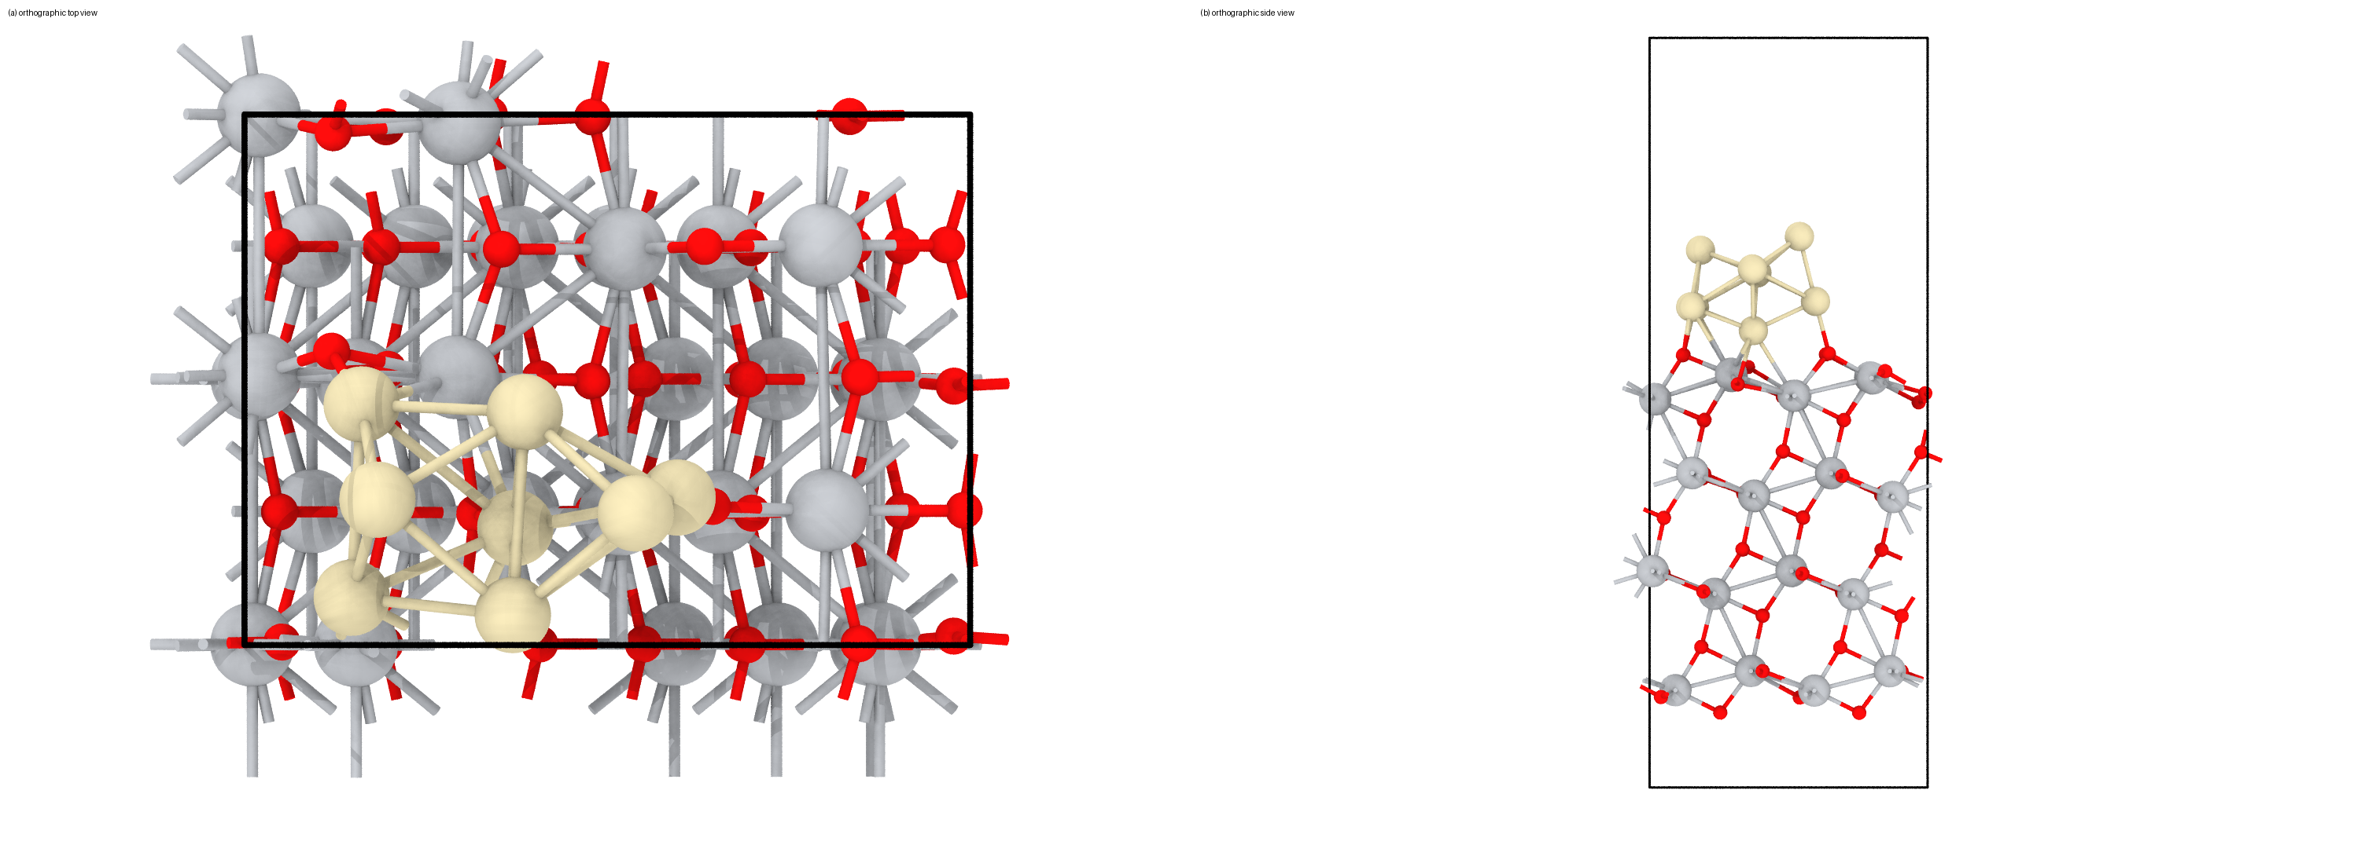
Figure 1. Pt8/TiO2 relaxed model used in the DFT analysis: (a) orthographic top view and (b) orthographic side view. Source structure: work/calc/static/pt8/POSCAR, generated from the validated relaxation CONTCAR.
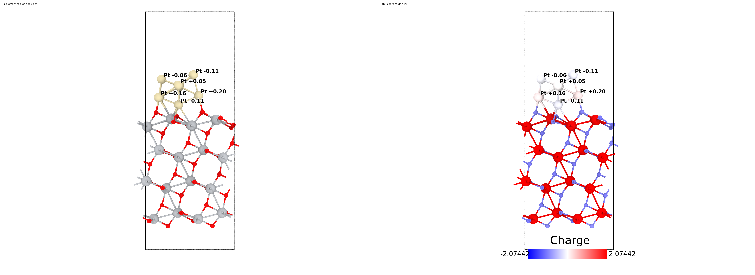
Figure 2. Pt8/TiO2 Bader-charge visualization: (a) same side-view geometry with element colors and (b) Bader net charge q = ZVAL - N_Bader in e. Positive values indicate electron depletion relative to neutral valence. The color map is a visualization of partial charge only, not a formal oxidation-state assignment.
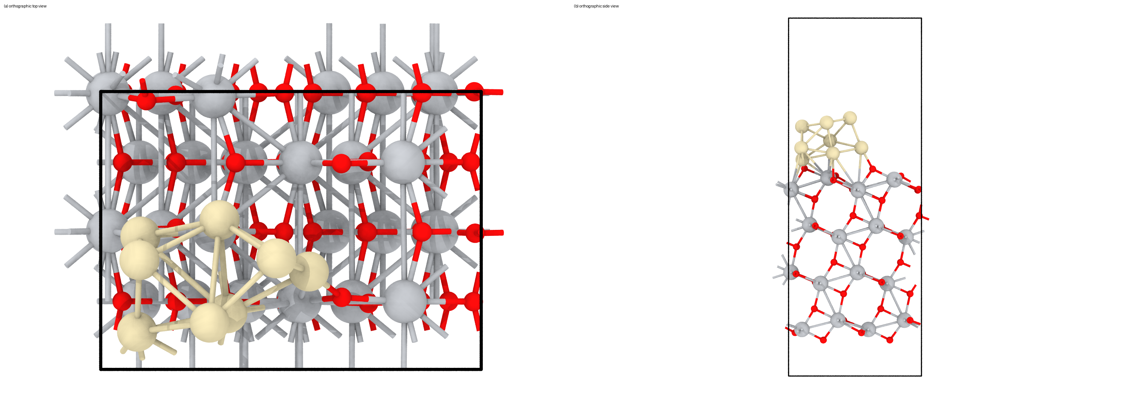
Figure 3. Pt8/TiO2-Ov relaxed model used in the DFT analysis: (a) orthographic top view and (b) orthographic side view. Source structure: work/calc/static/Ov/POSCAR, generated from the validated relaxation CONTCAR.
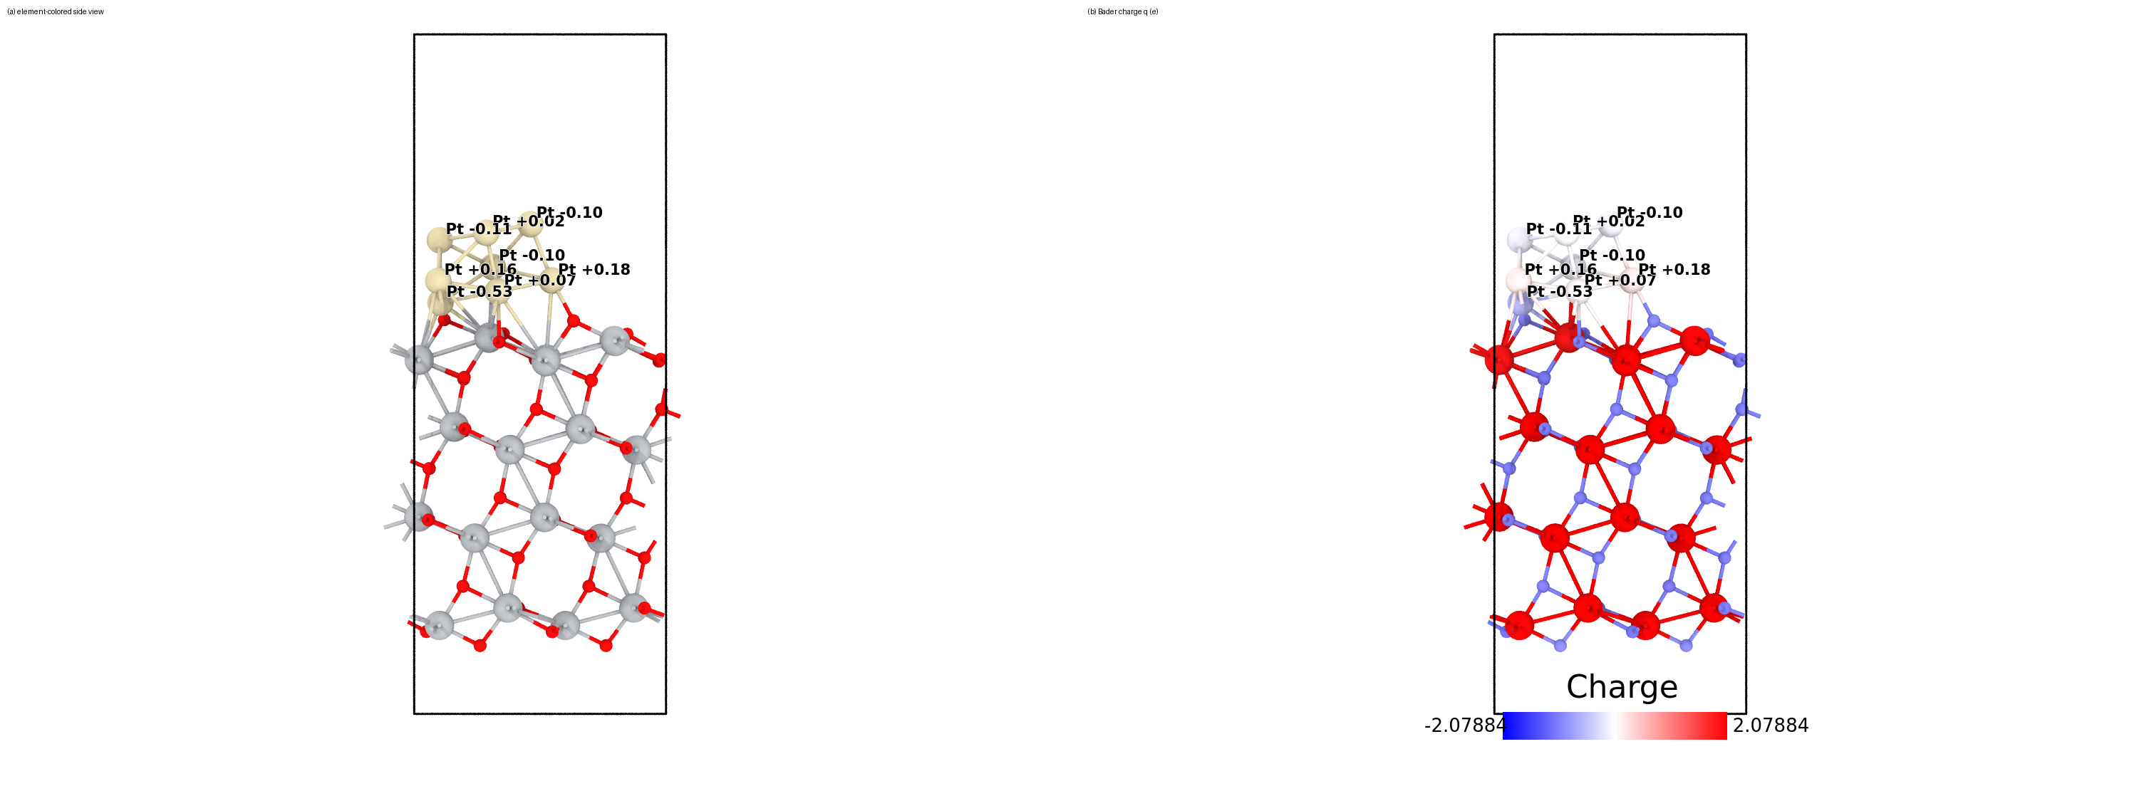
Figure 4. Pt8/TiO2-Ov Bader-charge visualization: (a) same side-view geometry with element colors and (b) Bader net charge q = ZVAL - N_Bader in e. Positive values indicate electron depletion relative to neutral valence. The color map is a visualization of partial charge only, not a formal oxidation-state assignment.
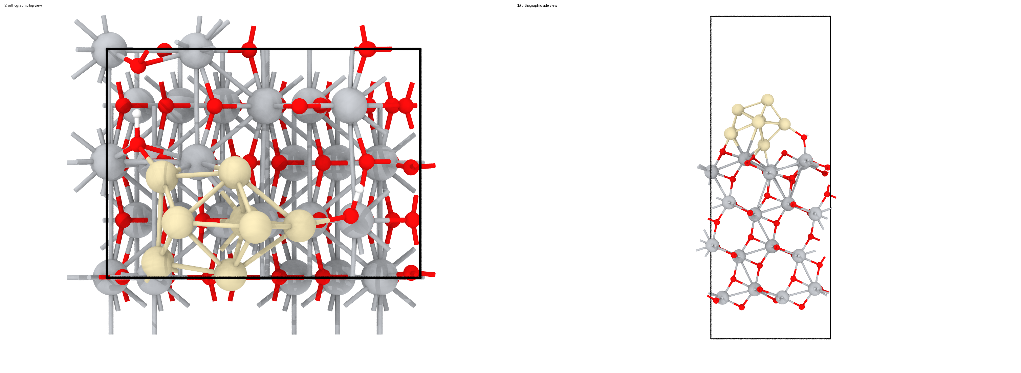
Figure 5. Pt8/H2O-TiO2-Ov relaxed model used in the DFT analysis: (a) orthographic top view and (b) orthographic side view. Source structure: work/calc/static/pt8_h2o/POSCAR, generated from the validated relaxation CONTCAR.
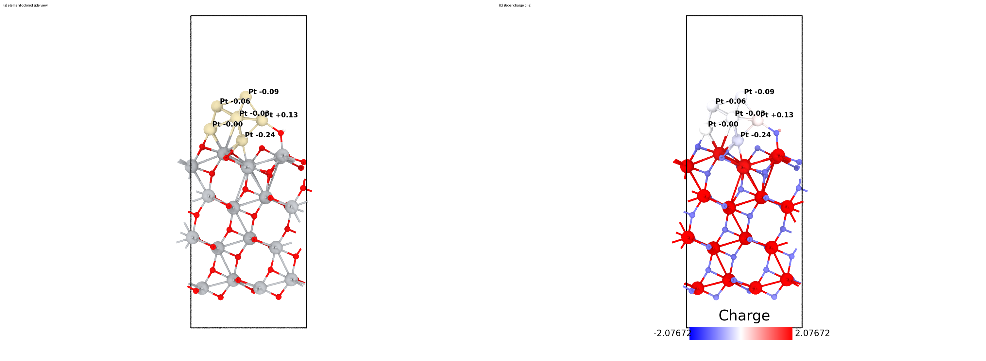
Figure 6. Pt8/H2O-TiO2-Ov Bader-charge visualization: (a) same side-view geometry with element colors and (b) Bader net charge q = ZVAL - N_Bader in e. Positive values indicate electron depletion relative to neutral valence. The color map is a visualization of partial charge only, not a formal oxidation-state assignment.
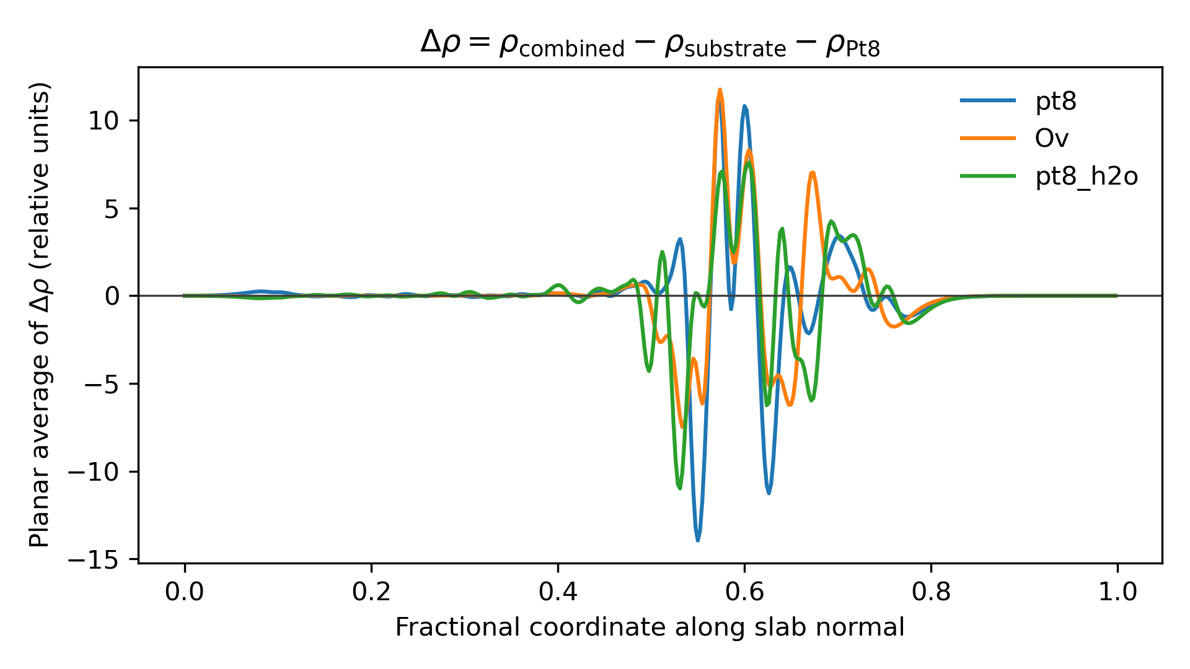
Figure 7. Planar-averaged charge-density difference profiles for the final static models. Delta rho is defined as rho(combined) - rho(substrate fragment) - rho(Pt8 fragment), using frozen geometries and the same cell/cutoff/k-mesh. The profile is qualitative evidence for interfacial charge rearrangement and is interpreted together with Bader charges.

Electronic-State Results
Table 1 summarizes model-level Bader and local-moment evidence. The Pt numbers should be read as partial charges on a supported Pt8 cluster, not as formal oxidation states. The reduced-Ti count uses a local-moment screening threshold of |m| >= 0.4 mu_B and is used as an indicator of vacancy-induced electron localization.
The decisive trend is that none of the validated models gives a uniformly positive Pt ensemble. Mean q(Pt) values are +0.030 e for Pt8/TiO2, -0.051 e for Pt8/TiO2-Ov, and -0.047 e for the H2O/OH-containing vacancy model. Individual interfacial Pt atoms are polarized, but the per-atom spread is larger than the mean shift, so the calculation supports Pt-cluster/metallic-like character with interfacial polarization rather than a formal, unique Pt0 or Pt_delta+ assignment.
Table 2 lists the closest Pt atoms to the oxide/interface in each model. These are the atoms most relevant to the reviewer question because they are most strongly perturbed by Pt-O/Pt-Ti contacts and therefore most likely to show Pt_delta+ polarization if present.
Table 1. Validated static/Bader summary for the three slab models. q(Pt) is Bader net charge q = ZVAL - N_Bader in e. Distances are in Angstrom. These are relative electronic-structure descriptors, not formal oxidation states.
Model | mean q(Pt) | min q(Pt) | max q(Pt) | max |m(Ti)| (mu_B) | Ti moment count | min Pt-O (A) | min Pt-Ti (A) | static finished
Pt8/TiO2 | 0.030 | -0.114 | 0.197 | 0.03 | 0 | 1.99 | 2.59 | yes
Pt8/TiO2-Ov | -0.051 | -0.535 | 0.181 | 0.01 | 0 | 2.02 | 2.46 | yes
Pt8/H2O-TiO2-Ov | -0.047 | -0.236 | 0.131 | 0.15 | 0 | 2.03 | 2.48 | yes
Table 2. Most interfacial Pt atoms by nearest oxide contact. q is Bader net charge in e; m is local magnetic moment in mu_B.
Model | Pt atom | q(Pt) | m(Pt) | nearest O (A) | nearest Ti (A)
pt8 | 97 | 0.091 | 0.01 | 1.99 | 2.85
pt8 | 103 | 0.197 | 0.19 | 2.00 | 3.58
pt8 | 99 | 0.158 | 0.21 | 2.03 | 3.10
pt8 | 98 | -0.114 | 0.32 | 2.10 | 2.59
Ov | 102 | 0.181 | 0.13 | 2.02 | 3.44
Ov | 98 | 0.159 | 0.03 | 2.06 | 3.35
Ov | 97 | 0.067 | 0.01 | 2.10 | 2.57
Ov | 96 | -0.535 | 0.02 | 2.99 | 2.46
pt8_h2o | 99 | -0.001 | 0.03 | 2.03 | 2.58
pt8_h2o | 103 | 0.131 | -0.01 | 2.07 | 3.64
pt8_h2o | 97 | -0.064 | -0.05 | 2.08 | 2.56
pt8_h2o | 98 | -0.236 | -0.01 | 2.12 | 2.48

Water/Vacancy Energetics
The relative energy in Table 3 evaluates whether the H2O/OH-containing model is energetically compatible with interaction of water at the vacancy-bearing Pt8/TiO2 interface. Because no vibrational or configurational entropy terms were computed, the value is an electronic Delta E, not a Gibbs free energy or a kinetic barrier.
Table 3. Relative electronic energy for H2O interaction with the vacancy-containing Pt8/TiO2 model. Negative values favor the H2O/OH-containing product state relative to Pt8/TiO2-Ov + gas H2O within this specific model.
Process | Expression | Delta E (eV) | Limitations
H2O filling/interaction with vacancy-containing Pt8/TiO2 | E(pt8_h2o) - E(Ov) - E(H2O_gas) | 0.166 | electronic energy; no ZPE/entropy correction

Direct Response Text
Proposed response to Reviewer #2 Comment 8: We thank the reviewer for raising this important point. To test whether the interfacial species assigned as Pt0 could instead be better described as a purely Pt_delta+-OH-Ti4+ species, we carried out VASP DFT calculations on the supplied Pt8/TiO2, oxygen-vacancy, and H2O/OH-containing interface models. For each relaxed model, we performed final static calculations followed by AECCAR-referenced Bader charge analysis, local magnetic moment analysis, and charge-density-difference analysis.
The computational result is classified as addresses-with-limitations. Across the validated model set, the Pt8 ensemble remains near-neutral on average by Bader analysis, with only partial interfacial polarization. This supports a metallic-like Pt-cluster interpretation rather than requiring replacement by a purely Pt_delta+-OH-Ti4+ species, while still acknowledging that Bader charge is not a formal oxidation state.
Accordingly, we will not describe the calculation as proving a formal Pt0 oxidation state. The appropriate conclusion is that the interfacial Pt atoms are partially polarized by the oxide/OH/vacancy environment, but the supported Pt8 ensemble retains Pt-cluster/metallic-like character in the model. This supports the revised manuscript language that hydroxyl-tuned TiO2 promotes Pt species with more metallic electronic character and stronger CO-activation tendency, while acknowledging that dynamic interfacial polarization under WGS conditions cannot be excluded by Bader analysis alone.

Validation and Limitations
Validation checks included strict VASP input preflight, Slurm test submission, parser-based relaxation/static convergence checks, Bader charge consistency checks, FFT-grid checks for charge-density differences, and nonblank image checks for report figures.
Limitations: the supplied structures define a compact single-motif Pt8/TiO2 model set; no alternate slab termination, supercell, Pt size, hydroxyl coverage, CO coverage, ab initio dynamics, free-energy correction, or explicit kinetic barrier was computed. Therefore, the results are model-level support for the experimental interpretation rather than an exhaustive proof of the operando catalyst state.
The relative energy reported for the water/vacancy model is electronic only. It should not be called a Gibbs free energy and should not be used to claim a rate-determining elementary step.

Calculation Directory Index
All files below are under the project work directory unless otherwise indicated. Original PDFs and original POSCAR files in the project root were not modified.
Table 4. Provenance map from report items to calculation/data directories.
Report item | Data used | Directory or file
Table 1 | static slab calculations + Bader summaries | work/calc/static/{pt8,Ov,pt8_h2o}/
Table 2 | interfacial Pt Bader charges and contact distances | work/calc/static/{pt8,Ov,pt8_h2o}/ACF.dat, POSCAR, OUTCAR
Table 3 | water/vacancy electronic reaction energy | work/calc/static/Ov, work/calc/static/pt8_h2o, work/calc/gas/h2o_static_cpu
Figure: pt8 geometry | relaxed top/side structure | work/calc/static/pt8/POSCAR
Figure: pt8 Bader charge | paired element/charge structure render | work/analysis/pt8_bader_charge.xyz; work/calc/static/pt8/ACF.dat
Figure: Ov geometry | relaxed top/side structure | work/calc/static/Ov/POSCAR
Figure: Ov Bader charge | paired element/charge structure render | work/analysis/Ov_bader_charge.xyz; work/calc/static/Ov/ACF.dat
Figure: pt8_h2o geometry | relaxed top/side structure | work/calc/static/pt8_h2o/POSCAR
Figure: pt8_h2o Bader charge | paired element/charge structure render | work/analysis/pt8_h2o_bader_charge.xyz; work/calc/static/pt8_h2o/ACF.dat
Figure: CDD planar profiles | charge-density-difference planar averages | work/analysis/cdd_planar_*.csv; work/calc/cdd_fragments/

