Consolidated Computational Response to Reviewer
RuOx OER reviewer-response package; draft for authors

Current Status
This consolidated report merges the first-wave proxy-model calculations, the second-wave reconstructed amorphous h-RuOx model, and the complete second-wave CHE endpoint update into one reviewer-response document.
Report mode: reviewer-response draft for the authors. The first-wave proxy claims for proton uptake feasibility and hydroxylated/coordinated-water motifs are retained only within proxy-model limits. The second-wave h-RuOx CHE profile is now complete at the electronic-energy screening level because tightened rerun *OOH job 667108 passed validation.
The previous waiver-mode and failed endpoint values are not used in this report. Failed endpoint energies are not reported as CHE evidence.
Table 1. Reviewer-question crosswalk and current computational status.
Reviewer issue | Current evidence | Response status
Replace crystalline RuO2-derived proxy as the main h-RuOx model | Hydrous amorphous Ru24O46H8 parent generated by AIMD disordering/quench and post-AIMD relaxation; amorphous slab accepted for OER adsorbates | Addressed for model construction; first-wave crystalline proxy is demoted to background
Provide complete CHE OER profile on h-RuOx | Clean, *OH, *O, and tightened rerun *OOH endpoints are validated; full DG1-DG4 table is computed | Addressed at electronic-energy CHE screening level
Clarify H uptake and water/hydroxyl evidence | First-wave RuO2-derived proxy shows exothermic H uptake and dissociative H2O stabilization; second-wave h-RuOx CHE uses the amorphous model | Use proxy values only as background feasibility evidence, not direct proof of h-RuOx H uptake
Avoid relabeling missing values | Exact OH adsorption/product-desorption pairs and ESP-isosurface artifacts are not present as validated current outputs | Mark unavailable rather than relabeling proxy or failed CHE quantities

Model Comparison
The second-wave model is a reconstructed hydrous amorphous h-RuOx model, not a crystalline RuO2 slab with vacancy/proton/water substitutions. The parent Ru24O46H8 structure was generated from a hydroxylated/oxygen-deficient Ru-O-H precursor, disordered by AIMD, and relaxed after AIMD before slab construction.
The anh-RuO2(110)-like first-wave surface remains useful only as a crystalline anhydrous comparator and as background feasibility evidence. It is not used as a surrogate proof for h-RuOx H uptake.
Table 2. h-RuOx amorphous model compared with the anh-RuO2(110)-like crystalline comparator.
Observable | h-RuOx AIMD-derived model | anh-RuO2(110)-like comparator
Model origin | Ru24O46H8 hydroxylated/oxygen-deficient precursor; AIMD disordering/quench; post-AIMD relaxation | Rutile RuO2-derived crystalline (110) slab from first-wave construction
Thermodynamic role | Main model for second-wave h-RuOx slab and CHE endpoint screening | Crystalline anhydrous comparator only
Hydroxyl content | Distributed O-H motifs in the hydrous precursor; relaxed bulk audit shows short O-H contacts near 0.987-0.994 A | Stoichiometric clean surface has no H; protonated surface comparator has O-H = 0.9706 A
Validation status | Bulk relaxation job 666068 and clean slab job 666151 parser-converged; AIMD energies excluded from thermodynamics | First-wave static surface calculations parser-validated
Use in response | Primary reconstructed h-RuOx model for OER intermediate energetics | Background comparator; not evidence for h-RuOx H uptake

Complete CHE Profile
The final second-wave CHE update uses only validated endpoints from the current jobs. The tightened rerun *OOH job 667108 completed normally, reached EDIFFG = -0.03 eV/A, and passed the VASP parser.
The complete four-step profile is an electronic-energy CHE screening result. The calculations do not include ZPE, finite-temperature, entropy, solvation, pH, or constant-potential corrections.
Table 3. Endpoint validation status for the complete h-RuOx CHE update.
State | Job/source | Parser verdict | Ionic steps | Force criterion (eV/A) | Max free-atom force (eV/A) | Report use
* | 666151 | pass | 147 | 0.03 | 0.024636 | Accepted clean-state endpoint
*OH | 666669 | pass | 104 | 0.03 | 0.018878 | Accepted *OH endpoint
*O | 666401 | pass | 60 | 0.03 | 0.022106 | Accepted *O endpoint
*OOH | 667108 | pass | 66 | 0.03 | 0.024505 | Accepted tightened rerun *OOH endpoint
Table 4. Complete electronic-energy CHE profile at U = 0 V and pH = 0. O2 is back-calculated from 2H2O -> O2 + 2H2 with DG = 4.92 eV.
Step | Reaction | DG (eV) | DG - 1.23 eV (eV)
DG1 | * + H2O -> *OH + H+ + e- | -0.131915 | -1.361915
DG2 | *OH -> *O + H+ + e- | -0.220095 | -1.450095
DG3 | *O + H2O -> *OOH + H+ + e- | 2.152844 | 0.922844
DG4 | *OOH -> * + O2 + H+ + e- | 3.119166 | 1.889166
Limiting potential | max(DG1-DG4) | 3.119166 V vs RHE
Overpotential | max(DG1-DG4) - 1.23 V | 1.889166 V

Proxy Evidence
The first-wave crystalline RuO2-derived models are retained only as background feasibility checks for proton uptake and hydroxylated/coordinated-water motifs. They should not be presented as direct h-RuOx H uptake calculations.
Within that proxy scope, internal H uptake is exothermic but less favorable than the surface-H comparator. Dissociative H2O uptake is exothermic for both the surface vacancy and internal vacancy proxies, supporting the plausibility of stable OH/coordinated-water motifs in defect-rich RuOx.
Table 5. First-wave proxy H uptake electronic energies in eV. Negative values indicate exothermic uptake. Reference states are clean host plus 0.5 H2.
Quantity | Delta E (eV) | Formula | Allowed interpretation
H uptake on stoichiometric RuO2(110) | -1.0719 | E(surface_H) - E(surface_clean) - 0.5 E(H2) | Surface-only protonation comparator
Internal H uptake in crystalline RuO2 proxy | -0.1419 | E(bulk_H_internal) - E(bulk_clean) - 0.5 E(H2) | Feasibility check for internal proton-containing states
Internal H uptake minus surface H uptake | +0.9300 | DeltaE_internal - DeltaE_surface | Surface protonation is more exothermic in this proxy comparison
Table 6. First-wave proxy dissociative H2O uptake electronic energies in eV. Negative values indicate exothermic uptake. Reference states are O-vacancy host plus gas-phase H2O.
Quantity | Delta E (eV) | Formula | Allowed interpretation
Dissociative H2O uptake at surface O vacancy | -1.1163 | E(surface_Ovac_H2O_diss) - E(surface_Ovac) - E(H2O) | Surface CUS/vacancy hydroxylation comparator
Dissociative H2O uptake at internal O vacancy | -1.4266 | E(bulk_Ovac_H2O_diss_internal) - E(bulk_Ovac_internal) - E(H2O) | Internal coordinated-water proxy
Internal minus surface H2O dissociation | -0.3103 | DeltaE_internal - DeltaE_surface | Selected internal vacancy proxy is more exothermic than selected surface vacancy comparator
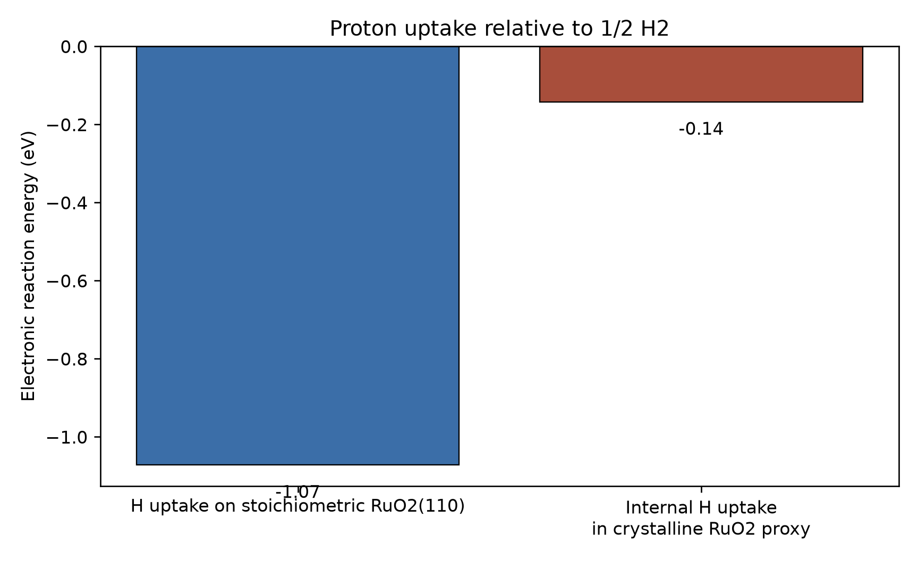
Figure 1. First-wave proxy H uptake electronic energies from static VASP calculations on relaxed structures. Negative values indicate exothermic uptake relative to the clean host and 0.5 gas-phase H2.
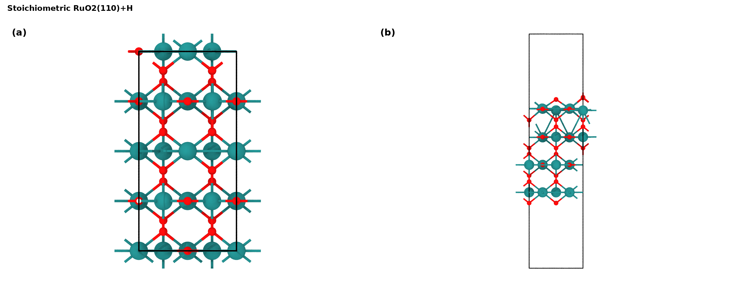
Figure 2. Relaxed stoichiometric RuO2(110)+H proxy used for the surface H uptake comparator: (a) orthographic top view; (b) orthographic side view. Source: work/runs/first_wave/surface_H/relax/CONTCAR.
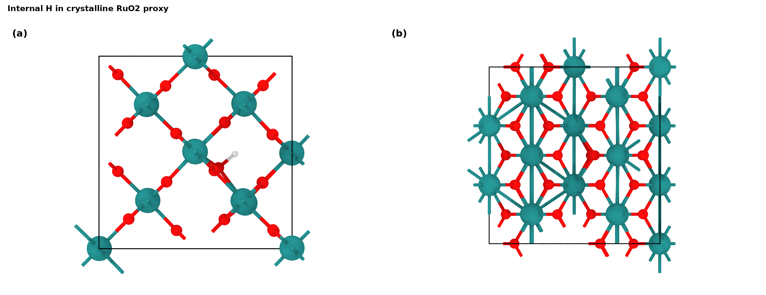
Figure 3. Relaxed internal H proxy used for the crystalline RuO2 proton-incorporation feasibility check: (a) orthographic top view; (b) orthographic side view. Source: work/runs/first_wave/bulk_H_internal/relax/CONTCAR.
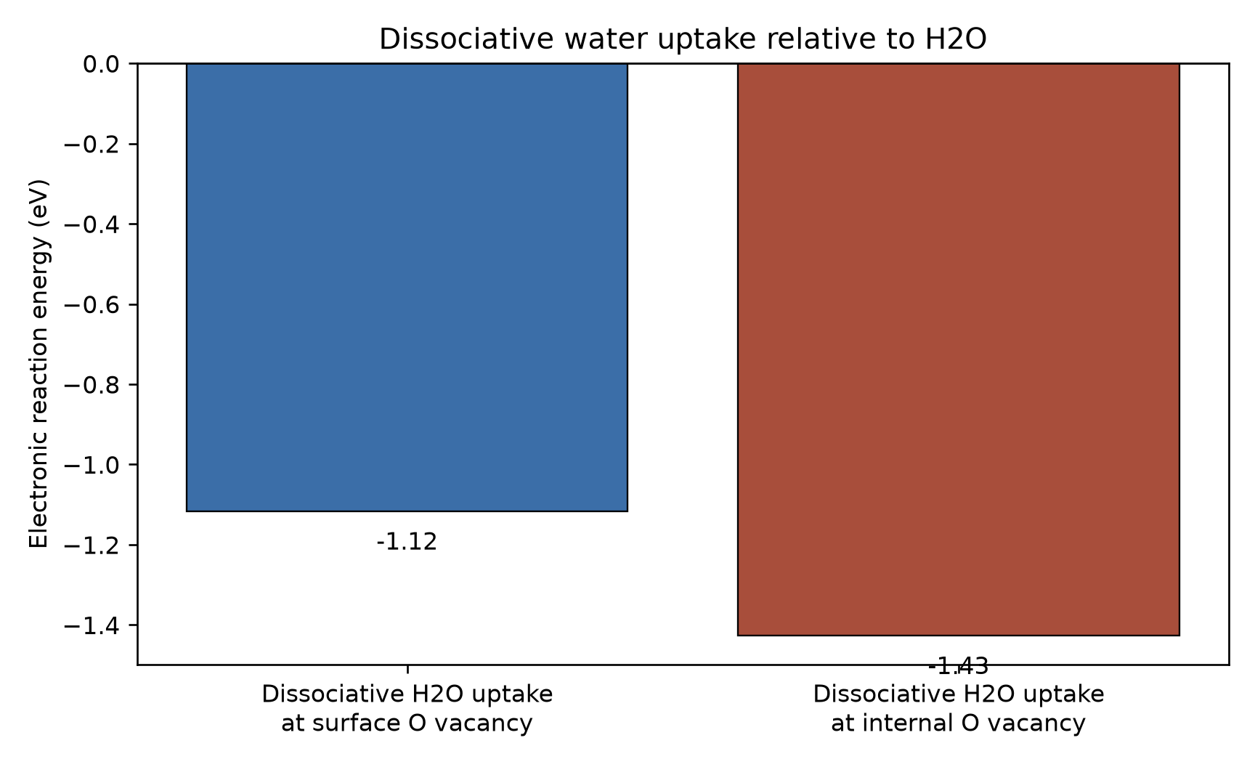
Figure 4. First-wave proxy dissociative H2O uptake electronic energies from static VASP calculations on relaxed O-vacancy structures. Negative values indicate exothermic uptake relative to the vacancy host and gas-phase H2O.
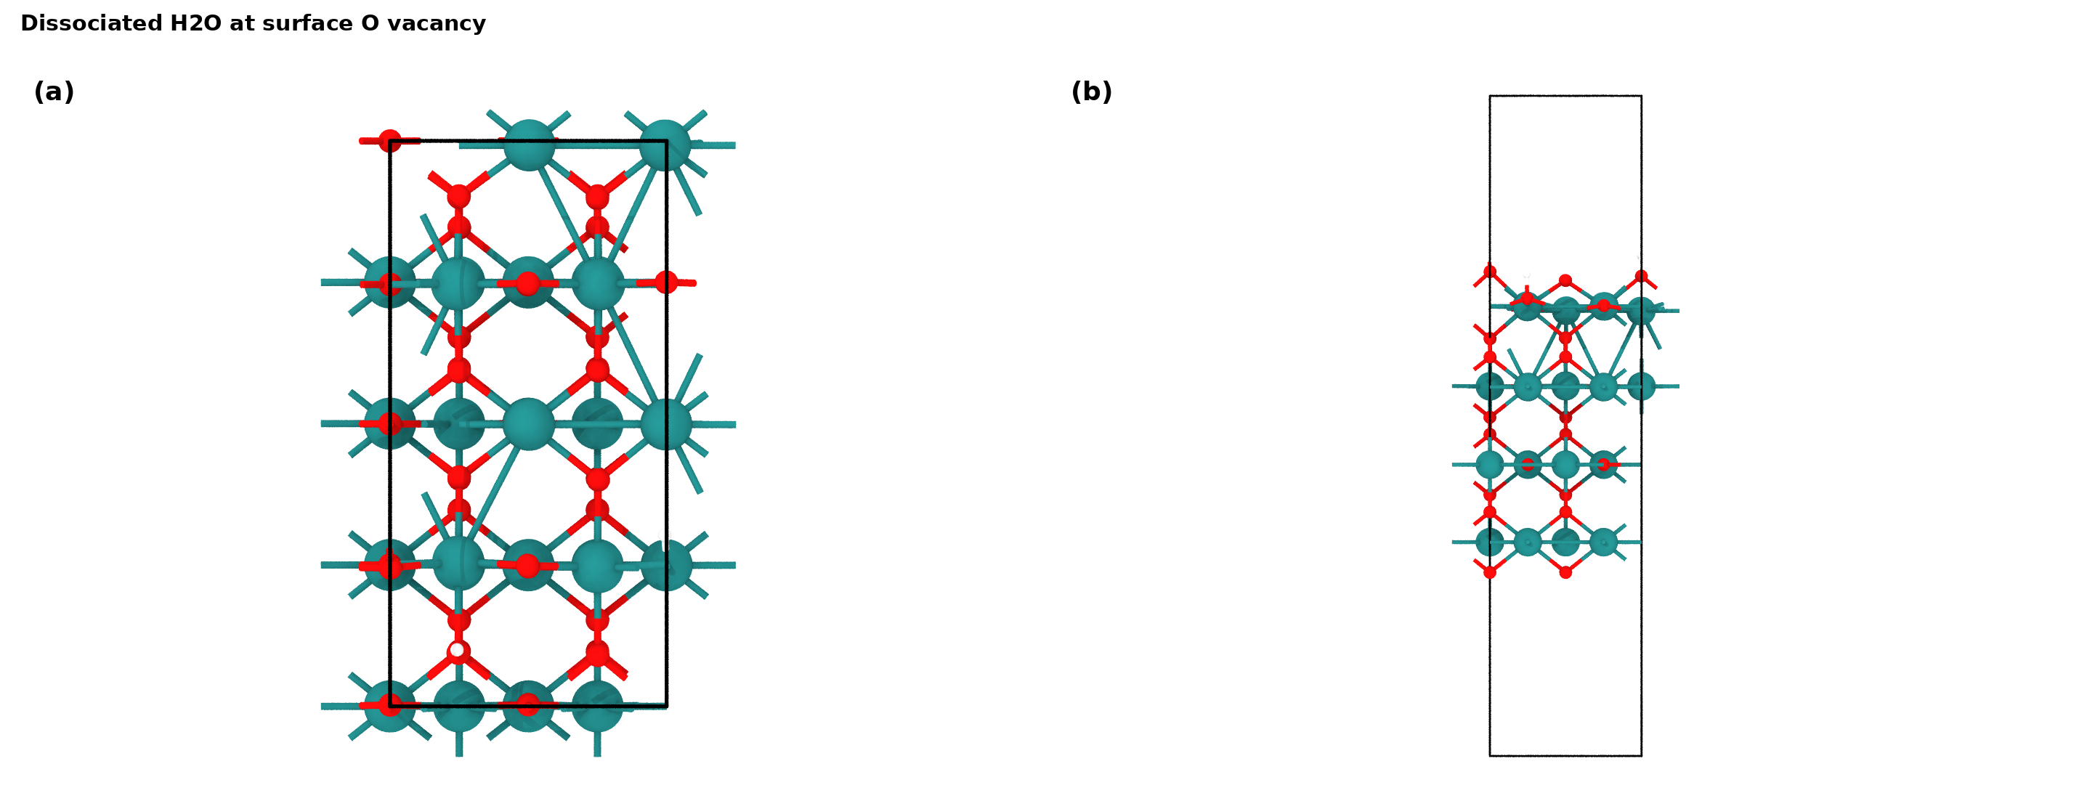
Figure 5. Relaxed surface O-vacancy plus dissociated H2O proxy: (a) orthographic top view; (b) orthographic side view. Source: work/runs/first_wave/surface_Ovac_H2O_diss/relax/CONTCAR.
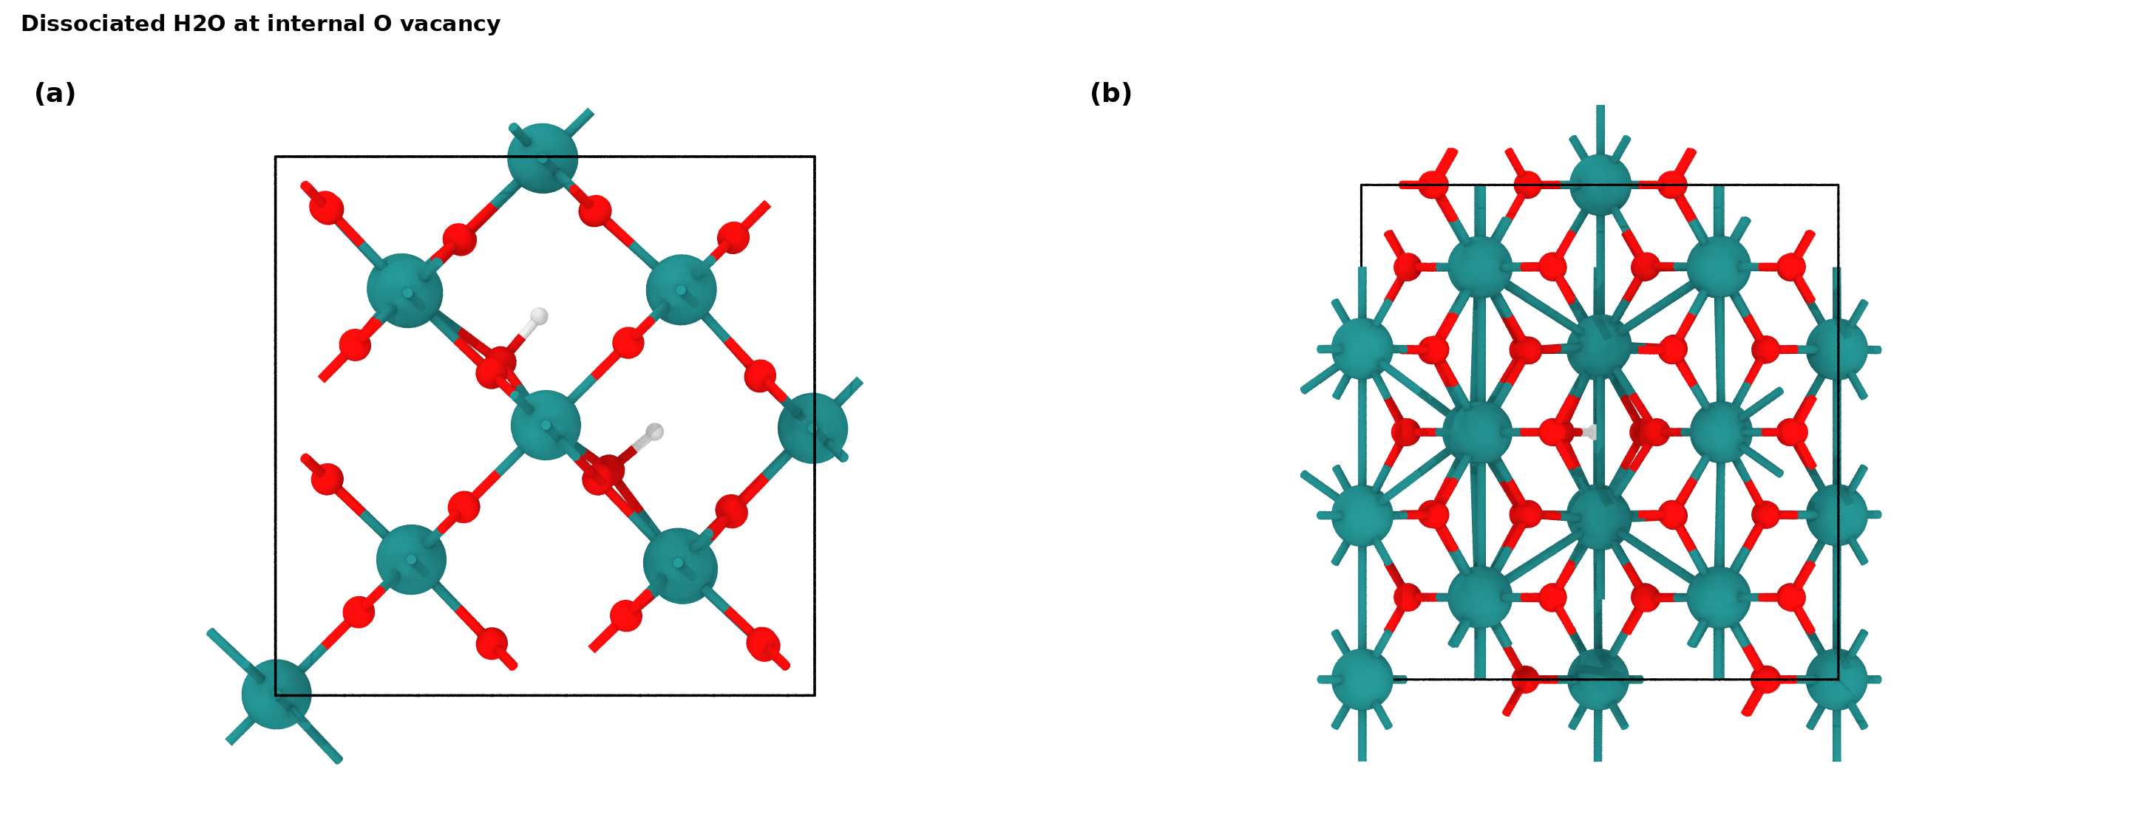
Figure 6. Relaxed internal O-vacancy plus dissociated H2O proxy: (a) orthographic top view; (b) orthographic side view. Source: work/runs/first_wave/bulk_Ovac_H2O_diss_internal/relax/CONTCAR.

Reviewer Response Text
We thank the reviewer for identifying the weakness in the previous theoretical discussion. We have revised the computational response so that the crystalline RuO2-derived vacancy/proton model is no longer used as evidence for H uptake in h-RuOx. Instead, the main h-RuOx OER model is a reconstructed hydrous amorphous RuOx slab derived from AIMD disordering and post-AIMD relaxation of a Ru24O46H8 precursor.
Using the validated h-RuOx endpoint set, the complete electronic-energy CHE profile is DG1 = -0.131915 eV, DG2 = -0.220095 eV, DG3 = 2.152844 eV, and DG4 = 3.119166 eV at U = 0 V and pH = 0. The largest uphill step is DG4, giving U_L,OER = 3.119166 V vs RHE at pH 0 and eta = 1.889166 V.
The earlier RuO2-derived proton/vacancy/water calculations are retained only as background feasibility checks. They show that proton-containing and hydroxylated/coordinated-water motifs can be electronically stable in defect-rich RuO2-derived environments, but they are not direct evidence for H uptake in h-RuOx and should not be worded as such.
Electrostatic-potential isosurfaces and exact OH adsorption/product-desorption pairs are not present as validated current artifacts in this calculation package. They are therefore marked unavailable rather than fabricated or relabeled from different observables.

Limitations
This document is a draft for the authors. The h-RuOx result is a single representative amorphous site, vacuum electronic-energy CHE only, with no ZPE, entropy, solvation, pH, constant-potential, or site-statistics corrections.
The tightened rerun *OOH endpoint passed EDIFFG = -0.03 eV/A, with max free-atom force 0.024505 eV/A. This threshold is disclosed in the endpoint table.
The first-wave proxy results remain exploratory reconstructed models, not direct h-RuOx H uptake calculations.

Calculation Directory Index
This index maps report statements to raw directories and analysis artifacts so the authors can audit each number.
Table 7. Traceability map for tables, figures, and response claims.
Report item | Source artifacts
h-RuOx model construction | work/structures/second_wave_hruox; work/analysis/second_wave_bulk_relax_from_aimd_result.json; work/analysis/second_wave_slab_clean_relax_algoall_result.json
Complete CHE endpoint table | work/analysis/second_wave_oer_che_profile.json; work/analysis/second_wave_oer_che_profile.csv; work/reviews/second_wave_oer_che_result_gate.yaml
*OH validation | work/runs/second_wave_hruox/hruox_slab_oh_relax; work/analysis/second_wave_oh_relaxed_666669_audit.json
*OOH validation | work/runs/second_wave_hruox/hruox_slab_ooh_relax; work/analysis/second_wave_ooh_relaxed_667108_audit.json
First-wave H uptake proxy | work/analysis/relative_energies.csv; work/figures/energy_proton_uptake.png; work/figures/structures/surface_H_top_side_panel.png; work/figures/structures/bulk_H_internal_top_side_panel.png
First-wave water/hydroxylation proxy | work/analysis/relative_energies.csv; work/analysis/geometry_metrics.csv; work/figures/energy_water_hydroxylation.png; work/figures/structures/surface_Ovac_H2O_diss_top_side_panel.png; work/figures/structures/bulk_Ovac_H2O_diss_internal_top_side_panel.png
Reviewer-response snippets | work/analysis/second_wave_response_text_snippets.md; work/reports/second_wave_reviewer_response_update.md

