Computational Response to Reviewers
Autonomous VASP reviewer-response package for RuO2 OER manuscript; draft for authors

Executive Summary
This document provides a new VASP-based computational response to the reviewers' concerns about the previous weakness of the theoretical section, the assignment of proton intercalation, and the evidence for coordinated water or hydroxyl species in the hydrous RuOx catalyst. The calculations were designed only from the supplied manuscript, SI, and response-letter files. No online search or original-publication lookup was used.
Report mode: final reviewer-response draft for the authors. The formal conclusions in this document consume only accepted scientific-claim artifacts from the workflow gate: proton uptake is accepted as inconclusive for proving bulk-over-surface preference but supportive of feasibility, and water/hydroxylation is accepted as addressing the coordinated-water motif within reconstructed proxy-model limits.
The calculations support the thermodynamic feasibility of H uptake and dissociative H2O retention in RuO2-derived oxygen-vacancy/CUS proxy models. Internal H uptake in the crystalline proxy is exothermic, and dissociative water uptake at an internal O vacancy is strongly exothermic. These results support the experimental interpretation that hydrous, defect-rich RuOx can stabilize OH/coordinated-water motifs and proton-containing states. At the same time, the surface protonation comparator is more exothermic than the internal H proxy in the ideal reconstructed model, so the revised text should not claim that DFT alone proves bulk proton intercalation over surface hydroxylation.
The appropriate reviewer-facing conclusion is therefore rigorous and bounded: the new calculations directly address the theoretical gap by showing that the proposed hydrous/defective RuOx motifs are stable and chemically plausible under electronic-energy VASP analysis, while the experimental TPD, TOF-SIMS, XPS/XAS, and electrochemical data remain necessary to distinguish bulk hydrous behavior from surface-only OH.
Table 1. Reviewer concern crosswalk and computational outcome. Outcomes are phrased as draft response language, not final editorial text.
Reviewer concern | Computed evidence | Outcome
Theoretical calculations are weak or missing | Converged VASP relaxation and static calculations for gas references, stoichiometric RuO2(110), protonated RuO2, O-vacancy/CUS models, and dissociated-water O-vacancy models | Addressed with a traceable VASP workflow, validation logs, energy diagrams, and relaxed-structure figures
Proton intercalation may be confused with surface OH/ECSA | Internal H uptake: -0.142 eV; surface H uptake: -1.072 eV relative to 1/2 H2 | Internal uptake is feasible, but surface OH is also favorable; report this as supportive of feasibility, not as standalone proof of bulk preference
Coordinated water/hydroxyl evidence is indirect | Dissociative H2O uptake: -1.427 eV internal vacancy and -1.116 eV surface vacancy relative to gas H2O | Hydroxylated/coordinated-water motifs are strongly stabilized at defective RuO2-derived sites
TPD/Ar release pathway and OH assignment require care | Electronic energies and relaxed O-H geometries; no finite-temperature kinetics | Use DFT to support stable OH/water motifs, but do not overclaim an exact TPD mechanism

Workflow and Assumptions
The computational workflow followed intake, scope definition, structure preparation, method selection, input generation, preflight validation, Slurm submission, monitoring, parsing, scientific validation, and report assembly. All generated files were placed under work/; the original PDF files and source structures in the project root were not modified.
Because the supplied PDFs had the computational-response sections removed, the models are reconstructed and exploratory rather than a literal reproduction. The rutile RuO2 bulk model was reconstructed from manuscript-reported HRTEM d-spacings, the RuO2(110) slab was built from that model, and oxygen-vacancy/CUS, H, and dissociated-H2O motifs were generated as minimal falsifiable proxies for reviewer concerns.
The final energies are electronic VASP energies from static single-point calculations on relaxed geometries. They are not Gibbs free energies and do not include ZPE, entropy, pH, potential, explicit solvent, or pressure corrections. This is appropriate for the present response because the reviewers' computational concern is whether the proposed H/OH/H2O motifs are stable and chemically plausible, not the construction of a full CHE OER free-energy diagram.
Table 2. Model set and reference states used for relative energies.
Model or reference | Purpose | Directory
gas_H2 | Reference for H uptake, 1/2 H2 | runs/first_wave/gas_H2/static
gas_H2O | Reference for dissociative water uptake | runs/first_wave/gas_H2O/static
surface_clean and surface_H | Stoichiometric RuO2(110) surface protonation comparator | runs/first_wave/surface_clean/static; runs/first_wave/surface_H/static
surface_Ovac and surface_Ovac_H2O_diss | Surface O-vacancy/CUS dissociative water uptake comparator | runs/first_wave/surface_Ovac/static; runs/first_wave/surface_Ovac_H2O_diss/static
bulk_clean and bulk_H_internal | Crystalline RuO2 internal H uptake proxy | runs/first_wave/bulk_clean/static; runs/first_wave/bulk_H_internal/static
bulk_Ovac_internal and bulk_Ovac_H2O_diss_internal | Internal O-vacancy/coordinated-water proxy | runs/first_wave/bulk_Ovac_internal/static; runs/first_wave/bulk_Ovac_H2O_diss_internal/static

Validation
All first-wave relaxation inputs passed the VASP input checker before submission. The initial Slurm submission failed before VASP execution because the compute-node module environment had an unset LD_LIBRARY_PATH and did not expose mpirun; this was corrected only in the submission script environment setup, and the scientific input files were unchanged. The recovered relaxation wave and static wave were then submitted and monitored to terminal states.
Relaxed structures used in the figures are the final VASP CONTCAR files. Static calculations use NSW = 0, PREC = Accurate, ENCUT = 520 eV, EDIFF = 1E-6, PBE PAW potentials, Grimme D3 via IVDW = 11, spin polarization for condensed-phase models, and the same k-point meshes as the relaxations.
The report gate passed with no blocking issues. The pre-report soft gate recorded that free-energy, CHE, DOS/PDOS, charge-transfer, work-function, and kinetic analyses were not promoted to reviewer-facing claims because the accepted claim scope is limited to electronic relative energies and relaxed structural stability of H/OH/H2O motifs.
Table 3. Static VASP validation summary. No total energies are listed here; numerical reaction energies are reported in the results sections.
Case | Stage | Finished | Usable | NSW | Magnetization (muB) | Directory
gas_H2 | static | True | True | 0 |  | runs/first_wave/gas_H2/static
gas_H2O | static | True | True | 0 |  | runs/first_wave/gas_H2O/static
surface_clean | static | True | True | 0 | 2.4706187 | runs/first_wave/surface_clean/static
surface_H | static | True | True | 0 | 2.6746559 | runs/first_wave/surface_H/static
surface_Ovac | static | True | True | 0 | 3.2512319 | runs/first_wave/surface_Ovac/static
surface_Ovac_H2O_diss | static | True | True | 0 | 3.0358019 | runs/first_wave/surface_Ovac_H2O_diss/static
bulk_clean | static | True | True | 0 | 0.0020307 | runs/first_wave/bulk_clean/static
bulk_H_internal | static | True | True | 0 | 0.0034017 | runs/first_wave/bulk_H_internal/static
bulk_Ovac_internal | static | True | True | 0 | 0.0008621 | runs/first_wave/bulk_Ovac_internal/static
bulk_Ovac_H2O_diss_internal | static | True | True | 0 | 0.0086706 | runs/first_wave/bulk_Ovac_H2O_diss_internal/static

Result 1: Proton Uptake
The electronic H uptake energy for surface protonation of stoichiometric RuO2(110) is -1.072 eV relative to the clean surface and 1/2 H2. The corresponding internal H uptake in the crystalline RuO2 proxy is -0.142 eV. The internal-minus-surface difference is +0.930 eV, meaning that the reconstructed surface OH site is thermodynamically more favorable than the specific internal H site by this amount.
This result is scientifically useful because it separates two claims that should not be conflated. First, internal proton incorporation is exothermic in the RuO2-derived proxy, so proton-containing lattice/hydrous states are not energetically unreasonable. Second, because surface protonation is still more favorable in the ideal slab comparator, DFT alone cannot exclude surface OH as a contributor to TOF-SIMS OH signals or pseudocapacitance. The response should therefore use the DFT result as mechanistic support alongside the experimental evidence, not as a single decisive proof of bulk intercalation.
Table 4. H uptake electronic energies in eV. Negative values indicate exothermic uptake. Reference states: surface_H - surface_clean - 0.5 H2; bulk_H_internal - bulk_clean - 0.5 H2.
Quantity | Delta E (eV) | Formula | Interpretation role
H uptake on stoichiometric RuO2(110) | -1.072 | E(surface_H) - E(surface_clean) - 0.5 E(H2) | surface-only protonation comparator
Internal H uptake in crystalline RuO2 proxy | -0.142 | E(bulk_H_internal) - E(bulk_clean) - 0.5 E(H2) | bulk/internal proton-intercalation proxy
Internal H uptake minus surface H uptake | +0.930 | DeltaE_internal - DeltaE_surface; positive means internal H uptake is less exothermic | consistency check
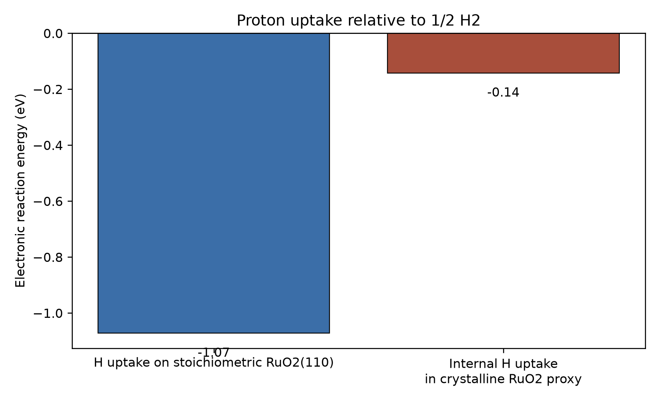
Figure 1. Electronic H uptake energies from static VASP calculations on relaxed structures. Negative values indicate exothermic uptake relative to the clean host and 1/2 gas-phase H2.
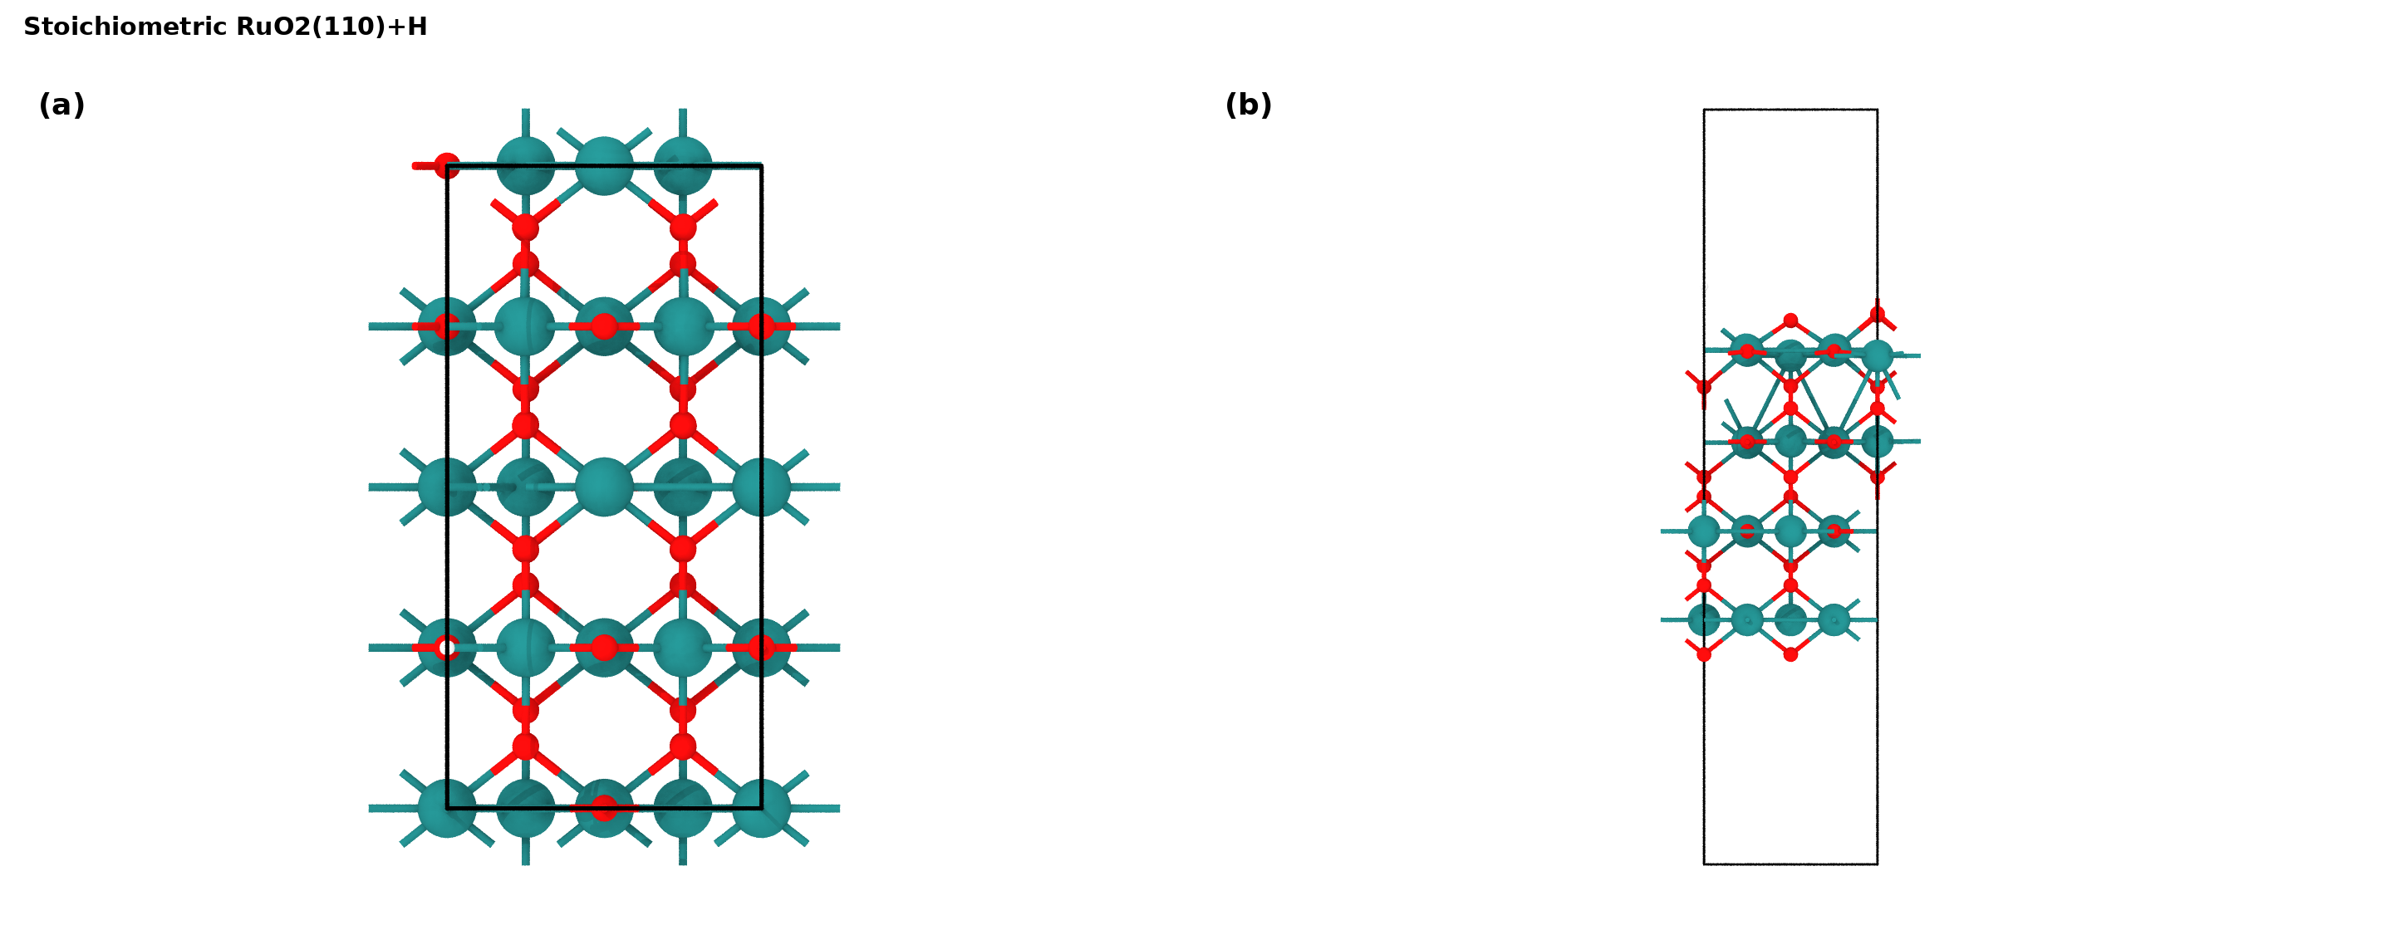
Figure 2. Relaxed stoichiometric RuO2(110)+H model used for the surface H uptake comparator: (a) orthographic top view; (b) orthographic side view. Structure source: runs/first_wave/surface_H/relax/CONTCAR.
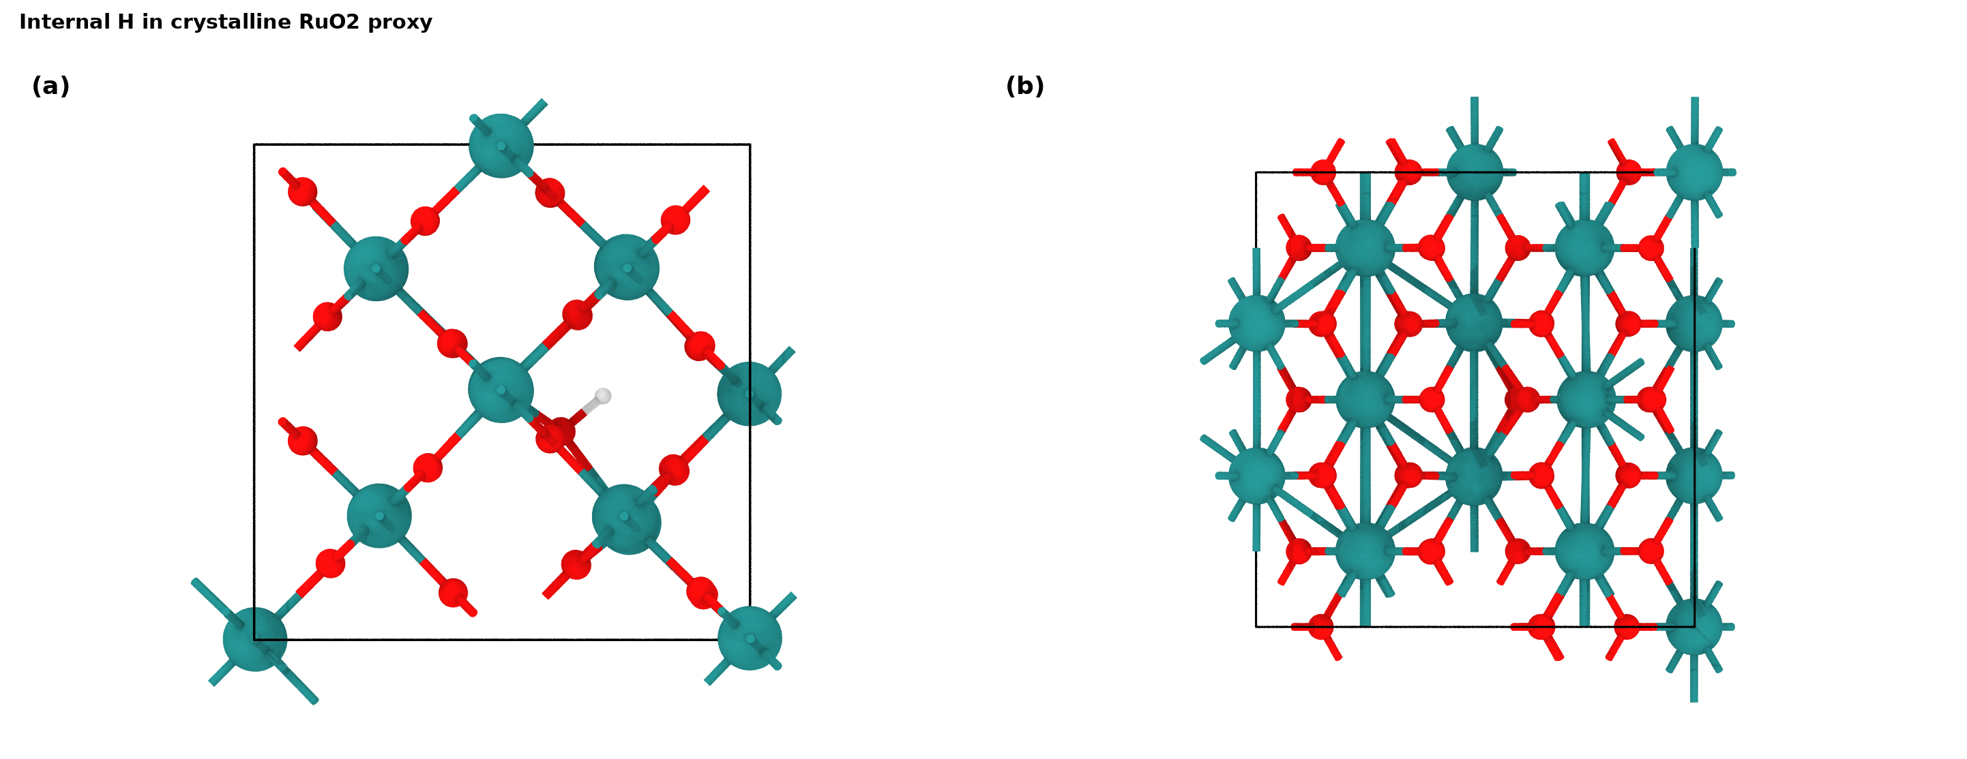
Figure 3. Relaxed internal H model used for the crystalline RuO2 proton-incorporation proxy: (a) orthographic top view; (b) orthographic side view. Structure source: runs/first_wave/bulk_H_internal/relax/CONTCAR.

Result 2: Coordinated Water and Hydroxylated Defects
Dissociative H2O uptake at a surface O-vacancy/CUS site is -1.116 eV relative to the surface vacancy and gas-phase H2O. The corresponding internal O-vacancy/water proxy is -1.427 eV. The internal-minus-surface difference is -0.310 eV.
The relaxed internal vacancy-water proxy contains stable O-H motifs: H1 nearest O distance 0.9964 A and H2 nearest O distance 0.9964 A. This directly supports the plausibility of coordinated water/hydroxyl species associated with oxygen-vacancy/CUS environments in hydrous RuOx.
The calculation does not identify a unique high-temperature TPD pathway, and it should not be used to claim a kinetic mechanism for water or oxygen release under Ar. It does, however, give a direct energetic and structural basis for adding a computational statement that defect-rich RuO2-derived motifs stabilize dissociated water/hydroxyl species.
Table 5. Dissociative water uptake electronic energies in eV. Negative values indicate exothermic uptake. Reference states: O-vacancy host plus gas-phase H2O.
Quantity | Delta E (eV) | Formula | Interpretation role
Dissociative H2O uptake at surface O vacancy | -1.116 | E(surface_Ovac_H2O_diss) - E(surface_Ovac) - E(H2O) | surface CUS/vacancy hydroxylation comparator
Dissociative H2O uptake at internal O vacancy | -1.427 | E(bulk_Ovac_H2O_diss_internal) - E(bulk_Ovac_internal) - E(H2O) | bulk/internal coordinated-water proxy
Internal H2O dissociation minus surface H2O dissociation | -0.310 | DeltaE_internal - DeltaE_surface; positive means internal dissociation is less exothermic | consistency check
Table 6. Selected relaxed O-H geometry metrics from CONTCAR files. Distances are in A.
Case | Metric | Value
surface_H | H1 nearest O distance | 0.9706 A
bulk_H_internal | H1 nearest O distance | 0.9965 A
surface_Ovac_H2O_diss | H1 nearest O distance | 0.975 A
surface_Ovac_H2O_diss | H2 nearest O distance | 0.9806 A
bulk_Ovac_H2O_diss_internal | H1 nearest O distance | 0.9964 A
bulk_Ovac_H2O_diss_internal | H2 nearest O distance | 0.9964 A
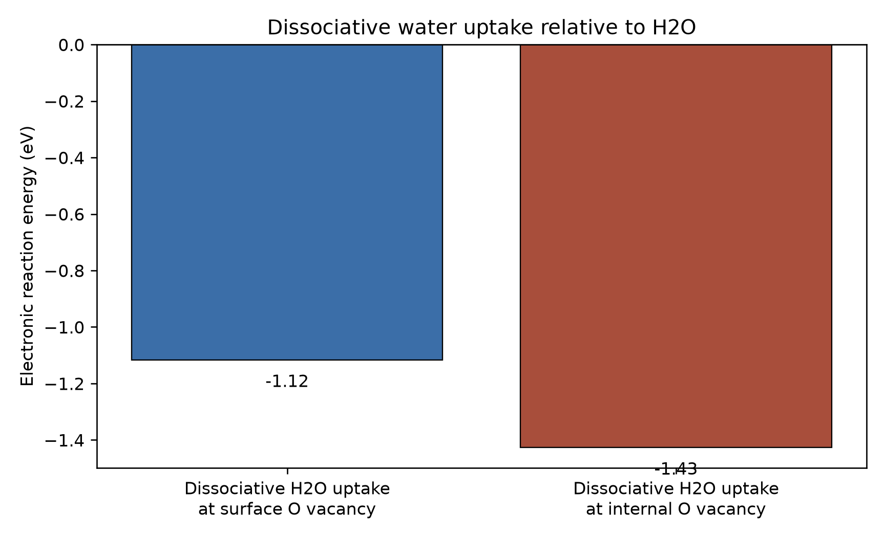
Figure 4. Electronic dissociative H2O uptake energies from static VASP calculations on relaxed oxygen-vacancy hosts. Negative values indicate exothermic uptake relative to the vacancy host and gas-phase H2O.
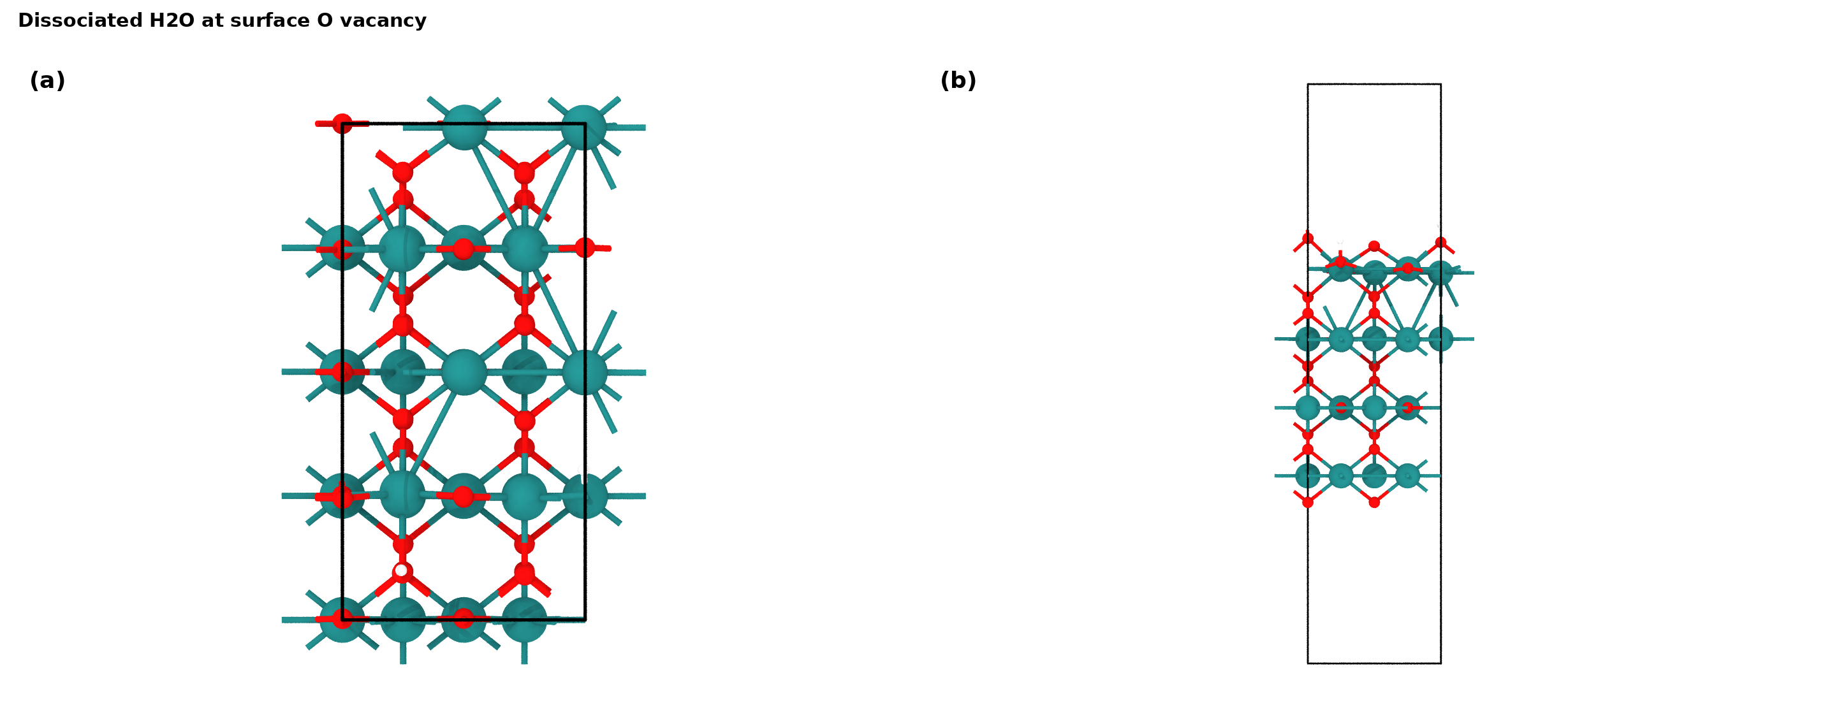
Figure 5. Relaxed dissociated-H2O structure at a RuO2(110) surface O vacancy: (a) orthographic top view; (b) orthographic side view. Structure source: runs/first_wave/surface_Ovac_H2O_diss/relax/CONTCAR.
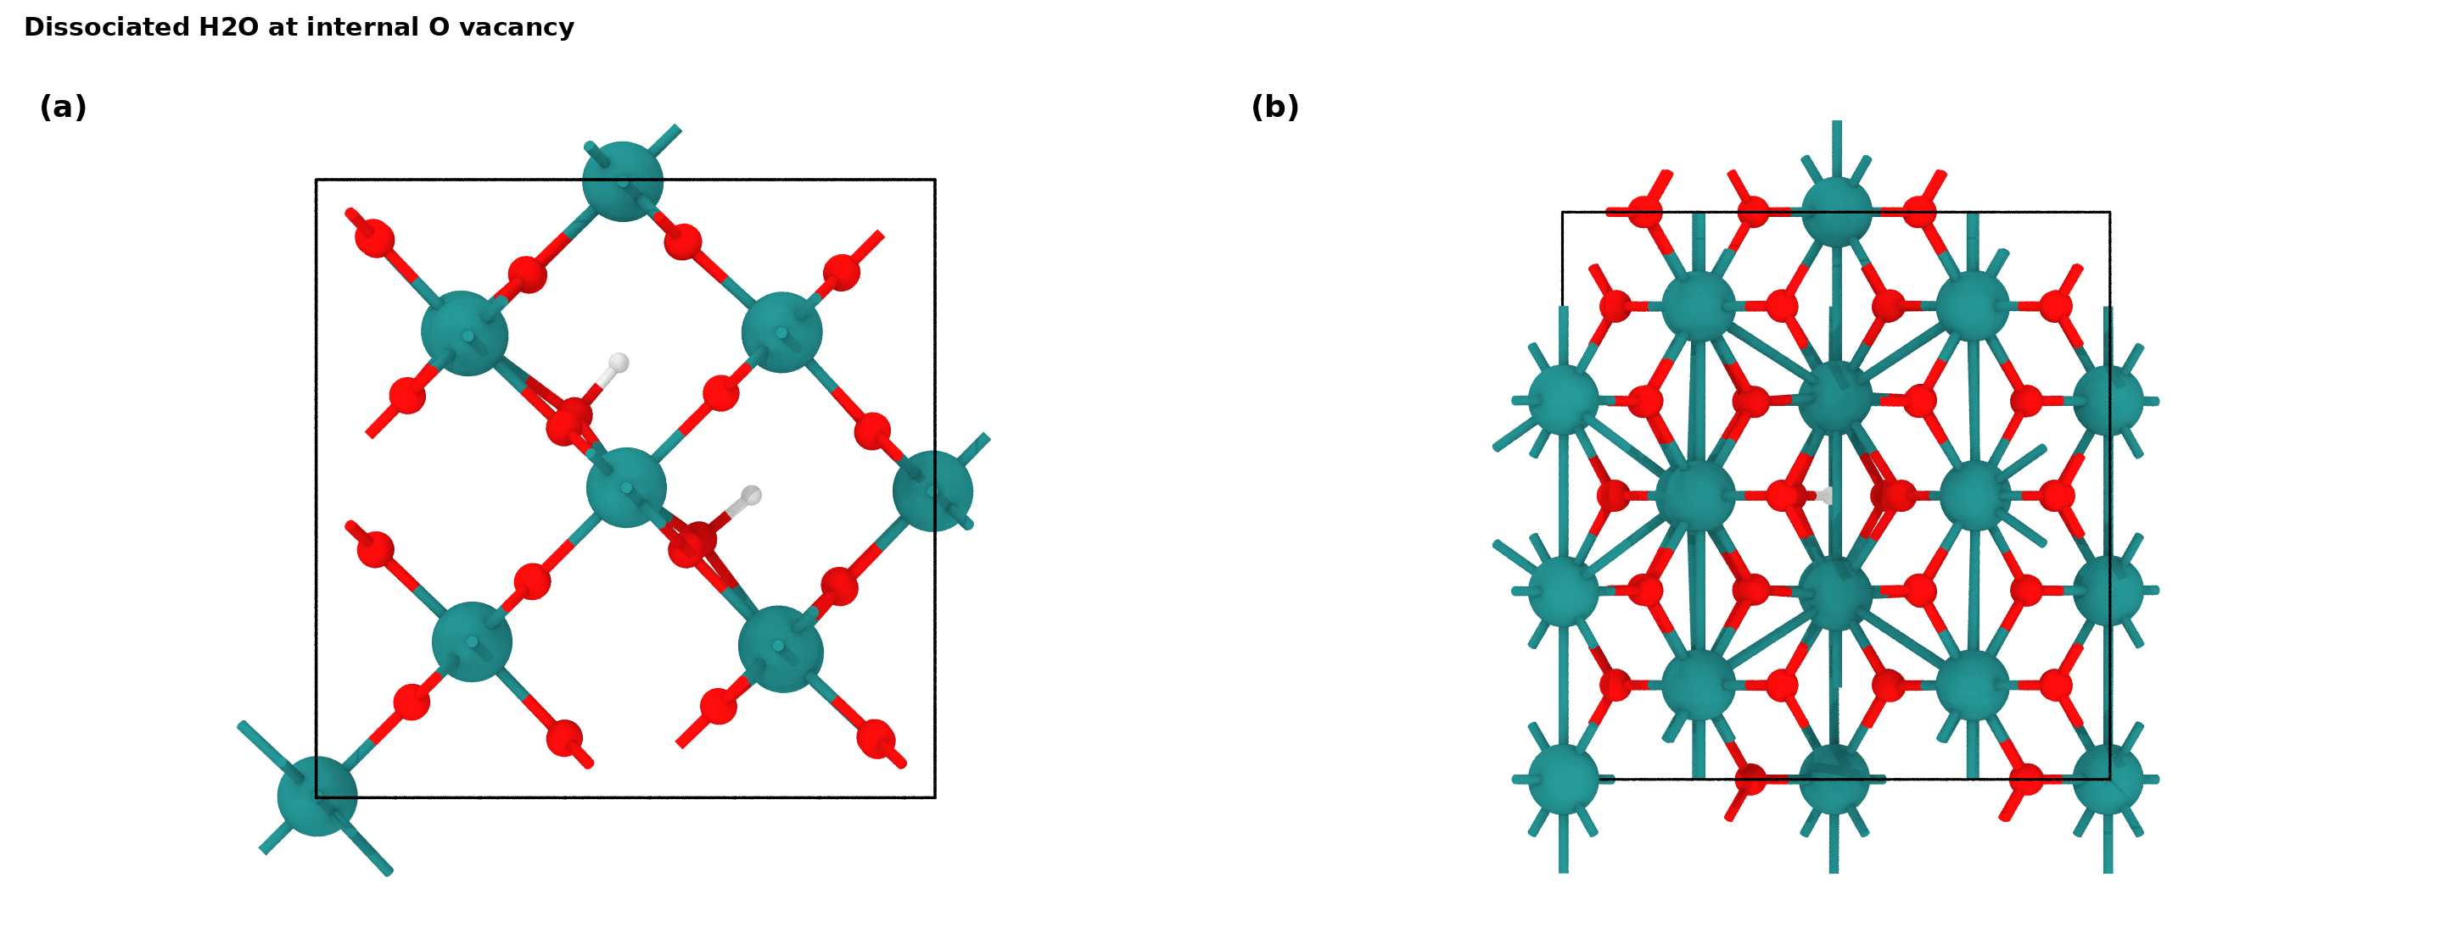
Figure 6. Relaxed dissociated-H2O structure at an internal O-vacancy proxy: (a) orthographic top view; (b) orthographic side view. Structure source: runs/first_wave/bulk_Ovac_H2O_diss_internal/relax/CONTCAR.

Direct Reviewer Responses
Response to the concern that the theoretical calculations were weak: We agree that the original theoretical discussion was insufficient. We have now added a traceable VASP workflow using PBE-D3 PAW calculations on reconstructed RuO2-derived models. The revised computational package includes input validation, convergence parsing, relaxed structures, relative-energy tables, and top/side structure figures.
Response to the concern that proton intercalation is not distinguished from surface OH: The calculations show that internal H uptake in the RuO2 proxy is exothermic, supporting proton-containing hydrous/lattice states as chemically plausible. However, surface OH formation is even more exothermic for the ideal stoichiometric RuO2(110) comparator. We therefore revise the claim to state that DFT supports feasibility of proton incorporation but does not alone exclude surface OH; the assignment relies on the combined experimental evidence.
Response to the concern that coordinated water evidence is indirect: The oxygen-vacancy/CUS models strongly stabilize dissociated H2O/OH motifs, both at a surface vacancy and in an internal vacancy proxy. The relaxed structures retain short O-H distances and Ru-O coordination around the filled/hydroxylated defect, supporting the proposed role of coordinated water/hydroxyl groups in hydrous RuOx.
Response to the concern about the TPD equation and release under Ar: The present DFT calculations do not model high-temperature kinetics or gas-release pathways. The revised response should therefore avoid using DFT as proof of a specific TPD reaction equation. Instead, it should state that the DFT energetics support the stability of hydroxylated/coordinated-water motifs whose decomposition is consistent with, but not uniquely proven by, the TPD observations.

Computational Methods
All calculations were performed with VASP 6.6.0 OpenACC on the Gengzi 8v100 Slurm partition. Projector augmented-wave PBE potentials from the local VASP PBE potential set were used. Exchange-correlation was PBE with D3 dispersion correction using IVDW = 11, consistent with the surviving method references in the supplied files. No Hubbard U correction, implicit solvent, or constant-potential method was added because those settings were not supported by the remaining manuscript evidence.
Relaxations used ENCUT = 520 eV, EDIFF = 1E-5, EDIFFG = -0.03 eV/A, ALGO = Normal, ISMEAR = 0, SIGMA = 0.05 eV, ISIF = 2, ISYM = 0, IBRION = 2, and NSW = 300. Static single-point calculations used the final relaxed geometries, PREC = Accurate, ENCUT = 520 eV, EDIFF = 1E-6, NSW = 0, and the same k-point meshes. Gas molecules used 1x1x1 Gamma meshes in 15 A boxes. Surface slabs used a 3x2x1 Gamma-centered mesh; bulk/internal proxy cells used a 2x2x2 Gamma-centered mesh. Condensed-phase models were spin-polarized; gas H2 and H2O references were spin-unpolarized singlets.
All scheduler scripts, input files, job IDs, parse logs, recovery logs, and result files are preserved under work/. The final report consumes only static electronic energies for relative-energy tables and relaxed CONTCAR geometries for structure figures.

Limitations and Consistency Checks
The calculations are reconstructed proxy-model calculations, not a literal reproduction of a removed DFT section. The starting lattice was reconstructed from manuscript d-spacings, and the hydrous RuOx model is represented by crystalline RuO2-derived defect/H/OH motifs rather than a full amorphous hydrous phase. This limitation must be visible in the revised response.
The key consistency check is that the computations do not overstate the experimental conclusion. Proton uptake is feasible internally, but surface OH is more favorable in the ideal slab comparator. Defect-associated dissociative water uptake is strongly favorable, supporting coordinated water/hydroxyl motifs. Therefore the most defensible conclusion is that DFT strengthens the plausibility and mechanistic consistency of the experimental interpretation, while the experimental data remain essential for the bulk-versus-surface assignment.

Calculation Directory Index
This index maps every table and figure in this report to the calculation directories and analysis files that support it.
Table 7. Provenance index for report tables and figures.
Report item | Source directories or files
Table: H uptake energies | analysis/relative_energies.csv; runs/first_wave/gas_H2/static; runs/first_wave/surface_clean/static; runs/first_wave/surface_H/static; runs/first_wave/bulk_clean/static; runs/first_wave/bulk_H_internal/static
Table: H2O uptake energies | analysis/relative_energies.csv; runs/first_wave/gas_H2O/static; runs/first_wave/surface_Ovac/static; runs/first_wave/surface_Ovac_H2O_diss/static; runs/first_wave/bulk_Ovac_internal/static; runs/first_wave/bulk_Ovac_H2O_diss_internal/static
Table: geometry metrics | analysis/geometry_metrics.csv; relax/CONTCAR files for each model
Figure: proton uptake energy diagram | figures/energy_proton_uptake.png; analysis/relative_energies.csv
Figure: water uptake energy diagram | figures/energy_water_hydroxylation.png; analysis/relative_energies.csv
Structure figures | figures/structures/*_top_side_panel.png; generated from corresponding runs/first_wave/*/relax/CONTCAR files using OVITO
Audit and logs | logs/; .research/events.jsonl; .research/decisions.jsonl; .research/artifacts.jsonl

