Shilei Lin

ID:260887631

COMP553 Assignment 2

10/22/2019

**The Ghost Documentation**

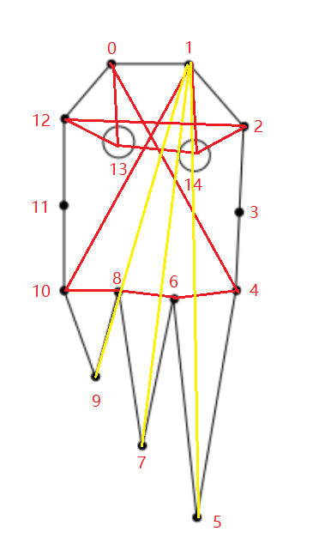

1. **The Ghost consists of 14 verlets.**
   1. Verlet 13,14 are eyes;
   2. Verlet 0,1,2,3,4,6,8,10,11,12 are the bodies part;
   3. Verlet 5,7,9 are the flexible parts which provide floppy appearance.
2. **The black and yellow lines are the constraints.**