Scavenger Hunt App — Walkthrough

Author: Semen Kolesnykov  
Date: 02/02/25

1. Task List View Controller

This is the main screen where the list of all tasks is managed. It loads mocked data, sets up the table, and handles transitions to detail or compose screens.

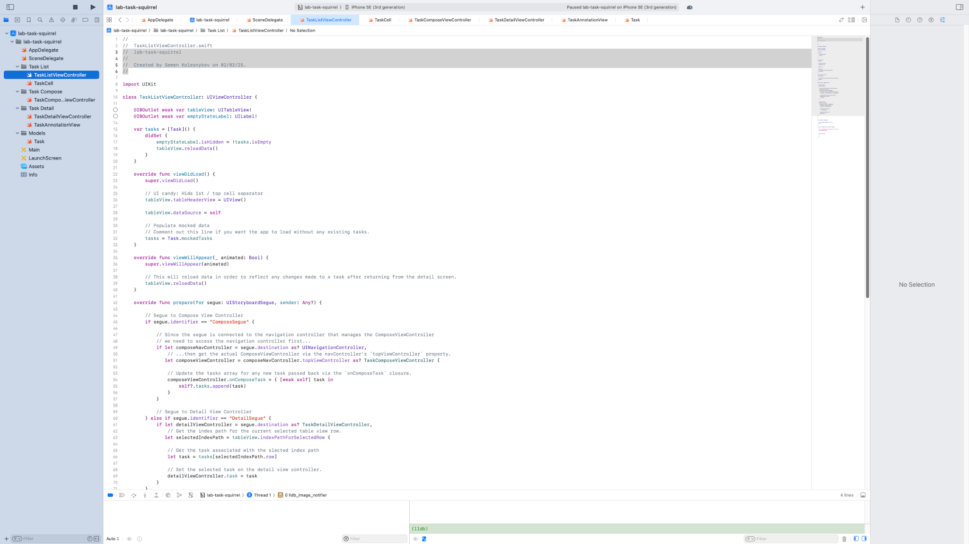

2. Task Cell

This code defines how each task is displayed — including title and status indicator.

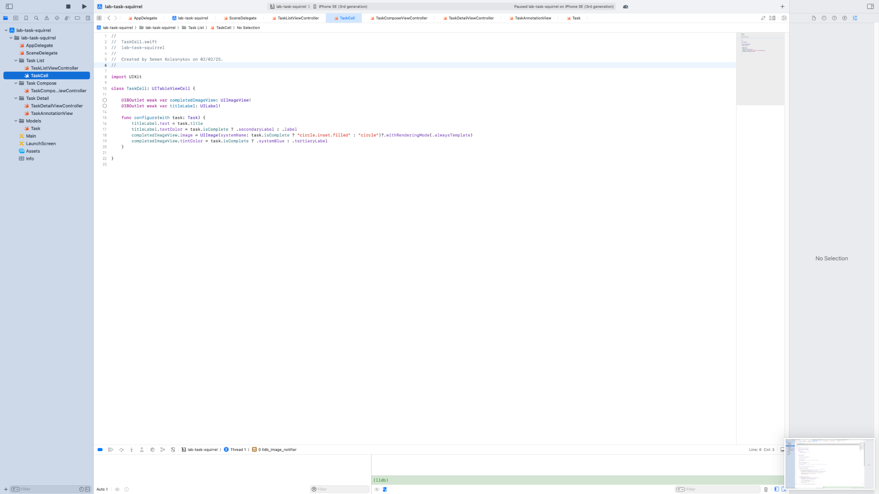

3. Task Detail View (Setup and Update)

Initial map setup, updating the UI with the current task’s status and info, and rendering annotations.

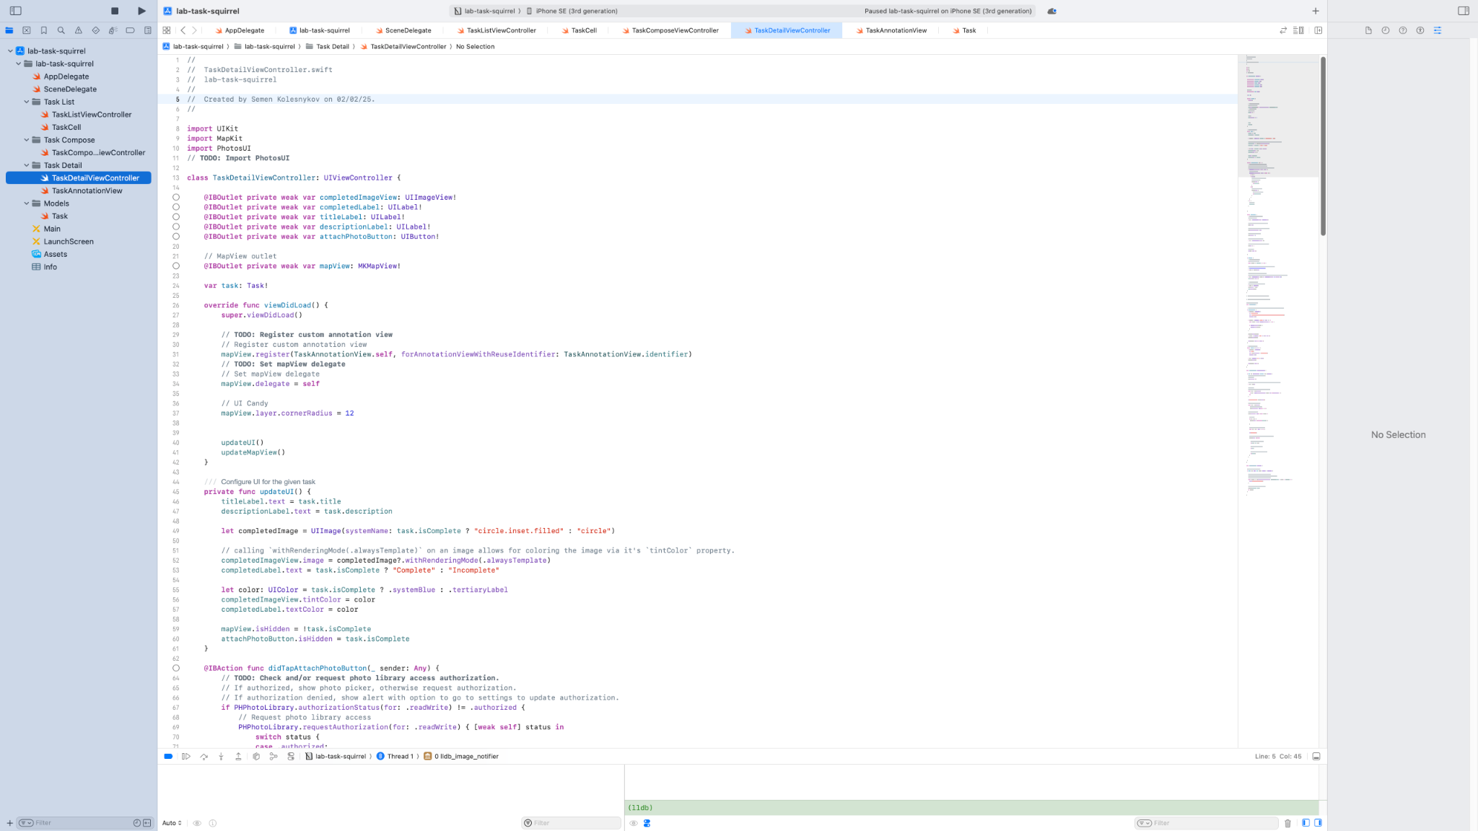

4. Photo Picker and Permissions

Handling permissions and photo selection with PHPickerViewController.

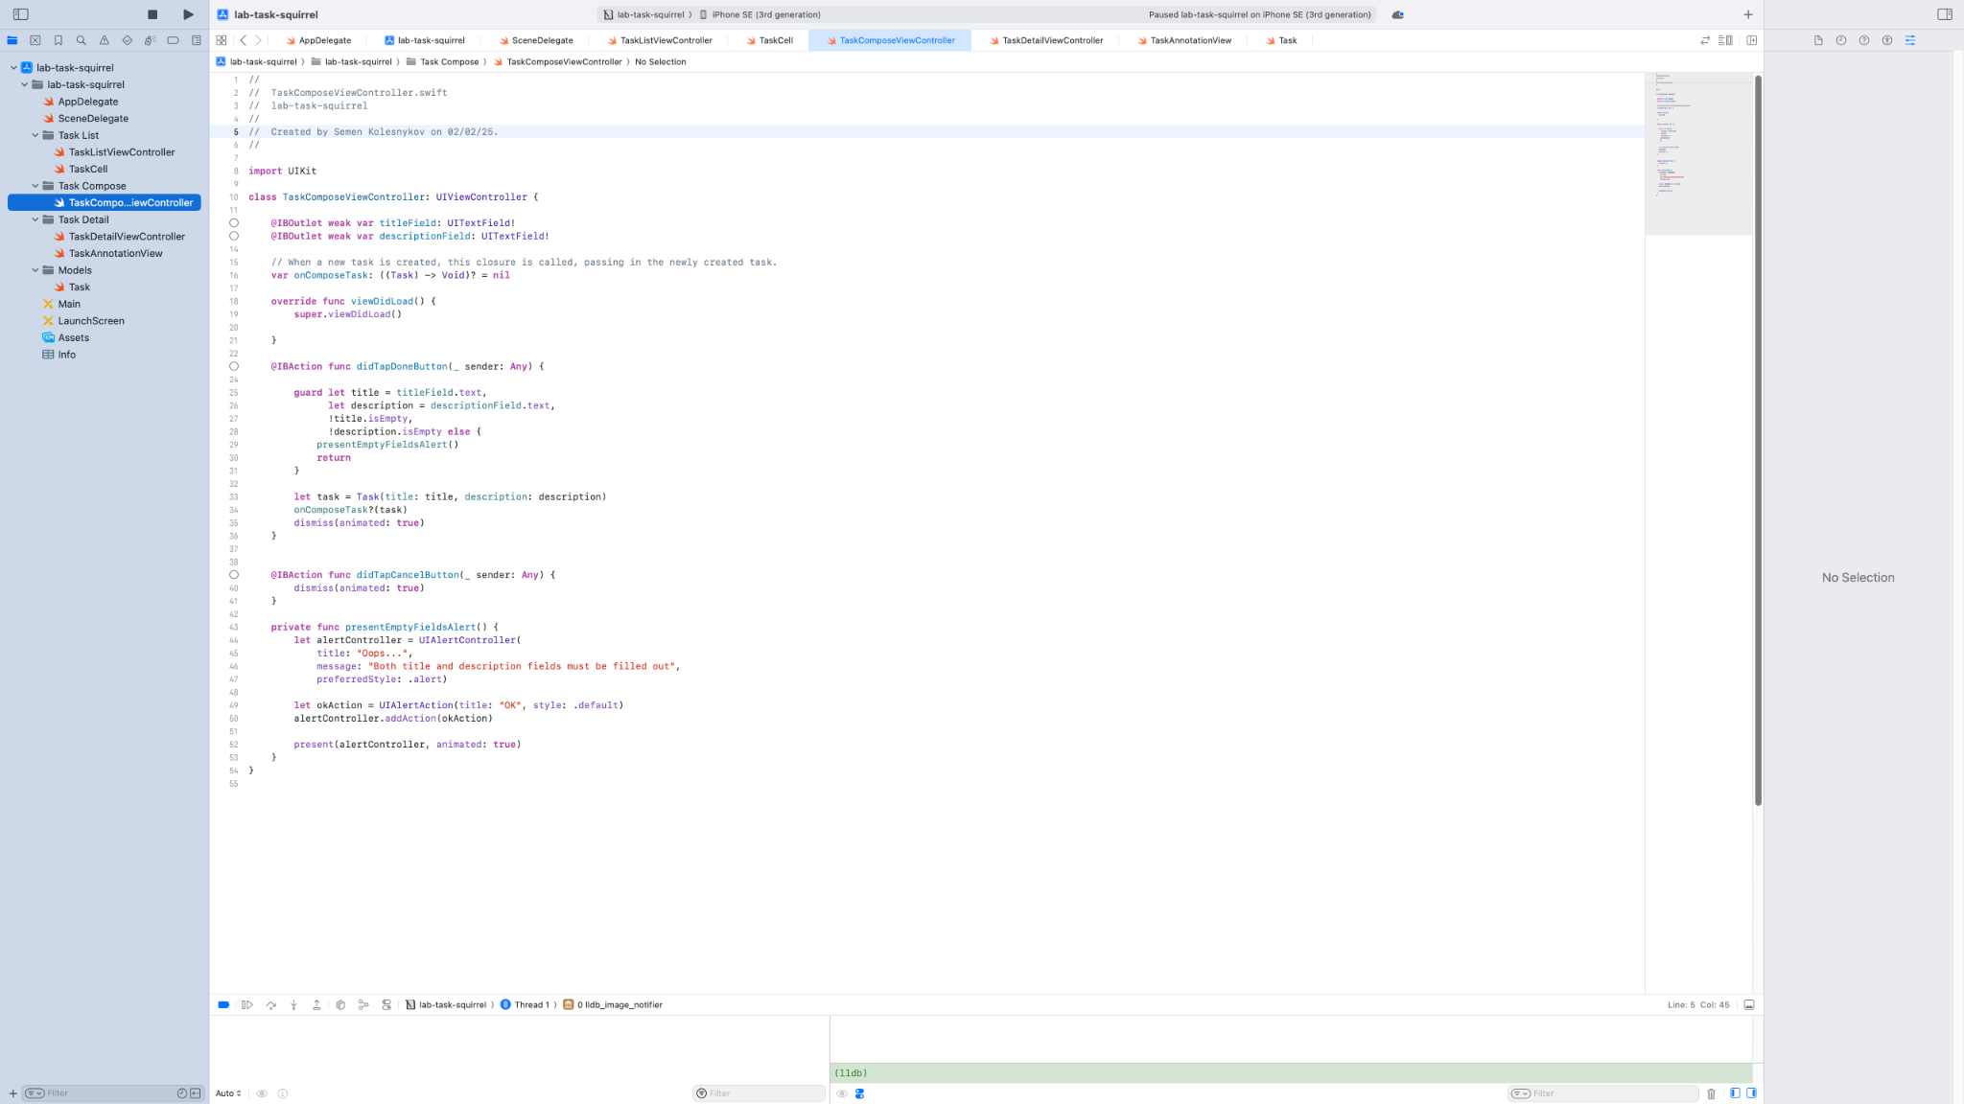

5. Handling Results and Image Processing

After selecting an image, the app fetches metadata including the location and updates the map.

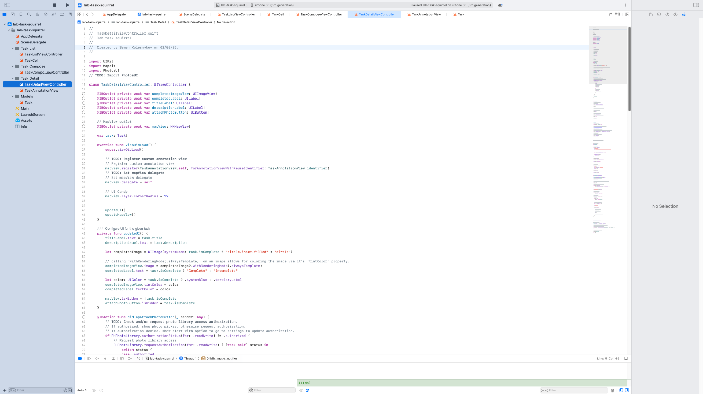

6. Map Annotation Setup

The selected photo’s location is marked on the map using a custom annotation pin.

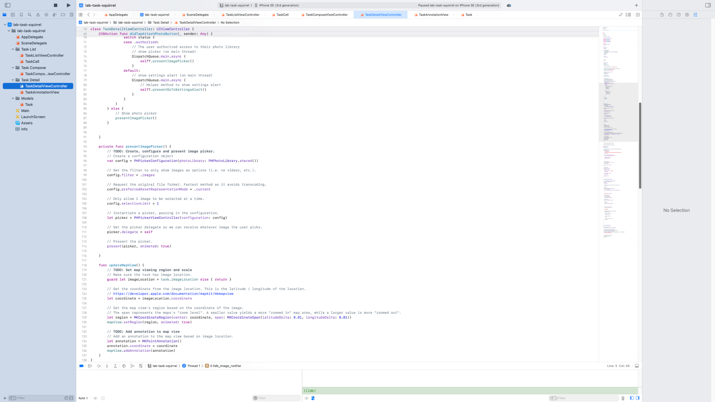

7. Custom Annotation Styling

The appearance of the pin on the map is fully customized to enhance visual clarity.

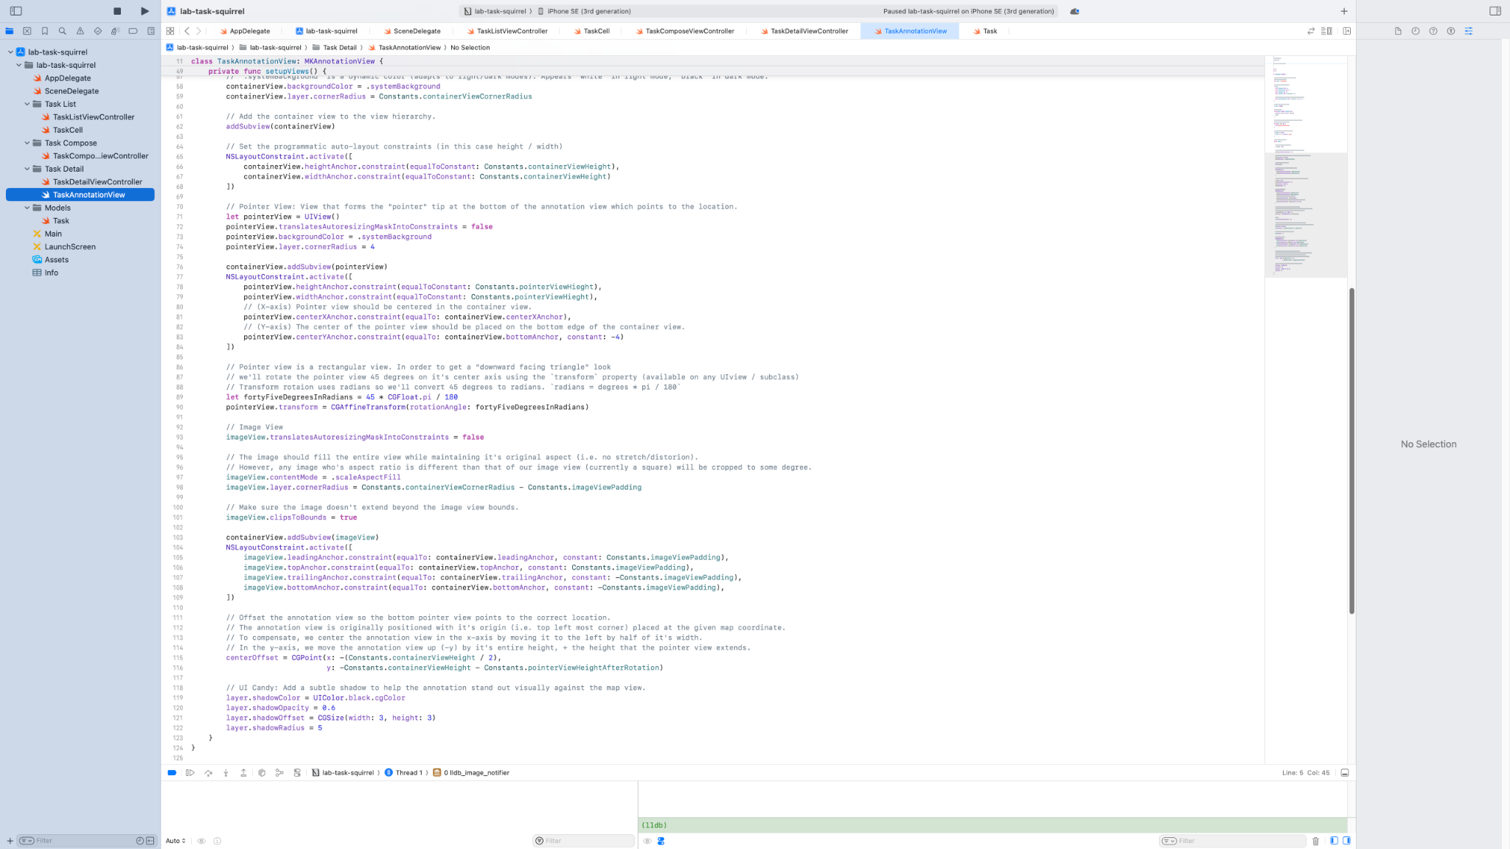

8. Task Model

Defines the structure of a task: title, description, image, and location metadata.

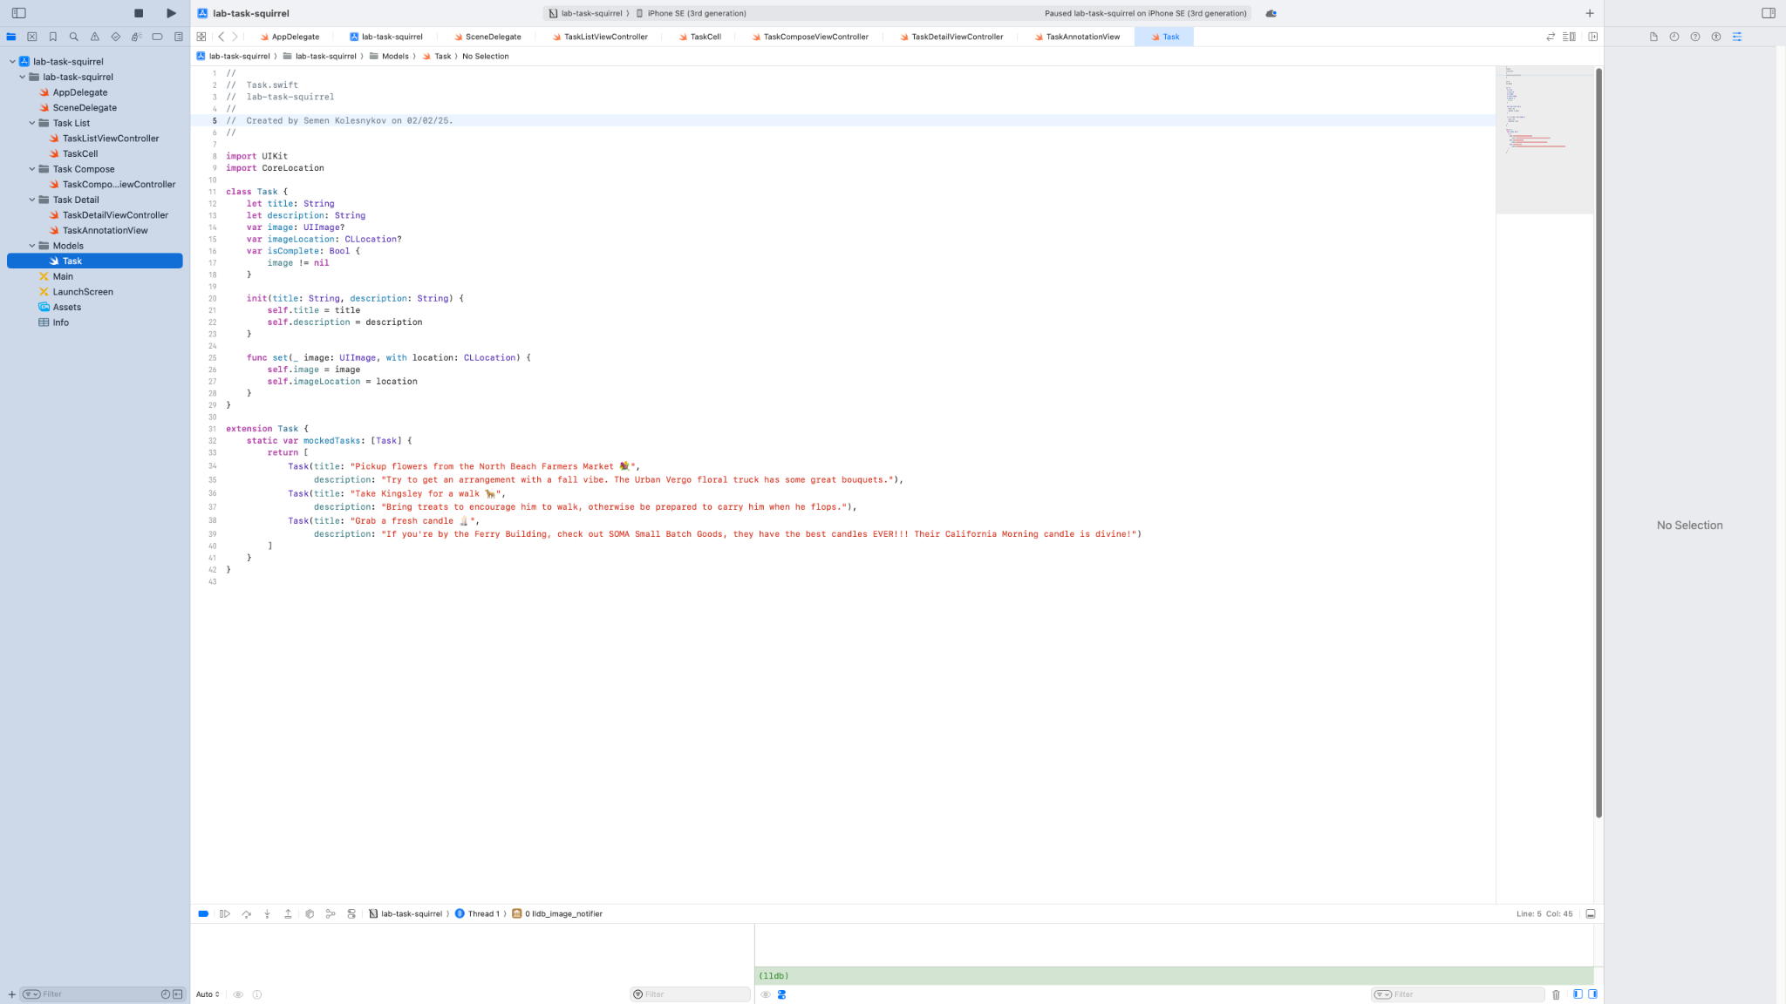

9. AppDelegate.swift

Standard file for app lifecycle. Contains default boilerplate setup for launch behavior.

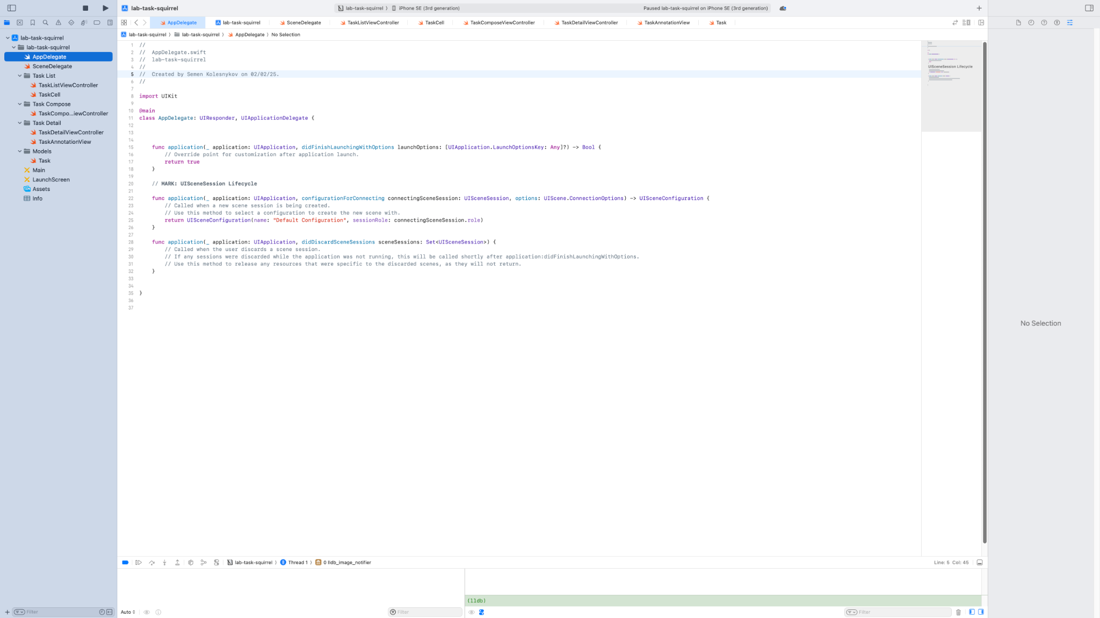

10. SceneDelegate.swift

Manages scene lifecycle events like backgrounding, activation, and foreground transitions.

