BeReal Clone – Project 3 Walkthrough

This walkthrough demonstrates the functionality of the BeReal Clone app developed as part of Project 3. Screenshots are used instead of a screen recording due to simulator issues on the FIU Library iMac. The app runs correctly on a physical device.

Image picker setup to choose photos from the library.

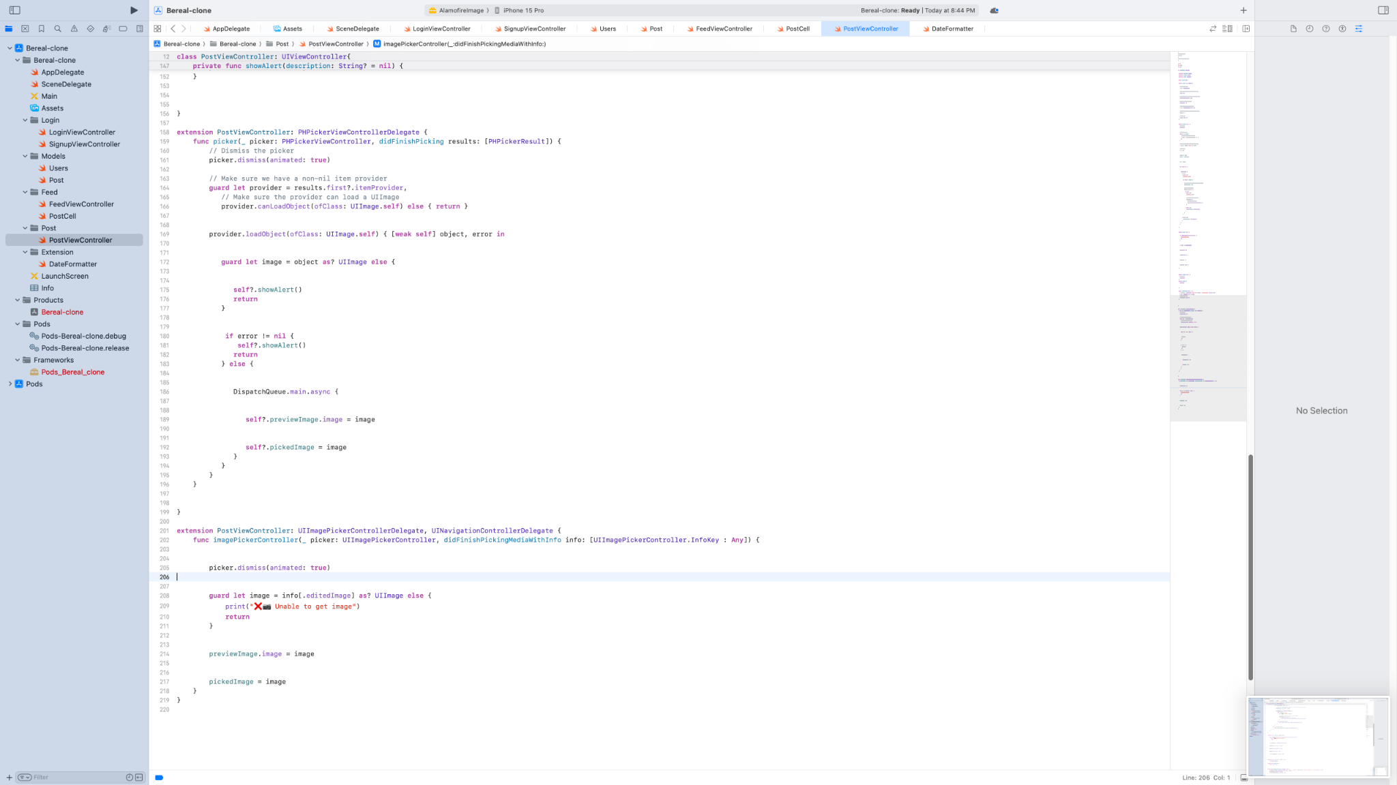

Extension to handle photo selection from PHPicker.

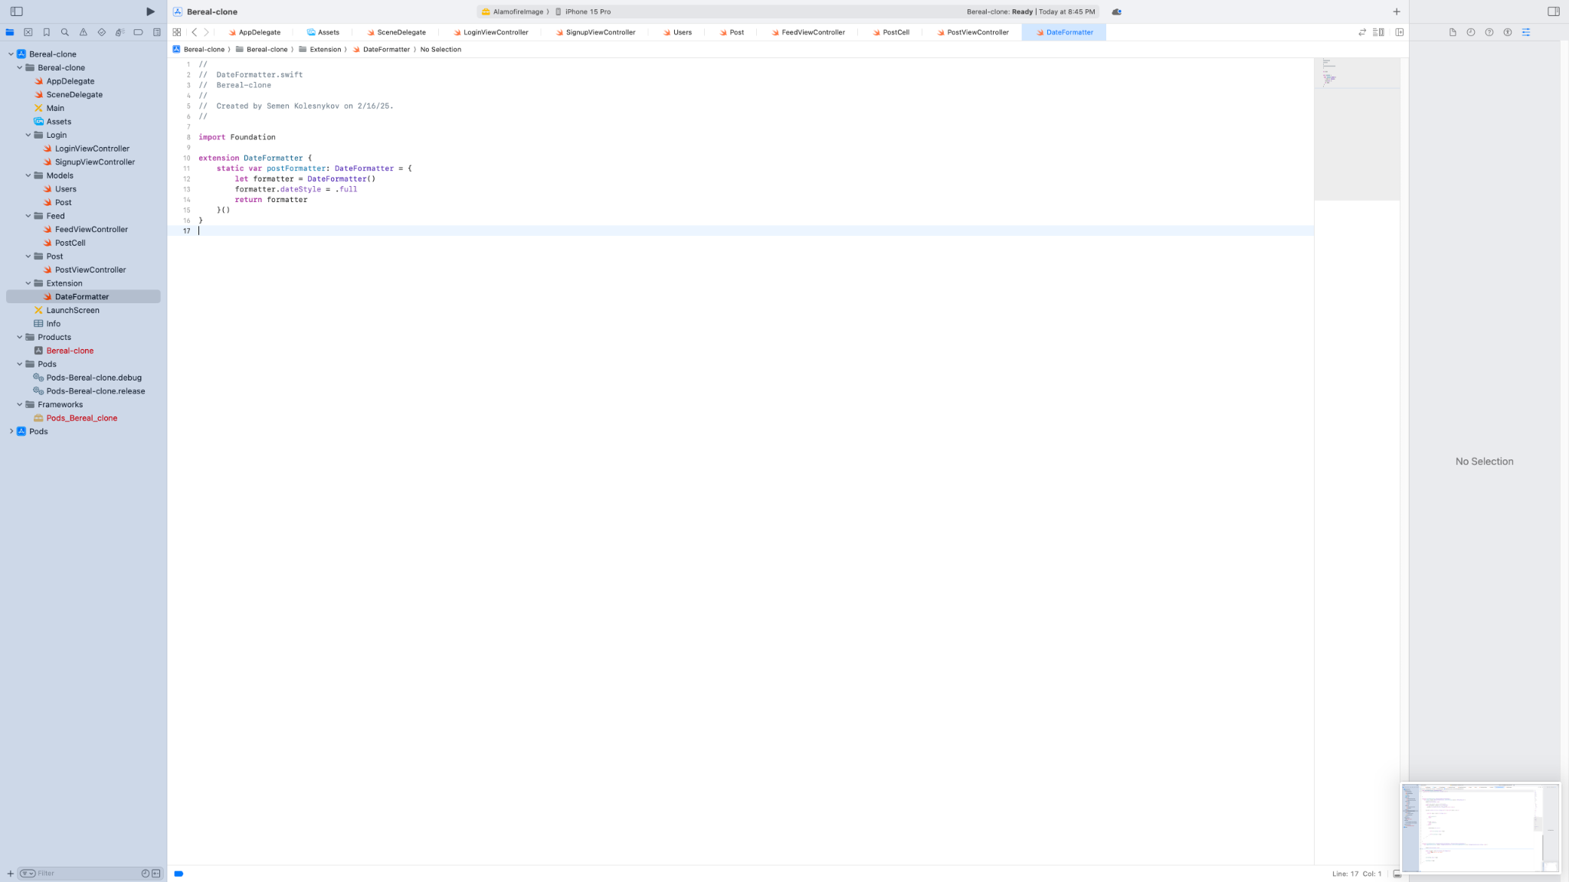

Date formatter for displaying post creation time.

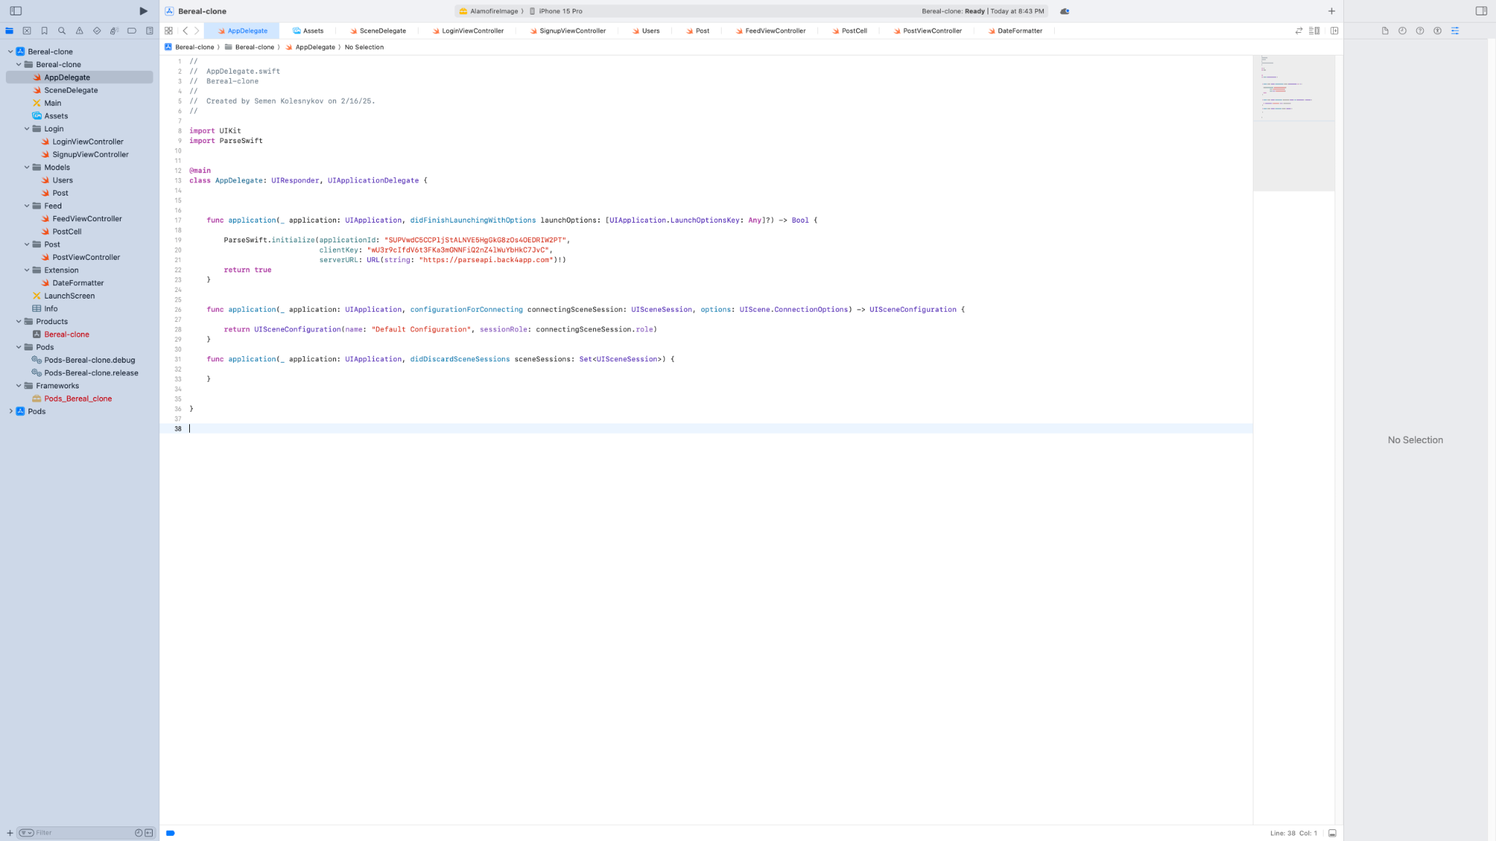

AppDelegate.swift with Parse initialization.

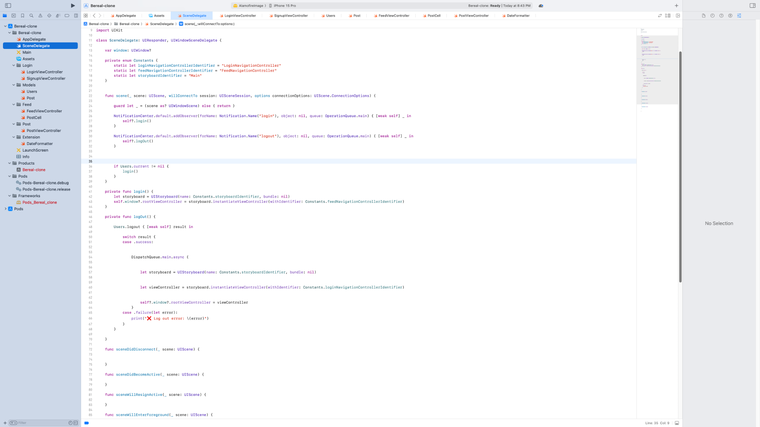

SceneDelegate.swift with login and logout logic.

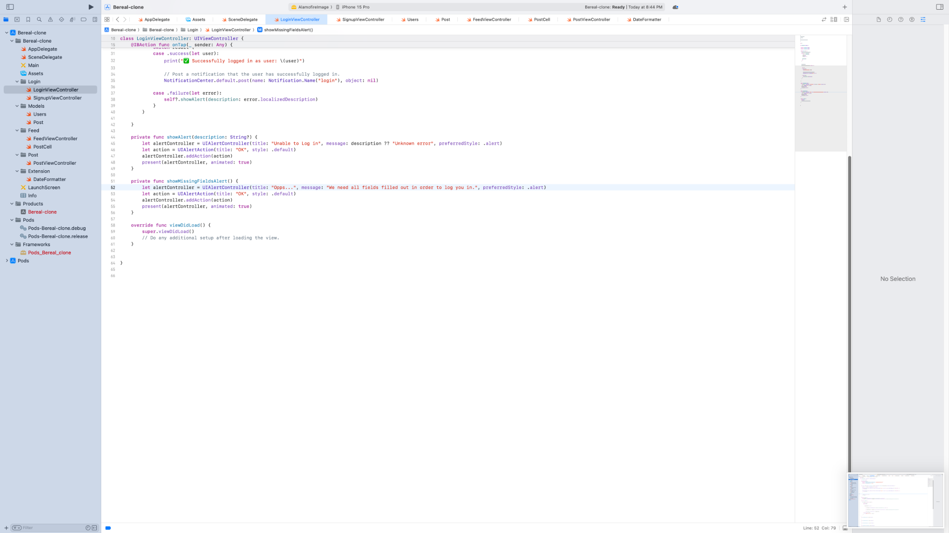

LoginViewController.swift showing login logic and alerts.

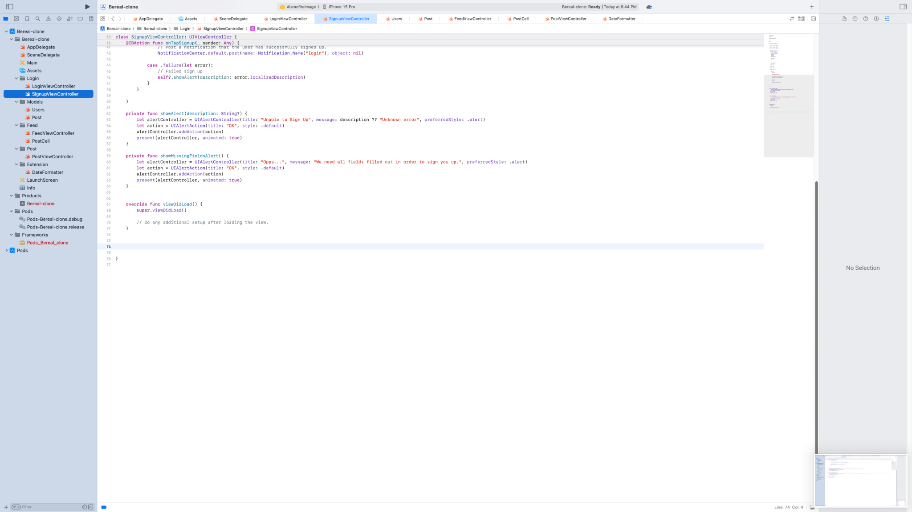

SignupViewController.swift showing sign-up and alert handling.

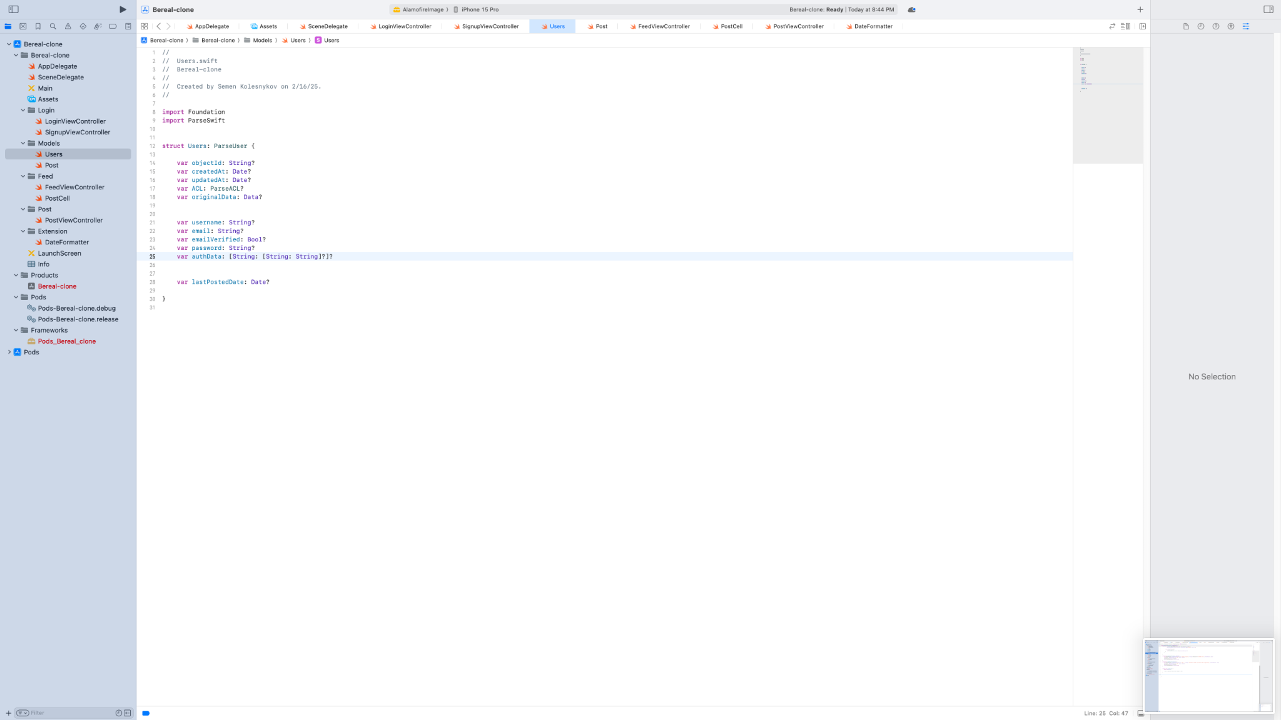

Users.swift model with custom property lastPostedDate.

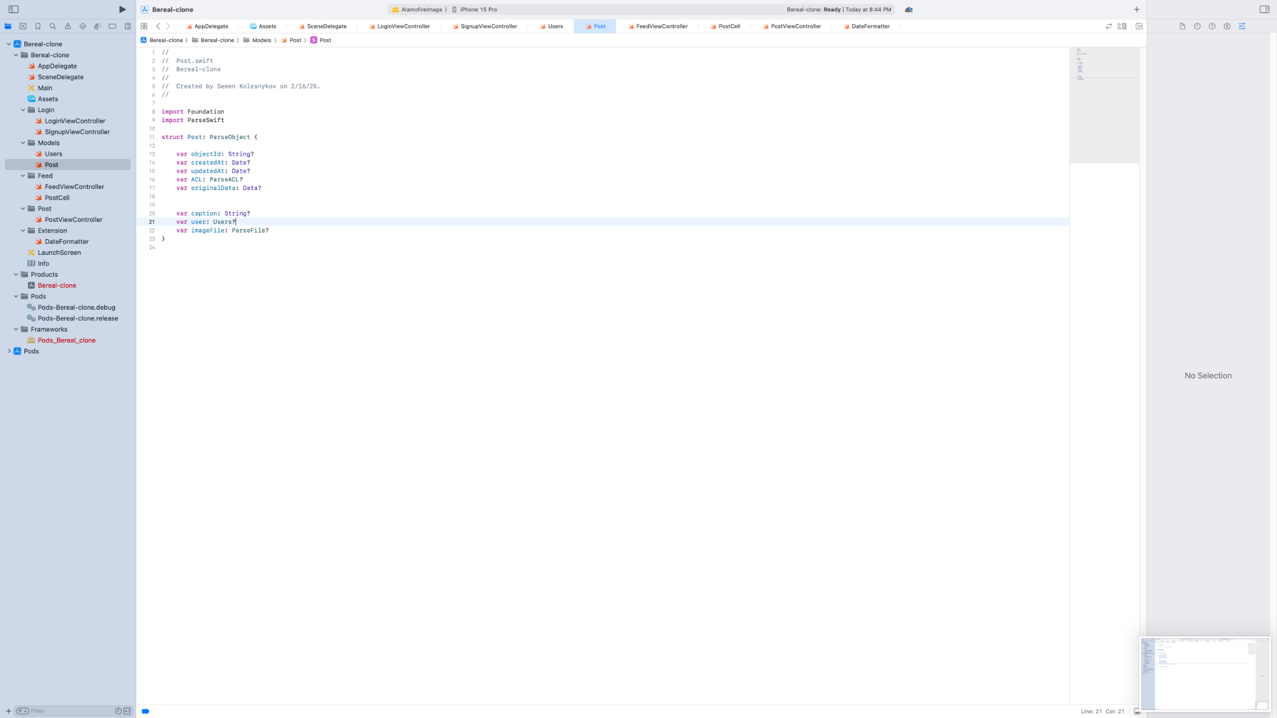

Post.swift model defining a post’s image, user, and caption.

