Memory Game Project Walkthrough

This is the data model for the memory card. Each card has a unique ID, content, and boolean flags to track if it’s face up or matched.

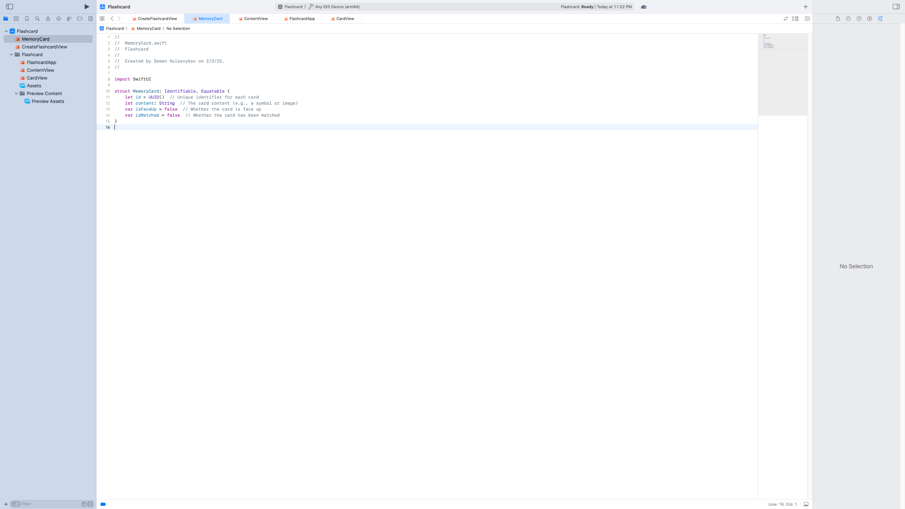

This view allows the user to create a new flashcard by entering a question and answer. When 'Add Card' is tapped, the card is saved and the view is dismissed.

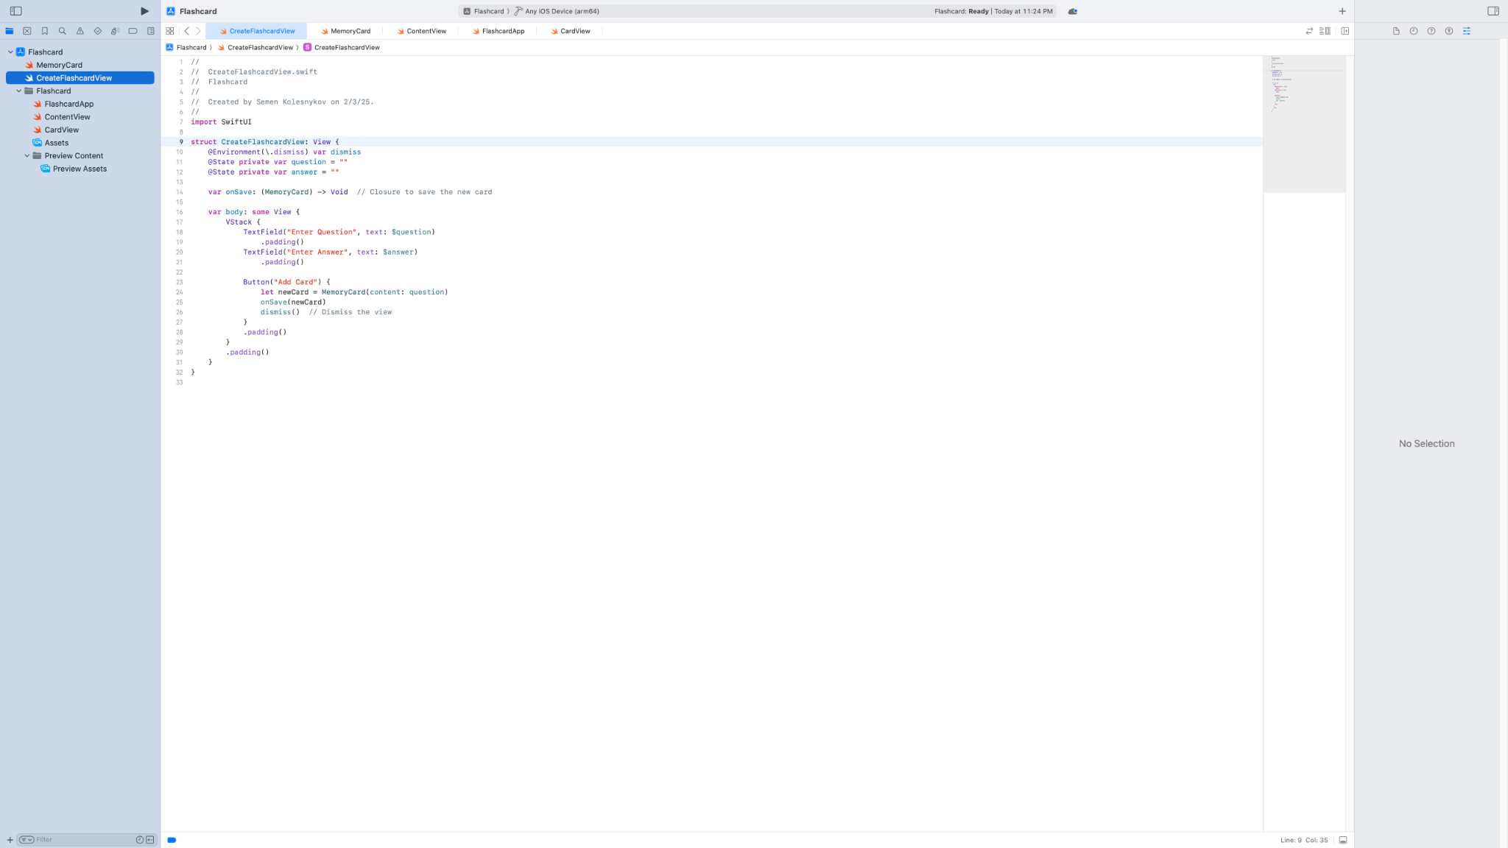

This is the main app struct which defines the app’s entry point. It launches the ContentView when the app starts.

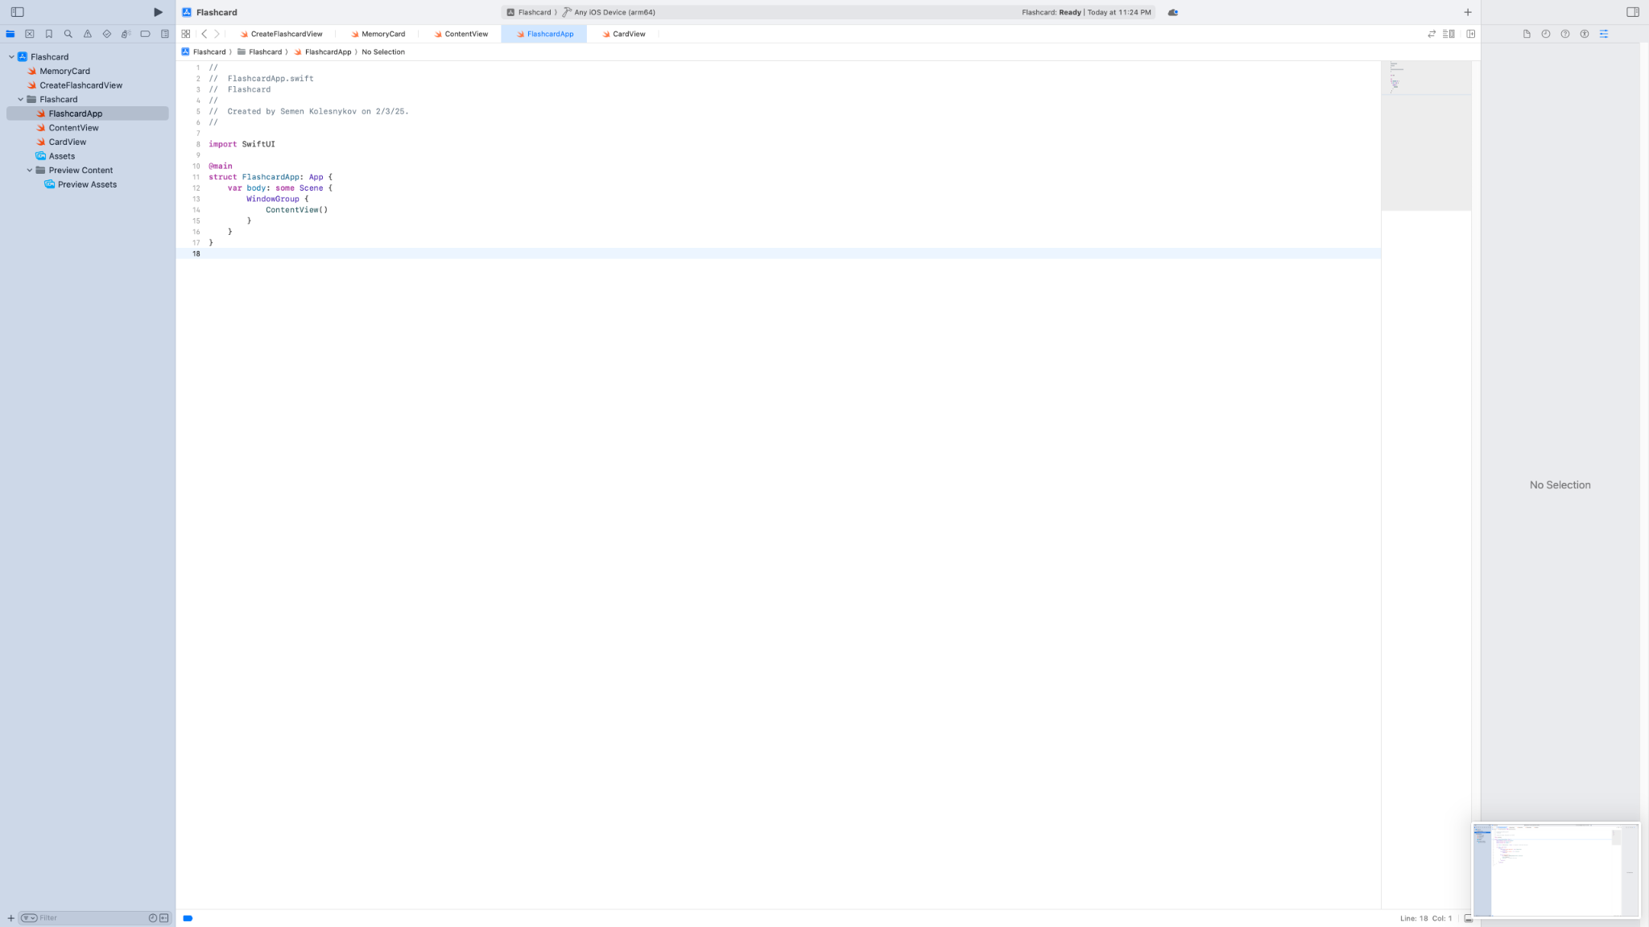

The ContentView is the heart of the app. It manages the game logic, including card flipping, matching, and reset. It also includes buttons to reset the game or choose a deck size.

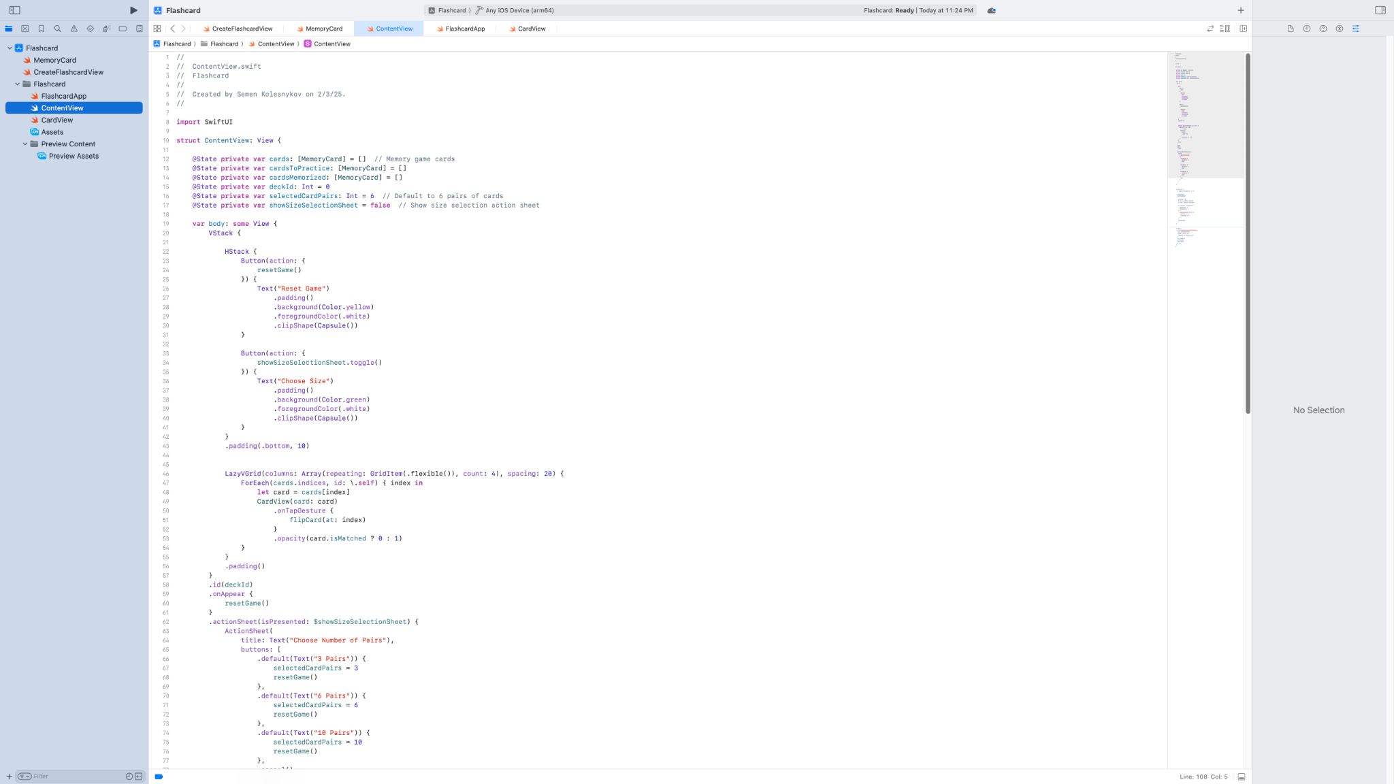

Here you see the matching logic in action. If two selected cards match, they are marked as matched. If not, they are flipped back over after a delay.

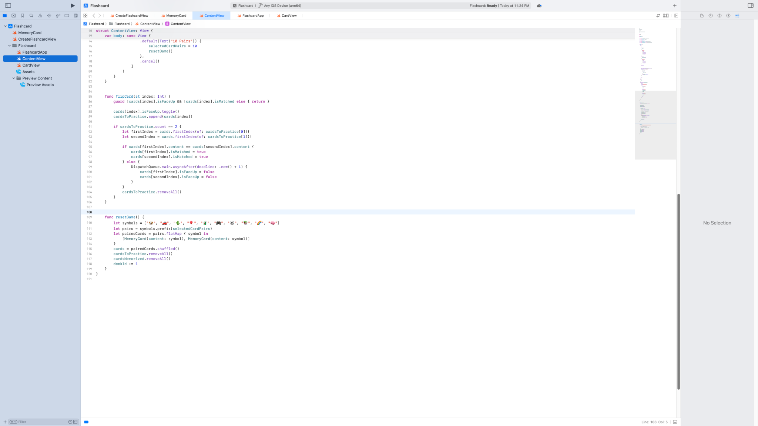

This view represents each individual card. If the card is face up, its content is shown; otherwise, it displays a blue rectangle.

