“operationalLayers":[{"id":"PN_2022_3_2324

"title":"-","itemId":"c45a5daecd044f9c98e0583d8369212f","popupInfo":{"title":"{type}","fieldInfos":[{"fieldName":"Oblast","isEditable":true,"visible":true,"label":"Область"},{"fieldName":"ADMIN_3","isEditable":true,"visible":true,"label":"Тергромада"},{"fieldName":"type_np","isEditable":true,"visible":true,"label":"Тип НП"},{"fieldName":"Settlement","isEditable":true,"visible":true,"label":"Населений пункт"},{"fieldName":"Address","isEditable":true,"visible":true,"label":"Адреса"},{"fieldName":"Name","isEditable":true,"visible":true,"label":"Назва"},{"fieldName":"type","isEditable":true,"visible":true,"label":"Тип"},{"fieldName":"generator","isEditable":true,"visible":true,"label":"Генератор"},{"fieldName":"zaryad","isEditable":true,"visible":true,"label":"Підзарядка гаджетів"},{"fieldName":"grafic","isEditable":true,"visible":true,"label":"Графік роботи"},{"fieldName":"FID","label":"FID","isEditable":false,"visible":false},{"fieldName":"number","label":"number","isEditable":true,"visible":false,"format":{"places":0,"digitSeparator":true}},{"fieldName":"IDF","label":"IDF","isEditable":true,"visible":false,"stringFieldOption":"textbox"},{"fieldName":"new_id","label":"new_id","isEditable":true,"visible":false,"stringFieldOption":"textbox"},{"fieldName":"ADMIN_2","label":"ADMIN_2","isEditable":true,"visible":false,"stringFieldOption":"textbox"},{"fieldName":"type_tg","label":"type_tg","isEditable":true,"visible":false,"stringFieldOption":"textbox"},{"fieldName":"COD_TG","label":"COD_TG","isEditable":true,"visible":false,"stringFieldOption":"textbox"},{"fieldName":"COD_NP","label":"COD_NP","isEditable":true,"visible":false,"stringFieldOption":"textbox"},{"fieldName":"sector","label":"sector","isEditable":true,"visible":false,"stringFieldOption":"textbox"},{"fieldName":"Bulerjan","label":"Bulerjan","isEditable":true,"visible":false,"stringFieldOption":"textbox"},{"fieldName":"kotel","label":"kotel","isEditable":true,"visible":false,"stringFieldOption":"textbox"},{"fieldName":"star","label":"star","isEditable":true,"visible":false,"stringFieldOption":"textbox"},{"fieldName":"opt","label":"opt","isEditable":true,"visible":false,"stringFieldOption":"textbox"},{"fieldName":"vid","label":"vid","isEditable":true,"visible":false,"stringFieldOption":"textbox"},{"fieldName":"pidzariadk","label":"pidzariadk","isEditable":true,"visible":false,"stringFieldOption":"textbox"},{"fieldName":"y","label":"y","isEditable":true,"visible":false,"format":{"places":2,"digitSeparator":true}},{"fieldName":"x","label":"x","isEditable":true,"visible":false,"format":{"places":2,"digitSeparator":true}},{"fieldName":"primitka","label":"primitka","isEditable":true,"visible":false,"stringFieldOption":"textbox"}],"description":null,"showAttachments":false,"mediaInfos":[]}},

“operationalLayers”:[{"id":"PN_2022_2_4573

"title":"Пункти Незламності відповідального бізнесу","itemId":"08f7940613904f5a8284c8dc55a5db26","layerDefinition":{"drawingInfo":{"renderer":{"authoringInfo":{"colorRamp":

[{"fieldName":"Oblast","isEditable":true,"visible":true,"label":"Область"},{"fieldName":"ADMIN_3","isEditable":true,"visible":true,"label":"Тергромада"},{"fieldName":"type_np","isEditable":true,"visible":true,"label":"Тип НП"},{"fieldName":"Settlement","isEditable":true,"visible":true,"label":"Населений пункт"},{"fieldName":"Address","isEditable":true,"visible":true,"label":"Адреса"},{"fieldName":"Name","isEditable":true,"visible":true,"label":"Назва"},{"fieldName":"type","isEditable":true,"visible":true,"label":"Тип"},{"fieldName":"generator","isEditable":true,"visible":true,"label":"Генератор"},{"fieldName":"zaryad","isEditable":true,"visible":true,"label":"Підзарядка гаджетів"},{"fieldName":"grafic","isEditable":true,"visible":true,"label":"Графік роботи”},{"fieldName":"FID","label":"FID","isEditable":false,"visible":false},{"fieldName":"number","label":"number","isEditable":true,"visible":false,"format":{"places":0,"digitSeparator":true}},{"fieldName":"IDF","label":"IDF","isEditable":true,"visible":false,"stringFieldOption":"textbox"},{"fieldName":"new_id","label":"new_id","isEditable":true,"visible":false,"stringFieldOption":"textbox"},{"fieldName":"ADMIN_2","label":"ADMIN_2","isEditable":true,"visible":false,"stringFieldOption":"textbox"},{"fieldName":"type_tg","label":"type_tg","isEditable":true,"visible":false,"stringFieldOption":"textbox"},{"fieldName":"COD_TG","label":"COD_TG","isEditable":true,"visible":false,"stringFieldOption":"textbox"},{"fieldName":"COD_NP","label":"COD_NP","isEditable":true,"visible":false,"stringFieldOption":"textbox"},{"fieldName":"sector","label":"sector","isEditable":true,"visible":false,"stringFieldOption":"textbox"},{"fieldName":"Bulerjan","label":"Bulerjan","isEditable":true,"visible":false,"stringFieldOption":"textbox"},{"fieldName":"kotel","label":"kotel","isEditable":true,"visible":false,"stringFieldOption":"textbox"},{"fieldName":"star","label":"star","isEditable":true,"visible":false,"stringFieldOption":"textbox"},{"fieldName":"opt","label":"opt","isEditable":true,"visible":false,"stringFieldOption":"textbox"},{"fieldName":"vid","label":"vid","isEditable":true,"visible":false,"stringFieldOption":"textbox"},{"fieldName":"pidzariadk","label":"pidzariadk","isEditable":true,"visible":false,"stringFieldOption":"textbox"},{"fieldName":"y","label":"y","isEditable":true,"visible":false,"format":{"places":2,"digitSeparator":true}},{"fieldName":"x","label":"x","isEditable":true,"visible":false,"format":

“operationalLayers”:[{"id":"PN_2022_1_6039

"title":"Пункти Незламності","itemId":"c69c4bf63b6143d09b5ff619a28144ea","layerDefinition":{"drawingInfo":{"renderer":{"authoringInfo":{"colorRamp":

{"fieldName":"ADMIN_3","isEditable":true,"visible":true,"label":"Тергромада"},{"fieldName":"type_np","isEditable":true,"visible":true,"label":"Тип НП"},{"fieldName":"Settlement","isEditable":true,"visible":true,"label":"Населений пункт"},{"fieldName":"Address","isEditable":true,"visible":true,"label":"Адреса"},{"fieldName":"Name","isEditable":true,"visible":true,"label":"Назва"},{"fieldName":"type","isEditable":true,"visible":true,"label":"Тип"},{"fieldName":"generator","isEditable":true,"visible":true,"label":"Генератор"},{"fieldName":"Bulerjan","isEditable":true,"visible":true,"label":"Булер'ян"},{"fieldName":"kotel","isEditable":true,"visible":true,"label":"Твердопаливний котел"},{"fieldName":"star","isEditable":true,"visible":true,"label":"Старлінк"},{"fieldName":"opt","isEditable":true,"visible":true,"label":"Оптоволоконне підключення до мережі інтернет"},{"fieldName":"zaryad","isEditable":true,"visible":true,"label":"Підзарядка гаджетів"},{"fieldName":"vid","isEditable":true,"visible":true,"label":"Інформація про початок роботи пункту"},{"fieldName":"grafic","isEditable":true,"visible":true,"label":"Графік роботи”},{"fieldName":"FID","label":"FID","isEditable":false,"visible":false},{"fieldName":"number","label":"number","isEditable":true,"visible":false,"format":{"places":0,"digitSeparator":true}},{"fieldName":"IDF","label":"IDF","isEditable":true,"visible":false,"stringFieldOption":"textbox"},{"fieldName":"new_id","label":"new_id","isEditable":true,"visible":false,"stringFieldOption":"textbox"},{"fieldName":"ADMIN_2","label":"ADMIN_2","isEditable":true,"visible":false,"stringFieldOption":"textbox"},{"fieldName":"type_tg","label":"type_tg","isEditable":true,"visible":false,"stringFieldOption":"textbox"},{"fieldName":"COD_TG","label":"COD_TG","isEditable":true,"v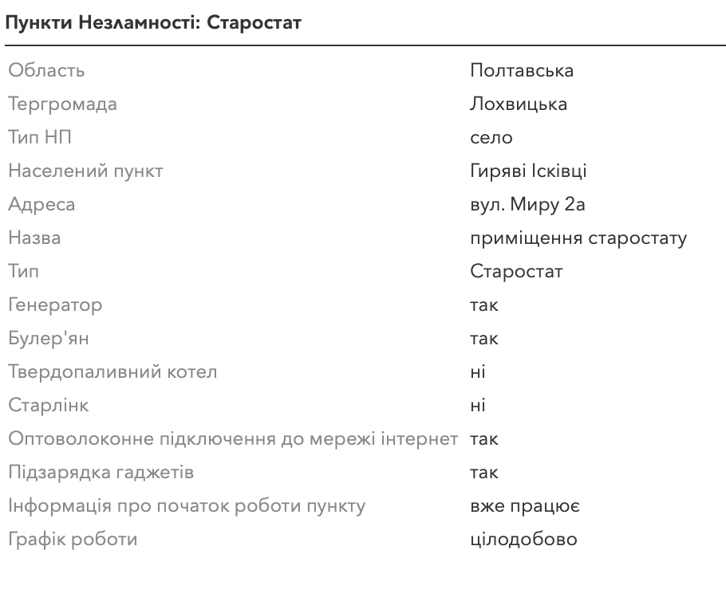isible":false,"stringFieldOption":"textbox"},{"fieldName":"COD_NP","label":"COD_NP","isEditable":true,"visible":false,"stringFieldOption":"textbox"},{"fieldName":"sector","label":"sector","isEditable":true,"visible":false,"stringFieldOption":"textbox"},{"fieldName":"pidzariadk","label":"pidzariadk","isEditable":true,"visible":false,"stringFieldOption":"textbox"},{"fieldName":"y","label":"y","isEditable":true,"visible":false,"format":{"places":2,"digitSeparator":true}},{"fieldName":"x","label":"x","isEditable":true,"visible":false,"format":{"places":2,"digitSeparator":true}}],"description":null,"showAttachments":false,"mediaInfos":[]}}],"baseMap":{"baseMapLayers":