ADVANCED JAVA
(3160707)

LABORATORY MANUAL

B.E. Semester-VI

Computer Engineering

PREPARED BY:
CE DEPARTMENT- 2024-2025
VADODARA INSTITUTE OF ENGINEERING, KOTAMBI-391510

PRACTICAL - 1
TCP One way communication

Aim: Create an application using TCP to implement one way communication.

Theory:
- Java Socket programming is used for communication between the applications running on different JRE.
- Java Socket programming can be connection-oriented or connection-less.
- Socket and ServerSocket classes are used for connection-oriented socket programming and DatagramSocket and DatagramPacket classes are used for connection-less socket programming.
Syntax:
ServerSocket ss=new ServerSocket(6666);
Socket s=ss.accept();//establishes connection
DataInputStream dis=new DataInputStream(s.getInputStream());
void recursion(){
recursion();/* function calls itself */}
int main()
{
recursion();
}

Flowchart/Figure/Algorithm:

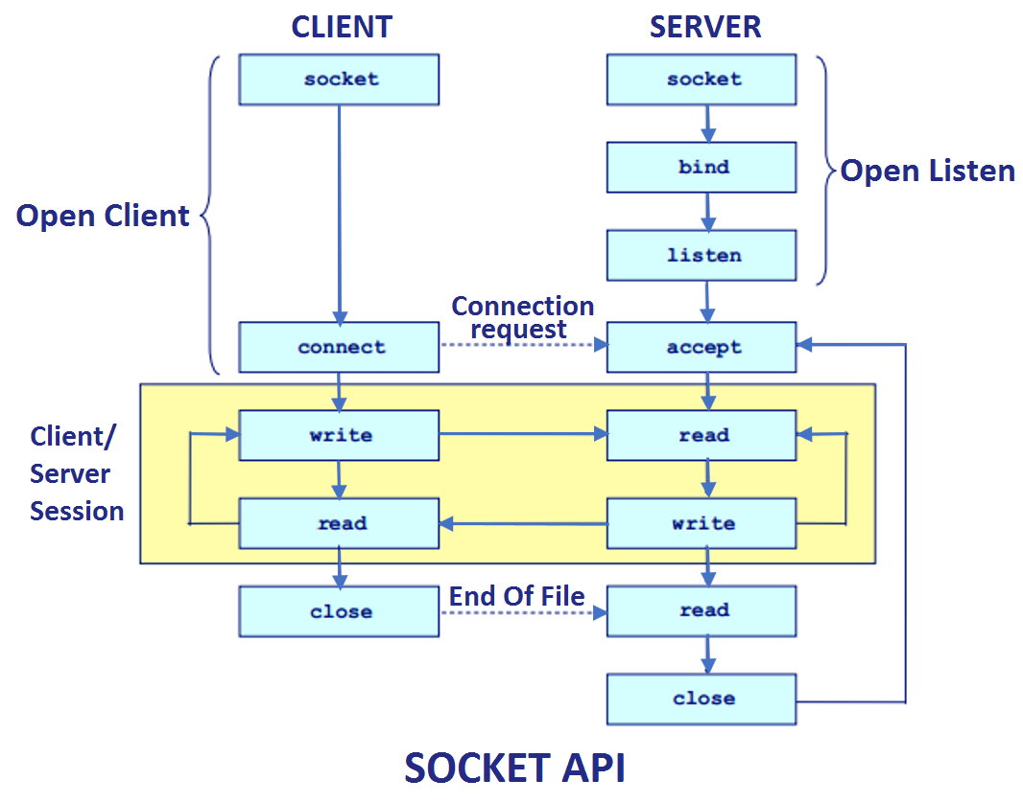
Fig.1: Flowchart of Socket Programming

Program/Implementation:

SenderServer.java

package mynetworkapp;

import java.io.*;

import java.net.*;
import java.util.Scanner;

public class SenderServer {

public static void main(String[] args) {
// TODO code application logic here
try{
ServerSocket ss=new ServerSocket(4020);
System.out.println("wating for client to connect");
Socket s=ss.accept();

System.out.println("connection established");

PrintStream ps=new PrintStream(s.getOutputStream());
BufferedReader kb=new BufferedReader(new InputStreamReader(System.in));

System.out.println("Enter data :");
String str=kb.readLine();

while(!str.equals("exit"))
{ ps.println(str);
System.out.println("Enter data :");
str=kb.readLine();
}
ps.close();
s.close();
ss.close();

}catch(IOException e)
{
System.out.println(e);
}
}
}

ReceiverClient.java

package mynetworkapp;

import java.net.InetAddress;
import java.net.Socket;
import java.util.*;
import java.io.*;

public class ReceiverClient {

public static void main(String[] args) {
// TODO code application logic here
try{

// InetAddress ip=InetAddress.getLocalHost();

Socket s=new Socket("localhost",4020);

BufferedReader br=new BufferedReader(new InputStreamReader(s.getInputStream()));

String str;

str=br.readLine();

while(str!=null)
{
System.out.println(str);
str=br.readLine();
}
br.close();
s.close();
}catch(Exception e)
{
System.out.println(e);
}

}
}

Output:
Server Side

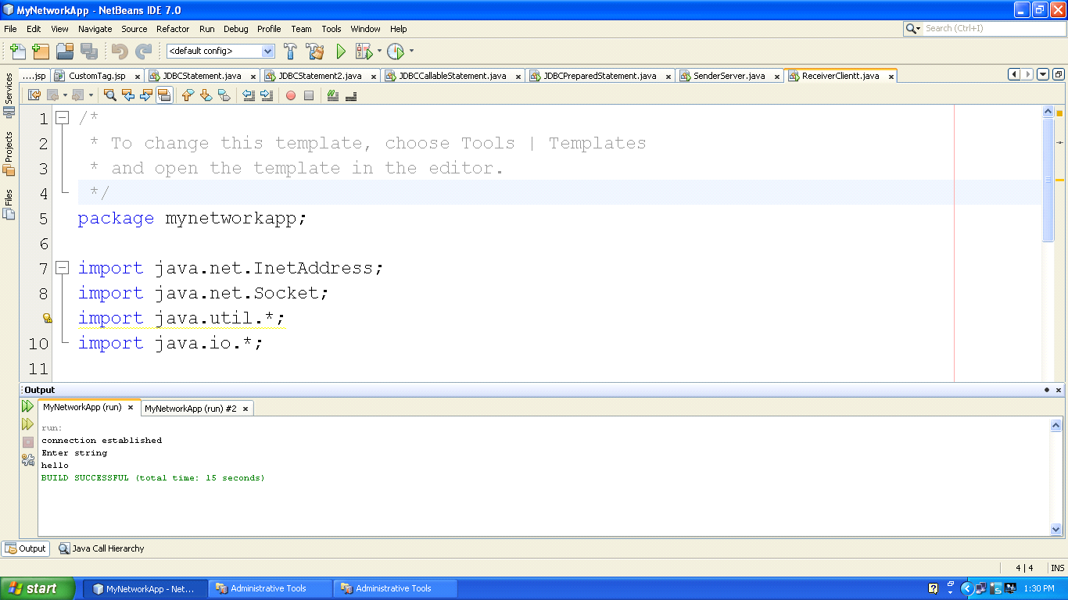
Client Side
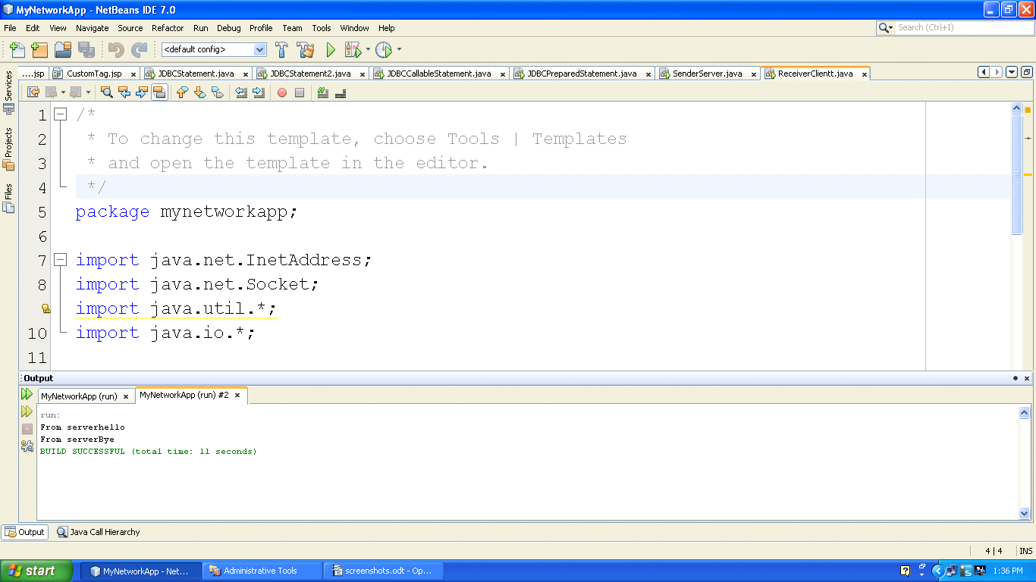

Logical Questions:

1. How to establish connection between client and server?
2. How to send message from server to client only?

PRACTICAL -2
TCP Two way communication

Aim: Create an application using TCP to implement two way communication.

Theory:
- Java Socket programming is used for communication between the applications running on different JRE.
- Java Socket programming can be connection-oriented or connection-less.
- Socket and ServerSocket classes are used for connection-oriented socket programming and DatagramSocket and DatagramPacket classes are used for connection-less socket programming.
Syntax:
ServerSocket ss=new ServerSocket(6666);
Socket s=ss.accept();//establishes connection
DataInputStream dis=new DataInputStream(s.getInputStream());
DataOutputStream dout=new DataOutputStream(s.getOutputStream());
void recursion(){
recursion();/* function calls itself */}
int main()
{
recursion();
}

Flowchart/Figure/Algorithm:

Fig.1: Flowchart of Socket Programming

Program/Implementation:

Server.java
package mynetworkapp;

import java.io.*;

import java.net.*;

public class TwoWayServer1 {

public static void main(String[] args) {

try{
ServerSocket ss=new ServerSocket(4021);
System.out.println("Wating for client to connect");
Socket s=ss.accept();

System.out.println("connection established");

BufferedReader br=new BufferedReader(new InputStreamReader(s.getInputStream()));
BufferedReader kb=new BufferedReader(new InputStreamReader(System.in));
PrintStream ps=new PrintStream(s.getOutputStream());

String str,str1;
str=br.readLine();//read frm client

while(str!=null)
{
System.out.println(str);//reads frm client n writes on server
System.out.print("Write something : ");
str1=kb.readLine();
ps.println(str1);

str=br.readLine();//reads frm client
}
ps.close();
br.close();
kb.close();
s.close();
ss.close();
}catch(IOException e)

{
System.out.println(e);
}
}
}
Client.java

package mynetworkapp;

import java.io.*;
import java.net.*;

public class TwoWayClient1 {

public static void main(String[] args) {

try{
Socket s=new Socket("192.168.1.46",4021);

BufferedReader br=new BufferedReader(new InputStreamReader(s.getInputStream()));
BufferedReader kb=new BufferedReader(new InputStreamReader(System.in));
PrintStream ps=new PrintStream(s.getOutputStream());

System.out.print("write something : ");
String str=kb.readLine()

String str1;

while(!(str.equals("exit")))
{
ps.println(str);

str1=br.readLine();
System.out.println(str1);
System.out.print("write something : ");
str=kb.readLine();
}
ps.close();
br.close();
kb.close();
s.close();
System.out.println("client program ended");

}catch(IOException e)
{
System.out.println(e);
}
}
}

Output:

Client Side

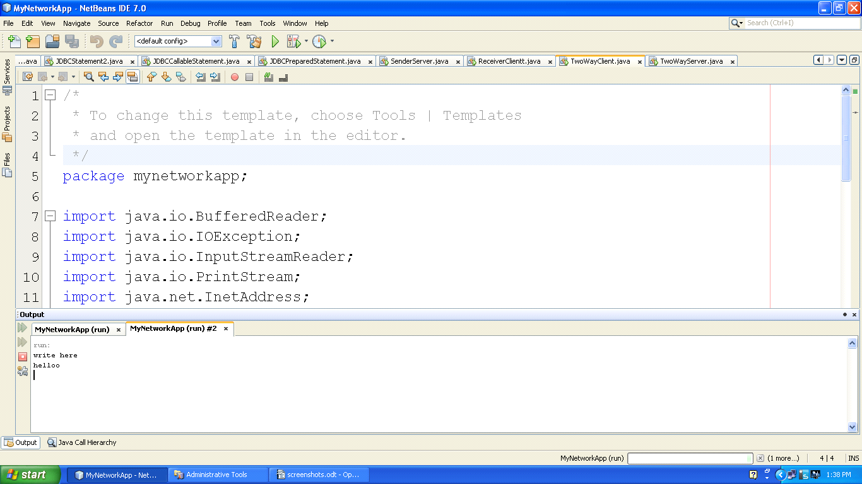
Server side

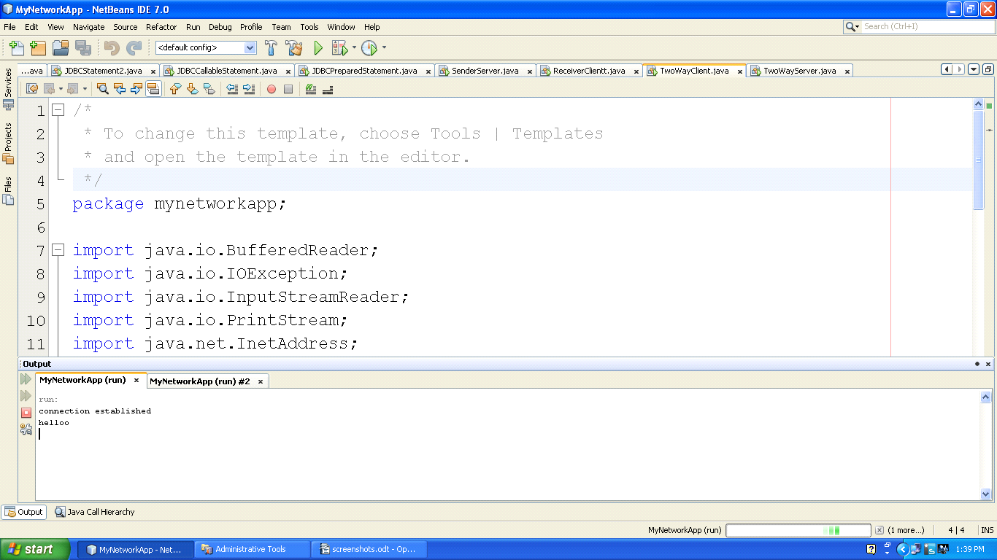

Logical Questions:

1. Write a program in which server sends a string and client reply with reverse of that string?
2. Write a client server program using TCP where client sends astring and server checks whether that string is palindrome or not and responds with appropriate message.

PRACTICAL - 3
FileTransfer

Aim: Implement TCP Server for transferring files using Socket and ServerSocket.

Theory: File Transfer
- Client can send the file name to the server to access that file.
void recursion(){
recursion();/* function calls itself */}
int main()
{
recursion();
}
- After sending the file name by client,server checks that the file is available or not.If it is available than server sends the contents of that file to the client.
Syntax:

File f=new File(fname);

Flowchart/Figure/Algorithm:

Fig 2. Flowchart for File Transfer

Program/Implementation:

FileServer.java
package mynetworkapp;

import java.io.*;

import java.net.*;

public class FileServer {

public static void main(String[] args) {

try{
ServerSocket ss=new ServerSocket(4022);
System.out.println("Wating for client to connect");
Socket s=ss.accept();

System.out.println("connection established");

BufferedReader br=new BufferedReader(new InputStreamReader(s.getInputStream()));

PrintStream ps=new PrintStream(s.getOutputStream());//client

String fname;
fname=br.readLine();

File f=new File(fname);
if(f.exists()==true)
{
BufferedReader br1=new BufferedReader(new FileReader(fname));
String str;
str=br1.readLine();
while(str!=null)
{
ps.println(str);
str=br1.readLine();
}
br1.close();
}
else
{
ps.println("file doesnt exist");
}
ps.close();
br.close();
s.close();
ss.close();

}catch(IOException e)

{
System.out.println(e);
}
}
}

FileClient.java

package mynetworkapp;

import java.io.*;
import java.net.InetAddress;
import java.net.Socket;

public class FileClient {

public static void main(String[] args) {

try{
Socket s=new Socket("localhost",4022);

BufferedReader br=new BufferedReader(new InputStreamReader(s.getInputStream()));
BufferedReader kb=new BufferedReader(new InputStreamReader(System.in));
PrintStream ps=new PrintStream(s.getOutputStream());

System.out.print("Enter file name : ");
String str=kb.readLine();
ps.println(str);

String st=br.readLine();
while(st!=null)
{
System.out.println(st);
st=br.readLine();
}
ps.close();
br.close();
kb.close();
s.close();
System.out.println("client program ended");
}
catch(IOException e)
{
System.out.println(e);
}
}
}

Output:

Client Side

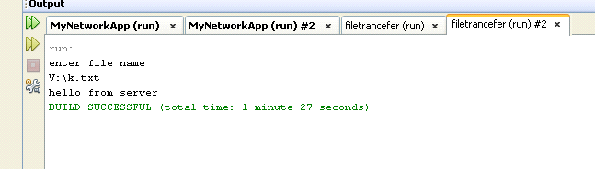

Server Side
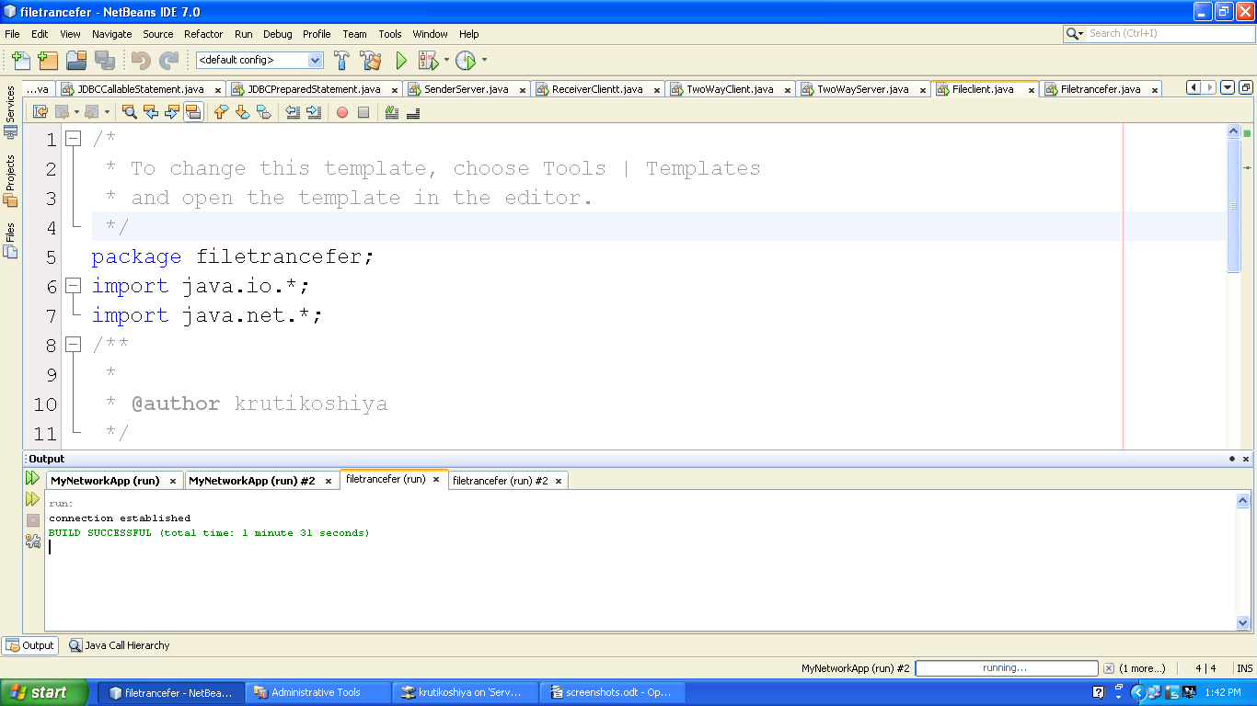

Logical Questions:

1. Write a TCP program to access the contents of file at client side.
2. Which classes are used for file transfer in socket programming?

PRACTICAL - 4
Statement and prepared Statement
Aim: User can create a new database and also create new table under that database. Once the database has been created then user can perform database operation by using Statement Interface.

Theory: Statement
- The Statement interface provides methods to execute queries with the database. The statement interface is a factory of ResultSet i.e. it provides factory method to get the object of ResultSet.
- The PreparedStatement interface is a subinterface of Statement. It is used to execute parameterized query.

Syntax:
Statement stmt=con.createStatement();
PreparedStatement stmt=con.prepareStatement("insert into Emp values(?,?)");

Flowchart/Figure/Algorithm:

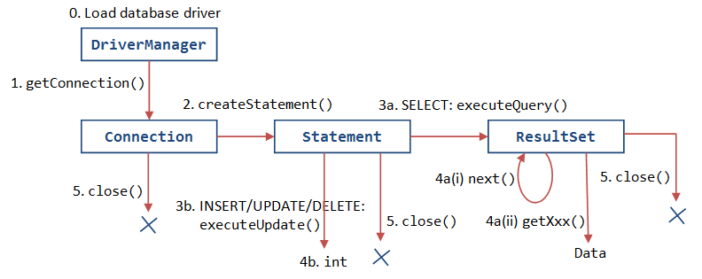
Fig.1: Flowchart of statement and preparedstatement interface

Program/Implementation:

package myfirstapp;
import java.sql.*;

public class JDBCStatement {

public static void main(String[] args) {

try
{
Class.forName("sun.jdbc.odbc.JdbcOdbcDriver");

Connection con=DriverManager.getConnection("jdbc:odbc:TempDataSource","system","system");
Statement st=con.createStatement();

ResultSet rs=st.executeQuery("select * from student");

while(rs.next())
{

System.out.println(rs.getString("id") + " "+rs.getString("s_name")+ " "+ rs.getString("address"));

}

}catch(SQLException e)
{
System.out.print(e);
}
catch(ClassNotFoundException e)
{
System.out.print(e);
}

}

}

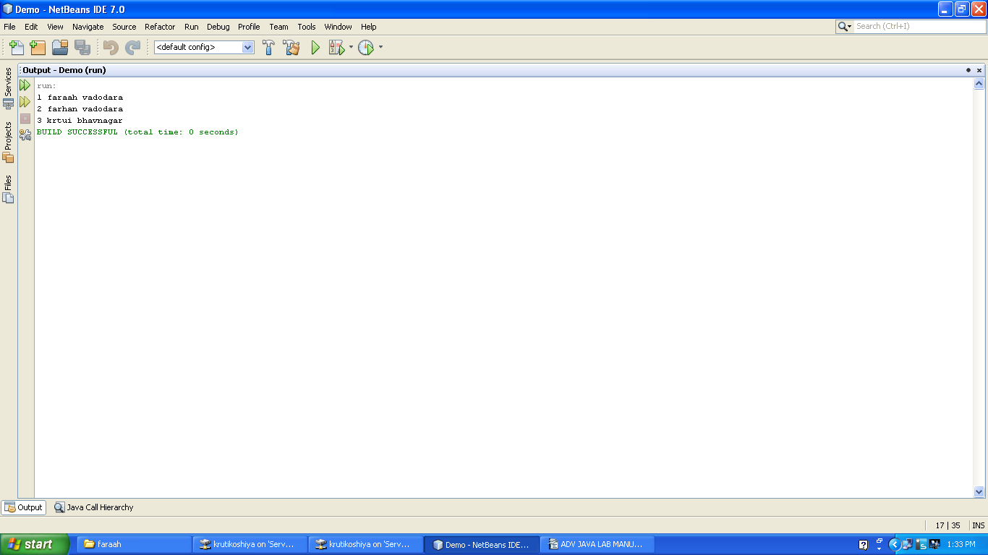
Output:

PRACTICAL - 5
Callable Statement
Aim: Implement Student information system using JDBC Callable Statement.

Theory: Callable Satement
- Callable Statement interface is used to call the stored procedures and functions.
- We can have business logic on the database by the use of stored procedures and functions that will make the performance better because these are precompiled.
void recursion(){
recursion();/* function calls itself */}
int main()
{
recursion();
}
Syntax:

CallableStatement stmt=con.prepareCall("{call myprocedure(?,?)}");

Flowchart/Figure/Algorithm:

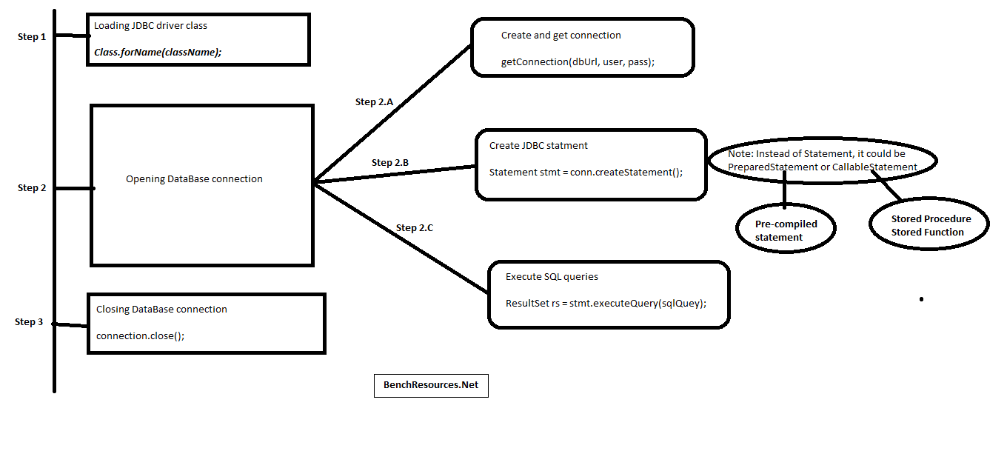
Fig 2. Flowchart for CallableStatement Interface

Program/Implementation:

package myfirstapp;

import java.sql.*;
import java.util.Scanner;

public class JDBCCallableStatement {

public static void main(String[] args) {

try
{
String name="vrushil11";
int enr=13;
int sem=5;
String add="kotambi";
int per=99;

Class.forName("sun.jdbc.odbc.JdbcOdbcDriver");

Connection con=DriverManager.getConnection("jdbc:odbc:TempDataSource","system","system");

CallableStatement cs=con.prepareCall("call add_student_details (?,?,?,?,?)");

cs.setInt(1, enr);

cs.setString(2, name);
cs.setInt(3,sem);
cs.setString(4, add);
cs.setInt(5, per);

cs.execute();

System.out.println("Data entered");

}
catch(SQLException e)
{

System.out.print(e);
}
catch(ClassNotFoundException e)
{
System.out.print(e);
}
}
}
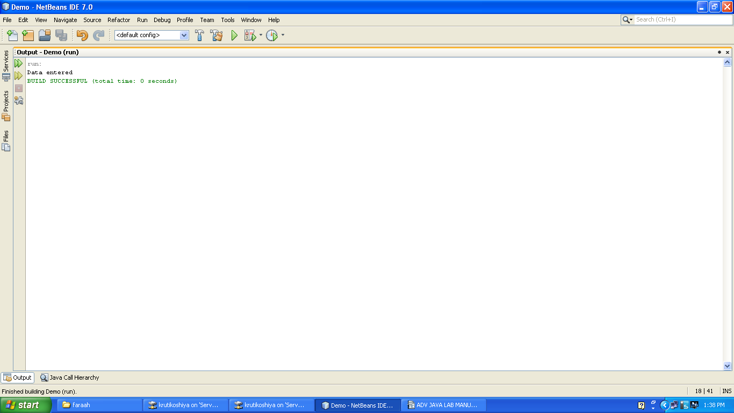
Output:

Logical Questions:

1. What is Stored Procedure?
2. How to execute more than one query by using callable statement interface?
3. Update the record in the database by using callable statement interface.

PRACTICAL - 6
ServletContex and ServletConfig

Aim: Create a Servlet and retrieve Context and Config parameters.

Theory: ServletContex and ServletConfig
- An object of ServletConfig is created by the web container for each servlet. This object can be used to get configuration information from web.xml file.
- An object of ServletContext is created by the web container at time of deploying the project. This object can be used to get configuration information from web.xml file. There is only one ServletContext object per web application.
void recursion(){
recursion();/* function calls itself */}
int main()
{
recursion();
}
Syntax:

ServletConfig config=getServletConfig();
ServletContext application=getServletConfig().getServletContext();

Flowchart/Figure/Algorithm:

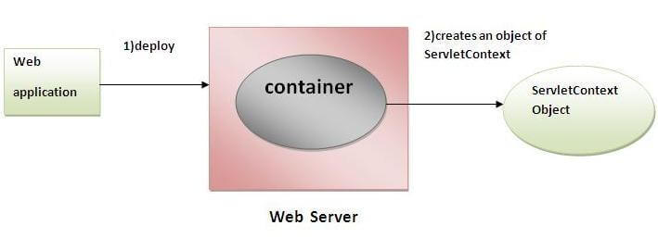
Fig 2. Flowchart for ServletContex

Program/Implementation:

index.jsp
<%--
Document : index
Created on : Feb 16, 2016, 10:37:58 AM
Author : faraahdabhoiwala
--%>

<%@page contentType="text/html" pageEncoding="UTF-8"%>
<!DOCTYPE html>
<html>
<head>
<meta http-equiv="Content-Type" content="text/html; charset=UTF-8">
<title>JSP Page</title>
</head>
<body>
<a href="RetriveParam"> Go to MyServlet</a>
</body>
</html>

WEB-INF

<?xml version="1.0" encoding="UTF-8"?>
<web-app version="3.0" xmlns="http://java.sun.com/xml/ns/javaee" xmlns:xsi="http://www.w3.org/2001/XMLSchema-instance" xsi:schemaLocation="http://java.sun.com/xml/ns/javaee http://java.sun.com/xml/ns/javaee/web-app_3_0.xsd">
<context-param>
<param-name>admin</param-name>
<param-value>dhaval</param-value>
</context-param>
<context-param>
<param-name>user</param-name>
<param-value>saifali</param-value>
</context-param>
<servlet>
<servlet-name>RetriveParam</servlet-name>
<servlet-class>RetriveParam</servlet-class>
<init-param>
<param-name>country</param-name>
<param-value>india</param-value>
</init-param>
<init-param>
<param-name>college</param-name>
<param-value>vier</param-value>
</init-param>
<init-param>
<param-name>s_name</param-name>
<param-value>nirlay</param-value>
</init-param>
</servlet>
<servlet-mapping>
<servlet-name>RetriveParam</servlet-name>
<url-pattern>/RetriveParam</url-pattern>
</servlet-mapping>
<session-config>
<session-timeout>
30
</session-timeout>
</session-config>
</web-app>

RetriveParam.java

import java.io.IOException;
import java.io.PrintWriter;
import javax.servlet.ServletConfig;
import javax.servlet.ServletException;
import javax.servlet.http.HttpServlet;
import javax.servlet.http.HttpServletRequest;
import javax.servlet.http.HttpServletResponse;
import javax.servlet.*;
import java.util.*;

public class RetriveParam extends HttpServlet {

protected void processRequest(HttpServletRequest request, HttpServletResponse response)
throws ServletException, IOException {
response.setContentType("text/html;charset=UTF-8");
PrintWriter out = response.getWriter();
ServletConfig sc=this.getServletConfig();

Enumeration e=sc.getInitParameterNames();
while(e.hasMoreElements())
{
String str=(String)e.nextElement();//name of param
out.print("<br><b>"+sc.getInitParameter(str));//value
}
ServletContext sc1=this.getServletContext();
Enumeration e1=sc1.getInitParameterNames();
while(e1.hasMoreElements())
{
String str1=(String)e1.nextElement();//name of param
out.print("<br>"+str1);
out.print("<br><b>"+sc1.getInitParameter(str1));
}

}

@Override
protected void doGet(HttpServletRequest request, HttpServletResponse response)
throws ServletException, IOException {
processRequest(request, response);
}
@Override
protected void doPost(HttpServletRequest request, HttpServletResponse response)
throws ServletException, IOException {
processRequest(request, response);
}

OUTPUT:

dhaval
saifali
india
vier
nirlay

Logical Questions:

1. Write a program for getting all the initialization parameter from the web.xml file and printing this information in the servlet.
2. Which methods are used for ServletContext and ServletConfig?

PRACTICAL - 7
Servlet with database

Aim: Create Servlet file to insert, update and delete records of particular table of database.

Theory: Servlet with database
- To access the database by using servlet,within a servlet file we can use JDBC code for the same.
void recursion(){
recursion();/* function calls itself */}
int main()
{
recursion();
}
Syntax:

ServletConfig config=getServletConfig();
ServletContext application=getServletConfig().getServletContext();

Flowchart/Figure/Algorithm:

ss
Fig 2. Flowchart for ServletContex

Program/Implementation:

Student.html
<!--
To change this template, choose Tools | Templates
and open the template in the editor.
-->
<!DOCTYPE html>
<html>
<head>
<title></title>
<meta http-equiv="Content-Type" content="text/html; charset=UTF-8">
</head>
<body>

<form action="JDBCServlet">
Name<input type="text" name="name"></input>
<br>
Enrollment NO<input type="text" name="enr"></input>
<br>
Semester<input type="text" name="sem"></input>
<br>
<input type="submit" value="insert" name="submit"></input>
<input type="submit" value="update" name="submit"></input>
<input type="submit" value="delete" name="submit"></input>
</form>
</body>
</html>

JDBCServlet.java

import java.io.IOException;
import java.io.PrintWriter;
import javax.servlet.ServletException;
import javax.servlet.http.HttpServlet;
import javax.servlet.http.HttpServletRequest;
import javax.servlet.http.HttpServletResponse;
import java.sql.*;

public class JDBCServlet extends HttpServlet {
int enr,sem;
String name;
protected void processRequest(HttpServletRequest request, HttpServletResponse response)
throws ServletException, IOException {
response.setContentType("text/html;charset=UTF-8");
PrintWriter out = response.getWriter();

enr=Integer.parseInt(request.getParameter("enr"));
name=request.getParameter("name");
sem=Integer.parseInt(request.getParameter("sem"));

String str=request.getParameter("submit");
if(str.equals("insert"))
{
String s=insertData();
out.println("<br> "+s);
}
else if(str.equals("update"))
{
updateData();
out.println("<br> data updated successfully");
}
else if(str.equals("delete"))
{
deleteData();
out.println("<br> data deleted successfully");
}
}
public String insertData()
{
try
{
Class.forName("sun.jdbc.odbc.JdbcOdbcDriver");
Connection con=DriverManager.getConnection("jdbc:odbc:TempDataSource","system","system");
Statement st=con.createStatement();
String query="insert into f_student values("+enr+",'"+name+"',"+sem+")";

int count=st.executeUpdate(query);
return "data inserted succesfully";
}
catch(Exception e)
{
return e.toString();
}
}
public void updateData()
{
try
{
Class.forName("sun.jdbc.odbc.JdbcOdbcDriver");
Connection con=DriverManager.getConnection("jdbc:odbc:TempDataSource","system","system");
Statement st=con.createStatement();
String query="update f_student set name='"+name+"' where enr="+enr+"";
int count=st.executeUpdate(query);

}catch(Exception e)
{

System.out.print(e);

}
}
public void deleteData()
{ try
{
Class.forName("sun.jdbc.odbc.JdbcOdbcDriver");
Connection con=DriverManager.getConnection("jdbc:odbc:TempDataSource","system","system");
Statement st=con.createStatement();
String query="delete from f_student where enr="+enr+"";
int count=st.executeUpdate(query);

}catch(Exception e)
{

System.out.print(e);

}

}

@Override
protected void doGet(HttpServletRequest request, HttpServletResponse response)
throws ServletException, IOException {
processRequest(request, response);
}

@Override
protected void doPost(HttpServletRequest request, HttpServletResponse response)
throws ServletException, IOException {
processRequest(request, response);
}

@Override
public String getServletInfo() {
return "Short description";
}// </editor-fold>
}

OUTPUT:

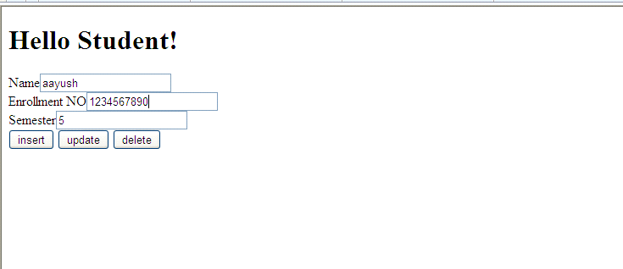

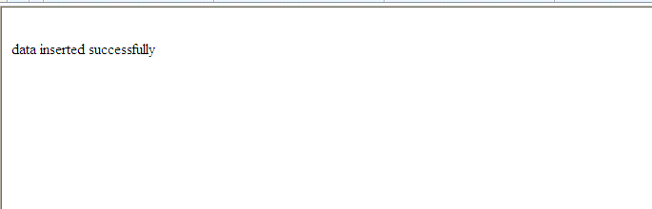

Logical Questions:

1. How we can insert the record in the database by using servlet?
2. How we can update the record in the database by using servlet?

PRACTICAL - 8
Cookies
Aim: Write a program to handle cookies.

Theory: Cookie
- Cookie is used to transmit identifier between client and server.
void recursion(){
recursion();/* function calls itself */}
int main()
{
recursion();
}
Syntax:

Cookie co =new Cookie(“name”,”XYZ”);
response.addCookie(co);

Flowchart/Figure/Algorithm:

ss 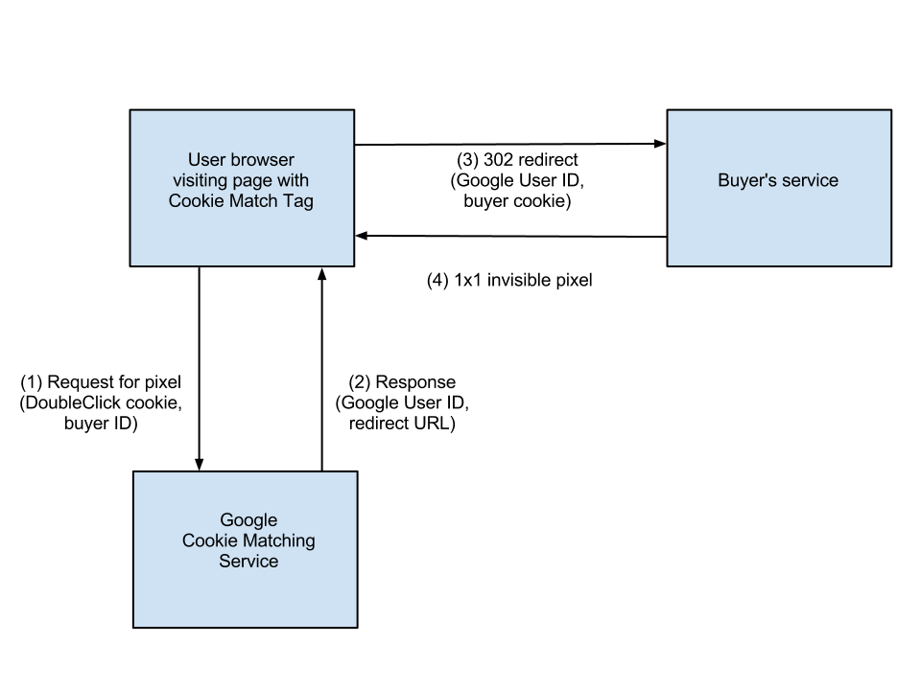
Fig 2. Flowchart for Cookie

Program/Implementation:

SessionCookies.jsp
<%--
Document : SessionCookies
Created on : Feb 19, 2016, 11:57:27 AM
Author : faraahdabhoiwala
--%>

<%@page contentType="text/html" pageEncoding="UTF-8"%>
<!DOCTYPE html>
<html>
<head>
<meta http-equiv="Content-Type" content="text/html; charset=UTF-8">
<title>JSP Page</title>
<a href="SessionCookies">Retrive My Cookies</a>

</head>
<body>
<h1>Hello World!</h1>
</body>
</html>

SessionCookies.java

import java.io.IOException;
import java.io.PrintWriter;
import javax.servlet.ServletException;
import javax.servlet.http.Cookie;
import javax.servlet.http.HttpServlet;
import javax.servlet.http.HttpServletRequest;
import javax.servlet.http.HttpServletResponse;
import javax.servlet.http.HttpSession;

public class SessionCookies extends HttpServlet {

protected void processRequest(HttpServletRequest request, HttpServletResponse response)
throws ServletException, IOException {
response.setContentType("text/html;charset=UTF-8");
PrintWriter out = response.getWriter();

Cookie c1=new Cookie("username","faraah");
Cookie c2=new Cookie("password","f1234");

response.addCookie(c1);
response.addCookie(c2);
Cookie[] c=request.getCookies();
for(int i=0;i<c.length;i++)
{
out.println("<br>name of cookie is"+c[i].getName()+"value="+c[i].getValue());
}

}

@Override
protected void doGet(HttpServletRequest request, HttpServletResponse response)
throws ServletException, IOException {
processRequest(request, response);
}
@Override
protected void doPost(HttpServletRequest request, HttpServletResponse response)
throws ServletException, IOException {
processRequest(request, response);
}

/**
* Returns a short description of the servlet.
* @return a String containing servlet description
*/
@Override
public String getServletInfo() {
return "Short description";
}// </editor-fold>
}

OUTPUT:

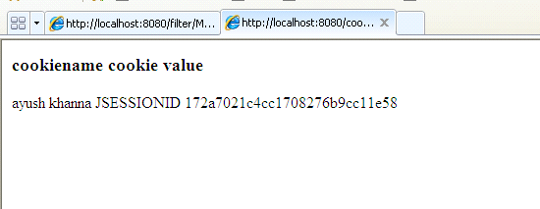

Logical Questions:

1. To add the cookie in the browser, which method is used?
2. .How to retrieve the cookie value on browser?

PRACTICAL - 9
Filter
Aim: Write a program to create filter which does pre and post processing.
Theory:Filter
- Filter is a java class which performs pre and post processing.
void recursion(){
recursion();/* function calls itself */}
int main()
{
recursion();
}
Syntax:

public void init(FilterConfig filterConfig)

Flowchart/Figure/Algorithm:

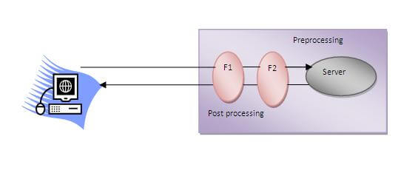
Fig 2. Flowchart for Filter

Program/Implementation:

newhtml.html

<!DOCTYPE html>
<html>
<head>
<title></title>
<meta http-equiv="Content-Type" content="text/html; charset=UTF-8">
</head>
<body>
<div>TODO write content</div>
<a href="testServlet">go to my filter</a>
</body>
</html>

MyFilter.java

import java.io.IOException;
import java.io.PrintStream;
import java.io.PrintWriter;
import java.io.StringWriter;
import javax.servlet.Filter;
import javax.servlet.FilterChain;
import javax.servlet.FilterConfig;
import javax.servlet.ServletException;
import javax.servlet.ServletRequest;
import javax.servlet.ServletResponse;

public class MyFilter implements Filter {

private static final boolean debug = true;

private FilterConfig filterConfig = null;

public MyFilter() {
}
private void doBeforeProcessing(ServletRequest request, ServletResponse response)
throws IOException, ServletException {
if (debug) {
log("MyFilter:DoBeforeProcessing");
}
}
private void doAfterProcessing(ServletRequest request, ServletResponse response)
throws IOException, ServletException {
if (debug) {
log("MyFilter:DoAfterProcessing");
}
}
public void doFilter(ServletRequest request, ServletResponse response,
FilterChain chain)
throws IOException, ServletException {

if (debug) {
log("MyFilter:doFilter()");
}
doBeforeProcessing(request, response);
PrintWriter out=response.getWriter();
out.print("<br>hi from filter");
Throwable problem = null;
try {
chain.doFilter(request, response);
} catch (Throwable t) {
problem = t;
t.printStackTrace();
}
doAfterProcessing(request, response);
out.print("<br> after processing bye from filter");
if (problem != null) {
if (problem instanceof ServletException) {
throw (ServletException) problem;
}
if (problem instanceof IOException) {
throw (IOException) problem;
}
sendProcessingError(problem, response);
}
}
public FilterConfig getFilterConfig() {
return (this.filterConfig);
}
public void setFilterConfig(FilterConfig filterConfig) {
this.filterConfig = filterConfig;
}
public void destroy() {
}
public void init(FilterConfig filterConfig) {
this.filterConfig = filterConfig;
if (filterConfig != null) {
if (debug) {
log("MyFilter:Initializing filter");
}
}
}
@Override
public String toString() {
if (filterConfig == null) {
return ("MyFilter()");
}
StringBuffer sb = new StringBuffer("MyFilter(");
sb.append(filterConfig);
sb.append(")");
return (sb.toString());
}
private void sendProcessingError(Throwable t, ServletResponse response) {
String stackTrace = getStackTrace(t);

if (stackTrace != null && !stackTrace.equals("")) {
try {
response.setContentType("text/html");
PrintStream ps = new PrintStream(response.getOutputStream());
PrintWriter pw = new PrintWriter(ps);
pw.print("<html>\n<head>\n<title>Error</title>\n</head>\n<body>\n"); //NOI18N

pw.print("<h1>The resource did not process correctly</h1>\n<pre>\n");
pw.print(stackTrace);
pw.print("</pre></body>\n</html>"); //NOI18N
pw.close();
ps.close();
response.getOutputStream().close();
} catch (Exception ex) {
}
} else {
try {
PrintStream ps = new PrintStream(response.getOutputStream());
t.printStackTrace(ps);
ps.close();
response.getOutputStream().close();
} catch (Exception ex) {
}
}
}
public static String getStackTrace(Throwable t) {
String stackTrace = null;
try {
StringWriter sw = new StringWriter();
PrintWriter pw = new PrintWriter(sw);
t.printStackTrace(pw);
pw.close();
sw.close();
stackTrace = sw.getBuffer().toString();
} catch (Exception ex) {
}
return stackTrace;

public void log(String msg) {
filterConfig.getServletContext().log(msg);
}
}
MyServlet.java

import java.io.IOException;
import java.io.PrintWriter;
import javax.servlet.ServletException;
import javax.servlet.http.HttpServlet;
import javax.servlet.http.HttpServletRequest;
import javax.servlet.http.HttpServletResponse;

public class MyServlet extends HttpServlet {

protected void processRequest(HttpServletRequest request, HttpServletResponse response)
throws ServletException, IOException {
response.setContentType("text/html;charset=UTF-8");
PrintWriter out = response.getWriter();
out.print("<br>hello from servlet");
}

@Override
protected void doGet(HttpServletRequest request, HttpServletResponse response)
throws ServletException, IOException {
processRequest(request, response);
}
@Override
protected void doPost(HttpServletRequest request, HttpServletResponse response)
throws ServletException, IOException {
processRequest(request, response);
}
@Override
public String getServletInfo() {
return "Short description";
}// </editor-fold>
}

WEB-INF

<?xml version="1.0" encoding="UTF-8"?>
<web-app version="3.0" xmlns="http://java.sun.com/xml/ns/javaee" xmlns:xsi="http://www.w3.org/2001/XMLSchema-instance" xsi:schemaLocation="http://java.sun.com/xml/ns/javaee http://java.sun.com/xml/ns/javaee/web-app_3_0.xsd">
<context-param>
<param-name>admin</param-name>
<param-value>khyati</param-value>
</context-param>
<context-param>
<param-name>user</param-name>
<param-value>sunny</param-value>
</context-param>
<filter>
<filter-name>MyFilter</filter-name>
<filter-class>MyFilter</filter-class>
</filter>
<filter>
<filter-name>StudentFilter</filter-name>
<filter-class>StudentFilter</filter-class>
</filter>
<filter-mapping>
<filter-name>StudentFilter</filter-name>
<servlet-name>StudentServlet</servlet-name>
</filter-mapping>
<servlet>
<servlet-name>StudentServlet</servlet-name>
<servlet-class>StudentServlet</servlet-class>
</servlet>

<filter-mapping>
<filter-name>MyFilter</filter-name>
<servlet-name>MyServlet</servlet-name>
</filter-mapping>
<servlet>
<servlet-name>RetriveContextParam</servlet-name>
<servlet-class>RetriveContextParam</servlet-class>
<init-param>
<param-name>country</param-name>
<param-value>india</param-value>
</init-param>
<init-param>
<param-name>state</param-name>
<param-value>gujarat</param-value>
</init-param>
</servlet>
<servlet>
<servlet-name>SessionCookies</servlet-name>
<servlet-class>SessionCookies</servlet-class>
</servlet>
<servlet>
<servlet-name>testcookie</servlet-name>
<servlet-class>testcookie</servlet-class>
</servlet>
<servlet>
<servlet-name>URLRewriting</servlet-name>
<servlet-class>URLRewriting</servlet-class>
</servlet>
<servlet>
<servlet-name>JDBCServlet</servlet-name>
<servlet-class>JDBCServlet</servlet-class>
</servlet>
<servlet>
<servlet-name>MyServlet</servlet-name>
<servlet-class>MyServlet</servlet-class>
</servlet>

<servlet-mapping>
<servlet-name>RetriveContextParam</servlet-name>
<url-pattern>/RetriveContextParam</url-pattern>
</servlet-mapping>
<servlet-mapping>
<servlet-name>SessionCookies</servlet-name>
<url-pattern>/SessionCookies</url-pattern>
</servlet-mapping>
<servlet-mapping>
<servlet-name>testcookie</servlet-name>
<url-pattern>/testcookie</url-pattern>
</servlet-mapping>
<servlet-mapping>
<servlet-name>URLRewriting</servlet-name>
<url-pattern>/URLRewriting</url-pattern>
</servlet-mapping>
<servlet-mapping>
<servlet-name>MyServlet</servlet-name>
<url-pattern>/MyServlet</url-pattern>
</servlet-mapping>
<session-config>
<session-timeout>30</session-timeout>
</session-config>
</web-app>

OUTPUT:

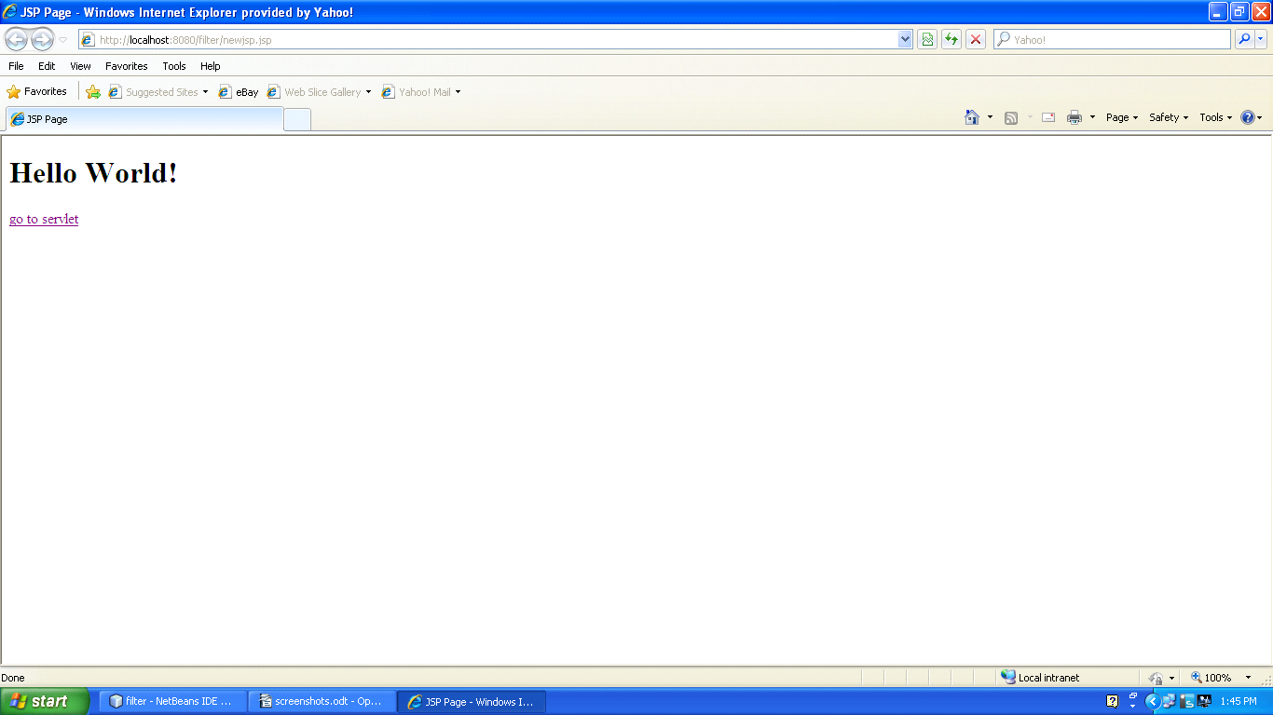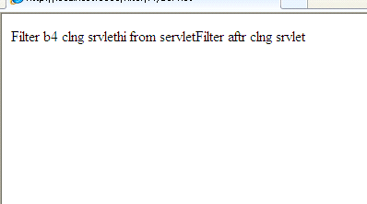

Logical Questions:

1. What is the use of filterchain interface?
2. .which are the applications of filter?

PRACTICAL - 10
useBean
Aim: Write a program to implement useBean action tag.

Source Code:
JBeanEmpInfo.jsp
<%--
Document: JBeanAddEmpInfo Created on : Feb 25, 2016, 8:59:56 AM Author : faraahdabhoiwala
--%>
<%@page contentType="text/html" pageEncoding="UTF-8"%>
<!DOCTYPE html>
<html>
<head>
<meta http-equiv="Content-Type" content="text/html; charset=UTF-8">
<title>JSP Page</title>
</head>
<body>

<form method="post" action="JBeanViewEmpDetails.jsp"> Employee Code :<input type="text" name="empCode"> </input>
Employee Name :<input type="text" name="empName"> </input>
<input type="submit" value="submit">
</input>
</form>
</body>
</html>

JBeanEmpDetails.jsp
<%--
Document : JBeanViewEmpDetails Created on : Feb 25, 2016, 9:08:06 AM Author : faraahdabhoiwala
--%>
<%@page contentType="text/html" pageEncoding="UTF-8"%>
<!DOCTYPE html>
<html>
<head>
<meta http-equiv="Content-Type" content="text/html; charset=UTF-8">
<title>JSP Page</title>
</head>
<body>
<jsp:useBean id="emp" class="p1.JBean" />
<jsp:setProperty name="emp" property="*" />
<jsp:getProperty name="emp" property="empCode" />
<jsp:getProperty name="emp" property="empName" />
</body>
</html>

JBean.java
package p1;
import java.io.*;

public class JBean implements Serializable {
private String empCode;
private String empName;
public String getEmpName()
{
return empName;
}
public void setEmpName(String empName)
{
this.empName=empName;
}
public String getEmpCode()
{
return empCode;
}
public void setEmpCode(String empCode)
{
this.empCode=empCode;
}
}

OUTPUT:

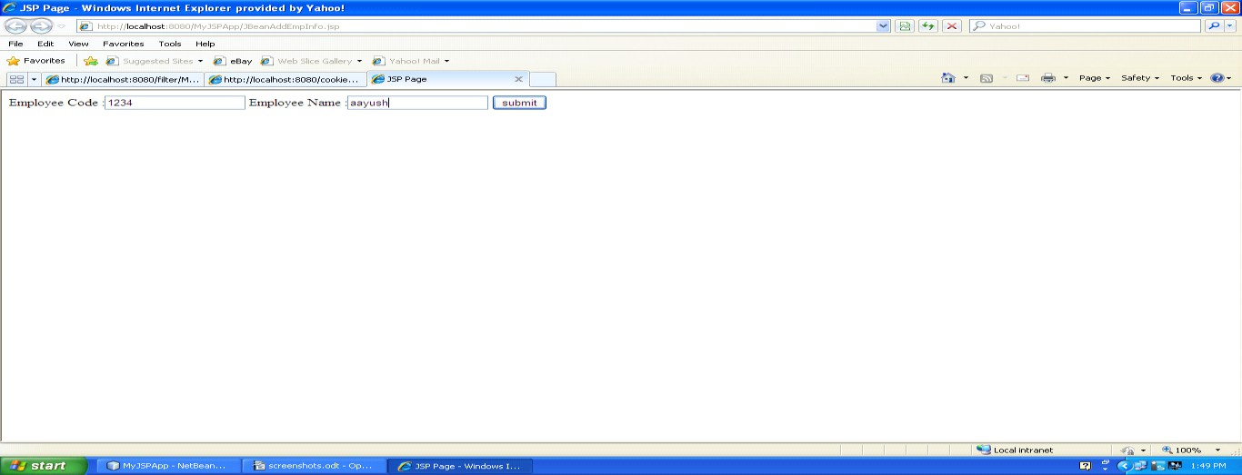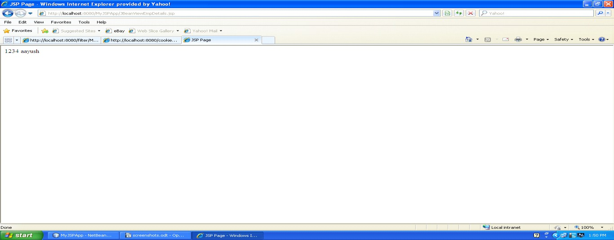

Logical Questions:
- What is the use of Serializable interface?
- .which are use os useBean action tag?

PRACTICAL – 11
JSP page
Aim: Write a program to create a Custom tag and use it in a JSP page.

Source Code:

MyTagHandler.java

package p1;
import java.io.IOException;
import javax.servlet.jsp.JspWriter;
import javax.servlet.jsp.JspException;
import javax.servlet.jsp.tagext.JspFragment;
import javax.servlet.jsp.tagext.SimpleTagSupport;

public class MyTagHandler extends SimpleTagSupport {
@Override
public void doTag() throws JspException ,IOException{
JspWriter out = getJspContext().getOut();
out.print("hello everyone this is custom tag");
}
}

Mytag_libraray.tld

<?xml version="1.0" encoding="UTF-8"?>
<taglib version="2.1" xmlns="http://java.sun.com/xml/ns/javaee" xmlns:xsi="http://www.w3.org/2001/XMLSchema-instance" xsi:schemaLocation="http://java.sun.com/xml/ns/javaee http://java.sun.com/xml/ns/javaee/web- jsptaglibrary_2_1.xsd">
<tlib-version>1.0</tlib-version>
<short-name>mytag_library</short-name>
<uri>/WEB-INF/tlds/Mytag_library</uri>
<tag>
<name>Display</name>
<tag-class>p1.MyTagHandler</tag-class>
<body-content>scriptless</body-content>
</tag>
</taglib>

CustomTag.java
<%@taglib prefix="f" uri="/WEB-INF/tlds/Mytag_library" %>
<%@page contentType="text/html" pageEncoding="UTF-8"%>
<!DOCTYPE html>
<html>
<head>
<meta http-equiv="Content-Type" content="text/html; charset=UTF-8">
<title>JSP Page</title>
</head>
<body>
<f:Display></f:Display>
</body>
</html>

OUTPUT:
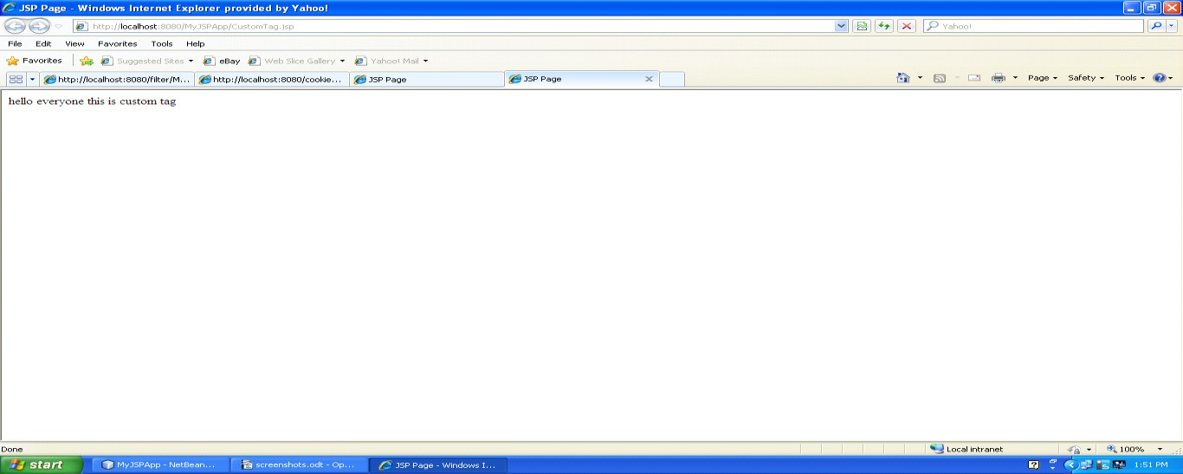

Logical Questions:

- Who catch the exceptions and which type of exceptions?
- Which are the use of custom tag?

PRACTICAL – 12
Aim: Write a program using connectionless protocol in which the client sends a string to server and server converts the string into uppercase and sends it back to client
Source Code:

DatagramServer.java

package mynetworkapp;
import java.net.*;
import java.io.*;

public class DatagramServer {

public static void main(String[] args) {

try{
DatagramSocket ds=new DatagramSocket(2000);//port no of socket--Socket Exception
byte b[]=new byte[100];
DatagramPacket dp=new DatagramPacket(b,b.length);//blank packet
ds.receive(dp);
b=dp.getData

String d=new String(b).trim();//convert to string
System.out.println(d);
//task to be performed on string//
String d1=d.toUpperCase();//task
System.out.println(d1);

byte b1[]=new byte[100];//byte array for sending data b1=d1.getBytes();//convert string form data to bytes
DatagramPacket sp=new DatagramPacket(b1,b1.length,dp.getAddress(),dp.getPort()); ds.send(sp);//send the packet to client--throws IOException
}
catch (Exception e) {
System.out.println(e);
}

}
}

DatagramClient.java

package mynetworkapp;

import java.net.*; import java.util.Scanner;

public class DatagramClient {

public static void main(String[] args) {

try {
DatagramSocket ds=new DatagramSocket();//thows SocketException
Scanner sc=new Scanner(System.in);
System.out.print("Enter a String :");
String str=sc.next();
byte b[]=new byte[100]; b=str.getBytes();
//create a packet and store the data in it
DatagramPacket dp=new DatagramPacket(b,b.length,InetAddress.getLocalHost(),2000);
//send the packet ds.send(dp);
byte b1[]=new byte[100];
//create an empty packet to receive the data DatagramPacket rp=new DatagramPacket(b1,b1.length);
//fill the packet ds.receive(rp);
//unpack the data in byte form b1=rp.getData();
String d=new String(b1).trim(); System.out.println(d);

} catch (Exception e) {
System.out.println(e);
}
}
}

OUTPUT:

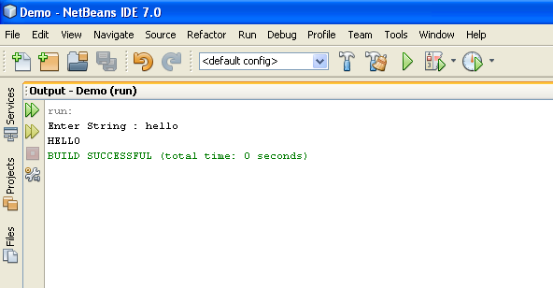

Logical Questions:

- What is connectionless protocol?
- Name of connectionless protocol.

PRACTICAL – 13
Aim: Write a JSF application to create a login form.
Source Code:
LoginBean.java

import java.io.Serializable;
import java.sql.Connection;
import java.sql.DriverManager;
import java.sql.ResultSet;
import java.sql.SQLException;
import java.sql.Statement;
import javax.faces.bean.ManagedBean;
import javax.faces.bean.SessionScoped;

@ManagedBean(name = "loginBean")

public class LoginBean implements Serializable{
String userName;
String password;
public String getPassword() {
return password;
}
public void setPassword(String password) {
this.password = password;
}
public String getUserName() {
return userName;
}
public void setUserName(String userName) {
this.userName = userName;
}
public String checkValidUser()
{
try{
Class.forName("sun.jdbc.odbc.JdbcOdbcDriver");
Connection con=DriverManager.getConnection("jdbc:odbc:TempDataSource","system","system");
Statement st=con.createStatement();

ResultSet rs=st.executeQuery("select * from user1 where username='"+userName+"' and password='"+password+"'");
rs.next();
if(rs.getRow()==1)
{
return "success";
}
else
{
return "failure";
}
}catch(Exception e)
{
return e.toString();
}
}
public LoginBean() {
}

}

login.jsp

<%--
Document : login
Created on : Mar 15, 2016, 9:33:42 AM
Author : faraahdabhoiwala
--%>
<%@taglib uri="http://java.sun.com/jsf/core" prefix="f"%>
<%@taglib uri="http://java.sun.com/jsf/html" prefix="h"%>
<%@page contentType="text/html" pageEncoding="UTF-8"%>
<!DOCTYPE html>
<f:view>
<html>
<head>
<meta http-equiv="Content-Type" content="text/html; charset=UTF-8">
<title>JSP Page</title>
</head>
<h1>Hello World!</h1>
<body>
<h:form>
Enter UserName :<h:inputText id="userName" value="#{loginBean.userName}"><br/>

</h:inputText>
Enter Password : <h:inputText id="password" value="#{loginBean.password}"/><br/>
<h:commandButton value="login" action="#{loginBean.checkValidUser()}"/>
</h:form>

</body>
</html>
</f:view>

success.jsp
<%--
Document : success
Created on : Mar 15, 2016, 9:21:09 AM Author : faraahdabhoiwala
--%>
<%@page contentType="text/html" pageEncoding="UTF-8"%>
<!DOCTYPE html>
<html>
<head>
<meta http-equiv="Content-Type" content="text/html; charset=UTF-8">
<title>JSP Page</title>
</head>
<body>
<h1>login successful</h1>
</body>
</html>

failure.jsp
<%--
Document : failure
Created on : Mar 15, 2016, 9:21:21 AM Author : faraahdabhoiwala
--%>
<%@page contentType="text/html" pageEncoding="UTF-8"%>
<!DOCTYPE html>
<html>
<head>
<meta http-equiv="Content-Type" content="text/html; charset=UTF-8">
<title>JSP Page</title>
</head>
<body>
<h1>invalid username/pwd <br/>login failed</h1>
</body>
</html>

OUTPUT:

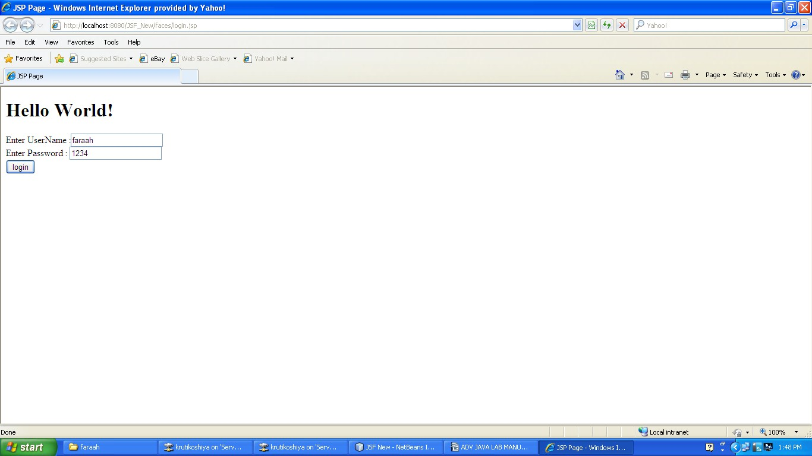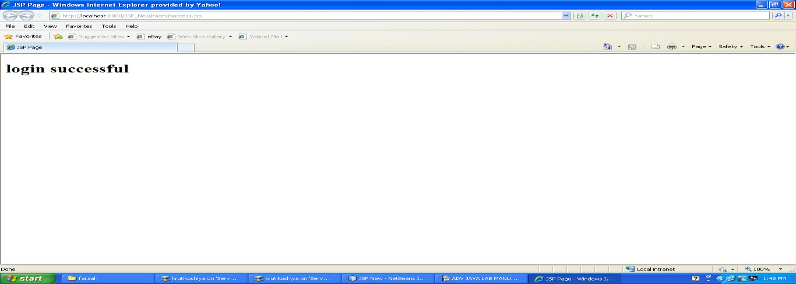

Logical Questions:

- What is the use of JSF?
- Which libreries required for JSF?

PRACTICAL – 14
Aim: Write a JSF application to insert, update and delete record from database.
Source Code:

LoginBean.java

import java.io.Serializable;
import java.sql.Connection;
import java.sql.DriverManager;
import java.sql.ResultSet;
import java.sql.SQLException;
import java.sql.Statement;
import javax.faces.bean.ManagedBean;
import javax.faces.bean.SessionScoped;

@ManagedBean(name = "loginBean")
//@Dependent
@SessionScoped
public class LoginBean implements Serializable{
String userName;
String password;
public String getPassword() {
return password;
}
public void setPassword(String password) {
this.password = password;
}
public String getUserName() {
return userName;
}
public void setUserName(String userName) {
this.userName = userName;
}
public String checkValidUser()
{
try
{
Class.forName("sun.jdbc.odbc.JdbcOdbcDriver");
Connection con=DriverManager.getConnection("jdbc:odbc:TempDataSource","system","system");
Statement st=con.createStatement();

ResultSet rs=st.executeQuery("select * from user1 where username='"+userName+"' and password='"+password+"'");
rs.next();
if(rs.getRow()==1)
{
return "success";
}
else
{
return "failure";
}
}catch(Exception e)
{
return e.toString();
}

}

public LoginBean() {
}
}

login.jsp

<%--
Document : login
Created on : Mar 15, 2016, 9:33:42 AM
Author : faraahdabhoiwala
--%>
<%@taglib uri="http://java.sun.com/jsf/core" prefix="f"%>
<%@taglib uri="http://java.sun.com/jsf/html" prefix="h"%>
<%@page contentType="text/html" pageEncoding="UTF-8"%>

<!DOCTYPE html>
<f:view>
<html>
<head>
<meta http-equiv="Content-Type" content="text/html; charset=UTF-8">
<title>JSP Page</title>
</head>
<h1>Hello World!</h1>
<body>
<h:form>
Enter UserName :<h:inputText id="userName" value="#{loginBean.userName}"><br/>
</h:inputText>
Enter Password : <h:inputText id="password" value="#{loginBean.password}"/><br/>
<h:commandButton value="login" action="#{loginBean.checkValidUser()}"/>
</h:form>
</body>
</html>
</f:view>

success.jsp

<%--
Document : success
Created on : Mar 15, 2016, 9:21:09 AM
Author : faraahdabhoiwala
--%>
<%@page contentType="text/html" pageEncoding="UTF-8"%>

<!DOCTYPE html>
<html>
<head>
<meta http-equiv="Content-Type" content="text/html; charset=UTF-8">
<title>JSP Page</title>
</head>
<body>
<h1>login successful</h1>
</body>
</html>

failure.jsp

<%--
Document : failure
Created on : Mar 15, 2016, 9:21:21 AM
Author : faraahdabhoiwala
--%>
<%@page contentType="text/html" pageEncoding="UTF-8"%>
<!DOCTYPE html>
<html>
<head>
<meta http-equiv="Content-Type" content="text/html; charset=UTF-8">
<title>JSP Page</title>
</head>
<body>
<h1>invalid username/pwd <br/>login failed</h1>
</body>
</html>

OUTPUT:

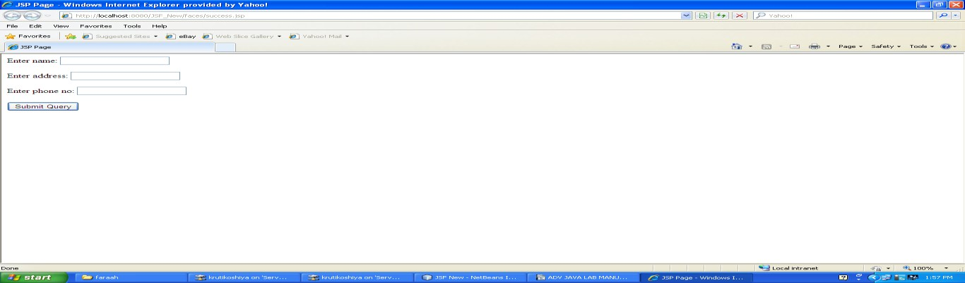
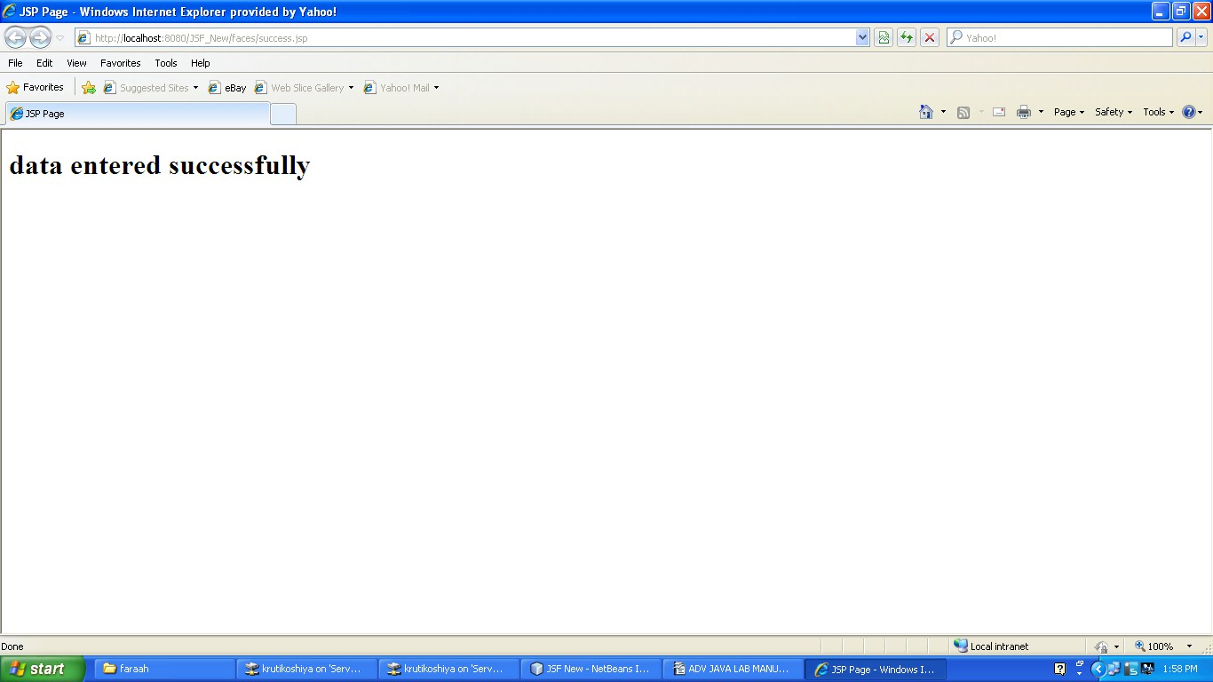

Logical Questions:

- How JSF application connect with Database?
- How data retrive from the database?

