  - Flowchart and Algorithm:
  - Flowchart :
  - Introduction
  - A flowchart is a graphical representation of an algorithm or a process. It visually illustrates the sequence of steps, decisions, and operations involved in solving a problem or executing a task. Flowcharts use standardized symbols to represent different types of actions or steps (e.g., ovals for start/end, rectangles for processes, diamonds for decisions) and connecting arrows to indicate the flow of control and information. Flowcharts serve as a visual aid for understanding, designing, documenting, and analyzing algorithms and processes, making complex logic more accessible and easier to follow, especially for beginners in programming. They are a powerful tool for planning and visualizing program logic before writing actual code.
- Advantages of using a Flowchart
  - Flowcharts are a better way of communicating the logic of the system.
  - Flowcharts act as a guide for blueprint during program designed.
  - Flowcharts help in debugging process.
  - With the help of flowcharts programs can be easily analyzed.
  - They provide better documentation.
  - Flowcharts serve as a good proper documentation.

- Disadvantages of using a Flowchart
  - It is difficult to draw flowcharts for large and complex programs.
  - There is no standard to determine the amount of detail.
  - It is very difficult to modify the Flowchart.
  - Making a flowchart is costly.
  - If changes are done in software, then the flowchart must be redrawn

  - Examples of flowchart
  - 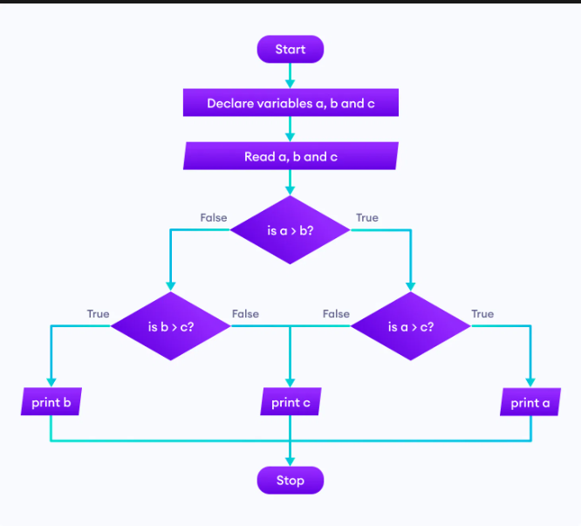

  - 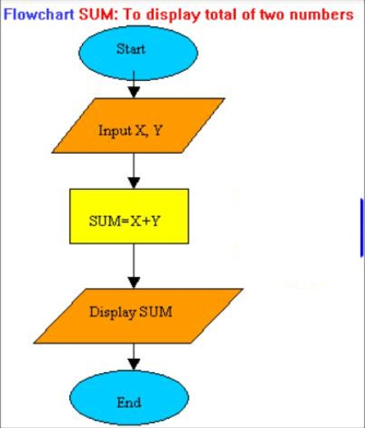

- Algorithm:
  - An algorithm is a finite set of well-defined, unambiguous instructions or a step-by-step procedure for solving a computational problem or achieving a specific task. Algorithms are fundamental to computer science and programming, providing the logical blueprint for how a program will process data and produce results. Key properties of algorithms include being finite (terminating after a finite number of steps), definite (each step is precisely defined), having inputs, producing outputs related to those inputs, and being effective (each step can be performed in a finite amount of time).
- Advantages of Algorithms:
  - It is easy to understand.
  - An algorithm is a step-wise representation of a solution to a given problem.
  - In an Algorithm the problem is broken down into smaller pieces or steps hence, it is easier for the programmer to convert it into an actual program.

- Disadvantages of Algorithms:
  - Writing an algorithm takes a long time so it is time-consuming.
  - Understanding complex logic through algorithms can be very difficult.
  - Branching and Looping statements are difficult to show in Algorithms(imp).

- Developing and writing algorithm using pseudo codes
- What is an Algorithm?
- An algorithm is a step-by-step procedure to solve a problem or perform a task.
- It’s like a recipe in cooking: a set of instructions that leads to the desired result.
  - 2. What is Pseudocode?
- Pseudocode is a way to describe an algorithm in plain, structured English (not actual programming code).
- It’s not bound to any programming language.
- It helps you think logically before coding.

- Steps in Developing an Algorithm
  - When you want to write an algorithm:
- Understand the problem → What is the input? What is the expected output?
- Plan the steps → Break down the solution into logical steps.
- Write in pseudocode → Use simple keywords like START, IF, WHILE, PRINT.
- Check correctness → Dry-run with examples to verify.
- Convert to real code later (in C, Python, Java, Dart, etc.).

  - 4. Example Problem & Pseudocode
  - Problem: Find the largest of two numbers.
  - Algorithm steps:
- Start
- Input two numbers
- Compare the numbers
- Print the larger number
- Stop
  - Pseudocode:
  - START
  - READ number1, number2
  - IF number1 > number2 THEN
  - PRINT number1
  - ELSE
  - PRINT number2
  - ENDIF
  - STOP

  - Algorithm
  - 1. What is an Algorithm?
  - An algorithm is a clear, step-by-step method for solving a problem or performing a task.
  - Think of it as a recipe: it defines the sequence of actions needed to get the final result.

  - 2. What is Pseudocode?
  - Pseudocode is a simplified, language-agnostic way of describing an algorithm using plain English (with some programming-like structure).
  - It ignores syntax details of a programming language.
  - It helps you plan before coding.

  - 3. Steps in Developing an Algorithm with Pseudocode
  - Understand the Problem – Identify inputs, outputs, and requirements.
  - Design the Solution – Break the problem into small logical steps.
  - Write Pseudocode – Express steps using simple keywords like READ, IF, WHILE, PRINT.
  - Validate – Dry-run with sample data to confirm correctness.
  - Translate into Code – Convert pseudocode into a real programming language.

  - 4. Advantages of Using Pseudocode
  - Easy to read & understand – No coding knowledge required.
Focuses on logic – No distractions with syntax errors.
Can be written quickly – Faster than actual coding.
Helps in teamwork – Programmers and non-programmers can communicate.
Language-independent – Can later be converted to any programming language.

  - 5. Disadvantages of Using Pseudocode
  - Not executable – You can’t run pseudocode directly.
No strict standard – Different people may write pseudocode differently.
May be ambiguous – Lack of syntax rules can lead to misinterpretation.
Still needs real code – It’s only a planning tool, not the final product.

  - 6. Examples
  - Example 1: Find the Largest of Two Numbers
  - Algorithm:
  - Start
  - Read two numbers
  - Compare them
  - Print the larger number
  - Stop
  - Pseudocode:
  - START
  - READ number1, number2
  - IF number1 > number2 THEN
  - PRINT number1
  - ELSE
  - PRINT number2
  - ENDIF
  - STOP

- Constants , variables and DataTypes:
- Character Set
  - Before understanding identifiers and tokens, you need to know what characters are valid in your C source.
  - Source character set: all the characters that can appear in the program’s source file. This includes letters (A-Z, a-z), digits (0-9), punctuation, whitespace (space, tab, newline), special symbols, etc. The standard requires a basic character set, plus possibly extended characters.
  - Execution character set: the set of characters the compiled program uses when it runs, especially for character constants / string literals etc. After preprocessing, string/character constants from the source set get mapped to the execution set.
  - Hence:
  - Not every encoding is allowed, but implementations usually accept ASCII or UTF-8 etc.
  - When naming identifiers, using characters outside the basic source set may lead to implementation-defined behaviour.

  - 2. Tokens, Keywords, Identifiers
  - Tokens
  - Tokens are the smallest meaningful building blocks in a C program. The compiler breaks your source into tokens. types of tokens include: punctuators, keywords, strings (literals), operators, identifiers, constants.

  - Examples of tokens:
  - int, if, return (keywords)
  - x, sum, count (identifiers)
  - 123, 3.14, 'a', "hello" (constants / literals)
  - Symbols like (, ), {, }, ;, , etc. (punctuators)
  - Operators: +, -, *, /, %, ==, <, &&, etc.
  - Keywords
  - Reserved words that have special meaning in C. Cannot be used as identifiers.
  - Examples: int, char, float, double, if, else, for, while, switch, return, struct, typedef, const, extern, static, etc.
  - The exact number of keywords depends on the C standard version (C90, C99, C11, C23 etc.).
  - Identifiers
  - Names you give to variables, functions, arrays, etc.
  - Rules:
  - Must start with a letter (A-Z or a-z) or underscore _.
  - After the first character, can have letters, digits (0-9), or underscore.
  - Cannot be a keyword.
  - Case-sensitive (MyVar is different from myvar).
  - Some older constraints: only first N characters considered (but modern compilers accept longer names).

  - 3. Constants
  - Constants (or literals) are fixed values in the code. They don’t change during execution.

- Types of constants / literals:
  - Integer constants: e.g. 123, -45, 0, 07 (octal), 0x1A (hexadecimal).
  - Floating-point constants: e.g. 3.14, -0.001, 2.0e5 etc.
  - Character constants: a single character in single quotes, e.g. 'a', 'Z', '\n' etc. These are usually stored as integer types corresponding to the character encoding.
  - String constants (literals): sequence of characters in double quotes, e.g. "Hello, world!". These are arrays of char ending in a null character \0.
  - Named constants: using const keyword or preprocessor #define. More in section on symbolic constants.

  - 4. Variables
  - Variables are named storage locations whose contents can change during execution.
  - Each variable has a type which determines what kind of data it can hold, and how much memory is needed.

  - 5. Data Types
  - C is statically typed. That means you declare a variable’s type at compile time, and once declared, its type cannot change.
  - Major built-in data types include:
- Category | - Examples | - Description
- Integer types | - int, short, long, unsigned int, signed char etc. | - Whole numbers (positive/negative/zero).
- Character type | - char | - Single character, typically 1 byte.
- Floating types | - float, double, long double | - Numbers with fractional part.
- Void | - void | - Represents absence of type; used in functions returning no value, or pointers to unknown types etc.

  - Declaration of Variables & Assigning Values
  - Declaration
  - You tell the compiler: here is a variable of a certain type, with a certain name.
  - Syntax:
  - type variable_name;
  - or multiple:
  - type var1, var2, var3;
  - You can also declare and initialize together:
  - type variable_name = initial_value;
  - Example:
  - int age;
  - float salary;
  - char grade;
  - int x = 10;
  - char c = 'A';

- Managing Input and Output Operations:
  - Standard I/O library: functions for input/output are in stdio.h
  - Streams: stdin, stdout, stderr are standard input, output, error streams.
  - Formatted vs unformatted I/O:
  - Formatted I/O means using format specifiers—reading or writing values in particular formats.
  - Unformatted I/O involves simpler functions (often character or string based) without format specifiers.
  - Reading / Writing a Character
  - These are the basic character-level I/O functions.
- Function | - Description
- getchar() | - Reads one character from stdin. Blocks until input is available. Returns the character (as an int), or EOF.
- putchar(int c) | - Writes one character (the c) to stdout.

  - Formatted Input & Formatted Output
  - Formatted Output: printf() family
  - printf(const char *format, ...) prints to standard output using format specifiers
  - Format specifiers: %d / %i for integers, %f for floats, %lf for double, %c for character, %s for string, %u, %o, %x, etc.
  - Formatted Input: scanf() family
  - scanf(const char *format, ...) reads from stdin according to a format string. Variables must be passed by pointer (using &) so scanf can store into them.
  - Common specifiers are same as printf: %d, %f, %lf, %c, %s, etc.

  - Operators and Expressions in C Language
  - Introduction
  - Operators are special symbols that perform specific operations on one or more operands (values or variables). Expressions are combinations of operands and operators that evaluate to a single value. In C programming, operators are fundamental building blocks that allow you to manipulate data and control program flow.
  - An expression can be as simple as a single variable or constant, or as complex as a mathematical formula involving multiple operators and operands.
  - Arithmetic Operators
  - Arithmetic operators perform mathematical calculations on numeric operands.
  - Binary Arithmetic Operators:
  - + (Addition): Adds two operands
  - - (Subtraction): Subtracts the second operand from the first
  - * (Multiplication): Multiplies two operands
  - / (Division): Divides the first operand by the second
  - % (Modulo): Returns the remainder after division
  - Unary Arithmetic Operators:
  - + (Unary plus): Indicates positive value
  - - (Unary minus): Negates the value
  - int a = 10, b = 3;
  - int sum = a + b; // 13
  - int diff = a - b; // 7
  - int product = a * b; // 30
  - int quotient = a / b; // 3 (integer division)
  - int remainder = a % b; // 1
  - Relational Operators
  - Relational operators compare two operands and return either 1 (true) or 0 (false).
  - == (Equal to): Returns 1 if operands are equal
  - != (Not equal to): Returns 1 if operands are not equal
  - > (Greater than): Returns 1 if left operand is greater
  - < (Less than): Returns 1 if left operand is smaller
  - >= (Greater than or equal to)
  - <= (Less than or equal to)
  - int x = 5, y = 8;
  - int result1 = (x == y); // 0 (false)
  - int result2 = (x < y); // 1 (true)
  - int result3 = (x >= 5); // 1 (true)

  - Logical Operators
  - Logical operators perform logical operations on boolean expressions.
  - && (Logical AND): Returns 1 if both operands are true
  - || (Logical OR): Returns 1 if at least one operand is true
  - ! (Logical NOT): Returns 1 if operand is false, 0 if operand is true
  - int a = 1, b = 0;
  - int result1 = a && b; // 0 (false)
  - int result2 = a || b; // 1 (true)
  - int result3 = !a; // 0 (false)
  - Assignment Operators
  - Assignment operators assign values to variables.
  - Simple Assignment:
  - = (Assignment): Assigns right operand value to left operand
  - Compound Assignment Operators:
  - += (Add and assign): a += b is equivalent to a = a + b
  - -= (Subtract and assign)
  - *= (Multiply and assign)
  - /= (Divide and assign)
  - %= (Modulo and assign)
  - int x = 10;
  - x += 5; // x becomes 15
  - x -= 3; // x becomes 12
  - x *= 2; // x becomes 24
  - Increment and Decrement Operators
  - These operators increase or decrease the value of a variable by 1.
  - Increment Operator (++):
  - Pre-increment: ++variable (increment first, then use)
  - Post-increment: variable++ (use first, then increment)
  - Decrement Operator (--):
  - Pre-decrement: --variable (decrement first, then use)
  - Post-decrement: variable-- (use first, then decrement)
  - int a = 5;
  - int b = ++a; // a becomes 6, b gets 6
  - int c = a--; // c gets 6, a becomes 5
  - Conditional Operator (Ternary Operator)
  - The conditional operator ? : provides a shorthand way to write simple if-else statements.
  - Syntax: condition ? expression1 : expression2
  - int a = 10, b = 20;
  - int max = (a > b) ? a : b; // max gets 20
  - Bitwise Operators
  - Bitwise operators perform operations on individual bits of operands.
  - & (Bitwise AND): Sets bit to 1 if both bits are 1
  - | (Bitwise OR): Sets bit to 1 if at least one bit is 1
  - ^ (Bitwise XOR): Sets bit to 1 if bits are different
  - ~ (Bitwise NOT): Inverts all bits
  - << (Left shift): Shifts bits to the left
  - >> (Right shift): Shifts bits to the right
  - int a = 5; // Binary: 0101
  - int b = 3; // Binary: 0011
  - int result1 = a & b; // 1 (Binary: 0001)
  - int result2 = a | b; // 7 (Binary: 0111)
  - int result3 = a << 1; // 10 (Binary: 1010)
  - Arithmetic Expressions
  - Arithmetic expressions combine variables, constants, and arithmetic operators to produce numeric results. They can be simple or complex and follow mathematical rules.
  - int result = 2 * 3 + 4 * 5 - 6; // Complex arithmetic expression
  - float average = (a + b + c) / 3.0; // Using parentheses for clarity
  - Evaluation of Expressions
  - Expression evaluation follows specific rules:
  - Precedence: Operators with higher precedence are evaluated first
  - Associativity: When operators have the same precedence, associativity determines evaluation order
  - Parentheses: Override normal precedence and associativity rules
  - Short-circuit evaluation: In logical expressions, evaluation may stop early
  - Precedence of Arithmetic Operators
  - From highest to lowest precedence:
  - () (Parentheses)
  - +, - (Unary plus and minus)
  - *, /, % (Multiplication, division, modulo)
  - +, - (Addition and subtraction)
  - int result = 2 + 3 * 4; // Evaluates to 14, not 20
  - int result2 = (2 + 3) * 4; // Evaluates to 20
  - Type Conversions in Expressions
  - When operands of different types are used in expressions, C performs automatic type conversions following these rules:
  - Implicit Type Conversion (Type Promotion):
  - char and short are promoted to int
  - If one operand is double, the other is converted to double
  - If one operand is float, the other is converted to float
  - If one operand is unsigned long, the other is converted to unsigned long
  - int a = 5;
  - float b = 2.5;
  - float result = a + b; // 'a' is converted to float, result is 7.5
  - Explicit Type Conversion (Type Casting):
  - int a = 10, b = 3;
  - float result = (float)a / b; // Explicit casting to get 3.333...
  - Operator Precedence and Associativity
  - Complete precedence table (highest to lowest):
  - (), [], ->, . (Left to right)
  - !, ~, ++, --, +, -, *, &, sizeof (Right to left)
  - *, /, % (Left to right)
  - +, - (Left to right)
  - Evaluation of Expressions
  - The compiler evaluates expressions based on:
  - Order of Evaluation:
  - Precedence determines which operations are performed first
  - Associativity determines the order when precedence is equal
  - Parentheses can override natural precedence.

