Practical 1
Aim: Practice using scratch programming/snap programming.
Code:
- Open Scratch
- Go to scratch.mit.edu.
- Click Create (top menu).
You’ll see the stage (right side), sprite (cat), and blocks (left side).
- Understand the Interface
- Stage (top right): Where your program runs.
- Sprites (bottom right): Characters/objects in your project.
- Blocks (left): Drag-and-drop code blocks.
  - Motion (blue) → Move, turn
  - Looks (purple) → Say, costumes
  - Sound (pink) → Play sounds
  - Events (yellow) → Start with clicks/keys
  - Control (orange) → Loops, if statements

- First Program (Hello World)
- From Events, drag when green flag clicked.
- From Looks, drag say "Hello!" for 2 seconds under it.
- Click the green flag ▶️ — the cat says "Hello!"
- Add Movement
- Drag when green flag clicked.
- Add move 10 steps.
- Add a Control → forever loop around it.
- Add if on edge, bounce.
- Use Keyboard Input
- Drag when [right arrow] key pressed.
- Add change x by 10.
- Duplicate, but change:
  - left arrow → change x by -10
  - up arrow → change y by 10
  - down arrow → change y by -10

Practical 2
Aim: Design and develop various problem statement using flowchart and Algorithm.

- Sum of 2 given numbers
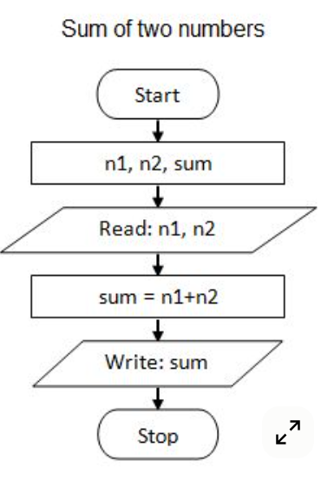

  - Start
  - Input A, B
  - Compute SUM = A + B
  - Print SUM
  - Stop

- Find max of 2 numbers
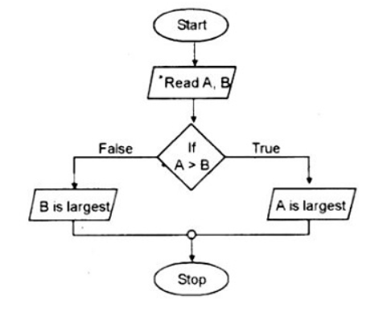

Algorithm:
  - Start
  - Input A, B
  - If A > B
- Print “A is greater”
Else
- Print “B is greater”
  - Stop

- Find if given number is odd or even
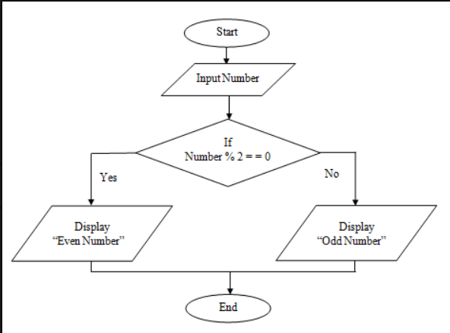

Algorithm
  - Start
  - Input N
  - Compute R = N % 2
  - If R == 0 → Print “Even”
Else → Print “Odd”
  - Stop

Practical 3
Aim: Design and test C programs using constants, variables, data types and different operators.

Code .
#include <stdio.h>
int main() {
// Constants
const float PI = 3.14159;

// Variables
int a = 10, b = 3;
float result;

// Arithmetic operators
result = a + b;
printf("Addition: %d + %d = %.2f\n", a, b, result);

result = a - b;
printf("Subtraction: %d - %d = %.2f\n", a, b, result);

result = a * b;
printf("Multiplication: %d * %d = %.2f\n", a, b, result);

result = (float)a / b;
printf("Division: %d / %d = %.2f\n", a, b, result);

result = a % b;
printf("Modulus: %d %% %d = %.2f\n", a, b, result);

// Relational operators
printf("a > b: %d\n", a > b);
printf("a < b: %d\n", a < b);
printf("a == b: %d\n", a == b);
printf("a != b: %d\n", a != b);

// Logical operators
printf("(a > 5 && b < 5): %d\n", (a > 5 && b < 5));
printf("(a < 5 || b < 5): %d\n", (a < 5 || b < 5));
printf("!(a == b): %d\n", !(a == b));

// Using constant
printf("Value of PI constant: %.5f\n", PI);
return 0;
}
Output:
Addition: 10 + 3 = 13.00
Subtraction: 10 - 3 = 7.00
Multiplication: 10 * 3 = 30.00
Division: 10 / 3 = 3.33
Modulus: 10 % 3 = 1.00
a > b: 1
a < b: 0
a == b: 0
a != b: 1
(a > 5 && b < 5): 1
(a < 5 || b < 5): 1
!(a == b): 1
Value of PI constant: 3.14159

Practical 4
Aim: Design and test C programs to show formatted and unformatted input and output.

Code:
#include <stdio.h>
int main() {
int age;
char name[50];
float salary;
// Formatted Input
printf("Enter your name: ");
scanf("%s", name); // formatted input for string
printf("Enter your age: ");
scanf("%d", &age); // formatted input for integer
printf("Enter your salary: ");
scanf("%f", &salary); // formatted input for float
// Formatted Output
printf("\n--- Formatted Output ---\n");
printf("Name: %s\n", name);
printf("Age: %d\n", age);
printf("Salary: %.2f\n", salary);
printf("Age: ");
putchar(age + '0'); // convert single digit integer to character (works if age < 10)
printf("\n");
printf("Salary: ");
printf("%f\n", salary); // unformatted floating point using default format
return 0;
}

Output:
Enter your name: John
Enter your age: 25
Enter your salary: 5000.50
--- Formatted Output ---
Name: John
Age: 25
Salary: 5000.50
--- Unformatted Output ---
Name:
John
Age: 2
Salary: 5000.500000

Practical 5
Aim: Design and test at least one C programs using below given decision making statements: (1) Simple if (2) if…else (3) Nested if (4) if…else ladder (5) switch (6) goto

Code
#include <stdio.h>

int main() {
int num, choice;

// 1. Simple if
printf("Enter a number for simple if check (>0): ");
scanf("%d", &num);
if (num > 0) {
printf("Number is positive.\n");
}

// 2. if…else
printf("Enter a number for if-else check: ");
scanf("%d", &num);
if (num % 2 == 0) {
printf("Number is even.\n");
} else {
printf("Number is odd.\n");
}

// 3. Nested if
printf("Enter a number for nested if check: ");
scanf("%d", &num);
if (num != 0) {
if (num > 0) {
printf("Number is positive and non-zero.\n");
} else {
printf("Number is negative.\n");
}
} else {
printf("Number is zero.\n");
}

// 4. if…else ladder
printf("Enter a number (1-3) for if-else ladder: ");
scanf("%d", &num);
if (num == 1) {
printf("You entered One.\n");
} else if (num == 2) {
printf("You entered Two.\n");
} else if (num == 3) {
printf("You entered Three.\n");
} else {
printf("Number is out of range.\n");
}

// 5. switch
printf("Enter a number (1-3) for switch case: ");
scanf("%d", &num);
switch (num) {
case 1:
printf("Switch: One\n");
break;
case 2:
printf("Switch: Two\n");
break;
case 3:
printf("Switch: Three\n");
break;
default:
printf("Switch: Out of range\n");
}
// 6. goto
printf("Enter a number (1-3) for goto demonstration: ");
scanf("%d", &num);
if (num < 1 || num > 3) {
goto error;
}
printf("You entered %d correctly.\n", num);
return 0;
error:
printf("Error: Invalid input, out of range.\n");
return 1;
}

Output:
Enter a number for simple if check (>0): 5
Number is positive.
Enter a number for if-else check: 4
Number is even.
Enter a number for nested if check: -2
Number is negative.
Enter a number (1-3) for if-else ladder: 2
You entered Two.
Enter a number (1-3) for switch case: 3
Switch: Three
Enter a number (1-3) for goto demonstration: 5
Error: Invalid input, out of range.

Practical 6
Aim: Design and test C programs using the for, while and do. While loop.

Code
#include <stdio.h>
int main() {
int i, n;
// 1. For loop
printf("For Loop: Enter a number n to print numbers 1 to n: ");
scanf("%d", &n);
printf("Numbers using for loop: ");
for (i = 1; i <= n; i++) {
printf("%d ", i);
}
printf("\n");

// 2. While loop
printf("While Loop: Enter a number n to print numbers 1 to n: ");
scanf("%d", &n);
i = 1;
printf("Numbers using while loop: ");
while (i <= n) {
printf("%d ", i);
i++;
}
printf("\n");

// 3. Do-While loop
printf("Do-While Loop: Enter a number n to print numbers 1 to n: ");
scanf("%d", &n);
i = 1;
printf("Numbers using do-while loop: ");
do {
printf("%d ", i);
i++;
} while (i <= n);
printf("\n");

return 0;
}

Output:
For Loop: Enter a number n to print numbers 1 to n: 5
Numbers using for loop: 1 2 3 4 5
While Loop: Enter a number n to print numbers 1 to n: 3
Numbers using while loop: 1 2 3
Do-While Loop: Enter a number n to print numbers 1 to n: 4
Numbers using do-while loop: 1 2 3 4

Practical 7
Aim:Design and test a C program using break and continue statements.
Code
#include <stdio.h>
int main() {
int i, n;

printf("Enter a number n: ");
scanf("%d", &n);

printf("Demonstrating break:\n");
for (i = 1; i <= n; i++) {
if (i == 5) {
printf("Break encountered at i = %d\n", i);
break; // exit loop when i is 5
}
printf("%d ", i);
}
printf("\n");

printf("Demonstrating continue:\n");
for (i = 1; i <= n; i++) {
if (i % 2 == 0) {
continue; // skip even numbers
}
printf("%d ", i);
}
printf("\n");

return 0;
}

Output:
Enter a number n: 7
Demonstrating break:
1 2 3 4 Break encountered at i = 5
Demonstrating continue:
1 3 5 7

Practical 8
Aim:Design and test C programs using one dimensional array and two dimensional arrays.

Code:
#include <stdio.h>
int main() {
int i, j, n, rows, cols;

// One-dimensional array
printf("Enter the size of 1D array: ");
scanf("%d", &n);
int arr1D[n];

printf("Enter %d elements for 1D array:\n", n);
for (i = 0; i < n; i++) {
scanf("%d", &arr1D[i]);
}

printf("1D Array elements are: ");
for (i = 0; i < n; i++) {
printf("%d ", arr1D[i]);
}
printf("\n");

// Two-dimensional array
printf("Enter number of rows and columns for 2D array: ");
scanf("%d %d", &rows, &cols);
int arr2D[rows][cols];

printf("Enter elements for 2D array:\n");
for (i = 0; i < rows; i++) {
for (j = 0; j < cols; j++) {
scanf("%d", &arr2D[i][j]);
}
}

printf("2D Array elements are:\n");
for (i = 0; i < rows; i++) {
for (j = 0; j < cols; j++) {
printf("%d ", arr2D[i][j]);
}
printf("\n");
}

return 0;
}

Output:
Enter the size of 1D array: 3
Enter 3 elements for 1D array:
5
10
15
1D Array elements are: 5 10 15
Enter number of rows and columns for 2D array: 2 3
Enter elements for 2D array:
1 2 3
4 5 6
2D Array elements are:
1 2 3
4 5 6

Practical 9
Aim: Design and test C programs using pointers.

Code
#include <stdio.h>
int main() {
int a = 10;
int b = 20;
int *ptrA, *ptrB, sum;

// Pointer initialization
ptrA = &a;
ptrB = &b;

printf("Address of a: %p, Value: %d\n", ptrA, *ptrA);
printf("Address of b: %p, Value: %d\n", ptrB, *ptrB);

// Using pointers to modify values
*ptrA = *ptrA + 5;
*ptrB = *ptrB + 10;

printf("Modified values using pointers: a = %d, b = %d\n", a, b);

// Sum using pointers
sum = *ptrA + *ptrB;
printf("Sum of a and b using pointers: %d\n", sum);

// Pointer to pointer
int **ptrPtr = &ptrA;
printf("Pointer to pointer points to value: %d\n", **ptrPtr);

return 0;
}

Output:
Address of a: 0x7ffee3f6a99c, Value: 10
Address of b: 0x7ffee3f6a998, Value: 20
Modified values using pointers: a = 15, b = 30
Sum of a and b using pointers: 45
Pointer to pointer points to value: 15

Practical 10
Aim: Design and C programs using user defined Functions
Code
#include <stdio.h>

// Function prototypes
int add(int x, int y);
int multiply(int x, int y);
void greet(char name[]);
int main() {
int a, b;
char name[50];

// User input
printf("Enter your name: ");
scanf("%s", name);
greet(name);

printf("Enter two numbers: ");
scanf("%d %d", &a, &b);
// Using functions
printf("Sum: %d + %d = %d\n", a, b, add(a, b));
printf("Product: %d * %d = %d\n", a, b, multiply(a, b));
return 0;
}
// Function to add two numbers
int add(int x, int y) {
return x + y;
}
// Function to multiply two numbers
int multiply(int x, int y) {
return x * y;
}
// Function to greet user
void greet(char name[]) {
printf("Hello, %s!\n", name);
}

Output:
Enter your name: Alice
Hello, Alice!
Enter two numbers: 5 7
Sum: 5 + 7 = 12
Product: 5 * 7 = 35
Practical 11
Aim: Design and test recursion function.

Code
#include <stdio.h>

// Recursive function to calculate factorial
int factorial(int n) {
if (n == 0 || n == 1)
return 1;
else
return n * factorial(n - 1);
}

int main() {
int n;
printf("Enter a number to calculate factorial: ");
scanf("%d", &n);

printf("Factorial of %d is %d\n", n, factorial(n));

return 0;
}

Output:
Enter a number to calculate factorial: 5
Factorial of 5 is 120

Practical 12
Aim: Design and test a C program to test various inbuilt string functions.

Code
#include <stdio.h>
#include <string.h>

int main() {
char str1[50], str2[50], str3[50];

// Input strings
printf("Enter first string: ");
scanf("%s", str1);
printf("Enter second string: ");
scanf("%s", str2);

// strlen: string length
printf("Length of '%s' is %lu\n", str1, strlen(str1));

// strcpy: copy string
strcpy(str3, str1);
printf("Copied string: %s\n", str3);

// strcat: concatenate strings
strcat(str1, str2);
printf("Concatenated string: %s\n", str1);

return 0;
}

Output:
Enter first string: Hello
Enter second string: World
Length of 'Hello' is 5
Copied string: Hello
Concatenated string: HelloWorld

Practical 13
Aim:Design and test C programs using file operations

Code
#include <stdio.h>

int main() {
FILE *fp;
char filename[50], ch;

// Input filename
printf("Enter filename to create and write: ");
scanf("%s", filename);

// Open file for writing
fp = fopen(filename, "w");
if (fp == NULL) {
printf("Error opening file!\n");
return 1;
}

// Write to file
fprintf(fp, "This is a sample text written to the file.\n");
fclose(fp);
printf("Data written to file successfully.\n");

// Open file for reading
fp = fopen(filename, "r");
if (fp == NULL) {
printf("Error opening file!\n");
return 1;
}
printf("Contents of the file:\n");
while ((ch = fgetc(fp)) != EOF) {
putchar(ch);
}
fclose(fp);

return 0;
}

Output
Enter filename to create and write: sample.txt
Data written to file successfully.
Contents of the file:
This is a sample text written to the file.
Practical 14
Aim: Design and test C programs using Command line arguments

Code
#include <stdio.h>
#include <stdlib.h>

int main(int argc, char *argv[]) {
if (argc != 3) {
printf("Usage: %s <num1> <num2>\n", argv[0]);
return 1;
}

int num1 = atoi(argv[1]); // convert string to integer
int num2 = atoi(argv[2]);

printf("Number 1 = %d\n", num1);
printf("Number 2 = %d\n", num2);
printf("Sum = %d\n", num1 + num2);
printf("Product = %d\n", num1 * num2);

return 0;
}

Output
$ gcc program.c -o program
$ ./program 5 7
Number 1 = 5
Number 2 = 7
Sum = 12
Product = 35

