




Vadodar
Dat

Mobile Application Development

DI04016051
LABORATORY MANUAL

Diploma Semester-4

Prepared By:- CE/IT Department
Vadodara Institute of Engineering (080) Kotambi, Vadodara – 391510
Academic Year : 2025-2026

Index

Sr No | Practicals
1 | Write android program to display "Welcome to android".
2 | Write android program to demonstrate usage of string.
3 | Write android program to demonstrate activity life cycle.
4 | Write android program to change the background of activity.
5 | Write android program to perform all operation in calculator.
6 | Write android program to create multiple activities within an application.
7 | Write android program to demonstrate action button by implementing ONCLICKLISTENER.
8 | Write android program to demonstrate sound button application.
9 | Write an Android application to convert into different currencies for example, Rupees to dollar.
10 | Write an android application to count library overdue.
11 | Write an android application to convert a ball from size of radius 2(colour red) to radius 4(colour blue) to radius 6 (colour green). The ball must rotate in circle for 1 minute before changing size and colour.
12 | Write an application to mark the daily route of travel in map.
13 | Write an application to record video and audio on topic "Intent" and play the audio and video
14 | Write android program to set the wallpaper of your device using bitmap class.

Software Requirements

Sr No | Software Requirement | Hardware Requirement
1 | Android Studio | 64-bit OS
 |  | RAM-16 GB
 |  | Processor (Intel i5/i7, AMD Ryzen, etc.)
 |  | Hard Disk- 512 GB

Date:

Practical 1
AIM: Write Android program to display "Welcome to android".

<!-- res/layout/activity_main.xml -->
<?xml version="1.0" encoding="utf-8"?>
<LinearLayout xmlns:android="http://schemas.android.com/apk/res/android"
android:layout_width="match_parent"
android:layout_height="match_parent"
android:gravity="center"
android:orientation="vertical">
<TextView
android:id="@+id/textView"
android:layout_width="wrap_content"
android:layout_height="wrap_content"
android:text="Welcome to android"
android:textSize="24sp"
android:textStyle="bold"/>
</LinearLayout>

Output:
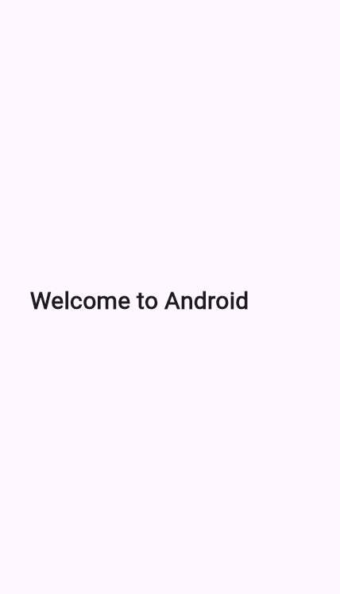
Date:

Practical 2

AIM: Write android program to demonstrate usage of string.

Program:

<?xml version="1.0" encoding="utf-8"?>

<LinearLayout xmlns:android="http://schemas.android.com/apk/res/android"

android:layout_width="match_parent"

android:layout_height="match_parent"

android:orientation="vertical"

android:gravity="center"

android:padding="20dp"

android:background="#FFFFFF">

<TextView

android:id="@+id/textViewResult"

android:layout_width="wrap_content"

android:layout_height="wrap_content"

android:text="String Example"

android:textSize="22sp"

android:textColor="#000000" />

</LinearLayout>

Main Activity.java

package com.example.stringdemo;

import androidx.appcompat.app.AppCompatActivity;
import android.os.Bundle;
import android.widget.TextView;

public class MainActivity extends AppCompatActivity {

@Override
protected void onCreate(Bundle savedInstanceState) {
super.onCreate(savedInstanceState);
setContentView(R.layout.activity_main);

TextView textView = findViewById(R.id.textViewResult);

// String usage demonstration
String firstName = "Android";
String lastName = "Programming";

// Concatenation
String fullName = firstName + " " + lastName;

// Display result
textView.setText("Concatenated String: " + fullName);
}
}
Output:

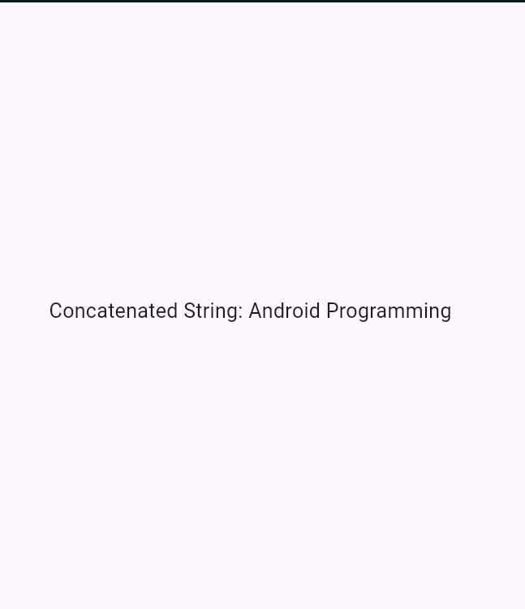

Date:

Practical 3

AIM: Write android program to demonstrate activity life cycle.

Program:

XML Layout (activity_main.xml)
<?xml version="1.0" encoding="utf-8"?>
<LinearLayout xmlns:android="http://schemas.android.com/apk/res/android"
android:layout_width="match_parent"
android:layout_height="match_parent"
android:orientation="vertical"
android:gravity="center"
android:background="#FFFFFF"
android:padding="20dp">

<TextView
android:id="@+id/textViewLifeCycle"
android:layout_width="wrap_content"
android:layout_height="wrap_content"
android:text="Activity Life Cycle Demo"
android:textSize="20sp"
android:textColor="#000000"/>
</LinearLayout>

Java Code (MainActivity.java)
package com.example.lifecycleapp;

import androidx.appcompat.app.AppCompatActivity;
import android.os.Bundle;
import android.util.Log;
import android.widget.TextView;
public class MainActivity extends AppCompatActivity {
private static final String TAG = "ActivityLifeCycle";
TextView textView;
@Override
protected void onCreate(Bundle savedInstanceState) {
super.onCreate(savedInstanceState);
setContentView(R.layout.activity_main);
textView = findViewById(R.id.textViewLifeCycle);
textView.setText("onCreate() called");
Log.d(TAG, "onCreate() called");
}

@Override
protected void onStart() {
super.onStart();
Log.d(TAG, "onStart() called");
}

@Override
protected void onResume() {
super.onResume();
Log.d(TAG, "onResume() called");
}

@Override
protected void onPause() {
super.onPause();
Log.d(TAG, "onPause() called");
}

@Override
protected void onStop() {
super.onStop();
Log.d(TAG, "onStop() called");
}

@Override
protected void onRestart() {
super.onRestart();
Log.d(TAG, "onRestart() called");
}

@Override
protected void onDestroy() {
super.onDestroy();
Log.d(TAG, "onDestroy() called");
}
}

Output:

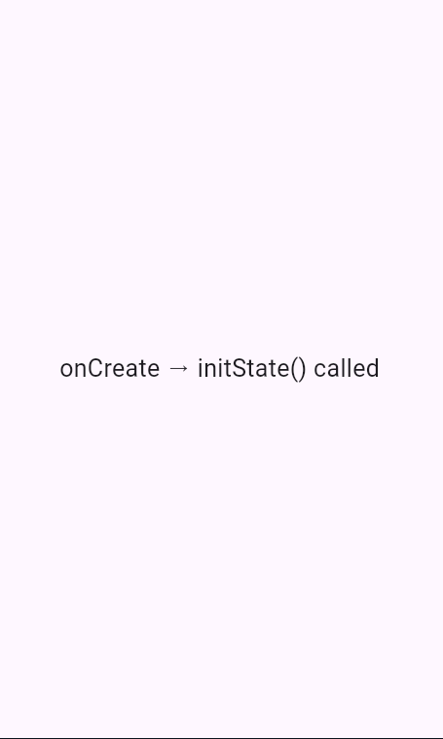
Date:

Practical 4
AIM: Write android program to change the background of activity.

Program:
XML Layout (activity_main.xml)

<?xml version="1.0" encoding="utf-8"?>

<LinearLayout xmlns:android="http://schemas.android.com/apk/res/android"

android:layout_width="match_parent"

android:layout_height="match_parent"

android:orientation="vertical"

android:gravity="center"

android:padding="20dp"

android:id="@+id/mainLayout">

<Button

android:id="@+id/btnChangeColor"

android:layout_width="wrap_content"

android:layout_height="wrap_content"

android:text="Change Background" />

</LinearLayout>

Java Code (MainActivity.java)

package com.example.backgrounddemo;

import androidx.appcompat.app.AppCompatActivity;

import android.os.Bundle;

import android.graphics.Color;

import android.view.View;

import android.widget.Button;

import android.widget.LinearLayout;

public class MainActivity extends AppCompatActivity {

LinearLayout mainLayout;

Button btnChange;

@Override

protected void onCreate(Bundle savedInstanceState) {

super.onCreate(savedInstanceState);

setContentView(R.layout.activity_main);

mainLayout = findViewById(R.id.mainLayout);

btnChange = findViewById(R.id.btnChangeColor);

btnChange.setOnClickListener(new View.OnClickListener() {

@Override

public void onClick(View v) {

// Change background color on button click

mainLayout.setBackgroundColor(Color.CYAN);

}

});

}

}

Output :

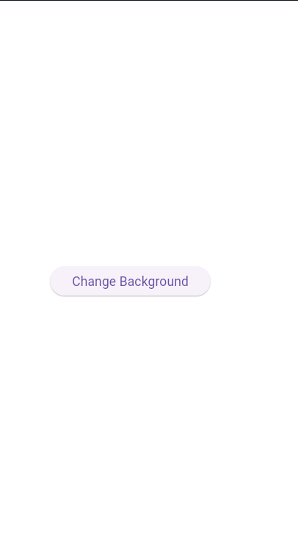
Date:

Practical 5

AIM: Write android program to perform all operation in calculator.

Program:

XML Layout (activity_main.xml)
<?xml version="1.0" encoding="utf-8"?>
<LinearLayout xmlns:android="http://schemas.android.com/apk/res/android"
android:layout_width="match_parent"
android:layout_height="match_parent"
android:orientation="vertical"
android:padding="20dp"
android:gravity="center"
android:id="@+id/mainLayout">

<EditText
android:id="@+id/etNum1"
android:layout_width="match_parent"
android:layout_height="wrap_content"
android:hint="Enter First Number"
android:inputType="numberDecimal"
android:layout_marginBottom="10dp"/>

<EditText
android:id="@+id/etNum2"
android:layout_width="match_parent"
android:layout_height="wrap_content"
android:hint="Enter Second Number"
android:inputType="numberDecimal"
android:layout_marginBottom="20dp"/>

<LinearLayout
android:layout_width="match_parent"
android:layout_height="wrap_content"
android:orientation="horizontal"
android:gravity="center"
android:layout_marginBottom="20dp">

<Button
android:id="@+id/btnAdd"
android:layout_width="wrap_content"
android:layout_height="wrap_content"
android:text="+" />

<Button
android:id="@+id/btnSub"
android:layout_width="wrap_content"
android:layout_height="wrap_content"
android:text="-"
android:layout_marginLeft="10dp"/>

<Button
android:id="@+id/btnMul"
android:layout_width="wrap_content"
android:layout_height="wrap_content"
android:text="×"
android:layout_marginLeft="10dp"/>

<Button
android:id="@+id/btnDiv"
android:layout_width="wrap_content"
android:layout_height="wrap_content"
android:text="÷"
android:layout_marginLeft="10dp"/>
</LinearLayout>

<TextView
android:id="@+id/tvResult"
android:layout_width="wrap_content"
android:layout_height="wrap_content"
android:text="Result will be shown here"
android:textSize="20sp"
android:textColor="#000000"/>
</LinearLayout>

Java Code (MainActivity.java)

package com.example.calculatordemo;

import androidx.appcompat.app.AppCompatActivity;
import android.os.Bundle;
import android.view.View;
import android.widget.Button;
import android.widget.EditText;
import android.widget.TextView;
import android.widget.Toast;

public class MainActivity extends AppCompatActivity {

EditText etNum1, etNum2;
Button btnAdd, btnSub, btnMul, btnDiv;
TextView tvResult;

@Override
protected void onCreate(Bundle savedInstanceState) {
super.onCreate(savedInstanceState);
setContentView(R.layout.activity_main);

etNum1 = findViewById(R.id.etNum1);
etNum2 = findViewById(R.id.etNum2);
btnAdd = findViewById(R.id.btnAdd);
btnSub = findViewById(R.id.btnSub);
btnMul = findViewById(R.id.btnMul);
btnDiv = findViewById(R.id.btnDiv);
tvResult = findViewById(R.id.tvResult);

btnAdd.setOnClickListener(new View.OnClickListener() {
@Override
public void onClick(View v) {
calculate('+');
}
});

btnSub.setOnClickListener(new View.OnClickListener() {
@Override
public void onClick(View v) {
calculate('-');
}
});

btnMul.setOnClickListener(new View.OnClickListener() {
@Override
public void onClick(View v) {
calculate('*');
}
});

btnDiv.setOnClickListener(new View.OnClickListener() {
@Override
public void onClick(View v) {
calculate('/');
}
});
}

private void calculate(char operator) {
String num1Str = etNum1.getText().toString();
String num2Str = etNum2.getText().toString();

if (num1Str.isEmpty() || num2Str.isEmpty()) {
Toast.makeText(this, "Please enter both numbers", Toast.LENGTH_SHORT).show();
return;
}

double num1 = Double.parseDouble(num1Str);
double num2 = Double.parseDouble(num2Str);
double result = 0;

switch (operator) {
case '+':
result = num1 + num2;
break;
case '-':
result = num1 - num2;
break;
case '*':
result = num1 * num2;
break;
case '/':
if (num2 != 0) {
result = num1 / num2;
} else {
Toast.makeText(this, "Cannot divide by zero", Toast.LENGTH_SHORT).show();
return;
}
break;
}

tvResult.setText("Result: " + result);
}
}

Output :

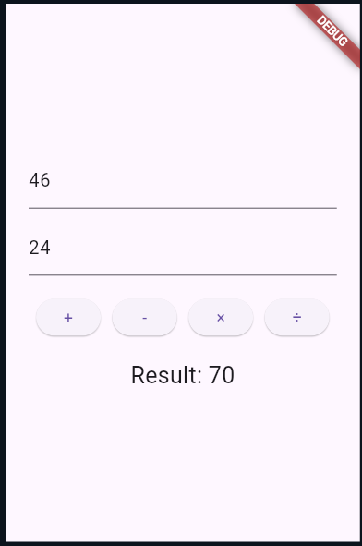

Date:

Practical 6

AIM: Write android program to create multiple activities within an application.

Program:

XML Layout for MainActivity (activity_main.xml)

<?xml version="1.0" encoding="utf-8"?>

<LinearLayout xmlns:android="http://schemas.android.com/apk/res/android"

android:layout_width="match_parent"

android:layout_height="match_parent"

android:orientation="vertical"

android:gravity="center"

android:padding="20dp">

<Button

android:id="@+id/btnNext"

android:layout_width="wrap_content"

android:layout_height="wrap_content"

android:text="Go to Second Activity" />

</LinearLayout>

XML Layout for SecondActivity (activity_second.xml)

<?xml version="1.0" encoding="utf-8"?>

<LinearLayout xmlns:android="http://schemas.android.com/apk/res/android"

android:layout_width="match_parent"

android:layout_height="match_parent"

android:orientation="vertical"

android:gravity="center"

android:padding="20dp">

<TextView

android:id="@+id/tvMessage"

android:layout_width="wrap_content"

android:layout_height="wrap_content"

android:text="Welcome to Second Activity"

android:textSize="20sp"

android:textColor="#000000"/>

</LinearLayout>

Java Code for MainActivity.java

package com.example.multipleactivities;

import androidx.appcompat.app.AppCompatActivity;

import android.content.Intent;

import android.os.Bundle;

import android.view.View;

import android.widget.Button;

public class MainActivity extends AppCompatActivity {

Button btnNext;

@Override

protected void onCreate(Bundle savedInstanceState) {

super.onCreate(savedInstanceState);

setContentView(R.layout.activity_main);

btnNext = findViewById(R.id.btnNext);

btnNext.setOnClickListener(new View.OnClickListener() {

@Override

public void onClick(View v) {

// Intent to open SecondActivity

Intent intent = new Intent(MainActivity.this, SecondActivity.class);

startActivity(intent);

}

});

}

}

Java Code for SecondActivity.java

package com.example.multipleactivities;

import androidx.appcompat.app.AppCompatActivity;

import android.os.Bundle;

public class SecondActivity extends AppCompatActivity {

@Override

protected void onCreate(Bundle savedInstanceState) {

super.onCreate(savedInstanceState);

setContentView(R.layout.activity_second);

}

}

AndroidManifest.xml (Add Second Activity)

<application

android:allowBackup="true"

android:icon="@mipmap/ic_launcher"

android:label="@string/app_name"

android:supportsRtl="true"

android:theme="@style/Theme.AppCompat.Light.NoActionBar">

<activity android:name=".SecondActivity"></activity>

<activity android:name=".MainActivity">

<intent-filter>

<action android:name="android.intent.action.MAIN" />

<category android:name="android.intent.category.LAUNCHER" />

</intent-filter>

</activity>

</application>

Output :
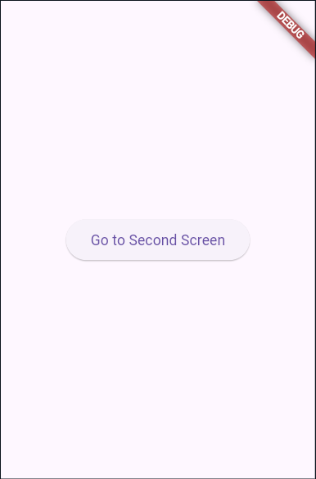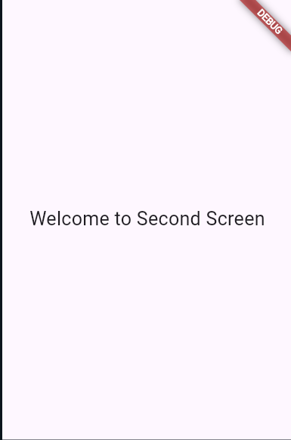

Date:

Practical 7
AIM: Write android program to demonstrate action button by implementing ONCLICKLISTENER.

Program:
XML Layout (activity_main.xml)
<?xml version="1.0" encoding="utf-8"?>
<LinearLayout xmlns:android="http://schemas.android.com/apk/res/android"
android:layout_width="match_parent"
android:layout_height="match_parent"
android:orientation="vertical"
android:gravity="center"
android:padding="20dp">

<Button
android:id="@+id/btnClickMe"
android:layout_width="wrap_content"
android:layout_height="wrap_content"
android:text="Click Me" />

<TextView
android:id="@+id/tvResult"
android:layout_width="wrap_content"
android:layout_height="wrap_content"
android:text="Result will appear here"
android:textSize="20sp"
android:layout_marginTop="20dp"/>
</LinearLayout>

Java Code (MainActivity.java)
package com.example.onclickdemo;
import androidx.appcompat.app.AppCompatActivity;
import android.os.Bundle;
import android.view.View;
import android.widget.Button;
import android.widget.TextView;

public class MainActivity extends AppCompatActivity implements View.OnClickListener {

Button btnClickMe;
TextView tvResult;

@Override
protected void onCreate(Bundle savedInstanceState) {
super.onCreate(savedInstanceState);
setContentView(R.layout.activity_main);

btnClickMe = findViewById(R.id.btnClickMe);
tvResult = findViewById(R.id.tvResult);

// Set OnClickListener
btnClickMe.setOnClickListener(this);
}

@Override
public void onClick(View v) {
if (v.getId() == R.id.btnClickMe) {
tvResult.setText("Button Clicked Successfully!");
}

Output :

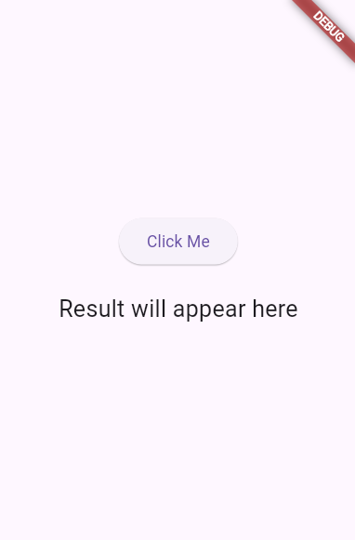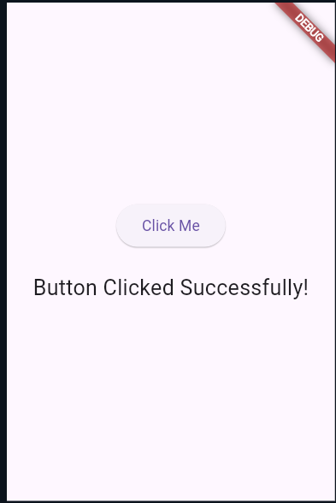
Date:

Practical 8
AIM: Write android program to demonstrate sound button application.

Program:

XML Layout (activity_main.xml)

<?xml version="1.0" encoding="utf-8"?>

<LinearLayout xmlns:android="http://schemas.android.com/apk/res/android"

android:layout_width="match_parent"

android:layout_height="match_parent"

android:orientation="vertical"

android:gravity="center"

android:padding="20dp">

<Button

android:id="@+id/btnPlaySound"

android:layout_width="wrap_content"

android:layout_height="wrap_content"

android:text="Play Sound" />

</LinearLayout>

Java Code (MainActivity.java)

package com.example.soundbuttonapp;

import androidx.appcompat.app.AppCompatActivity;

import android.media.MediaPlayer;

import android.os.Bundle;

import android.view.View;

import android.widget.Button;

public class MainActivity extends AppCompatActivity {

Button btnPlaySound;

MediaPlayer mediaPlayer;

@Override

protected void onCreate(Bundle savedInstanceState) {

super.onCreate(savedInstanceState);

setContentView(R.layout.activity_main);

btnPlaySound = findViewById(R.id.btnPlaySound);

// Initialize MediaPlayer with sound file from res/raw

mediaPlayer = MediaPlayer.create(this, R.raw.clicksound);

btnPlaySound.setOnClickListener(new View.OnClickListener() {

@Override

public void onClick(View v) {

// Play sound when button clicked

if (mediaPlayer != null) {

mediaPlayer.start();

}

}

});

}

@Override

protected void onDestroy() {

super.onDestroy();

if (mediaPlayer != null) {

mediaPlayer.release();

mediaPlayer = null;

}

}

}

Output :

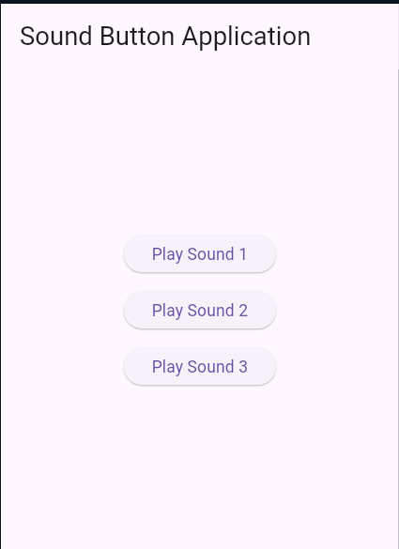

Date:

Practical 9

AIM: Write an Android application to convert into different currencies for example, Rupees to dollar.

Program:

XML Layout (activity_main.xml)
<?xml version="1.0" encoding="utf-8"?>
<LinearLayout xmlns:android="http://schemas.android.com/apk/res/android"
android:layout_width="match_parent"
android:layout_height="match_parent"
android:orientation="vertical"
android:gravity="center"
android:padding="20dp">

<EditText
android:id="@+id/etRupees"
android:layout_width="match_parent"
android:layout_height="wrap_content"
android:hint="Enter amount in Rupees"
android:inputType="numberDecimal"
android:layout_marginBottom="15dp"/>

<Button
android:id="@+id/btnConvert"
android:layout_width="wrap_content"
android:layout_height="wrap_content"
android:text="Convert to Dollar" />

<TextView
android:id="@+id/tvResult"
android:layout_width="wrap_content"
android:layout_height="wrap_content"
android:text="Result will appear here"
android:textSize="20sp"
android:layout_marginTop="20dp"/>
</LinearLayout>

Java Code (MainActivity.java)
package com.example.currencyconverter;
import androidx.appcompat.app.AppCompatActivity;
import android.os.Bundle;
import android.view.View;
import android.widget.Button;
import android.widget.EditText;
import android.widget.TextView;
import android.widget.Toast;

public class MainActivity extends AppCompatActivity {
EditText etRupees;
Button btnConvert;
TextView tvResult;

// Conversion rate (Example: 1 Rupee = 0.012 USD)
final double DOLLAR_RATE = 0.012;

@Override
protected void onCreate(Bundle savedInstanceState) {
super.onCreate(savedInstanceState);
setContentView(R.layout.activity_main);

etRupees = findViewById(R.id.etRupees);
btnConvert = findViewById(R.id.btnConvert);
tvResult = findViewById(R.id.tvResult);

btnConvert.setOnClickListener(new View.OnClickListener() {
@Override
public void onClick(View v) {
String rupeesStr = etRupees.getText().toString();

if (rupeesStr.isEmpty()) {
Toast.makeText(MainActivity.this, "Please enter amount in Rupees", Toast.LENGTH_SHORT).show();
return;
}

double rupees = Double.parseDouble(rupeesStr);
double dollars = rupees * DOLLAR_RATE;

tvResult.setText("USD: $" + String.format("%.2f", dollars));
}
});
}
}

Output :

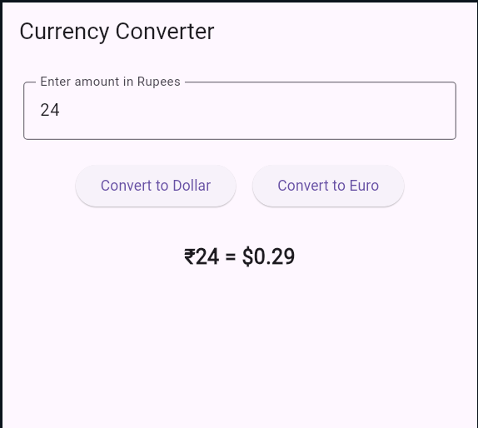

Date:

Practical 10

AIM: Write an android application to count library overdue.

Program:
XML Layout (activity_main.xml)

<?xml version="1.0" encoding="utf-8"?>
<LinearLayout xmlns:android="http://schemas.android.com/apk/res/android"
android:layout_width="match_parent"
android:layout_height="match_parent"
android:orientation="vertical"
android:gravity="center"
android:padding="20dp">

<EditText
android:id="@+id/etDays"
android:layout_width="match_parent"
android:layout_height="wrap_content"
android:hint="Enter number of overdue days"
android:inputType="number"
android:layout_marginBottom="15dp"/>

<Button
android:id="@+id/btnCalculate"
android:layout_width="wrap_content"
android:layout_height="wrap_content"
android:text="Calculate Fine" />

<TextView
android:id="@+id/tvResult"
android:layout_width="wrap_content"
android:layout_height="wrap_content"
android:text="Fine will appear here"
android:textSize="20sp"
android:layout_marginTop="20dp"/>
</LinearLayout>

Java Code (MainActivity.java)
package com.example.libraryfine;
import androidx.appcompat.app.AppCompatActivity;
import android.os.Bundle;
import android.view.View;
import android.widget.Button;
import android.widget.EditText;
import android.widget.TextView;
import android.widget.Toast;
public class MainActivity extends AppCompatActivity {

EditText etDays;
Button btnCalculate;
TextView tvResult;

// Fine rate per day
final int FINE_RATE = 2;

@Override
protected void onCreate(Bundle savedInstanceState) {
super.onCreate(savedInstanceState);
setContentView(R.layout.activity_main);

etDays = findViewById(R.id.etDays);
btnCalculate = findViewById(R.id.btnCalculate);
tvResult = findViewById(R.id.tvResult);

btnCalculate.setOnClickListener(new View.OnClickListener() {
@Override
public void onClick(View v) {
String daysStr = etDays.getText().toString();

if (daysStr.isEmpty()) {
Toast.makeText(MainActivity.this, "Please enter overdue days", Toast.LENGTH_SHORT).show();
return;
}
int days = Integer.parseInt(daysStr);
int fine = days * FINE_RATE;

tvResult.setText("Total Fine: ₹" + fine);
}
});
}
}

Output :

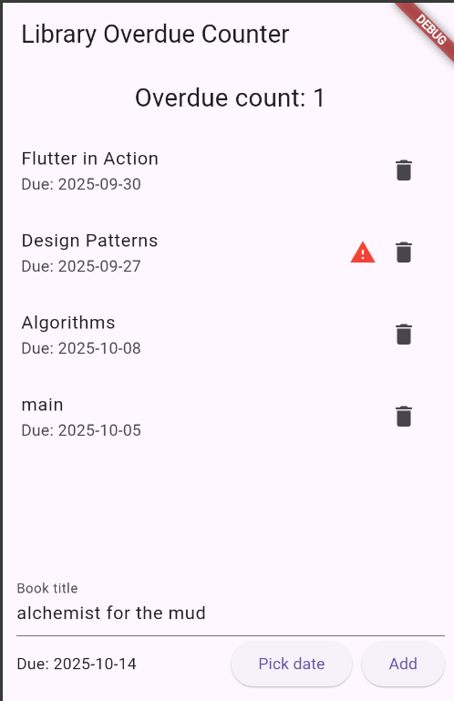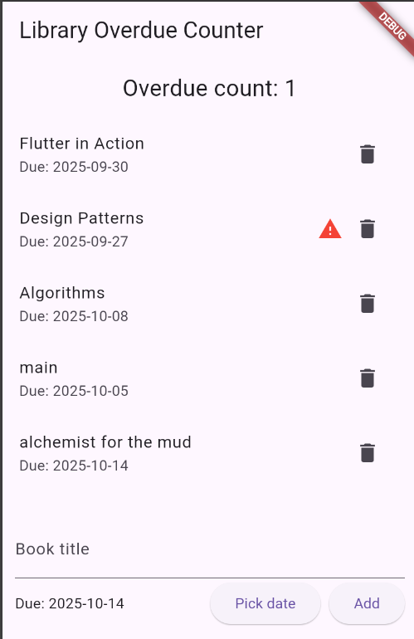

Date:

Practical 11

AIM: Write an application to mark the daily route of travel in map.

Program:

XML Layout (activity_main.xml)
<?xml version="1.0" encoding="utf-8"?>
<fragment xmlns:android="http://schemas.android.com/apk/res/android"
android:id="@+id/map"
android:name="com.google.android.gms.maps.SupportMapFragment"
android:layout_width="match_parent"
android:layout_height="match_parent"/>

Java Code (MainActivity.java)

package com.example.dailyroute;
import androidx.fragment.app.FragmentActivity;
import android.os.Bundle;
import com.google.android.gms.maps.CameraUpdateFactory;
import com.google.android.gms.maps.GoogleMap;
import com.google.android.gms.maps.OnMapReadyCallback;
import com.google.android.gms.maps.SupportMapFragment;
import com.google.android.gms.maps.model.LatLng;
import com.google.android.gms.maps.model.MarkerOptions;
import com.google.android.gms.maps.model.PolylineOptions;
public class MainActivity extends FragmentActivity implements OnMapReadyCallback {
private GoogleMap mMap;
@Override
protected void onCreate(Bundle savedInstanceState) {
super.onCreate(savedInstanceState);
setContentView(R.layout.activity_main);

SupportMapFragment mapFragment = (SupportMapFragment) getSupportFragmentManager()
.findFragmentById(R.id.map);
if (mapFragment != null) {
mapFragment.getMapAsync(this);
}
}

@Override
public void onMapReady(GoogleMap googleMap) {
mMap = googleMap;

// Example route: Home -> Bus Stop -> Office
LatLng home = new LatLng(28.6139, 77.2090); // Delhi example
LatLng busStop = new LatLng(28.6200, 77.2100);
LatLng office = new LatLng(28.6250, 77.2150);
// Add markers
mMap.addMarker(new MarkerOptions().position(home).title("Home"));
mMap.addMarker(new MarkerOptions().position(busStop).title("Bus Stop"));
mMap.addMarker(new MarkerOptions().position(office).title("Office"));

// Draw route with Polyline
mMap.addPolyline(new PolylineOptions()
.add(home, busStop, office)
.width(8)
.color(0xFF2196F3)); // Blue
// Move camera to Home
mMap.moveCamera(CameraUpdateFactory.newLatLngZoom(home, 14));
}
}

Output :

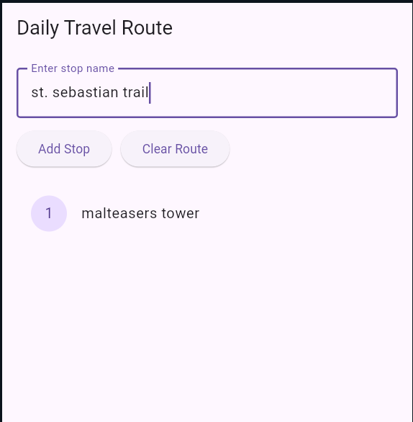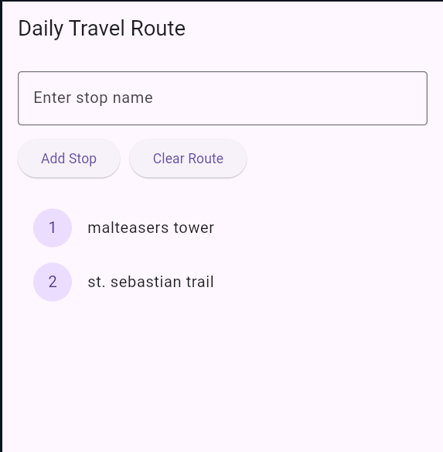

Practical 12

AIM: Write an Android application to convert into different currencies.

Program:

XML Layout (activity_main.xml)
<?xml version="1.0" encoding="utf-8"?>
<LinearLayout xmlns:android="http://schemas.android.com/apk/res/android"
android:layout_width="match_parent"
android:layout_height="match_parent"
android:orientation="vertical"
android:gravity="center"
android:padding="20dp">

<EditText
android:id="@+id/etRupees"
android:layout_width="match_parent"
android:layout_height="wrap_content"
android:hint="Enter amount in Rupees"
android:inputType="numberDecimal"
android:layout_marginBottom="15dp"/>

<Button
android:id="@+id/btnConvert"
android:layout_width="wrap_content"
android:layout_height="wrap_content"
android:text="Convert to Dollar" />

<TextView
android:id="@+id/tvResult"
android:layout_width="wrap_content"
android:layout_height="wrap_content"
android:text="Result will appear here"
android:textSize="20sp"
android:layout_marginTop="20dp"/>
</LinearLayout>

Java Code (MainActivity.java)
package com.example.currencyconverter;
import androidx.appcompat.app.AppCompatActivity;
import android.os.Bundle;
import android.view.View;
import android.widget.Button;
import android.widget.EditText;
import android.widget.TextView;
import android.widget.Toast;

public class MainActivity extends AppCompatActivity {
EditText etRupees;
Button btnConvert;
TextView tvResult;

// Conversion rate (Example: 1 Rupee = 0.012 USD)
final double DOLLAR_RATE = 0.012;

@Override
protected void onCreate(Bundle savedInstanceState) {
super.onCreate(savedInstanceState);
setContentView(R.layout.activity_main);

etRupees = findViewById(R.id.etRupees);
btnConvert = findViewById(R.id.btnConvert);
tvResult = findViewById(R.id.tvResult);

btnConvert.setOnClickListener(new View.OnClickListener() {
@Override
public void onClick(View v) {
String rupeesStr = etRupees.getText().toString();

if (rupeesStr.isEmpty()) {
Toast.makeText(MainActivity.this, "Please enter amount in Rupees", Toast.LENGTH_SHORT).show();
return;
}

double rupees = Double.parseDouble(rupeesStr);
double dollars = rupees * DOLLAR_RATE;

tvResult.setText("USD: $" + String.format("%.2f", dollars));
}
});
}
}

Date:

Practical 13
AIM: Write an application to record video and audio on topic "Intent" and play the audio and video.

Program:

AndroidManifest.xml

<uses-permission android:name="android.permission.CAMERA"/>

<uses-permission android:name="android.permission.RECORD_AUDIO"/>

<uses-permission android:name="android.permission.WRITE_EXTERNAL_STORAGE"/>

<uses-permission android:name="android.permission.READ_EXTERNAL_STORAGE"/>

<application

...>

<activity android:name=".MainActivity">

<intent-filter>

<action android:name="android.intent.action.MAIN"/>

<category android:name="android.intent.category.LAUNCHER"/>

</intent-filter>

</activity>

</application>

XML Layout (activity_main.xml)

<?xml version="1.0" encoding="utf-8"?>

<LinearLayout xmlns:android="http://schemas.android.com/apk/res/android"

android:orientation="vertical"

android:gravity="center"

android:layout_width="match_parent"

android:layout_height="match_parent"

android:padding="20dp">

<Button

android:id="@+id/btnRecordAudio"

android:layout_width="wrap_content"

android:layout_height="wrap_content"

android:text="Record Audio"/>

<Button

android:id="@+id/btnRecordVideo"

android:layout_width="wrap_content"

android:layout_height="wrap_content"

android:text="Record Video"

android:layout_marginTop="15dp"/>

<Button

android:id="@+id/btnPlayAudio"

android:layout_width="wrap_content"

android:layout_height="wrap_content"

android:text="Play Audio"

android:layout_marginTop="15dp"/>

<Button

android:id="@+id/btnPlayVideo"

android:layout_width="wrap_content"

android:layout_height="wrap_content"

android:text="Play Video"

android:layout_marginTop="15dp"/>

</LinearLayout>

Java Code (MainActivity.java)

package com.example.intentmediaapp;

import androidx.appcompat.app.AppCompatActivity;

import android.content.Intent;

import android.net.Uri;

import android.os.Bundle;

import android.provider.MediaStore;

import android.view.View;

import android.widget.Button;

import android.widget.Toast;

public class MainActivity extends AppCompatActivity {

Button btnRecordAudio, btnRecordVideo, btnPlayAudio, btnPlayVideo;

Uri audioUri, videoUri;

final int AUDIO_REQUEST = 1;

final int VIDEO_REQUEST = 2;

@Override

protected void onCreate(Bundle savedInstanceState) {

super.onCreate(savedInstanceState);

setContentView(R.layout.activity_main);

btnRecordAudio = findViewById(R.id.btnRecordAudio);

btnRecordVideo = findViewById(R.id.btnRecordVideo);

btnPlayAudio = findViewById(R.id.btnPlayAudio);

btnPlayVideo = findViewById(R.id.btnPlayVideo);

// Record Audio

btnRecordAudio.setOnClickListener(new View.OnClickListener() {

@Override

public void onClick(View v) {

Intent audioIntent = new Intent(MediaStore.Audio.Media.RECORD_SOUND_ACTION);

try {

startActivityForResult(audioIntent, AUDIO_REQUEST);

} catch (Exception e) {

Toast.makeText(MainActivity.this, "No app found to record audio", Toast.LENGTH_SHORT).show();

}

}

});

// Record Video

btnRecordVideo.setOnClickListener(new View.OnClickListener() {

@Override

public void onClick(View v) {

Intent videoIntent = new Intent(MediaStore.ACTION_VIDEO_CAPTURE);

try {

startActivityForResult(videoIntent, VIDEO_REQUEST);

} catch (Exception e) {

Toast.makeText(MainActivity.this, "No app found to record video", Toast.LENGTH_SHORT).show();

}

}

});

// Play Audio

btnPlayAudio.setOnClickListener(new View.OnClickListener() {

@Override

public void onClick(View v) {

if (audioUri != null) {

Intent playAudio = new Intent(Intent.ACTION_VIEW);

playAudio.setDataAndType(audioUri, "audio/*");

startActivity(playAudio);

} else {

Toast.makeText(MainActivity.this, "No audio recorded", Toast.LENGTH_SHORT).show();

}

}

});

// Play Video

btnPlayVideo.setOnClickListener(new View.OnClickListener() {

@Override

public void onClick(View v) {

if (videoUri != null) {

Intent playVideo = new Intent(Intent.ACTION_VIEW);

playVideo.setDataAndType(videoUri, "video/*");

startActivity(playVideo);

} else {

Toast.makeText(MainActivity.this, "No video recorded", Toast.LENGTH_SHORT).show();

}

}

});

}

@Override

protected void onActivityResult(int requestCode, int resultCode, Intent data) {

super.onActivityResult(requestCode, resultCode, data);

if (resultCode == RESULT_OK) {

if (requestCode == AUDIO_REQUEST) {

audioUri = data.getData();

} else if (requestCode == VIDEO_REQUEST) {

videoUri = data.getData();

}

}

}

}

Output :

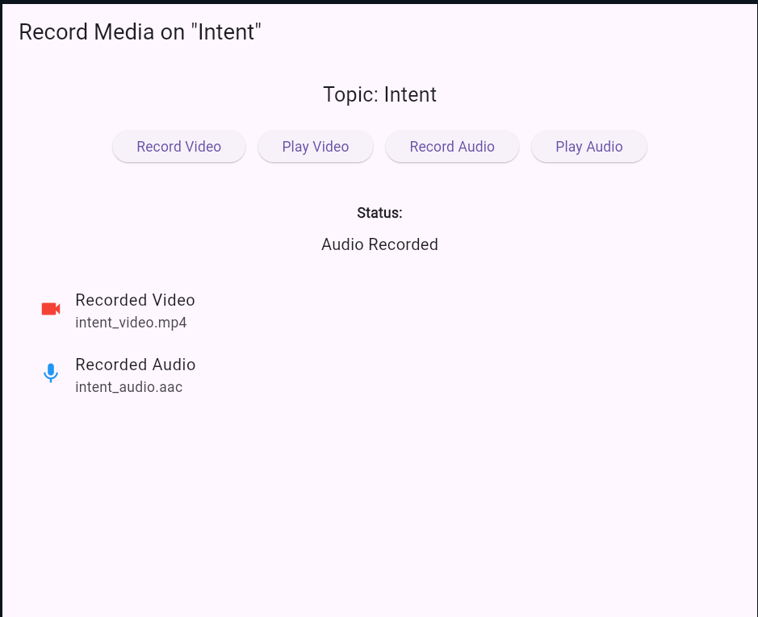
Date:

Practical 14

AIM: Write android program to set the wallpaper of your device using bitmap class.

Program:

XML Layout (activity_main.xml)

<?xml version="1.0" encoding="utf-8"?>

<LinearLayout xmlns:android="http://schemas.android.com/apk/res/android"

android:orientation="vertical"

android:gravity="center"

android:layout_width="match_parent"

android:layout_height="match_parent"

android:padding="20dp">

<Button

android:id="@+id/btnSetWallpaper"

android:layout_width="wrap_content"

android:layout_height="wrap_content"

android:text="Set Wallpaper"/>

</LinearLayout>

Java Code (MainActivity.java)

package com.example.wallpaperapp;

import androidx.appcompat.app.AppCompatActivity;

import android.app.WallpaperManager;

import android.graphics.Bitmap;

import android.graphics.BitmapFactory;

import android.os.Bundle;

import android.view.View;

import android.widget.Button;

import android.widget.Toast;

import java.io.IOException;

public class MainActivity extends AppCompatActivity {

Button btnSetWallpaper;

@Override

protected void onCreate(Bundle savedInstanceState) {

super.onCreate(savedInstanceState);

setContentView(R.layout.activity_main);

btnSetWallpaper = findViewById(R.id.btnSetWallpaper);

btnSetWallpaper.setOnClickListener(new View.OnClickListener() {

@Override

public void onClick(View v) {

// Load bitmap from drawable

Bitmap bitmap = BitmapFactory.decodeResource(getResources(), R.drawable.wallpaper_image);

// Set wallpaper using WallpaperManager

WallpaperManager wallpaperManager = WallpaperManager.getInstance(getApplicationContext());

try {

wallpaperManager.setBitmap(bitmap);

Toast.makeText(MainActivity.this, "Wallpaper Set Successfully", Toast.LENGTH_SHORT).show();

} catch (IOException e) {

e.printStackTrace();

Toast.makeText(MainActivity.this, "Failed to Set Wallpaper", Toast.LENGTH_SHORT).show();

}

}

});

}

}

Output :

