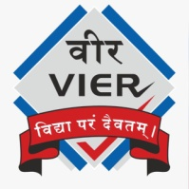 | Vadodara Institute  Details of Republic Day Event
- Title of Event: Republic Day Celebration
- Type of Event: Republic Day Celebration
- Date, Time and Venue of the Event: 26th January 2026 , 9:30M onwards, Vadodara Institute of Engineering
- Description of Event: Our college celebrated 26th January (Republic Day) with great enthusiasm and patriotic spirit. The event showcased the talents of our students through a variety of cultural activities including patriotic songs, energetic dance performances, and thought-provoking dramas highlighting the values of freedom, unity, and democracy. Students actively participated and expressed their love for the nation through art and performance. The celebration emphasized the importance of the Indian Constitution and reminded everyone of their duties as responsible citizens. The program concluded with a message of national pride, unity, and commitment towards building a better future for India.
- List of Experts and their brief speech: Dr. Jayeshkumar Patel ,the principal’s speech on Republic Day highlighted the significance of the day as a celebration of India’s Constitution and democratic values. The principal spoke about the sacrifices of freedom fighters, the importance of unity, equality, and responsibility among citizens, and encouraged students to contribute positively to the nation’s progress. The speech inspired everyone to respect the Constitution, uphold national values, and work towards building a strong and inclusive India.
- Name of Faculty Coordinator/s: Prof. Naman Shah
- Name of Student Coordinator/s: Vanshika Shah, Aditya Yadav, Dev Kapatel
- List and number of Participants (Attendance with Signature): attached with sign
- Geotag Photographs of the Event:
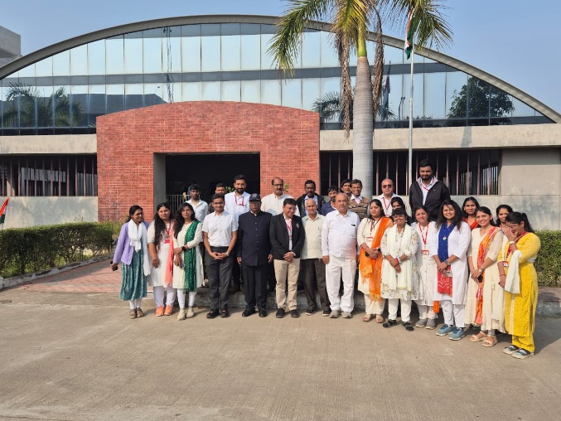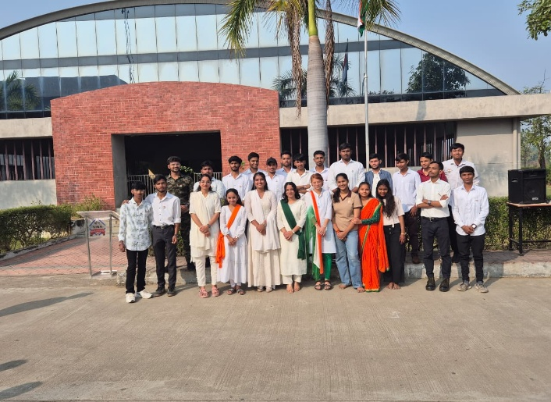
- Feedback: The Republic Day celebration was well organized and inspiring. The speeches and performances beautifully reflected patriotism and unity, making the event meaningful, engaging, and memorable for everyone present.
- Video Feedback/Media Coverage of the Event:
- Social Media Post link: https://www.facebook.com/share/p/1AkPvzYr9Q/?mibextid=wwXIfr
https://www.instagram.com/p/DUuLviSkf_a/?img_index=1&igsh=YTB6dzJ1ZGdnMjE3

