The SpiritWiki in Detail

Mike Sosteric
2026

Support the SpiritWiki
Join our Patreon

The most up to date version of this article
may be found at the SpiritWiki Repository.

https://repo-spiritwiki.lightningpath.org

Abstract
The SpiritWiki is a dynamic, curated knowledge ecosystem that integrates semantic linking, stewardship-based quality control, and a mycelial web structure to overcome the limitations of traditional textbooks, static journal articles, and open platforms like Wikipedia. This article traces the SpiritWiki's evolution from a personal Memex (inspired by Vannevar Bush) into a global public resource receiving over one million unique monthly visitors. It articulates the system's pedagogical advantages—guided instruction, cognitive agency, safe exploration, ecosystem integrity, comprehensive integration, flexible entry points, and AI-readiness—and contrasts these with the frozen, gatekept, and commercially distorted models of conventional scholarly communication. The article also examines how the SpiritWiki's living, semantically linked architecture prevents the theoretical ossification and canonical distortion exemplified by Abraham Maslow's pyramid of needs, which was a business-friendly corruption of Maslow's original Eupsychian vision. By replacing anonymous peer review with accountable knowledge stewards and by embedding firm ontological and epistemic controls, the SpiritWiki aims to accelerate insight, democratize expertise, and support planetary healing. The article concludes that such knowledge technologies are not only possible but already operational, offering a scalable foundation for global transformation in an era of polycrisis.
Keywords: knowledge technology; semantic web; mycelial web; epistemic infrastructure; Eupsychian theory; Maslow; pedagogy; scholarly communication; AI training; SpiritWiki

What is the SpiritWiki?
The SpiritWiki is a sophisticated Knowledge Technology, like a textbook, or an online course. It helps with Knowledge Production and Knowledge Distribution. It does this by providing a self-contained Knowledge Ecosystem, a place where we can put ideas down, edit them, organize them, reorganize them, publish, and distribute across the entire globe instantly. We can work within this knowledge ecosystem as individuals or in collaboration. We can contribute small little droplets of knowledge or even rewrite the Epistemic Infrastructures of our societies if we so choose. We, and by we I mean scholars, teachers, artists, musicians, etc., can even take the knowledge contained therein and build new knowledge, new frameworks, and (most importantly) new stories that transform, uplift, and connect rather than suppress, repress, and disconnect.
This article explores what the SpiritWiki is, how it came into being and how it developed from its early days as a personal public notebook into a global knowledge resource which currently (April 17, 2026) receives over twenty million hits a month from over one million unique visitors from countries all over the world, a knowledge resource that I believe represents a transformative paradigm shift in how we create, organize, and transmit knowledge.

Cloudflare Web Statistics
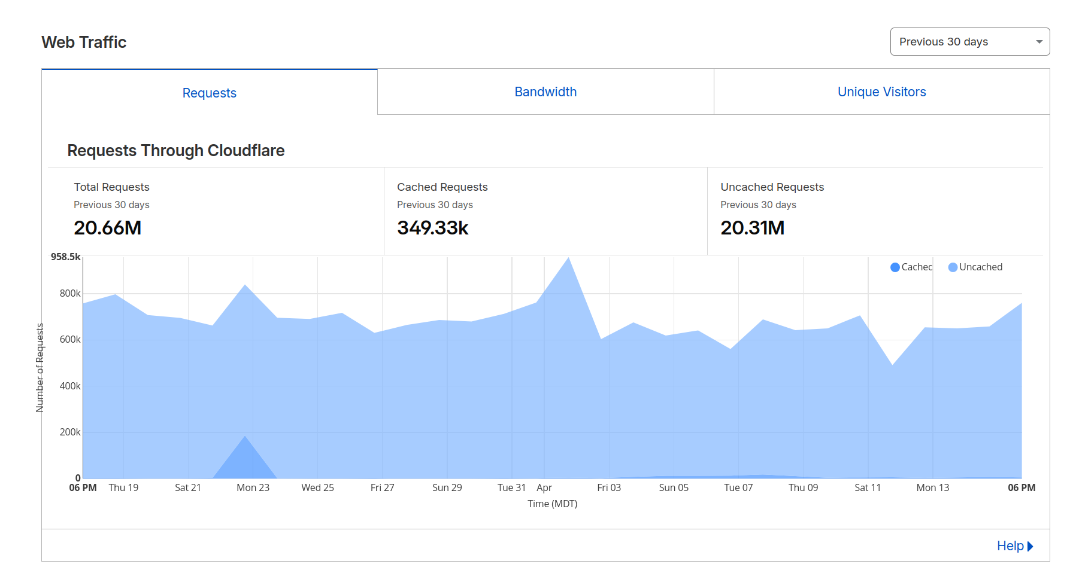
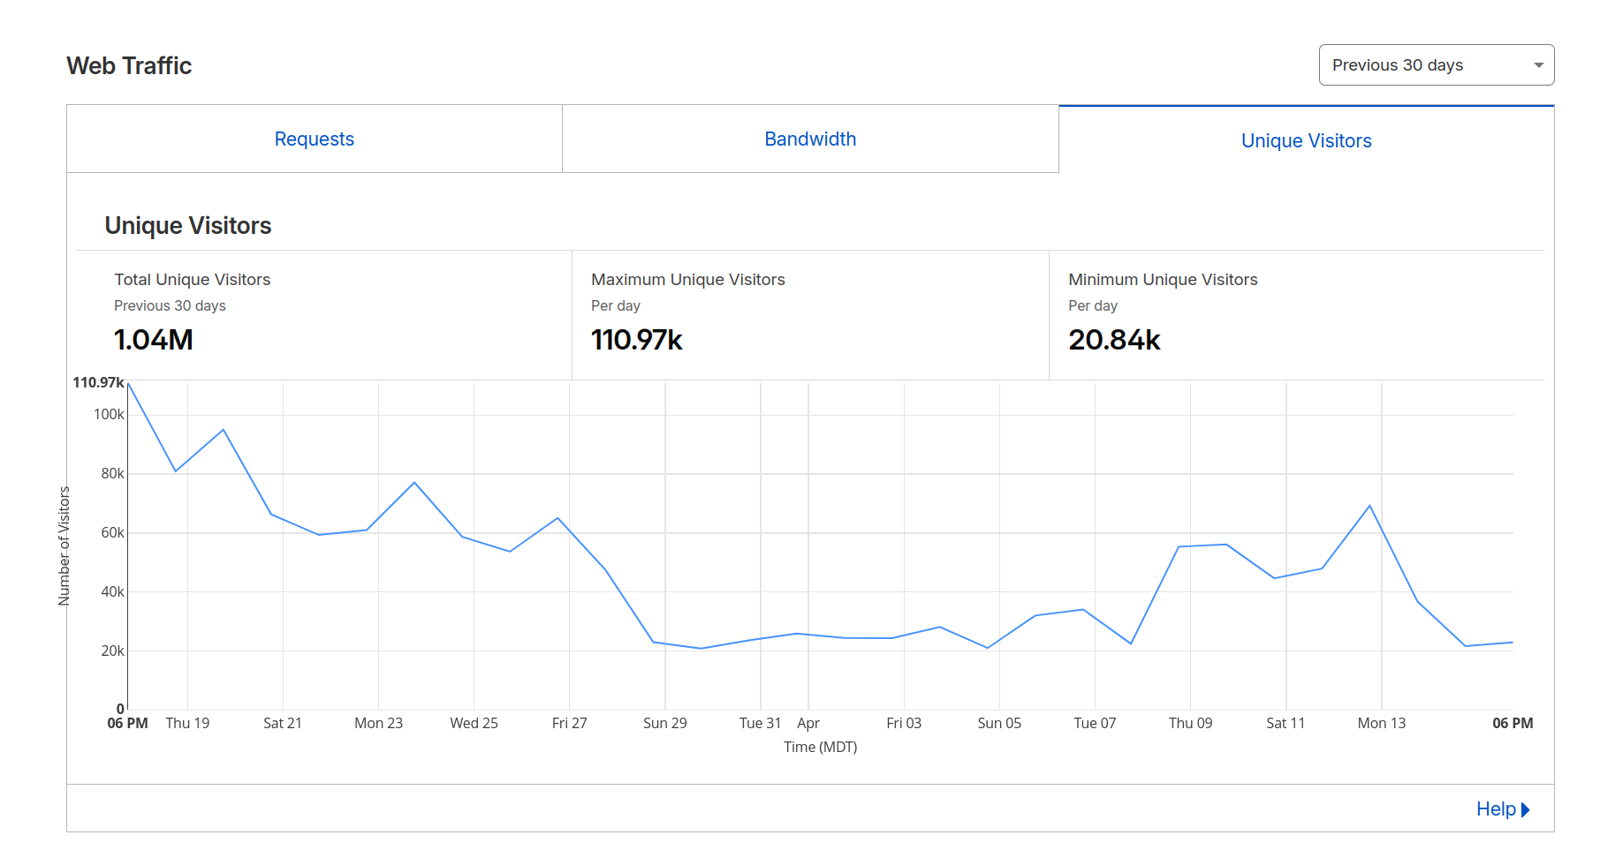

FROM PERSONAL NOTEBOOK TO GLOBAL REPOSITORY

Origins: The Memex Vision
As I explain in more detail elsewhere (Sosteric 2022), the SpiritWiki began as a personal knowledge base, a “Memex” just like Vannevar Bush imagined (Bush 1945). According to Bush, a memex was a device to help individuals store and retrieve vast amounts of personal knowledge in an systematic and organized way. Bush imagined a technology that would allow scholars to create personalized encyclopedias with appropriate interlinking that could then be consulted with speed and flexibility. Interestingly, Bush saw this Memex as the foundation for a post-war, peace oriented scholarship, a tool that could be used to expand not to destroy human life but to expand human intellect (Sosteric 2026a).
That’s what I wanted. As a budding theoretician, I had a lot of information floating around in my head and I needed something to keep it all organized. I had learned about the memex when I did my dissertation on scholarly journals (Sosteric 1996)and so I naturally settled on that idea. I searched around for a tool that could help and landed on MediaWiki software, the perfect tool to build my personal, public memex.

The MediaWiki Solution
In 2007, I installed MediaWiki software, the same open-source platform that powers Wikipedia, and began jotting things down. For the first few years, I just spit raw concepts and ideas down onto the page. A concept would come up, an idea would emerge, I’d create an entry and move on. I wasn’t too worried about the quality of the information in the early days. I didn’t even care if the statements were logical or empirically grounded. I figured I’d work on that later. The point was just to get everything down.
As time passed and concepts accumulated, I started to go back and edit, refine, and update. At a certain point, I made the decision to add a notes section. In this section, I threw down whatever I thought was relevant to the particular entry. It could be a note. It could be a quote. It could be a badly formed thought. Like I said, I wasn’t worried about quality. I just wanted to get things down.
I think of the early days of the SpiritWiki using the metaphor of a potter working at a wheel. The potter throws a lump of clay down and gets it into a rough shape. It doesn’t look pretty in the beginning. It is just a raw form, but then the shaping begins. At that point a concern for “quality” enters the process. The potter is going to make something nice. Just like the potter at the wheel, I did eventually start to think about the quality of the ecosystem. As I revisited entries, I began to edit with that in mind, improving definitions, adding and refining notes, etc. In line with this concern for quality I also began to ground the ecosystem. Nov 14th 2018 I started to add citations to relevant sources, starting with a citation to C. G. Jung.
https://spiritwiki.lightningpath.org/index.php/Ideological_Bleed
I spent a few years adding citation to the SpiritWiki. As the number of concepts continued to grow, I made the decision to begin manually link concepts together, initially under a “See Also” heading. For example, I have a concept, “Toxic Socialization,” which is relevant to the idea of Human Flourishing. Linking concepts together allowed me to develop associative pathways in the Memex,. It was not too long after I began this associative linking that I began to see the pedagogical value of what I was building. Using this linking you could provide directed pathways through knowledge ecosystem. Somebody learning about toxic socialization could easily be led to into other related concepts, like Species Potential, Human Diminution, or even the Seven Essential Needs. Early on I recognized the power behind this approach. Moving beyond the idea of a personal memex, I began thinking in terms of a knowledge repository in the form of a Semantic Web of the type envisaged by Tim Berners-Lee (Berners-Lee 2001), the guy who created the Internet, but curated and controlled, with firm ethical, epistemic, pedagogical, and ontological grounding. More on all that later.
I did semantic linking manually for a few years. Then, while out for a stroll in the wilds of cyberspace one day, I chanced upon the Semantic MediaWiki extension. This MediaWiki extension allows one to link concepts semantically. I added that extension to the installation and began to develop a more semantically structured strategy for linking. I played around with how to do that for a while, eventually settling on a page structure (see our Entry Template) that included four compulsory sections (definition, concept map, notes, and quotes) and a number of optional sections, still in development.
The Definition sections includes a definition, obviously. One that is concise, clear, and that avoids EPMO, or what Pennycook et al. Call “pseudo-profound bullshit” (Pennycook et al. 2015).
The Concept Map includes a varying number of sections (Key Terms, Key Figures, Related LP Terms, Non-LP Related Terms, and Syncretic Terms) that semantically link to other SpiritWiki pages. When I initiated these sections I tended to spam the related terms, linking willy-nilly to other pages. As my theoretical understanding has grown I try to be more careful, linking for clear pedagogical or theoretical reasons.
The Notes section includes whatever notes I think are relevant, either to myself or to a person crossing paths with the page.
Finally, the Quotes section contains interesting and edifying direct quotes, suitable for memetic treatment.
At this point, I would say the semantic linking coupled with the organic way in which pages can be instantly updated creates not so much a semantic web but a Mycelium Web (MW). I would say this mycelium web is the foundation for the SpiritWiki Knowledge Ecosystem, for any knowledge system really. I would also say that this MW has significant pedagogical, scholarly, and theoretical benefits, benefits which I will briefly examine now.

Epistemic Foundations

Pedagogical Benefits: Fostering Exploration and Cognitive Agency
Pedagogically, the SpiritWiki is an exceptional teaching tool with several distinct advantages.

One: Guided Instruction
The SpiritWiki is a guided educational resource, like a textbook. Instead of authors however we have Knowledge Stewards. A knowledge steward presents the information in a way that facilitates student learning. They create the definition, add edifying notes, organize it into a semantic hierarchies, and then create semantic links that provide curated pathways through the network. They do this with pedagogical (and theoretical) purpose in mind. This guided approach ensures learners encounter ideas in meaningful sequences while maintaining freedom to diverge where interests take them.

Two: Cognitive Agency
Rather than presenting knowledge as a fixed doctrine to be memorized, the SpiritWiki invites users to explore, connect, and discover. Once an individual enters the network, they can follow whatever path they choose. The interlinked structure encourages independent navigation—readers follow their own curiosity and intuition, building their own understanding and developing their critical thinking capacities.

Three: Safe Exploration
Rather than adopting the toxic informational free-for-all characteristic of the current knowledge landscape, the knowledge contained within the SpiritWiki ecosystem is anchored by firm, crystal-clear Ontological Foundations and strong Epistemic Controls. Users can explore wherever their curiosity, logic, or intuition leads them, expanding their knowledge and understanding rapidly, but always within a contained space carefully curated by vetted Field Experts. The container protects learners from the misinformation, ideological distortion, and the Epistemic Violence rampant in the rampant uncontrolled information environments.

Four: Ecosystem Integrity
Unlike open-access platforms like Wikipedia, only vetted and qualified knowledge stewards may create or modify entries. Multiple knowledge stewards, field experts who have committed to the ontological foundations and epistemic controls of the SpiritWiki ecosystem, maintain and evolve the resource. This ensures strong internal fact checking, quality, consistency and, most importantly, alignment with the system's purposes, which in the case of the SpiritWiki are personal and collective healing and global transformation.

Five: Comprehensive Integration
The curated interlinking and fostering of cognitive agency makes the SpiritWiki a powerful foundation for conveying knowledge—not just the Lightning Path Human Development Framework (LP), but other developmental frameworks like Maslow’s Eupsychian Framework as well.

Six: Flexible Windows of Entry.
The SpiritWiki offers multiple pathways for engagement, accommodating diverse learning styles, levels of familiarity, and modes of discovery. Users may enter independently, diving directly into the mycelium web and following their own curiosity, or they may approach through carefully guided portals, either independently with with the help of a Knowledge Guide of some sort. This article itself functions as one such window, introducing the nature of the SpiritWiki and the theoretical foundations that undergird it. Other entry points might focus on specific domains: Eupsychia and the principles of healthy society; educational theory and the LP pedagogy; the ontological groundings that provide the system's philosophical foundation; or practical applications like the Pathfinder training model. Whether a seeker arrives with questions about human development, scholarly interests in epistemic infrastructure, or simply curiosity about the Lightning Path, they will find a welcoming aperture into the knowledge ecosystem.

Seven: Supports AI Integration.
The SpiritWiki's structured, semantically rich content makes it ideal for AI training. The LP AI Pathfinder and future AI assistants can access, process, and understand the LP framework with accuracy and nuance in an instant. As AI translation and instruction capabilities expand, this structured foundation will enable global, personalized education at unprecedented scale. Unlike large language models trained on the chaotic, uncurated content of the commercial internet—prone to hallucination, bias, and epistemic pollution—AI systems trained on the SpiritWiki inherit its ontological clarity, ethical grounding, and semantic precision.

Taken together, these seven advantages demonstrate the SpiritWiki's clear pedagogical superiority, particularly over traditional textbooks and conventional educational technologies. Where textbooks offer static, frozen knowledge fixed at publication date, the SpiritWiki provides dynamic, evolving content always current with the latest insights. Where textbooks present isolated facts in linear sequence, the SpiritWiki offers semantic integration—1,700+ interlinked concepts forming a mycelium web of expanding context and meaning. Where textbooks enforce passive consumption of authoritative doctrine, the SpiritWiki fosters cognitive agency—empowering learners to explore, discover, and build understanding according to their own curiosity and need. Where textbooks are gate-kept by price and publisher, the SpiritWiki ensures global, instant, free access to high-quality educational content. Where textbooks are vulnerable to ideological capture and commercial distortion, the SpiritWiki maintains Ecosystem Integrity through knowledge stewards, epistemic controls, and firm ontological grounding. Where textbooks offer single entry points and rigid curricula, the SpiritWiki provides flexible windows of entry accommodating diverse learners and purposes. Where textbooks remain isolated from emerging technologies, the SpiritWiki enables AI integration for personalized, scalable, symbiotic instruction. And critically, where textbooks serve profit motives and the Regime of Accumulation, the SpiritWiki serves Human Flourishing—knowledge as a public good, freely given, ethically stewarded, and dedicated to healing and transformation. In sum: the SpiritWiki is not merely an improved textbook. It is a fundamentally different kind of educational technology, one that embodies the emancipatory potential Bush and Berners-Lee envisioned, realized at last through the Lightning Path's firm commitment to epistemic democracy, organic scholarship, and planetary healing.

Scholarly Benefits: An Interconnected Knowledge Web
In addition to the pedagogical benefits outlined above, there are scholarly benefits as well. This structure enables what we might call Organic Scholarship. Unlike traditional academic publishing, where ideas are gatekept by commercial presses where they become frozen in static journal articles and ossified in textbooks which are expensive and difficult to maintain, the SpiritWiki allows concepts to evolve as new insights and research emerge. Definitions can be refined, connections can be added, and research frameworks can grow more sophisticated and integrated without losing their coherence or accessibility. The mycelium structure ensures that theoretical expansions integrate logically—unlike traditional academic silos where subdisciplines diverge into mutual incomprehensibility.
From a research perspective, the SpiritWiki functions as a living document, constantly updated, immediately accessible, and transparently developed. New concepts are discussed and added as they emerge. Citations are immediately integrated to maintain academic rigor. Theoretical problems are flagged and addressed through collaborative engagement rather than being buried in correspondence between editors and reviewers, never to see the light of day. The complete edit history preserves transparency about how understanding develops, creating an archaeological record of theoretical evolution that traditional publishing—with its anonymous peer reviews and hidden editorial decisions—simply cannot provide.
From a quality control perspective, the SpiritWiki functions as an organic vetting system. Here, primitive epistemic controls like peer review with all its associated inefficiencies, delays, and gatekeeping are replaced with a vastly superior organic system of Stewardship carried out by trained and aligned Field Experts. This approach solves several problems endemic to scholarly communities that rely on traditional research communication (Sosteric 1999) while offering significant advantages:

Traditional/Inorganic Scholarly Communication | Organic Scholarship
Slow publication cycles (months to years) | Immediate publication and updating
Anonymous, unaccountable peer review | Transparent, attributable collaborative review
Static, frozen knowledge | Living, evolving theoretical development
Gatekeeping by established interests | Knowledge development and open access stewarded by Field Experts
Limited distribution (academic libraries) | Global, instant, free access

The stewardship model eliminates the pathologies of anonymous peer review, where reviewers, hidden behind confidentiality, may delay publication for competitive reasons, demand irrelevant changes, or reject innovative work simply because it challenges established paradigms. In the SpiritWiki, stewards are accountable, their contributions visible, their expertise grounded in the system's ontological foundations. Quality emerges not from the threat of rejection but from collaborative refinement and the collective commitment to epistemic integrity.
Moreover, the SpiritWiki addresses the economic violence of traditional scholarly communication. As documented in earlier analyses of the academic publishing crisis (Sosteric 1996), commercial publishers have exploited the inelastic demand of scholarly markets to extract monopoly profits, creating a system where universities produce the research, provide the labor of peer review, and then pay exorbitant prices to access the results. The SpiritWiki demonstrates that this exploitation is technologically unnecessary. By removing the profit motive and the bureaucratic apparatus of commercial publishing, resources are redirected toward knowledge creation rather than shareholder returns.
The democratization of expertise enabled by this model has profound implications for global scholarship. Qualified contributors worldwide can participate in theoretical development without needing affiliation with wealthy institutions or approval from established gatekeepers. Ancient insights and modern discoveries can be woven into coherent frameworks without the distortions imposed by market considerations. Acceleration of insight replaces the glacial pace of traditional publication. Ideas spread instantly rather than through slow institutional channels, allowing scholarship to respond with appropriate urgency to our era of existentially threatening Polycrisis.
Finally, the SpiritWiki's AI-ready structure enables a new symbiosis between human and machine intelligence. Unlike large language models trained on the chaotic, uncurated content of the commercial internet, prone to hallucination, bias, and Epistemic Pollution, AI systems trained on the SpiritWiki inherit its ontological clarity, ethical grounding, and semantic precision. This positions the SpiritWiki not merely as an improved repository but as foundational infrastructure for the future of knowledge work.
In sum: the SpiritWiki transforms scholarship from a static inheritance hoarded by privileged institutions into a dynamic, collaborative, globally accessible project. It honours what Vannevar Bush envisioned, not merely storing knowledge, but enabling its continuous evolution all the while preserving accessibility, clarity, and democratic participation, most importantly with the purpose of the expansion of human intellect and the creation of a better world.
https://www.facebook.com/photo/?fbid=122128796571087625&set=a.122103123249087625

Theoretical Benefits: Organic Development and Canonical Currency
Beyond pedagogy and scholarship, the SpiritWiki represents a fundamental advance in how theoretical knowledge develops, stabilizes, and transmits, a shift from static, fossilized theory to living, evolving Theoretical Coherence.
Consider the cautionary tale of Abraham Maslow. In his seminal 1943 article "A Theory of Human Motivation" (Maslow 1943) Maslow proposed not one but two distinct hierarchies: the basic needs hierarchy that would become iconic, and a parallel cognitive needs hierarchy (to know and understand, to be curious, to explore). Yet this second hierarchy was universally ignored by every single person who ever read that article. Despite being published alongside the basic needs framework in the very same foundational text, it has, to my knowledge, yet to be incorporated into any mainstream presentation of Maslow's theory. This is theoretically outrageous: an entire dimension of human motivation, cognitive needs, was systematically erased from the scholarly record, not through refutation or empirical disconfirmation, but through sheer inattention. The field fixated exclusively on the physiological-to-self-actualization pyramid, while the cognitive hierarchy vanished into the bibliographic void. Maslow himself continued to develop his thinking, later adding aesthetic needs, the need for transcendence, and a theory of "meta-needs," but these elaborations fared no better. The field remained fixated on the earliest, most incomplete version—the now-iconic pyramid that Maslow never even proposed It was invented by a business theorist in 1960 (McDermid 1960; Bridgman et al. 2019), its disgusting purpose maximizing the "motivational impact of management initiatives" (Sosteric 2026b), a complete and vile bastardization of Maslow’s original visionary intent (Sosteric 2025).
Why?
Partly because Maslow lacked adequate knowledge technology. He worked on typewriters. He had no email, no collaborative editing, no instant global distribution (Sosteric 2026c). When he revised his thinking, those updates entered the slow, fragmented channels of academic publishing, journals, books, lectures, where they competed with earlier, simpler versions already entrenched in textbooks and popular imagination. The result: theoretical ossification and fragmentation, with subsequent scholars inevitably centering on his undeveloped early definitions even though Maslow himself had moved far beyond them.
The SpiritWiki eliminates this problem entirely. Concepts are created and updated in live-time. When a knowledge steward refines a definition, incorporating new empirical findings, correcting errors, or expanding conceptual scope, that change becomes instantly canonical. There is no lag between insight and dissemination. No competing versions persist in separate textbooks, lecture notes, or journal articles. The "official" definition is always the current one, accessible instantly to all users.
This represents a huge leap forward for theoretical development. In traditional systems, theories become frozen at publication, then misinterpreted, oversimplified, or ideologically corrupted as they pass through successive citations. The pyramid of needs is the perfect example: a business-friendly distortion replaced Maslow's nuanced, holistic vision because the technology didn't exist to keep his evolving theory intact and accessible. Lack of appropriate knowledge technology made his theory vulnerable. The SpiritWiki ensures this can never happen. The theory is always up to date, always canonical, always true to its most developed form. If Ideological Pollution occurs, a forensic trail remains so correction can be made.
Moreover, the organic nature of this development preserves theoretical integrity while enabling growth. Changes are transparent (full edit histories are maintained), collaborative (multiple Knowledge Stewards contribute expertise), and accountable (grounded in the system's ontological foundations and epistemic controls). New concepts emerge naturally, linked semantically to existing ones, allowing theories to grow more sophisticated without losing coherence. The mycelium structure ensures that expansions integrate logically, unlike traditional academic silos where subdisciplines diverge into mutual incomprehensibility.
For the Lightning Path specifically, this means the Seven Essential Needs theory, Toxic Socialization theory, the Eupsychian framework, and all associated concepts can evolve as new insights and research emerge, incorporating cross-cultural perspectives, neuroscientific findings, or clinical observations, without fear that early, incomplete versions will persist in textbooks or popular discourse. The canonical truth is the current truth.
This capacity for organic theoretical development transforms knowledge from a static inheritance into a dynamic, collaborative project. It honors what Bush envisioned: not merely storing knowledge, but enabling its continuous evolution while preserving accessibility and clarity. In the SpiritWiki, we do not merely stand on the shoulders of giants, we actively extend their reach, ensuring their insights grow more precise, more comprehensive, and more beneficial with each passing day.
The SpiritWiki and Global Transformation – At the Speed of Thought
The implications of the SpiritWiki extend far beyond its boundaries. It represents a proof of concept for how knowledge technology can be harnessed for planetary transformation:
• Democratization of expertise: Qualified contributors worldwide can participate in theoretical development without institutional gatekeeping or geographic privilege
• Acceleration of insight: Ideas spread instantly rather than through slow institutional channels, allowing scholarship to respond with appropriate urgency to our era of polycrisis
• Preservation of evolution: The complete edit history maintains transparency about how understanding develops, creating an archaeological record impossible in traditional publishing
• Integration of wisdom: Ancient insights and modern discoveries can be woven into coherent frameworks without the distortions imposed by market considerations, ideological pollution, or disciplinary boundaries
• Scalable education: AI-ready structure enables personalized, global instruction trained on ontologically clear, ethically grounded content rather than the epistemic pollution of the commercial internet
In an era of polycrisis, environmental collapse, social fragmentation, spiritual alienation, we need knowledge systems capable of rapid, collaborative, transformative development. The SpiritWiki demonstrates that such systems are not only possible but already operational. The only thing left is to scale.

References
Berners-Lee, Tim. 2001. “The Semantic Web.” Scientific American.
Bridgman, Todd, Stephen Cummings, and John Ballard. 2019. “Who Built Maslow’s Pyramid? A History of the Creation of Management Studies’ Most Famous Symbol and Its Implications for Management Education.” Academy of Management Learning & Education 18 (1): 81–98. Business Source Complete. https://doi.org/10.5465/amle.2017.0351.
Bush, Vannevar. 1945. “As We May Think.” The Atlantic Monthly. https://cdn.theatlantic.com/media/archives/1945/07/176-1/132407932.pdf.
Maslow, Abraham H. 1943. “A Theory of Human Motivation.” Psychological Review 50 (4): 370–96. https://doi.org/10.1037/h0054346.
McDermid, Charles D. 1960. “How Money Motivates Men.” Business Horizons 3 (4): 93–100. ScienceDirect.
Pennycook, Gordon, James Allan Cheyne, Nathaniel Barr, Derek J. Koehler, and Jonathan A. Fugelsang. 2015. “On the Reception and Detection of Pseudo-Profound Bullshit.” Judgment and Decision Making 10 (6): 549–63. Cambridge Core. https://doi.org/10.1017/S1930297500006999.
Sosteric, Mike. 1996. “Electronic Journals and the Scholarly Communication Process: Notes and Issues.” Electronic Journal of Sociology 2 (1).
Sosteric, Mike. 2022. “Connection 100 – An Auto-Ethnography of My (Mystical) Connection Experiences.” Religions 13 (10). https://doi.org/https://doi.org/10.3390/rel13100993.
Sosteric, Mike. 2025. “Abraham Maslow’s Vision for a Psychology of the Peace Table.” The Peace Table. https://medium.com/the-peace-table.
Sosteric, Mike. 2026a. “‘As We May Think’: A Post-War Vision for Knowledge Production.” The SpiritWiki. www.patreon.com/posts/155506910.
Sosteric, Mike. 2026b. Eupsychian Theory I: Reclaiming Maslow and Rejecting The Pyramid—The Seven Essential Needs. 2 (1). https://www.academia.edu/44676359/. https://www.academia.edu/44676359/.
Sosteric, Mike. 2026c. “Humanity’s Indomitable Drive for Change and What We Can Do to Reignite It.” The Peace Table. https://medium.com/the-peace-table/e1c5bde7302b.

{Citation}

This first entry is preserved in the SpiritWiki here https://spiritwiki.lightningpath.org/index.php?title=References&oldid=10669
https://spiritwiki.lightningpath.org/index.php/EPMO
https://spiritwiki.lightningpath.org/index.php/Mycelium_Web
Maslow’s original formulation was nested boxes which could be shifted back and forth in organic fashion.

