Gate Keeping the Stone:
Email Chain

Mike Sosteric

Do you have a documented case study of scholarly gate keeping?
Consider including it in the scholarly gate keeping repo.
https://repo-epistemocracy.lightningath.org

Introduction
The following email chain documents the complete editorial correspondence between myself, Dr. Mike Sosteric (Athabasca University) and the editorial team of Sociological Forum (Wiley), spanning December 10, 2024, through January 14, 2025. The exchange concerns the desk rejection of the manuscript "Religion Matters (But It's Only Half the Story)," a ~2,000-word Forum submission responding to Samuel L. Perry's (2023) article and extending its argument to include the sociological study of mystical or "connection" experience.
This correspondence is preserved in full because it reveals a pattern of post-hoc rationalization, procedural inconsistency, and ethical non-compliance that exceeds a routine editorial dispute. Over the course of five weeks, the editorial team provided three distinct and mutually incompatible justifications for rejection: (1) no substantive reason whatsoever; (2) the manuscript was not a reply to a previously published Forum article; and (3) the manuscript was submitted under the incorrect article type. At no point was the content, quality, or scholarly merit of the manuscript addressed. Throughout, requests for transparency, independent oversight, and acknowledgement of COPE (Committee on Publication Ethics) Core Practices were stonewalled or deflected.
The bulleted list accompanying this document (below) provides a step by step breakdown of the rapid escalation of justifications on December 18, 2024, the twenty-four-hour period in which the editorial team produced four separate responses—each shifting the grounds for rejection as the author's rebuttals exposed the logical and policy deficiencies of the previous claim. The chain concludes with Wiley's Peer Review Manager offering resubmission under a corrected article type only after formal complaint and the implied threat of public exposure, while simultaneously admitting that the journal's own guidelines "could be clarified"—an admission that validates the author's central charge that the original rejection was constructed retroactively and without legitimate foundation.
In the next section, these materials are presented as primary data for a forthcoming article examining editorial gatekeeping, disciplinary bias against the study of mystical experience, and the gap between published ethical standards and their enforcement in commercial academic publishing. A short analysis follows presentation of the evidence.

Journal Statements
We are committed to upholding the unique namesake tradition of the journal. To do so we are soliciting short works of up to 2,000 words that reflect the spirit and tradition of the Forum. We welcome submissions on any topic of sociological interest... which we will publish in the form of Forum Replies...
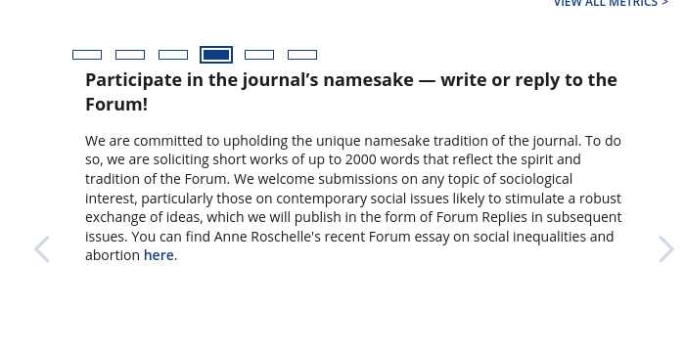
https://onlinelibrary.wiley.com/page/journal/15737861/homepage/forauthors.html
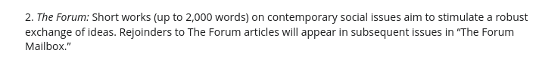

Email Chain
From: onbehalfof@manuscriptcentral.com
Sent: 16 December 2024 12:07
To: Mike Sosteric <mikes@athabascau.ca>
Subject: Sociological Forum - Decision on Manuscript ID SOCF-2024-0307
16-Dec-2024
Dear author(s):
Thank you for submitting your manuscript to Sociological Forum. We are sorry to tell you that we have decided against moving forward with the manuscript. To put this into context, we accept less than 15% of the manuscripts we receive.
Thank you for considering Sociological Forum as an outlet for your work and we send our best wishes for success in your ongoing projects.
Respectfully,
Editors, Sociological Forum

From Mike Sosteric <mikes@athabascau.ca>
Date Mon 16/12/2024 12:09
To sociologicalforum@udel.edu
Subject: Sociological Forum - Decision on Manuscript ID SOCF-2024-0307
Are you going to provide a reason?
From Mike Sosteric <mikes@athabascau.ca>
Date Tue 17/12/2024 16:43
To sociologicalforum@udel.edu <sociologicalforum@udel.edu>
Subject: Sociological Forum - Decision on Manuscript ID SOCF-2024-0307
Hey there. I'm going to ask again, are you going to provide a reason for rejecting this paper before sending it out for peer review.
I see that Wiley expects its editors to follow COPE Core practices and to provide a reason for desk rejection. Desk rejection is usually based on a manuscript failing to align with journal aims and content, or failing to meet quality standards. I don't believe either of these reasons apply here so I'd be curious about the specific reason or reasons this submission to the forum was rejected.
I would also like to note that your failure to supply a specific reason for the desk rejection is in violation on of COPE's requirement for transparent communication with authors about the reason papers are rejected.
From Sociological Forum <sociologicalforum@udel.edu>
Date Wed 18/12/2024 06:43
To Mike Sosteric <mikes@athabascau.ca>
Subject: re: [sociologicalforum] Re: Sociological Forum - Decision on Manuscript ID SOCF-2024-0307
Dear Dr. Sosteric,
Your manuscript was submitted as a "forum reply" article. However, as it is not a response to a previously published Forum article (our short commentary section, distinct from our original research articles), it is not appropriate for that article type. In addition, Forum articles and Forum Replies are editor reviewed, not peer reviewed.
Respectfully,

Editors, Sociological Forum

From Mike Sosteric <mikes@athabascau.ca>
Date Wed 18/12/2024 06:55
To Sociological Forum <sociologicalforum@udel.edu>
Subject: re: [sociologicalforum] Re: Sociological Forum - Decision on Manuscript ID SOCF-2024-0307
Was this article even read by your editors, or simply summarily dismissed? It is a direct response to a previous forum article, specifically
Perry, S. L. (2023). Religion Matters (And Doesn’t Go Away When Sociologists Ignore It). Sociological Forum, 38(4), 1456–1463. Academic Search Index. https://doi.org/10.1111/socf.12960
This is noted in the opening sentence of the paper.
And yes, forum submissions are editorially reviewed. this does not account for the reason for the rejection, which looks even more suspect now, frankly.
From Mike Sosteric <mikes@athabascau.ca>
Date Wed 18/12/2024 06:56
To Sociological Forum <sociologicalforum@udel.edu>
Subject: re: [sociologicalforum] Re: Sociological Forum - Decision on Manuscript ID SOCF-2024-0307
Is there an over-site board, independent of this journal, whom I can contact about this. I would like to lodge a formal complaint.

From Sociological Forum <sociologicalforum@udel.edu>
Date Wed 18/12/2024 08:47
To Mike Sosteric <mikes@athabascau.ca>Subject: re: [sociologicalforum] Re: Sociological Forum - Decision on Manuscript ID SOCF-2024-0307
Thank you for your concerns. Unfortunately, the Perry (2023) article to which you refer is an original article, not a Forum essay, to which Forum replies do not apply.
From Mike Sosteric <mikes@athabascau.ca>
Date Wed 18/12/2024 08:58
To Sociological Forum <sociologicalforum@udel.edu>
Subject: re: [sociologicalforum] Re: Sociological Forum - Decision on Manuscript ID SOCF-2024-0307
Thanks for this explanation. The question still remains, why a reason was not provided or a suggestion made to resubmit under the appropriate category. Given the inclusion of the Perry article, the paper seems to be within the purview of the journal. Providing a reason is a requirement according to COPE guidelines.
Is it common practice for your journal to issue desk rejections without explanation?
From Mike Sosteric <mikes@athabascau.ca>
Date Wed 18/12/2024 09:08
To Sociological Forum <sociologicalforum@udel.edu>
Subject: re: [sociologicalforum] Re: Sociological Forum - Decision on Manuscript ID SOCF-2024-0307
Also, could you point me in the direction of where it states on your website that forum submissions must be in response to previously submitted forum articles? I checked the website and there appears to be zero indication that forum submissions must be in response to previous forum submissions. In fact, the wording seems to indicate that "fresh" submissions are accepted, even elicited.
Please also let me know if there is an oversite body where I can direct my complaint
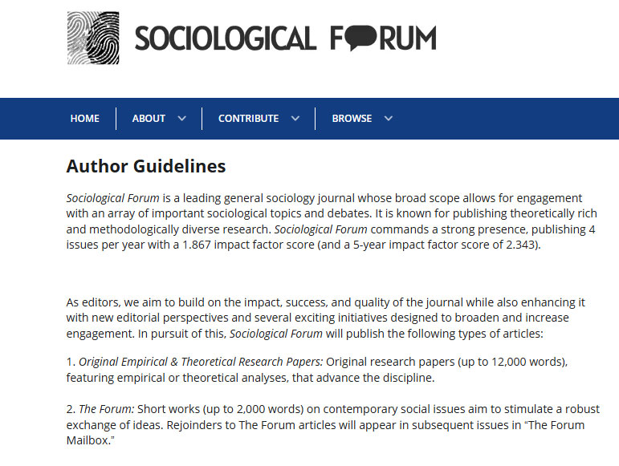

Date Wed 18/12/2024 09:32
To Sociological Forum <sociologicalforum@udel.edu>
Subject: re: [sociologicalforum] Re: Sociological Forum - Decision on Manuscript ID SOCF-2024-0307
So let me get this straight. The reason this submission was rejected was for no other reason than that it wasn't in response to a previous forum submission. Is that correct?
I'm going through the forum submissions now and none of them appear to be in response to previous forum submissions. All of them appear to be one‐off articles dealing with one or another substanive issue. In fact, the invitation to participate in the forums calls authors to either "write or reply to the forum"
I believe that this will be my third request to be pointed in the direction of Wiley's independent oversight board for this journal. is it your intention to provide that information or will I have to waste more of my time searching it out on my own..
m

From Sociological Forum <sociologicalforum@udel.edu>
Date Wed 18/12/2024 10:42
To Mike Sosteric <mikes@athabascau.ca>
Cc Sociology / Eastern Sociological Society [Eastern Sociological Society contact redacted]
Dear Dr. Sosteric,
Sociological Forum is the flagship journal of the Eastern Sociological Society. Please reach out to its Executive Officer, [name redacted], cc'd on this email, with any questions or concerns.
Respectfully,
Journal Editors

From Mike Sosteric <mikes@athabascau.ca>
Date Wed 18/12/2024 12:32
To Sociological Forum <sociologicalforum@udel.edu>
Cc Sociology / Eastern Sociological Society <ESS@wpunj.edu>

I'm asking for an independent body, maybe through Wiley since this is a Wiley journal. I frankly don't trust your process or your ability to remain objective and unbiased here.
From Mike Sosteric <mikes@athabascau.ca>
Date Wed 18/12/2024 13:14
To Sociological Forum <sociologicalforum@udel.edu>
Cc Sociology / Eastern Sociological Society <ESS@wpunj.edu>
Never mind. I found the Wiley complaint form.

From Peer Review Manager
Date Mon 06/01/2025 08:06
To Mike Sosteric <mikes@athabascau.ca>
Dear Dr. Mike Sosteric,
I hope you’re well.
I am the Peer Reviewer Manager for Sociological Forum and am writing to follow up on your complaint regarding some editorial practices. Please let me know your concerns and how I can help.
Looking forward to hearing from you.
Thank you,

Associate Peer Review Manager

From Mike Sosteric <mikes@athabascau.ca>
Date Mon 06/01/2025 08:08
To Peer Review Manager
Hi [peer review manager].
Sure. Give me a couple days to put together a paragraph outlining the events.
From Mike Sosteric <mikes@athabascau.ca>
Date Mon 06/01/2025 11:54
To Peer Review Manager
2 attachments (337 KB)
complaint letter.pdf; complaint letter.pdf

From Peer Review Manager
Date Mon 06/01/2025 13:26
To Mike Sosteric <mikes@athabascau.ca>
Dear Dr. Sosteric,
Thank you very much for sharing this letter with me. I will review it alongside the Publisher and journal team so we can prepare a formal response and action plan. I will follow up with updates as soon as I can.
Thank you,

Associate Peer Review Manager
From Peer Review Manager
Date Mon 13/01/2025 14:23
To Mike Sosteric <mikes@athabascau.ca>

Dear Dr. Mike Sosteric,
Thank you for your patience as I investigated this more.
It seems that the cause of the administrative rejection was the manuscript type. The article you wrote your reply to was an “Original Article”.
“Forum Replies” must be written in response to a published “Forum” article.
The editors decided to immediately reject as the journal does not have a manuscript type for responses to “Original Article”.
I appreciate that this wasn’t the type of news you were hoping to receive. Please let me know if you have any questions or if I can help with anything else.

From Mike Sosteric <mikes@athabascau.ca>
Date Mon 13/01/2025 15:17
To Peer Review Manager
1 attachment (203 KB)
Sociological Forum - 2024 - Sinha - The promise of public sociology in India Looking at Burawoy and beyond.pdf;

On the journal home page there is a call for forum articles that does not say the forum submissions need to be replies to preexisting forum articles. In fact, it says exactly the opposite. It says "write...to the forum. " That is what I did. I wrote to the forum in the spirit of the call for participation. This paper does not need to be classified as a reply to an article. It could simply be classified for what it is, a forum article, which, like all articles, often refers back to other people's research, like this other forum article "The promise of public sociology in India" does.
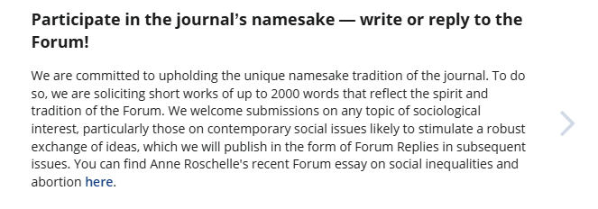
Arguably, this article is a topic of sociological interest, the issue is contemporary, and it's likely to stimulate a robust exchange of ideas. When you think about it, the rejection on reason is completely absurd. Scholarship is all about responding to other people's work, building on it, moving it forward.
It seems pretty obvious this is being rejected on a technicality and because of editorial bias, and not for any substantive reasons. I think that most scholars, when presented with the evidence, will agree that this is an example of editorial gatekeeping in direct viola on of the journal's stated aims.
It doesn't matter what your journal does here. The reasons behind these actions are transparent and this article will get much wider exposure as the center of an editorial controversy.
From Peer Review Manager
Date Tue 14/01/2025 08:51
To Mike Sosteric <mikes@athabascau.ca>

Hi Mike,
Thank you for following up and providing the example.
Your paper can be resubmitted as a Forum article. If you are interested in continuing with the submission , I can help expedite the submission and check-in process. However, I cannot guarantee acceptance, and papers will proceed to peer review at the editors discretion but they will be asked to include reasons for rejection or for requesting a revision. Please let me know how you’d like to proceed.
I do agree that the wording in the guidelines could be clarified to state the Forum is a particular section, designated by article type, and not the journal in general. I will work with the Publisher and editor to update the language.

From Mike Sosteric <mikes@athabascau.ca>
Date Tue 14/01/2025 10:56
To Peer Review Manager
[Peer Review Manager]
The editors should have advised me to resubmit as a forum article at the very start, or simply changed the category themselves to the appropriate submission type, as all scholars would consider appropriate. That they never did, instead providing an unethical rejection, and that you are only doing this now under the threat of exposure looks, well, not good. Why did the editors not invite that resubmission at the very start? Why didn’t you invite that resubmission in your first email response?
Why, after several email exchanges where I expressed grave concerns about the bias and ethics of the journal, am I only now being invited to do this? I will be honest, I am not confident I`d get a fair shake. I wrote a fairly detailed complaint letter and you addressed none of my concerns in your response, which was as perfunctory as the original. Most importantly, you did not address the ethical issues I raised, which given the original perfunctory dismissal of the paper, and your own, do not simply go away. You also did not address the logical and scholarly inconsistencies inherent in suggesting a forum submission must be a response to a previous forum response, particularly since none of the current article published in the forum are responses to previous forum articles. I raised that issue multiple times and every me I did the correct response would been to point out that the submission should have been submitted ed as forum submission, and not a forum response.
Any attempt to change wording now will just underline everything I`ve said so far. Indeed, changing them now will look like an ad hoc attempt at damage control, which is exactly what it is. This does not look good and everybody will see it.
Also, and I think you should pay careful attention here, your suggestion on that Forum Articles need to be peer‐reviewed directly contradicts an email I received Dec 18th at 6:42 AM where the editors said, and I quote (my emphasis)
``your manuscript was submitted as a "forum reply" article. However, as it is not a response to a previously published Forum article (our short commentary sec on, dis nct from our original research articles), it is not appropriate for that article type. In addition Forum articles and Forum Replies are editor‐reviewed, not peer reviewed.``
I do not have to point out just how bad that looks. Either you are uninformed about the journals policies, or you met with them to [assert] those policies ad‐hoc. Either way, this has the potential to completely destroy the reputation of this journal. The sociological biases against studying mystical cal experience are well‐known, and completely irrational, as I politely point out in the forum submission. This is a great case study on biases in peer review, in sociology, in how commercial publishers gatekeep, in damage control, and how their claims to moral and ethical rectitude are lip services only. I wrote my PhD dissertation on this, ironically enough.
It is going to take me a while to write this up, but you may want to give your superiors a heads up.
Or, do the right thing and insist Sociological Forum lives up to its published mandate, its stated editorial, and its ethical commitments.
m

You can examine the Forum Submissions by browsing the 2024, 2025, or 2026 archives of the journal (e.g. https://onlinelibrary.wiley.com/toc/15737861/2024/39/4). For example, Volume 38, Issue 4 contains an article entitled “The promise of public sociology in India” which is a discussion of the work of Michael Burawoy and sociology’s “critical imagination.”
I’m asking for an independent overseer.

