Lightning Path
Workbook Four
Discuss Big lie, old energy archetypes
Flow Purification
and FlowControl with the
Triumph of Spirit Archetype System

Version 0.80

Published by Lightning Path Press
St.Albert, Alberta Canada

©2020 Lightning Path
All rights reserved.

No part of this book may be reproduced,
stored in a retrieval system, or transmitted by any means,
electronic, mechanical, photocopying, recording,
or otherwise without written permission.
Table of Contents
Lightning Path Workbook Four 1
Preface 6
PART ONE: ARCHETYPES AND FLOW PURIFICATION 8
Introduction to Flow Purification and Flow Control 9
Some Important Terms 26
PART TWO: OLD ENERGY ARCHETYPES 42
Old Energy Archetypes 43
Old Energy Archetypes II 58
PART TWO: NEW ENERGY ARCHETYPES 71
Introduction 72
The TOSAS 79
Joyful 81
Master 87
Formation 93
Rebirth 98
Force 105
Realization 111
Victory 117
Strength 122
The Promise 130
Lightworker 136
World 141
Alignment 147
Sacrifice 155
Initiation 162
Emancipation 168
The Calling 173
The Star 178
Passage 183
Connection 188
Power 195
Activation 200
Graduation 205
References 211

Ideas to incorporate – trained from an early age with wrong thought (from appendix two, wkbk III)

Flow Control moved from wkbkIII How do you do that? That depends on whether the problem is just intense flow or whether you have negative thoughts and emotions going along with the intense flow. If flow is simply intense, then you basically turn down the flow like you turn the water down on a garden hose. There are two ways to do that.
The first way to stem the flow is by redirecting your attention, by distracting yourself. You can do this by listening to calming music, going for a walk in nature, playing a familiar computer game, or reciting an affirmation/mantra. Any affirmation that helps you affirm your power over the flow will work. Something like “I am strong, I am capable, I can handle the flow” is just fine. Simply repeat until you have got a handle on the powerful energies.
The second way you can engage in flow control is by saying to yourself, to your Consciousness, “slow down,” and then willing the slow down to happen. In this case, you simply assert mental control over your thought processes. Although you might have trouble controlling the flow during your first few powerful connection events, it is possible to do this. Forms of connection practice like transcendental meditation are designed to train you to control the flow.
Now, the above flow control strategies work if the problem is simple intensity of flow. However, if negative ideas (i.e., “I am stupid,” “I am worthless,” “God hates me,”etc.) and negative emotions (i.e., guilt, shame, and fear) are part of your experience, then it can be a little harder to control the flow because these ideas and emotions can overwhelm your sense of self and sense of control. To get control when negative emotions are at play, you can do two things.
First, face the negativity. Face the negative ideas. Face the guilt, shame, or fear. Facing means acknowledging the ideas or emotions are there and not distracting yourself or otherwise running away from them. If all of a sudden you have a frightening idea that God will punish and damn you, acknowledge that this idea is there. If it is fear you are experiencing, acknowledge that fear. If you are feeling guilt or shame, acknowledge that guilt or shame. Do not deny the thought or emotions. Do not pretend they do not exist. Do not repress them back down. Become aware and acknowledge.
The second thing you can do to get control over negative emotions and ideas is to carefully limit and control the flow of oxygen into the room to make sure you can handle the information that flows with a brighter ego flame. If you are using Connection Supplements, this involves carefully controlling the dosage so that you don’t open a connection wider than you can handle. If you are availing yourself of Connection Practices, this means moderating their use and backing away from practice when things move to fast to handle. If you are doing connection affirmations and connection visualizations and things start to heat up, simply stop or reverse the affirmation. Instead of saying “I wish to connect” say “I need to slow down for a while so I can process.”
Once you have faced the negativity, then the next thing you do depends on what ideas or emotions you are facing. In cases where guilt and shame suddenly rise up during your connection experience, you will need to figure out where the guilt and shame is coming from (hint, it is coming from some harmful actions on your part) and then resolve to atone for the bad actions. If you do that, then next time you make a connection you will not have to deal with it. Of course, you cannot atone during the actual connection event, so make a resolution to fix the damage as soon as you can. Say something like, “I know what I did and I promise to make the things right.” Be sincere about this and then when your connection experience is done, make sure you follow through on your promise. If you do not follow through, you will confront guilt and shame again, and it may very well be harder.
Guilt and shame are not the only emotions that can rise up. Confusion and fear can also be issues. Confusion is caused when new and dramatically different ideas enter into the flow in a sudden and intense fashion. In these cases, you can be overwhelmed by novelty and enormity of the information flow. This is especially true when ideas go dramatically against what you already believe. Ideas that we are one with God can cause a lot of anxiety and confusion when they come up against Catholic ideas that we are sinful, ejected rejects. Generally, fear during connection events is caused by negative ideas and archetypes you absorbed from parents, teachers, priests, and other authority figures who tell you stories and give you ideas designed to control how you think. The ideas that cause fear can be religious ideas, like you are a sinful reject from the Garden, or God is going to punish you if you do not follow “his” rules, or there are demons out to get you, or they can be secular ideas, like the idea that the experience of intense flow is going to make you crazy, that flow is primitive. infantile madness, or that you are going to lose touch with reality if you explore too much.
Whatever the ideas are that cause confusion and fear, you have to address them, otherwise you might be traumatized by the connection, develop a connection pathology, or be scared away from further connection practice all together. The best way to do that is to suppress the ideas during connection—simply try not to think them—and then to purify your mind, either during the connection event if you can, or when you are back to normal.
Flow purification
Flow purification very difficult to put into practice, and this for at least three reasons.
The first reason it can be difficult to practice flow purification because we are not taught, as a rule, to examine the ideas in our brains. Rather, we are taught to just accept whatever was poured and implanted into us when we were children. Because we were not taught to think critically, we do not have the skills to immediately begin the process, or to carry out flow purification in a successful fashion. This does not mean we cannot develop the skills necessary. We can if we practice. It just means that at the start, we do not know what to do.
The second reason it can be difficult to engage in flow purification is because we often feel like we should not engage in critical examination of some of the ideas and archetypes in our brain. Why? Because many people are taught, by priests and gurus who tout “sacred” books, that the archetypes and ideas that were implanted in their brain when they were children are “sacred” in some way. They are the “word of God,” they are the sacred teachings of ancient rishis, and so on. As a consequence of the purported sacred nature of the archetypes, we feel we should not examine or touch them. This ten thousand year ruse, this idea that some ideas are sacred and should not be questioned or touched, keeps you from engaging in the flow purification necessary to improve and strengthen connection. This perspective, this position, this fear, if you have it, is misplaced. You have every right to question what a priest or guru says to you. You have every right to question the ideas and archetypes in your head. You have every right to wilfully decide which ideas you want to think with and which archetypes you wish to filter your world experience with. If you want to move forward, you have to claim that right.
Finally, the third reason that flow purification can be a challenge is because the archetypes and ideas in your head that disconnect you and corrupt the flow are complicated, deeply buried, subtle, and seductive, particularly when the bodily ego is severely damaged. Even if you have developed the skill to begin sorting it out, even if you get over the nonsense about “sacred” ideas, it is still hard to sort it all out and make progress because of how complicated and confusing it can be. It is an understatement to say that there are many traps, pitfalls, and swindles put in your way to divert you from finding and achieving authentic and persistent connection.

Preface
Greetings and welcome to the Lightning Path (or just LP for short). The Lightning Path is a modern and authentic Human Development Framework that blends Authentic Spirituality and connected science into a powerful representation of core human and spiritual truths designed to take you from disconnected and depressed to healthy, connected, and empowered both quickly and safely.
Recognizing that the Accumulating Class, those who create the realities of this world to favour themselves, have been interfering in our understanding and practice of spirituality for thousands of years, the Lightning Path offers a decolonized spiritual perspective and practice. The LP strips elite influence from the corpus and provides a grass-roots spirituality rooted in mystical, religious, and transcendent experience and refined through a critical and scientific lens.
The book that you have in your hand is book four of the Lightning Path Workbook series. In this book you are introduced to the Triumph of Spirit Archetype System (TOSAS). The TOSAS is a book about Flow Purification, what it is, why you need it, and how to accomplish it. This book is organized into two parts. Part one is an introduction to flow purification and the Old Energy Archetypes which distort and block connection, and which you need to remove as part of your intermediate connection practice. Part Two introduces you to the emancipating and empowering New Energy Archetypes of the Triumph of Spirit Archetype System.
This LP Workbook, which builds upon the information provided in previous LP Workbooks, should be used in combination with the Triumph of Spirit Archetype Cards. This is a small deck of twenty-two archetypal images that help you incorporate the emancipating new energy archetypes provided by the TOSAS. You can browse the archetype cards online by visiting or purchase a print version to take along with you.
To browse online:
https://www.lightningpath.org/intermediate/tosas-archetypes/
To purchase a print version:
https://tiny.cc/TOSAS
Note, there is a lot of information and material contained in this workbook and it will take time to process, integrate, and ground the information into your reality. If you want to derive full benefit from the information provided here, be prepared to read through this workbook more than once.

PART ONE:
ARCHETYPES AND FLOW PURIFICATION

Introduction to
Flow Purification
and Flow Control
Greetings and welcome to this fourth LP Workbook. As you learned in the previous workbooks, the goal of human spirituality, the goal of human development is to heal damage done by Toxic Socialization so you can make a strong and healthy connection between your spiritual ego and bodily ego. As we have seen, getting started with this strong connection requires a healthy body and mind as well as an open, aware, accountable, aligned and activated physical unit.
Once you begin your Connection Practice, making a strong connection between your spiritual ego and bodily ego also requires, as noted at the end of LP Workbook Three, that you train your bodily ego to be able to handle the bright and powerful light of your spiritual ego. Two key aspects of this training are Flow Purification and Flow Control. As suggested at the end of LP Workbook Three, flow purification and flow control are connection practices used to “clear the pipes” so that your spiritual ego and bodily ego can connect and communicate without blockage and interference.
To understand what these mean, you first have to first understand what The Flow is. The Flow, a.k.a. The Flow of Consciousness or the Stream of Consciousness, refers to the natural flow of ideas, images, sounds, and archetypes that constantly stream through the mind of your [wiki]Physical Unit[/wiki]. Everybody has a flow of consciousness. Everybody has flow. If you sit back in your chain and pay attention to the thoughts, images, and sounds in your mind, you will see for yourself what we call the Flow.

Flow Control, Flow Purification, and the Parable of the Candle
So what is flow purification and flow control and why is it needed? To wrap your head around the idea of flow control, imagine a large room filled with crumpled up pieces of paper. Imagine that in the middle of this room is a stool and on that stool is a sputtering candle. Let us say that the candle is your bodily ego. The crumpled paper fills the room up to the seat of the chair, and the candle flame is just about touching the piles of crumpled paper. The candle lights the room, but dimly. Under these dimly-lit conditions, you can see what is written on the paper, but only if you focus and squint.
If you do examine the paper, you can see written on these clumps all the ideas your brain has absorbed as a consequence of your time here on Earth. Some of these ideas are personal (for example, “I am male,” “I am white”), some are religious (“Jesus is Lord,” “God is vengeful,” “Evil is real,” “The universe was created with a big bang,” etc.), some are political (“Socialism is bad, capitalism is Good”), some are negative (I am not worthy, I’m not good enough, I’m a loser, I’m a sinner), and so on and so forth.
The ideas in your head can be empowering and emancipating. However, because of the indoctrination that goes on during this planet’s Toxic Socialization process, many (perhaps most) of the ideas in your head are not empowering at all. Instead, most of the ideas in your head limit and suppress you in various ways. These limiting ideas suppress you and suppress your connection by
- limiting your perception of self, making you feel worthless and unworthy, undermining your self-worth and self-esteem (I'm a reject from "the garden," I'm a violent ape evolving, I am a cosmic school child here to learn lessons or pay off karmic debt, etc.).
- causing anxiety and fear (God will punish you, you are a bad person and you will burn in hell),
- encouraging you to engage in unaligned actions, like hitting others because you think they are bad, or exploiting others just to get rich.
Now, think back to the image of the candle on the chair and all the crumpled pieces of paper in the room. All these bad ideas surround you and flow dimly in and out of consciousness, influencing your thinking and behaviour. However, because the candle lights the room only dimly, these ideas usually lie just below your awareness. You are not completely aware of them, you do not notice them, unless you focus in. Even then, the ideas are weak and dimly lit. They only influence you in subtle and unconscious ways.
Now imagine that directly over the candle, about twenty feet above it, is a domed ceiling. In the very middle of this domed ceiling is a large hole. This hole is currently closed, but as you watch, a metal mechanism slides and the hole opens. As the hole opens, usually as a consequence of connection practice, but sometimes “accidentally” as a result of trauma, desperation, or despair, pure oxygen begins to flow into the room. As the oxygen fills the room, the candle flame grows and the room becomes brighter. As this happens, it becomes easier to see all the ideas written on the crumpled papers. In fact, as the room becomes brighter, the ideas become impossible to ignore.
Remember, many of the ideas in this room, many of the ideas in your head, are negative, fearful, hate-filled, and designed to diminish and limit you. Lightening up the room with oxygen means that you may suddenly become aware of all these negative ideas. Sudden awareness of all the dimly lit ideas may overwhelm you, causing unpleasant Nadir Experiences, anger, anxiety, fear, and even panic, especially if you are not prepared and do not understand what is happening. If there is a lot of ego damage, if there are a lot of negative ideas and archetypes crumpled up on the paper, suddenly adding oxygen to the room can cause serious Connection Pathology and even, if all that crumpled paper suddenly catches fire, a terrifying Spiritual Emergency.
Flow Purification: In the context of a room filled to the brim with toxic ideas which need to be dealt with before you can turn the oxygen flow even higher, flow purification is the process of examining the crumpled pieces of paper and purifying your mental spaces so you can handle the extra oxygen in the room.
Flow Control: In the context of a room filled to the brim with toxic ideas which need to be dealt with before you can turn the oxygen flow even higher, flow control is the process of managing the flow of ideas to you are not overwhelmed by a high pressure flow. When you engage in flow control, you slow down or even stop the flow of ideas so they do not overwhelm you.

The Parable of the Child
Another way to look at flow purification and flow control is to think of your bodily ego as a small child sitting in a field all alone, and your spiritual ego as a powerful and brilliant being of pure love, light, and intelligence floating in a ball about thirty feet above your small child. Imagine an energy pipe between the child in the field and the bright and powerful spiritual ego above. Imagine that pipe as a clean, scintillating conduit of bidirectional energy flow. See energy, ideas, images, sound, and light flowing back and forth between the child on the ground and the spiritual ego up above.
Now, imagine that for some reason, the pipe between the two is all blocked up and corrupted with gooey, icky, gunk. In this context, flow purification is the process of cleaning the gunk out of the pipe so information, energy, and ideas can flow free and pure. By the same token, flow control is learning to manage and handle the speed of the flow in the conduit once the gunk is cleared out and it begins to flow again.

Wrong Thought
On the LP, we call the gunk in the connection between the spiritual ego and the bodily ego, or all the negative ideas on the crumpled up paper in your mental room, Wrong Thought. There is nothing complicated about the idea of wrong thought. Wrong thought is simply any thought that undermines and prevents healing and connection.
Note, not all negative thought is wrong thought. Negative thoughts that point to things that need to be changed in your life, or on this planet, are important. For example, insights that come to you during your connection experiences about the toxicity of your relationships, the state of the world, etc., are important insights that facilitate healing and connection by pointing you towards realities that need to be changed and aligned. If you push those ideas out, if you fail to ground and act on them, you won’t make any progress, so you have to accept those into your mind.
You can get a better idea of what wrong thought is and is not by considering some examples.
With regards to healing, wrong thought is thought that
- encourages you to engage in wrong action, which is action that damages your body and mind or the body and mind of another.
- discourages you from taking the proper actions to recover and heal from that damage.
For example, when somebody tells you that to “spare the rod is to spoil the child,” or that it is OK to scream, yell at, hit, and abuse children, they are giving you an idea that encourages you to damage your children. Since this idea encourages and supports actions that harm the body and mind, this is wrong thought. Similarly, if you suffer some kind of emotional or psychological trauma and abuse and somebody tells you it’s OK because life trauma “builds character” or “makes you stronger,” that is also wrong thought because that thought encourages you to accept abuse and trauma as a good and positive thing. If you accept abuse and trauma as something that makes you stronger, your body and mind will take ongoing damage and you will never be able to heal and connect. If you accept abuse and trauma as something that makes you stronger, you might not seek professional assistance to help heal the damage, even when the damage is quite severe.
With regards to connection, wrong thought is thought that
- encourages ineffective connection practice.
- causes you to disconnect from your spiritual ego, through fear or misconception.
- causes you to disconnect from your spiritual ego as a consequence of low-self esteem or feelings of shame and unworthiness
- corrupts and distorts the flow of Consciousness, often in service to the elite accumulation agenda
- encourages you to engage in wrong actions, which in turn cause misalignment, disjuncture, and disconnection.
- causes connection pathology, like Ego Inflation, Egoic Explosion, and Egoic Collapse. In the worst cases, wrong thought can even cause Spiritual Emergency and Spiritual Psychosis, including forms of schizophrenia.
If you do experience really negative outcomes from your connection practice, make sure to seek professional assistance
On the topic of ineffective connection practice, some ideas can lead you to engage in ineffective connection practice. This is especially true around the penetration of consumerism into religion. Some folks would have you believe that buying crystals or surrounding yourself with expensive spiritual props will facilitate spiritual practice and spiritual connection. This is not true. Props might create an environment conducive to connection, candles and essential oils can help create a relaxing environment, but they themselves are unnecessary and insufficient. All you really need to practice connection is a quite space. If you rely on props too much, you might be distracted from the actual process and you might miss the authentic techniques you need to engage in to facilitate and strengthen connection.
On the topic of wrong thought that causes fear, in Catholicism, for examples, some priests seed into children a deep fear of God as a vengeful, punishing patriarch. This fear gets written onto the crumpled up paper in the room of your mind. When the light in the room is dim, this fear is nascent and unconscious. However, this fear can easily be triggered during connection experiences. When triggered, fear, even panic, can overwhelm the bodily ego and force it to shut down connection in instinctual self-defence.
Note that you do not have to be taught religious dogma to have your connection shut down by fear. On a more secular note, erroneous ideas about “going crazy” or losing control of your mind during connection experiences can also cause anxiety and fear and can lead your bodily ego to subvert connection. There is some basis to this fear. During connection experiences, powerful ideas flow rapidly through your stream of consciousness. The rapid flow of powerful ideas can be disconcerting and it can feel like you are losing control. If this occurs, it is important to remember that connection experiences are temporary and you will eventually return to normal consciousness where you can analyze and ground your experience.
It is not just ideas that cause fear and anxiety that are a problem for connection. Ideas that cause low self-esteem can also undermine connection, either because you feel you are unworthy of connection and the benefits that accrue from it, or because you do not believe the insights delivered. For example, sometimes, connection experiences can lead you to the realization that you are a powerful spark of Consciousness participating in the co-creation of the universe. Ideas that cause low self-esteem, like you are an unworthy sinner or a violent ape, make it hard for you to accept just how wonderful and amazing you really are. Consequently, you doubt the truth and might even become frightened by the realization and the implications. Doubt and fear caused by low self-esteem can, once again, lead your bodily ego to shut down the connection.
It is not always the case that wrong thought impedes connection practice or causes disconnection. Sometimes, connection can occur despite the presence of wrong thought. In those cases where connection proceeds despite the presence of wrong thought, wrong thought can corrupt and distort the information that flows through a connection.
For example, a common insight that people have when they make a strong connection is the insight that “I am God” or “I am one with God/Consciousness/Creation.” On the LP we call this type of realization an Ascension Experience, because your bodily ego “ascends” and connects with God or some other exalted location in The Fabric of Consciousness. The common insight that we are all connected and that we are all God can cause incredible bliss and euphoria, but because of some of the toxic wrong thought written on the crumpled up paper in the room, it can also cause fear. If you were raised Catholic, for example, the idea that you might be a spark of creator Consciousness would be considered sacrilege, despite the fact that Jesus and many others said it was true. If you think the thought during a connection experience when oxygen is pouring into your room, your bodily ego, trained with the judgmental dogma of the church, might react with guilt, horror, and fear at the thought, and it might consequently shut the connection down.
Jesus says, Is it not written in your law, “I have said you are gods.” John 10:34
In addition to causing fear and guilt, this idea that we are God can also be corrupted and twisted to suit an elite agenda. Elitists, especially those in the white male esoteric traditions of the West like Freemasonry, twist this idea by suggesting in their spiritual propaganda materials (what they euphemistically call their “teachings”) that “only the chosen few,” or even “only the chosen one” are able and worthy enough to make this type of realization/connection. When this elite idea is present, ascension experiences that should lead to a realization that we are all one and all an equal part of the great Fabric of Consciousness that is God can, in those who have been indoctrination by “the teachings,” to inflated ego, elitism, and exclusionary practices, all of which undermine, through misalignment, not only the connection of the elites who “benefit” the teachings, but everybody else who suffers under their yoke as well.
As noted above, wrong thought can also cause misalignment, which in turn makes connection more difficult. Actions that cause misalignment include actions that are violent, exploitative, and that harm your self or others. When misalignment occurs, the bodily ego is out of intellectual, emotional, moral, and behavioural step with the spiritual ego. When the bodily ego and spiritual ego are misaligned and out of step, when your bodily ego is thinking and doing things that your spiritual ego does not like, disjuncture, which is an emotional state of unease, disquiet and discomfort, is the result. Painful unease and discomfort caused by disjuncture makes connection difficult to initiate because you feel unworthy and shameful, and difficult to maintain because the feeling of disjuncture can be heightened during connection experiences.
Finally, in addition to encouraging ineffective connection practice, causing fear, or corrupting and distorting the flow, wrong thought, especially when coupled with a damaged or shattered bodily ego, can also lead to various forms of connection pathology (like Ego Inflation, Egoic Explosion, Flooding, Egoic Collapse, and Egoic Confusion). In the worst cases, wrong thought can even cause Spiritual Emergency and Spiritual Psychosis, including forms of schizophrenia. If you do experience really negative outcomes from your connection practice, make sure to seek professional assistance.

Flow Control
As you can see, if you want to clear out all the crumpled up pieces of toxic wrong thought, if you want to clear out the pipe and engage in healthy, positive, connection practice, you need to engage in flow control and flow purification.
Flow control, as we have seen, is basically the ability to stem and get control of the flow of ideas, images, and visions that can attend a wide open connection. Flow controls means being able to slow the flow of ideas and images if they become too overwhelming.
As explained in more detail in LP Workbook Three, flow control is fairly straight forward. To engage in flow control,
- Redirect your attention, take deep breaths and distract your self. You can do this by listening to calming music, staring at a candle, holding a single positive thought in your mind by repeating an affirmation "I am strong, I am capable, I can handle the Flow," and so on.
- Will the Flow of Consciousness to slow down. In other words, assert mental control over your thought process. Forms of connection practice like Transcendental Meditation are designed to train you to control the flow.
Note that the goal of flow control is not complete control of the ideas. During connection, you do actually want to let the ideas flow, but only positive, uplifting, life-affirming ideas that lead to improvements in your life and well being should be allowed to flow. The goal of flow control is not stop all thought, just wrong thought—negative ideas that rise up during connection and that undermine your healing and connection work.
Negative ideas can be hard to identify, especially since they are inserted into our bodily consciousness at a very young age. To help you identify these ideas, we’ll examine them in more detail in our section on old energy archetypes below.

Flow Purification
Engaging in flow control is fairly straight forward. Simply suppress negative old energy ideas. Engaging in flow purification is a little more complicated and involved. To engage in flow purification, carefully examine the crumpled up papers in your mind. As you do, throw out thoughts and ideas that cause anxiety, fear, and limit and disconnect you, and preserve or insert ideas that heal, emancipate, and empower.
On the LP, we break down flow purification into a three-step process of recognize, root out, and replace.
Step one, is to recognize the wrong thought in your brain. To recognize wrong thought, be mindful and pay attention to your thoughts. When a wrong thought comes up, make a note of it. It might sound trite, but it is important. If you do not first recognize wrong thought, you won’t be able to root it out and replace it.
Once you have recognized a wrong thought in your brain, step two is to root it out. To root out a wrong thought, tell yourself that the idea is wrong and that you do not have to believe it. In other words, do not think the thought. For example, when I first started my connection practice, every once in a while, thoughts from my Catholic indoctrination would pop into my head and I would suddenly feel unworthy, sinful, and deserving of punishment. When these thoughts came up, they interfered and corrupted my connection. When this happened, I told myself these thoughts were not true and I suppressed them so I would not think them. At first, it was difficult; however, after a while, and in particular as I practised with the Triumph of Spirit Archetype Deck I was developing (more on this below), the thoughts weakened till eventually they no longer came up at all.
Rooting out wrong thought is a lot like pulling weeds in a garden. You recognize the weed is there and then you pull it out. Keep in mind, when you pull weeds, bits of the root can remain in the soil and can regrow. If you want to prevent the weed from popping up again, you have to dig deep until you have “rooted out” all remaining vestiges of the negative idea.
Once you have recognized and rooted out wrong thought, step three is to replace the wrong thought in your brain with right thought. Remember, wrong thought is thought that diminishes you and causes anxiety, fear, hatred, and even paranoia, right thought is thought that facilitates and supports healing and connection. To replace wrong thought with right thought, simply think positive, healing, and connecting thoughts. For example, during my early connection practice, when thoughts of my unworthiness came up, I would use the Triumph of Spirit Archetype deck to remind myself that I was a Joyful and Masterful co-creator, worthy of care, love, and attention. I also reminded myself that God was not a punishing patriarch and that I had done nothing wrong. Over time, these ideas took root and became stronger. Eventually, all wrong thought ceased. Now, I never have any difficulty at all while practising connection.
As you can see, flow purification is technically a simple process. It is simply a question of recognize, root out, and replace. Flow purification is also an essential process—it an essential step on the road to healing and stronger connection. Without Flow Purification, anxiety, fear, misconception, and ego damage caused by wrong thought can exacerbate various ego pathologies, contribute to distortion and corruption of the Flow, and even shut down your connection and spiritual practice altogether. It is very important that you engage in flow purification.
Note that even though flow purification is relatively straight forward, there are a couple challenges.
One challenge is that it can be quite hard to recognize wrong thought for what it is. This is because wrong thought is generally introduced into your consciousness when you are a small child. As a consequence, you either do not know it is there or, if you do, you accept it as if it is a deep truth. This is the case, for example, with notions that God is a judgmental God or that suffering and pain are karmic comeuppance or some kind of cosmic life tests. We learn these ideas so young we accept them without ever questioning them.
A second challenge is that it can be hard to know what to replace wrong thought with. What ideas replace ideas of judgment and punishment? What ideas replace notions of karma and life tests? Nobody ever taught us alternative ways of thinking and so it is hard to know what to replace it with.

Conclusion
That brings us to the end of this unit. In this unit we have learned about flow control and flow purification and why they are important. You have learned that connection can lead to a rapid inflow of thoughts and sudden awareness of all the crumpled up papers sitting just below conscious awareness. This inflow and sudden awareness can be a challenge to handle, especially if your brain contains a lot of wrong thought. The presence of wrong thought coupled with a rapid flow of ideas can overwhelm, cause fear and anxiety, disconnect you, and sometimes cause serious ego pathology. To avoid all that, you have to engage in flow purification and flow control. Flow control involves carefully controlling the speed and intensity of the thoughts that flow during a connection event. Flow purification involves examining all the negative, disconnecting wrong thought in your brain and replacing that with salutatory right thought that uplifts and connects. This can be a challenge, as we have seen, but not to worry. The rest of this book is devoted to helping you with these challenges. In part two of the book we provide several examples of wrong thought which you may have absorbed as part of the indoctrination that accompanies toxic socialization. Once you familiarize yourself with this wrong thought it will be easier to recognize and root out the ideas from your brain. Finally, the third part of this book introduces you to the Triumph of Spirit Archetype System (TOSAS) and the accompanying Triumph of Spirit Archetype Deck. This archetype system, this ideas system, will provide you with a host of ideas that will help you heal and connect. Learning the Triumph of Spirit Archetypes will make it a lot easier to finally replace all the damaging wrong thought in your brain with uplifting, healing, and connecting right thought.

Some Important Terms
In the last lesson, we learned about the importance of flow purification and flow control. Flow control is straightforward; however, as we learned in the last lesson, flow purification can be a challenge. Flow control is a challenge not only because it can be difficult to recognize wrong thought but also because it can be hard to find something to replace it with. The truth is, wrong thought has penetrated into every emotional and psychic corner of our modern world to the point where any alternatives that do exist are disjointed, disorganized, and difficult to see. If you don’t have something to replace wrong thought with, you will have a hard time completing the process of flow control.
In order to help with the process of recognizing and replacing wrong thought, part two of this book will provide key examples of wrong thought so that you can learn to recognize it in your own mind. Finally, part three of this book will complete the training process by introducing you to the Triumph of Spirit Archetype System and the Triumph of Spirit Archetype Deck. The Triumph of Spirit Archetype system is a system ideas that you can use to help you replace all the wrong thought percolating in your head.
Before we get to that, there are a few key concepts that you need to know. Knowing these concepts will help you develop a deeper understanding of the process of flow purification.

Archetypes
The first concept you have to be aware of is the concept of archetypes. Archetypes are essentially big ideas that answer Big Questions. Big questions are the ultimate, existential questions of our life and being. Big questions are existential or spiritual questions of existence, purpose, place, and so on. If you ask questions like “Who am I?”, “Why am I here?”, “What is my purpose?”, “What happens after I die?”, and so on. The answers you provide to these big questions are archetypes.
You can understand the idea of archetypes by simply asking yourself the existential question “Why am I here.” A typical atheist answer to that question might be “I am here to struggle and survive.” A typical religious or spiritual answer to that question might be “I am here to learn my lessons” or “I am here to pay off my karmic debt.” Both of these answers are archetypes. Any answer you provide to big questions, true or not, are archetypes. Archetypes are big ideas that answer big questions.
It is important to understand about archetypes for at least three reasons. One reason to understand the idea of archetypes is because not all wrong thought or right thought is archetypal. There are a lot of ideas that undermine healing and connection, or that support healing and connection, that do not rise to the level of archetype. An idea like it’s OK to eat a lot of meat is wrong thought because it is not healthy to eat a lot of meat. At the same time, this idea is not archetypal; it does not answer a big question.
The second reason why it is important to understand about archetypes is that archetypes are a powerful class of ideas that have a major influence on how we think and behave in the world. Archetypes are buried deep into our unconsciousness where they subtly (and sometimes not so subtly) influence our thinking about the world, our place in it, the actions we should take, and the kind of life we should live. For example, if you answer the big question “Why am I here” with a Darwinian “survival of the fittest” type answer that says the reason you exist is to struggle and compete, you might spend your entire life clawing your way up a corporate hierarchy until you “triumphantly” arrive at the top of the corporate food chain. On the other hand, if you see your life as some kind of karmic test or battle to redeem yourself, then you might spend your life trying either trying to “make up” for past sins or trying to redeem yourself from in the eyes of some creator figure. In both cases, the answer to the question “why am I here” determines your view of self and your behaviour in the world.
Despite what you might think, this is not far-fetched. We have lots of examples of how ideas that answer big questions drive human experience and human behaviour. As the sociologist Max Weber pointed out in his classic book The Protestant Ethic and the Spirit of Capitalism, protestant ideas about salvation and redemption were behind the growth of capitalism. That is, protestant archetypes and ideas shaped people into good little capitalist managers and worker bees, and these good little worker bees helped grow the capitalist regime of accumulation. How did protestant archetypes do that? Simple. Protestants are taught to believe that you have to be redeemed by God before you can get into heaven. Protestants are also taught that being successful, particularly in business, is a sign that God has redeemed you. If you are rich and wealthy, if you are successful in business, this is because God has “chosen” you. This idea that being wealthy meant being “chosen” encouraged a protestant work ethnic that emphasized sacrifice and hard work. If you sacrificed and worked hard, you would one day be successful and this success would give you confidence in your “chosen” status. In this way, this protestant archetype, this protestant answer to the big question about why we are here (you are here to work hard and redeem yourself), drives people to work long hard hours so they can prove their special status. Thus, Martin Luther and his protestant work ethic helped create an army of people willing to sacrifice their time and their life to build the capitalist system.
Note that protestant ideas about hard work and redemption are not the only archetypes which shape your behaviour in a way conducive to the capitalist system. There is an entire suite of these ideas tracing back thousands of years which have been designed and developed specifically to shape human behaviour in ways conducive to elite accumulation. We will examine these ideas in more detail when we look at old energy archetypes in part two of this workbook.
The third reason it is important to understand archetypes is because archetypes are not random. Archetypes are not some mystical outgrowth of human evolution as Carl Jung said, nor are they deep aspects of human spirituality and existence, as Joseph Campbell might say. Archetypes are intentionally created by humans, most often by elites because they are usually the only ones with the resources capable of producing and distributing them widely, for the purpose of shaping thought and behaviour. Going back to our example of the Protestant religion, protestant archetypes were created by Martin Luther. His family owned copper mines and smelters, thus Martin Luther was a member of the elite accumulating class. It should come as no surprise to learn that when he grew up, he created archetypes designed to manipulate the working and middle classes into sacrificing their lives through hard work. His ideas, the archetypes he created, serviced the accumulating class.
The Protestant “faith” is not the only example of the elites creating ideas to manipulate the population. The Western Tarot deck, which we will learn about more below and in the article “A Sociology of Tarot,” was created by Freemasons during the Industrial revolution to manipulate not only the working classes, but the accumulating classes as well. Freemasons used the Tarot to provide a complete system of archetypes, a complete set of answer to big questions, that encouraged a view of self and society that helped insert people into the emerging industrial capitalist system as hard-working peons. Freemasons created the tarot to manipulate thought and behaviour, and they did an awesome job. The system was so effective that it prompted Decker, Depaulis, and Dummet, the world’s foremost tarot historians, to say that the tarot was the
…most successful propaganda campaign ever launched: not by a very long way the most important, but the most completely successful. An entire false history, and false interpretation, of the Tarot pack was concocted by the occultists; and it is all but universally believed.”
Another example of elites creating archetypes to manipulate thought and behaviour is provided by the Zoroastrian religion which, as argued in the article “From Zoroaster to Star Wars, Jesus to Marx: The Art, Science, and Technology of Mass Human Manipulation,” was started by the mystic Zoroaster but was eventually co-opted and corrupted by a Persian autocrat in order to consolidate his imperial power. We will be examining some of the Zoroastrian archetypes in part two of this workbook when we look at old energy archetypes. If you are interested in the full story, download and read that article.

Old Energy Archetypes and New Energy Archetypes
It is true that elites create archetypes for the purpose of manipulating human behaviour, but elites are not the only ones that create archetypes. Regular people, artists, musicians, writers, etc., can also create archetypes. Unless they are co-opted by the System, artists working at the grassroots level create archetypes designed to expose elite archetypes or to provide answers to big questions. A good example of this is John Lennon’s song “Working Class Hero” which is a song that exposes the harsh and toxic realities that the elites create for the working class. The lyrics are included below and you can listen to the song on YouTube.
Working Class Hero
As soon as you're born they make you feel small
By giving you no time instead of it all
'Til the pain is so big you feel nothing at all
A working class hero is something to be
A working class hero is something to be
They hurt you at home and they hit you at school
They hate you if you're clever and they despise a fool
'Til you're so fucking crazy you can't follow their rules
A working class hero is something to be
A working class hero is something to be
When they've tortured and scared you for 20 odd years
Then they expect you to pick a career
When you can't really function, you're so full of fear
A working class hero is something to be
A working class hero is something to be
Keep you doped with religion, and sex, and T.V.
And you think you're so clever and classless and free
But you're still fucking peasants as far as I can see
A working class hero is something to be
A working class hero is something to be
There's room at the top they are telling you still
But first you must learn how to smile as you kill
If you want to be like the folks on the hill
Another example of an artist working to expose and replace old energy archetypes is Banksy. Banksy creates cultural images that call attention to ideas that support the elites system of accumulation.
Because not all archetypes are created by elites, because some archetypes are created to challenge elite ideas and resist elite realities, we break archetypes down into two categories, old energy archetypes and new energy archetypes.
Old energy archetypes are elite-designed archetypes that shape your thoughts and behaviour in ways that fit you into their regime of accumulation. When you absorb old energy archetypes, you become a compliant and hard-working cog. Since the elite’s regime of accumulation is a toxic system, old energy archetypes also undermine healing and connection.
On the other hand, new energy archetypes are archetypes that challenge elite ideas about who you are and why you are here. New energy archetypes also promote and support healing and connection. When you absorb new energy archetypes, you resist insertion into the System and, if the archetypes are well designed, you work towards healing and reconnection.

The Relationship between Wrong Thought and Archetypes – Creation Templates
At the start of this workbook you were introduced to the idea of wrong thought and right thought. In the last few pages, we have been talking about archetypes, old and new. The question now becomes, what is the relationship between the two? Answering this question is easy.
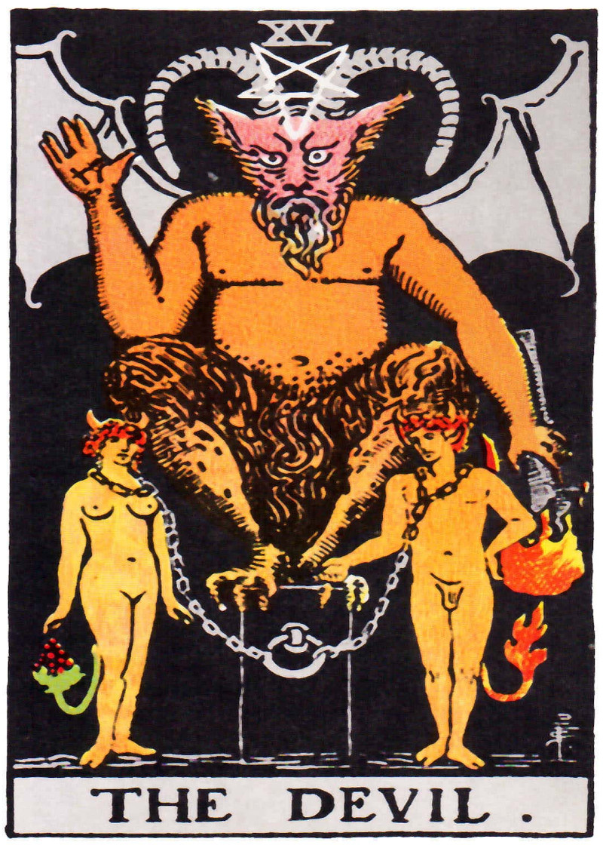
As regards old energy archetypes, pause for a moment and imagine a brick wall. If you think of wrong thought like a wall preventing you from healing, connecting, and entering a beautiful garden, then old energy archetypes are the ideas, i.e., the bricks, that build up that wall. Old energy archetypes make up a “wall of archetypes” that shape your perceptions and behaviour in ways that a) prevent you from healing and connecting (i.e., from healing and entering the Garden) and b) that facilitate your insertion (we might say enslavement, as illustrated in the Freemason’s Tarot’s Devil card) into the System. To tear down that wall, you have to remove the bricks, the archetypes, one block at a time.
As regards new energy archetypes, pause for a moment and imagine a staircase or a ladder that helps you climb out of the muck and morass of old energy existence. New energy archetypes are the planks or the bricks that make up that ladder. New energy archetypes create a staircase of ideas that help you extricate yourself from the old energy muck and mud of the elite’s regime of accumulation and that help you heal and reconnect.
To summarize, old energy archetypes create a wall of wrong thought that controls your thoughts and behaviours in ways favourable to the Regime and that prevents you from healing and connecting. New energy archetypes create a staircase of right thought that challenges elite archetypes and that helps you heal and connect.
On the LP, we have a special name for these archetypal walls and staircases—Creation Templates. We call them creation templates because the archetypes that make them up are designed to create a specific type of world.
For our purposes, we can identify two different types of creation templates, old energy creation templates and new energy creation templates. An Old Energy Creation Template is a collection of related old energy archetypes organized into a coherent whole designed to facilitate the elite agenda, which is to accumulate as much money and power as possible. On the other hand, a New Energy Creation Template is a collections of new energy archetypes designed to help you extricate yourself from toxicity of the System so you can properly heal and connect. New energy creation templates contain new energy archetypes which, as we have seen, challenge the elite view of the world and elite generated ideas with ideas and archetypes that emancipate, heal, and connect.
A great example of an old energy creation template is the modern tarot deck which, as we saw earlier, was created by Freemasons specifically to help lubricate the transition from feudalism to capitalism. This tarot-based creation template is presented in a tarot deck that consists of 22 major trump cards and with 56 minor trump cards. These tarot trumps, like the Devil card on the previous page, are visual depictions of various masonic archetypes. The major trump cards are the main archetypal statements and convey all of the main ideas in the elite’s creation template. Archetypes that make up this Masonic creation template are designed to create people who will fit into and support the Capitalist regime of accumulation. specific worldview and encourage specific type of actions in the world. Because the Masonic tarot deck is such a great example of a creation template, we will be using this deck in part two of this workbook to help identify and unpack key old energy archetypes.
There are a lot of examples of old energy creation templates available. The Zoroastrian religion, for example, provides a creation template that is present not only in the Zoroastrian faith, but in Christianity, Islam, and even popular cultural productions like Star Wars. Unfortunately, there are not a lot of new energy creation templates around. In fact, there may be none. This is because whilst artists do create new energy archetypes, the time, energy, and resources required to systematize these archetypes into a well-formed creation template and then distribute that template to a population is beyond the skill and resources of most grassroots operators and operations. That said, on the LP we have developed our own new energy creation template which we call the Triumph of Spirit Archetype System. Like the Freemason’s creation template, it comes with a deck of archetype cards, the Triumph of Spirit Archetype Deck. We will introduce this new energy creation template in part three of this workbook.

Symbol Factories
We have already seen that elites create archetypes to manipulate mass behaviour. We also know that it takes a lot of resources to do this. Consequently, elites typically carry out the production of creation templates in what we call symbol factories. Symbol factories are elite-controlled institutions where System Agents, typically priests, gurus, or other “spiritual” authorities, create, recreate, package, and repackage archetypes designed to enable and support the elite’s economic and political agenda. The best example of a symbol factory is the Freemason’s lodge which, as we have seen, was used to create the Masonic Creation Template (i.e., Masonic Tarot deck).
Note that system agents working in symbol factories typically do not construct creation templates from scratch. Usually, they take what is already there and modify, refresh, or update it in some way. This was the case with the Freemasons who looked to ancient archetypes and ancient creation templates for inspiration. Freemasons did not create something new, they simply updated something that was already there.
The Freemason’s lodge is not the only example of a symbol factory. Elite organized religions like the Protestant or Catholic religion also function as symbol factories. We have already seen how Martin Luther created archetypes that encouraged people to engage in hard work and sacrifice for the capitalist system. We have also talked briefly about Zoroastrianism and how it was created by an elite Persian autocrat Aradashir for the purposes of assisting with his imperial aims. The same thing can be said for Catholicism. The Catholic religion was formed when the Roman emperor Constantine “converted” to Christianity and then took control of the religion. At that time, many writings about Jesus Christ and his teachings were circulating through the grassroots of the region. Not all of these writings made it into the bible, however. Those that did were chosen by elite Bishops at the Council of Rome in 382 A.E. This elite constructed bible was then hidden away from view for a 1,000 years where it was edited and modified. This modification was not benign. It was used to undermine Christ’s progressive teachings and replace them with system-friendly ideas. A very clear example of this is the surreptitious introduction of archetypes aimed at undermining Jesus’s gender progressive teachings and subordinating women to patriarchal authority. You can read all about it in the article “Editing the Bible for Patriarchy—How Church scribes diminished and devalued women in the early Christian Church.”
Note, it is not just secret societies and religions that operate as symbol factories. Secular organizations also function as such. The Walt Disney corporation, for example, is a symbol factory. Just like the Freemasons, Disney writers and artists take available archetypes, modify them when necessary to suit extant cultural and psychological predilections, and then distribute them in packages designed to engage and entertain. This is a particularly effective form of delivery because packaging these archetypes as entertainment facilitates acceptance and absorbtion. It is easier to accept archetypes of good versus evil.
Disney is not the only example of a secular symbol factory. Other examples include Fox Entertainment, major corporate record labels and book companies, and so on. Any organization that uses creative talent (writers, musicians, etc.) to create entertaining cultural products with an archetypal payload are symbol factories that are creating and distributing archetypes and creation templates.

Ideological Institutions
Symbol factories are not the only institution involved with archetypes and creation templates. On the LP, we also identify ideological institutions. Ideological institutions are like symbol factories in that they distribute archetypes; however, unlike symbol factories, they do not have the authority to create, modify, and adjust the archetypes, they just distribute them. Examples here include the modern education system which, in addition to educating the population, also conveys key old energy archetypes. For example, the school system teaches you the “value” of hard work, which we have already seen are values linked to protestant archetypes of redemption. The school system also normalizes old energy ideas of justice, judgment, and punishment. In schools, you are rewarded (gold stars, good grade) when you follow the rules and work hard and you are punished (detention, exclusion, shaming, failing) when you not perform. Don’t worry if you’re not familiar with old energy archetypes of justice, judgment, and punishment. We will examine those in detail in part two of this book when we examine old energy archetypes.
It is not just the K12 education system where we find a hidden archetypal curriculum. Modern universities, for all their empirical, progressive, and liberal focus, also help distribute old energy archetypes that help maintain the System. Finally, corporations, especially larger ones like Google or IBM with their own internally constructed corporate cultures, also function as ideological institutions.

Conclusion
This brings us to the end of this section on key concepts. In this lesson, we introduced several key terms, archetypes (both old and new), creation templates, symbol factories, and ideological institutions. These key terms should help you understand and engage in the process of flow purification. In addition to providing a better understanding of flow purification, these concepts should also have given you a glimpse of the historical, cultural, spiritual, and even political significance and importance of archetypes and creation templates and how these archetypes are created, controlled, and distributed by elites for the purpose of mass manipulation of the population.
With this section of the workbook complete, it is time to move on. In part two of this workbook, we will examine in some detail the old energy archetypes created and distributed by elites. In the final section we will introduce the Triumph of Spirit Archetype System which, as you already know, is a LP rooted new energy creation template that you can use to help you with the process of flow purification..
As a final comment, I just want to say, archetypes, creation templates, symbol factories, and ideological institutions are complicated topics and we cannot do them justice in this short workbook. All we have done here is provide a basic framework to help you understand their significance so you can better navigate through the process of flow purification. If you are interested in learning more about symbol factories, archetypes, creation templates, and the like, you can find out more in the suggested readings below.

Additional Reading
- “A Sociology of Tarot,”
- A Short Sociology of Archetypes – This article examines the Freemason’s Creation Template, who created it, and why. https://www.academia.edu/25055505/
- From Zoroaster to Star Wars, Jesus to Marx: The Art, Science, and Technology of Mass Human Manipulation” –this article examines the original and still highly relevant Zoroastrian creation template, created by Aradashir. https://www.academia.edu/44254363/
- Rethinking the Origins and Purpose of Religion: Jesus, Constantine, and the Containment of Global Revolution—This article examines the teachings of Jesus Christ and shows how these teachings were co-opted and corrupted by Roman elites. https://www.academia.edu/34970150/
- The video series “The System” also provides a contextualized discussion of symbol factories and ideological institutions, both of which are involved in the creation and dissemination of old energy archetypes.

PART TWO:
OLD ENERGY ARCHETYPES

Old Energy Archetypes
So far in this workbook we have learned about flow control and flow purification. We learned that flow purification involves a three step process of recognize, root out, and replace. Recognize old energy archetypes, root them out from your consciousness, and replace them with empowering and uplifting new energy archetypes. In the last lesson, we also learned about archetypes, creation templates, and ideological institutions. At this point, it is time to introduce you to actual examples of old energy archetypes so that you can learn to recognize these in your own brain.
As noted in the previous section, we will be using the Freemason’s tarot to illustrate several old energy archetypes. This is because the Freemason’s tarot is a complete old energy creation template containing almost all of this world’s old energy archetypes.
The original Freemason’s tarot is exemplified by the Rider-Waite tarot deck. This deck, which is the culmination of many years of work inside the Mason’s symbol factory, was created by high-level Freemason Arthur Edward Waite (A.E. Waite) working with the cultural creative Pamela Colman Smith.
We use the Masonic deck, the masonic creation template, for two reasons.. Number one, we use it because it is a hugely influential creation template. Not only is it the model form which virtually all other tarot decks derive, . The Rider-Waite deck is in fact the template from which all modern tarot decks arise, with the notable exception of Oracle Cards. You can recognize the Freemason’s tarot by the singular presence of the Fool card. If the tarot deck you have in your hand has a Fool card, it is derived from the Masonic Tarot.
The second reason we use the Freemason’s tarot deck to illustrate old energy archetypes is because it is a completely formed creation template. It contains all the basic old-energy archetypes that agents of consciousness draw upon when they construct their creation templates. These archetypes include the
- Fool in school archetype,
- Good versus evil archetype,
- Judge and punish/reward archetype,
- Compliance and submission archetype,
- Binary gender archetype,
- Excuse and justification archetype,
- Only the chosen archetype, and finally the
- Secrets archetype.
All these are archetypes in the Freemasons’ creation template, and we are going to turn our attention to that right now. Before we do however, it is important to understand the structure of the deck. The tarot deck itself constructed from an Italian picture deck of 78 cards. The cards themselves are broken down into two sections, twenty-two major arcana and fifty-six minor arcana. The major arcana include cards like the Fool, Judgment, the High Priestess, and so on. The minor arcana are typical suit cards you would find in any modern deck of playing cards. Unlike modern cards which contain diamonds, clubs, hearts, and spaces, the tarot suits are cups, wands, swords, and pentacles.
For your information, the major arcana are the main archetypal statements in the Mason’s creation template, while the minor arcana provide context and elaboration of the main themes.
Note that we are not going to be engaging in an exhaustive archetypal analysis here. Instead, we will be focusing on the main archetypal messages as presented in the major arcana, highlighting what they are and where they appear. Also, since many of the archetype cards overlap (i.e. they send the same message, just in a slightly different way), we are going to be going through each individual card in detail. Instead, we’ll just focus on the main themes using a few key cards as examples. A more comprehensive and systematic treatment of the tarot creation templates is provided in the BOT, which should be available at some later date.
With that said, let us begin our analysis of old energy archetypes by looking at the most important archetype in the whole deck, the Fool in School archetype.

You are a Fool in School
First archetype we look at is Fool in School archetype. The Fool in School archetype answers the big questions “who am I?” and “why am I here?” by suggesting you are a childish, misbehaving, or unevolved fool in a cosmic school, here on this earth to learn lessons, clear karma, work hard, evolve, and maybe redeem yourself.
This archetype is clearly conveyed by the Fool card in the Masonic tarot deck. This card literally shows a fool stepping off a cliff in order to enter an earthly school of hard knocks. Typical old energy commentaries describe the fool as on a journey of learning, lessons, and self discovery. If you ever ask yourself the questions “Who am I” and “Why am I here,” and if your answer to that is, I am here to learn lessons, clear karma, work hard, and redeem myself, then you have absorbed the Fool in School archetype as the answer to your big question.
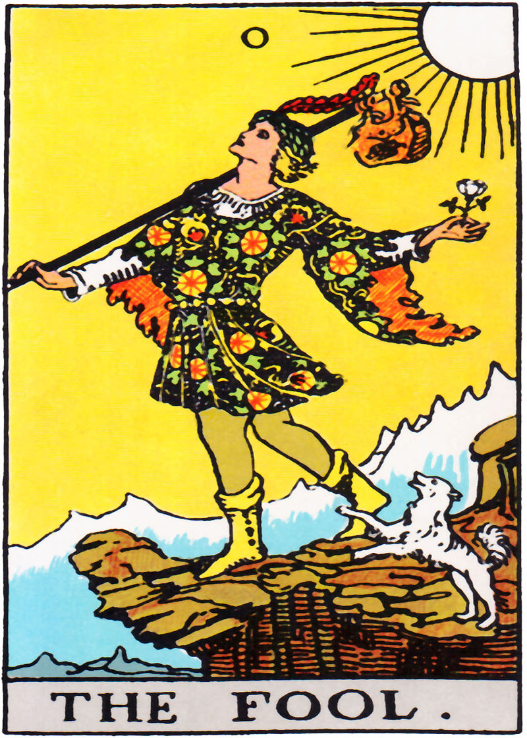
The description of this card provided on the Biddy Tarot website captures this old energy archetype perfectly.
On the Fool Tarot card, a young man stands on the edge of a cliff, without a care in the world, as he sets out on a new adventure. He is gazing upwards toward the sky (and the Universe) and is seemingly unaware that he is about to skip off a precipice into the unknown. Over his shoulder rests a modest knapsack containing everything he needs – which isn’t much (let’s say he’s a minimalist). The white rose in his left hand represents his purity and innocence. And at his feet is a small white dog, representing loyalty and protection, that encourages him to charge forward and learn the lessons he came to learn. The mountains behind the Fool symbolise the challenges yet to come. They are forever present, but the Fool does not care about them right now; he’s more focused on starting his expedition .
Why is the Fool in School archetype an old energy archetype and not a representation of actual spiritual truth? Because it does not teach you the truth of who you are, which is that you are a spiritual adult here to do adult spiritual things. Instead, it teaches you ideology that helps fit you into The System. It teaches you are a cosmic child or a sinful reject. It says you have done bad things. By teaching you that you are here to learn lessons, pay of karma, and redeem yourself, it primes you for passive acceptance of things. By teaching you that you have to work hard to prove your worth, it primes you to accept exploitation. It also blames you for any troubles that you experience in your life, and not the larger economic system. If you are poor, if you are excluded from power and privilege, it is because you did something in a past life to deserve that. Most importantly, this archetype encourages you to accept the all suffering of poverty and exploitation as part of some divine/cosmic “lesson” plan. According to this archetype, pain and suffering of all forms are the “cosmic forge.” You cannot have beauty without pain, you are told. You cannot have love without hate, say the pundits. You cannot grow strong without experiencing a lot of pain. All these things, they will tell you, help you appreciate love and beauty. They temper your soul, and that make you who you are. Because you are a Fool in School, you should accept bad things because they are part of your lesson plan. Accept, learn your “lesson,” and move on.
Of course, as you know, putting up with suffering, assault, and exploitation does not make you stronger, it damages you. Nor is suffering, exploitation, poverty, and abuse of any form your karmic punishment or karmic debt. Suffering and exploitation are caused by the actions of human beings and it is to the people who cause your pain and suffering that you should look if you want it to stop. Contrary to the advice provided by the Fool in School archetype, and as you learned in LP Workbook Two: Healing, if you want to heal and connect, you have have to actively pursue safe and healing environments. If you do not take action to change violent and toxic situations because you feel “everything happens for a reason” or there is a “silver lining” in the suffering you experience, if you do not stand up against oppression and violence, if you just sit back and accept, you will not become a better person, you will not heal, and you will not reconnect; instead, you will find yourself increasingly sick, damaged, and diminished by the toxic world around you. Better to reject the Fool in School archetype and replace it with something new.

It’s a Fight between Good and Evil
No overt card, but embedded in several. The second old energy archetype you need to be aware of is the Good versus Evil archetype. This old energy archetype, which originated in the courts of Sassanian high priests in ancient Persia, sends the message that life is a cosmic war between the forces of good and evil. This war, which goes on for a long time, inevitably ends with the destruction of evil and the triumph of good. You, as an individual soul, have to pick a side in this battle. If you pick the right side, you get to go to heaven and become a member of a Utopian society that unfolds at the end of time. If you make t he wrong choice, you will either be annihilated outright, or sent to hell so you can suffer eternal torment.
Like the Fool in School archetype, the good versus evil archetype answers several big questions. It answers the three original fool questions “Who am I,” “Why and I here?”, and “What is my purpose?” with the answer that you are here to participate in a cosmic struggle where you will fight and suppress evil and strive to be good. In addition, it answers a fourth question not addressed by the Fool archetype which is “why do bad things happen?” The answer provided is that bad things happen because of evil. This evil can be personified into a figure like Satan, or depersonalized into an abstract force like “the dark side” in the Star Wars movies. It can even be located in inside the human psyche, as for example when psychologists say we have a violent and instinctual “Id” or a dark and dangerous Shadow.
How is the good and evil archetype an old energy archetype? This archetype facilitates the elite’s weaponization of the masses. When this archetype is in operation, people are primed to harm people they think are evil. This is what the archetype says is our human purpose, after all. We are good people and we are here to fight evil. The ability to weaponize the masses is of a course a useful power. It allows the masses to be manipulated into violent actions that support elite agendas, it creates a smoke-screen for elite actions, and it provides a useful scapegoat for the self-same actions of the elites.
As regards manipulation, when people believe that the world is organized around a fight between good and evil, it is easier to get them to fight wars, colonize nations, and take from other people. This is how early European colonizers justified and enabled the colonization of Indigenous lands. They cast indigenous people as Godless evil savages. This portrayal enabled and encouraged their populations to act violently towards indigenous populations, and it justified all sorts of colonial military and police violence. Notably, the same strategies of weaponization are used today by political elites the world over. If a society’s elite has military objectives, like controlling the oil of another country, they will cast their opponents as evil to gain broader public support. Then, when they have the support they need, they will send their armies, who believe they are fighting evil and not engaged in imperialistic activities, to gain more control.
And note, it is not just big colonial and military events that can be invoked. Anybody “in the know,” can use these archetypes to inflame a certain segment of the population against others. Thus, politicians have used these archetypes to suppress and encourage violence against the LGBTQ+ community, women, ethnic minorities, indigenous populations, and any one else “in the way” of their power and profit.
As regards a smoke screen. If you invade a country for its oil, or colonize a country for its land, you can hide those rotten, greedy actions behind the archetypal smoke provided by the good versus evil archetype. It is not that one country is invading another because the elites want the oil or their land, it is to save our world from the savage/terrorist hoards.
Finally, the good versus evil archetype also provides a useful scapegoat. When this archetype is in operation in your brain, then when you see something bad happen in the world, like the dumping of toxic wastes, the exploitation of child labour, the murder of 12 million innocents in Nazi concentration camps, and so on, you blame it on the evil actions of a single person, a single “fall-guy,” and not the systemic action of greedy actors acting in service to the System. This is significant. Blaming the bad things of the world on some abstract notion of evil, some evil internal, infernal homunculus like the Id, some dark and mysterious “shadow,” or some superstitious belief in “Satan,” instead of, for example, the actions of corrupt politicians or greedy corporate officials, leads to passive acceptance of the world “as it is,” which of course benefits the elites and their status quo. If you get cancer because of toxins dumped in the environment by a corporation, it is not Capitalism and the greed it encourages that is bad, it is because that one CEO made the decision. If your economy is doing poorly, it is not because some greedy bankers and Wall Street speculators have destroyed it in their quest for more and more, it is because of the greedy actions of a handful of “evil” others. This archetype helps preserve the System and the status quo by providing a scapegoat for realities that would otherwise be blamed on the System, or the Accumulating Class, etc..
Like the Fool in School archetype, this good versus evil archetype is pervasive in popular and elite culture, and exoteric (Christianity, Judaism, Islam, etc.) and esoteric (Freemasonry) religious cultures. We find it in all the Marvel superhero movies, in science fiction productions like Star Wars, on television shows like the popular series Game of Thrones, in children’s books like Harry Potter, and in sprawling creative works like Tolkien’s Lord of the Rings. In Christian circles, the Left Behind books of Christian fundamentalist Tim LaHaye are clearly carriers of the good versus evil archetype.
Like the Fool in School archetype, this archetype does not represent any significant spiritual truth. In reality, this archetype is used to manipulate and control you so that you will act and react in service to the System. Also, like the Fool in School archetype, this archetype makes it much harder for you to connect. It primes you to be passive in the face of exploitation and abuse, which is bad because exploitation and abuse damages your physical unit and makes it much harder to connect. It also primes you to harm others that you think are evil, or wrong, even when these others are your children or intimate partners. Harming others not only damages their physical systems thereby making it harder to connect, it throws you out of alignment and causes the push-pull of misalignment identified in LP Workbook Three. The more you harm other life forms, the more out of alignment you are, and the harder it is for you to connect.

Judgment, Justice, Punishment/Reward
The “Good versus Evil” archetype encourages you to see bad things in the world as the operation of evil and not the systemic racism, abuse, exploitation, greed, violence promoted by the elites of this world. It makes you easier to weaponize and it encourages you to harm others who you, or someone else, define as evil. In this regard, this archetype does not stand alone. The good versus evil archetype works in combination with other archetypes, specifically the Judgment/Justice archetype, and the Punishment/Reward archetype.
Briefly, the Judgment archetype teaches you to judge the acts of others on a scale of “justice,” where one side of the scale represents bad behaviour and the other side of the scale represent good behaviour. The judgment and justice archetypes basically answer the big questions created by the previous good versus evil archetype, which is, “what do we do with good and bad people?” For those who have absorbed this archetype, the answer comes quickly to mind—you must apply justice. In old energy systems of thought, justice is basically “getting what you deserve.” If you are judged then the cosmic principle of “justice” suggests you should get what you deserve.
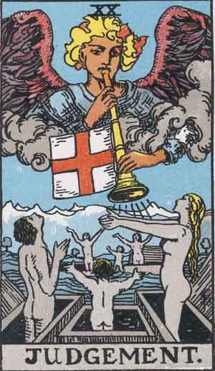
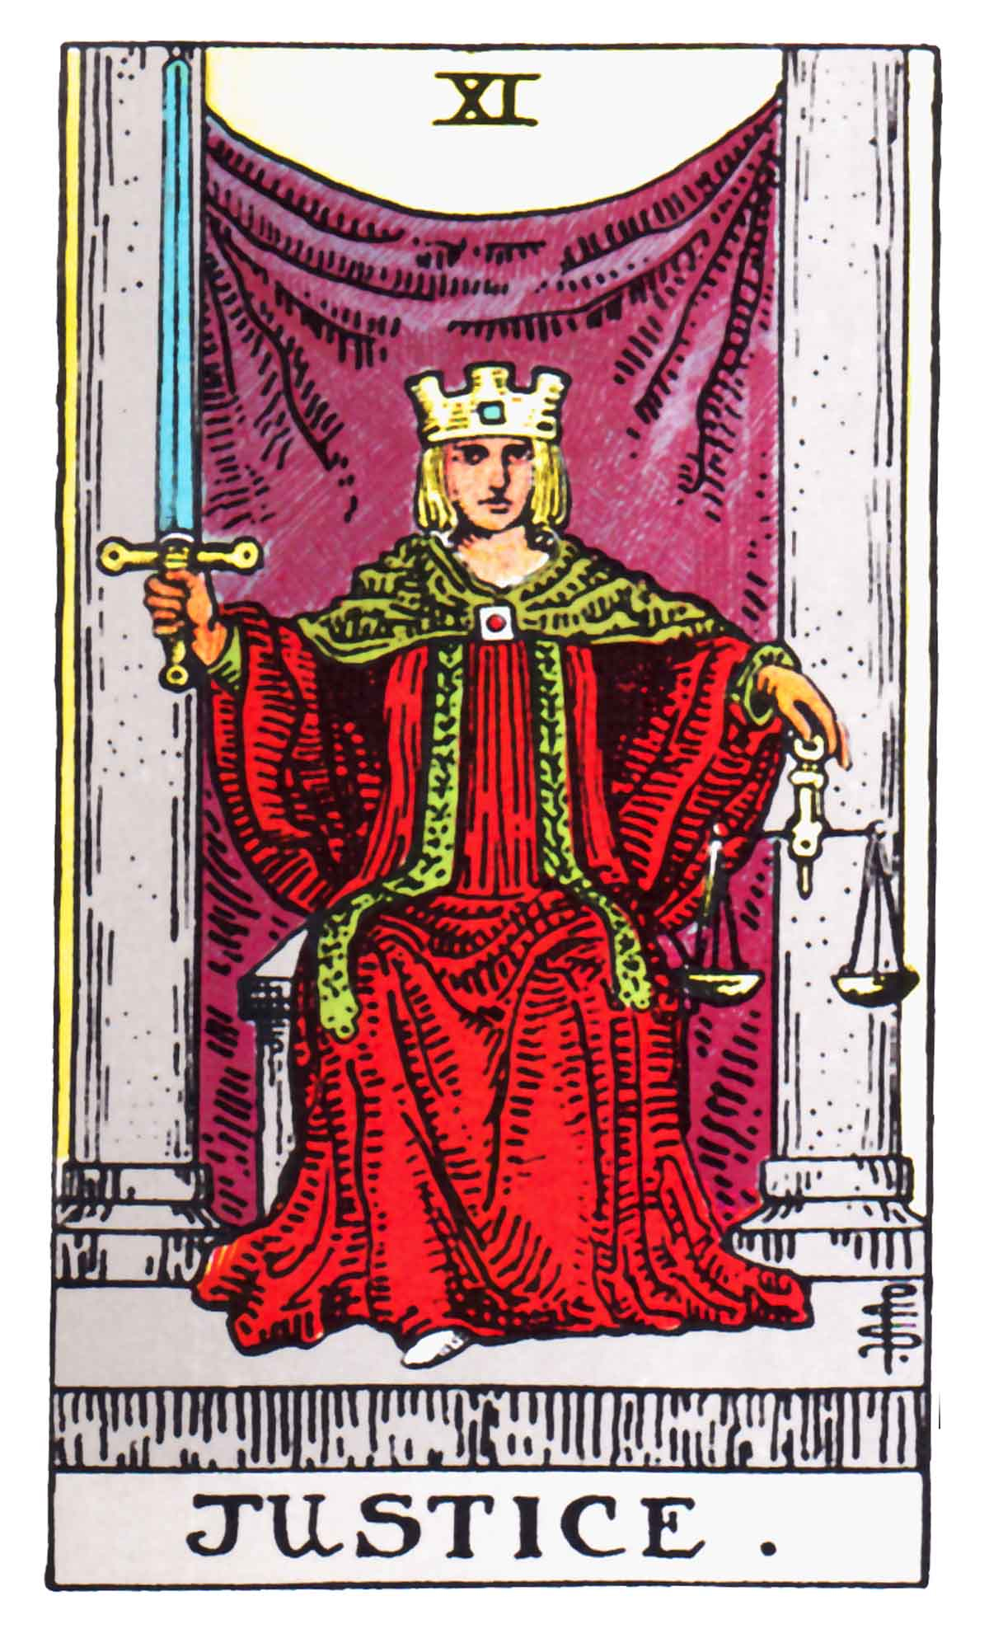
We learn to engage in this judgment and justice process very early on, primarily from our parents, teachers, priests, and “friends,” who are constantly “judging” our behaviour and telling us when we are good or bad. Parents teach us about judgment through their own daily activities, but also in cultural myths like Santa Clause who judges all children of the Earth and denies them Christmas joy when they are bad. Priests and gurus are a special source of this archetype since they teach that the universe is a universe of judgment and punishment. Priests tell you all about the cosmic principles of justice and judgment, telling you that God is a cosmic judge constantly assessing your behaviour. Gurus tell you about “karma” and say it is a cosmic principle of judgment, of you getting what your actions deserve. We also see these archetypes reflected quite clearly in the Freemasons’ Tarot, in the Judgment and Justice cards.
Taken together, the judgment and justice archetypes teach us that it is OK to judge others. If it is good enough for God, the universe, and Santa, it is good enough for all of us. I think it is fair to say that by the time we are adults, we are all primed to judge others, and unless we make a conscious effort to stop, we are doing it all the time.
Justice and judgment say that the universe/God/karma gives us what we deserve. And what do we deserve? The answer to that big question is provided by the punishment and reward archetypes. The basic idea behind these archetypes is simple. You get a reward if you are judged to be good or have engaged in good actions, and you get a punishment if you are judged to be bad. What the punishment is depends on your belief system and the country you live in, but it basically it comes down to some form of harm. If you are bad, punishment means being hurt in some way. If you are a child, this can mean physical assault like spanking, or emotional assaults like name-calling or shaming. If you are an adult, it can be public shaming, psychological, physical and emotional abuse, incarceration, and even execution. The details of the violence are not important. What is important is that you realize the end result of the good versus evil, judgment, justice, and punishment archetypes is justification for harming others.
The justification for harm provided by these four archetypes is quite powerful. By the time you get down to the punishment and reward archetype, it all seems eminently sensible. God hurts people. Karma ensures you get what you “deserve.” Everybody should experience “justice.” If you have done bad things, you should be harmed. Hurting others is natural, inevitable, cosmic, and divine. It is part of grand cosmic drama. When you judge and harm others, it is OK. After all, you are just playing your chosen part in a big cosmic show.
By now we know this is BS.
Harming other people causes damaged to physical unit. This damage lowers your ability to function and undermines your ability to connect. Lots of research shows how even minor forms of psychological or emotional assault can have long term negative consequences for the individual and society. The idea that you should judge others and that this should lead to harm is silly superstition at best. At worst, it represents intentional efforts to lower your ability to function so you will be a better fit in all the low skill, low paid jobs of the world. Really, harming others because of some notion of “justice” has no place in a modern society or in modern systems of human development.
Of course, it is important for there to be consequences for bad actions, but these consequences should not involve causing more harm, especially to children. A more progressive form of justice is restorative justice. Restorative justice is justice that brings victims and perpetrators together in order to find ways to repair damage and prevent violations from reoccurring. Rather than causing more harm, disability, and dysfunction by hurting another person, thereby reinforcing violence and perpetuating dysfunction, restorative justice ends the cycle of violence and despair, heals the damage done, and transforms individuals and communities. If there is a cosmic or divine principle of justice, it is to be found in restorative justice and not the violence and abuse that passes for justice in so-called modern societies.
At this point, it should be clear in your mind that old energy archetypes encourage acceptance of violence and suffering, and encourage interpersonal harm. We know this is bad for us, so the question now is, why? Why do parents harm their kids and call it discipline? Why does society harm its people and call it justice? The answer to that is quite simple. All that “judgment” leads to violence, and violence is useful to economic and political elites because it damages you, diminishes you, and makes you easier to manipulate and control. It does this in a couple of ways.
For one, violence and threat of violence keeps you compliant and inline. In a society primed to violence by these old energy archetypes, violence and the threat of violence is ubiquitous. If you do something that somebody else, like a parent, partner, or friend, considers bad or out of line, they will feel justified in hurting you. They will act on this and you will learn that to avoid pain and suffering you need to stay within the boundaries of good behaviour. Note that despite what some might say, this does not make you weak in any way. It is the way your body and mind are programmed. Remember the pleasure principle from our first course. Your body is programmed to avoid pain and seek pleasure. Once it has learned that being “bad” brings pain, it will do what it can to avoid that pain. All you have to do to control someone in this fashion is to suggest their behaviour is bad and they will immediately take a step back. If that does not work, you can escalate with threats of violence. For most adults, this is enough to control behaviour.
The second way the violence encouraged by these old energy archetypes controls your behaviour is that it damages you and makes it harder for you to connect. As we learned in LP Workbook One, a disconnected person is a diminished person. As you will learn now, a disconnected person is also a person without a strong self and without a strong sense of their own worth, or their fundamental rights. The bottom line is, it is easier to get a disconnected and damaged person to work long hours in a factor and easier to fool a disconnected person into thinking the System is good. Having a lot of diminished and disconnected people running around is great if you are a capitalist who needs a compliant workforce, but not so good for the people involved, or the society they live in. The perpetual assault that many experience creates an underclass of people easy to manipulate and control and not living up to their full potential.
To be clear, old energy archetypes of good and evil, judgment, justice, punishment and reward, are all about control. They control us by damaging, diminishing, and disconnecting us, and they control by providing an ideological foundation that makes it easier for them to justify war and violence. Obviously, if you interested in achieving your full potential, you have have to get rid of these archetypes and replace them new energy archetypes that emancipate and uplift. As you know, the TOSAS provide in part two of this workbooks provides such a new energy framework. We will look at the TOSAS shortly. Before we get to that however, I want to briefly examine a second set of old energy archetypes that diminish, disconnect, and make you easy to manipulate. These archetypes are less common, but they are still present in consciousness. Once we cover those we have a solid understanding of the old energy archetype system, and a strong foundation upon which you can use the TOSAS system to build a new way of looking at the world.

Old Energy Archetypes II
In the last lesson, we learned a few of the deeply embedded old energy archetypes, like the Fool in School archetype, the Good versus Evil archetype, and the Judge/Punish/Justice archetypes. As we have seen, these archetypes lead to views of the self and views of the world that damage, diminish, disconnect, and make you easier to manipulate and control. If you want to move forward, heal, and connect, you need to recognize and root out those archetypes.
Unfortunately, the old energy archetypes from the last lesson are not the only ones you have to deal with. There are a few more archetypes that are pressed into your brain as you grow up and that sit percolating in your unconsciousness all the days of your life. These secondary archetypes are less about creating conditions that damage and disconnect you, although this is certainly a goal, and more about inserting you into hierarchies of command and control as a willing, even enthusiastic, cog. These secondary archetypes are common in Ideological Institutions, like the Catholic Church, Freemasonry, Skull and Bones, and I suspect Hollywood and elsewhere where they are used to control the thoughts and actions of the people who participate in these institutions.
In this lesson, we are going to look at these other archetypes so you can learn to recognize them. Following this, we will turn our attention to the Triumph of Spirit Archetype System and learn how to use the new energy archetypes provided by the TOSAS to replace all these ugly old energy archetypes.

Compliance and Submission
The first additional archetype to discuss is the Compliance and Submission archetype. The compliance and submission archetype answers the big question, “what should I do to be a good person?” with the answer that you should follow the rules, listen to authority, and do what you are told.
Like most old energy archetypes in an old energy creation template, this archetype does not function alone. Promises of reward (“the boys” will help out your business) and threats of judgment and punishment (eternal damnation, being cut to pieces by your brothers) are used to create a meniscus of fear over your individual consciousness. These threats are backed up with real consequences, like spanking if you are a child, or incarceration and economic punishment if you are an adult. The basic idea is simple. If you follow the rules and do what you are told, you will avoid pain and gain pleasure. If you do not do what you are told, the hammer is going to fall.
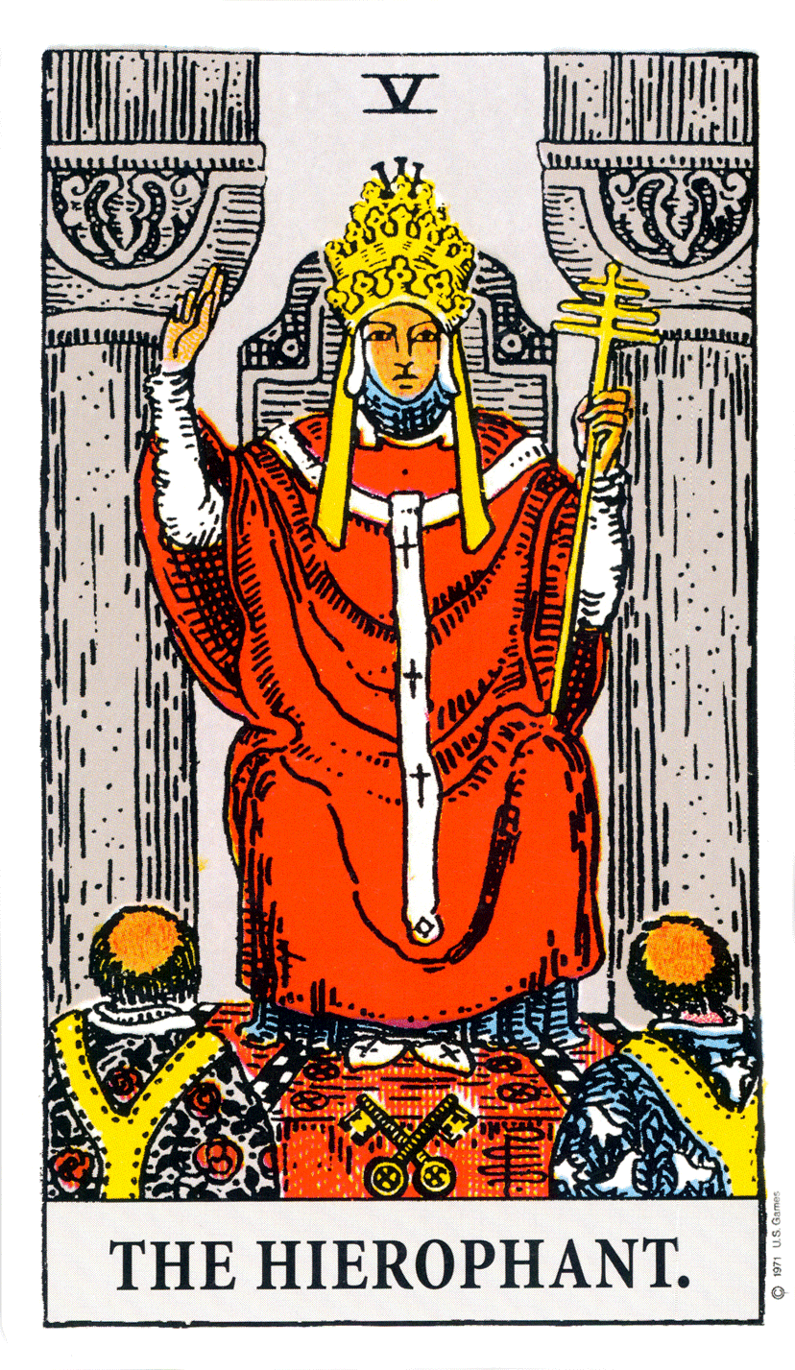
This archetype is obvious in Western patriarchal monotheisms like Judaism, Catholicism, and Islam whose priests teach you that you should cower in fear and follow the authority of God. This archetype is also obvious in esoteric doctrine found in secret clubs like Freemasonry or Skull and Bones where compliance and submission is framed as a positive step on an ascending hierarchy of privilege and power. Finally, you can see this archetype clearly articulated in the Hierophant card in the Freemason’s tarot. This card shows two figures submitting before a powerful authority figure who holds the keys to their further advancement. According to Paul Foster Case, the Hierophant is the “revealer of mysteries” and if one wants to be “initiated into the mysteries” (the reward) one must conform and submit. As Benebell Wen notes:
The Hierophant card suggests conformity as a prevailing impulse. To conform, one must repress certain aspects of oneself that are different from others....
The message here is clear; if you want to know the “truth,” you need to kneel before the Hierophant.
Why is compliance and submission old energy? It is quite simple. Submission ties your energy and actions to the will of another person, specifically to the authority that stands above you. Of course, there is nothing particularly wrong with following an “authority” on something. If you want to be a musician, it makes sense to learn from the masters. However, there are limits, as for example when you are taught to follow people blindly regardless of morality or ethics, or when you unfairly sacrifice your own identity, will, and desire, for money or power and such. In these cases, blindly following authority can lead you to expose yourself to violence and abuse, engage in unaligned actions, or sacrifice your own essential needs, health, and well-being, to benefit another person or organization. It should never be that way. Nobody should be required to expose themselves to violence and abuse. Nobody should be required to harm other beings. Nobody should be required to sacrifice their own identity. Nobody should be required to submit their own will to the will of another, for any reason. If you want to move forward and connect, you have to protect yourself from harm, establish right action, and be true to your Self. Doing these things can be quite difficult while you are servile and submissive to another.

Only the Chosen
In western religious teachings, both esoteric and exoteric, the compliance and submission archetype is often combined with the Only the Chosen archetype. According to this archetype, only the “chosen” people get into the special lodge. Only the chosen get to enter the inner sanctum of the temple. Only the chosen get to enjoy utopia. If you are not chosen, you are simply not allowed.
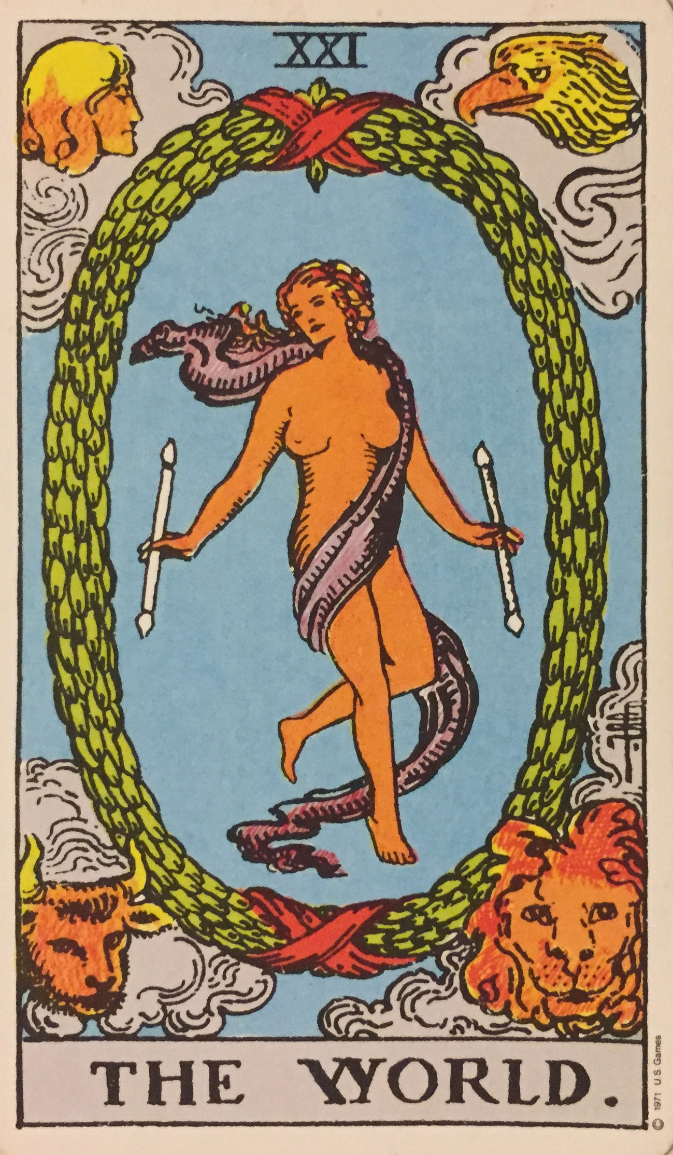
How do you get chosen? In the past, you would have had to be born into specific castes or ethnicities and genders (i.e., white/male) to be included in the special club. The assumption here is that if you are member of the correct class, or gender, or ethnicity, you are someone better, smarter, wiser, and more graced than the “others.” These days, being chosen is usually based on some measure of merit. The Skull and Bones society of Princeton, for example, selects students who are at the top of their classes to be members of their filial, quasi-religious old-boys organization. Freemasons require the recommendation of members. You can see the “chosen one” presented as suitably rewarded in the World card of the Freemason’s tarot.
Why is the Only the Chosen archetype an old energy archetype. In authentic human spirituality, God or the universe does not create a hierarchy and does not exclude people based on merit. The exclusion implied by the only the chosen archetype is designed specifically to preserve and enhance elite systems of power and privilege. The archetype provides a ready-made justification for exclusion and privilege that neatly shifts blame for being excluded onto the individual. If you do not get into “the club” it is not because club members are intentionally working to keep you out, or because your parents did not have enough money, or because you do not quite fit into the box provided, it is because you do not deserve it. You have weak genes. You lack talent. You are lazy and unmotivated. You are not one of “God’s” chosen ones. Whatever the justification is, is does not matter. The point to take away is that the Only the Chosen archetype provides a justification for lavishing rewards on the “chosen ones” while excluding certain people from getting into the special club.
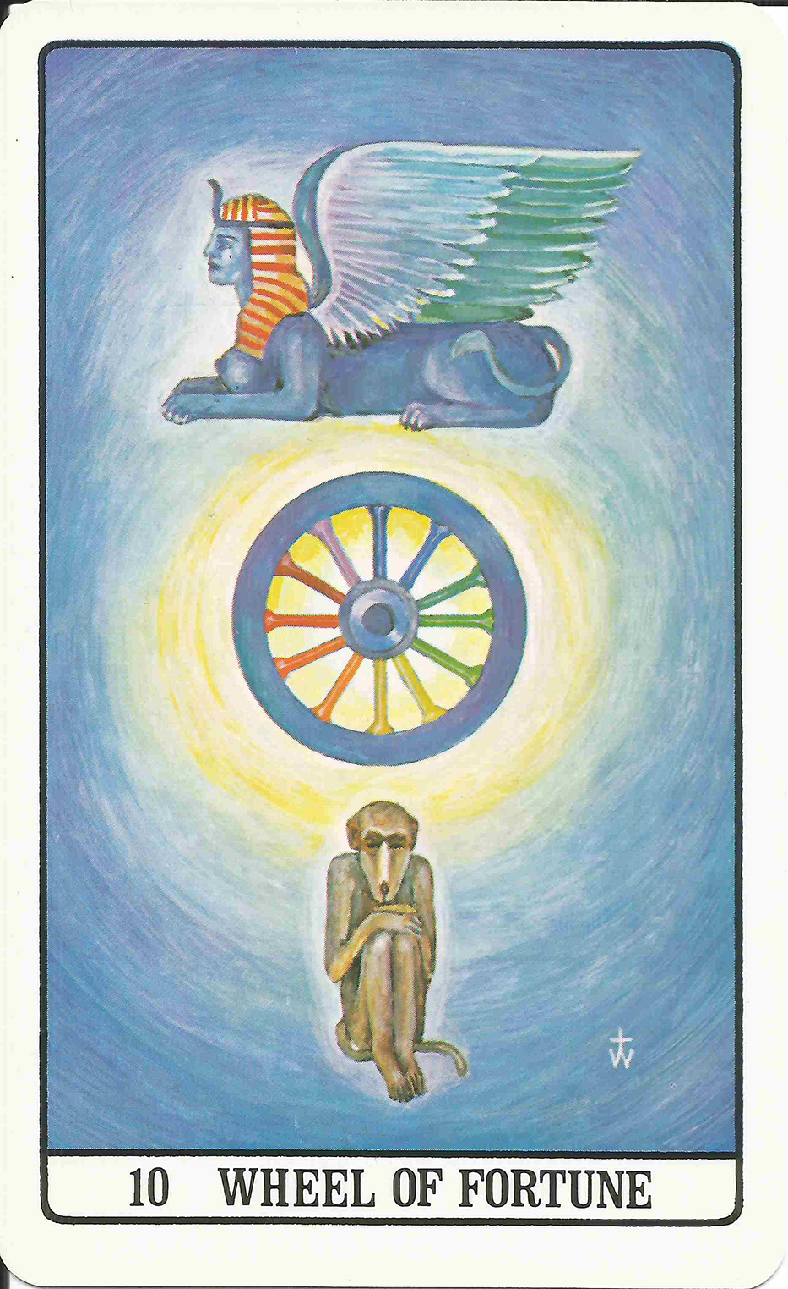
Like all old energy archetypes, this archetype limits you. This is true whether you are, as illustrated in the Golden Dawn Tarot card “Wheel of Fortune” one of chosen elite’s at the top, or the excluded human detritus down below. For those at the top, the archetype limits you because it creates a wall of wrong action, wrong thought, misalignment, and disjuncture through between you and true spiritual connection. For those down below, the archetype limits you economically and politically. If you are excluded from the special clubs, you are excluded from information and opportunities needed for worldly success. This archetype also builds a psychological and emotional wall between you and your powerful spiritual ego that can be very difficult to climb over or breakthrough, especially during powerful connection events. When you have a connection event, thoughts and feelings of unworthiness, of not being among the “chosen,” of being worthless, of being subject to judgment and punishment, can bubble up. When they do, these thoughts can cause intense anxiety and fear. Fear during a connection event shuts the connection down. Indeed, intense fear during connection events can also scare you away from connection practice, make you very reluctant to try again later. It is important, therefore, to be aware of this “only the chosen” archetype so if it does come up you can work to put it aside.

Secrets
In esoteric teachings, the compliance and submission and only the chosen archetypes are often combined with the Secrets archetype. The Secrets archetype conveys the idea that certain truths shouldn’t be shared with those who are not “worthy” or not “chosen” (i.e., not members of the club). The Secrets archetype suggests that the “heathen masses” and “unwashed savages” cannot handle the truth and would use powers provided by “the truth” to destroy themselves and the world. It’s only the elite “chosen ones” with the grace, talent, ability, or the genes who are capable of handling the truth.
You can see the Secrets archetypes embedded in various esoteric teachings where it is often combined with the Only the Chosen archetype. Israel Regardie, for example, suggests that esoteric secrets are only for the "very few in life [who]... can attain to the full realization of their divine origin and nature.” Madame Blavatsky is not so subtle about it when she calls humans “perverse,” “selfish,” and shortsighted who “could never be entrusted with divine secrets” because they would simply pervert the “sublime truths” and symbols. It is notable that Madam Blavatsky, like many others admitted into this world’s “secret” organizations, was a member of society’s nobility, specifically the Russian nobility.
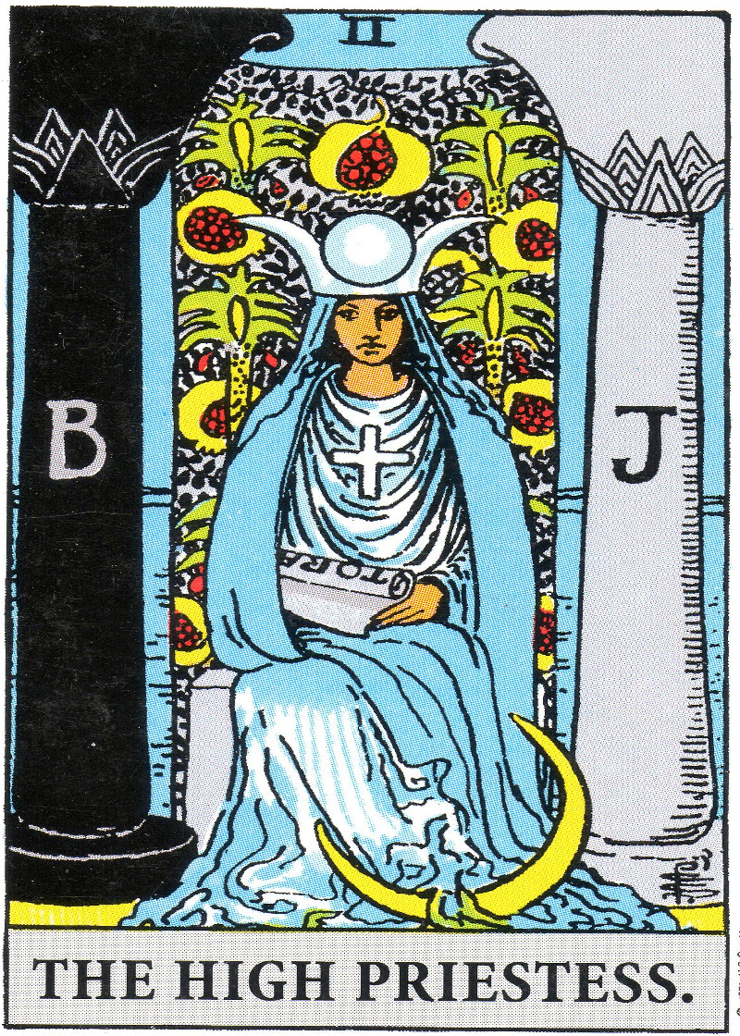
The Secrets archetype is most common in esoteric systems where it is used to justify secrecy among members of the accumulating class, and lack of transparency. Members of the ruling class invoke this archetype as an excuse and justification for keeping the masses in the dark. They use this archetype to give themselves the latitude they need to keep the venal and profiteering actions they take that harm others a secret. After all, you cannot tell the masses what is really going on. They would not understand. They cannot handle the truth. Better to keep all these business things a secret.
In the Freemasons’ Tarot, you find this archetype expressed in the High Priestess archetype. This card which shows the High Priestess (a.k.a. Isis) guarding a veil behind which lie the secrets of the order. One tarot commentator writes, in sexist and classicist fashion, “Isis only entrusts the key to mysteries to her sons, to the 'Children of the Wisdom' worthy of knowing her secrets.”
This archetype is also propagated in popular culture. One of the clearest representations is in the 1998 movie Sphere, starring Dustin Hoffman, Sharon Stone, and Samuel L. Jackson. This movie chronicles a group of people who find a “sphere” deep in the ocean. This sphere gives them magical powers to manifest whatever it is in their thoughts. They end up destroying things because they cannot properly control their thoughts—“they can’t handle the truth.” In the end, they use the sphere to make themselves forget and go back to sleep.
Why is this idea of keeping secrets and old energy archetype? How does the old energy Secrets archetype limit you? For one, keeping secrets from others just so you can enjoy power, privileged, and wealth is unaligned behaviour. It is manipulative. It is violent. It is stealing. As you know from LP Workbook Three, when you engage in unaligned actions, the push-pull between your spiritual ego and bodily ego makes it harder to make making and maintain connection.
Another way the Secrets archetype limits you is that it undermines your self-esteem, particularly if you are on the “outside” of the power structures of society. If you accept the notion that you are “not worthy,” if you believe that secrets can only be handled by the chosen few, if you think you must comply and submit before being allowed into the temple, then you may be reluctant to pursue truth, growth and power on your own. You may feel unworthy. Consequently, you may prefer to sit in impotent normal consciousness and wait for somebody else to guide your progress. You may even fearfully reject connection experiences that convey the message that you are powerful and bright. This fearful rejection of your own power is not as uncommon as you might think.

The Chosen One
In addition to the compliance and submission, only the chosen, and Secrets archetype, an additional old energy archetype that we want to deal with here is the chosen one archetype. The messaging of the chosen one archetype answers the question, “how will we save ourselves, and the world.” The only the chosen archetype answers the question by saying a chosen one with special powers and abilities will arrive sometime in the future and solve all the world’s problems. This archetype is incredibly common and you find it in many of the world’s religions and many of the world’s top cultural productions. You find it in Neo in The Matrix who one day takes a pill, wakes up and battles the evil machines in order to save humanity. You find it in Annakin in Star Wars who we are repeatedly told is the “chosen one” sent to bring “balance” to the Force. In the book series Dune, Paul Atreides is the white saviour who saves the galaxy. Harry Potter in the Harry Potter books series, singularly saves the world from the evil Voldemort. Frodo in Lord of the Rings saves the world from the evil Sauron. Even Jesus in the Bible is presented by Church officials as the chosen one. Politicians will even use this archetype. At one point, Donald Trump brazenly suggested he was “the chosen one.” This archetype is so common and so well known that it was even the subject of parody in the Spy Kids 4 movie where the game players make fun of “The Guy” who is a saviour come to save the game world.
Why is this archetype an old energy archetype? It is old energy because it discourages you from taking action to save yourself and the world. As we already know, you cannot handle the responsibility anyway. Instead, you give your “power” away to some mythical figure who will never really come. This abdication of personal power while you wait for a saviour benefits those with power who can then rely on you to sit back and do nothing while the world burns around you. After all, you are not worthy, strong, or special enough to do anything significant in this regard. You have to wait for the chosen one.
This archetype is also old energy because it prevents you from engaging in serious healing and connection practice. It prevents you from making changes that need to be made so you can move forward. After all, if a saviour is going to come and wave a magic wand and get you into “the kingdom,” what is there you have to do except wait for “the man” (and it almost always a man, and usually a white one) to come along and do all the hard work for you.
Like all old energy archetypes, this archetype benefits economic and political elites who rely on your passive inaction. If you are trained to comply and submit, if you are not one of the “chosen,” if a saviour is coming to save you, then you do not have to act for yourself, you just have to sit back and wait. This is great news for people who would be bothered by your resistance. It is not so good for the planet and for all the people who suffer under the yoke of exploitative systems.

Binary Gender
The final archetype to look at in this section on old energy archetypes is the binary gender archetype. The binary gender archetype answers big questions about sex and gender. The binary gender archetype conveys the message that there are only two genders, male and female. More to the point, the binary gender stipulates how these genders should act. Women are supposed to be passive, nurturing, receptacles—domestic types whose power resides in the home—while men are supposed to be the active, aggressive, alpha go-getters who go out into the world and work.
Why is binary gender an old energy archetype? For a few reasons. Binary gender disempowers women, for example, by suggesting they confine their power, influence, needs, and desires to the home life. Keeping women at home preserves patriarchal power structures by limiting women’s power in the external world. There is nothing wrong with staying home and raising children, but some women don’t want to do that, while some men do. Arbitrarily limiting who does that benefits capitalists who devalue “women’s” work and then get a cheap source of domestic labour to raise the next generation of workers. It also benefits patriarchs who benefit from women’s domestic subservience. It does not benefit individuals who end up living a life they do not want to live just so the System can continue to operate.
Binary gender is harmful in other ways as well. Binary gender causes individuals to amputate certain aspects of their being. In order to fit into the binary gender stereotypes, women often amputate the forceful
“masculine” of themselves, living lives as passive receptacles for the will of others. Boys and men do not fair much better. They are told to suppress, even amputate their emotional responses. They are told to be tough and disconnected. Amputating emotions benefits the Capitalist system because it encourages men to detach from their families so they can leave and go to work out of the home for long periods of time. It does not benefit men however because it means living life as an emotionally disabled amputee. And obviously, cutting off your emotions makes alignment and connection more difficult. It is much easier to suppress Steering Emotions like guilt and shame when you have disabled your emotional sensitivity. Being able to ignore steering emotions definitely benefits the accumulating class. Suppressing steering emotions allows them to more easily “do what needs to be done” (to enhance profit) out in the “real” world of business, even if that means harming thousands, millions, or even billions of people.

Summary and Conclusion
This now brings us to an end of our examination of old energy archetypes. In this and the previous section, we have learned several key old energy archetypes that are used to diminish us, control us, and insert us as compliant cogs into a system of accumulation that benefits a few while exploiting the many. The point of this examination was to help you familiarize yourself with old energy archetypes so you can engage in successful flow purification.
As you know, learning to recognize old energy archetypes is only the first step we need to take. Now that you know the old energy archetypes, you need to learn the new energy archetypes designed to replace them. In the rest of this workbook, we take a closer look at the Triumph of Spirit Archetype System which is a system of new energy archetypes designed to help with flow control so you can heal and reconnect to the powerful consciousness that resides within you.

PART TWO: NEW ENERGY ARCHETYPES

Introduction
In part one of this workbook, we learned about flow control, flow purification, wrong thought, archetypes, and creation templates. As we have seen, archetypes come in two flavours, old energy and new energy. Old energy archetypes are archetypes designed to diminish and disconnect you so you can be inserted into the System as a compliant cog. New energy archetypes are designed to uplift, empower, and connect you to your spiritual ego. In the old energy, archetypes are like bricks in a wall of wrong thought. The wall is a Creation Template designed to create psychological, emotional, and spiritual conditions that prevent you from healing and connecting. In the new energy, archetypes are steps on a staircase that facilitate healing and reconnection.
With these concepts in mind, it is now time to learn more about new energy archetypes. The new energy archetypes that we will be examining are provided in the Triumph of Spirit Archetype System (TOSAS). The TOSAS consists of a collection of twenty-two new energy archetype images and textual commentary that explains the symbolism. You can find the images online and also printed on colourful Archetype Cards which you can purchase. You can find links for purchase and free online browsing in the preface of this book.
There are two ways to use the archetype cards. The first way is to use them for daily meditative practice. The second way is to use them to steer your connection practice, particularly when you are using Connection Supplements.
To use the cards for daily meditative practice, study the images and the associated textual elaborations. It is best to study no more than one image a day. Simply pick one card a day, read the commentary, think about the imagery, and absorb the ideas provided. You should examine and think about each entry long enough so that you have memorized the basic gist of the archetypes. You need to memorize the basic gist so you can “invoke” the new energy archetype when an old energy archetype pops into your brain. For example, if you are having an interaction with your boss (or anybody else, for that matter) and suddenly you feel unworthy, insignificant, incompetent, and small, recognize that this is an old energy archetype influencing your feelings of self. To combat the old energy archetype, recall the Joyful, Master, and Power archetypes and remind yourself of the new energy ideas contained therein. This process of recognize, root out, and replace will help you resist and diminish the power of old energy archetypes.
The second way you can use the cards is in connection practice. Using the archetype cards during connection practice will help you connect directly to the archetypes behind the images and will help clear any old energy archetypes that pop up and interfere with connection. For example, you might experience a connection event, and during that event the old energy Fool in School archetype might come up, making you feel unworthy and powerless. Because you are connected, this feeling might be particularly strong, and you may feel strong emotions of guilt, shame, and unworthiness all of which can disturb and disconnect you. To avoid that, when you begin to notice the Fool in School idea popping into your mind, invoke the Joyful archetype by looking at the card image and recalling the associated ideas. Reread the descriptions if necessary. Repeat the new energy idea in your head while gazing at the card until the old energy archetype is suppressed.

Some General Advice
As you can see, the process of flow purification with the TOSAS is straightforward. Look at the cards, think about the commentary, and be mindful of the ideas in your brain. When an old energy archetype pops up, remind yourself of the new energy version. Keep thinking about the new energy version until the old energy archetype dissipates and disappears. Simple. Before turning you lose into the archetypes, however, there are a few things to keep in mind.
Number one, this works best if you engage in daily, disciplined practice. Just doing it once in a while will not work. Wrong thought is deeply buried and pervasive in our individual and collective psyche. The deep, spiderweb-like penetration of wrong thought makes it hard to get it all out. The only way to do it is to be consistent and persistent. Practice every day until all the old energy archetypes are gone, or at least severely weakened.
Number two, keep in mind, the wrong thought can cause Nadir Experiences—experiences of anxiety, fear, and even paranoia, particularly when experiencing a powerful connection event. If you do have a nadir experience during connection, there are a few things you can do to calm yourself and maintain control. For one, breathe deeply. Deep breathing will help calm and ground you. Also, as much as is possible while you are in the middle of an experience of fear and confusion, have faith. Have faith in yourself that you are a good person deep down. Have faith that even if you did really bad things, God/Cosmic/Creation will forgive you. Remember from LP Workbook Three, all you have to do is acknowledge and atone. Finally, have faith the “universe” is a universe of love, compassion, and forgiveness and not violence, exclusion, and death.
If you have a nadir experience, you may find it helpful to practice the following affirmation of love and power. Breathe deeply and recite the affirmation as many times as necessary until you are calm, grounded, and in control of your thoughts and emotions.
Affirmation of Love and Power
The universe is a universe of love and compassion.
I am a Joyful being of power and might.
I am safe. I am loved. I am loving. I am Light.
I have the authority to make this all right.
Number three, be prepared for significant and rapid shifting. If you are disciplined about this and if you can calm your anxieties and fears vis a vis connection, significant and rapid shifting can occur. A powerful connection experience can contribute to the resolution of psychological and emotional trauma. It can contribute to deep shifts of personality as well as provide dramatic insight, even enlightenment. As positive as these shifts are, they can rattle your sense of self and reality. If combined with low self-esteem and psychological trauma, these shifts can even throw you out of psychological and emotional balance. When these shifts happen, take deep breathes and ground yourself. If you struggle, or if they lead to anxiety, recite the affirmation of love and power and reach out and talk about them with knowledgeable people who can help you centre and ground.
Number four, as noted a few times throughout these LP workbooks, be prepared for external resistance. Although dramatic and rapid shifting is something to aspire to, if you move forward fast, you might experience resistance from those around you who feel threatened by your progress. Resistance usually comes in the form of efforts to suppress and control with various forms of psychological, emotional, or even physical violence. This resistance can be a challenge. It can make you afraid to move forward. It can make you doubt what you are doing. It can make you question your progress. It can lead you to choose “normal” just to avoid conflict.
If you do experience resistance from others, politely ask them to stop. If these are intimate partnerships or close friendships, reassure them you still love them. Say “everything is going to be fine.” If they are open, share with them what you are doing. If this does not reduce their resistance, create firm boundaries and expectations. Reject violence and abuse. If they ignore your boundaries and continue with their assaults, you may have to consider removing them from your life. Always remember, assault of any form damages you, so do not accept it. If you do not want to remove them, if you find removing them is a challenge, or if they become abusive and violent when you try to break free, seek professional guidance, therapeutic assistance (e.g., couple’s counselling, family counselling, etc.), and police intervention. If that does not help, your only option may be to flee. Remember, do not just “let it go” just so you can “get along.” Do not “give up and give in.” Do not put aside your personal journey back to Self just because somebody else does not like the direction you are going. If the only way to get the message to a person is by cutting ties and excluding them from your space, do that.
Finally, number five, realize that new energy archetypes do not work in isolation. Each archetype card carries with it a certain empowering and uplifting new energy message. These messages can stand on their own, but they are really designed to work together to provide a complete new energy narrative about your identity, purpose, and place in the universe. You will need to learn all the TOSAS archetypes before the full power of the TOSAS completely emerge.
With that, let us now turn our attention to the TOSAS and the new energy archetypes contained therein.
Before turning you lose on the archetype, a few final words about how the archetype and commentaries are organized.

Organization
Each archetype begin with a card image and a key phrase. The card image contains important symbolism which is explained in the “Symbolism” section. The key phrase captures the essence of the TOSAS archetype and gives you an easy mnemonic that can help you “invoke” the ideas and the energies. It is best to memorize the key phrases so they can bubble up as necessary. The narrative then provides an extended explication of the new energy narrative, followed by guidance on how to use the new energy archetype to conduct flow purification.
Finally note, words in bold refer directly to archetypes in the TOSAS system. If you read, “you are a powerful lightworker incarnated on this world to complete the Great Work.” The words power, lightworker, and world refer to three corresponding archetypes in the TOSAS.

The TOSAS

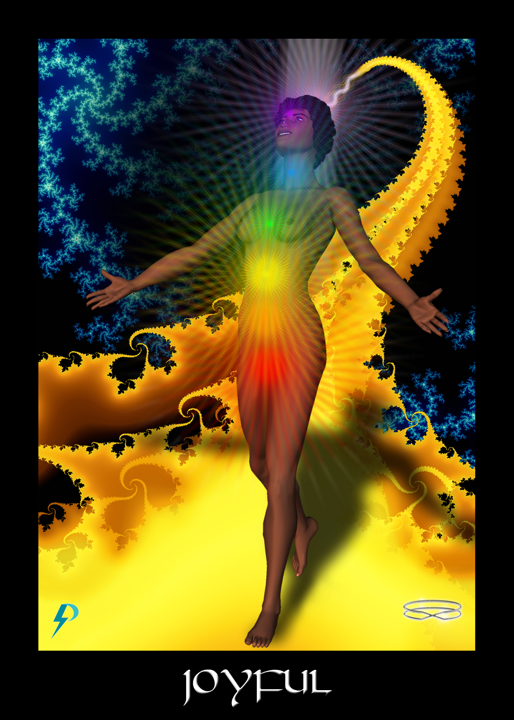

Joyful
Key Phrase: I Am Joyful in Manifestation.
Symbolism: A Joyful soul is shown walking a yellow brick road into manifestation. The road emerges from the crown of the figure, indicating that the individual soul constructs its own path into incarnation. A beam of light represents a strong Connection to Source. Seven chakras support the body (and The Body). Before the figure lies the vast untapped potential of creation. The fractal blue waters of creation support the figure and the road. This figure, about to manifest in a physical body, is on a joyful creative journey.

New Energy Narrative
This archetype answers the big questions “Who am I?”, “Where am I going?” and “What is my purpose?”
As for who you are, despite what you may have been taught, you are not a “fool in school,” you are not an evolving ape (though you live in a physical unit that is evolving), and you are not here to learn karmic lessons.
In the new energies, you are a joyful master and lightworker, victoriously incarnated in a powerful physical unit. You are a joyful spark of creator Consciousness on a joyful creative journey to create wonderful playgrounds for Spirit.
As for where you are going, in this card, you are shown walking into birth and expressing the will of God, which is your will. You are connected to Source, to the Fabric of Consciousness, and you are joyful in your magnificence. You are, after all, a spiritual emissary here on a creative mission. However, you are probably not aware of this fact just yet because, like all others who enter into manifestation under old energy conditions on this earth, you are as yet subject to the limitations of the Blindfold. Of course, these limitations can be overcome any time you wish. Simply set your intent to heal and reconnect.
As for what is your purpose, you are here to enjoy life and be creative, that is true. But the truth is much bigger and more glorious than that. You are also here to complete the Great Work, which is the evolution of this planet’s Pinnacle Species, and its final celebratory graduation.
At the highest and most aligned levels, this archetype depicts the beginning of the creative journey of your spiritual ego as it enters into a physical body to accomplish its work, the Great Work. Understand, you are not alone in this work, nor are you new to this gig. As a member of the family of Spirit incarnated on this world, you are joyful, masterful, and powerful. Embracing light, life, and connection, you descend into physical creation. You sacrifice so that you might uplift, create, and enjoy.
To step onto the path, set your intent and recite an Awakening Affirmation. Say to yourself (and to your guide network),
“I wish to move forward.
I wish to awaken.
I wish to ascend.”
There is much for you to remember, but it is easier than you think. Your time to return is now, and there is no time to waste! Heal and reconnect so you can awaken, activate, and ascend to glorious union. Renew and reveal your true glorious Self. Remember and rejoice in the glory of your true Divinity.
Expansion, (spiritual, emotional, psychological, etc.) growth, evolution, healing, and connection lie ahead, but only if you take the next step. As with all journeys, work is involved. You may refuse if you wish, but the choice to remain in the old energies leads inevitably to diminishment of soul and death of the body. Avoid that fate. Gather strength and move forward.

Flow Purification
In the old energy, you are taught that you are Fool in School here to learn lessons and clear karmic debt. The fool archetype teaches that you are on some spiritual path of tutelage that requires you to pay attention, learn rules, give away your power, submit, and work hard so that one day you can reach some vague spiritual or evolutionary goal. It tells that you are a sinner and that in order to redeem yourself you must work hard and learn your lessons. To be a good girl or boy, follow the rules, follow authority, and do what the authorities (teachers/masters/managers/God) command that you do. This old energy fool in school archetypes diminishes you, disconnects you, and sets your feet firmly upon The Wheel by teaching that you are less than you truly are.
The TOSAS flips this message on its head and instead teaches that you are a fully connected, accomplished, and mature soul here on a divine evolutionary mission.
Replacing the old energy Fool with the new energy Joyful can be a challenging task because old energy ideas are buried deeply in consciousness. The following are ideas you can watch out for. If you find these ideas in your life, and in your consciousness, pause for a moment to recognize, root out, and replace.
- Watch out for ideas that treat life as a lesson. Do not look for the “silver lining” behind every dark cloud, because there often isn’t one. When bad things happen, it is never part of a cosmic lesson plan but always the result of actions and activities of people. Do not give in to the self-mutilating fantasy of the fool. To end suffering and pain, look for the true cause of events, and deal with that.
- Watch out for justification and excuse. Bad things that happen in your life are not part of a divine, karmic, or cosmic lesson plan and you do not deserve them. Quit making excuses and instead take control and take action to change things for the betterment of your life and all life on Earth.
- Carefully examine your thought processes and replace limiting statements like “I do not deserve,” “I am unworthy,” “I am not capable,” “I won’t live up to expectations,” “I cannot do it,” “I’m not strong enough,” or “I’m still learning” with this empowerment mantra; “I am powerful, capable, worthy, strong, and experienced.”
- Watch out for violence and competition. Beating another person down does not make you an evolved specimen of human potential, it makes you a callous, broken, bully. Friendly games are one thing, but a driving compassionless, urge to take others down in any form is toxic and undivine. We are a joyful family of Spirit rooted in the Fabric of Consciousness. Learn to act like it.
- Remember the “only the chosen” archetype. Watch out for ego-stroking and intimations that you are special and should be judged above and given more money or power because of your “special” status. Everybody works, everybody sacrifices, everybody contributes, and everybody deserves reward. No joyful master ever deserves to suffer in poverty, filth, and disease.
- Watch out for suggestions that you have to “prove yourself” worthy to gain access and “entry” into the secret spaces and inner circles. Taking you in and closing the doors so others cannot see what is happening to you is not about lifting you up, it is about locking you down, inserting you into the System, and controlling how you think and feel. Reject the asphyxiating Hierophant and instead emancipate and empower.

Connection Coach Question
- What does it mean to say you are a “fool in school?” What impact does this have on your self-esteem, and the expression of your potential? Think of examples from your own life where this “fool in school” belief has shaped your self-esteem and limited your actions.
- What sorts of actions might you take, and what sorts of things might you change, in your life once you realize you are not a fool in school here to learn lessons, but are instead a joyfully and powerful master of creation? What changes could you immediately make? What changes might be harder to make, and why?
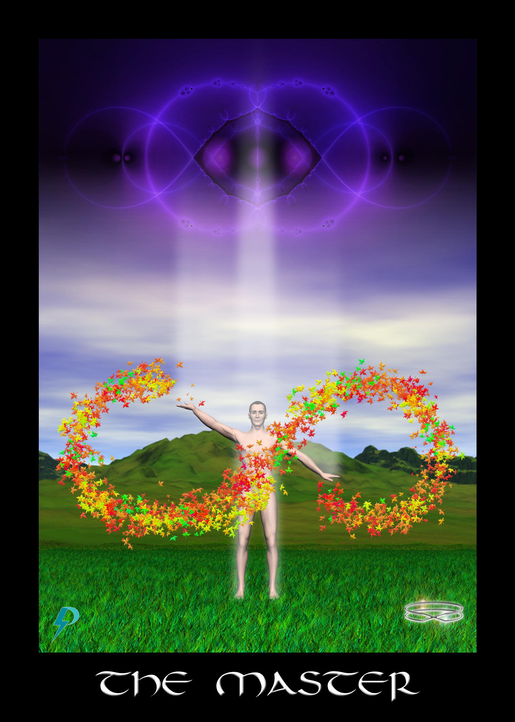

Master
Key Phrase: There is a master within.
Symbolism: In this image we see the physical unit is mature, healthy, and strong. A lemniscate above connects your Spiritual Ego to your Bodily Ego below. When properly realized, this is a strong connection. The figure stands tall, aligned, confident and proud. Palm pointed up, palm pointed down, this master implements the Divine Plan and completes The Great Work. Highest Self united with self. Bodily Ego merged with Spiritual Ego and aligned. That which is in Consciousness above reflected perfectly in matter below. The Soul has arrived in an open, receptive, healthy, and mature Physical Unit. United as one, they manifest physical creation in the direction of light, love, and magic.

New Energy Narrative
Archetypes answer big questions like “Who am I?” and “Why am I here?” This Master archetype is an extension of the Joyful archetype. This archetype provides an elaboration on the big questions “Who am I” and “Why am I here.” As you learned with the Joyful archetype, in the new energy, you are here with a joyful purpose and that purpose is to complete the Great Work so that the planet may graduate. As you learn with this archetype, you are skilled master who has been in training for a very long time. The basic message is simple: you are joyful master and you are here to complete the Great Work.
Please take note, you are a true master. You are no passive receptacle. You are no mere vessel. You are no empty conduit. You are no simple servant. You are no passive lamb. You are no fallen angel. You are no descended ape. You are not here to “learn your lessons” or prove your worth. You are not here to “find your place” in the castes and classes of this world. On the contrary, you are a caretaker, nurturer, and gardener. You are an “old soul,” as are we all. You have incarnated in a Physical Unit many times before in order to prepare for this moment. You have gained much experience on your journeys and now you are an expert at what you do. When fully awakened and activated, you are a Creator Cell, a master of manifestation and creation. Now, respond to the Calling. Awaken, connect, and use your vast knowledge and the mastery that lifetimes of experience have has provided to manifest and complete the Great Work.

Flow Purification
In the old energy, you are taught that you are an unworthy fool in school here to learn lessons and pay off debt before you can be admitted into the “special” club. In the old energy you are told you can’t handle the truth. In the old energy, you are told you are not worthy. To become worthy, comply. Pay your dues. Work hard. Follow the rules. Submit yourself to judgment and “justice.” Conform in order to gain admittance into the club.
The new energy archetype teaches the exact opposite. The Master archetype sends the message that you do not have to be “chosen” or deemed worthy by some worldly figure, like a priest, brother, or boss. You are already a Powerful and Joyful Master on a Divine mission for which you have spent lifetimes preparing. All you have to do is heal, connect. All you have to do is awaken and take your power back. The TOSAS Master also reminds you that there is no one standing above us in judgment. Rather, our connection to Consciousness and God, symbolized by the energetic connection to the lemniscate, is one of support and empowerment, not diminishment and control.
With these new energy ideas in mind....
- Watch out for suggestions that your purpose is to run a gauntlet so you can prove yourself. Reject this notion. Understand, you are a spark of Divine Consciousness incarnated in a physical unit. You do not have to prove anything to anybody. You only have to heal, align, and connect to your Spiritual Ego.
- Watch out for ideas that you are here to “learn lessons,” pass tests, or otherwise grow and develop. It is true that your physical unit needs to mature and strengthen to accommodate Consciousness, and it may need training (voice lessons, music lessons, education, etc.) to be able to properly express its full potential, but that's not You, that’s your body. Your Spiritual Ego is an evolved master of creation. If you want to accomplish something in this life, do what it takes to train and prepare the bodily ego so it can connect and express the powerful and joyful master within.
- Watch out for ideas that have you bowing to authority or submitting to another’s will. Why would a master need to submit? In any case, God/Spirit never requires submission. God expects only joyful participation and responsible co-creation. It is OK to follow a competent and connected leader, but you do not have to submit to another’s will, pass tests, or endure judgment to prove yourself worthy. Remember, you are already a powerful spark of incarnated divinity. Start acting like the thing that you are.
- Watch out for suggestion that you are less worthy (or more worthy, for that matter) and capable than other people. Remember, the message of the Master archetype. We have all incarnated in a body many times. We all have lifetimes of experience. We all have a superpower buried deep down inside which, given proper education, training, and satisfaction of the [wiki]Seven Essential Needs[/wiki], will automatically manifest. Reject notions that justify hierarchy and inequality and remember we are all equally masters in incarnation.

Connection Coach Question
- Our societies constantly give us the message that we are limited, undeveloped, impotent, sheeple. We often hear that only a few people are special, and only are few are “chosen.” The message is repeated often and is supported by reward systems and ceremonies as small as commencement and as big as the Olympics. On this world we worship the winners but consign the losers to poverty and obscurity, trying never to think about them again, and putting them down if they complain about their lot. After reading the above, what thoughts come to mind about your life, your workplace, etc.? Share your thoughts, positive or negative, with the group.
- Think back to your own childhood. How did it feel when you were in the “losers” circle? Did being in the losers circle motivate you to do more, or did it demotivate, suppress, or even depress you? Do you remember what happened if you complained? Share your thoughts with the group.

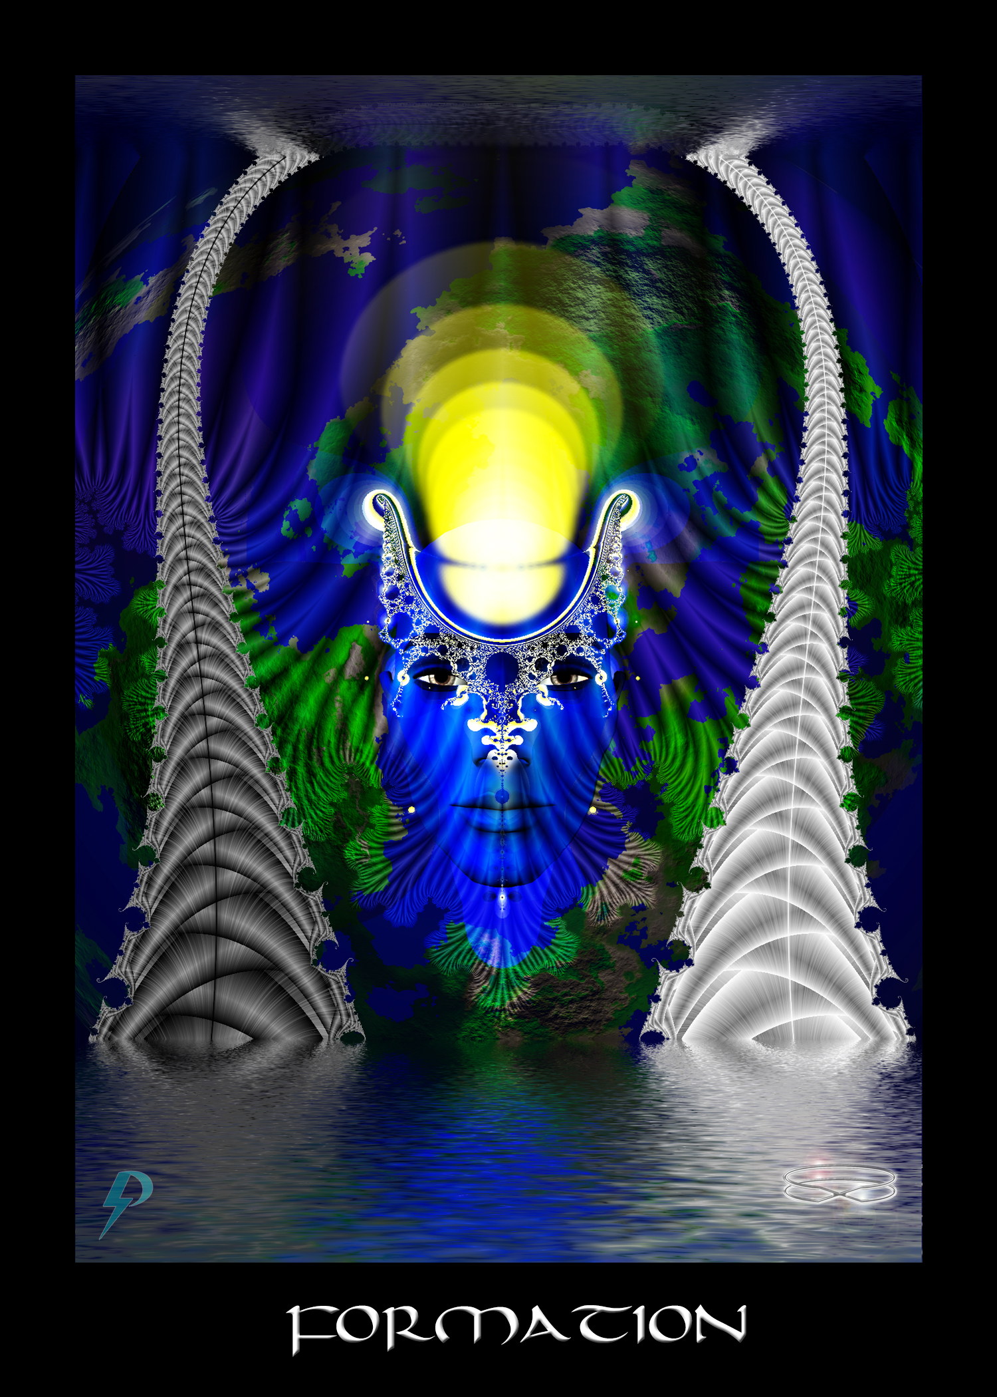

Formation
Key Phrase: Consciousness forms.
Symbolism: A human face sits betwixt the pillars of force and formation (also known as yang and yin). The sun of higher Consciousness shines fully and brightly, taking the shape of the container of mind. As above in Consciousness, so below in matter. The message is clear. Through the archetypes and ideas in our mind, we form creation. From the waters above to the water below, and into the Malkuth of Earth, we use energy shaped by ideas to manifest and create the world. Note, this archetype shows force and formation used in balance, the direction we all must move towards now.

New Energy Narrative
This archetype answers a big question and that is, “How does Consciousness create?” The answer is that Consciousness creates through the application of force, tempered and shaped with formation. The equation here is simple: will as Force combines with will as Formation to move the universe forward. This principle is encapsulated in Creation’s Equation.
Creation’s Equation
Force + Formation = Creation
The formation archetype presents us with the formative side of the equation. Here we are reminded of the power and significance of ideas and archetypes. Through the formative (yin) power of ideas, we shape and direct the wilful force (energy/power) of our Consciousness. Formation is the guiding hand that forms and directs the forceful yang energies represented by the conjoint Force card.
In the new energy we are taught that Formation/Yin (represented by the darker pillar) works in balance with Force/Yang (the lighter pillar) to manifest creative intent. As noted in the BOLIFE, ideally, we use energy in balance. Balanced use of energy leads to the most stable forms of creation. Balanced use of energy allows for the full expression of Divinity. For these reasons, balanced use of energy is almost always the preferred mode of creation.
At the highest and most aligned levels, this archetype represents our creative desire, ambition, and the intent of our Highest Self, formalized into archetypes that direct the flows of creation. This is our individual and collective Creation Template, which can be positive, emancipating and new energy, or putrid, negative and old energy. Do you feel yourself to be a cosmic loser? Do you think you are merely an ape? Do you think you are here to learn lessons? Do you think you are being punished for sins? Think again. Change your ideas and change yourself. Use new energy archetypes to form a new World. Remember, you are a joyful master. You are a cosmic victor. You are Called to awaken. You have the power to activate. You have the ability to connect. Embrace purpose and honour your Sacrifice. Ascend and graduate this world.

Flow Purification
Old energy creation templates deal with the question of creation and they often speak of it correctly as a combination of force and formation, but the use different names for force and formation (like yin and yang, light and dark), and twist it in subtle (and sometimes not so subtle) ways. Most important to understand, in the old energy, this equation is sexualized and used it to justify their greedy and exploitative actions. You see this messaging clearly in the High Priestess card in the Masonic Creation Template. As one commentator notes, “She is the great feminine force controlling the very source of life, gathering into herself all the energising forces and holding them in solution until the time of release.” As another says, “...she is veiled and offers up a cup.... she is the bride who offers up her virginity.” As Pollack notes, she has a "fluidic" nature and is the "feminine counterpart of the masculine..."
In the new energy we accept the power that comes from understanding creation, but we understand that this force must be used in proper balance with formation. In the new energy, we understand that formation represents the ideas and archetypes in our mind that form our creation. Force represents the creative will that makes it all so. Together force and formation work within us to manifest physical creation.
To properly exit the old energies,
- Reject the notion of binary gender and the notion that Force and Formation are someone tied to male and female. They are not. Acceptance of binary gender reflects a more general masonic acceptance of duality, but it also justifies the suppression of “female” energies, when these energies are associated with Yin/Form. Remember, Spirit has no gender. Consciousness simply is. Consciousness emanates as a consequence of Force and Formation. Allow for a rainbow spectrum of expression. Embrace colours of the rainbow as we all work to Graduate the World.
- Reject subtle notions, sometimes expressed when discussing the feminine side, that we need to keep secrets away from the masses. The masses are not dangerous. The masses are not stupid. The true danger to this planet and to the people comes sfrom the delusion elites who scramble to always have more and who maintain their privilege with violence and justify their actions with excuse. The only reason to keep Creation’s Equation from the masses, the only reason to obscure the truth, is to preserve creative power in the hands of the few.
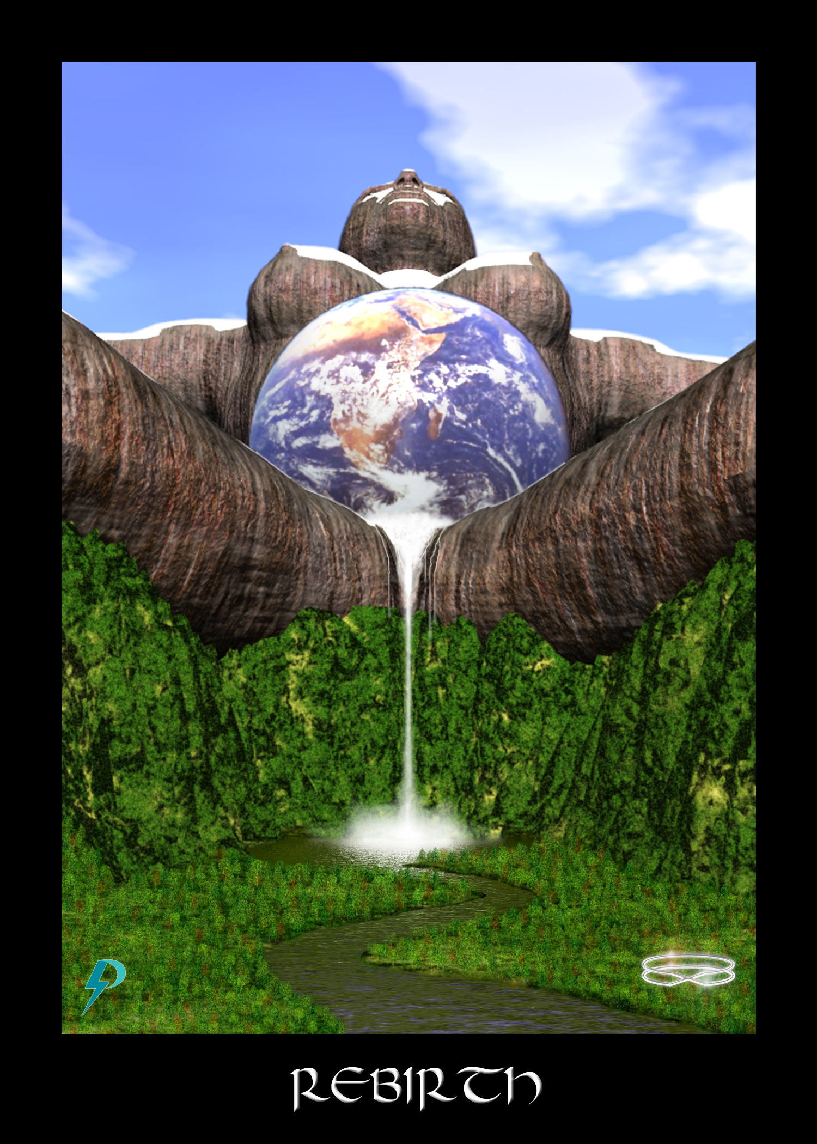

Rebirth
Key Phrase: It is time for the rebirth of your Self.
Symbolism: Mother Earth is giving birth: fecundity; a nurturing space. All of creation embraced and supported. Water, the fountain of creation, life, and growth. Life grows freely when water is present. The planet upon which we live symbolizes the support of our creation. Gaia works with the energy from the Sun to create a biosphere capable of supporting life. Manifestation and creation spring forth. Without Gaia, there is no life. Without nurturing and supportive environments, there is no healing and connection. This should be an obvious truth.

New Energy Narrative
In the new energy, this archetype represents creation, birth, and rebirth. This is the birth of a new body and the incarnation of a new soul in that body. This is also the spiritual, emotional, or psychological rebirth that arises when one awakens, aligns, and atones. Understand, this is a rebirth not because of some deep esoteric or spiritual necessity. We are not on some fool’s journey of redemption. This rebirth is required because the violence of Toxic Socialization has disconnected and damaged the Bodily Ego to the point where healing and reconnection is required. From our healing work we emancipate, find passage, and reconnect.
In addition to representing creation, birth, and rebirth, this archetype also represents the nurturing and supportive environments that provide appropriate spaces for growth. In the new energy, this archetype points to the importance of safe, healthy, and nurturing spaces filled with prosperity and abundance. In the new energy, this archetype reminds us of the significance of Gaia, the who provides the life support system upon which we all depend. Here, Gaia is presented as the loving and nurturing platform for our birth and rebirth, an environment within which we can grow to our full potential. This is the example you should follow. This is the hero you should model. Male or female, father or mother, high or low, you must learn to do the same. Immediately begin to create loving and supportive environments where you and the people around you can heal, blossom, grow, and live life to their true and fullest potential. Create loving and nurturing spaces. Start in the home by ending violence of all forms. Continue in the workplace which is the focal point of exploitation. Create nurturing environments so we can all heal and connect. Allow full human potential to freely blossom. The rest will take care of itself.
At the highest and most aligned levels, this archetype represents physical creation and the ongoing evolution and emanation of The Body, your Physical Unit, this planet, and all life on it. At mundane levels, this archetype represents birth or rebirth of an idea into reality, or a body, into physical creation. This is the fecund product of the union of Force and Formation when exercised in a supportive and nurturing environment. This is the generative output and birthright of all living things.
Kabbalistically speaking, this is Kether’s initial and ongoing realization in Malkuth, and the divine design, preparation, and support that brings us all home. This is the manifestation of the emanation of Consciousness, filtered through archetypes in the individual, collective, and Divine Mind. Note that birth and creation are not events, they are processes of evolution, emanation, and eternal becoming.

Flow Purification
In the old energy, birth and rebirth are devalued and consigned as women’s work. In the old energy, nurturing environments are belittled and dismissed. In the old energy, care and concern are confined to the female form. The truth, we are told, is that suffering and struggle strengthen and temper. It is in the “fires” of toxic experience where we gain our true power.
Of course, by now you know, this is not true. Toxicity damages the body and makes it harder to connect. In addition, it is not just the female that must work to create nurturing environments at home, we must all work to create a better, safer, more utopian world spaces where we can all heal and reconnect.
Complete transformation of our families, a complete shift in our school systems, and a global revision of socialization processes is really the only way forward. To move forward into the new energies, put aside concerns for domination and oppression and embrace unity, equality, creativity, and free expression of Consciousness. To move forward into the new energies, put aside violence and abuse and embrace compassionate, loving concern and support for all planetary life. To move forward into the new energies, embrace unconditional love and support for all living beings. To move forward into the new energies, create safe and nurturing environments wherever you may roam. Also...
- Reject Binary Gender stereotypes and notions that it is the female’s job in the home to create appropriate spaces. We all must do our part in creating a better world.
- Men, watch out for anything that discourages the display of love and compassion, or that blocks you from playing a loving and nurturing role. Beware when people tell you that “big boys do not cry,” or that you should “toughen up.” Men have the same love and deep light that women do, and allowing this expression is a step towards creating a world where you can become a nurturing and supportive caregiver. Male or female, we need to embrace compassion and empathy, and we need to create environments that uplift life, not destroy it.
- Reject ideas that encourage violence in the name of love and protection (i.e. “spare the rod and spoil the child” ideas). Science is clear on the issue; violence and neglect do nothing but harm. When you are violent with people (especially children), when you assault them in any way, be it physical, emotional, psychological, or spiritual, you damage them, cause negative changes in their body’s systems, and undermine their ability to connect. Therefore, reject all ideas and archetypes that justify and excuse violence and abuse. It is never OK to harm another, no matter what they have done.

Connection Coach Question
- Explore the exclusive association of females with mothering energy. Were you brought up in a home where the mom was the primary caregiver, and where the dad was “absent” in some way? Did you hear ideas that suggested that women were the naturally nurturing ones, the ones who should stay home and raise up the kids?
- An old saying says “It takes a community to raise a child.” Explore this idea in the context of the birth/rebirth archetype. What can communities do, what can your community do, to create safe, nurturing spaces where children can uplift, grow, and connect. What do you think of the statement, “All parents in a child’s life should be loving, nurturing, protective, connected, and there for the child?”
- It is not just children who we need safe, loving, supportive, and nurturing spaces. Explore your family group, your friend group, your work group, and any other community you spend any significant amount of time in. What is the “character” of these communities? Are these communities safe? Are they authentically supportive? Or, are there subtle (or maybe not so subtle) expressions of jealousy, violence, anger, hatred, etc. If negativity remains, you’re going to have to change your environments, or find new ones. It is going to take a few years for the world to change, so you may be alone for a while. do not be afraid. On the horizon you can see the “sun” rising. The Promise is about to be fulfilled.

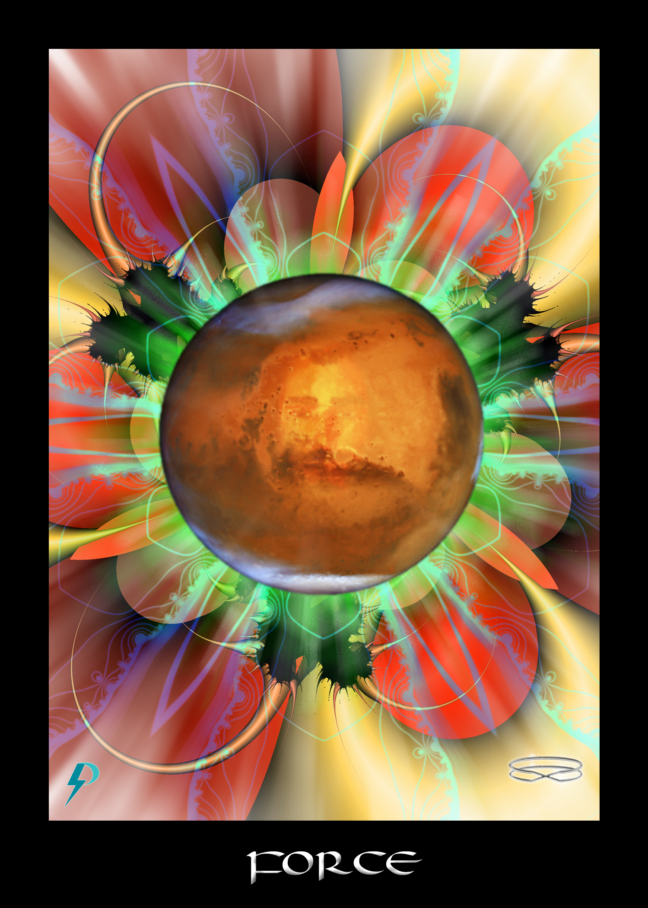

Force
Key Phrase: Consciousness generates.
Symbolism: An androgynous face sits amidst the powerful and expansive red energies of force.

New Energy Narrative
Creation’s Equation
Force + Formation = Creation
In the new energy, this archetype teaches a fundamental truth of creation’s magic, which is that nothing happens, nothing is created, nothing is formed, without the driving force of energy, and the will that directs it. Passive attraction and sheep-like “acceptance of what is” accomplishes nothing, or serves another’s agenda. In order to be a fully empowered lightworker, you must not passively submit. In order to be a fully empowered star, you must gather strength and shift yourself into creative and willful action. Only then will things begin to manifest in a direction favourable to you and the planet.
At the highest and most aligned levels, this archetype represents the mission-drive that comes with full realization and acceptance of your purpose here on Earth. Having responded to the call, you have emancipated and reformed your mind. Leaving behind your past and moving forward, you have healed and reconnected. Now, you are a confident and joyful master here to work on the world. Free of self-doubt, you no longer accept limitation. Aligned with your highest Self, you draw strength and remove archetypal shackles. Emancipated and activated, you are reborn in full power. Finally, you embrace your full willful.
At mundane levels, this archetype represents the purpose-driven action that comes with confidence, strength, and power. You should not be afraid of personal power and control. You should not be afraid of your own will or imposing creative direction. Remember, you are a joyful master of creation and you are here on a mission. Use Force + Formation in balance to finish The Plan and graduate the show.

Flow Purification
Force is only one side of Creation’s Equation. Force also needs Formation. If you want to be an empowered and connected creator, you need to cultivate both will and imagination, both force and formation. In the old energy, however, this equation is obfuscated and confused in various ways, the goal being dis-empowerment of the masses.
One way this equation is obfuscated and used to disempower is by assigning these categories to gender. Males become associated with force and females with formation. This association disempowers women who need formation and force in order to act as equal co-creators, and it makes insensitive pricks out of men who then use all their “alpha male” force to claim authoritarian, “virile” power over others. Claiming exclusive use of force, obfuscated as male energies, they then act in the world without due consideration (i.e., without a balance of formation).
Another way the idea of force + formation is obfuscated and confused is to overwrite this equation with “light” (good) and “dark” (evil). Thus
Force + Formation = Creation
becomes
Light + Dark = Creation
or even
God + Satan = Creation
This schema, which is often used in esoteric societies like Freemasonry, where it is represented by the iconic Masonic checker board, provides a ready made justification for wrong action. According to this thinking, both light and dark, both good and evil, both god and the devil, are required for creation to move forward. There’s always going to be good and evil, because that’s the way creation works. Bad actions, like dumping toxic waste into a water supply, can be justified and excused in this manner.
The message of the new energy archetype should be clear Reject the association of force and formation with male and female genders and reject the association of force and formation with light and dark. Regardless of our gender, we must cultivate both force and formation in balance. Balancing force with formation ensures a more thoughtful, considered, and compassionate creative process. Balancing formation with force ensures that imagination will actually get manifested in reality. Breaking the association with good and evil removes the justification for wrong action and the exploitation of billions. Guided by compassionate right action, we use force and formation in balance to manifest and create.
To eliminate old energy force archetypes from your brain,
- Realize that force is not a bad thing. Force is one side of creation’s equation. High or low, male or female, learn to accept force as an energy and use it to manifest your creation. Just remember, reject the dominating, patriarchal, exclusionary, and out of balance use of force that comes without the balance of formation. Use force and formation in balance.
- More stereotypically, watch out for notions that men should be in control, that men are natural leaders, and that God is a male on a throne. These ideas are archetypes designed to enable patriarchal and imperialistic power, keeping women in the home where they cannot unduly influence the compassionless and vile activities of the elites. Instead, embrace respectful creative will and collective and loving formation.
- Reject the ridiculous idea that evil must exist for good to exist, or that good and evil are simply part of the “Divine Plan.” Evil is not a characteristic of creation. Evil is not required for beauty to exist. God does not require the “devil” in order to function. You do not have to experience suffering to appreciate beauty. Evil and the suffering that arises as a consequence is a function of greed and the damage done by Toxic Socialization, not some universal prerequisite of creation.

Connection Coach Question
- Both force and formation are about rebalancing yin and yang energies. This rebalance requires identification of gender-based stereotypes in consciousness and rejection of these stereotypes. Examine your old energy ideas of gender. On a notepad write the headings MALE and FEMALE and underneath these write out the stereotyped characteristics of gender you were trained to accept as reality. When you have written these out, take a moment to recognize that these are all just personality characteristics which you can choose from to construct the manifested you.
- If you are a patriarch/matriarch in a home, a corporation, or a military hierarchy, take a few moments and examine the justifications you use to normalize your power over others and excuse your toxic behaviours. Why is it OK for you to give orders without reference to the needs or desires of those below? Whose agenda do you serve with your submission, loyalty, and deference? What sacrifices have you made so that you can play a role in the toxic show?
- It is OK to use force to create your life, so long as you do it with balance and consideration for all life forms, not just your own. Harm nothing (ahimsa) and uplift everything is the ideal you should live and strive for. With this in mind, examine areas in your life where more force is needed in or to create and transform. When you have identified these areas, apply appropriate force. It always helps to visualize, so imagine your hands uplifted and directing force (think master and force archetypes). do not leave it at visualization though. Always follow your visions with the physical actions required to manifest.
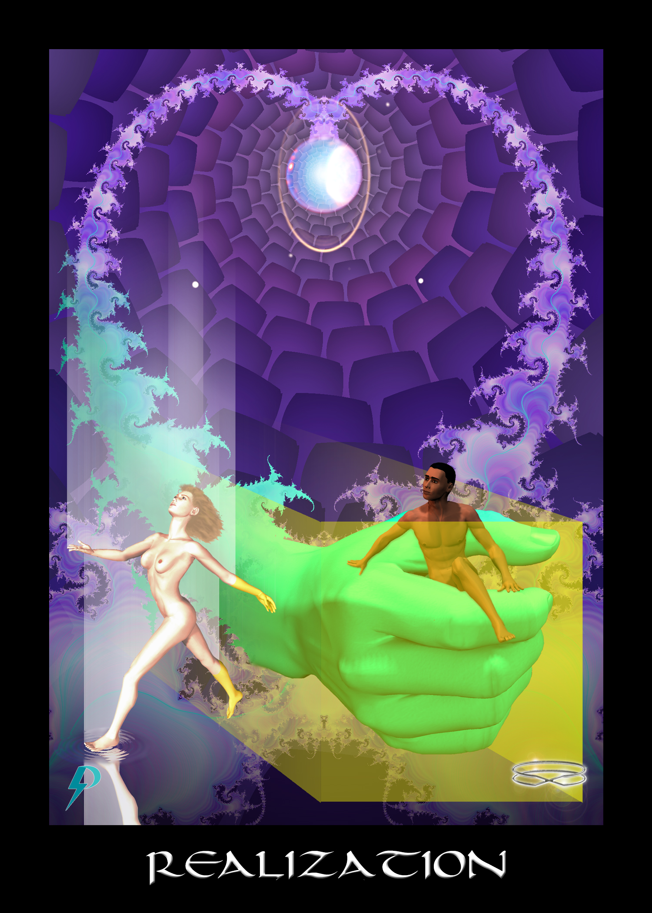

Realization
Key Phrase: The mind’s true liberation
Symbolism: The pearl-like globe embedded in purple energies indicates the involvement of the crown chakra, your brain. The yellow box is a box of constriction and limitation. The hand represents authority, power, and control implemented through ideology and archetypes. The archetypes in our mind bind or emancipate. The hand of authority emerges through the mind and clutches the figure in the box, but the figure is breaking free. Another figure has already escaped. Striving for connection (looking up), she dips her foot in the new reality (the water) below. Moving forward, she rejoins all who are free.
Breaking free from the limitations of mental slavery, you realize the truth. You accept the sacrifice that brought you here. You remember the promise of healing and reconnection. You reclaim your status as a joyful master of creation. No longer confined within the delusions and self delusions of maya, you work on the world and help others heal and connect. Together, we will graduate our creation.

New Energy Narrative
This archetype represents the mind’s true liberation. This is the lightning flash of creative/intuitive/intellectual realization. This is powerful, electrical, inspiration. This is enlightenment, big and small, as it electrifies your body and reverberates throughout your creation.
The basic new energy message of this card is quite simple to understand—realization is an event that occurs as we heal and reconnect, but this is not just one event. Many realizations occur as we walk towards emancipation, empowerment and reConnection.
At the highest and most aligned levels, as you move forward towards healing and reconnection, you realize (or begin to realize) the truth of things. You begin to realize you have been lied to. You begin to realize you have been severely limited by archetypal deceptions. You are more than an ejected Adam. You are more than a temptress named Eve. You are more than a broken down soul. You are more than a submissive chela. You are more than a fool in school. Indeed, you are much more than what you have been told.
At mundane levels, this archetype points you towards a breakthrough. You remove a brick in the old energy wall. You break through a blockage or obstacle. Breaking free of control, error, familiarity, and limitation, you embrace diversity and pursue new energy alternatives and new energy solutions.
You would think realization is a simple thing. Look at reality, see the what is there, realize truth. In fact, there can be challenges. Indoctrination of Toxic Socialization confuses us and blinds are eyes. Disconnectioon caused by damage we incur restricts insight and creativity. As explained in more detail in the Agents of The System (System Agents), represented by the old energy tarot card Devil, work hard to keep us confused and enthralled.
The solution to the conundrum is simple—appropriately forceful and properly formed will and intent. You do not have to wait for a saviour to save you. You do not have to wait for some angel to guide you. Simply set your intent. Repeat the following affirmation as many times throughout the day as you can remember.
I wish to wake up. I wish to move forward. I wish to realize the truth. I wish to take my power back.

Flow Purification
In the old energy, realization and enlightenment are suppressed in multiple ways. For example, toxic socialization experiences damage the body and lower the capacity of the mind. In addition, as children we are all taught to identify the truth represents conformity with what the “authorities” tell us. In the old energy tarot, this message is most clear in the Hierophant card where submission to the philosophical will of the Hierophant is on clear display, and where we are told that in order to get admitted to “the club,” we must submit and comply. According to the old energy Compliance and Submission archetype, there is no other way. No matter how high or low you might be, independent thought and feeling are not allowed. To gain entry to the club, to gain access to the Secrets, you must submit and follow the leader.
If y0u want to get out of the old energies, you need to understand, compliance and submission have nothing to do with realization and emancipation. In fact, they are the complete antithesis of each other. Realization comes internally via connection, not externally by following another. Emancipation comes by breaking through the control of the “masters.” Those who comply and submit inevitably find themselves cut off from their own inspiration, indoctrinated, and in thrall to The System.
Understand, there is nothing wrong with finding a good teacher or seeking instruction in things. In fact, a good teacher can speed the process and ease the challenges of learning. However, at no time should spiritual instruction be dependent on compliance and servitude. At no time should you be required to sit at the feet of some “master,” literally or figuratively. Authentic Spirituality is about emancipation and empowerment. Authentic teachers will never require submission and compliance.
To get out from under the thumb of the old energy archetypes that teach you to comply and submit,
- Watch out for appeals to authority and tradition. You do not need to believe something just because somebody in a fancy costume says it, or because it is written in an aging “sacred” book. In fact, be wary of fancy costumes and ritual accoutrements. These are inevitably manipulative props designed to dazzle and confuse. Be on your guard against ancient spiritual “wisdom,” since it is often designed intentionally to confuse. Remember, you always have a right to ask questions and you always have the right to disagree, though you should always be respectful of others.
- Archetypes of compliance and submission are often linked with threats of punishment and damnation but remember, failing to follow “the rules” does not lead to eternal damnation, and it should not lead to violence and assault. God, Consciousness, Spirit, never punishes simply because violence damages the Physical Unit and corrupts and undermines pure Connection. Punishment is only useful to those who require compliance. Patient, persistent, and restitution work better to correct unaligned behaviour. Therefore, reject all justification for harming others and accept no justification for violence against self. There is no valid justification for violence.
- Finally, reject anyone or anything that requires your compliance and submission. Never sit submissive at the foot of another. Never array yourself around somebody’s throne. Instead, take back joyful power and authority for yourself. Participate as an equal in the Great Work. Work together with others to transform and graduate this world.

Connection Coach Question
- Examine your life for messages that encourage compliance and servitude. What persons required and trained you to comply and submit (i.e., parents, teachers, priests, officers)? What were the things they offered you in return for following the rules they set out? Was it entrance into the club, passage into heaven, power and privilege over others, or something more?
- Overcoming compliance and submission can be challenging, particularly at an emotional and psychological level. We have been trained from an early age to comply and submit and when we do not, we often hurt (i.e. “punished”) as a result. Consequently, when we reject authority we may experience, depending on the severity and history of our “punishments,” anxiety, fear, even paranoia. Nevertheless, it is necessary to reject authority in order to reclaim your power. Can you think of specific practices that can help you “take back your power.” Share your thoughts with the group.
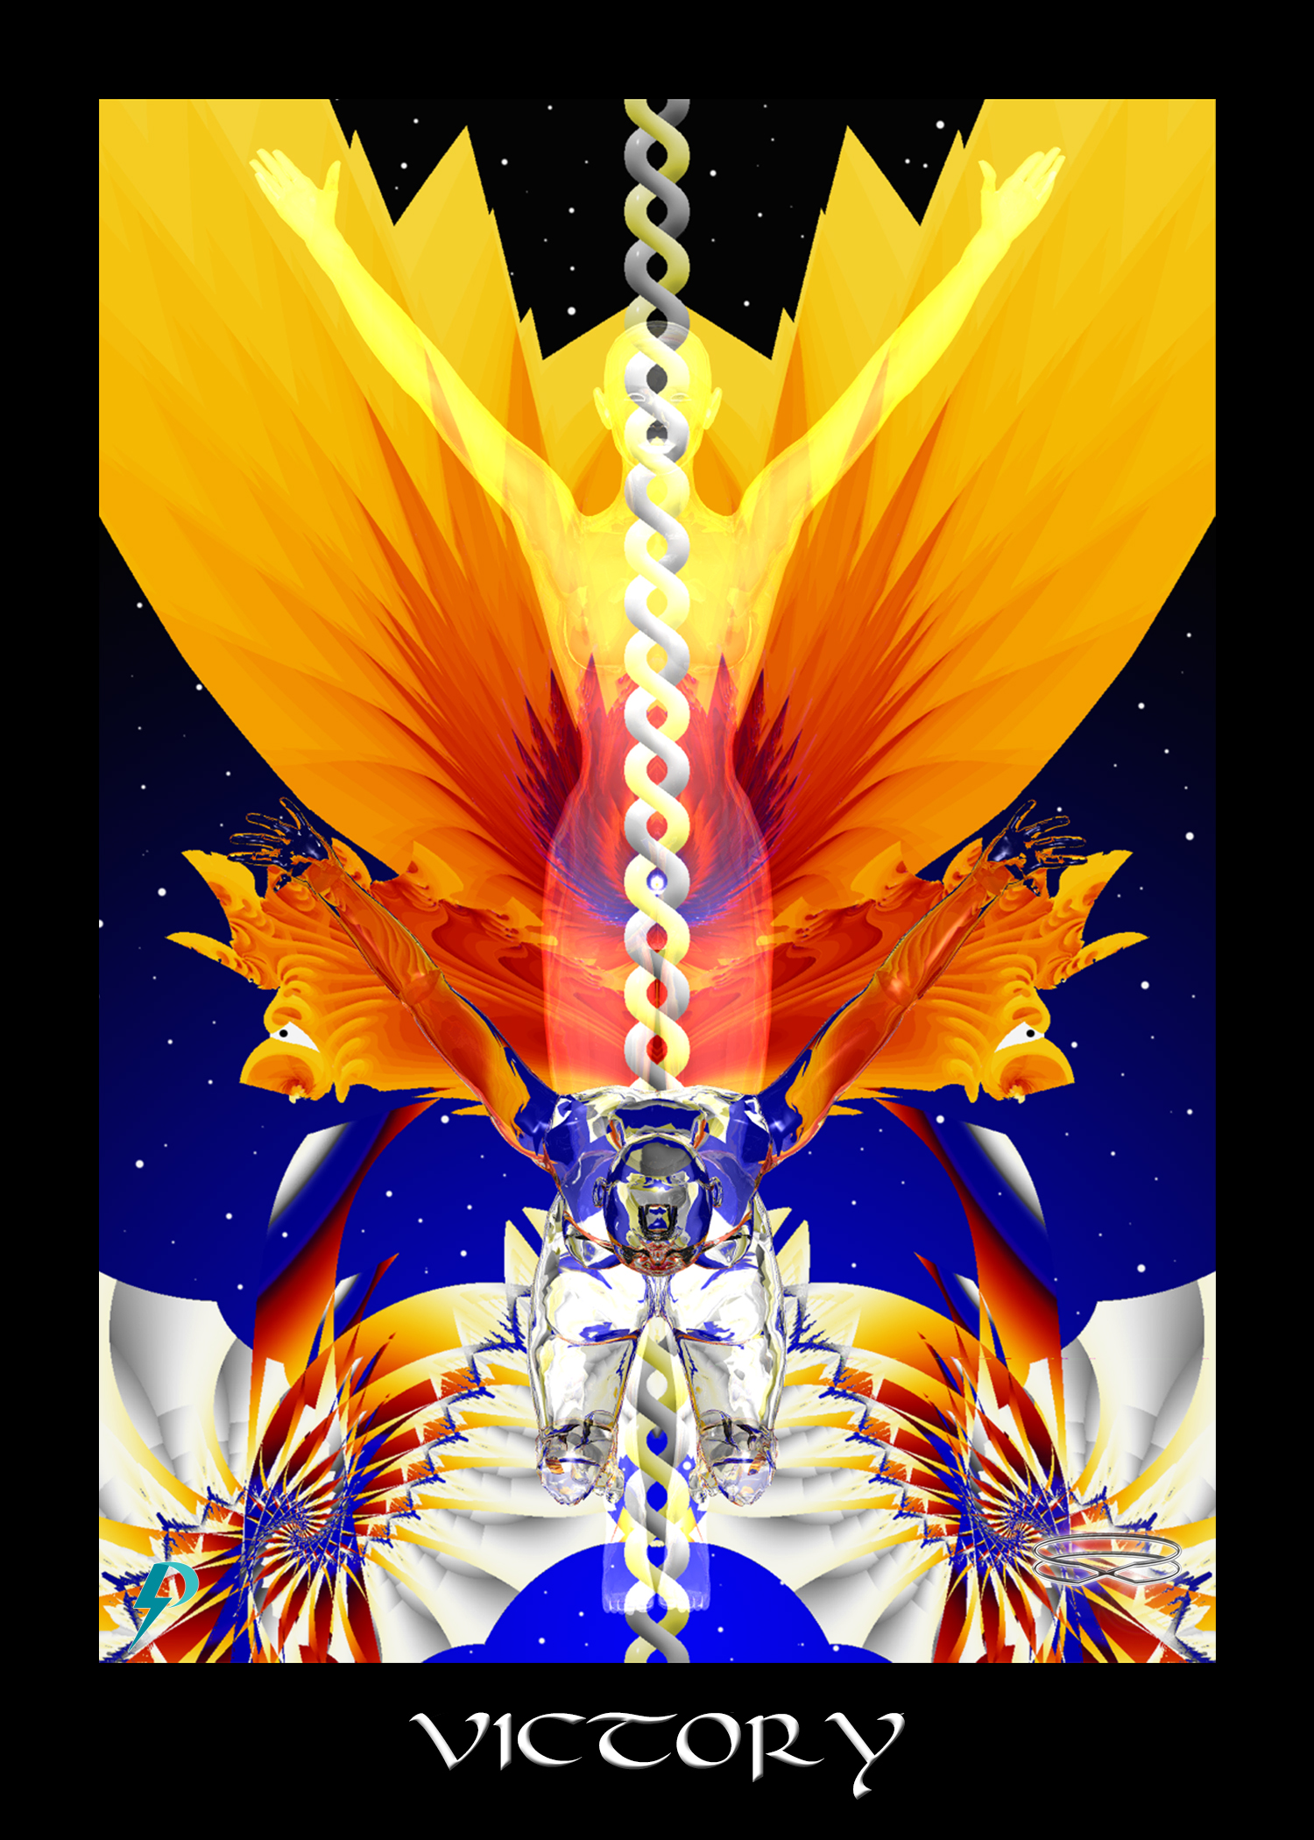

Victory
Key Phrase: This is my Spirit triumphant.
Symbolism: The human body evolved, empowered, and connected. The Divine Spirit fully activated finally triumphant. Encased in flame, rising like a phoenix, you joyfully and powerfully rise up and transform your self and this world. DNA fully actualized and divinity fully articulated, you welcome Highest Self. You rejoice as the body (and Body) connects and transforms. Universal energies provide the necessary force as the world realigns and ascends towards graduation.

New Energy Narrative
Narrative: This archetype represents the individual and collective Triumph of Spirit. This is complete connection, total empowerment, and personal and global transformation. This is the ultimate victory, which is not simply the victory of Spirit over the body, but the victory of Spirit over the Body.
At the highest collective level, this archetype represents final triumphant ascension of the planet. This is The Great Work completed. Perhaps vestiges of the old world remain, perhaps people are still in need of assistance, but rapidly dissolving old energy power structures and increasingly sophisticated tools and techniques make it easier to heal, connect, and to help those who need assistance. Finally, the day of reckoning has arrived. Resistance continues to dissipate. Welcome the elimination of all darkness. Remember, though times are dark now, there is nothing but joyful celebration ahead. Persistence, dedication, training, and sacrifice have finally paid off. Empowered and strong, we take the final collective step forward.

Flow Purification
In the old energy, this archetype provides additional commentary on the Fool’s/Hero’s journey. In the old energy, this is the fool/hero victorious and fully evolved. This is “conquest and triumph over obstacles...” This is the end of the journey. In the old energy, this is when all the lessons are learned and all karma has been repaid. As Pollack notes, “‘lessons’' of the early cards have been absorbed, the adolescent period of searching and self-creation has been passed, and now we see the mature adult...”
In esoteric traditions, victory is typically portrayed as the suppression of emotions, ascendance of intellect, and passive acceptance and compliance. Victory, we are told, comes to those that tame the savage beast inside. Of course, there is nothing particularly vile about suggesting there is a victorious end to personal development. The problem comes in what counts as fully evolved. In the old energy, victory and graduation comes via submission, compliance, the abolishment of conflict (in the lodge), the suppression of emotions, the exaltation of a disconnected intellectual normality, and abstract acceptance of “what is,” no matter how vile that may be. Old energy guidance goes to create compliant cogs in the System who would suppress empathy and compassion and would rather “go along” than stand up and cause conflict in the room. However, in the new energy, perfection and graduation comes from healing and reConnection to the joyful master within. This reconnection is not without its problems and challenges, but in the process of healing and reconnection, we do not amputate parts of ourselves or accept the world as it is. Instead, we embrace our full power, align with our Highest Self, and work on the world together in order to graduate and ascend. Remember, in the new energies, the struggle is not tame the beasts, suppress emotions, or amputate parts of our self; the struggle is to heal and awaken so we can activate and ascend. In the new energies, the struggle is to establish Right Environment, Right Thought, and Right Action. In the new energies, the struggle is to uplift and connect all of creation. Therefore, to clear old energy thought,
- Watch out for advice and guidance that encourages you to view your self as a sinful, violent, primitive, ape on a journey that requires suppression of your emotions, the avoidance of conflict, and submission to those above. Instead, embrace your powerful and victorious Self and change the world.
- Watch out for advice and guidance that directs you to repress your emotions or your “animal self.” There is no animal self that needs repression, no beast that you need to denude. Emotions are an important aspect of being human. Their repression undermines potential and connection, puts you out of touch and alignment with Highest Self, makes you easier to manipulate, and easier for you to engage in selfish, toxic, and unaligned behaviours.
- Watch out for excuses and justifications of violence or abuse, like notions that violence and abuse are good for you, that they strengthen and/or temper you. Understand, conflict, struggle, strife, violence, aggression, war, etc., are never justified. Violence and assault cause emotional, psychological, spiritual, and even physical damage to the vessel, which undermines development and your ability to connect. Remind yourself; the human body is a sensitive instrument of Consciousness, a Star when fully activated connected.

Connection Coach Question
- In the new energy, this card is about successful and more permanent activation and connection. As you walk your path to this goal, now is a time for useful reflection and review. Ask yourself, what are some of the things you need to do in order to “prepare the vessel” (i.e. get the chariot ready) for activation and connection? Draw on early LP workbooks and your own intuition. Write down the things that come to your mind. Share.
- Have you ever had chakra or kundalini activations? You can recognize chakra activation by palpitations, tingling, energy flow, shivers, and uncontrollable movements. You can recognize kundalini activations by the powerful and expansive energy that flows through your entire body. These activations can be frightening, disturbing, and difficult to ground, especially if you are unprepared or surrounded by toxic folk. Fear, paranoia, egoic bloating, egoic collapse, and egoic explosion, and other forms of ego pathology may result. The negative experience can be so bad that you run away from spirituality and hide in the “normal” world. Think back. Have you had negative activation experiences? Do these now prevent you from pursuing a triumphant activation? Consider that you were simply improperly prepared. What things would you do now to better prepare? Share with the group.
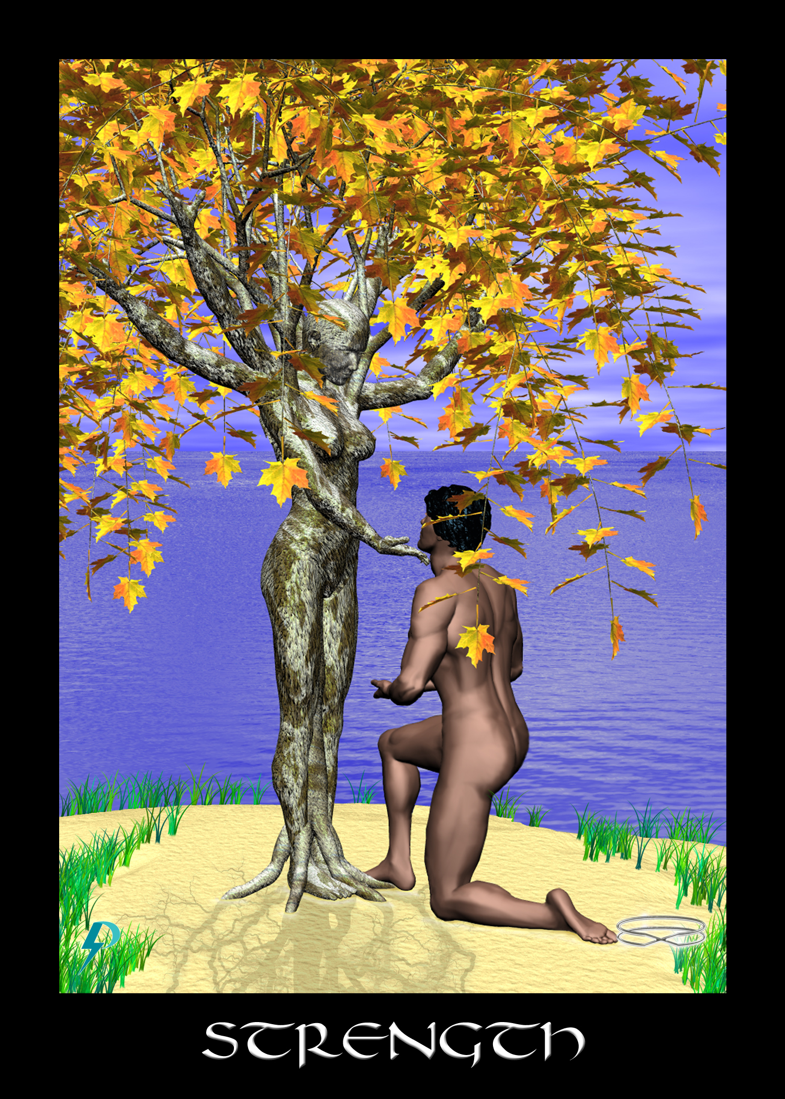

Strength
Key Phrase: I serve the Divine Plan.
Symbolism: Here we see Gaia embodied as the tree of all life. A kneeling figure, an empowered, but humble servant of God, honouring Gaia, and willing to complete The Great Work. Gaia, charging for the task at hand, which is the evolution and healing of The Body in order to enable its full connection to Consciousness. Land, barren, grass, beginning to grow as Consciousness begins to flow. When the figure stands, life and power burst forth. Waters of manifestation, Waters of Consciousness, Waters of Creation. From the Water emerges all physical creation. The Water feeds physical manifestation and nurtures the new Garden (of high Consciousness) emerging.

New Energy Narrative
This archetype represents true strength, which is not psychopathic domination and control of others for the purpose of exploitation, but the strength that comes from comprehension, awareness, service, compassion, connection, and power used in service, to support the growth and development of individuals and, indeed, all of creation. The model of this true strength is Gaia who through her commitment and deep strength provides the ground and support for all life on this planet.
Recognizing that Gaia is the ground upon and through which we connect, we kneel, not in obeisance and servitude, but with respect and gratitude for the environment she provides. We draw the strength and energy from Gaia that we need to complete the task of evolving and graduating this Earth. In service, we carry forward with the Divine Plan.
The message of the new energy archetype should be clear. We are not on this planet to rape and exploit. We are not on this planet to dominate and abuse. We are not on this planet to justify and excuse. We gather strength, connection, and grounding from Gaia in order that we might humbly and respectfully serve. It is useful to look to indigenous populations for the proper attitude and orientation.
At the highest and most aligned levels, this is the strength that comes when you serve The Great Work, which is the divine evolutionary plan to connect the Body (and the body) with higher Consciousness. On this Earth, you do not incarnate primarily for business or pleasure. You incarnate to uplift creation. At mundane levels, this is the strength that you need to get through life. This is physical, psychological, emotional, and even spiritual strength when applied to mundane tasks. Remember, you are a joyful master. Never doubt you are strong. Never doubt you have what it takes to get through.
At another level this card represents our environment and our orientations to that environment, specifically in the context of our mission and purpose. Our mission, our purpose, our goal, the entire reason for our existence, is to help foster ascension/connection, to help graduate the planet by creating nurturing and supportive environments.
At yet another level, this card represents an important requirement of activation and ascension, which is grounding and connection with Gaia. Full and final connection only occurs if we successfully connect to the ground. We must do that spiritually, as when we connect and ground with Gaia in mutual support, but also electrically, as when we connect the subtle spinal energies to the necessary ground of Earth.
At the deepest level, this card represents a key to successful kundalini activation. Kundalini is a subtle energy flow (like electricity) through the body. Just like with electricity, kundalini energies require a ground through which to flow. When we realize this, we realize the full significance of Earth. Gaia provides the ground for full activation and connection. Without a proper ground, we cannot fully connect and we cannot assume full power.

Flow Control
In the old energy, this archetype is an archetype of repression, specifically the repression of passions, emotions, and even anger. In the old energy, this is also an archetype of control. “Strength signifies true control of the situation...” In the old energy, we are told to suppress our animal nature, to tame the savage beast, to control and repress our raging emotions. Taming the beast is an evolutionary step, we are told. Taming the beast makes us civilized, they will say. Taming the beast is necessary because inside we are savage beasts. “In the Strength Tarot card, a woman gently strokes a lion on its forehead and jaw. Even though it is known for its ferociousness, the woman has tamed this wild beast with her calming, loving energy. The lion is a symbol of raw passions and desires, and in taming him, the woman shows that animal instinct and raw passion can be expressed in positive ways when inner strength and resilience are applied.” This sentiment that strength is equal to domination, of self and of others, is set in psychological terms by Pollack who suggest “the beast” is our unconsciousness whose energy we must “calm” and tame. "Now consider Strength.... The picture shows a woman taming a lion. Briefly, the image suggests the energy of the unconscious released and calmed, 'tamed' by the direction of conscious understanding."
Contrary to what you might have been told, there is no wild beast inside and your unconsciousness does not need to be “tamed.” As science is increasingly discovering, humans are by nature gentle, ethical, and collectively (i.e. socially) oriented. If passions, anger, resentment, anxiety arise, it is often because realities are not properly aligned. We are right to be angry at injustice. We are right to get mad at exploitative bosses. We are right to rise up against oppression and exploitation. We are right to shove off those who violate our boundaries. In adequate and nurturing environments, left to themselves, humans exist in collective peace. It is only when perturbed by outside forces, or damaged by collective trauma (e.g., famine, war, toxic socialization), or suffering under the yoke of servitude, slavery, and oppression, that passions come boiling to the surface.
The question is of course raised at this point. If, by nature, humans are good inside, then why the admonition to repression? The answer is simple. Repression protects The System. Rather than getting angry at the exploitation one is subjected to, rather than feeling bad about the horrible things that we do as we service the System, we suppress and repress our true compassionate nature so we can faithfully function within the System. You are not supposed to get angry with the way the world is. You are supposed to accept it calmly and work with it, just as it is. Be grateful. Be wise. Evolve. Tame the wild beast so that the System may continue.
It is important to note this is an amputation of Self. This amputation does not make us strong, it makes us weak. Disconnected and repressed, we are unable to stand up against social pressure, convention, authority, and the aggressive domination of others in order to do what we know to be right, which is to transform and uplift the world. Disconnected, unaligned, and repressed, we turn to alcohol, money, and other addictions as a salve against painful disjuncture.
In the new energies, strength is defined as the willingness to courageously serve humanity and the divine evolutionary plan. In the new energies, strength comes from alignment and connection. In the new energies, submission to authority or renunciation of Self are not required. In the new energies, domination and exploitation of others is not accepted.
To purify the old energy archetypes of strength,
- Watch out for old energy ideas of strength as competition, control, violence, and domination over others, even if that domination is polite and “civilized”. We move forward into the new energies and towards graduation by consensus and accommodation and not cunning and “understanding.”
- What out for subtle self-deception. Focusing on the cheap T-shirts you produce, and looking the other way while your company exploits child labour is not strength, it is symptomatic of repression, disconnection, misalignment, and profound self-delusion. Always remember, the good that you do does not balance out the evil that supports it.
- Watch out for identification with old energy definitions of weakness. Emotions and passions are not a sign of weakness; they are simply a feature of the human body. Love and compassion are not flaws to be subverted and bent “under will;” they are facets of the bright light of Consciousness. Anger is often justified by the oppressive conditions foisted by The System. Right expression of emotions is necessary, but suppression and sublimation is not. Always remember, true strength is to be found in connection with Earth, alignment with Highest Self, and service to the Divine Plan, not in compliance, self-repression, and servitude to the System.

Connection Coach Question
- Ask the people around you in group, or your friends and family, what they think “strength” means, and what they think it means to be strong. Summarize/write down their answers. Do most of them define strength as domination and control over others? Share their responses with the group.
- Think about the answers you received to question one. Think a little deeper about the sources of these ideas. What are the ideologies (Christianity, Freemasonry, Star Wars, Sports, Olympics, etc.) that convey/support these old energy versions of strength?
- Old energy ideas of strength are often associated with old energy archetypes of punishment and judgment. Spare the rod and spoil the child, as the Catholic priests say. We are being “strong” when we “justifiably” harm others, because they are being “bad” and they deserve it. Note, harming others is not strength, it is harmful violence against others and there is never any excuse for that. True strength is nurturing and support. Examine your life, your childhood, your parenting style, your work relationships, your intimate relationship, etc., and realize the places where you harm others. Take immediate steps to reduce and eventually eliminate that harm.

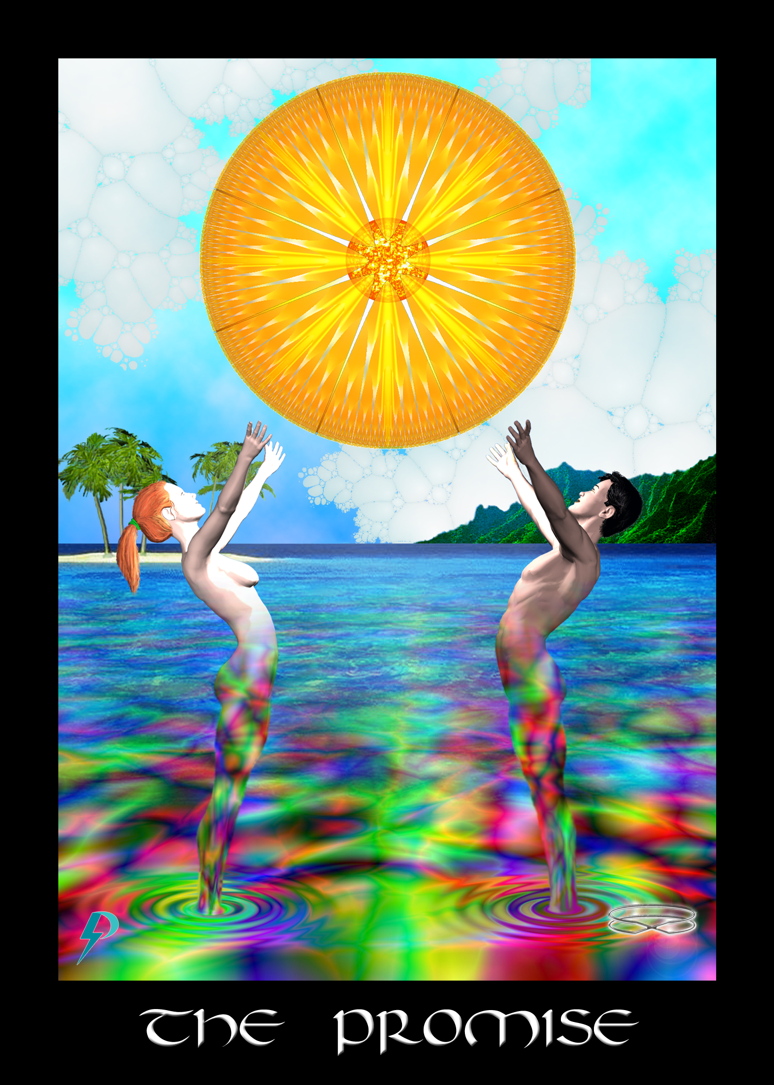

The Promise
Key Phrase: The Garden of Full Connection.
Symbolism: Two figures rejoice in paradise. Bathed in the highest light of Consciousness/Christ/God (the Sun), they stand firmly in the waters of manifestation. Having, through sacrifice and masterful effort, uplifted the dense and inanimate disk of physical creation (this Earth) to full and connected life, they now bask in the glory of an ascended planet. This planet, once inanimate, then cold and submerged, is now elevated and filled with the Light. Consciousness floods the land. This is the Crowning of Malkuth. This is the purpose achieved. This is the promise of the power and the glory of Consciousness, descended and fully expressed in the body and also The Body.

New Energy Narrative
This archetype teaches you the point and the purpose of your joyful incarnation. You are not here to learn lessons or pay off Karma. You are here to evolve the planet’s social, technological, economic, and political systems to the point where integration into interplanetary civilization becomes possible. You are here to build a Garden so that we might, at the end of the sixth day, graduate, celebrate, and play in our new creation.
In addition to representing the crowning of physical creation with Consciousness, this archetype also represents a promise of forgiveness, healing, and return. Let us be clear. While sacrificing in the darkness, while stumbling beneath The Blindfold, we all do bad things. This archetype represents the promise that if you undertake the sacrifice of disconnection in order to uplift and graduate a planet, then no matter how damaged and twisted you may be, no matter how far you have fallen, a way home will always be provided for you. Despite all propaganda to the contrary (i.e. notions that you will be judged and discarded into hellfire), this is the unbreakable Covenant of Consciousness. This is the promise that no matter where you stand, no matter what you have done, no matter how far you have fallen from connection, the door to your Highest Self will always remain open. If you wish to return home, simply embrace the rising sun of your own Highest Self.
At the highest and most aligned levels, this archetype represents the exaltation of Consciousness in matter, the end-point of planetary gestation, the glorious end-times summation. This is the collective recognition of divinity, mass reconnection, and the glorious culmination of the Plan. This is not graduation per se., for that is a celebratory and interplanetary event. However, this is successful manifestation of the Garden of Connection (a.k.a. Garden of Eden, Kingdom of Heaven, or Shambhala). It should be noted, from collective realization of divinity and the final ascent of Consciousness, it is only a short step up the podium for graduation.
At lower levels, this is the promise made to you before incarnation. There is no “karmic cleansing.” There is no foolish tutelage. At the end of the day, there is no judgment and no punishment, no matter what you may have done. You are forgiven for your sins. To return home, set your foot upon The Path and move forward.

Flow Purification
In both the old and new energies, archetypes speak of a plan, of a journey, and of an eventual “triumph over dark.” The difference is that in the old energy, this is not a win for everybody, this is a win only for the “chosen few,” the “silver seed,” as one sixties songwriter put it. In the old energy, this is the personal triumph of the hero as they complete the Fool’s journey. “He [sic] went forth to accomplish a mission, thus grasping it, he enters the path of wisdom and after trial and ordeal manifestation united with the Divine....[This is] tests of courage, obstacles overcome, drive and ambition.” It should be clear. In the old energy, there is an exclusionary message. In the old energy, this win the Aryan “warriors” grandiose and violent assertion of privilege.
Of course, to move forward, to find passage, to arrive in the promised land, you must remember, we are all part of the same family of Spirit. Any form of privilege and exclusion does not align well with Highest Self. It is necessary, therefore, to put aside exclusionary rhetoric and justification. The final step before collective connection and graduation is to simply assert, admit, and accept that in the new energy there can be no elements of privilege or exclusion and no intimations of final judgment and woe. True, we have sacrificed while we have laboured towards graduation. True, we have all done many horrible things. However, at the end of the sixth day, when graduation day is here, everyone (and I do mean everyone) is entitled to celebratory renewal. This is God’s promise to you. Everybody gets to join in the party. Nobody gets “left behind.” With this in mind, remember...
- Getting out of the ugly old energy is easy; watch out for ideas that support and justify exclusion in any way, be that by gender, ethnicity, social class, or whatever. Watch out for subtle messages of rapture and ascent that deny and exclude others. At the end of the sixth day, there is no judgment. The chosen ones will not be raptured into heaven or flown off in a spaceship to a new world. We are all welcomed with open arms back into the family of spirit. We all graduate together, or we don’t graduate at all.
- The best practice for this card is celebratory love. Be warm, accepting, and compassionate to all beings. When you see evil in the world, when you witness Wrong Thought or Wrong Action, resist the urge to judge and condemn. Instead, work to fulfill the promise by helping to heal and transform. Remember, graduation is a collective process. Nobody gets left behind.

Connection Coach Question
- If you come from a religious background (and in the general container of religion we include all known and unknown esoteric brotherhoods, fraternities and sisterhoods), spend a few moments digging out the “promises” of your faith. What sorts of things are you promised for being good? What sorts of things are you promised for following the rules? What sorts of things are you promised for performance? What reward is offered? What happens when the work is complete? Who gets the reward and who is excluded? Share with the group.
- It is not just exclusionary ideology that has to be rooted out and eliminated. You need to practice inclusion as well. This means that exclusionary political or social activities are no longer acceptable. Boys clubs are designed to exclude women. Cliques are designed to exclude the “uncool.” Hierarchies of all sorts, whether they are based on the colour of skin, the shape of genitals, grades on exams, or whatever meaningless tests are devised, serve only the powerful and privileged. They attenuate our power and dominate us by dividing us from each other. Therefore, examine your thoughts and actions. What sorts of exclusionary practices did you practice? Share your thoughts with the group.

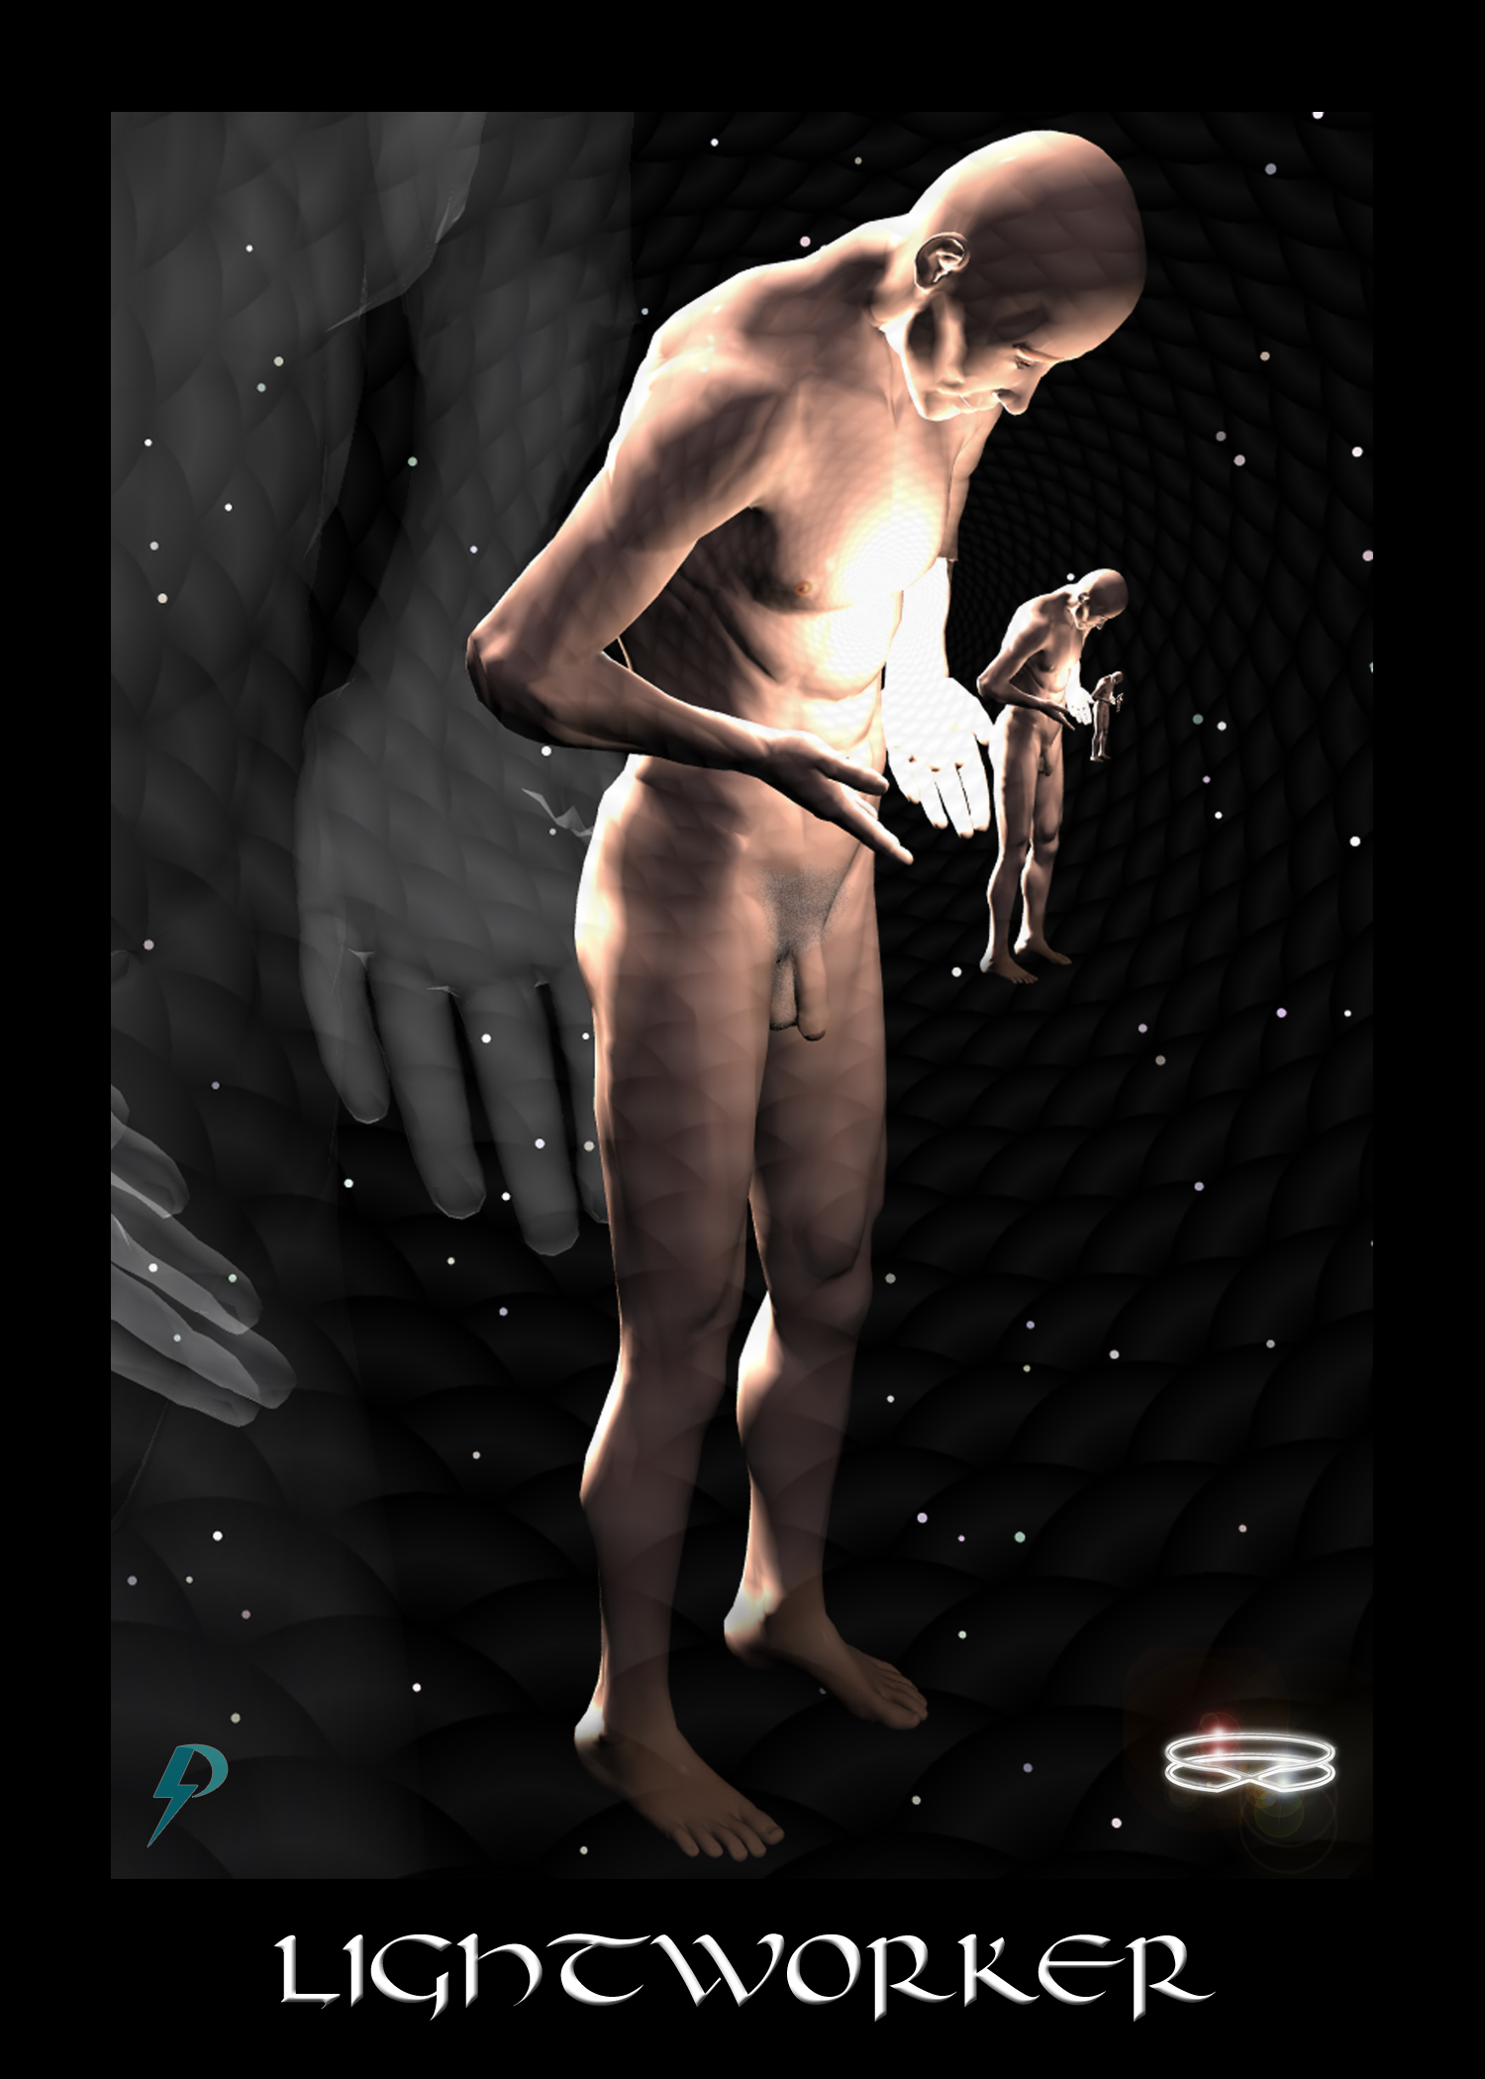

Lightworker
Key Phrase: A new light is born in the world.
Symbolism: A multidimensional figure representing your Highest Self/Spiritual Ego/Soul/Atman as it emanates and “descends” into physical creation. The figure holds the light of Consciousness in its hands, presenting itself to itself, and working with itself at each new level of The Unfolding. The message should be clear. The light of consciousness is reflected and refracted within you and the physical universe.
The nude figure indicates that despite the sacrifice, your highest Light is unencumbered by the dirt and detritus of disconnected physical existence. The diminishing figure indicates our connection and power dim as we descend into the cold, opaque, and unascended physical universe. However, remember the promise. Full power will be restored when we all achieve graduation.

New Energy Narrative
This archetype teaches a sacred truth, which is that we are all sparks of eternal Consciousness, that we all “descend” into physical manifestation, and that we all hold the Light of Consciousness so we can uplift and ascend physical creation. This archetype represents you as a pure and perfect reflection of Highest Self, somewhat diminished as you descend into physicality (for the physical molecules of creation are weak and ephemeral and cannot contain the full power and might that is You), but powerful and mighty all the same.
You are a masterful manifestation of the word and the will of Spirit. You are a perfect expression of the Love of glorious God. You are a lightworker here to uplift and graduate the planet. To realize this, emancipate your bodily ego, connect your mind to your Highest Self, and reclaim full power. The Word, the Will, the Power, and the Love of God are in your hands even now.
At the highest and most aligned levels, this is the Light of your Highest Self as it, as You, pass into physical existence in order to incarnate and complete the Great Work. Know, this is not the work of soul evolution or karmic cleansing. This is the work of planetary evolution.
At mundane levels, this is positive recognition and affirmation of Self, and positive and life-affirming work. This is, psychologically, the healing and exaltation of the Bodily Ego as it unites and merges with its own Highest Self (i.e. its own Spiritual Ego). This is self and Self reunited. A creative and healthy emanation.

Flow Purification
In the old energy, you are told that you are a broken down soul who has made bad decisions in the past. In the old energy, you are told that you are weak and unworthy. In the old energy, they say you come with “original sins” In the old energy, you are told to submit to those “wiser” and more “powerful” than you. Only by complying will you gain admittance in the end.
In the new energy, we reject this nonsense. To be sure, we might need training. A carpenter, a musician, a surgeon, must train the hands. A psychologist, a healer, an empath, must train the mind. To be sure, we all have skills to learn. But these are things for the body to learn, not the soul. The soul, the Highest Self, the Spiritual Ego, is descended and connected to God. The soul, the Highest Self, the Spiritual Ego, has trained for eons and is by now a powerful and joyful master. Therefore...
- Reject the big lie that you are a bad child sent to Earth to learn some lessons. Reject notions that there is sin for you to replay. Reject notions that you should comply and submit. Reject that there are any inherently wiser than you. Instead, embrace the truth which is that you are God’s light descended into incarnation to evolve and uplift this planet. You have all the wisdom and power of God within you. Diminished you might be, but powerless and disconnected you are not.

Connection Coach Question
- The message of the new energy Lightworker card is clear. You are a descended spark of God’s light. Unfortunately, this is not what you learned in your family, in church, or in schools. You learned you were created separate. You learned you came to this Earth with karma. They said you were born with “original sin.” Take a few moments to share the old energy things you were taught in your family and religion to the group. Do these old energy archetypes still diminish you? Do you still struggle to root out and replace these? These tendrils run deep. Be persistent, consistent, and have faith.
- One of the most important messages of the Lightworker card is that no matter how deep down into the dark we may fall, we are all emanations of the Divine Highest Self. Yet, we never hear this root truth. Instead, in the old energy, emperors, empresses, hierophants, and hermits teach judgment, inequality and privilege for a few, and exclusion and exploitation for the many. Spend a few moments considering the judgmental ideas and ideological excuses you use to exclude others from this planet’s bounty. Are they stupid? Are they unworthy? Are they primitive? Are they lazy? Are they bad? Are they the wrong skin colour? Don’t be ashamed. These lies were taught to you. Simply recognize and release them. If you feel comfortable, share your observations with the group. Then, move beyond these dualities and, as depicted in the Lightworker archetype, see everyone for what they are, expression/refractions/emanations of a Divine and beautiful Light.
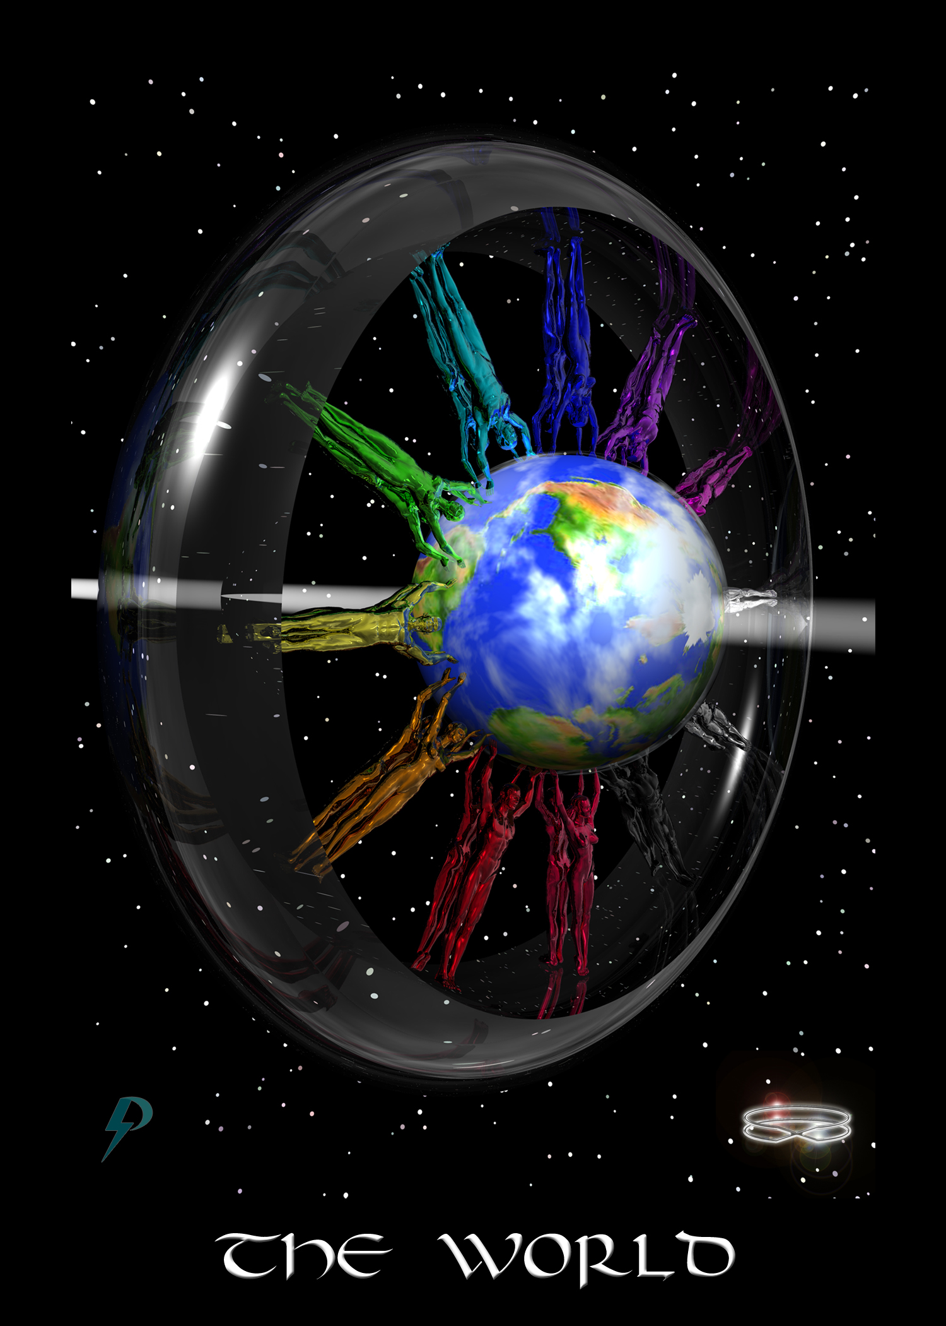

World
Key Phrase: We are responsible for the world as we complete the Great Work.
Symbolism: Twenty-four multi-coloured figures, representing all life on Earth, take responsibility and complete The Plan. Twenty-four multi-coloured figures, symbolic of the twelve signs of the Zodiac and the entire gender spectrum (the Rainbow Spectrum), work together and with Gaia to complete the Great Work. The meniscus represents this planet’s Creation Template which informs and guides our thoughts and actions.
RESPONSIBILITY

New Energy Narrative
This archetype answers the big question “Why am I here.” The answer it conveys is simple. You are here not for individual attainment, but to help implement the Divine Plan. You are not here for personal evolution nor to overcome delusional imperfection, but to evolve the planet. You are here not for karmic reparation, but to work on and graduate this world. You are here as a joyful and powerful master of creation to create a joyful playground for spirit. You are here to complete the Great Work.
At the highest and most aligned levels, this is the work of evolving and ascending a planet, a new pearl in the vast cosmic ocean of time-space. You should know, this is a big job and it takes a long time. Furthermore, this is not an individual process and there are no bystanders in this process. As you can see if you consider the card, this is not an individual project, it is a collective action. All life forms, not only humans, are implicated. To maintain the biosphere, to evolve society, to graduate a planet, all life is required. Respect even the lowly worm because their work is as essential as yours is.
At a mundane level, this is your job, a hobby, your home, your family, your life, and the people that help you create and maintain it all. Never forget, you are part of a local, national, and global community. Despite the lies you have been told, there is no such thing as individual attainment. Take a look around you at all the food grown by strangers and the things made by others. Remember, none survive but that they are supported by the farmers, the trades, and the services. Take a look behind you at those that have nurtured and guided. None thrive but for the support and the guidance of others. Always remember, no human is an island and we all arrive here to complete the Great Work.

Flow Purification
In the old energy, you are told that your purpose is karmic. In the old energy, you are told you’re not worthy. In the old energy, you’re told you are imperfect. In the old energy, you’re told “that’s just life.” In the old energy, you are suppressed and diminished. In the old energy, you’re told you’re the fool. However, in the new energy, that changes. In the new energy, you are a joyful master here to uplift and graduate creation. In the new energy you realize you are God’s light here to ascend and reconnect us to source. In the new energy, you do not work are alone. Therefore...
- Reject all excuse and justification for the world as it is. The bad things that happen do not just happen, they are caused by unaligned individuals committing sin. If we are to improve the world, we must put aside wrong action and join together. Only then can we implement the final Plan, complete the Great Work, and finally transform this world.
- Reject the delusion of self achievement. Your rise or fall is predicated not exclusively upon your own individual effort, but on the support, or lack thereof, of the people around you. Those that tell you otherwise are either misinformed or blatant hypocrites. After all, the reason for joining a lodge it to secure the support and protection of your “brothers.”
- Reject isolated individualism. Realize that when properly aligned and connected, we do not operate as individuals. When properly aligned and connected, we operate as a galactic collective.
- Accept responsibility. Moving forward we must together acknowledge, atone, and account for the things we have done in the past. Moving forward, we must together take responsibility and transform this world.

Connection Coach Question
- The new energy card is all about the Great Work, which is the work of uplifting all things, starting with your self, your local life, your community, your nation, and finally, the planet. It is a big job but it is easier when you start small. Look at your current life situation. Are there actions, people, and things in your life that need uplifting and fixing? Do you need to release anger and forgive? Do you need to create boundaries to protect yourself? Do you need to apologize and atone? Are you rich? Are you a capitalist? Do you need to pay your fair share? Do you need to pay your employees a living wage? Do you need to make your workplace safer and more interesting? Do you need to treat people better? Are you a parent? Do you need to give more attention to your kids? Are you a politician? Do you need to change some laws? Make a list of the things you need to change. The end is here. Do not delay. Take immediate action.
- No doubt, the list you come up with can be quite overwhelming, and might even seem impossible. That is because you are limited by past “old energy” experiences, where change and transformation have been painful and slow. Remember, however, you are not the only person waking up. As more and more people awaken, resistance to transformation will gradually fall away and, like a cool northern breeze, collective support will be the game of the day. Eventually, even difficult transformations will be easy. With this in mind, look at your list and prioritize. What changes can be accomplished in your life, at work, and at the top, now? What will have to wait a few years more? Remember, the new energy World card shows people at work. There are no bystanders in this end-of-cycle process of graduation. Share your top priorities with the group.
- Facing the reality of the old energy world and how toxic and violent it is can, and has always been, cause anxiety, stress, and fear. When you see the truths that surround you, you are wise to be anxious and stressed. Anxiety and stress identify areas of concern that require attention. However, too much can be quite debilitating. Therefore, if you do feel anxiety and stress, practice breathing, meditation, and mindfulness. If legal in your area, CBD Cannabis oils and strains are quite helpful in this regard. Once you are calm, identify the source of the anxiety/stress. Is it world events? Is it challenging issues in your family? Are you feeling overwhelmed? Are you experience resistance from those that surround. Right the sources down and share with the group. Strategize ways to address and transform.

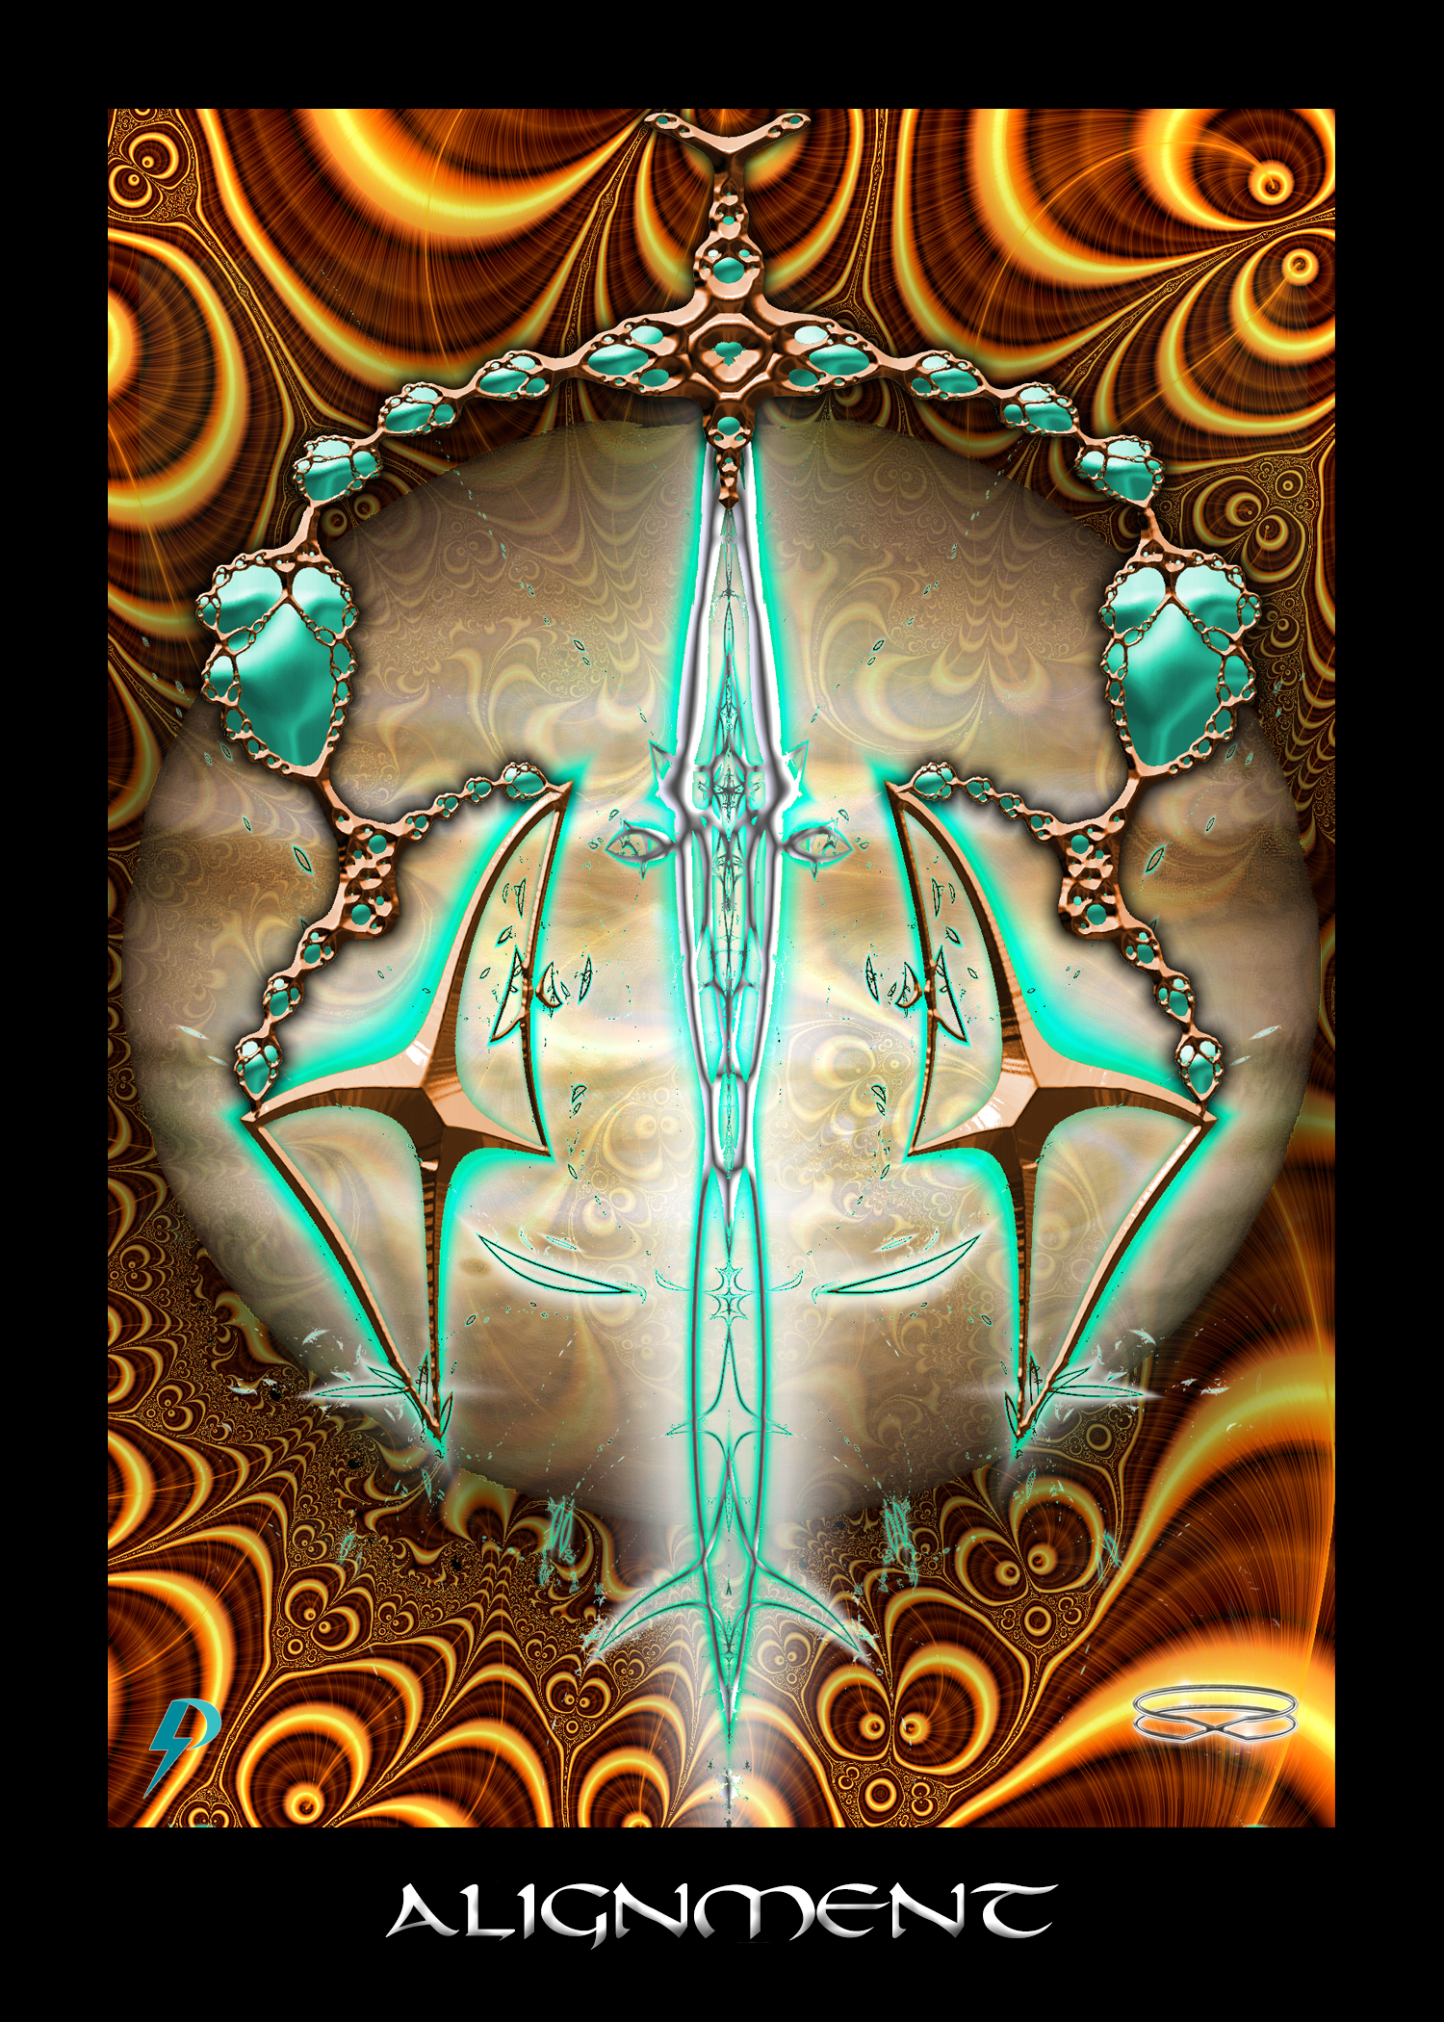

Alignment
Key Phrase: To mine own Self be true
Symbolism: An abstract representation of alignment. A sword, balanced on either side by force and formation (yang and yin). This is not the sword of judgment, punishment, and reward, as it would be in the old energy. This is the sword of discernment and full alignment with Highest Self and the glorious Fabric of Consciousness. This is, above all, the key to the “Kingdom of Pure Consciousness.” To enter the “Garden of full Connection,” throw off self-delusion and excuse and align your Bodily Ego with your Highest Self / Spiritual Ego.

New Energy Narrative
This archetype teaches us the key to our forward movement. To be perfectly clear, this archetype teaches the key to emancipation, activation, connection, and graduation. The key is alignment with your own Highest Self. Always remember, the physical unit is merely a vehicle for the bright sun of your Highest Self. To move forward, align the thoughts and actions of your physical unit with your perfect and immortal Highest Self.
At the highest and most aligned levels, this is perfect alignment with Self, perfect alignment with Consciousness, and the active and eyes-wide-open pursuit thereof. Recognizing the importance of your Spiritual Ego/Highest Self, you work to establish Right Thought, Right Action, and Right Environment. The closer are your approximations, the stronger are your connection experiences.
Understand here that alignment is always a choice. You are not forced to align with Highest Self. No God stands in judgment of you and no cosmic justice system stands by to punish you for your choice. There is no karmic retribution and no eternal damnation for living and acting in misaligned darkness. You may eschew alignment and choose to live a life according to the whims, passions, and pathologies of your disconnected bodily ego, if you want. Life goes on, and your body survives (after a fashion), even when empty of Consciousness.
Of course, while it is true that you may eschew alignment and deny your higher Consciousness, there are natural consequences for your actions. Understand, the suffering and disconnection that ensues when you live an unaligned life is neither judgment nor condemnation. It is neither karma nor justice. God has no hand in the difficulties you face. It is simply a question of spiritual responsibility, choice, and natural consequences. To be clear, it is a simple technical relationship. Eat improperly and your body will degrade and die. Soak yourself in stress and your body and mind will age and debilitate. Disregard your higher Self, live a life of darkness, fail to align with Consciousness, and disjuncture, guilt, shame, and lowered functionality will ensue.
Finally, note that alignment is not an onerous chore. Alignment does not require a Fool’s journey. Alignment does not require pain, suffering, and darkness. Alignment requires only the choice to be who you truly are inside, though to be fair, it is not really a choice. Alignment brings power, peace, contentment, happiness, joy, and the attainment of stronger connection. Disjuncture brings pain, suffering, decrepitude, and death. Only a person who does not know better chooses the hard path and the severe consequences of disconnection.
At mundane levels, this is healing and repair of the physical body and mind through accurate alignment with Self. Putting aside hypocrisy and self-delusion, you align thought and action with your Self. Breathing deeply, you happily atone for past “sin.” Focusing on the manifestation of the promise, you fix that which is broken in your world.

Flow Control
In the old energy, the concept of alignment is corrupted with notions of justice and judgment. In the old energy, this is reward for following the rules and punishment for productive failure. As Wirth notes, the universe does not reward the slacker. “We live in order to work, not to enjoy life without paying. Increases in salary reward the good 'workman' who by aiming at living better, benefits from the superior way of life to which he has risen.” This is “fair” cosmic/karmic/divine justice, and the “active administration of law” and the idea that you should passively accept whatever “is” as something natural, inevitable, chosen by God, and something you deserve. The universe is a universe of law, order, submission, and violence. If you do not do the “right thing,” you will be punished and perhaps even destroyed for none escape the absolute “wrath” of karma.
The message in the old energy is clear. If you are poor, it is not because The System keeps you down, it is because you deserve it. If you are rich, it is not because you exploited other people, it is because you deserve it. If you suffer, it is a lesson. If you get cancer, there is a purpose. Look for the silver lining and understand, a divine/cosmic/natural justice permeates existence; all things exist, including pestilence, war, suffering, and death, exist as they should.
Above all, the message in the old energy is that you should accept. Accept the bad things that happen in life as lessons. Accept inequality as divine justice. Accept violence as God’s hand in sanction. Accept that whatever has happened to you, you deserve it in some way. As Pollack says, “As long as we believe that our past lives just happen, that we do not bring our own selves into existence through everything we do, then the past remains a mystery, and the future an endlessly turning wheel, empty of meaning. But when we accept that every event in our lives has helped to form our characters, and that in the future we will continue to create ourselves through our actions, then the sword of wisdom cuts through the mystery.”
Of course, in the new energy, we reject the idea of judgment, justice, and punishment and the notion that it is “our hand” that is exclusively responsible for the world that surrounds us. Instead, we emphasize the idea of atonement and alignment. The truth is, there is no cosmic principle of justice that condemns the “sinful” and ensures punishment and exclusion of the unworthy. God does not keep childish score and the “universe” does not track your transgressions. Old energy ideas simply justify old energy power and privilege, so put aside that nonsense once and for all. The truth is, you cannot have rich except in relation to poor, and you cannot have power except in relation to powerlessness. It is the acceptance of this idea in consciousness, the acceptance of his notion that there is a cosmic/karmic/Divine justice, that allows The System to continue. Why change anything if it’s all working properly as is?
To get into the new energies you must put aside old energy notions of justice and punishment, and any and all notions that this world is OK as it is. This world is not OK as it is. Unless you are perfectly aligned with your Higher Self, you have work to do to establish right thought, right action, and right environment. To move forward towards alignment and connection, you need to stop passively accepting and instead figure out the things that you need to change.
Moving forward, keep the following things in mind.
- In the old energy, the need for alignment is corrupted into the idea of justice and judgment. Instead of aligning with your Highest Self, you are taught to align with the values and expectations of The System. Failing to follow the rules of The System, you are judged and punished as such. To get out of this old energy you have to learn not to align with external notions of justice, judgment, and karma, but to your own inner compass. Inside, you are a compassionate being of awareness, bliss, and love. To move forward, learn to align with your own power and glory.
- In the old energy, justice and judgment are often used to support privilege and exclusion. You get into the secret clubs and enjoy all the privileges because you are “better” than those other people. You find yourself at the bottom of the pile because karma or God’s will put you there. It’s not true of course. High are low you got there because a rigged system put you there. Maintaining delusions of justice simply preserves these systems of privileges. More to the point, excluding and exploiting others puts you into a state of mis-alignment, from which it is hard to break free. Nevertheless, you have to. To get into the new energies, reject all justification and excuses (spiritual, social, legal, etc.) you use to exclude and exploit. Reject all moral and cosmic justifications that allow you to claim a superior status. In reality, we are all members of a glorious family of Spirit and we all belong wherever we desire to be.
- Are you angered by dismissals and exclusions? Does inequality make you fume? Do not suppress that anger. Instead, embrace it, channel it, and use it to uplift and transform the world. The suppression of justifiable anger prevents you from claiming your rights and recognizing the injustice of it all.

Connection Coach Question
- Chances are that in the past you have been excluded from something you wanted to be a part of. Think about those times. How did it make you feel to be excluded? What sorts of ideas or behaviours did you use to justify the exclusion to yourself and to make yourself feel better about it. Share with the group.
- Are you a member of any private social grouping (old boys network, girls club, teenage social cliques, etc.)? Did you practice the dark arts of exclusion? If so, what tools do you use to accomplish this exclusion? What ideas do you rehearse? What emotions do you suppress? What lies do you tell so you can justify and excuse your callous and exclusionary actions? Gather up the courage and share with the group. Do not be ashamed. Do not feel guilty. Simply make a commitment to change. We move forward much faster when we share.
- Put yourself in the shoes of another person. Think about a person or group you have excluded in the past. Think about the impact of this exclusion on their life, their family, and their mental well being. How do you think the exclusion made them feel? What damage might it have done to their psyche and their life? Do you feel empathy for the people you have hurt? If not, your heart (chakra) is tightly closed. Visualize its reactivation and practice love and compassion.
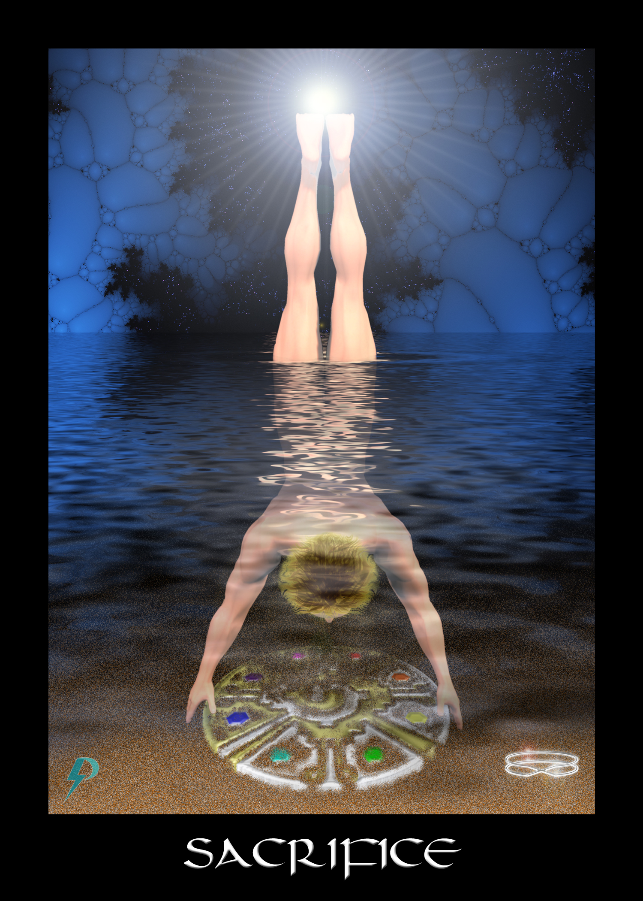

Sacrifice
Key Phrase: My sacrifice is disconnection from Self.
Symbolism: Here we see a joyful master sacrificing connection to Consciousness in order to descend into The Waters (of Manifestation) and uplift physical creation (the earthen disk). Anchored by the light of Consciousness, but submerged, inverted, and with no light at the Crown (chakra), we are all disconnected. Embracing physical creation, we strain and struggle to uplift this planet, and others before it. Through sacrifice and hard work, we lift physical creation up through the darkness of in-animation towards animate life capable of containing the highest levels of Consciousness.

New Energy Narrative
This archetype teaches you of your sacrifice. You cannot deny the Great Work is challenging and difficult. Many have suffered and sacrificed as we struggle to evolve the planet and its Pinnacle Species, and move it towards graduation. If you are reading these words, you have accepted this challenge. If you incarnate on this Earth, it was with full awareness of the difficulties involved. Individually we might fail. Along the way, many battles are lost. But in the end, the outcome was never in doubt.
At the highest and most aligned levels, this is the sacrifice required to undertake the Great Work, which is the work of evolution and ascension. Disconnected and blindfolded, you descend into darkness in order that you might ascend physical creation. It is hard work, the conditions are not ideal, and so you struggle and suffer. You accept and endure for the reward of your effort is a pearl of inestimable value--an ascended and graduated world.
At mundane levels, these are the priorities we set and the sacrifices we make so that we can work and live the way we want. In the physical world, nothing good comes without work, effort, and sacrifice.

Flow Control
In both the old and new energy archetype systems, the basic idea of sacrifice is retained. It is certainly an appropriate idea. Incarnating on this Earth during Stage Five and Stage Six does require sacrifice. There can be no arguing this. The key difference between the old energy and the new energy is how the sacrifice is conceptualized, and what the sacrifice is all about. In the old energy, our sacrifice is turned into justification and excuse for abuse and exploitation. In the old energy, we are taught to accept whatever suffering and exploitation comes our way on the grounds that pain and suffering are good for us in some way. All the poverty, suffering, and woe is not caused by human hands, it is God's will and nature's way. We are “tempered” by the pain of our incarnation and “strengthened” by suffering we endure. We achieve enlightenment by accepting “what is” no matter how horrible it may be. By submitting and inserting ourselves into The System, by “paying our dues,” by accepting violence and exploitation, we move forward towards some lofty goal.
The message of the old energy sacrifice should be crystal clear. Put up, shut up, and smile. Accept whatever life throws your way because, in the end, no matter how painful it might be, no matter how much damage occurs, it is all part of some divine/cosmic plan.
In the new energy, the idea of sacrifice is still present, but the idea changes. No longer is it about unnecessary pain and suffering or putting up with violence and abuse. In the new energies, this is the sacrifice of disconnection from our own Highest Self, a disconnection required during Stage Five Expansion. In the new energies, this is the sacrifice we make as we work on the world. In the new energies, this is the sacrifice we make as we strive for graduation. In the new energy, this is the sacrifice we make as we give up our power and ability so we might evolve planetary systems. Just as we work hard to build a home, just as we sacrifice to successfully raise our children, so too we sacrifice as we work on The Plan. We put on The Blindfold and work in duality in order to evolve the planet, accomplish ascension, graduate, and achieve integration.
Putting aside old energy ideas of sacrifice can be difficult. To do so, remember...
- In the old energies, we are told pain and suffering is part of God’ s lesson plan. In the old energies, we are told that it makes us stronger in the end. Its not true, of course. The pain and suffering we endure is a consequence of Toxic Socialization and the exploitation we all endure. Remember, pain, abuse, and exploitation damage the physical unit and make it harder to connect. The pain and suffering we endure is not part of our “lesson plan.” It does not “make us stronger.” It is not “God’s will.” We are not being “tempered in the fires.” We are not being punished for sins, real or contrived. That is nonsense. Remember, we sacrifice, but this is the sacrifice of disconnection and hard work; beyond that, there is no deeper, karmic, or cosmic meaning.
- In the old energies we are often told we “deserve” to suffer because of some original sin or some past karmic crime. Our pain and suffering is a sacrifice necessitated by the working out of judgment and justice. If we believe this, we may experience guilt and shame when trying to heal and reconnect. If so, remember, no matter what anybody tells you, you do not deserve to be punished. Just because you have done something wrong, does not mean you deserve to be abused, incarcerated, and tortured. Don’t let guilt and shame block your progress. On an integrated world operating under a Divine World Order, all you have to do to move forward is acknowledge, atone, and and align.
- In the old energy, we are often told we are unworthy of healing and connection. It’s not true. Remember, you are not a fool in school. You are not here for karmic testing. You are not here to experience judgment. You are here to evolve and uplift this planet. You might not understand everything right now, but you are certainly worthy of “enlightenment” and reconnection. Whenever you experience self-doubt, or fear that you might be put down, take a deep breath and remember—you are a joyfully incarnated master here on a mission. You are here to work on the world and uplift the planet so we can graduate and take our place amongst all graduated start nations.

Connection Coach Question
- Ideas represented in this card are straightforward. The complexity comes in doctrinal variations. Think about your own archetypal indoctrination, be that Catholic, or Buddhist, or Darwinian. Do you find the old energies of sacrifice represented there, i.e. the justification of pain and suffering, the encouragement to passively accept, some variation of the belief that “what does not kill you makes you stronger?” If so, spend a few moments writing them down. When you are done, share your answers with your group.
- Working with this archetype can trigger deep feelings of shame, unworthiness, guilt, and even fear. The idea that we can throw off our chains, heal our self so we can connect with our Highest Self is appealing, but when we think about this idea we often invoke emotional blockages implanted to prevent it. When you work with this card, when you work with any of these cards, pay attention to any negative emotions that you feel. Make a note of them and share these feeling with the group. Where do you think these feelings come from? That is, how did they get into your body? Discuss with others.
- The idea that pain, suffering, sacrifice, submission, and diminishment are all unnecessary can be a hard pill to swallow, especially since we are taught from day one that pain, suffering, and sacrifice help us grow, mature, and develop. As a consequence of the deep indoctrination, we resist. We doubt that it is true or we make excuses so we do not have to change. If you experience this resistance, pay attention to it and write it down. Share our resistances and excuses with the group.

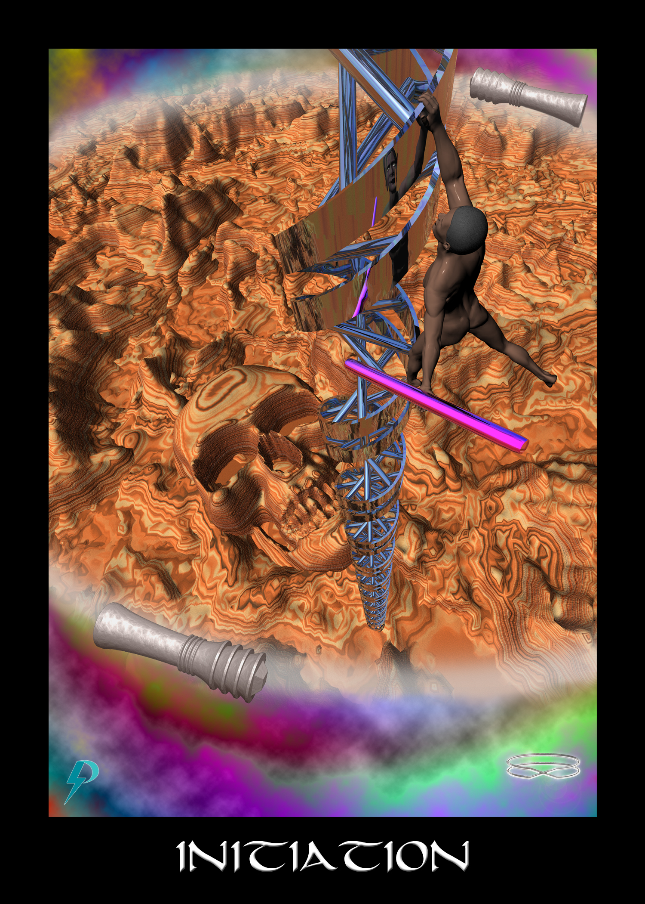

Initiation
Key Phrase: I am no longer weak and afraid.
Symbolism: As we respond to the calling, we begin our ascent. The chaos, darkness, disease, and death of Old Energy archetypes (symbolized by the muck) and the old energy reality they create lie below. A figure climbing an awakening and activation spiral struggles out of this darkness. The ladder is vertical; the climb is difficult; the pitfalls numerous. However, there is hope. We remember the promise and release fear. We realize and clarify so that understanding emerges. New ideas and new ways of looking at things bring renewed purpose. Strength slowly returns. The pace accelerates. New energies begin to flow. A circle/energy sphere provides a boundary to protect the climber and keep her on track.

New Energy Narrative
This archetype represents initiation and the process of awakening, healing, and reconnection that occurs as we will ourselves forward. This can represent the actual process itself, or it can represent a point of emotional, psychological, spiritual, and/or political maturation. This is the lightning flash of divine inspiration. You know, or begin to suspect, who we are. You understand the depth of your sacrifice. You realize your purpose on Earth. Moving forward, you roll up our sleeves and get down to work. As you lift yourself out of the muck, you gradually heal and reconnect.
At the highest and most aligned levels, this archetype represents the realization that there is more to life than meets the proverbial eye. As understanding dawns, we initiate the process of healing and reconnection. Having responded to the Calling, we perform an awakening affirmation and an awakening visualization. Gradually, we lift ourselves out of the old energy archetypal muck. As indicated in the card, this is a struggle and it does take work. As the world around us transforms, it gets easier as we go.
At mundane levels, this is a bright idea that leads to a confident change in direction, or the initiation of a project. This is the activity that follows an idea, and the consequent decision to build and create. This could represent a house, a screenplay, a business, a family, or anything else that you decide to build/create.
At a collective level, this is the initiation of global healing and reconnection during the penultimate evolutionary stage (i.e. Stage Six). Transformation starts slow, and resistance can be intense, but nothing can now halt the progress. It is a short step from collective initiation to planetary graduation.

Flow Purification
In the old energy, we also learn about “initiation” and ascent out of darkness. However, like all old energy archetypes, access is restricted and initiation is available only to the “chosen,” to the special few admitted into the special club. In the old energy, the masses remain in the muck not by a System that exploits them and by archetypes that undermine self-esteem, and sow fear and confusion. If they take a step up the ladder, they are swiftly knocked back down and then blamed for their failure to rise. When they inevitably struggle and fall, it is not because The System seeds fear and misconception, it is their own weakness that is to blame. Those who are fortunate enough to gain the “support” of the brothers pass into the temples of power and privilege smugly pat themselves on the back as strong, chosen, winners while sneering at the failures outside. .
In the new energy archetype, the idea is still of initiation, and there is a recognition that initiations may be powerful, disorienting, and challenging, especially at the beginning,. However, in the energy, we recognize, it a struggle to pull oneself out of the muck; it is a struggle to ascend the ladder. This struggle arises not because of weakness and limitation in the individual, but because of the systematic oppressions placed in our way. In the new energy we do not arrogantly point our fingers at those who struggle. In the new energy, we gather our own strength, reach out, and lend a hand.
To get yourself out of the old energy
- Pay attention to your tendency to “blame the victim,” and blame yourself. Damage caused by toxic socialization and the suppressive effect of old energy archetypes makes the ascent more difficult than it needs to be. You may be a bright spark of God consciousness inside, but slopping of the muck is a lot harder when weighted down by old energy thinking. If you struggle, don’t blame yourself; instead remember. The Great Work is a collective work. If you struggle and stumble, reach out for help.
- Pay attention to self-doubt and self-diminishment. These key messages in the old energy archetype system (you are an unworthy fool in school) form the foundation of suppression and control. They prevent initiation (if you doubt your ability, you fear stepping forward) and they make it harder to ascend (i.e., heal and reconnect). Remember the message of the new energy archetype system. You are a joyful master incarnated on Earth to work on the world and graduate the planet. Despite what you have been told, you are worthy and you have the natural ability to make the climb. If you struggle, repeat these words. “I am not a fool in school, I am a joyful master.
- Finally, pay attention to all forms of violence in your life. Those who fear our progress, those who are threatened by our ascent, those who benefit from our suppression, act out when we choose to climb up. Emotional, psychological, and physical violence are often invoked when we take a step forward. Remember, violence of any kind damage, distorts, and makes reconnection much harder. If you experience it, do what you need to do to stop it. If you allow it to continue, you will struggle to

Connection Coach Question
- Doctrines and ideologies that spread fear, anger, and hatred (e.g. religions that teach old energy archetypes of punishment and damnation) make initiation and ascend a difficult thing. Old energy archetypes corrupt realization and shape actions in ways that invoke fear, anxiety, and hatred, and that undermine your healing and connection activities. Think back and try to identify past initiatory experiences where fear, hatred, and self-diminishment were invoked. Write one or two of the most powerful of these experiences down. Did you successfully clear fears and hatred, or did you succumb, and were you “shutdown?” If you experienced a shutdown, do not worry about it. The climb out of darkness is an iterative, repetitive, trial and error process. You only fail if you stop trying. With that in mind, what can you do to increase your chances of success next time around?

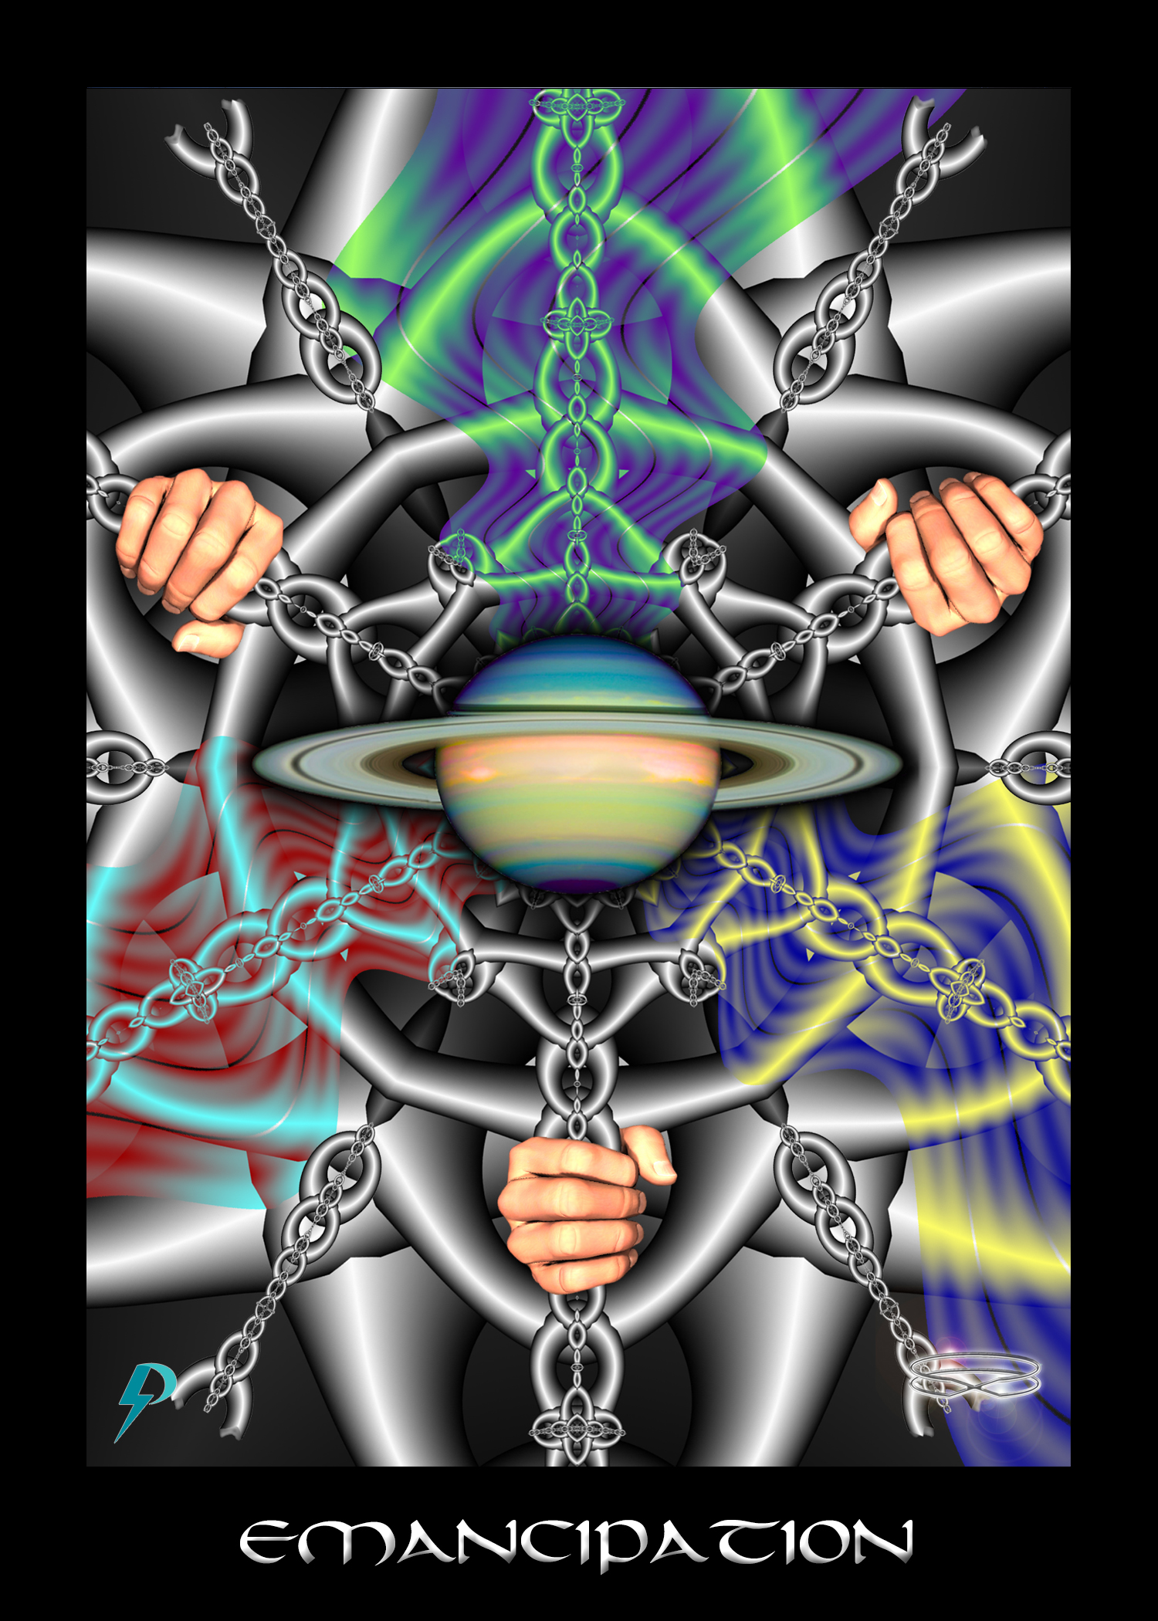

Emancipation
Key Phrase: Free at last.
Symbolism: The planet Saturn, with its ridged outer rings, represents boundaries and limitation. Archetypal chains bind the mind and the body. Our energies and actions have been restricted, but our bondage is coming to end. Three individuals grasp the archetypal chains that bind and pull, thus breaking the chains. By our own effort, and with the assistance of others, we emancipate and break free.

New Energy Narrative
This archetype represents emancipation from The System. This is release from the archetypal chains that bind. This is the emotional, psychological, and physical empowerment that results. This is growing freedom to act in the world in the best interests of yourself and your family.
At the highest and most aligned levels, this is emancipation of the physical unit (the body and the mind) from fear, uncertainty, and creative impotence. You answer the call and initiate. You overcome fear and self-loathing. You establish right thought and right action. You align, gather strength, and are freed. Your power and confidence grows. With clarity of purpose, you exert your will and finally break free. Consciousness/Spirit/God, progressively, and inevitably, breaks through
At mundane levels, this is freedom to act as you will and desire, without fear and uncertainty. You change your job. You change your lifestyle. You make an adjustment because you want to, because you can, and because it is right. Blockages dissolve and you move towards activation and full power.
Individually and collectively, this card represents the removal of old energy chains, emancipation from old energy archetypes, freedom from old energy delusions, refusal of old energy limitation, the rejection of your old energy self, and the ejection of old energy pain.

Flow Purification
In the old energy, enslavement and exploitation are justified and excused. In order to assuage their own guilt, elites tell themselves they must control the masses otherwise it would be primitive chaos and violence. In order to make themselves feel better, they tell themselves (and us) that the chains are voluntary and put there for our own good. It is to temper us in the fires. It’s so we can pay off our karmic debt. It’s so we can “grow” and evolve. We can always break free if we want, we are told; Just lift off the chains and walk free.
In truth and in practice, there is nothing in old energy archetypes that leads to mental freedom. The old energy system provides no path for the removal of chains. So-called esoteric secrets do nothing but strengthen your chains. Even the elites are contained in a tight box, though most would not care to admit it. The truth is, the only way out is through a new energy door. With this in mind
- Stop blaming yourself for the struggle and the limitation you experience. The System enslaves you and in the end will suck you quite dry. If you blame yourself, you preserve The System by distracting critical attention. To be sure, you have to be accountable for your actions. To move forward, you must atone and make things right; but, you shouldn’t blame yourself for your poverty, inequality, and despair because these are structural outcomes of a rigged economic system. Therefore, watch out for self-blame, and reject it when it appears. Focus your attention on the System; change it so all can be free. Remember, as a spark of creator Consciousness, as an incarnation of divine light and love, you deserve nothing but love, prosperity, kindness, and peace.
- Stop blaming yourself; stop blaming others. As part of the toxic socialization process we all endure, you have absorbed ideology and excuses used to justify exploitation and abuse. If somebody is poor or injured by The System, you have been trained to think its because they are losers and weak, not because The System keeps them down. As a consequence of this tendency to blame others, we participate, to one degree or another, in the exploitation and abuse. We all function as Agents of Consciousness. To move forward consider this; there is no judgment archetype in the energy system. Therefore, stop judging others. Do not dismiss their suffering and struggle as a personal failure, divine will, or cosmic judgment. Understand, the System oppresses, suppresses, abuses, and exploits everybody. It is toxic socialization, brutal exploitation, a rigged economic system, constant manipulation, and incessant attack, not personal weakness and failure, that leads to dysfunction, disease, and death. Instead of wagging a judgmental figure, help and support those in need.

Connection Coach Question
- Consider all the ways you blame yourself for the things that happen in your life. Now, consider that not all things that happen in your life are your fault. Many things that happen in your life (good and bad) are the result of the actions of others, at a personal, workplace, political, economic, and even global level. Spend a few moments considering how your life has been shaped by the actions of others, good or bad. Share your thoughts with the group. Are there things you can do to mitigate the negative impact others may have? Share.
- As noted, the old archetype encourages you to blame others, this way you do not blame the System. They are enslaved, repressed, oppressed because they deserve it, because they chose it, or because they did something wrong. Examine your own life and the acquaintances, work mates, friends, and family in that space. Are there things you dump on them, things you blame them for, like poverty, addictions, illness, personality disorders, etc., that are maybe caused by others (things, like the System, advertising, corporate malfeasance, toxic socialization, etc.) and that therefore you shouldn’t? Share your thoughts with the group.
- System justification moves both ways. That is, it’s not just the masses who are oppressed and suppressed. Do you consider yourself a member of the elites? Have you ever had to kneel down and submit before the altar of another? What justifications do you use that allow you to confuse strength with submission and servitude? Does power over others erase the reality of your own submission and bondage?
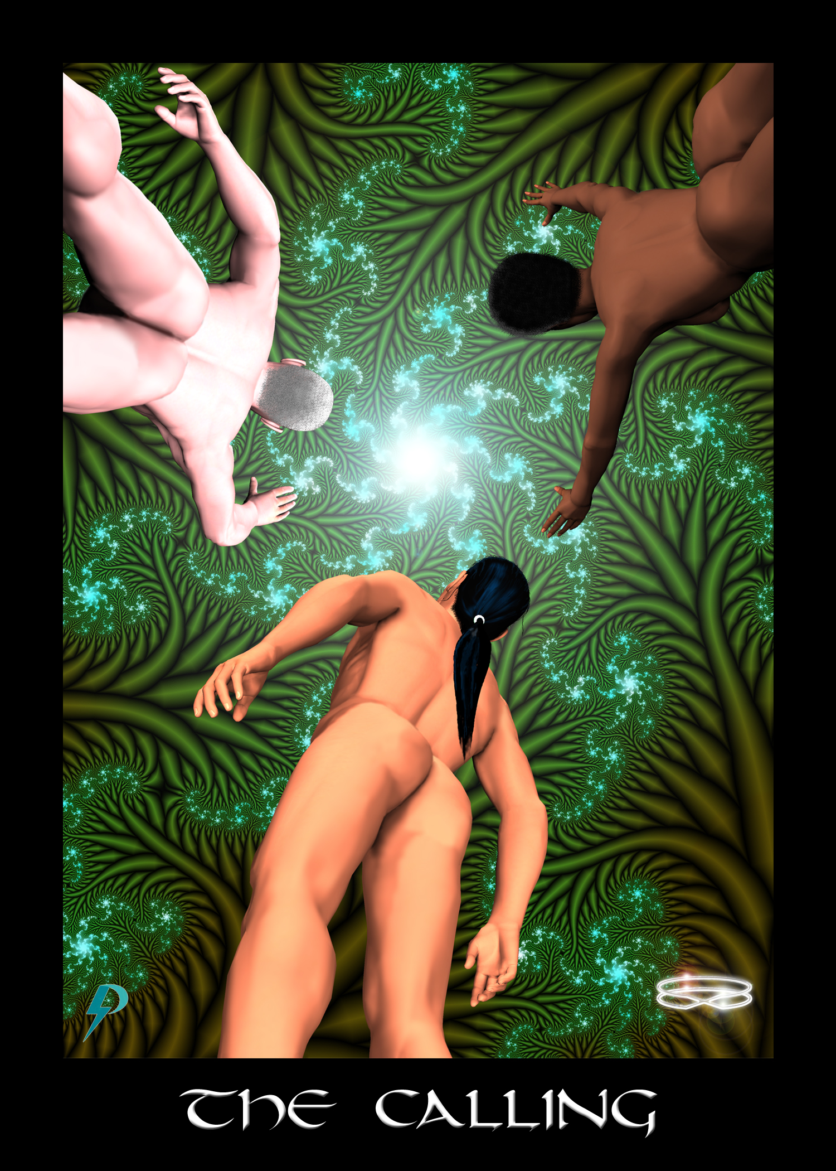

The Calling
Key Phrase: 11:11 is your time to wake up.
Symbolism: Consciousness/Spirit/God is calling you. Looking up, you respond to the Call. The body/mind begins to awaken. It is time to begin your journey healing journey home to stronger connection. Opening your heart and mind, engaging in Connection Practice or using Connection Supplements, you let the love, power, compassion, and understanding of Consciousness slowly (or rapidly) descend, heal, and transform you. A powerful pull that, for your own sake, and for the sake of all those who surround you, you should not ignore. The figures, representing the bodily ego, look up as they respond to the Call.

New Energy Narrative
This archetype represents the individual and collective call to awaken. The message is slowly getting through to everyone. As you respond to the Call and begin to awaken, the search for greater meaning, purpose, and understanding begins. The powerful urge to embrace truth and reality grows. You take a healing and connection step forward on The Path of empowerment and activation. You begin to realize, there is more to life than what you can see, and what you’ve been told. You begin to wonder, “What is this more?” As you progress, you remember, life isn’t about judgment and punishment or trials and tribulations. Life isn’t about karma and debt and foolish tutelage in a cosmic school. It is a joyful, divine, evolutionary dance.
At the highest and most aligned levels, this is the call to awaken to identity, to activate, to heal, to ascend to stronger connection and purpose. The time for pretending is over. The time to move forward is now.
At mundane levels this is the same call to remember, heal, and reconnect. You will feel the Call as a niggling push to move forward. Trust that you have what it takes to move forward and make the shift. You might have a problem or a blockage, but the solution is there. If you pay closer attention, if you listen to inner guidance, and if you trust your intuition, the solution is right there to hand.

Flow Purification
The Call comes to everyone, no matter what you have done. In the old energy, however, you are taught about judgment and the notion that in the end you move forward only if you’re judged worthy. You must have the right blood. You must be a hard worker. You must be one of the “chosen” ones. Be aware, if you are not worthy, you will be punished (i.e. harmed) in some way. Better be careful. Don’t step forward too fast.
Note that in the old energy, judgment and punishment is not merely conceptualization. From the time we are born until the time that we day we face ongoing judgment and the perpetual violence and abuse of punishment. Our painful experiences, coupled with archetypes of judgment and punishment, creates a deep fear and PTSD. When you feel the Calling, this you discount your ability, you doubt your own worth, and you fear judgment and the consequences that inevitably ensue. The fear rises and, in order to protect itself, your Bodily Ego shuts down nascent connection. It is a sophisticated system of spiritual suppression that culminates in subversion of the Calling.
To put aside old energy fears and misconception,
- Embrace your power and glory. Reject judgment. Reject punishment. Reject all notions that you must be worthy. After years and decades of indoctrination, we internalize the archetype of judgment and we apply it, often quite harshly to ourselves. When we judge ourselves unworthy, we reject the Calling. Therefore, replace negative self-statements (“I’m not good enough,” “I have no talent,” “I’m a loser,” etc.) with positive self-talk (“I’m strong,” “I’m beautiful,” “I’m worthy,” “I am a powerful master,” etc.). Remember, you are a joyful master incarnated to complete the Great Work.
- Remember, everybody deserves peace, prosperity, happiness, and positive regard. Everybody is given the opportunity to awaken. All are welcome to participate in the glorious end-times celebration. All you have to do is throw off the old energies, reject the old archetypes, and embrace the powerful, glorious, and light-filled divinity within all life forms. Remember, there are no justifiable exclusions. Everybody gets to come home in the end.
- Finally, watch out for the hurtful actions of authority figures, especially parents and teachers, as they enforce the old energies judgmental regime. You deserved none of the pain you received as a child. You deserve none of the suffering you experience as an adult. The new energy truth is simple. There are no valid excuses for hurting another living being. Remember. You are a powerful and joyful master. You have the strength, power, and freedom to walk away, so do that. If authorities do not step back, if they do not stop the hurt, walk away. This is the only way you’ll create a space where you can respond to your Calling.

Connection Coach Question
- Spend some time thinking about all the pain and suffering you have experienced on this earth. Who is responsible for that pain and suffering? Was it your parents, your teachers, your priests, your bosses? Did your parents beat you, or psychologically abuse you, or emotionally abuse you? Were you sexually assaulted by trusted adults in your life? Were you picked on and excluded at school? Did teachers “judge” you with a “C” and make you seem stupid in front of your peers? Did you own this suffering? Did you fall prey to the “judgments” of others? Did you think you deserved it? If so, take a few moments to reject all those judgments No matter how ugly or pretty, fat or thin, weak or strong, stupid or dumb, mean or vicious you may have been, you do not deserve any pain and suffering. What you deserve is love, support, guidance, and healing.
- Have you hurt others? Have you hit them, called them names, excluded them, made them feel bad, etc.? How did you justify this behaviour? What excuses did you give to yourself that made it OK to hurt others, even children? What do you think about those excuses now?
- Spend a few moments imagining a world where nobody judges, nobody punishes, and where violence and abuse of another simply does not occur. List two or three things about our current world that would have to change, in order for this non-violent utopia to emerge. Let your imagination run wild.

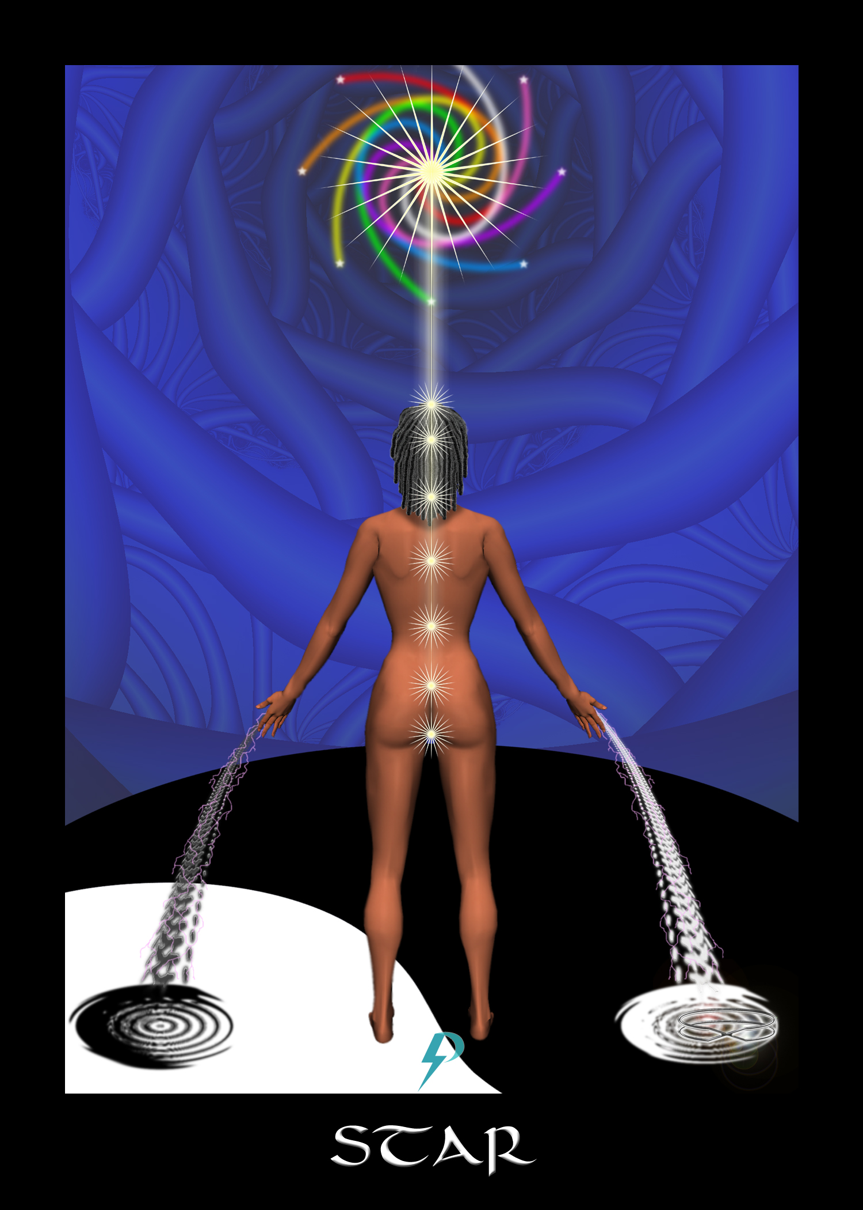

The Star
Key Phrase: Aligned, activated, and completely connected.
Symbolism: The yin/yang symbol on the floor symbolizes physical creation, the physical world, not cold, submerged, and disconnected as in sacrifice, but reflecting the will of Spirit, and created with balance and connection. The figure is shown connected to Source and fully activated. The figure pours balanced energy into physical creation, lifting it to a higher Consciousness. Star Consciousness incarnated. Aligned and efficient creation. The Master, fully engaged in light work. The Great Work nears its completion.
Narrative: This archetype represents a fully realized, activated, empowered, connected, and shortly victorious, lightworker, willfully undertaking The Great Work, which is the work of evolving and ascending creation. There is no longer any reason to fear, doubt, or deny. You are initiated and reborn and you are here to graduate the world.
At the highest and most aligned levels, this archetype represents integration of your power and mastery, realized in divine purpose. This is your inner divinity and powerful star-force shining brightly and rightly through you. You are a powerful, wilful, spark of co-creative brilliance. You are a star helping with manifestation and evolution of creation. You are a spark of God Consciousness in incarnation. Embrace this wonderful truth and let your star shine.
At mundane levels, this is identity and purpose realized and fully expressed. Self has merged with self and I and “i” are one. This is parenthood and work as a vocation. This is a career in alignment with Self. This is spirituality and religion fostering strong connection. This is science as a global avocation. This is a life lived with strength and in service to The Great Work. Life is not meaningless for the one who shines bright their own star.
At an individual level, this is one who is fully aligned, properly grounded, and completely connected. At the individual level, this card represents someone who has thrown off The Blindfold, has realized the truth, has understood their place, and is properly prepared and positioned.
At the collective level, this card represents a world that is fully aligned, properly grounded, and completely connected. This is a world that has thrown off The Blindfold, seen the truth, and is in proper position. This is a people on a planet comfortable, inclusive, and ready to ascend. None can be left behind.

Flow Control
Achievement of full connection is a thing even under oppressive old energy conditions. However, in the old energy you are told that you arrive at this point only through heroic struggle. You must pay your dues. You must earn your place. It’s not true however. If you struggle, it is not because you must pass through some cosmic forge, it is because you must heal from damaged caused by Toxic Socialization. If you sacrifice, it is not because God is trying to teach you lessons, it is because the work is challenging and you face much resistance along the way.
Nevertheless, despite misdirection, confusion, and attempts to make this about individual attainment, at a certain point, you arrive at this point. When you do, remember, this is not the endpoint—this is just the beginning. Even when the entire world is reconnected, there will still be work left to do. Moving forward, we heal the planet and its people. Moving forward, we transform The System. Moving forward, we save the world.
The basic truth of this archetype is simple enough to grasp. When aligned and fully connected, you are a powerful Star. However, the simplicity of this message is obscured by ideological obfuscations which sow doubt and disbelief. We struggle with the truth of this because of damaged and crushed self-esteem. Therefore, you may struggle to accept this deep truth. If you do struggle,
- Meditate on the meaning of the phrase, you are a star. What is a star but the manifestation of consciousness as light? What is the physical unit but a receptacle for the powerful might of Consciousness? One healing is complete, once alignment is achieved, the full power and glory can come shining through.
- Consider this: the chains that keep us from realizing our true nature as incarnated stars of Consciousness are conceptual, and ideological. You are told you a fool in school. You are told you are are broken-down karmic reject. You are told you are descended from apes. You are told you have been judged unworthy. You are told you deserve to be punished. All these old energy archetypes weigh heavily upon your light prevent you from accepting the truth. Uncorking the powerful consciousness that lies within depends on the removal of old energy archetypes that prevent our realization. Study hard and remove each. Be disciplined and persistent in your practice and watch out for distractions and diversions. Despite propaganda to the contrary, the truth isn't that hard to see, or handle. The real challenge is getting around all the obstacles, diversions, and distractions put in your way.
- Removing archetypes so the Star may be revealed is only part of the process. Consciousness is powerful and preparation is required. Watch out, therefore, for the power of consciousness emerging in your life. Watch out for increasing awareness (of slop), increasing confrontations with truth, increasing concern, compassion, and sensitivity, and increased power. Do not shirk, withdraw, or turn away. Instead, embrace the power and divinity that is the star within you.

Connection Coach Question
- Look back over your childhood, education, and socialization. Chances are high that you were repeatedly told how worthless, small, and broken you were not only by teachers and authorities, but by your trusted parents as well. List some of the negative messages that you received as you were growing up and reflect on how these messages impacted your self image and your understanding of your potential.
- Consider the opposite message, that you are star, or a powerful co-creator, or a spark of divinity. Have you ever heard that message before? If so, how did you “receive” that message? Did you take it seriously? Did you appreciate the full significance of the truth? Have you ever experienced the full significance of this truth? Share your experience.

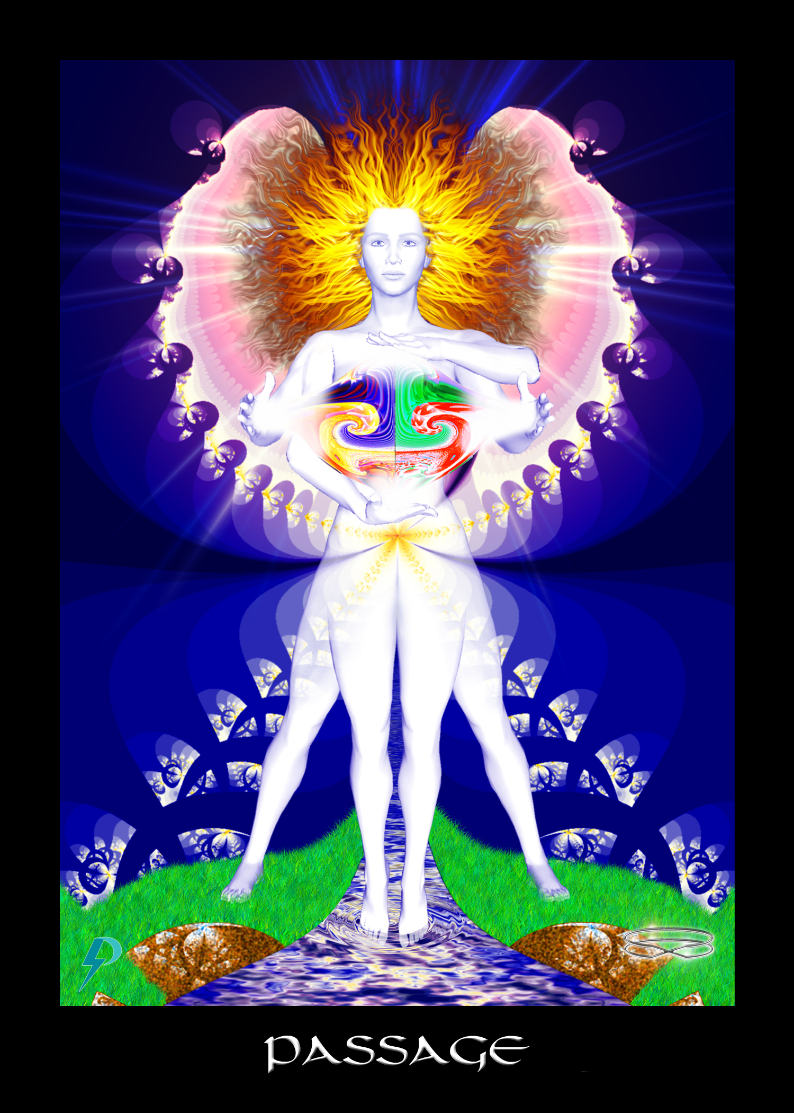

Passage
Key Phrase: My Highest Self stands in my way.
Symbolism: An angel representing your own Highest Self stands before you, blocking your Path back to full connection. Righteous and with hair afire symbolizing full and unmediated connection to Consciousness, your Highest Self holds the book of your life up for examination. A Self-evaluation is at hand.

New Energy Narrative
This archetype teaches of the significance and importance of alignment. Know this, you cannot move forward, activate, or connect until you properly align with your Self and commit to the work you came here to do. There are no other options represented here. To gain passage to full and empowered Connection, you must be true to your Self.
At the highest and most aligned levels, this archetype represents the necessity of full alignment with Self. This is your higher Self guarding passage into an empowered state. This is no joking matter. There is no moving beyond until you align. Take the time to evaluate your own progress. Have you responded to the calling? Have you initiated on a spiritual path? Have you realized the truth? Have you emancipated your mind? Have you purified your thoughts? Have you changed your behaviours? Do you draw strength from committed service? Are you aligned with Highest Self? If so, then Self welcomes you home.
At mundane levels, this is Right Action in the world. This is you righting all the wrongs for which you are responsible for, and later helping others do the same. Note, this is not a judgment and nobody is being punished. Should you wish to attain passage and move forward, simply acknowledge and atone for whatever it is you have done. Fix what you have broken and com home.
In the old energies, passage is generally limited to a chosen few. You must be worthy. You must be good. You must be strong. You must amputate your emotions. You must put aside your compassion. You must comply and submit in the hierarchy. You must press love under will. Only then can you gain entry. But all that’s not true. There is no test you need to complete. You don’t have to be “chosen” to move forward. You don’t have to compromise your values and ethics. You don’t have to do what you don’t want to do. To move forward, you must simply be your Highest Self. Find what’s in your heart and do that. Therefore,
- The old energy Fool in School, Judge and Punish archetypes all contribute to general feelings of unworthiness. When we meet our highest self, we feel diminished, small, and unworthy. Expecting a sinful reject, sometimes our own power and glory can be confusing. What it is, exactly, that stands on the Path. As we confront the angel of our higher selves, these feelings block our passage. We turn away in shame, feeling unworthy of the glory inside. Therefore, watch for feelings of unworthiness. We are all sparks of incarnated divinity and we are all called to move forward. To pass the angel, put aside feelings of unworthiness, take up the sword that is offered, and re-create the world in the image of your powerful and glorious divinity. Love, compassion, strength, and awareness rule the day.
- Judgment and punishment archetypes teach that if you do something “wrong,” you should be harmed. Judgment and punishment archetypes teach that if you act badly, you are a bad person and unworthy of reward. By constantly putting you down, old energy archetypes build up a wall of guilt and shame. When you meet this angel, these feelings may be invoked and you may have a hard time facing your own Self. If you struggle with guilt and shame, remember the new energy message. You are a powerful spark of joyful consciousness incarnated into a body to uplift and graduate this world. To be sure, you have done some bad things. To be sure, you have harmed others. While blindfolded, we all have. However, you do not deserve to be punished and there is no reason not to move forward. If ugly feelings of guilt and shame rise up, face those feelings head-on. If you have hurt others, you deserve to feel that way, but only for a moment or two. You are not meant to wallow in guilt and shame. You do not need to have anyone’s forgiveness. All you need to do to move forward is acknowledge your actions and atone for your sins. Do not turn away from the truth about yourself, or others. Out of guilt and shame, do not deny your actions.

Connection Coach Question
- Once you meet your Highest Self, the first step forward involves facing the truth about yourself. There is no point in continuing on with the bullshit because in the new energies you won't be fooling anyone, least of all your Self. Take a look back over your life and assess the damage you have done to your children, to your spouse, to your friends, to your co-workers, etc. List that damage now in all the ugly and gory detail that you can muster. How does listing your “sins” make you feel? Do you feel guilt and shame? Do you feel overwhelmed? Recognize those emotions and remember, you don’t deserve to be punished.
- The second step forward from here involves facing the truth about others. The truth is, we do not just lie to ourselves about the actions we have committed, we lie about the actions of others as well. We pretend our parents were loving and good when in fact they were hateful and mean. We excuse violence and abuse from our lovers out of a misplaced sense of loyalty, or fear. We justify greed and exploitation because of cosmic, or Darwinian, prerogative. This must end. Spend a few moments listing the “sins” of those around you, from parents and siblings to soldiers and CEOs. Remember, the point isn't to judge and condemn, the point is to identify and change. Assess the harm and consider what you might be able to do to help transform. Move forward righteously from there.

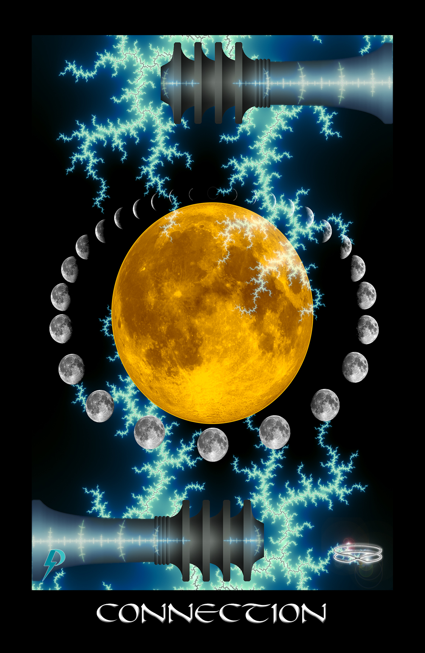

Connection
Key Phrase: Joyfully I reconnect.
Symbolism: The moon symbolizes your connection to higher Consciousness, to your Highest Self. The variable moon represents the waxing and waning strength of that connection, and the reality that connection is always a “work in progress,” and that repeated approximations are required before a more permanent connection is finally achieved, individually and collectively. Note that a new moon is disconnection while the full moon is full connection. Electrical discharge and the bright full moon represent the electrical/lightning power of a potent and direct connection. With proper care and attention, with only a little bit of healing, a lightning flash no longer shakes the tower but instead brings healing, insight, empowerment, and enlightenment.

New Energy Narrative
This archetype represents connection, which always leads, more or less, to insight, realization, emancipation, empowerment, activation, ascension, and connection. The archetype also represents ongoing will and intent. Responding to the call, realizing the truth, understanding reality, we must repeatedly make the decision to move forward and connect. Do we accept the revealed truth, step forward, and develop connection? Or, do we reject it out of fear, confusion, misunderstanding, or misdirection, and remain in Normal Consciousness? If we accept, we ascend the initiatory ladder to a higher state of knowing, if only for a moment or two.
Note, if you struggle, if you are stuck, do not despair. Even if you choose disconnection now, inevitably we must all find passage and re-connection. At some point, the attention and support you need will be there.
At the highest and most aligned levels, this is acceptance, asseveration, and declaration. We have cleared old energy thinking and archetypes and established new energy right thought. We understand that it is not an issue of judgment and/or damnation. We know there is nothing to fear. It is a simple question of choice and the supports we are able to acquire. Choosing to move forward, we work to create right environment. Working with archetypes, we slowly establish right thought. Acting with compassion and inclusive, more and more we engage in right action. Remember, this is not a test. There are no bystanders. No one is “left behind.” Embracing the inclusive truth, we connect and are reborn. Embracing our power, we activate, and graduate the entire planet.

Flow Purification
In old energy, connection is a thing, at least within the confines of esoteric institutions. We ascend the Masonic ladder. We enter the “kingdom of heaven.” We connect with all that there is. However, in the old energy, the processes which facilitate connection are obscured. Access to accurate information and training is shrouded in secrecy (Freemasons, for example, keep their methods a secret) and, wherever possible, limited to the “chosen” few, typically those willing to participate in systems of power and privilege that impoverish and disadvantage the many. In addition, in the old energy, systems of judgment and punishment work to undermine our sense of worth and sow fear, both of which make it harder to establish connection. We are limited by the shame and guilt instilled in us as children. We are told we are born unworthy and must struggle and “evolve” before we can claim one of the limited spaces. As a consequence of toxic socialization, we doubt our own ability to handle connection, if we can manage it.
Pay attention here because what I say next is important. All the old energy archetypes we learn as children and adolescents culminate at the point of connection to block us, divert us, corrupt the connection, and turn us away. Getting through this is an involved and challenging process of healing to strengthen and open the bodily ego, and flow purification to clear out the mind. It is important to understand how the cumulative weight of old energy systems of thought prevent us from establishing connection and it is important to remove those archetypes from our minds, otherwise, the most we will be able to attain is brief connection experiences, and eventually you’ll give up because you won’t make significant progress.
With the above in mind,
- Watch out for negative emotions like guilt, shame, self-doubt, and fear, especially when you experience these during connection events. Remember, you are a powerful lightworker incarnated in a physical unit. You are here to work on the world and uplift the planet so we might all graduate and join the Galactic Federation. Understand, you are not new to this position. You are no cosmic fool. You have incarnated thousands of times on multiple worlds in preparation for this. If you struggle, it is the damage and distortions accrued as as a consequence of toxic socialization. Heal as necessary and move forward persistently so you can build a stronger and more permanent connection.
- Always watch out for judgment. Judgment inflames insecurities and presses you down. More importantly, internalized judgment invokes fear and blocks your connection. If you feel judged, understand, you are an equal member of the glorious family of spirit and you deserve support and not judgment. Reject judgment and reject the people who judge you. Walk tall and proud. Embrace the powerful and joyful master that you are.
- Watch out for compromise. In the old energy, entry into the temple is marked by compromise. To enter the old energy temple we are told to compromise our independence, compromise what we know to be right, compromise our intimate relationships with our spouse (no women allowed), compromise our morality and our ethics, and compromise the truth of our shared divinity. Furthermore, we must pretend we are happy doing it. Of course, drugs, alcohol, money, power, and sex help distract from the disjuncture that results, but the consequences are the same nevertheless—brittle, cracked senescence are the ultimate result. Moving forward there can be no compromise. Remember the lessons from Workbook Three. Alignment is a key prerequisite of permanent connection. Therefore, we must learn to do what we know to be right and we must quit fooling ourselves into doing something else.

Connection Coach Question
- One of the ways passage through the new energy gates is blocked is by guilt, shame, and fear. If you can overcome guilt, shame, and fear, then connection can proceed. However, if you struggle with self-worth, if you don’t feel you are worthy, if you thrash about in fear, however sourced, your bodily ego will shut down connection and it will work to prevent it in the future. To avoid that, make a note of your emotions, especially during moments of connection. Once the connection experience is over, write down and explore your emotions? Do you experience guilt and shame. Where does this come from? How is it source. Does fear of God or madness shut you down. Make a note and try to remember who (priests, parents, friends) sowed these fears within you. Share with your group. Sharing helps demonstrate you are not alone. Guidance from others can help you sort out and localize the source.
- Connection requires alignment. Strong connection requires high levels of alignment. Therefore, open to your Self and ask, what am I doing wrong? Are you working in a job that’s aligned? Are you moving to express your full Self. Or, is your life path setting you back? Scan your life and make a note of wrong action. Do you judge others? Do you engage in forms of violence and suppression? Do you exploit or manipulate others? Do you harm other living beings? If you want to achieve stronger connection it is important to engage in aligned right action. Don’t be ashamed to look. Don’t be afraid to admit. Don’t turn your head and pretend. The first step towards change is admitting there needs to be change.

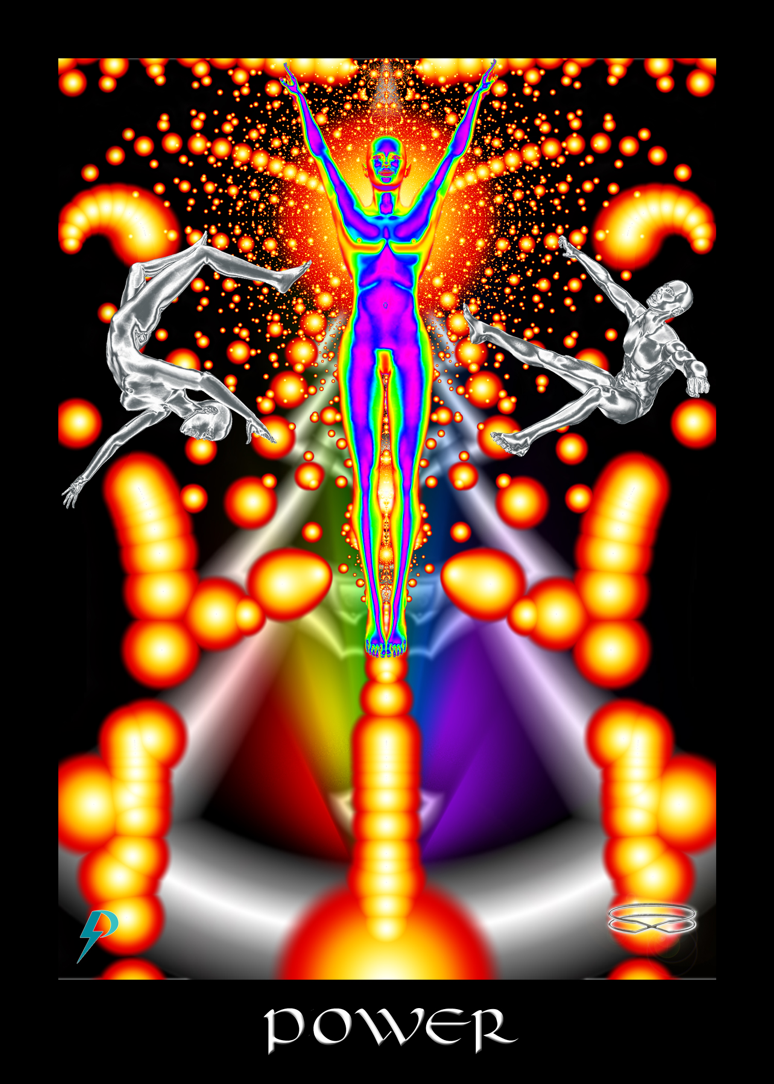

Power
Key Phrase: My power and my glory
Symbolism: An empowered figure in a fully activated physical unit embraces their divine creative power. The multicoloured power of creation shines brightly through. Unencumbered by Old Energy Archetypes of limitation and oppression, properly aligned and activated, empathic and connected to the Fabric of Consciousness, copious energies flow freely. Fully connected, the figure embraces highest purpose, which is self-conscious commitment to the Great Work. Consciousness explodes into the world. Knocked off balance by the power of Highest Self, the disconnected grasp, stumble, and eventually fall. This is the creative power of Spirit and the power and glory of The Fabric (i.e. God with a big “G”), no longer hidden, but on full display in the activated, aligned, and connected physical unit of a Shambhala Warrior. Look out world. Here we come.

New Energy Narrative
This archetype presents to you the full creative potential of Consciousness acting through a fully activated and aligned Physical Unit.
This is the individual lightworker in full manifestation.
This is the realized master, emancipated and in control.
This is unity of self with Self.
This is full expression of Consciousness, victory, and confident solidification of purpose.
This is realization of individual and collective divinity.
This is the glorious Triumph of Spirit.
At the highest and most aligned levels, this is Consciousness descended and the empowering impact thereof. Power is not about personal will and selfish strength; it is about the potential of Consciousness to alter reality, transform the world, and graduate creation. Realizing the lightworker you are, realizing why you are here, you move forward and claim full power with gusto. Using your newfound powers, you ensure the final Triumph of Spirit (i.e. victory and graduation).
At mundane levels, this is power over your world. Confident in your identity and abilities, confident in your understanding of life, you use your skills to create the world we all want and need. This is spirituality as science of connection. This is science as a manifestation of the Consciousness and power of God.

Flow Purification
In the old energy, you are told you cannot handle power. In the old energy, you are told you can’t handle the truth. In the old energy, you are told you are a foolish child. In the old energy, you are kept out of the club. In the old energies, you are told that you must submit, pay your dues, and accept judgment before you are given access to powerful “secrets.”
By this point in your study you should know that old energy archetypes are specifically designed to disempower and control you. They diminish your self-esteem, expose you to violence and abuse, create conditions that disconnect and then, when you are broken down shadow of yourself, they insert you into The System where they extract your labour value all the days of your life. You don’t have to submit that that BS anymore. Therefore,
- Reject all ideas that diminish you and make you feel small. You are not small. You are not powerless. In fact, just the opposite is true. You have the power of creation at your fingertips and all you have to do to access that power is to heal your mind and reconnect to the power within.
- Reject all ideas that suggest you are unworthy of power and truth. Embrace your joyful mastery. Embrace the power that is within you, stand up, and transform this world.
- Watch out for notions that insight and enlightenment require or followed by catastrophic psychological events. They do not. Healthy spiritual development is characterized by gentle and ongoing realization, and not punishing psychological/emotional falls. The imagery of the Tower applies to victims of Toxic Socialization only.

Connection Coach Question

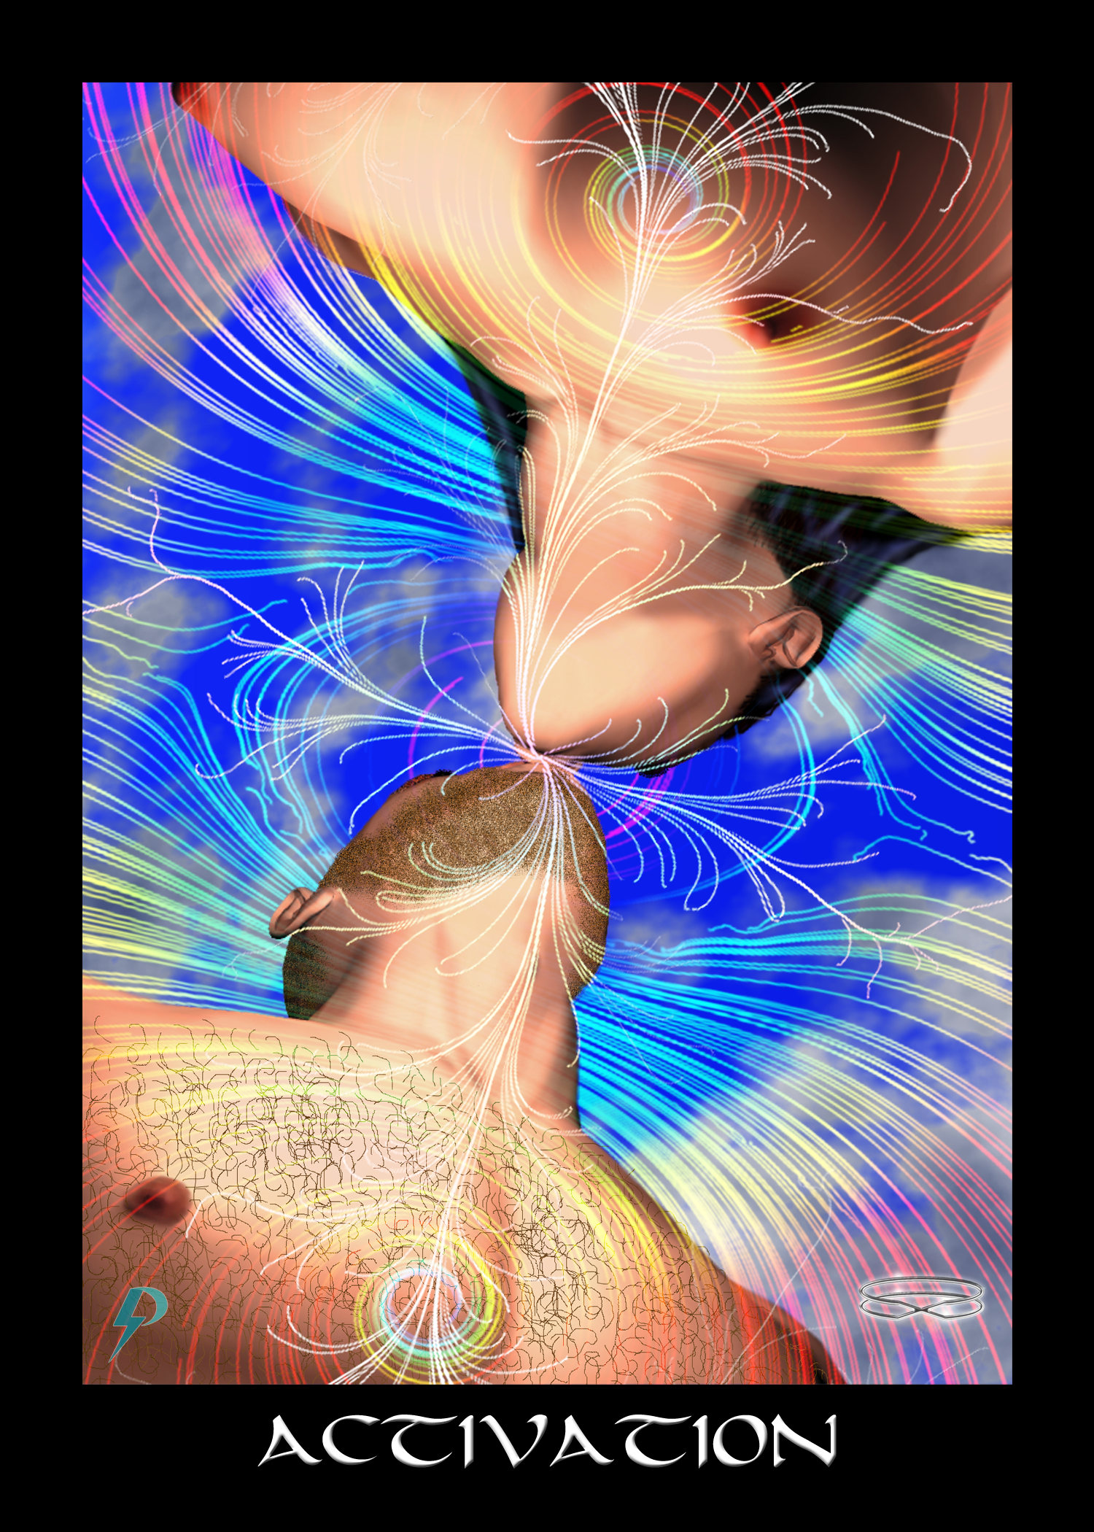

Activation
Key Phrase: It is time to activate the Master.
Symbolism: Force and Formation, here symbolized by male and female, applied in appropriate balance leads to full-scale activation of the physical unit. Chakras and kundalini light up. Remaining blockages and obstacles to healing and connection, symbolized by clouds in the sky, easily disperse. Intentions coalesce. Energies crackle. As you activate, as the world activates, reality begins to gently (and sometimes not so gently) align with Consciousness (with a capital “C”). Your world, and the entire world shortly begin to transform. Perfection and final graduation are only a step or two away.

New Energy Narrative
This archetype teaches of individual (and collective) activation. After preparations are complete, after the Physical Unit is prepared and aligned, after force and formation are in proper balance, after you emancipate yourself from the imitations of mental slavery, this is your individual and our collective activation.
At mundane levels, this is individual empowerment and advancement on the Path. Having established Right Thought and created Right Environment, having learned to live in a state of aligned right action, you embrace with confidence your Highest Self. Now that you consistently engage in Right Action, you reclaim original power. Activated and fully aware, you move forward and create the world that you came here to create.
At the highest and most aligned levels, this is the transformative “pop” that arises from collective activation. Blockages have disintegrated, resistances have evaporated, barriers have collapsed, bindings fall away, the masses rise up and transform. The activation and empowerment of billions terrifies some, but this is not random—it is divine. The ultimate destination is rejection of judgment and a positive transformation for the world, so really, there’s nothing to fear.

Flow Purification
In the old energy, there is such a thing as activation. In the old energy, some people do find their power. However, this is not a true activation. In the old energy, you are allowed to activate only insofar as you are firmly ensconced in the System. In the old energy, you rise insofar as you believe all the lies. Only the well-oiled cog gets this reward. This is why esoteric secrets are provided to the “chosen” few. It is easier to shape and control a few greedy, weak ones. Much harder to steer the vast masses. Let us be clear about this. The higher in The System you rise, the more “powerful” you become, the stronger the chains are that bind, and the less likely it is you’ll be free. Therefore, to move forward.
- Leave space for the possibility that your entire perspective is an inversion of reality. The powerful are really quite weak and addicted. The strong are those who resist and refuse to play the game. Stand up and cast off those chains. Break the foul spell that binds
- Understand, good and evil do not exist. It is the actions of those with power that cause suffering in this world. The balance you are looking for is not a balance between light and dark, good and evil, which is really nothing more than your excuse, but a personalized balance between force and formation. Put aside primitive and superstitious notions of “evil” and “good.” Put aside sexist attitudes that equate men with force/yang and women with formation/yin. Put aside your power and privilege. Strive for a true balance in life.
- If you want to move forward, don’t continue in your ruinous ways. Understand, we are all part of the same family of Spirit. Put aside your anger. Extinguish your hatred. Step down from that pedestal. Realize how damaged you are, but don’t dwell. Spread your arms. Gather your strength. Recite this activation affirmation. “I wish to wake up; I wish to activate; I wish to transform.” “I wish to wake up; I wish to activate; I wish to transform.”

Connection Coach Question

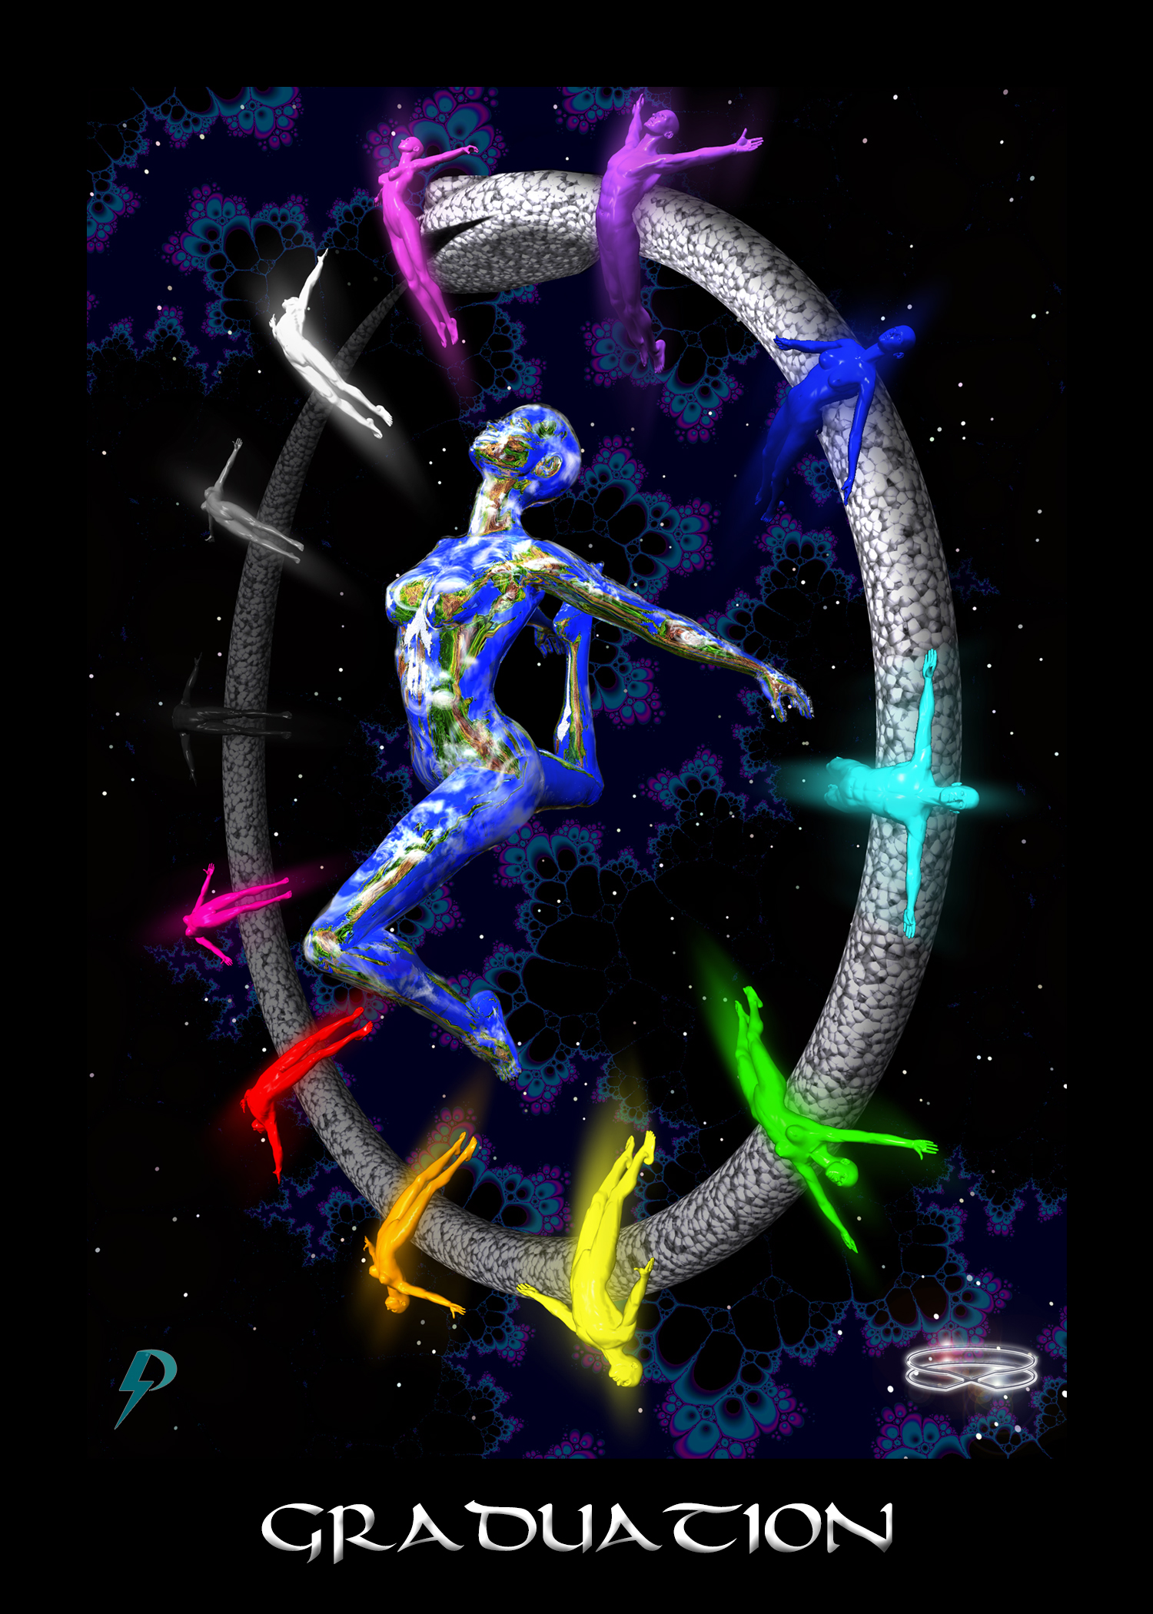

Graduation
Key Phrase: Our Joyful Graduation Dance
Symbolism: Twelve rainbow figures circle Gaia. The twelve figures represent the sum total of human life and planetary variation. These are the twelve signs of the zodiac and the Rainbow Spectrum of humanity. The snake ouroboros is the Creation Template driving the endless ascent of creation, now finally complete on this Earth. Gestation complete. Chrysalis transformation accomplished. The Body evolved and fully connected. Bondage broken. Mind emancipated. Humanity united. A cosmic graduation dance with all life joining in begins. Vulnerable and exposed, but safe all the same, a world contact jubilation welcomes us home.

New Energy Narrative
This archetype represents the Great Work complete. This is graduation and the associated celebration. Having responded to the call and reclaimed joyful mastery, having initiated, emancipated and aligned, we activate and are reborn. Realizing our birthright and purpose, we take our power, reconnect and victoriously shine our bright star. Consequently, darkness is swept away and the world rapidly transforms. Now we see clearly our sacrifice was worth it. Now we fulfill the promise and invite everyone to join in the joyous ceremonials.
At the highest and most aligned levels, we celebrate the culmination of human evolution and the fulfillment of the Divine Plan. United as one across the globe, we joyfully embrace a cosmic unity. A celebratory milestone welcomes us home, but this is not the end of our journey. This is merely the beginning of utopia on this world. The ascent of the universe is an eternal voyage. Through the eternal hallways of creation, we build a galactic star nation.
At mundane levels, this is graduation and commencement. We have worked hard and sacrificed much. We have victoriously achieved the goal we have set for ourselves, so celebrations are in order. Don’t rest too long, however, for much healing and transformation work remains.
At an individual level, this is the triumphant realization of evolutionary and spiritual purpose. At an individual level, this is rejoining the global and cosmic family of Spirit. We celebrate each other as we ring in a new dawn.
At a collective level, this is realization of unity, purpose, and Federation membership. Having travelled a difficult evolutionary path, having implemented the Divine Plan, having completed the Great Work, we reach the end of our journey. Tired and weary, but with the relief that comes after sacrifice and struggle, we stand up, rejoice, and join in.

Flow Purification
In the old energy, we are told this is an individual celebration. In the old energy, we are told that only the chosen few get to this point. In the old energy, we are told that only the worthy get in. In the old energy, we are told that the masses won’t ever measure up. In the old energy, this is the culmination of the “heroes” journey. But none of that is true. The message of the graduation archetype should be clear. The Great Work (all work in fact) is a collective project of planetary evolution. Whether we realize it or not, we all participate in the Great Work. On the right side or left, we all play a part in the Divine Plan. Why celebrate the individual victor when it is our collective work that accomplishes this end? Pay close attention. The key to your graduation is this. We all played a part. No one is deemed unworthy of graduation no matter what they might have done. No one is cast into the fire. No one is “left behind.” The entire planet joins in the celebration. Therefore, to transit into the new energies and reclaim your power...
- Watch out for characterizations that attribute success exclusively to individual effort and talent. Individual hard work and commitment are important, but no one survives and thrives without the ongoing and perpetual support of others, and society. The truth is, we do not graduate till everybody is home in the end.
- Watch out for characterizations of success and failure that attribute it exclusively to individual effort and talent, or lack thereof. Winners and losers are not born, they are made Individual hard work and commitment are important, but no one succeeds except by the hands of the many, and no one fails except for a lack of support, and a long and oppressive history of oppression and subjugation. Remember, the Great Work is the work of the collective, not the individual.

Connection Coach Question
- Like the water that surrounds a fish swimming, the work of individualism is the literal air we breathe. Spend some time thinking about your own upbringing, your own family life, etc. How was the individual Fool’s journey portrayed to you?

Glossary
Archetypes – Archetypes are ideas that answer big questions. Archetypes influence how you see yourself, how you see the world, and the actions you take in the world. Archetypes are powerful are elites use them to manipulate and control reality.
Creation Template – A creation template is a collection of archetypes designed with a specific creative goal in mind. For example, the old energy creation template is a collection of archetypes designed to create compliant and subservient peons suitable for insertion into systems of labour extraction.
Symbol Factories, are institutions which reproduce and distribute archetypes. Ideological institutions include things like the Catholic Church, Walt Disney Corporation, and various Hollywood studies.
We can break ideological institutions down into exoteric and esoteric institutions. Esoteric ideological institutions are institutions that are open to the general public, and that create archetypes for general public consumption. Examples include Disney, the Church, etc. On the other hand, esoteric ideological institutions are institutions that are open only to elites. Esoteric institutions create a parallel system of archetypes designed to manipulate and control societies political and ec0nomic elites. Examples include so-called secret societies like Freemasonry, Skull and Bones, etc.
The Tarot Deck – The western Tarot deck is an old energy creation template. As explained in the article “A Sociology of Tarot” it was designed by capitalist elites with a specific goal in mind, to support and grow the Capitalist Regime of Accumulation. Because the Tarot deck was created by Freemasons, we refer to it as a Masonic Tarot. The Masonic Tarot presents a view of self and society that is conducive to formation and operation of Capitalism.

References
Biddy, Bridget. “Justice Tarot Card Meanings.” Biddy Tarot, 2020. https://www.biddytarot.com/tarot-card-meanings/major-arcana/justice/.
———. “Strength Tarot Card Meanings.” Biddy Tarot, 2020. https://www.biddytarot.com/tarot-card-meanings/major-arcana/strength/.
Biddy Tarot. “Fool Tarot Card Meanings,” 2017. https://www.biddytarot.com/tarot-card-meanings/major-arcana/fool/.
Blavatsky, H. P. The Key to Theosophy: A Clear Exposition Based on the Wisdom Religion of All Ages. Theosophical University Press, 1889.
Campbell, Joseph. The Hero with a Thousand Faces. Oxford: Princeton University Press, 2004.
Case, Paul Foster. An Introduction to the Study of the Tarot. New York: Kindle Edition, 1920.
———. Learning Tarot Essentials: Tarot Cards for Beginners. Vancouver: Ishtar Publishing, 1932.
Cillizza, Chris. “Yes, Donald Trump Really Believes He Is ‘the Chosen One.’” CNN, 2019. https://www.cnn.com/2019/08/21/politics/donald-trump-chosen-one/index.html.
Decker, Ronald, Thierry Depaulis, and Michael Dummett. A Wicked Pack of Cards: The Origins of the Occult Tarot. New York: St Martin’s Press, 1996.
Edelwyn Collective. “The Strength Tarot Card’s True Meaning: Love, Health and Money.” Edelwyn, 2020. https://www.edelwyn.com/strength/.
Ehrman, Bart D. Misquoting Jesus: The Story Behind Who Changed the Bible and Why. Harper One, 2007.
Freud, Sigmund. Civilization and Its Discontents. New York: W.W. Norton, 1961. https://amzn.to/2STCpQT.
Harmless, William. Mystics. New York: Oxford University Press, 2008.
Jung, Carl G. The Archetypes and the Collective Unconscious. Edited by Gerhard Adler, Sir Herbert Read, Michael Fordham, and William McGuire. Translated by R.F.C. Hull. 2nd ed. New York: Princeton University Press, 1980.
Levinson, Barry. Sphere. Action, Mystery, Sci-Fi, Thriller. Warner Bros., Baltimore Pictures, Constant c Productions, 1998.
Miller, William R. “The Phenomenon of Quantum Change.” Journal of Clinical Psychology 60, no. 5 (2004): 453–60. doi:10.1002/jclp.20000.
Pollack, Rachel. Seventy-Eight Degrees of Wisdom. Harper Collins, 1980.
Regardie, Israel. The Middle Pillar: The Balance Between Mind and Magic. St Paul, Minnesota: Llewellyn, 2004.
Restorative Justice. “Restorative Justice,” 2020. https://restorativejustice.org/.
Rodriguez, Robert. Spy Kids 4: All the Time in the World. Action, Adventure, Comedy, Family, Sci-Fi. Dimension Films, Troublemaker Studios, Spy Kids 4 SPV, 2011.
Schreber, Daniel Paul. Memoirs of My Nervous Illness. New York: NYRB Classics, 2000. https://amzn.to/2U8Se6Q.
Sosteric, Michael. The Book of Light: The Nature of God, the Structure of Consciousness, and the Universe Within You. 4 vols. St. Albert, Alberta: Lightning Path Press, Unpublished.
Sosteric, Mike. “A Short Sociology of Archetypes,” 2020. https://www.academia.edu/44254363/.
———. “A Sociology of Tarot.” Canadian Journal of Sociology 39, no. 3 (2014). https://www.academia.edu/25055505/.
———. “Editing the Bible for Patriarchy.” Academia.Edu, 2020. https://www.academia.edu/43721896.
———. “From Zoroaster to Star Wars, Jesus to Marx: The Art, Science, and Technology of Mass Human Manipulation,” Under Review. https://www.academia.edu/34504691.
———. Lightning Path Workbook Three - Connection. Vol. 3. Lightning Path Workbook Series. St. Albert, Alberta: Lightning Path Press, 2017.
———. “Star Wars Is a Religion That Primes Us for War and Violence.” The Conversation, 2018. https://theconversation.com/star-wars-is-a-religion-that-primes-us-for-war-and-violence-89443.
Sosteric, Mike, and Gina Ratkovic. “Toxic Socialization,” 2016. https://www.academia.edu/25275338/Toxic_Socialization.
The Sun. Donald Trump: 'I Am the Chosen One’, 2019. https://www.youtube.com/watch?v=JgwalqjF5nw.
Wang, Robert. An Introduction to the Golden Dawn Tarot. Main: Sam Weiser, 1978.
Weber, Max. The Protestant Ethic and the Spirit of Capitalism. New York: Roxbury Press, 1904.
Wen, Benebell. Holistic Tarot: An Integrative Approach to Using Tarot for Personal Growth. Berkeley, CA: North Atlantic Books, 2015.
Wirth, Oswald. Tarot of the Magicians: The Occult Symbols of the Major Arcana That Inspired Modern Tarot. San Francisco. CA: Weiser Books, 1990.
Zalewski, Patrick, and Christine Zalewski. The Magical Tarot of the Golden Dawn. Aeon Books, 2008.

http://spiritwiki.lightningpath.org/index.php/Connection_Practice
See for example Sigmund Freud, The Future of an Illusion (New York: Anchor Books, 1961), https://amzn.to/2EZqqgZ.
To be frank, this is a bit of a danger. It can happen that you can lose your ground and become a little unhinged during and immediately after a connection experience, especially if that experience is powerful, if you are not prepared, and if you have experienced a lot of family violence and trauma as a child and adolescent. In a few very rare cases, psychosis can result. Nevertheless, proper preparation can provide a solid anchor in the ground, and a little bit of post-connection guidance can help bring you back down to Earth.
http://spiritwiki.lightningpath.org/index.php/Authentic_Spirituality
https://spiritwiki.lightningpath.org/index.php/Accumulating_Class
The term Connection Practice refers to any technique, such as meditation, writing, etc., that helps one strengthen and purify Connection. The term may also refer to any structured, daily, connection practice. https://spiritwiki.lightningpath.org/index.php/Connection_Practice
https://spiritwiki.lightningpath.org/index.php/Toxic_Socialization
https://spiritwiki.lightningpath.org/index.php/Alignment
https://spiritwiki.lightningpath.org/index.php/Nadir_Experience
https://spiritwiki.lightningpath.org/index.php/Connection_Pathology
https://spiritwiki.lightningpath.org/index.php/Spiritual_Emergency
https://spiritwiki.lightningpath.org/index.php/Wrong_Thought
William Harmless, Mystics (New York: Oxford University Press, 2008); William R. Miller, “The Phenomenon of Quantum Change,” Journal of Clinical Psychology 60, no. 5 (2004): 453–60, doi:10.1002/jclp.20000.
https://spiritwiki.lightningpath.org/index.php/Ascension_Experience
http://spiritwiki.lightningpath.org/index.php/Fabric_of_Consciousness
For some examples of people who say this, see “Who are you” https://www.lightningpath.org/advanced/who-are-you/
Israel Regardie, The Middle Pillar: The Balance Between Mind and Magic (St Paul, Minnesota: Llewellyn, 2004), 2004. Why teach someone this wrong thought? Because this thought takes the common spiritual truth that we are all one and equal in Consciousness and twists that to justify hierarchies and exclusionary privilege of the type the runs rampant in esoteric organizations and human society. More to the point, this thought allows the ruling classes of this planet, the “masters” as Adam Smith called them, to pursue the intellectual and emotional enhancements that come from connection while at the same time suppressing the progressive and egalitarian transformations that occur as a consequence.
See Michael Sosteric, The Book of Light: The Nature of God, the Structure of Consciousness, and the Universe Within You, 4 vols. (St. Albert, Alberta: Lightning Path Press, Unpublished).
https://spiritwiki.lightningpath.org/index.php/Misalignment
Daniel Paul Schreber, Memoirs of My Nervous Illness (New York: NYRB Classics, 2000), https://amzn.to/2U8Se6Q.
Max Weber, The Protestant Ethic and the Spirit of Capitalism (New York: Roxbury Press, 1904).
Carl G. Jung, The Archetypes and the Collective Unconscious, ed. Gerhard Adler et al., trans. R.F.C. Hull, 2nd ed. (New York: Princeton University Press, 1980).
Joseph Campbell, The Hero with a Thousand Faces (Oxford: Princeton University Press, 2004).
Mike Sosteric, “A Sociology of Tarot,” Canadian Journal of Sociology 39, no. 3 (2014), https://www.academia.edu/25055505/.
Ronald Decker, Thierry Depaulis, and Michael Dummett, A Wicked Pack of Cards: The Origins of the Occult Tarot (New York: St Martin’s Press, 1996), 27.
Mike Sosteric, “From Zoroaster to Star Wars, Jesus to Marx: The Art, Science, and Technology of Mass Human Manipulation” Under Review, https://www.academia.edu/34504691.
https://www.youtube.com/watch?v=D77dbv-xNfE
https://spiritwiki.lightningpath.org/index.php/Creation_Template
https://spiritwiki.lightningpath.org/index.php/Old_Energy_Creation_Template
Sosteric, “From Zoroaster to Star Wars, Jesus to Marx: The Art, Science, and Technology of Mass Human Manipulation.”
A System Agent is an individual who works, either unconsciously or consciously, and with more or less clarity, to maintain and expand the extant Regime of Accumulation (i.e. The System). For more, see https://spiritwiki.lightningpath.org/index.php/System_Agent
https://spiritwiki.lightningpath.org/index.php/Masonic_Tarot_Deck
Sosteric, “A Sociology of Tarot.”
Bart D. Ehrman, Misquoting Jesus: The Story Behind Who Changed the Bible and Why (Harper One, 2007); Mike Sosteric, “Editing the Bible for Patriarchy,” Academia.Edu, 2020, https://www.academia.edu/43721896.
Sosteric, “Editing the Bible for Patriarchy.”
https://www.youtube.com/watch?v=yVzVuwOQTNM&list=PLsPYCkCxjrQ05G1DhscDM0HRUM35r4HtI
https://en.wikipedia.org/wiki/Rider%E2%80%93Waite_tarot_deck
https://en.wikipedia.org/wiki/A._E._Waite#Freemason
Biddy Tarot, “Fool Tarot Card Meanings,” 2017, https://www.biddytarot.com/tarot-card-meanings/major-arcana/fool/ emphasis added.
Sosteric, “From Zoroaster to Star Wars, Jesus to Marx: The Art, Science, and Technology of Mass Human Manipulation.”
Sigmund Freud, Civilization and Its Discontents (New York: W.W. Norton, 1961), https://amzn.to/2STCpQT.
Jung, The Archetypes and the Collective Unconscious.
Mike Sosteric, “Star Wars Is a Religion That Primes Us for War and Violence,” The Conversation, 2018, https://theconversation.com/star-wars-is-a-religion-that-primes-us-for-war-and-violence-89443.
For more, see the article Ibid.
Mike Sosteric, Lightning Path Workbook Three - Connection, vol. 3, Lightning Path Workbook Series (St. Albert, Alberta: Lightning Path Press, 2017).
“Restorative Justice,” Restorative Justice, 2020, https://restorativejustice.org/.
An Ideological Institution is an institution that is tasked with controlling the minds and behaviours of a population. Ideological institutions operate by developing and inserting old energy archetypes into the consciousness of a target population. For more details, see https://spiritwiki.lightningpath.org/index.php/Ideological_Institutions
Paul Foster Case, An Introduction to the Study of the Tarot (New York: Kindle Edition, 1920).
Benebell Wen, Holistic Tarot: An Integrative Approach to Using Tarot for Personal Growth (Berkeley, CA: North Atlantic Books, 2015).
Regardie, The Middle Pillar: The Balance Between Mind and Magic, 7.
H. P. Blavatsky, The Key to Theosophy: A Clear Exposition Based on the Wisdom Religion of All Ages (Theosophical University Press, 1889), 0.
Oswald Wirth, Tarot of the Magicians: The Occult Symbols of the Major Arcana That Inspired Modern Tarot (San Francisco. CA: Weiser Books, 1990), 35.
Barry Levinson, Sphere, Action, Mystery, Sci-Fi, Thriller (Warner Bros., Baltimore Pictures, Constant c Productions, 1998).
The Sun, Donald Trump: 'I Am the Chosen One’, 2019, https://www.youtube.com/watch?v=JgwalqjF5nw; Chris Cillizza, “Yes, Donald Trump Really Believes He Is ‘the Chosen One,’” CNN, 2019, https://www.cnn.com/2019/08/21/politics/donald-trump-chosen-one/index.html.
Robert Rodriguez, Spy Kids 4: All the Time in the World, Action, Adventure, Comedy, Family, Sci-Fi (Dimension Films, Troublemaker Studios, Spy Kids 4 SPV, 2011).
https://spiritwiki.lightningpath.org/index.php/Connection_Supplement
http://spiritwiki.lightningpath.org/index.php/Nadir_Experience
http://spiritwiki.lightningpath.org/index.php/External_Resistance
The “key phrase” is a short mnemonic phrase designed to help you invoke the basic message of the archetype. Use the key phrase to remember and reinforce the message in your daily meditative practice, and during connection events to
https://spiritwiki.lightningpath.org/index.php/Connection
https://spiritwiki.lightningpath.org/index.php/The_Wheel_of_Fortune
https://spiritwiki.lightningpath.org/index.php/Hierophant
https://spiritwiki.lightningpath.org/index.php/Creation_Template.
Robert Wang, An Introduction to the Golden Dawn Tarot (Main: Sam Weiser, 1978), 136.
Patrick Zalewski and Christine Zalewski, The Magical Tarot of the Golden Dawn (Aeon Books, 2008), 73.
Patrick Zalewski and Christine Zalewski, The Magical Tarot of the Golden Dawn (Aeon Books, 2008), 73.
Mike Sosteric and Gina Ratkovic, “Toxic Socialization,” 2016, https://www.academia.edu/25275338/Toxic_Socialization.
Wen, Holistic Tarot: An Integrative Approach to Using Tarot for Personal Growth.
Ibid.
Rachel Pollack, Seventy-Eight Degrees of Wisdom (Harper Collins, 1980), 65.
Edelwyn Collective, “The Strength Tarot Card’s True Meaning: Love, Health and Money,” Edelwyn, 2020, https://www.edelwyn.com/strength/.
Bridget Biddy, “Strength Tarot Card Meanings,” Biddy Tarot, 2020, https://www.biddytarot.com/tarot-card-meanings/major-arcana/strength/.
Pollack, Seventy-Eight Degrees of Wisdom, 76.
Zalewski and Zalewski, The Magical Tarot of the Golden Dawn, 189–90.
For the Lightning Path definition of “sin,” see http://spiritwiki.lightningpath.org/index.php/Sin/.
Wirth, Tarot of the Magicians: The Occult Symbols of the Major Arcana That Inspired Modern Tarot, 171.
Bridget Biddy, “Justice Tarot Card Meanings,” Biddy Tarot, 2020, https://www.biddytarot.com/tarot-card-meanings/major-arcana/justice/.
Paul Foster Case, Learning Tarot Essentials: Tarot Cards for Beginners (Vancouver: Ishtar Publishing, 1932), 110.
Zalewski and Zalewski, The Magical Tarot of the Golden Dawn, 136.
Pollack, Seventy-Eight Degrees of Wisdom, 1993.
Sosteric, Lightning Path Workbook Three - Connection.
A Divine World Order is a world order characterized by high CQ amongst a sizeable majority of the population, with work underway to heal and connect all beings. For more, see https://spiritwiki.lightningpath.org/index.php/Divine_World_Order.
See Sosteric M. (2016a) Rocket Scientists' Guide to Money and the Economy: Accumulation and Debt., St Albert, Alberta: Lightning Path Press.
Sosteric, “A Sociology of Tarot.”

