The Seven Essential Needs: Why Maslow's Pyramid Was Never Enough

And what a circle can do that a triangle never could.

For
The Peace Table
https://peace-table.lightningpath.org
Join us at our Matrix Server
https://matrix.to/#/#the-peace-table---foyer:matrix.org

The Vision That Started It All
On December 8, 1941 — the day after Pearl Harbor — Abraham Maslow had a vision. Driving home, his car stopped by a parade of Boy Scouts and old uniforms, he began to cry. "I felt we didn't understand," he later wrote. "Not Hitler, nor the Germans, nor Stalin, nor the Communists. We didn't understand any of them." He imagined a "peace table" where people gathered to talk about "human nature and hatred and war and peace and brotherhood." That moment changed his life, and it would eventually give birth to The Peace Table itself.
Maslow spent the next three decades working towards a Eupsychian Psychology — a psychology not of pathology or control, but of Human Flourishing. At its center lay a theory of human needs. In 1943, he published two seminal articles proposing what we now know as the "hierarchy of needs": physiological needs at the bottom, then safety, love, esteem, and finally self-actualization at the top. The theory was elegant, intuitive, and revolutionary. It suggested that human beings are not merely driven by instincts or conditioned responses, but by a progressive unfolding of potentials, each level of need preparing the ground for the next.
Maslow was clear about where this led. "Human nature can be good under certain conditions," he wrote in an unpublished essay later brought to light by his biographer Edward Hoffman. Under good conditions, people manifest "affection, altruism, friendliness, generosity, honesty, kindness, and trust." Under bad conditions, you get something else entirely. The question, as Maslow insisted, was what those good conditions actually are.
He already knew the answer, or thought he did. It had to do with "basic-need gratification because such gratification composes the primary path for higher evolvement and humanness and greater self-actualization."
This was not merely "positive psychology." Maslow was interested in something far more ambitious: a psychology that would speak to "human potential and wholeness," that would provide "normative suggestions towards the development of a way of life, not only for the person himself within his own private psyche, but also for the same person as a social being, a member of society." He wanted a psychology that could help build what he called Eupsychia — the Good Society capable of creating the Good Person.
But Maslow died in 1970 before completing this work. And in the decades that followed, something strange happened to his theory.

How the Pyramid Betrayed the Vision
Unlike what you might think, Maslow never conceived his needs as a pyramid. The iconic image that now adorns millions of PowerPoint slides and textbook pages was invented not by Maslow, but by a business theorist named Charles McDermid, who published it in a 1960 magazine called Business Horizons. McDermid's goal was not to understand humanity but to "maximize the motivational impact of management initiatives." In other words, to manipulate workers. To manipulate them into working harder by tying their deepest aspirations to corporate goals. The pyramid was designed as a tool of control, not liberation.
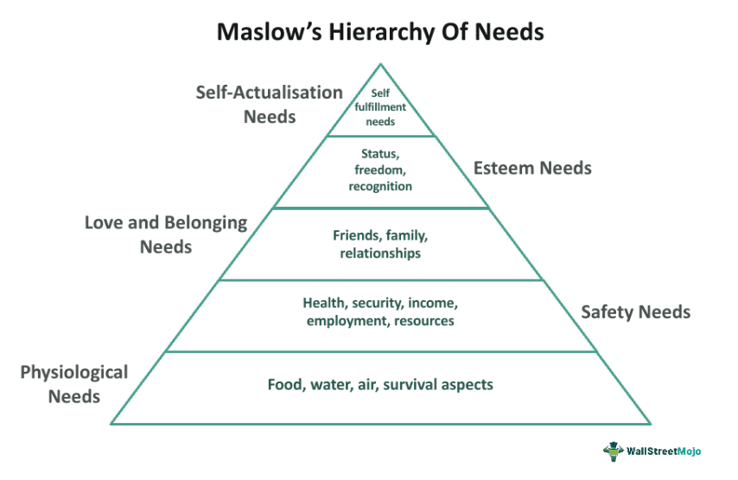
This matters not only because, you know, it is unethical, but because the pyramid is not merely a different shape. It is a different worldview. A pyramid is hierarchical, linear, competitive. It suggests that some needs are "lower" and less important, that you must climb past them, ascend above to reach what really matters, self-actualization, a peak occupied by only a very select/chosen few. It is the capitalist slave-ethic encapsulated and made iconic. It is, as the scholar Scott Barry Kaufman has called it, a "parody" — a caricature of Maslow's thinking.
The pyramid also systematically omits what Maslow actually wrote. In his original 1943 papers, Maslow included a second Hierachy of Cognitive Needs to supplement his Hierarchy of Basic Needs, the need to know and the need to understand — which he considered "either the most important or one of the most important characteristics of psychological health." To be blunt, if you want to be psychologically healthy, you have to live with the truth. This second hierarchy was central and there in the beginning. Yet this powerful, foundational statement has been entirely erased from the popular and even scholarly understanding of his work.
Similarly, Maslow's later additions, aesthetic needs, the need for creative outlets, the need for transcendence, the need for power, and a third hierarchy of "meta-needs" for beauty, justice, neatness, love, honesty, orderliness, and serenity, have been ignored or treated as footnotes. What we are left with, even after sixty-five years of on-again, off-again interest in Maslow, is a sanitized, stripped-down version of a far more sophisticated theory Maslow had in development, one better suited to corporate seminars than to the project of human liberation Maslow actually envisioned.
Sadly, the pyramid of needs has proven remarkably resistant to criticism. Over the decades, Maslow's theory has been called internally inconsistent, empirically weak, ethnocentric, sexist, and elitist. Critics have correctly identified its Western cultural bias, its neoliberal emphasis on individual improvement over social reform, and its blindness to the social, political, and economic conditions that facilitate or impede needs satisfaction. Yet the pyramid persists, floating above these objections like a brand logo too valuable to abandon.

The Circle of Seven Essential Needs
So, what are we going to do?
Well, what if we started anew, not by discarding Maslow, but by reclaiming and refreshing him?
My Seven Essential Needs theory (Sosteric, 2026) proposes exactly this. It rejects the pyramid as an ideological corruption and replaces it with a circle, as suggested by a member of the Carry the Kettle First Nation, and one that appears across Indigenous worldviews as a perpendicular cutaway of a tree stump. The truth represented by the circle is simple. For a tree to grow healthy, its needs must be sufficiently satisfied every single year. Each growth ring represents not a level to be transcended, but a set of needs (water, sun, nutrients) that were met satisfactorily (wide ring width) or not (narrow ring width). All needs are essential. All needs are interconnected. Satisfaction of all needs contributes to maximal growth.
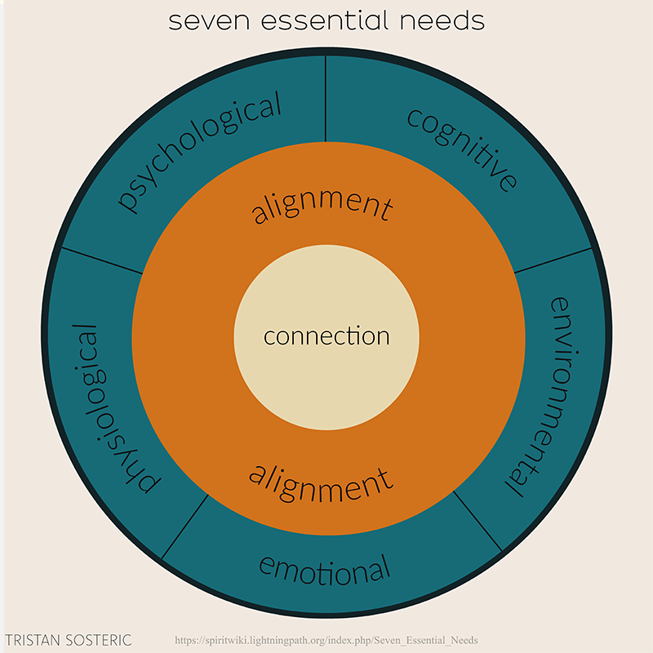
As you can see in the graphic, in the Seven Essential Needs theory, the circle has three layers: an outer layer of basic needs, an inner need for alignment, and at the very center, the core need of every living thing: connection.
Here is a quick summary

The Five Basic Needs (Outer Layer)
1. Physiological Needs — adequate food, water, rest, movement, shelter, and freedom from pain and bodily threat. This is Maslow's original foundation, retained unchanged. Meeting these needs keeps the body healthy and gives it the physical foundations for growth.
2. Environmental Needs — Maslow's original "safety needs" expanded to include not just physical security but nurturing environments. This means absence of assault of any kind — physical, emotional, psychological. It means stability: financial security, consistent relationships, healthy families. It means aesthetic quality, environments that are pleasing, not merely functional. And it means support for spontaneity, what Maslow called "pure spontaneity" — the "free, uninhibited, uncontrolled, trusting, unpremeditated expression of the self." Our brains simply do not function well in the "unnecessary and normalized rigidity, violence, and chaos that is our daily experience of colonized life."
3. Cognitive Needs — the need to know and the need to understand. Maslow defined the need to know as the "basic desire to know, to be aware of reality, to get the facts, to satisfy curiosity...to see rather than to be blind." The need to understand goes deeper: "the desire to understand, to systematize, to organize, to analyze, to look for relations and meanings." These are not luxuries or late-stage additions. Maslow considered them driving, biological needs, just like the basic needs. Yet they have been systematically excluded from the pyramid, perhaps because a population trained to truly understand the world by an education system designed to meet this need is harder to manipulate.
4. Emotional Needs — love, belonging, unconditional acceptance, inclusion. Maslow was unequivocal: "No psychological health is possible unless this essential core of the person is fundamentally accepted, loved and respected by others and [oneself]." These needs are no less important for physical health than physiological needs, further underlining why a hierarchical representation fails.
5. Psychological Needs — reconceptualized from Maslow's "esteem needs" to include not just confidence and recognition, but power ("the phenomenological sense that one can change the world in accord with one's desires") and freedom ("the need to explore, grow, and develop in line with one's preferences and predilections"). Maslow defined power not as domination but as "the feeling of having some control over fate, of not being a helpless tool, a passive object, a cork on the wave which is tossed here and there by forces out of control."

The Inner Need: Alignment
6. Alignment — The inner need is the need for alignment, what Maslow called self-actualization, but reconceptualized. The term "self-actualization" carries Western individualistic baggage, implying a "high performing self" more suited to capitalist labor markets than to genuine human development. Alignment is culturally and spiritually universal. It means coherence between self (ego), values, behavior, community, and "what is right and good." It includes what Maslow called the "intrinsic conscience" — the voice within that knows when we are living in integrity. It is both a prerequisite to connection and its natural consequence.

The Core Need: Connection
7. Connection — Finally, what Maslow called transcendence, but understood as the actual destination, not merely a step along the way. We transcend ideology, enculturation, trauma, ego, and emotional blockage in order to heal, strengthen, and establish connection with "something more" than the isolated self. Maslow described the experience: "When the distinction between self and not-self has broken down...the self has enlarged enough to include his child. Hurt his child and you hurt him....[he has fused] with the non-self...not only...the world of nature...[but] other human beings...[to the point that]...'selves overlap.'"
If I clean that up a bit it becomes “When the distinction between self and not-self has broken down, then the self has enlarged enough to include his child, the world of nature, and other human beings to the point that selves mesh, merge, and overlap.”
This can be a scary thought for some because they read into it the collapse and disappearance of a stable self, but that’s not what it entails. Based on personal experience I would say it actually involves a strengthening of self, individuality, perspective, purpose, and all the things that go into giving you your egoic sense of “I.” We’ll talk about this more later.

Why This Matters for Eupsychia
As Maslow explained in an interview (Maslow, 1961), his Eupsychian project was always about more than individual fulfillment. It was about building the Good Society, a society that provides "basic-need gratifications for its members" so that they can become "healthy, happy, and fully human." The circle carries this ambition in a way the pyramid cannot.
The circle does not ask “How can we motivate workers to be more productive?”
The circle asks “How can we build a world where every human being regardless of ethnicity, gender, or whatever, has what they need not just to survive, but to flourish?”
The pyramid assumes scarcity, competition, individual striving.
The circle assumes interdependence, mutual care, collective thriving.
The pyramid is a ladder you climb alone.
The circle is a table you gather around — a peace table, even — where all are seated, all are fed, and all are heard.
As Maslow wrote near the end of his life: "There is now available a new conception, of a higher possibility, of the healthy society. There are tools now available to judge and compare societies. One society can be judged to be better than another society, or healthier or possessing more 'growth-fostering-potential.'" The Circle of Seven Essential Needs is one such tool. It provides not merely a theory of motivation, but a framework for judgment, a way to ask, of any family, any school, any workplace, any society: Are the essential needs of all its members being met?
If not, the consequence is not merely individual unhappiness. It is the perpetuation of the very conditions that produce hatred, war, and the polycrisis now engulfing our civilization. Unmet needs do not simply persist; they fester, distort behavior, diminish potential, erupt into chaos and all forms of violence: emotional, psychological, spiritual, physical. The child who is not loved becomes the adult who has no empathy. The citizen who is not free becomes the tyrant who denies freedom. The child who is not heard becomes the adult who is confused and unsure. The human being who is not connected to anything larger than the self becomes the embodiment of the isolated, consuming, destructive individual that our economic system requires but that our planet cannot survive.
Maslow knew this. His vision of the peace table was not naive idealism. It was urgent, empirical realism. He understood that the question of human needs is ultimately the question of human survival, not merely physical survival, but the survival of our capacity for goodness, for beauty, for truth, for love.
The pyramid cannot take us there. It was never designed to. But the circle, the circle that remembers what the pyramid forgot, that honors what the pyramid excluded, that connects what the pyramid divided, the circle can.
And so we gather. Around a table. In a circle. Seven needs, one humanity, zero exceptions.
Welcome Home.

Readings
Maslow, A. H. (1943a). A preface to motivation theory. Psychosomatic Medicine, 5(1), 85-92.
Maslow, A. H. (1943b). A theory of human motivation. Psychological Review, 50(4), 370-396.
Maslow, A. H. (1954). Motivation and personality. Harper & Row.
Maslow, A. H. (1961). Eupsychia — The good society. Journal of Humanistic Psychology, 1(2), 1-11.
Maslow, A. H. (1967). *The creative attitude*. In G. T. Claxton (Ed.), Growth psychology. Penguin.
Maslow, A. H. (1968). Toward a psychology of being (2nd ed.). Van Nostrand.
Maslow, A. H. (1970). Religions, values, and peak-experiences. Viking.
Maslow, A. H. (1971). The farther reaches of human nature. Viking.
Maslow, A. H. (1991). *The need for self-actualization*. In A. H. Maslow, Motivation and personality (3rd ed.). Addison-Wesley.
Maslow, A. H. (1996). What is the essence of human nature? In E. Hoffman (Ed.), Future visions: The unpublished papers of Abraham Maslow. Sage.
Bridgman, T., Cummings, S., & Ballard, J. (2019). Who built Maslow's pyramid? A history of the creation of management studies' most famous symbol and its implications for management education. Academy of Management Learning & Education, 18(1), 81-98.
Hoffman, E. (1999). The right to be human: A biography of Abraham Maslow (Rev. ed.). McGraw-Hill.
Sosteric, M. (2026). Eupsychian Theory I: Reclaiming Maslow and rejecting the pyramid—The circle of seven essential needs. Athens Journal of Psychology, 2, 1-26.
---
The Peace Table is the public-facing journal of the Lightning Path — a project dedicated to advancing humanity's understanding of self with a view towards achieving peace at all levels. For deeper exploration of the concepts in this article, visit The SpiritWiki.

